Week 2

System Design and Architecture Planning

1. Game Features:
The Maze Game will include the following features:
- Start Game option
- Maze board display
- Player character movement
- Exit point to complete the level
- Timer system
- Score calculation system
- Restart game option
- Multiple difficulty levels (Easy, Medium, Hard)

2. Game Flowchart :

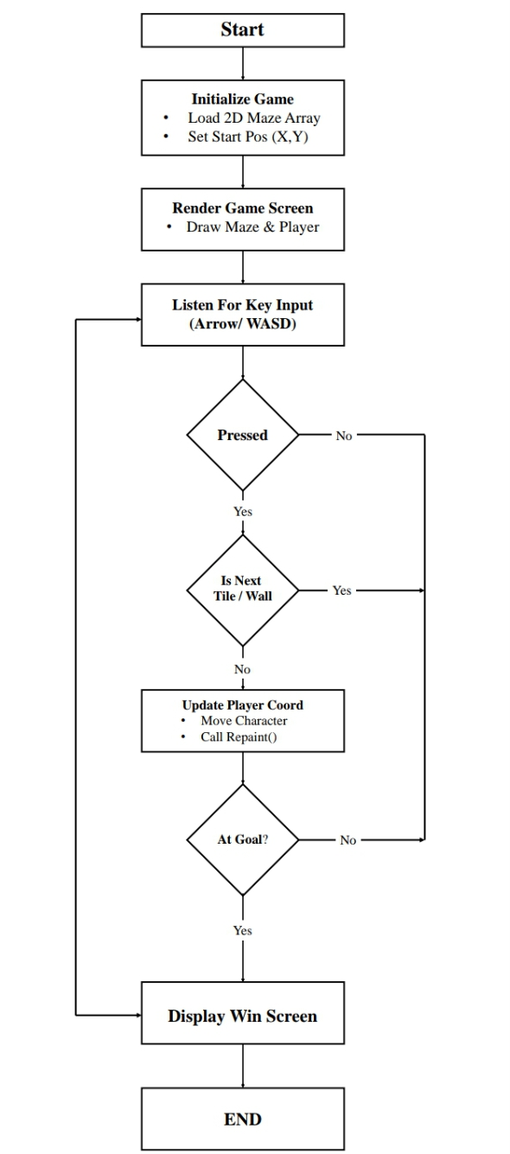

3. Class Structure:
The following classes are planned for the implementation of the Maze Game:

Class Name | Description
Main | Starts the application and controls the game execution.
Maze | Generates and manages the maze structure.
Player | Stores player information and movement details.
Game Panel | Displays the game screen and graphical interface.
Timer | Manages the game timer.
Score Manager | Calculates and maintains the player's score.

4. Maze Representation:
The maze will be represented using a two-dimensional array. Different values will represent walls, paths, the player, and the exit point.
- 1 = Wall
- 0 = Path
- S = Start (Entry Point)
- E = Exit Point

Example:
1 | 1 | S | 1 | 1 | 1
1 | 0 | 0 | 0 | 1 | 1
1 | 0 | 1 | 0 | 1 | 1
1 | 0 | 1 | 0 | 0 | 1
1 | 0 | 0 | 1 | 0 | E
1 | 1 | 1 | 1 | 1 | 1

5. User Interface Layout:
The game interface will contain the following components:
- Game title
- Timer display
- Score display
- Maze area
- Restart button
- Exit button

Basic Layout:
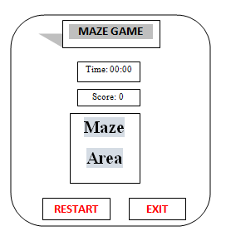

6. Development Environment:
The following tools and technologies will be used for the development of the Maze Game:
- Programming Language: Java
- Development Environment: NetBeans
- Java Development Kit (JDK): Version 17
- Development Approach: Object-Oriented Programming (OOP)

