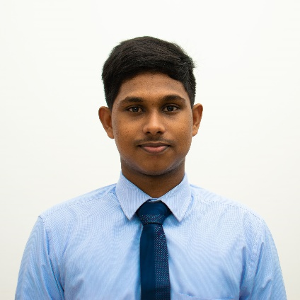

# Education

## **University of Moratuwa**

### **SEPTEMBER 2017 - PRESENT**

|  |  |
| --- | --- |
| Undergraduate, B.Sc. (Computer Science Engineering) | **3.7 CGPA** |

## **Sri Sumangala College, Panadura**

### **2008 - 2016**

|  |  |
| --- | --- |
| AL (2016) : 2A’s (Mathematics, Physics), 1B (Chemistry) | **1.9898 Z-Score** |
| OL (2013) : 8A’s, 1B (English Literature) |  |

## **ESOFT Metro Campus**

### **2016**

Diploma in IT & Python Programming Course

**Profile**

A 3rd year undergraduate with good skills and passion for learning. Have an interest in designing and developing mobile apps. Love to do robotics/IOT projects in leisure time.

**Technical Skills**

**Languages**

Python, Java, Dart, PHP

**Web Development**

HTML, CSS, JS, Bootstrap, Angular, Dash(python)

**Mobile Development**

Flutter, Dart

**Databases**

MySQL, PostgreSQL, Firebase

**Robotics**

Arduino, STM32

# Awards & Achievements

|  |  |
| --- | --- |
| HackX Startup Challenge2019 @University of Kelaniya | **Winners** |
| IESL Robo Games 2018 (Walking 4-legged Robot) | **Winners** |
| XO-Bot Robotic Competition @Techno’19 BMICH | **Runners Up** |
| RealHack2019 Hackathon @University of Kelaniya | **Runners Up** |
| IESL Idea Challenge 2018(Dengue Prevention App) | **Runners Up** |
| ‘Stay Home Coding Challenge’ by optimizesolutions.lk | **Runners Up** |
| Physics Olympiad, Sri Lanka 2016 | **Bronze Medal** |
| Mathematics Olympiad 2012 | **Zonal 1st** |
| Mathematics Quiz Competition2011 | **Zonal 1st** |
| Best Student of the year Awards (2015 & 2016) | **Sri Sumangala C.** |

# Projects

|  |  |
| --- | --- |
| Cellyzer – Call Details Records Analyzing Library **Python | HTML | CSS** | **FEB - JUNE 2020** |
| Neomerce – E Commerce Web App **NodeJS | PostgreSQL | HTML | CSS** | **NOV - DEC 2019** |
| MediKit – Web & Mobile Applications**PHP | MySQL | Flutter** | **JAN - MAY 2019** |
| Nano processor simulator- hardware level**Xilinix Vivado | Base3** | **AUG – DEC**  **2018** |
| Stair Climbing Robot**Arduino | SolidWorks** | **AUG - DEC**  **2018** |
| Micromouse Robot – Flood fill Algorithm **C++ | Arduino** | **AUG**  **2019** |
| Folk Social Media App - UI**Flutter** | **APRIL**  **2020** |

**T. Anju Chamantha**

**Computer Science Engineering Undergraduate**

11 A, Weragama Road, Wadduwa

0778396415

[chamantha97anju@gmail.com](mailto:chamantha97anju@gmail.com)

www.linkedin.com/in/anjuchamantha