**VSPK International School**

**Session 2020-21**

**Informatics Practices**

**Project File**

**Student Management System**

**-Aditya Verma**

**-Roll No ______**

**Certificate**

This is to certify that the Project/Dissertation Entitled **Student Management System** is a bona fide work done By **Aditya Verma** of **CLASS XII** submitted to **VSPK International School sector-13, Rohini, Delhi-85** for consideration in partial fulfillment of CBSE’s AISSCE EXAMINATION 2021 and has been carried out under my supervision and guidance. This report or a similar report on the topic has not been submitted for any other examination and does not form a part of any other course undergone by the candidate.

**_______________ _______________**

Signature of student Signature of Teacher

Name: Aditya Verma Name: Ms. Supriya Dhingra

Roll No.: _________ Designation: PGT (I.P)

Other Group Member: Anjul Bhatia

**Acknowledgement**

I undertook this project work, as the part of my XII-Informatics Practices course(085). I had tried to apply my best of knowledge and experience, gained during the study and class work experience. However, developing software system is generally a quite complex and time-consuming process. It requires a systematic study, insight vision and professional approach during the design and development. Moreover, the developer always feels the need , the help and good wishes of the people near you, who have considerable experience and idea.

I would like to extend my sincere thanks and gratitude to my teacher **Ms. Supriya Dhingra**, for giving valuable time and moral support to develop this software system.

I also feel indebted to my friends for the valuable suggestion during the project work.

**ADITYA VERMA**

**Roll No - _____**

**Table of Contents**

|  |  |  |
| --- | --- | --- |
| **Sr** | **Topic** | **Page** |
| 1. | Introduction |  |
| 2. | Theoretical Background |  |
| 3. | Software and Hardware Requirements |  |
| 4. | Source Code |  |
| 5. | Sample Output |  |
| 6. | Installation |  |
| 7. | Conclusion |  |
| 8. | Bibliography |  |

**Introduction**

A **Student Management System** is a [management information system](https://en.wikipedia.org/wiki/Management_information_system) for education establishments used to manage student data.

Student Management System facilitates in registering students in courses, maintaining students records, documenting grading, keeping records of academic achievement and co-curricular activities; forming student schedules; tracking attendance and managing other student-related data needs in an educational institution.

The following project is a Simple Student Management System which allows the user to enter students data either manually or import a csv format file of students data, analyze data using various operations and plots charts for visualizing vital information.

**Theoretical Background**

**Python -** Python is a high-level, interpreted, interactive and object-oriented scripting language. Python is designed to be highly readable. It uses English keywords frequently where as other languages use punctuation, and it has fewer syntactical constructions than other languages.

* Interpreted Language: Python is processed at runtime by Python Interpreter.
* Object-Oriented Language: It supports object-oriented features and techniques of programming.
* Interactive Programming Language: Users can interact with the python interpreter directly for writing programs.
* Easy language: Python is easy to learn, especially for beginners.
* Straightforward Syntax: The formation of python syntax is simple and straightforward, which also makes it popular.
* Easy to read: Python source-code is clearly defined and visible to the eyes.
* Portable: Python codes can be run on a wide variety of hardware platforms having the same interface.

**Python Libraries**

**Pandas -** Pandas is an open-source Python Library providing high-performance data manipulation and analysis tool using its powerful data structures.

• It is a package useful for data analysis and manipulation.

• Pandas provide an easy way to create, manipulate and wrangle the data.

• Pandas provide powerful and easy-to-use data structures, as well as the means to quickly perform operations on these structures.

**Matplotlib -** Matplotlib is one of the most popular Python packages used for data visualization. It is a cross-platform library for making 2D plots from data in arrays. Matplotlib is written in Python and makes use of NumPy, the numerical mathematics extension of Python.

**Software and Hardware Requirements**

RAM : 2 GB (Minimum)

: 4 GB (Recommended)

Operating System : Windows 7/8/10

: MacOS, Linux, Android (Using Pydroid)

OS Architecture : 32 bit x86 (Minimum)

: 64 bit x64 (Recommended)

Hardware Specifications : Keyboard

: Monitor

: CD/DVD/USB (for installation)

Python Version : 3.6 and above

Python Libraries : Pandas, Matplotlib

**Source Code** 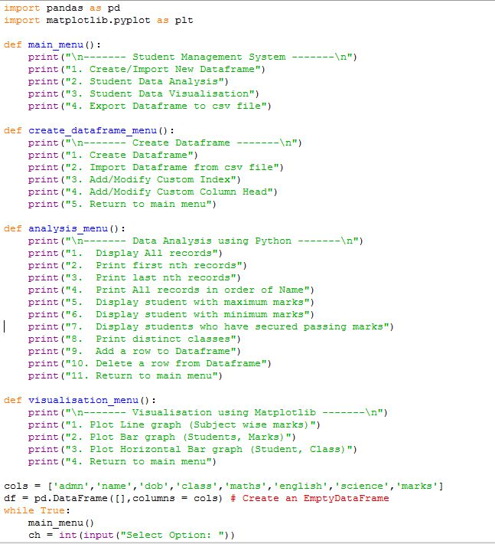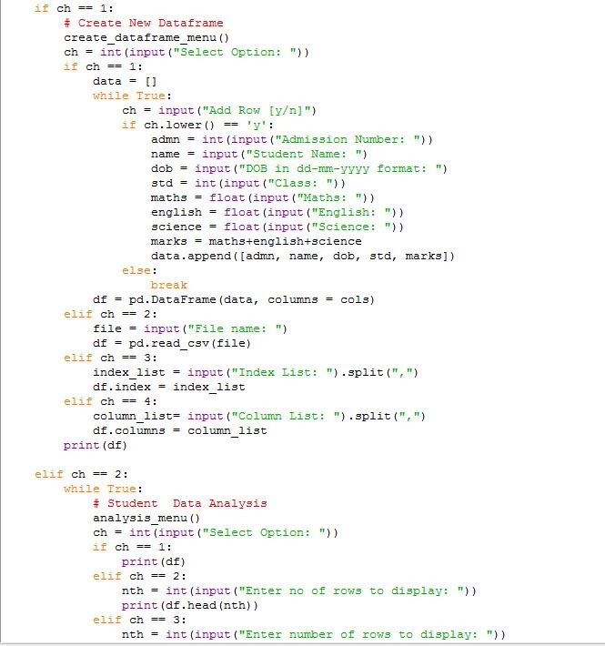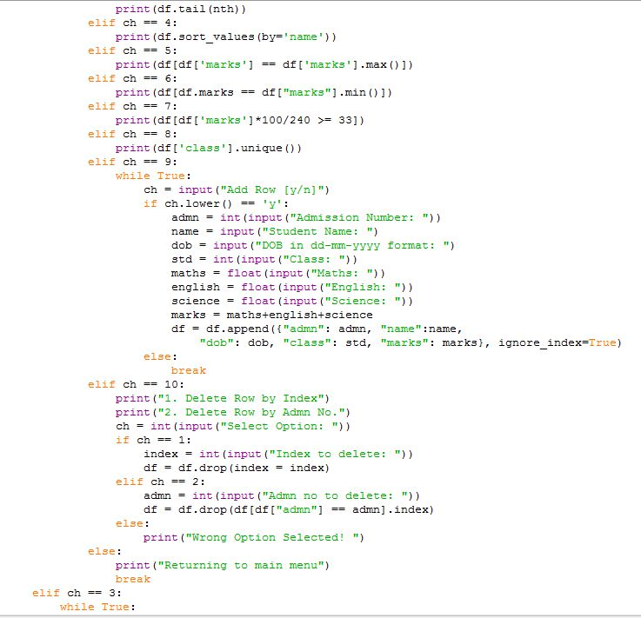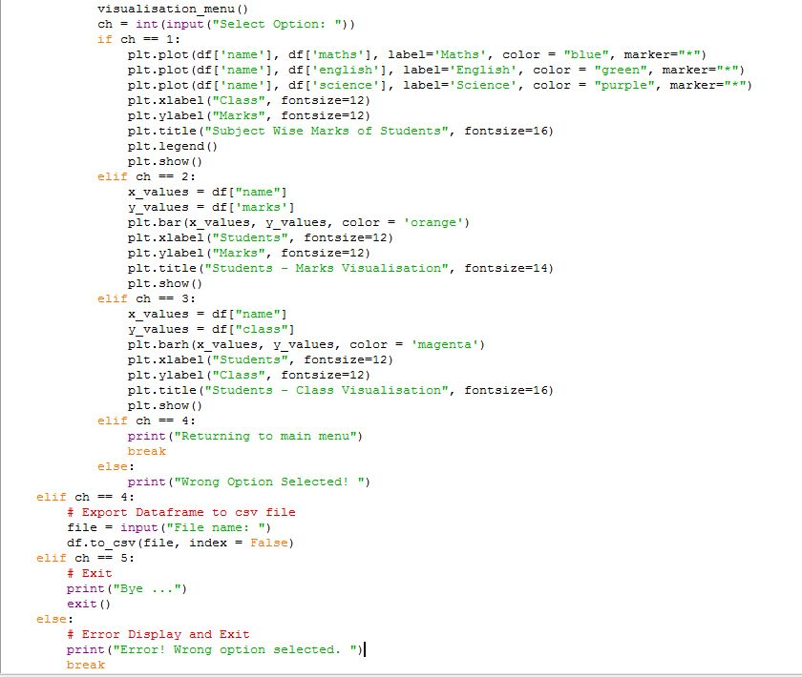

**Sample CSV**

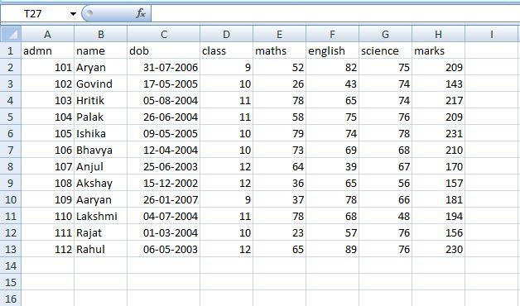

**Sample Output**

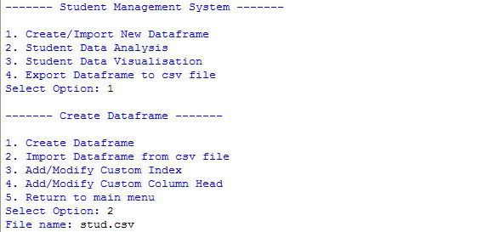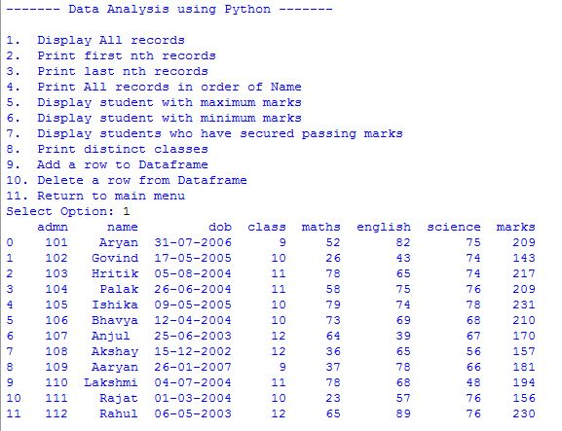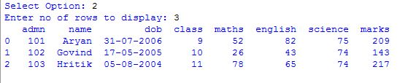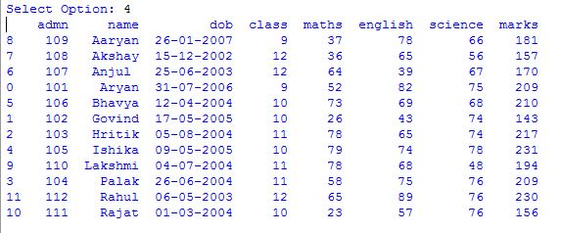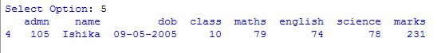**o6.JPG**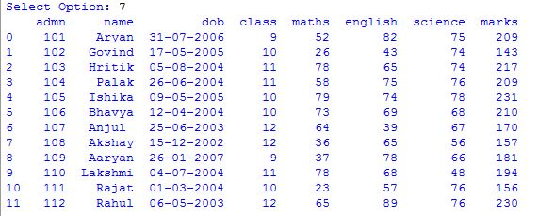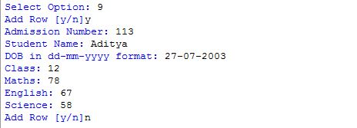

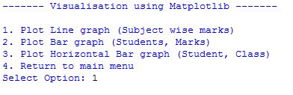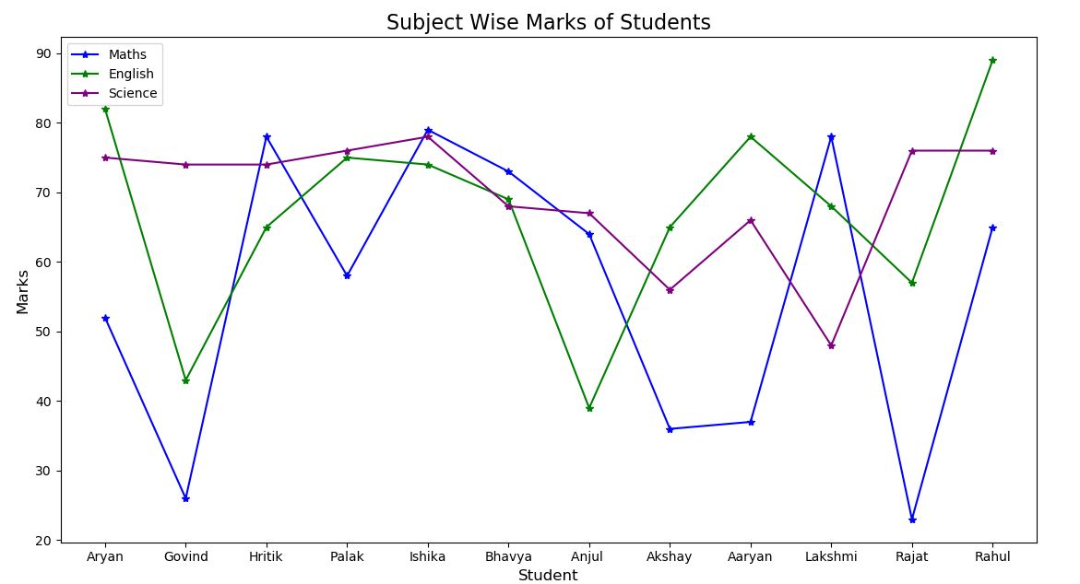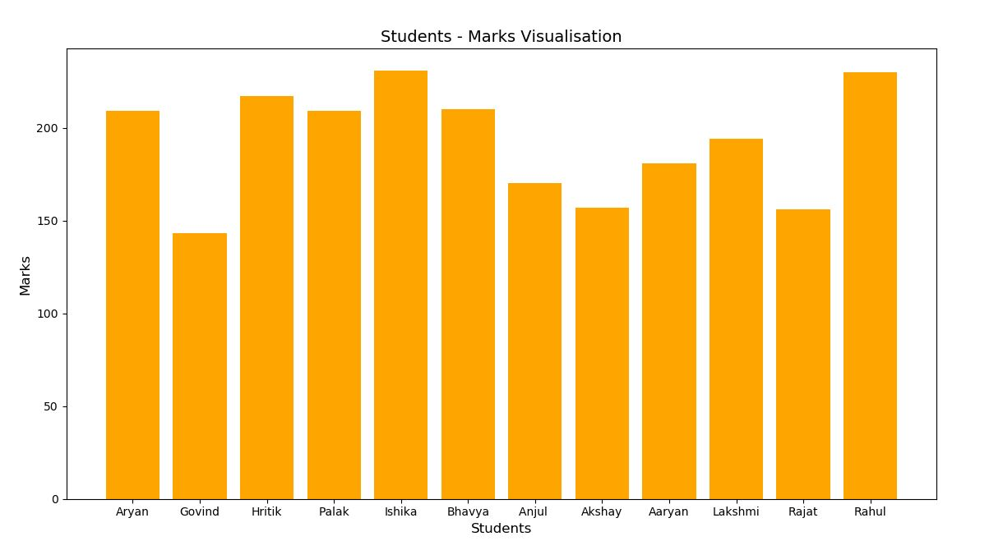

**Conclusion**

The above project is a real-world application of Student management system developed in python language. This is a simple demonstration on the application of python language and its libraries – pandas and matlotlib.

The Application can be extended to features like GUI, encrypted data storage and user password security.

**Bibliography**

* Online Classes by the teacher
* Friends and Family
* Informatics Practices Textbook Class 12 – Preeti Arora
* Informatics Practices Textbook Class 12 – Sumitra Arora
* <https://www.google.com>
* <https://www.tutorialspoint.com>
* <https://www.geeksforgeeks.com>
* <https://www.medium.com>
* <https://www.towardsdatascience.com>
* <https://www.w3schools.com>
* <https://www.instagram.com>
* <https://www.github.com>
* <https://www.stackoverflow.com>