
School: ............................................................................................................. Campus: ....................................................... Academic Year: ...................... Subject Name: ........................................................... Subject Code: ..........................
Semester: ............... Program: ........................................ Branch: ......................... Specialization: .......................... Date: .....................................
(Learning by Doing and Discovery)
* Coding Phase: Pseudo Code / Flow Chart / Algorithm
USDC → WETH Swap on Aave (Goerli Testnet)
Prerequisites:
- Ethereum wallet (e.g., MetaMask) connected to Aave.
- USDC tokens in your wallet (on Ethereum Goerli testnet).
- Some ETH on Goerli for gas fees.
Swap Procedure on app.aave.com:
- Open Aave
  - Go to: https://app.aave.com
- Connect Your Wallet
  - Top-right: Click Connect Wallet
  - Select MetaMask.
  - Approve the connection request in MetaMask.
- Select the Network
  - Ensure the network is set to Ethereum Goerli.
  - If not, switch to the Goerli testnet via MetaMask.
- Navigate to Swap
  - From the left menu, choose Swap (sometimes under More).
  - Aave uses ParaSwap integration for swaps.
- Choose Tokens
  - From: USDC
  - To: WETH
- Enter Swap Amount
  - Type the amount of USDC you want to convert to WETH.
- Check Swap Details
  - Review rate, slippage tolerance, minimum WETH to receive, and any protocol fees.
- Approve USDC (if it’s your first swap)
  - Click Approve and confirm in MetaMask.
  - This allows the swap contract to use your USDC.
- Execute Swap
  - Click Swap and approve the transaction in MetaMask.
  - Wait for the blockchain confirmation.
- Completion
  - Once confirmed, your WETH will appear in your wallet and be visible on the Aave dashboard.

Coding Phase: Pseudo Code / Flow Chart / Algorithm

* Softwares used
- Frontend: React.js, Ethers.js/Web3.js, wallet integration
- Backend: Aave Protocol V3, ParaSwap API, The Graph
- Smart Contracts: Aave Pool & Lending Contracts, DAI Token Contract, ParaSwap Contracts
- Wallet Tools: MetaMask, WalletConnect

- Testing Phase: Compilation of Code (error detection)

- Implementation Phase: Final Output (no error)
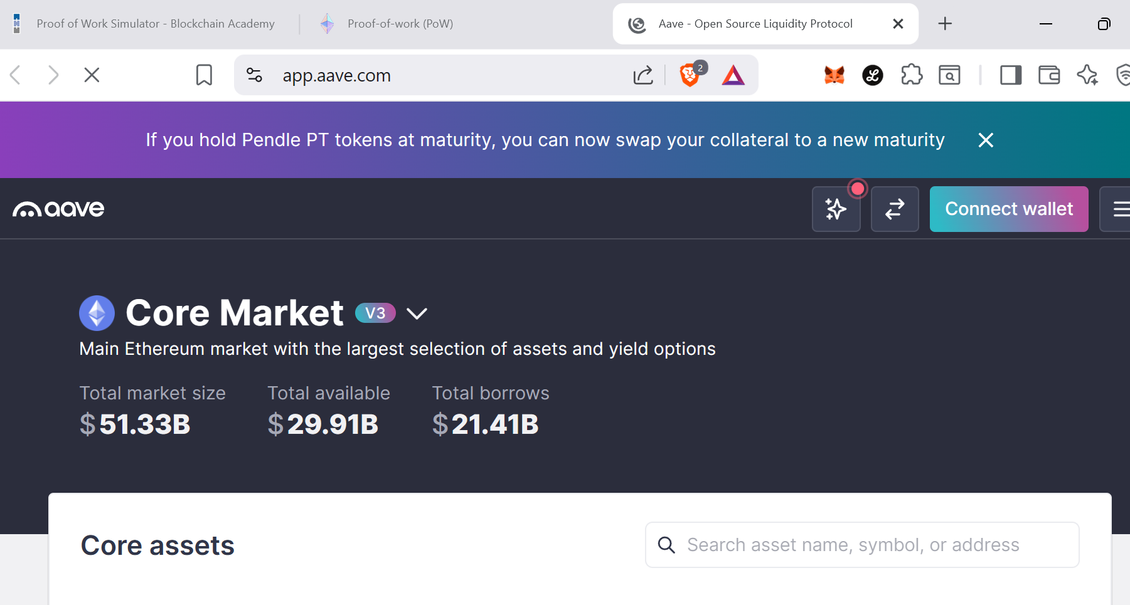

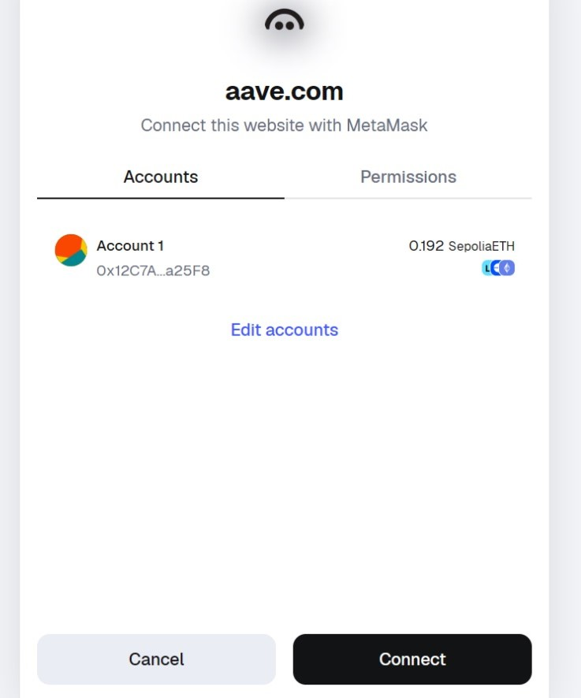

Implementation Phase: Final Output (no error)
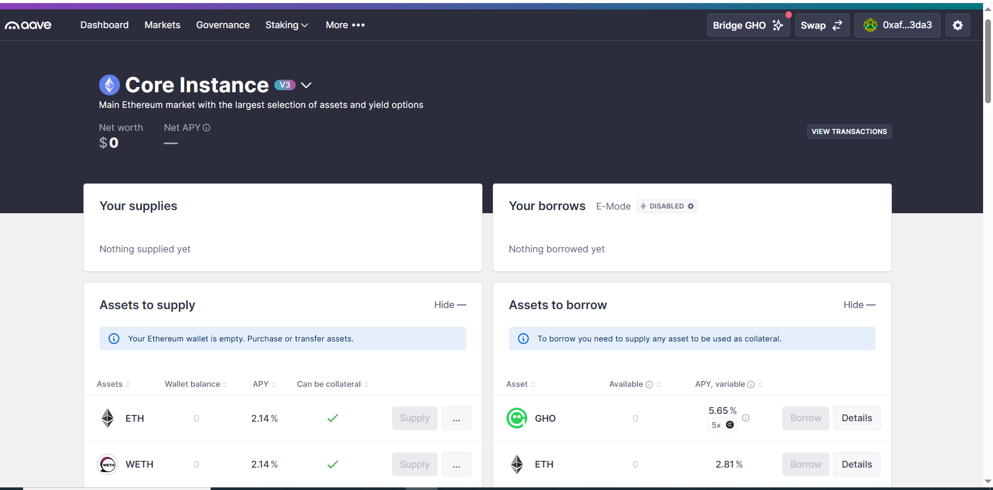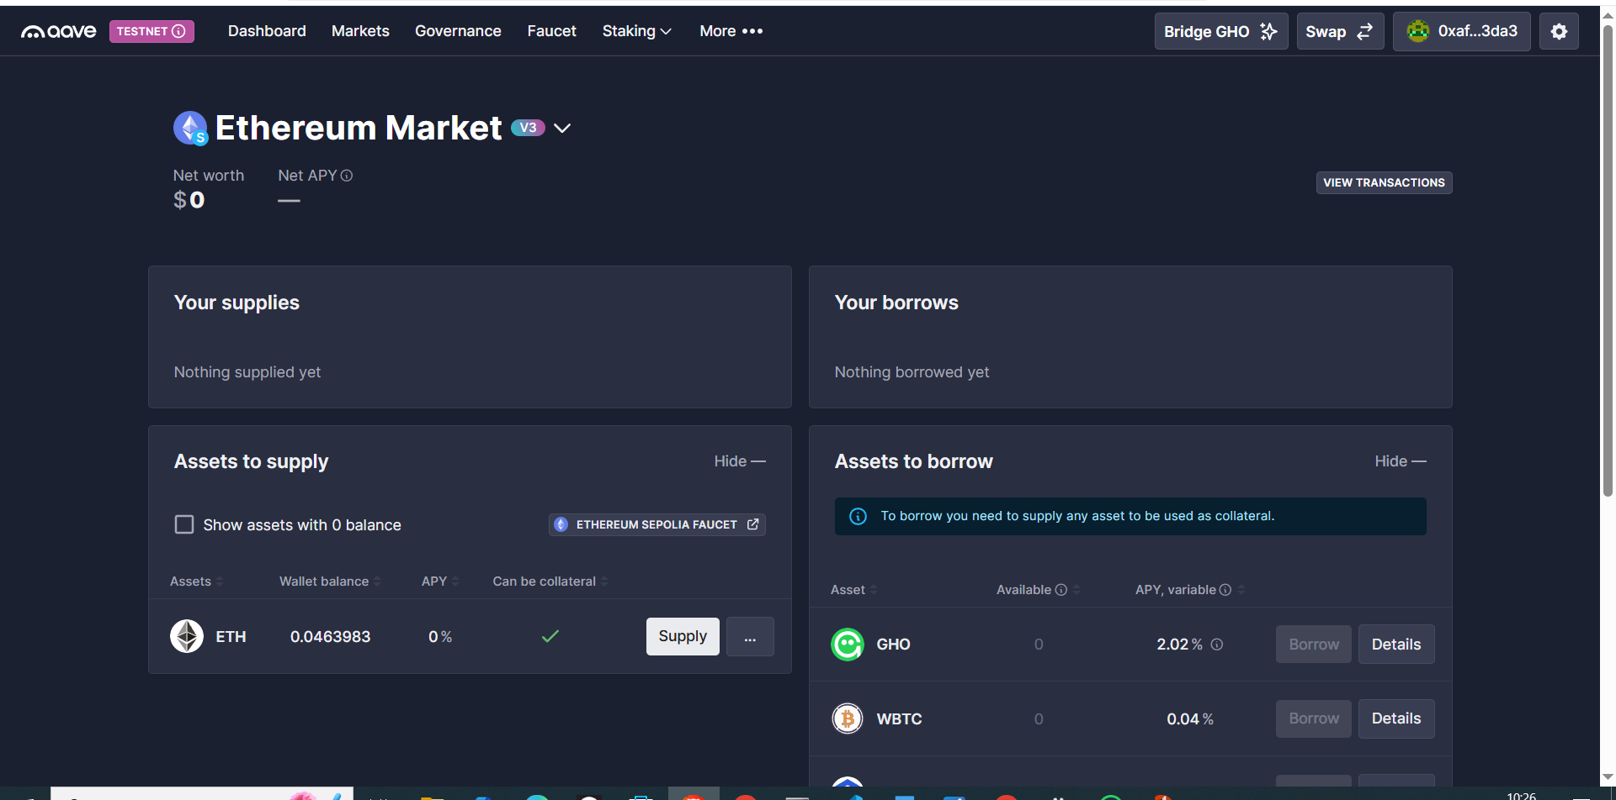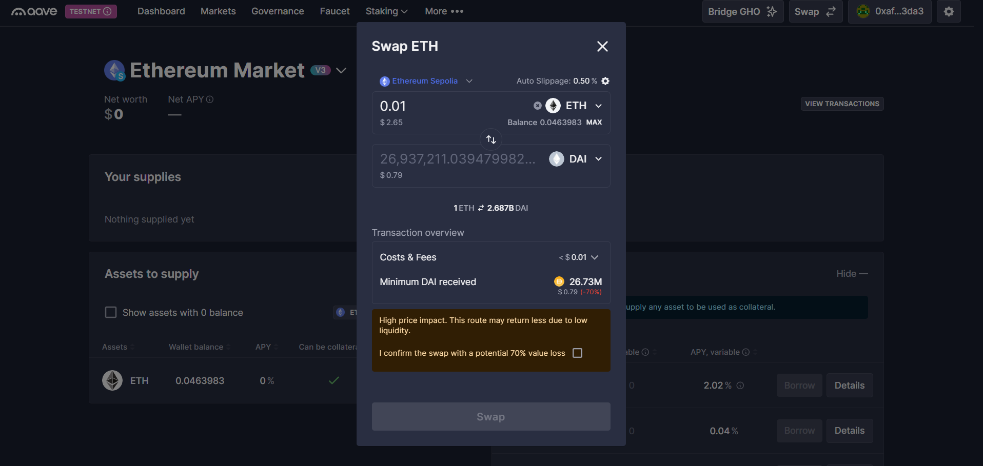

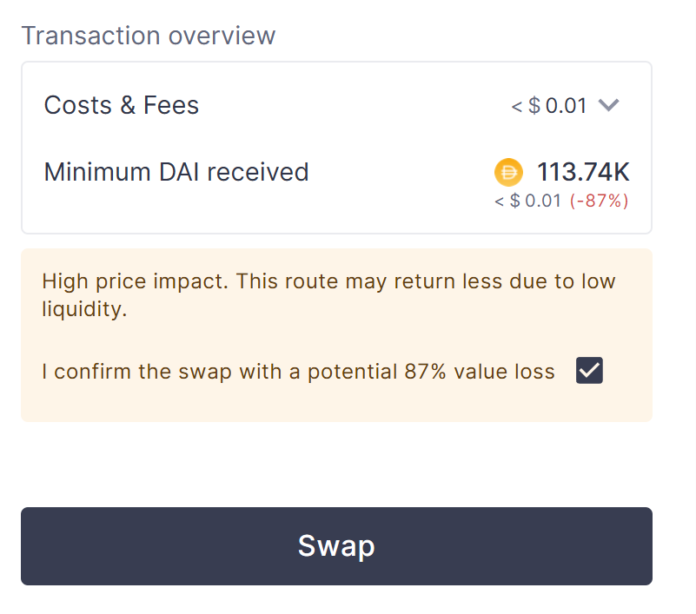

- Implementation Phase: Final Output (no error)
Applied and Action Learning

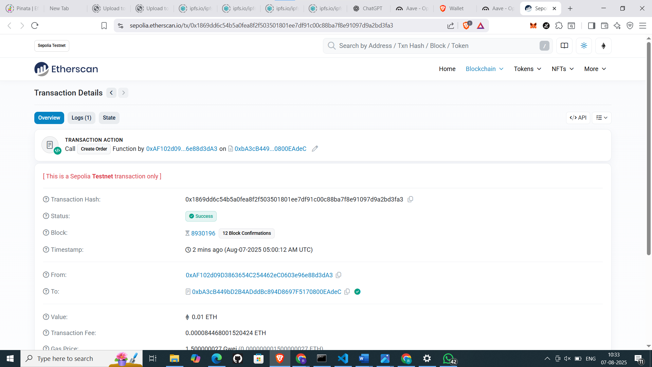

* Observations
- WETH Balance | Increases in your wallet and is visible on the Aave dashboard.
- USDC Balance | Decreases by the swapped amount plus any protocol and gas fees.
- Transaction Hash | Available on PolygonScan showing full swap path via ParaSwap integration.
- Gas Usage | Typically ranges between 120k–250k units depending on network congestion and routing.

ASSESMENT

Rubrics
Concept | 10
Planning and Execution/  Practical Simulation/ Programming | 10
Result and Interpretation | 10
Record of Applied and Action Learning | 10
Viva | 10
Total | 50

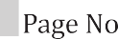
Signature of the Student:
Signature of the Faculty:

