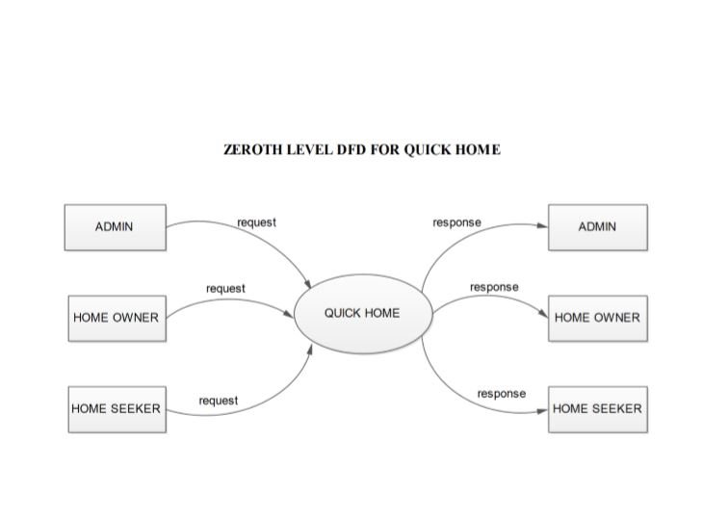

**FIRST LEVEL DFD FOR ADMIN**

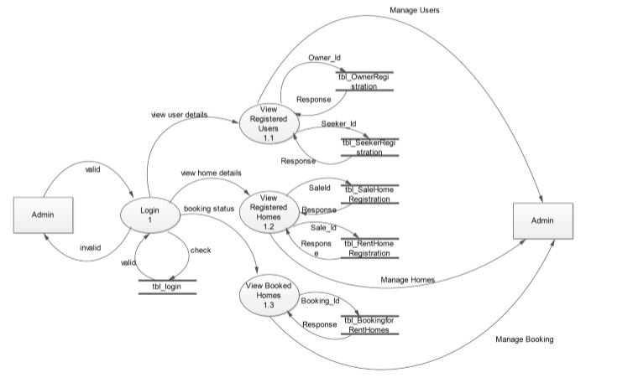

**FIRST LEVEL DFD FOR OWNER**

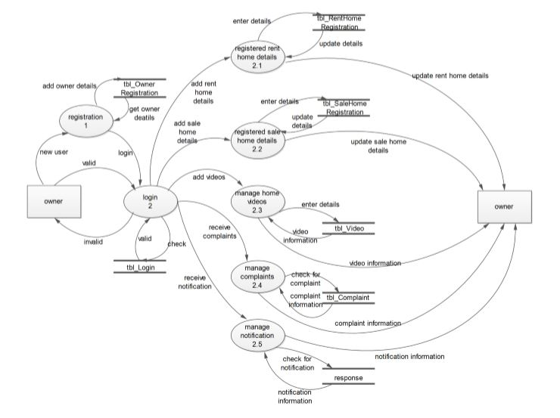

**FIRST LEVEL DFD FOR SEEKER**

