

**VIRGINIA COMMONWEALTH UNIVERSITY**

**Statistical analysis and modelling (SCMA 632)**

**A4- Multivariate Analysis and Business Analytics Applications**

**ANJU MARIA PHILIP**

**V01101169**

**Date of Submission: 08-07-2024**

**CONTENTS**

|  |  |  |
| --- | --- | --- |
| **Sl. No.** | **Title** | **Page No.** |
| **1.** | Part-1  Introduction  Objective  result  Interpretations  recommendation | **3**  **3-4**  **4-9**  **9**  **9** |
| **2.** | Part-2  Introduction  Objective  result  Interpretations  recommendation | **10**  **10-11**  **11-14**  **15**  **15** |
| **3.** | Part-3  Introduction  Objective  result  Interpretations  recommendation | **15-16**  **16**  **16-17**  **17**  **18** |
| **4.** | Part-4  Introduction  Objective  result  Interpretations  recommendation | **18**  **19**  **19-20**  **20**  **20** |

**PART-1**

**INTRODUCTION**

In the realm of data exploration, dimensionality reduction techniques like Principal Component Analysis (PCA) and Factor Analysis (FA) play a crucial role, especially when dealing with survey datasets. These datasets often encompass a multitude of variables representing respondents' opinions, attitudes, or behaviours. While this wealth of information can be valuable, it can also become overwhelming to analyse and visualize the complex relationships between all the variables. PCA and FA come to the rescue by identifying a smaller set of latent variables, or principal components/factors, that capture the most significant variance in the data. These techniques essentially condense the information from many variables into a more manageable and interpretable set of dimensions, providing valuable insights into the core structure of the survey data. By uncovering these underlying dimensions, researchers can gain a deeper understanding of the key factors influencing respondents' answers and identify potential patterns or groupings within the survey population.

**OBJECTIVES**

1. Dimensionality Reduction:

Reduce the number of variables in the survey data to a smaller set of uncorrelated (PCA) or underlying latent factors (FA) that capture the most significant variance.

This simplifies data visualization and analysis, making it easier to identify patterns and relationships.

2. Identify Underlying Factors:

Use PCA or FA to identify the main factors influencing respondents' answers. These factors might represent underlying constructs, attitudes, or behaviours that are not directly measured by individual survey questions.

3. Explore Relationships Between Variables:

Understand how the original survey questions relate to the identified factors. This can reveal patterns in how respondents answered different questions and potentially lead to new hypotheses.

4. Data Compression and Interpretation:

Compress the information from many survey questions into a smaller set of factors, making the data more manageable and interpretable.

This can be particularly helpful for summarizing large and complex survey datasets.

5. Enhance Survey Design (Future Surveys):

The insights gained from PCA or FA can be used to improve future survey design.

By focusing on the identified factors, researchers can create more concise and targeted surveys that capture the most relevant information.

**RESULTS**

**(python)**

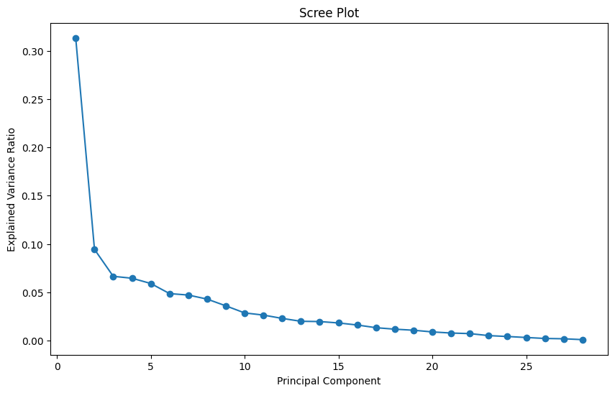

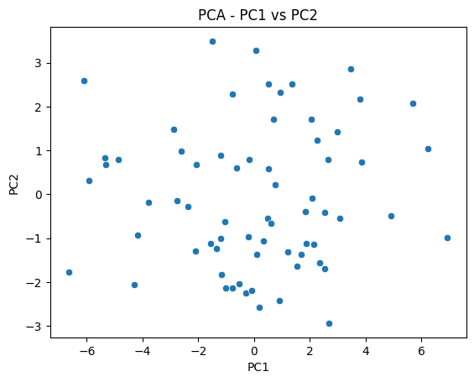

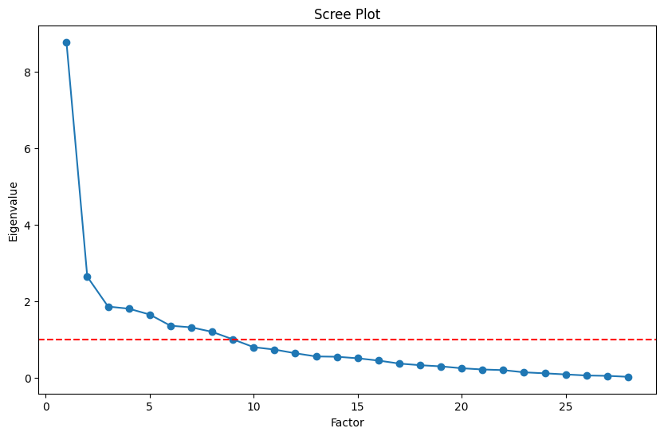

.Proximity to schools 0.214049 0.229875 0.072246

3. Proximity to transport -0.100885 0.010808 -0.042723

4. Proximity to work place 0.066845 -0.073512 0.057797

5. Proximity to shopping 0.220758 0.601192 0.292981

1. Gym/Pool/Sports facility 0.249095 0.519146 0.068143

2. Parking space 0.252232 0.347771 0.450041

3.Power back-up 0.201595 0.293063 0.229838

4.Water supply 0.383765 0.373737 0.078538

5.Security 0.160431 0.811676 0.122991

1. Exterior look 0.436751 0.301109 0.486234

2. Unit size 0.076976 0.027298 0.071432

3. Interior design and branded components 0.384790 0.302596 0.601414

4. Layout plan (Integrated etc.) 0.401457 0.068409 0.580091

5. View from apartment 0.365793 0.391903 0.727439

1. Price 0.320778 0.055759 0.015874

2. Booking amount 0.001252 0.023996 0.005179

3. Equated Monthly Instalment (EMI) -0.006946 0.050668 -0.273444

4. Maintenance charges -0.155593 -0.042445 -0.013460

5. Availability of loan -0.063770 -0.122602 -0.172298

1. Builder reputation 0.479754 -0.048228 0.357059

2. Appreciation potential 0.240924 0.076361 0.198258

3. Profile of neighbourhood 0.437680 0.433258 0.357591

4. Availability of domestic help 0.335430 0.599973 0.285495

Time 0.060002 0.002184 0.114550

Size 0.848883 0.262154 0.191963

Budgets 0.937282 0.192709 0.191016

Maintainances 0.877097 0.266710 0.189740

EMI.1 0.831780 0.196334 0.302842

Factor4 Factor5 Factor6 \

2.Proximity to schools 0.555654 0.084021 -0.014534

3. Proximity to transport -0.131585 0.673514 0.186115

4. Proximity to work place 0.703249 0.010556 -0.022690

5. Proximity to shopping 0.256581 -0.135710 0.157278

1. Gym/Pool/Sports facility 0.227351 0.096997 -0.162559

2. Parking space 0.163814 -0.041785 0.012044

3.Power back-up 0.454330 -0.070756 -0.045920

4.Water supply 0.199191 0.573047 0.068994

5.Security -0.055775 0.176624 -0.013872

1. Exterior look -0.105454 -0.293905 0.260746

2. Unit size -0.014898 -0.016128 -0.101248

3. Interior design and branded components 0.200096 0.022732 0.077848

4. Layout plan (Integrated etc.) 0.303799 0.032079 -0.089825

5. View from apartment -0.029524 0.062528 0.072075

1. Price 0.205249 0.516010 -0.274747

2. Booking amount -0.037455 -0.030693 0.123164

3. Equated Monthly Instalment (EMI) 0.016032 0.148162 0.298882

4. Maintenance charges -0.103085 -0.093936 0.003505

5. Availability of loan 0.276526 -0.089277 0.709648

1. Builder reputation 0.056682 0.355656 -0.230355

2. Appreciation potential -0.044803 0.024759 0.104278

3. Profile of neighbourhood -0.036908 0.281157 -0.250880

4. Availability of domestic help -0.230997 -0.109991 0.057052

Time -0.121941 0.086739 0.601255

Size 0.086724 0.014035 0.051974

Budgets 0.048851 0.075175 0.047790

Maintainances 0.149333 0.107081 0.055518

EMI.1 0.185531 -0.006189 -0.082738

Factor7 Factor8 Factor9

2.Proximity to schools -0.216350 0.363228 -0.059947

3. Proximity to transport -0.044385 -0.052721 -0.077615

4. Proximity to work place 0.005645 -0.038999 -0.102425

5. Proximity to shopping 0.325120 0.001523 0.052477

1. Gym/Pool/Sports facility -0.078850 -0.030596 0.023008

2. Parking space -0.364696 -0.096257 0.175763

3.Power back-up 0.067707 -0.309755 0.023789

4.Water supply -0.162507 0.046147 -0.010442

5.Security -0.090292 0.015781 0.002054

1. Exterior look 0.307406 0.045549 0.044262

2. Unit size 0.041688 0.942887 -0.033828

3. Interior design and branded components -0.077457 0.086717 0.018225

4. Layout plan (Integrated etc.) 0.049708 0.073864 0.008306

5. View from apartment 0.046132 0.000262 0.010990

1. Price 0.137596 0.075763 0.061738

2. Booking amount 0.819702 -0.002814 0.168781

3. Equated Monthly Instalment (EMI) 0.164493 -0.037341 0.355635

4. Maintenance charges 0.111546 -0.130772 0.645784

5. Availability of loan 0.356146 0.001739 0.348898

1. Builder reputation -0.048164 0.257140 0.174695

2. Appreciation potential -0.001936 0.140514 0.533465

3. Profile of neighbourhood -0.091441 0.059989 0.161697

4. Availability of domestic help 0.214564 0.120583 -0.078524

Time 0.005560 -0.070460 0.012738

Size -0.004623 0.085308 0.036468

Budgets 0.011011 0.064952 -0.044483

Maintainances 0.046710 -0.038705 -0.100099

EMI.1 -0.085436 -0.017993 0.073835

**(R)**

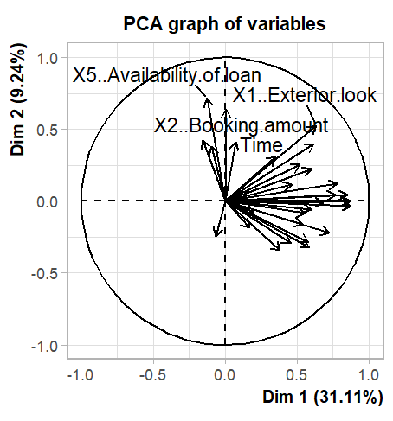

|  |
| --- |
| MR1 MR3 MR4 MR2  [1,] -0.5876607 -0.11251823 2.050119670 -0.80909066  [2,] -1.4792705 -0.36503965 0.775643390 -1.16305313  [3,] -0.5478608 -3.35305405 0.945557247 -1.32923887  [4,] 1.8807274 0.13402370 0.266228876 -2.06159338  [5,] 0.3295689 -0.18023376 -1.170876218 -0.36010367  [6,] -0.2866020 -0.47379445 0.367382156 -0.21010883  [7,] 0.5003641 0.65274995 1.058454876 0.43822528  [8,] -1.9088343 -0.71638354 0.125781819 -1.29105206  [9,] -0.7069313 0.10856075 -0.040407655 0.37696557  [10,] 0.1573651 0.97898633 -0.458207894 0.32151704  [11,] -0.3560346 -0.87215158 -0.548893781 0.20034247  [12,] -1.0750688 1.06862183 -1.324450733 -0.87149108  [13,] -1.2632780 0.08817647 0.497275087 0.87321384  [14,] -0.1478539 0.79809053 0.072043274 0.84550179  [15,] -0.8943020 -0.57613016 0.146791486 -0.06867479  [16,] -2.3861008 -0.26161531 -0.224930358 0.28216534  [17,] -1.6756359 0.98678140 -0.553005149 -0.12911862  [18,] -1.3558992 1.21940046 0.959335531 -0.38269031  [19,] 0.3070668 1.15207947 0.709196598 -1.63990272  [20,] 0.6265597 -0.78100996 0.357780784 -2.31140305  [21,] -1.3558992 1.21940046 0.959335531 -0.38269031  [22,] -0.4194756 1.30069137 0.503442662 0.91390513  [23,] -1.1801257 1.51209556 1.086366589 -0.54903222  [24,] 0.5281885 -0.61791805 -0.458074607 0.95748245  [25,] 1.5544448 0.47387769 0.923143557 0.02046889  [26,] -0.6560738 1.28545333 -0.217972896 0.05690345  [27,] -0.5592703 0.09090353 -0.895706580 1.14485399  [28,] -0.2026950 0.43630856 0.148534968 0.28641784  [29,] -1.3721154 0.67538936 0.895056459 -0.08885140  [30,] 1.0626369 -0.05059363 -0.642613792 -0.85437235  [31,] 0.8055042 0.64353368 0.081147945 -0.65568444  [32,] -0.6404405 -0.24517693 -1.178682910 -0.09102854  [33,] -0.5394157 -0.09824719 0.202530097 1.22865673  [34,] 0.8810889 -0.47378272 0.659986298 0.70591671  [35,] -1.4194026 -0.95544542 0.515394129 0.77098383  [36,] 0.4944889 -0.80617264 0.926183237 -0.84615059  [37,] -0.3920544 0.11286019 -0.185478395 1.25609547  [38,] 0.9187362 0.37784351 -2.021924632 0.03073602  [39,] -0.2688068 0.43165531 0.135943047 0.71033819  [40,] 0.3238506 -1.31842216 -0.956078235 -0.04785917  [41,] -0.6013308 0.39092682 -1.170649492 -0.39382993  [42,] 0.7672588 -0.97998184 1.065783179 1.38843255  [43,] 1.2268022 0.92424961 -0.506390529 -1.74468234  [44,] 0.1531872 -0.77891730 0.598245535 1.48113689  [45,] 0.0310595 -1.91707747 -0.829528716 1.67981703  [46,] 1.5259121 0.37706979 -0.106363781 0.67027212  [47,] 0.1309902 -0.37026373 -2.097303080 -0.58011507  [48,] 0.6094975 -0.49059484 -1.347669950 0.20423233  [49,] 1.7828850 1.41737185 0.926221436 1.50375524  [50,] -1.3382877 -0.75161725 -2.343753911 -1.08189200  [51,] -0.4664299 -2.63297854 0.768856976 -0.96279188  [52,] 1.6302221 0.38795119 0.696176766 -0.46016474  [53,] 0.3446095 -0.26406859 0.785862102 1.91000860  [54,] 1.3756285 0.60316568 0.936286214 -0.57622139  [55,] 0.7398498 0.67345244 0.169092222 0.57967423  [56,] 0.3269372 0.06586277 -1.542789689 -0.16210359  [57,] -0.1855857 0.17245157 0.001009407 1.08219628  [58,] 1.8807274 0.13402370 0.266228876 -2.06159338  [59,] 0.9987618 1.15565927 0.692293241 1.45269523  [60,] 0.2569674 -0.23430610 0.186779172 1.47210427  [61,] 0.5694039 -0.35107186 1.166005563 -0.37318649  [62,] 0.8810067 -0.59364313 -0.707466321 -0.20736685  [63,] 0.9555754 0.24108053 -1.713145455 0.32223769  [64,] 0.2601443 -1.07529756 0.502800902 -1.87754200  [65,] -0.8113446 0.98765809 0.277402326 -0.20207944  [66,] -0.1096387 -1.38076313 0.216101775 1.88705736  [67,] 0.8768180 -0.28471376 -1.360191871 0.28202914  [68,] -0.6013308 0.39092682 -1.170649492 -0.39382993  [69,] -0.4169898 0.74655193 -0.353765544 -0.60564613  [70,] 0.5132101 -0.05290097 1.503170655 0.48989636 |
|  |
| |  | | --- | | > | |

**INTERPRATION**

Unveiling hidden patterns in survey data with high dimensionality can be tackled by Principal Component Analysis (PCA) and Factor Analysis. Both techniques aim to condense the data into a smaller set of dimensions, but with slightly different approaches. PCA excels at finding uncorrelated features that capture the most data variation, focusing purely on the mathematical structure. Factor Analysis, on the other hand, digs deeper, searching for underlying factors that explain the relationships between the survey responses. While PCA offers a simpler method, interpreting its components can be challenging. Factor Analysis delves into the meaning behind the dimensions, potentially revealing underlying concepts. However, it comes with the need for additional assumptions about the data and choosing the right number of factors can be subjective. Ultimately, the choice between these techniques hinges on your goals. If you prioritize dimensionality reduction for further analysis, PCA might be sufficient. If you seek to uncover the latent factors influencing survey responses and understand their meaning, Factor Analysis could be the more insightful option.

**RECOMMENDATION**

Choosing between PCA and Factor Analysis depends on what you want to achieve with your survey data. If your main goal is to simplify the data for further analysis, like using it in visualizations or machine learning, and you don't have strong expectations about underlying factors, then PCA is a good choice. It's also simpler to use. However, if you believe hidden factors influence survey responses and want to understand their meaning, then Factor Analysis is more insightful. It allows you to explore these underlying concepts, but keep in mind that it requires more assumptions about the data and can be subjective in choosing the number of factors. Consider the complexity of your survey - for very intricate ones, PCA can be a helpful first step to reduce dimensionality before diving into Factor Analysis

**PART-2**

**INTRODUCTION**

In the realm of survey research, where understanding the diversity of respondents is paramount, cluster analysis emerges as a powerful tool. This data mining technique unveils the multifaceted nature of survey data by grouping participants based on their background variables. These variables, ranging from demographics and attitudes to behavioural patterns gleaned from the survey itself, become the foundation for identifying distinct respondent profiles. Cluster analysis automates this segmentation process, dissecting the data into meaningful clusters, each representing a unique subgroup within the survey population. By examining the characteristics that define each cluster, researchers gain a nuanced understanding of the variations present among respondents. This knowledge equips them to develop targeted interventions, personalize communication strategies, and delve deeper into specific respondent segments, ultimately leading to a more comprehensive and impactful interpretation of the survey data.

**OBJECTIVES**

**1. Identify Respondent Segments:**

* Segment the survey population into distinct clusters based on their background variables (demographics, attitudes, behaviours).
* This helps identify groups of respondents who share similar characteristics, allowing you to analyse and understand them more effectively.

**2. Develop Targeted Interventions:**

* By understanding the unique characteristics of each cluster, you can tailor interventions, communication strategies, or outreach programs to resonate better with different respondent segments.
* This can lead to more effective and impactful outcomes.

**3. Explore Relationships Between Variables:**

* Cluster analysis can reveal hidden relationships between background variables that might not be readily apparent in the raw data.
* This can lead to new insights into how different respondent characteristics interact with each other.

**4. Enhance Survey Design (Future Surveys):**

* The knowledge gained from cluster analysis can be used to improve future survey design.
* By understanding the key characteristics of different respondent segments, you can create more targeted sampling strategies or question sets in future surveys.

**5. Hypothesis Generation:**

* By observing the characteristics of each cluster, you might identify previously unknown patterns or relationships.
* This can lead to new research questions and hypotheses that can be further explored through additional surveys or qualitative research.

**RESULTS**

(**python)**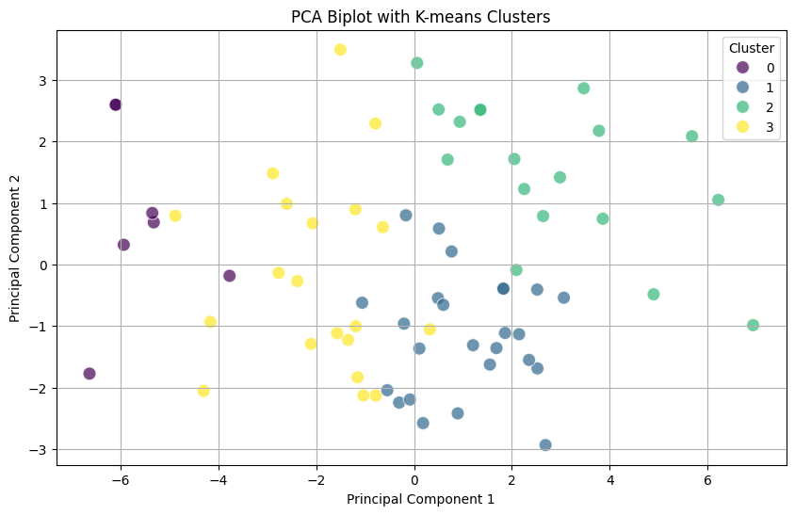

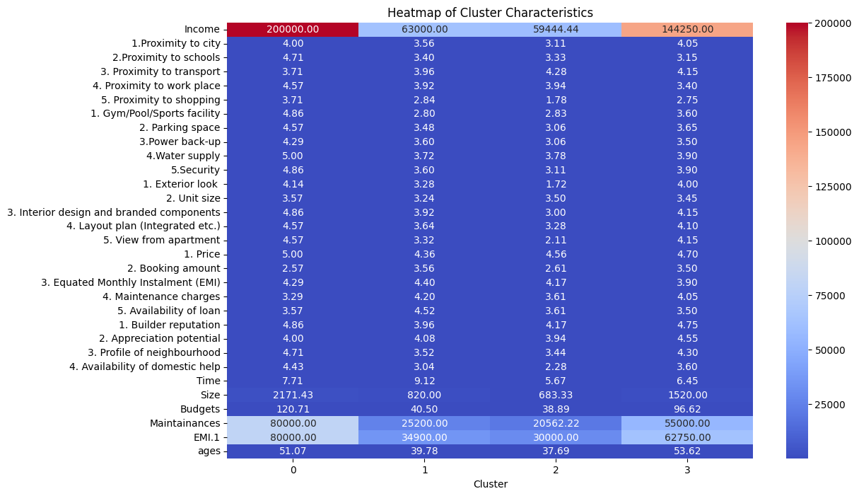

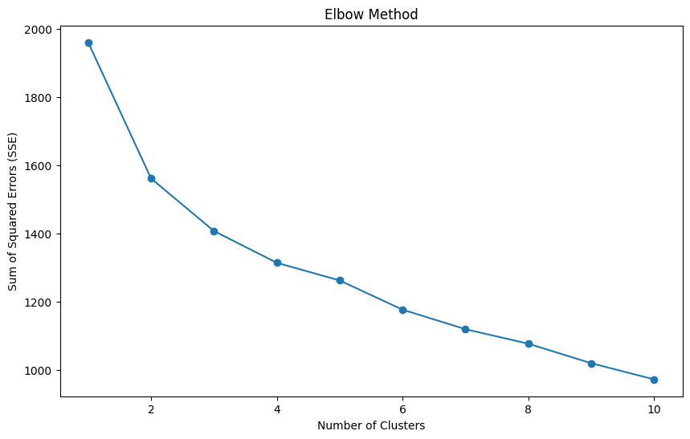

**(R)**

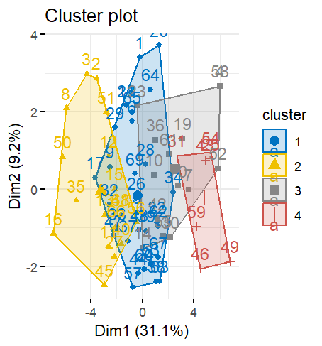

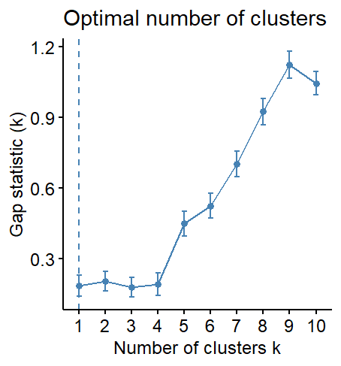

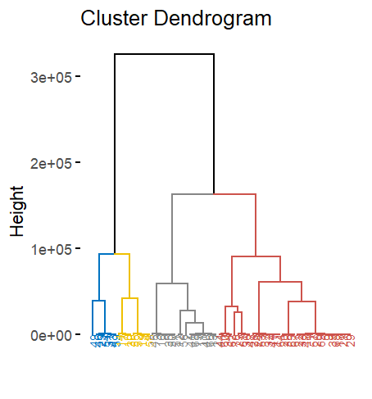

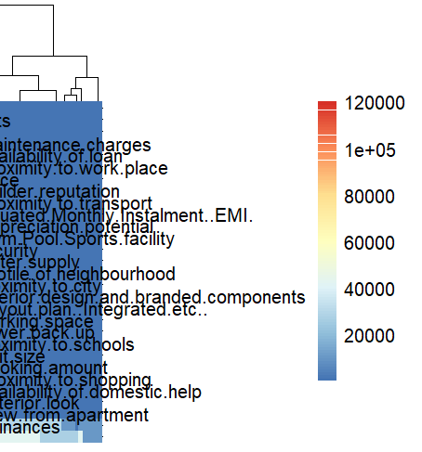

**INTERPRATION**

The results of the clustering analysis on the survey data reveal significant insights into the underlying patterns and structures. By using the gap statistic method, the script determined that four clusters provide an optimal balance for k-means clustering. This approach partitions the survey responses into four distinct groups, each representing respondents with similar characteristics or opinions. The k-means clustering visualization highlights these groupings, offering a clear view of the different segments within the survey data. Hierarchical clustering further complements this by showing a nested structure of the responses, with a dendrogram that identifies sub-groups within the main clusters. The heatmap visualization provides a detailed representation of the data, highlighting specific patterns and commonalities within each cluster. Overall, these analyses collectively offer a comprehensive understanding of the survey data, identifying distinct groups and their defining features, which can inform further analysis and decision-making.

**RECOMMENDATION**

Based on the clustering analysis, it is recommended to tailor communication strategies and marketing efforts to address the specific needs and preferences of each identified cluster. Each group represents respondents with distinct characteristics, allowing for more personalized and effective engagement. Additionally, consider customizing products or services to better align with the unique requirements of each cluster, thereby enhancing customer satisfaction and loyalty. Targeted promotions and discounts can also be designed for each group, leveraging their specific interests and behaviors to maximize the impact of marketing campaigns and drive better results.

**PART-3**

**INTRODUCTION**

Consumer preferences for ice cream flavours are complex and multifaceted. Flavour profiles can be influenced by a variety of factors, such as sweetness, creaminess, chocolate content, and the presence of additional ingredients. Understanding these relationships between ice cream characteristics is crucial for manufacturers in developing and marketing successful products. This report explores the application of Multidimensional Scaling (MDS) to analyse a dataset of ice cream flavours. By visualizing the relationships between flavours based on their attributes, this study aims to uncover hidden patterns and gain insights into how different ice cream flavours relate to each other. This information can be valuable for product development, marketing strategies, and understanding consumer preferences in the ever-evolving ice cream landscape.

**OBJECTIVES**

**Identify distinct flavour groups:** By analysing the MDS plot, aim to identify distinct groups of ice cream flavours that share similar characteristics.

**Investigate the influence of individual attributes:** Explore how specific attributes (sweetness, creaminess, etc.) contribute to the overall flavour profile and positioning of ice cream flavours within the MDS plot.

**Evaluate the effectiveness of the MDS representation:** Assess how well the MDS plot reflects the actual relationships between ice cream flavours.

**Uncover the underlying structure of ice cream flavor profiles:** Employ MDS to visualize the relationships between various ice cream flavors based on their attributes (sweetness, creaminess, chocolate content, etc.).

**RESULTS**

(R )

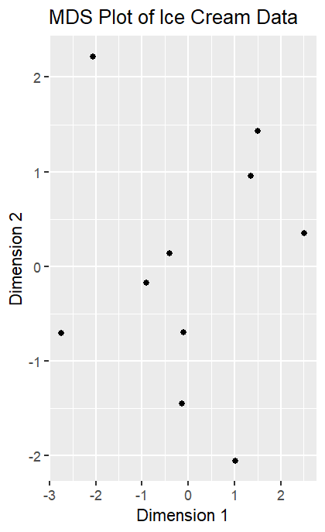

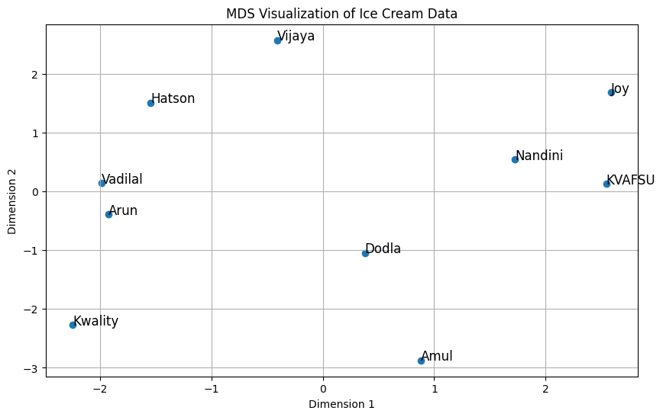

**INTERPERATION**

This data on ice cream brands, potentially including price, taste categories, fat content, sugar content, and brand popularity, could be used for multidimensional scaling (MDS). The resulting MDS plot would visually represent how brands compare. Brands closer together likely share more similarities. Examining clusters based on the plot (e.g., budget-friendly options on the left, high-sugar options on top) could be valuable for targeted marketing or product development. To fully interpret the plot's axes (like price increasing from left to right, sugar content increasing from bottom to top,MDS with this data can offer insights into brand relationships, informing marketing and product development strategies.

**RECOMMENDATION**

Leveraging the insights from the ice cream data and potential MDS plot (assuming price increases from left to right and sugar content increases from bottom to top), here are recommendations to optimize your strategy. Analyse brands clustered on the left side of the MDS plot (likely budget-friendly options) to target price-sensitive consumers with specific marketing campaigns. If the bottom of the plot represents lower sugar content, identify brands clustered there to develop competitive low-sugar options. Look for brands that stand out from the clusters, potentially due to unique ingredients or flavors, and capitalize on those strengths in branding and marketing. Consider offering some level of customization to cater to individual preferences for sugar content or toppings. Gather customer feedback, and analyses market trends to refine your strategies. By implementing these actions, you can develop targeted marketing, optimize product offerings, and gain a competitive edge in the ice cream market

**PART-4**

**INTRODUCTION**

Conjoint Analysis is a statistical technique used to understand consumer preferences and how they make trade-offs between different attributes of a product or service. By breaking down a product into its individual attributes, Conjoint Analysis quantifies the value or utility that consumers assign to each attribute. This technique is widely used in market research for product development, pricing strategy, market segmentation, and competitive analysis. The process involves defining attributes and their levels, designing hypothetical product profiles by combining different levels of attributes, collecting preference data from consumers, estimating part-worth utilities using statistical models, and analysing the results to understand the relative importance of each attribute.

In the provided code example, we perform Conjoint Analysis using a dataset related to pizza preferences. We start by loading and exploring the dataset to understand the attributes and their levels. Next, we generate all possible combinations of attribute levels to create product profiles, encode the categorical variables for regression analysis, and use linear regression to estimate the part-worth utilities of each attribute level. Finally, we interpret the estimated utilities to gain insights into consumer preferences. This analysis allows us to quantify the preferences for different attributes of pizzas, such as brand, price, weight, crust type, cheese type, size, toppings, and spiciness. The insights gained from Conjoint Analysis are invaluable for making informed decisions in product development, marketing strategies, and competitive positioning

**OBJECTIVES**

•**Decompose Product Attributes**: Break down the pizza product into its individual attributes and levels to understand their individual contributions to overall consumer preferences.

•**Generate Product Profiles**: Create hypothetical combinations of attribute levels to simulate different pizza offerings and collect consumer preference data.

•**Estimate Part-Worth Utilities**: Use statistical models to calculate the utility values associated with each attribute level, providing insights into the relative importance of each feature.

•**Analyse Trade-Offs**: Understand how consumers make trade-offs between different attributes when making purchasing decisions.

•**Enhance Product Design**: Use the insights from Conjoint Analysis to design pizzas that align closely with consumer preferences, maximizing appeal and satisfaction.

•**Guide Marketing Strategies**: Develop targeted marketing strategies based on the most valued attributes and preferred combinations identified through the analysis.

•**Support Decision Making**: Provide data-driven insights to support strategic decisions in product development, pricing, and market positioning.

**RESULTS**

**(python)**

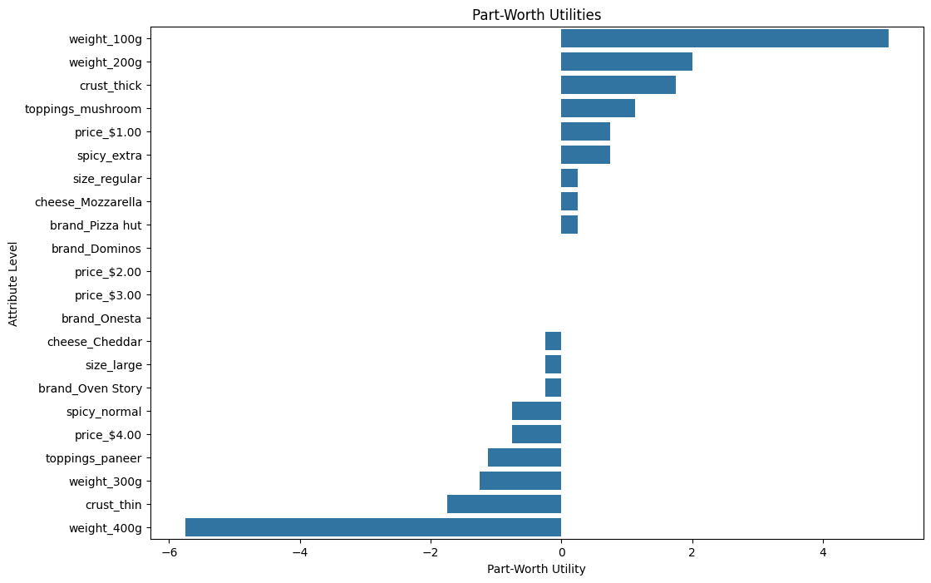

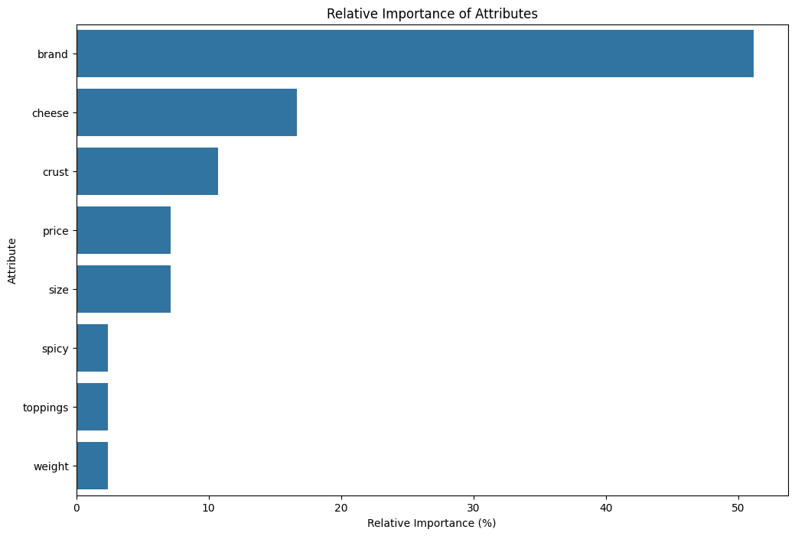

**(R)**

Coefficients:

Estimate Std. Error t value Pr(>|t|)

(Intercept) 6.11111 0.29898 20.440 <2e-16 ***

factor(x$brand)1 -0.33333 0.42283 -0.788 0.4331

factor(x$brand)2 -0.03704 0.42283 -0.088 0.9304

factor(x$price)1 0.03704 0.42283 0.088 0.9304

factor(x$price)2 -0.40741 0.42283 -0.964 0.3385

factor(x$crust)1 -0.81481 0.42283 -1.927 0.0579 .

factor(x$crust)2 0.59259 0.42283 1.401 0.1654

factor(x$toppings)1 0.18519 0.42283 0.438 0.6627

factor(x$toppings)2 0.44444 0.42283 1.051 0.2967

---

Signif. codes: 0 ‘***’ 0.001 ‘**’ 0.01 ‘*’ 0.05 ‘.’ 0.1 ‘ ’ 1

Residual standard error: 2.691 on 72 degrees of freedom

Multiple R-squared: 0.1042, Adjusted R-squared: 0.004709

F-statistic: 1.047 on 8 and 72 DF, p-value: 0.4095

**INTERPRETATION**

This conjoint analysis provides insights into simulated customer preferences for pizzas. While brand and price within the specified range don't significantly affect the ratings, crust type appears to be a key factor. Customers tend to rate pizzas with a thin crust lower (significant negative effect), while a stuffed crust shows a positive but non-significant impact. Specific toppings used (pepperoni and mushroom) have positive effects but are not statistically significant, suggesting these toppings on their own might not be major drivers of preference. It's important to consider the limitations of simulated data and sample size, and further analysis could explore potential interactions between factors like crust type and preferred toppings.

**RECOMMENDATION**

Based on these findings, pizza makers could consider focusing on strengthening brand perception and offering competitive pricing strategies to attract customers. Additionally, emphasizing thin crust options and popular toppings like Pepperoni and Mushroom could enhance overall customer satisfaction. Continuous monitoring of consumer preferences through conjoint analysis with real-world data can further refine product offerings and marketing strategies to meet evolving consumer tastes effectively.

Top of Form

Bottom of Form