**CHAPTER 1**

# INTRODUCTION

Semiconductor wafers serve as the foundational building blocks for the creation of integrated circuits (ICs), which are integral to virtually all modern electronic devices. A wafer’s quality is crucial as defects or faults in these wafers can lead to catastrophic failures in electronic systems. The detection of faulty wafers during manufacturing is essential to ensure the reliability and performance of the final product. To address this challenge, we propose a Wafer Fault Detection system using machine learning, which leverages data from multiple sensors to classify wafers as either "Good" or "Bad." In this project, we handle a dataset containing sensor measurements for each wafer, with a binary label indicating the wafer's status. The dataset is large, spanning multiple files, and comes with challenges such as missing values, inconsistent data formats, and potentially irrelevant features. The project aims to build an efficient system that not only cleans and validates the data but also builds a robust predictive model capable of determining wafer quality based on historical sensor readings.

**CHAPTER 2**

# LITERATURE SURVEY

In paper [1], the research titled "Silicon Wafer Fault Detection by Using Multiple Data Prediction" focuses on detecting and classifying semiconductor wafer faults to enhance manufacturing yield. The study identifies three defect types (Type-A: Random, Type-B: Systematic, and Type-C: Variable) and uses convolutional neural networks (CNNs) for classification. The work was conducted by Dhanshree M. Gharde, Prof. Jayant Adhikari, Prof. Priyanka Bhende, and Dr. Narendra Chaudhari and published in the (IRJET), Volume 08, Issue 05, May 2021.

In paper [2], the research titled "Optimizing Semiconductor Yield: A Focus on Wafer Fault Detection and Prediction" investigates the use of machine learning techniques to identify and predict wafer faults in semiconductor manufacturing. This study emphasizes the importance of wafer defect detection addressing challenges like defect clustering, environmental conditions, and process variability. The research employs Random Forest and XGBoost algorithms for classification. The work was conducted by T. Raghavendra Gupta, Naga Tanusri Nukala, R. Rishikesh Reddy, Neha Basvoju, and V. Sandeep Kumar, and was published in the International Journal of Creative Research Thoughts (IJCRT), Volume 11, Issue 12, December 2023.

In paper [3], the research titled “Silicon Wafer Fault Detection Using Machine Learning Techniques”. The study investigates machine learning and deep learning methods to classify defective silicon wafers in semiconductor manufacturing. B P Swathi (Corresponding Author), Divya Shree K V, Aaditya Balakrishna, Harshitha Jampala and Geetishree Mishra and was published by International Journal of Intelligent Systems and Applications in Engineering

In paper [4], the research title “Enhancing Wafer Defect Detection via Ensemble Learning” The research focuses on improving wafer defect detection in semiconductor manufacturing using ensemble learning techniques. It introduces a method that integrates multiple deep learning models to enhance detection accuracy and efficiency. A. Su Pan, B. Xingyang Nie and C. Xiaoyu Zhai

**CHAPTER 3**

# PROBLEM STATEMENT

* To build a classification methodology to predict the quality of wafer sensor based on the given training data

**CHAPTER 4**

# OBJECTIVES

#### To Design and Develop an Automated Wafer Fault Detection System:

To design a system that automatically detects the fault in wafer, which importantly avoids human error and works more effectively and efficiently than a manual method.

#### To Leverage Machine Learning for Fault Analysis:

Use Machine Learning algorithms which detects the faults more effectively than a manual inspection.

#### To Enhance Quality Control in Semiconductor Manufacturing.

To improve the standards and processes ensuring defect-free production in semiconductor manufacturing.

**CHAPTER 5**

# SCOPE OF THE PROJECT

Semiconductor wafer quality could cover various stages and aspects of the production process to ensure reliability, performance, and cost-effectiveness of semiconductor devices. Key areas to consider might include:

* Defect Detection and Classification: Implement advanced techniques for identifying and classifying defects at microscopic levels on wafers.
* Yield Improvement: Implement strategies to increase wafer yield, reducing the number of defective chips per wafer, which is crucial for meeting demand without excessive costs.

**CHAPTER 6**

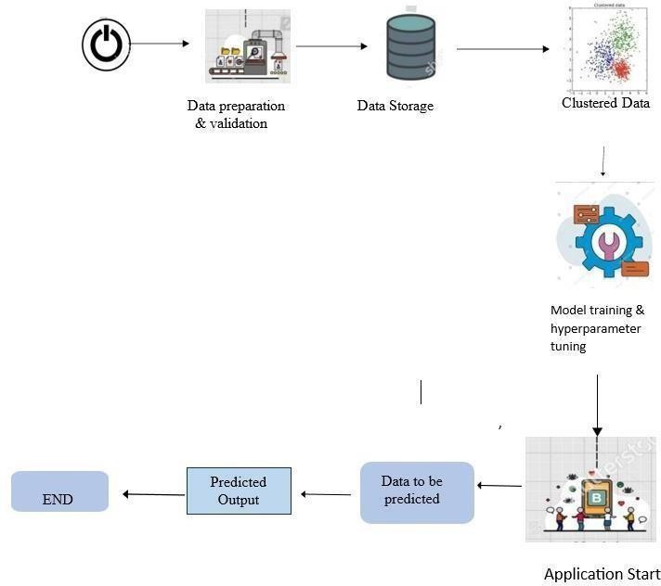**METHODOLOGY**

1. Data Collection: Gather sensor data from photovoltaic wafer manufacturing units, including attributes like wafer ID, timestamps, and target labels.
2. Data Preprocessing: Clean the data by handling missing values, removing irrelevant features, and scaling the data for better model performance.
3. Clustering: Use unsupervised learning techniques (e.g., K-means clustering) to group data based on similar characteristics, aiding in fault classification.
4. Model Training: Train machine learning models on the clustered and processed data using supervised algorithms (e.g., Random Forest, Gradient Boosting) to predict faults.
5. Model Evaluation: Validate the model's performance using metrics like accuracy, precision, recall, and F1-score to ensure its reliability.
6. Deployment: Build a user-friendly interface where users can upload new sensor data and receive predictions about wafer faults.
7. Result Visualization: Display model outputs and insights in an interpretable format,

decision-making.

**CHAPTER 7**

# REQUIREMENT ANALYSIS

## Hardware Requirements

* + - Memory-minimum 8 Gb ram.
    - Processor: Intel Core i5 or equivalent.

## Software Requirements

* + - Programming Language: Python (for model development).
    - Framework: Flask (for Web application).
    - Libraries: NumPy, Pandas, joblib, matplotlib.
    - Machine Learning Libraries: Random Forest, XGBoost.
    - Database: SQLite3.
    - Tool: PyCharm.
    - API Documentation Tool: Postman.

**Functional Requirements**

* Wafer Fault Prediction
* Data Upload and Validation
* Model Management

**Non-Functional Requirements**

* Performance
* Scalability
* Reliability

**CHAPTER 8 DESIGN**

# DATA FLOW DIAGRAM

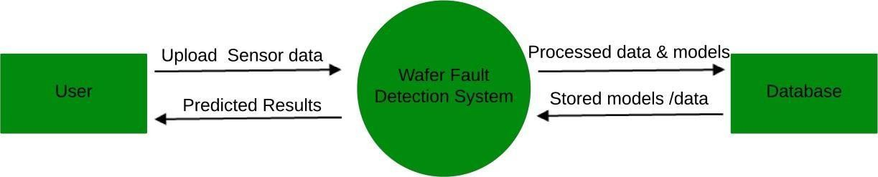

**0-LEVEL-DFD**

This Level 0 Data Flow Diagram illustrates the interactions between the primary entities of the Wafer Fault Detection System and the flow of data among them:

* User: The user uploads raw sensor data to the system. Once processed, the user receives the predicted results indicating whether faults exist in the wafer.
* Wafer Fault Detection System: This system processes the input sensor data, applies machine learning models, and generates predictions. It is the central component that interacts with both the user and the database.
* Database: The database stores processed data, trained models, and historical information. It provides stored models and data back to the system when required for prediction and processing.

# USE CASE DIAGRAM

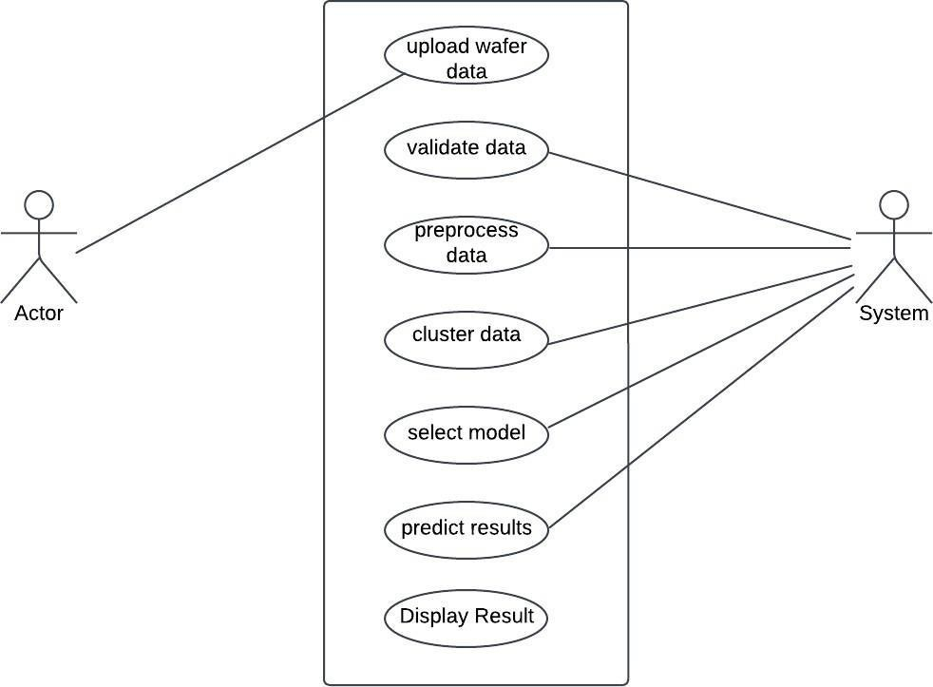

Wafer Fault Detection

System

This Use Case Diagram illustrates the interactions between the Actor (user) and the Wafer Fault Detection System. The user performs key actions such as uploading wafer data, which is then validated and preprocessed by the system. The system clusters the data, selects an appropriate model, predicts results, and displays them back to the user. Each step represents a systematic flow to ensure accurate fault detection.

* 1. **SEQUENCE DIAGRAM**

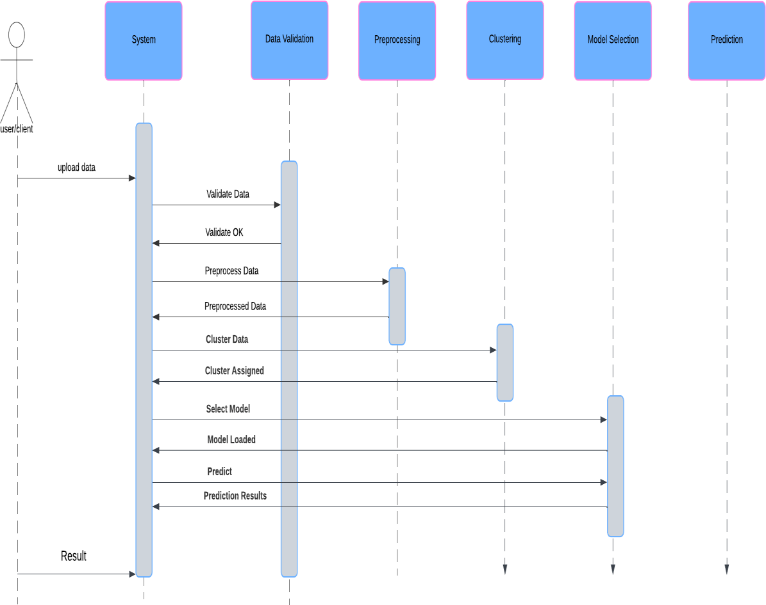

* 1. **ACTIVITY DIAGRAM**

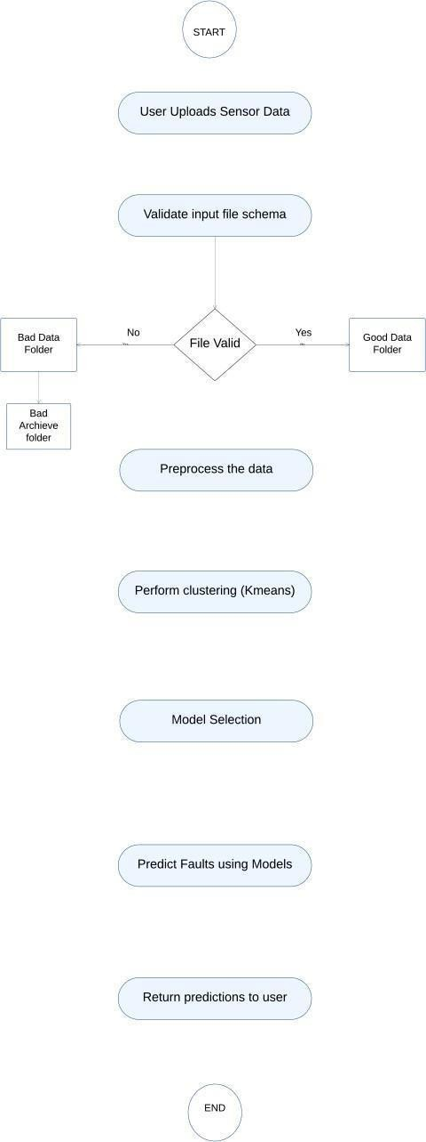

End

start

start

* 1. **ER DIAGRAM**

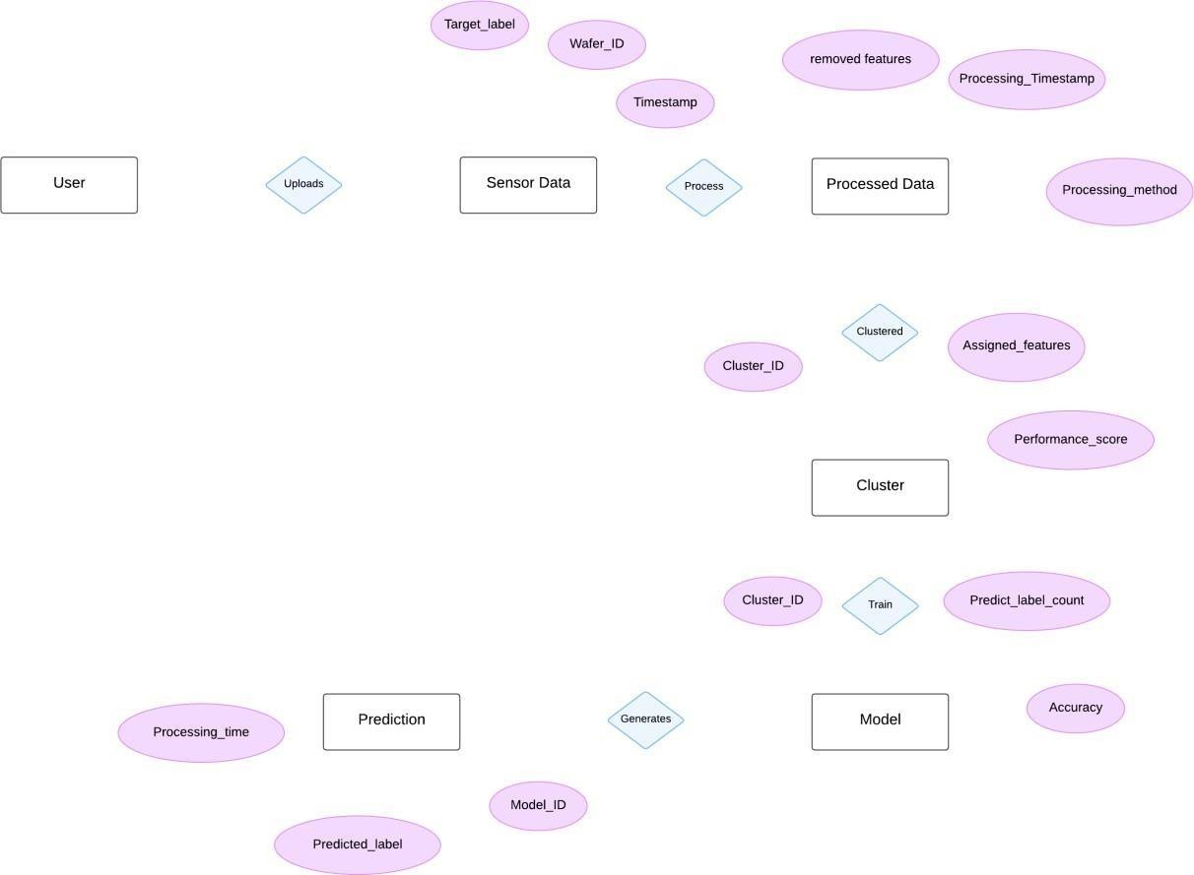

The user uploads sensor data, which includes attributes like wafer ID, timestamp, and target labels. The data is then processed to remove unnecessary features and generate processed data with information like processing timestamp and method. The processed data is clustered based on assigned features, generating cluster IDs and performance scores. Finally, the clusters are used to train a model, which predicts labels with details such as model ID, accuracy, and processing time. The predictions are returned to the user.

**CHAPTER 9**

# IMPLEMENTATION

#### Implementation of Wafer Fault Detection System

The implementation of the Wafer Fault Detection System involves several structured stages, from data collection to deploying a predictive model for classifying wafers as "Good" or "Faulty."

#### Data Collection and Database

Integration

The system begins by collecting sensor data from semiconductor wafers. This data, often in the form of multiple batch files, is uploaded by the user into the system.

* + Input Data: Sensor readings representing various wafer features.
  + Database: The input data is stored in a centralized database to ensure efficient management and retrieval during processing.

#### Data Validation

The next step involves validating the uploaded data to ensure consistency, completeness, and accuracy.

* + Validation Steps
  + Checking for missing values.
  + Ensuring consistent file formats.
  + Removing duplicate or irrelevant features.
  + Outcome: Only clean and relevant data is passed to subsequent stages.

#### Data Preprocessing

Preprocessing transforms the raw data into a format suitable for machine learning models. Key steps include:

* + Handling missing values using techniques like mean or median imputation.
  + Standardizing numerical features to ensure uniform scaling.
  + Encoding categorical features, if any, into numerical values.

#### Data Clustering

Clustering is performed to segregate wafers into groups based on similarities in feature sets.

* + Algorithm Used: K-Means Clustering groups the wafers into distinct clusters, enabling the system to train models separately for different clusters.
  + Purpose: Enhances model accuracy by allowing cluster-specific predictions.

#### Model Training

The clustered data is used to train advanced machine learning models that classify wafers as "Good" or "Faulty."

Algorithms Used:

* + Random Forest: For its robustness in handling high-dimensional data.
  + XGBoost: For its efficiency and ability to manage imbalanced datasets.
  + Support Vector Machine (SVM): For precise classification in complex scenarios.
  + Target Label: The system uses the target label (1 for Good and -1 for Faulty) from the input data for supervised learning.

#### Model Evaluation

The trained models are evaluated on test data to ensure their performance meets the desired accuracy.

Metrics Used:

* + Accuracy: To measure the percentage of correctly classified wafers.
  + Precision and Recall: To evaluate the model's performance on Faulty wafer detection.
  + F1-Score: To balance precision and recall metrics.

#### Deployment

The finalized model is integrated into the system for real-time predictions.

* + API Development: Flask APIs handle incoming requests, process sensor data, and return classification results.
  + Web Interface: A user-friendly web interface allows users to upload data, view predictions, and download reports.

#### Prediction and Output

Once deployed, the system predicts wafer quality for new sensor data:

* + Users upload sensor data files.
  + The system processes the data, applies clustering, and predicts wafer quality using the trained models.
  + The output is displayed as "Good" or "Faulty" wafers, and a detailed report can be generated.

**CHAPTER 10**

# TEST CASES

## Data Validation Test Cases

|  |  |  |  |  |
| --- | --- | --- | --- | --- |
| **Test ID** | **Test Scenario** | **Input** | **File passes**  **validation** | **Pass/Fail** |
| 001 | Validate file schema | File with correct schema | File fails  validation, logged as invalid | Pass |
| 002 | Detect missing columns in input data | File missing one or more columns | File fails  validation, logged as invalid | Pass |
| 003 | Validate column data types | File with  incorrect data types in columns | Missing values are imputed | Pass |
| 004 | Handle missing  values | File with Nan  values | Extra columns are  dropped | Pass |
| 005 | Identify extra columns | File with  additional unwanted columns | File fails  validation, moved to "Bad Data" folder | Pass |
| 006 | Validate file naming  convention | File with  incorrect name format | File passes validation | Pass |

## Data Preprocessing Test Cases

|  |  |  |  |  |
| --- | --- | --- | --- | --- |
| **Test ID** | **Description** | **Input** | **Expected**  **Outcome** | **Pass/Fail** |
| 001 | Handle missing values | Dataset with missing values | Missing values are imputed successfully | Pass |
| 002 | Handle missing values | Dataset with columns having zero variance | Columns are removed | Pass |
| 003 | Scale data to match training format | Dataset with mismatched feature scales | Data is scaled to match training data | Pass |
| 004 | Ensure alignment with training features | Dataset with missing training columns | Missing columns are  added with default values | Pass |
| 005 | Remove outliers | Dataset with extreme outlier values | Outliers are  removed or capped | Pass |

## Clustering Test Cases

|  |  |  |  |  |
| --- | --- | --- | --- | --- |
| **Test ID** | **Description** | **Input** | **Excepted**  **Outcome** | **Pass/Fail** |
| 001 | Assign correct clusters | Pre-processed data | Each wafer is assigned to A cluster | Pass |
| 002 | Handle Unclustered data | Data that doesn’t fit any cluster | Default cluster assigned or logged | Pass |

## Model Training Test Cases

|  |  |  |  |  |
| --- | --- | --- | --- | --- |
| **Test ID** | **Description** | **Input** | **Expected Outcome** | **Pass/Fail** |
| 001 | Validate model training process | Training dataset | Models are trained without errors | Pass |
| 002 | Save trained models | Trained Random Forest, XGBoost, SVM models | Models are saved in the correct directory | Pass |
| 003 | Evaluate model performance | Training and validation datasets | Models achieve expected accuracy/AUC | Pass |

## Prediction Test Cases

|  |  |  |  |  |
| --- | --- | --- | --- | --- |
| **Test ID** | **Description** | **Input** | **Expected Outcome** | **Pass/Fail** |
| 001 | Predict wafer faults with valid data | Preprocessed wafer data | Pre-processed wafer data | Pass |
| 002 | Handle data with missing columns during prediction | Dataset missing some features | Missing features are  filled with defaults | Pass |
| 003 | Validate output format | Input wafer data | Predictions are saved in  CSV/JSON  format | Pass |
| 004 | Test with incorrect cluster assignment | Input data not matching existing clusters | Default cluster or error is logged | Pass |
| 005 | Validate multi- model pipeline | Data spanning multiple clusters | Predictions made using respective models | Pass |

**CHAPTER 11**

# RESULTS AND DISCUSSION

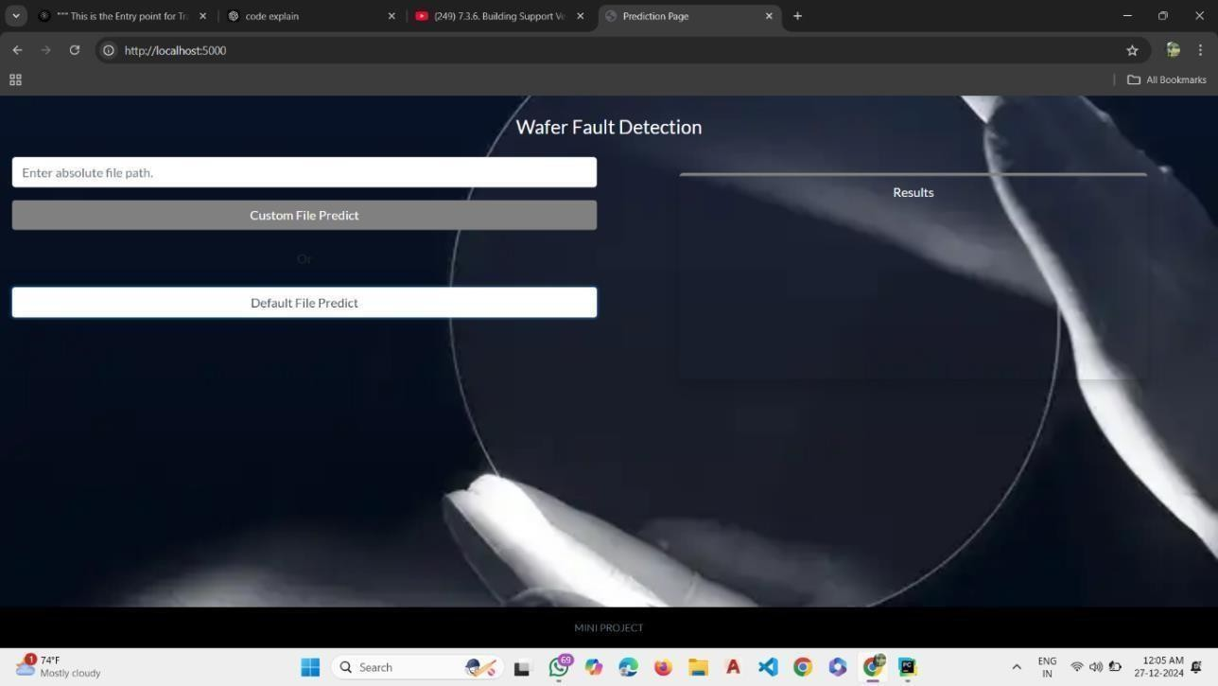

Fig 11.1: Output Of Webpage this figure shows the landing page of the wafer fault detection system. It allows users to input a file for fault analysis and displays navigation for prediction functionalities.

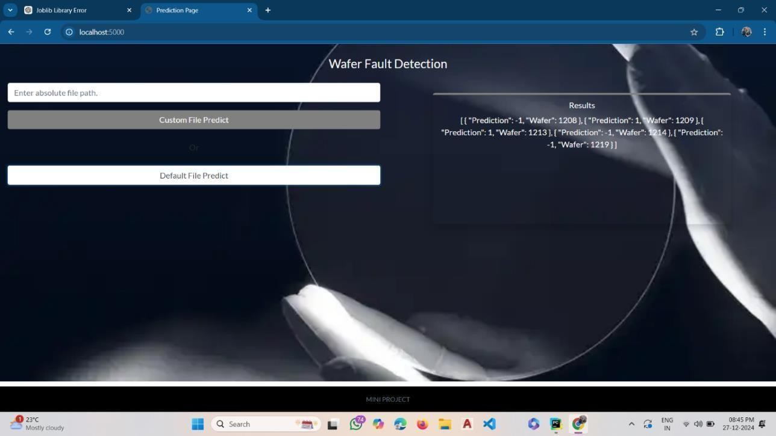

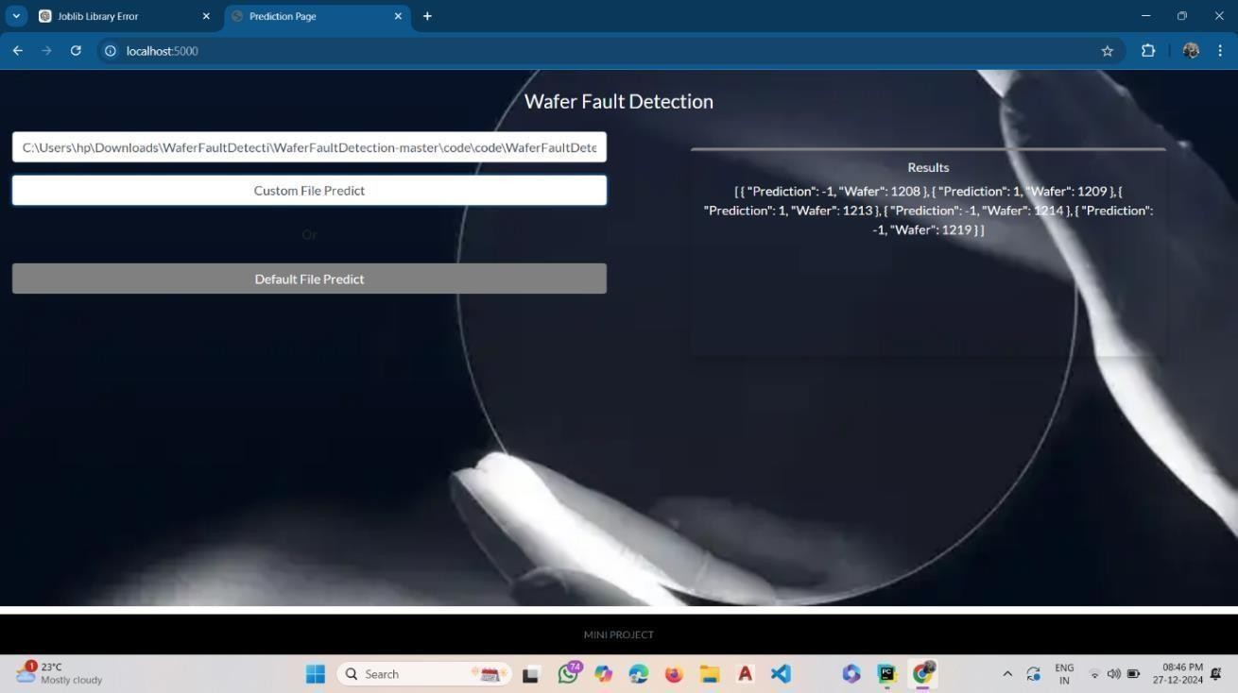Fig 11.2: Default File Prediction Page this figure illustrates the default file prediction process.

Fig 11.3: Custom File Prediction Page this figure demonstrates the prediction interface for a custom file upload. Users can upload their datasets, and the system outputs the results dynamically.

**CHAPTER 12**

## Advantages & Disadvantages

### Advantages

* + - Improved Yield and Productivity
    - Enhanced Quality Assurance
    - Integration with AI and Machine Learning
    - Cost Savings
    - Scalability.

### Disadvantages

* + - False Positives and Negatives
    - Data Overload
    - Adaptability Challenges
    - Dependency on Technology.

# APPLICATIONS

* + - Semiconductor Manufacturing: Improves yield and quality of microchips.
    - IC Production: Ensures functional and reliable integrated circuits.
    - MEMS: Detects faults in sensors and actuators.
    - Solar Panels: Inspects photovoltaic wafers for efficiency.
    - LED Manufacturing: Identifies defects for consistent performance.
    - Consumer Electronics: Ensures high-quality wafers for devices.
    - Automotive Electronics: Detects faults in wafers for ADAS and EVs.
    - Aerospace and Defense: Ensures reliability in avionics and military components.

**CHAPTER 14**

**CONCLUSION**

The Wafer Fault Detection project leverages advanced machine learning algorithms such as Random Forest, XGBoost, and SVM to automate the classification of wafers as faulty or non-faulty based on sensor data. This solution significantly enhances the efficiency of quality control in semiconductor manufacturing by eliminating manual inspections, reducing production costs, and minimizing wastage. The project effectively handles high-dimensional data, ensuring scalability and adaptability for large-scale industrial applications.

**CHAPTER 15**

**FUTURE SCOPE OF THE PROJECT**

The wafer fault detection system can be enhanced by improving model accuracy & through advanced techniques like deep learning or ensemble methods. Real-time fault detection can be achieved by integrating the system with IoT devices, enabling continuous monitoring in manufacturing units. Additionally, scalability can be ensured to handle larger datasets and adapt the system for industries like automotive and aerospace.

* Integrate IoT and advanced machine learning for real-time and accurate fault detection.
* Enhanced scalability and interpretability to adapt the system for broader industrial applications.

# REFERENCES

[1] Gharde, D. M., Adhikari, J., Bhende, P., & Chaudhari, N. (2021). Silicon Wafer Fault Detection by Using Multiple Data Prediction. International Research Journal of Engineering and Technology (IRJET), 8(5), 966-971. ISSN: 2395-0072

[2]. Gupta, T. R., Nukala, N. T., Reddy, R. R., Basvoju, N., & Kumar, V. S. (2023). Optimizing Semiconductor Yield: A Focus on Wafer Fault Detection and Prediction. International Journal of Creative Research Thoughts (IJCRT), 11(12) ISSN 2320-2882

[3]. Ma, J., Zhang, T., Yang, C., Cao, Y., Xie, L., Tian, H., & Li, X. (2023). Review of Wafer Surface Defect Detection Methods. Electronics, 12(1787). <https://doi.org/10.3390/electronics12081787>

[4]. Wang, Y., & Chen, H. (2024). Enhancing wafer defect detection via ensemble learning.

*AIP Advances, 14*(8), 085301. <https://doi.org/10.1063/>

[5] Ian Sommerville, Software Engineering, Pearson Education ISBN 13: 978-0-13- 703515-19th Edition 2011