Reproducible science Assignment
Anju mohan
2026-10-08
This is an R Markdown Notebook. When you execute code within the notebook, the results appear beneath the code.
Try executing this chunk by clicking the Run button within the chunk or by placing your cursor inside it and pressing Ctrl+Shift+Enter. #Introduction
In this exercise, we will perform multiple regression analysis.

Getting started
Install necessary libraries
library(car)
## Loading required package: carData
library(GGally)
## Loading required package: ggplot2
library(performance)
library(ggplot2)
library(readr)
library(dplyr)
##
## Attaching package: 'dplyr'
## The following object is masked from 'package:car':
##
## recode
## The following objects are masked from 'package:stats':
##
## filter, lag
## The following objects are masked from 'package:base':
##
## intersect, setdiff, setequal, union
library(tidyr)

Importing data set
Import the data set “WOLFPUPS.csv” Find the data file called “WOLFPUPS.csv” in the folder for this practical, and read it into a well-named data frame. Verify that it has loaded properly,
df_wp <- read_csv("WOLFPUPS.CSV")
## Rows: 45 Columns: 6
## ── Column specification ────────────────────────────────────────────────────────
## Delimiter: ","
## dbl (6): YEAR, ADULTS, CALVES, WORMS, PERMITS, PUPS
##
## ℹ Use `spec()` to retrieve the full column specification for this data.
## ℹ Specify the column types or set `show_col_types = FALSE` to quiet this message.

Data Quality control
This simulated dataset represents annual observations from a fictional wildlife park. We will examine how wolf pup numbers are associated with moose abundance, wolf parasite load, and hunting permits. The ecological setting provides context for practicing multiple regression; the data are not evidence about a real ecosystem. The predictor variables included in the dataset are the number of adult moose in the park (ADULTS), the number of moose calves born (CALVES), the average blood helminth load (WORMS) of trapped wolves (determined using blood samples from randomly selected wolves every year), and the number of moose hunting permits (PERMITS) issued by the park to human hunters. Use plotting commands to plot the data to do the quality control. check the conspicuous outlines. Plot histogram check the outlier of ADULTS Using Histogram and later checking the outliers of other columns in the data
df_wp |>
ggplot(aes(x=ADULTS)) + geom_histogram()
## `stat_bin()` using `bins = 30`. Pick better value `binwidth`.
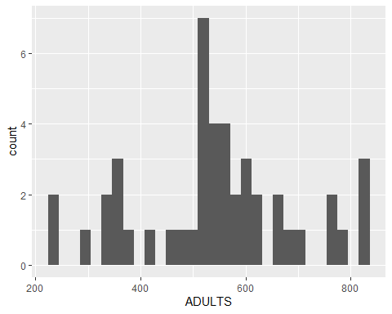
df_wp |>
ggplot(aes(x=CALVES)) + geom_histogram()
## `stat_bin()` using `bins = 30`. Pick better value `binwidth`.
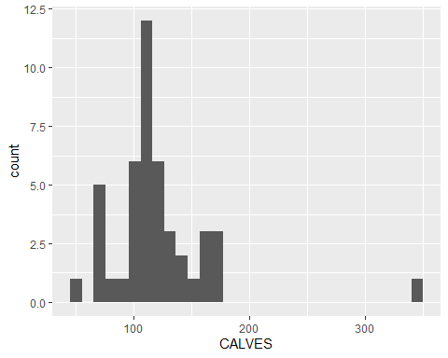 The above figure shows an extreme point above 300, that looks like an error.
df_wp |>
ggplot(aes(x=PERMITS)) + geom_histogram()
## `stat_bin()` using `bins = 30`. Pick better value `binwidth`.
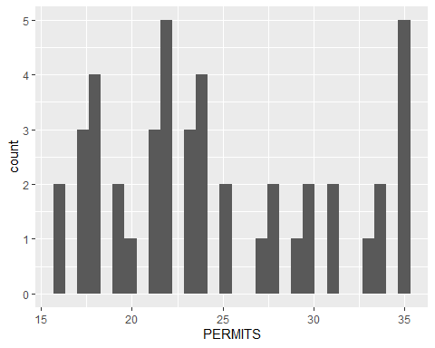
df_wp |>
ggplot(aes(x=WORMS)) + geom_histogram()
## `stat_bin()` using `bins = 30`. Pick better value `binwidth`.
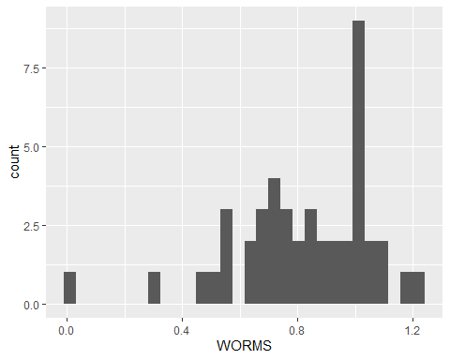 To produce a series of pairwise plots that illustrate bivariate relationships between all of the variables in your dataset, and search visually for strongly correlated predictors. use ggplot,
ggpairs(df_wp)
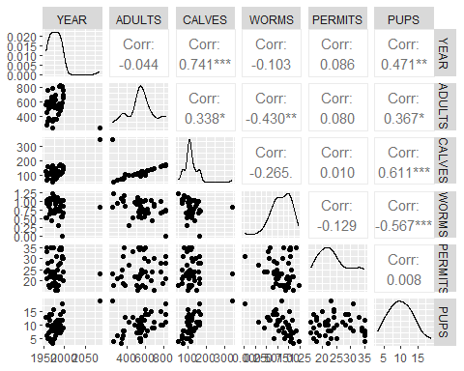 The figure above shows a number of quite strong relationships, but most of these are not strong enough to raise a concern. However the relationship between ADULTS and CALVES is so strong that models will have trouble distinguishing them. Before we start the modelling, let’s look closely at the relationships between PUPS and the other variables

Fitlering the data
Filtering only the Calves which is ,300 and then plot histogram
df_wp1<- df_wp |>
filter(CALVES<300)
df_wp1 |>
ggplot(aes(x=CALVES,Y=PUPS)) + geom_histogram()
## `stat_bin()` using `bins = 30`. Pick better value `binwidth`.
## Warning: The following aesthetics were dropped during statistical transformation: Y.
## ℹ This can happen when ggplot fails to infer the correct grouping structure in
## the data.
## ℹ Did you forget to specify a `group` aesthetic or to convert a numerical
## variable into a factor?
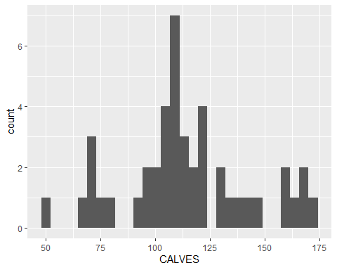 # Build a model
MOD.1 <- lm(PUPS ~ ADULTS+CALVES+WORMS+PERMITS, data = df_wp1)
Check the model
check_model(MOD.1)
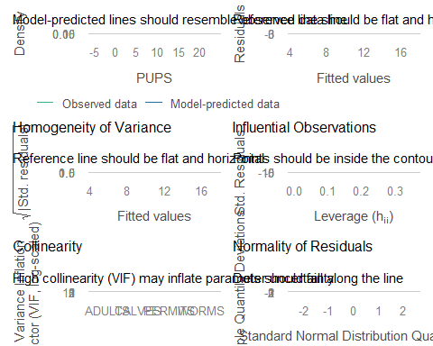 check the summary of the model
summary(MOD.1)
##
## Call:
## lm(formula = PUPS ~ ADULTS + CALVES + WORMS + PERMITS, data = df_wp1)
##
## Residuals:
## Min 1Q Median 3Q Max
## -4.812 -1.705 0.001 1.647 6.183
##
## Coefficients:
## Estimate Std. Error t value Pr(>|t|)
## (Intercept) 11.1813405 3.3963261 3.292 0.002118 **
## ADULTS -0.0008257 0.0111632 -0.074 0.941414
## CALVES 0.0480327 0.0559705 0.858 0.396037
## WORMS -6.8868917 1.9038081 -3.617 0.000843 ***
## PERMITS -0.0334569 0.0667088 -0.502 0.618813
## ---
## Signif. codes: 0 '***' 0.001 '**' 0.01 '*' 0.05 '.' 0.1 ' ' 1
##
## Residual standard error: 2.675 on 39 degrees of freedom
## Multiple R-squared: 0.4836, Adjusted R-squared: 0.4306
## F-statistic: 9.129 on 4 and 39 DF, p-value: 2.643e-05

Build an alternative Model
build an alternative model excluding one of the offending high VIF predictors, here excluding the ADULTS
MOD.2<- update(MOD.1,~. -ADULTS)
check the updated model
check_model(MOD.2)
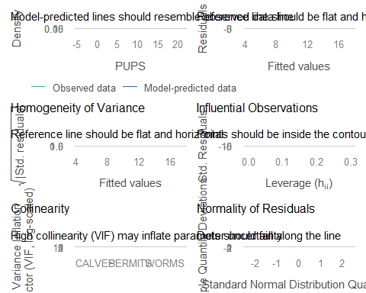 Take the summary of the MOD.2 and compare it with MOD.1
summary(MOD.2)
##
## Call:
## lm(formula = PUPS ~ CALVES + WORMS + PERMITS, data = df_wp1)
##
## Residuals:
## Min 1Q Median 3Q Max
## -4.896 -1.713 -0.001 1.650 6.088
##
## Coefficients:
## Estimate Std. Error t value Pr(>|t|)
## (Intercept) 11.16643 3.34793 3.335 0.00185 **
## CALVES 0.04406 0.01566 2.813 0.00757 **
## WORMS -6.87087 1.86778 -3.679 0.00069 ***
## PERMITS -0.03349 0.06587 -0.508 0.61400
## ---
## Signif. codes: 0 '***' 0.001 '**' 0.01 '*' 0.05 '.' 0.1 ' ' 1
##
## Residual standard error: 2.641 on 40 degrees of freedom
## Multiple R-squared: 0.4835, Adjusted R-squared: 0.4448
## F-statistic: 12.48 on 3 and 40 DF, p-value: 6.69e-06
Made an another model by excluding the PERMITS column
MOD.3<- update(MOD.2,~.-PERMITS)

Model Simplification
Taking the ANOVA
anova(MOD.2,MOD.3)
## Analysis of Variance Table
##
## Model 1: PUPS ~ CALVES + WORMS + PERMITS
## Model 2: PUPS ~ CALVES + WORMS
## Res.Df RSS Df Sum of Sq F Pr(>F)
## 1 40 279.05
## 2 41 280.85 -1 -1.8028 0.2584 0.614
To derive standardized regression coefficients, centre each predictor by subtracting its mean from each observation, then scale it by dividing by its standard deviation. You could work out how to do this easily enough, but R already has a built in function, scale() that will do it for you. You can easily nest scale() into the call for a linear model as follows:
MOD.3s <- lm(PUPS = Scale(CALVES)+Scale(WORMS),data = df_wp)
## Warning: In lm.fit(x, y, offset = offset, singular.ok = singular.ok, ...) :
## extra argument 'PUPS' will be disregarded

Inspecting added variable plots
We can use the avPlots() command from the car package to automatically generate “added variable plots” (but results may vary – some other students find added variable plots to be even more confusing than multiple regression!) These are simpler to generate than the visualisations below, but they are often more difficult to interpret in terms of the original scales of the data, and for that reason are rarely presented to readers in publications.
avPlots(MOD.3)
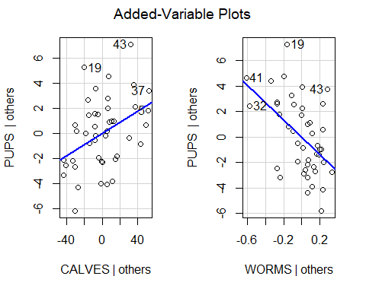
avPlots(MOD.3s)
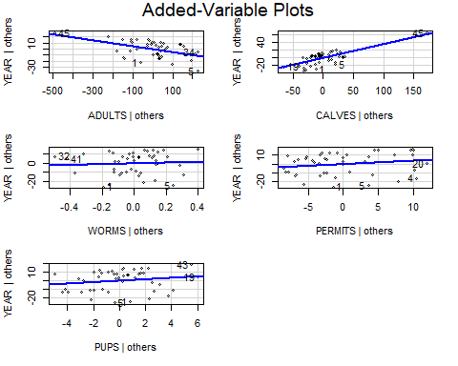 # Visualizing partial effects
‘partial effects’ refers to modelled associations conditional on the other included predictors, rather than demonstrated causal effects. Although the added variable plots can provide helpful insight into the model, we’ll usually want to illustrate the fitted model object along with the original data for our readers, as we did for univariate regressions.

Using predict()
Use the predict() command and ggplot package to add the lines and 95% confidence intervals to plots of the data. Use the tidyverse crossing() function to make a new data frame that varies only one of the key variables at a time,
NEWPUPS_varWORMS <- crossing(WORMS = seq(0.01,1.22,
length = 100),
CALVES = mean(df_wp1$CALVES),
PERMITS = mean(df_wp1$PERMITS))
Inspect this object – notice that it has three predictors, but only one of them varies, while the other is held to its mean value. Now use the predict command to generate the predicted number of PUPS for this particular combination (in doing so, we’re illustrating the partial effect of WORMS after controlling for CALVES, since all CALVES values are set to the mean):
NEWYUSINGWORMS <- predict(MOD.2,
newdata = NEWPUPS_varWORMS,
int = "c")
You should bind the matrix produced by predict with its corresponding new data frame before using ggplot, as follows:
varWORMS_PREDS <- bind_cols(NEWPUPS_varWORMS,
as_tibble(NEWYUSINGWORMS))

Plotting the data
ggplot(varWORMS_PREDS, aes(x=WORMS,y= fit))+
geom_line() +
geom_ribbon(aes(ymin=lwr,
ymax=upr),
alpha= 0.25)+
labs(x = "WORMS",
y = "PUPS") +
geom_point(data = df_wp1,
aes(y=PUPS),colour = "blue")+
theme_bw()
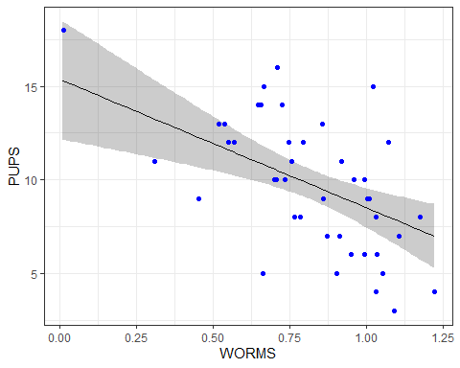 # Predicting the data
NEWPUPS_varCALVS <- crossing(CALVES = seq(50,175,
length = 100),
WORMS = mean(df_wp1$WORMS),
PERMITS = mean(df_wp1$PERMITS))
NEWUSINGCALVS<- predict(MOD.2,
newdata = NEWPUPS_varCALVS,
int= "c")
varCALVES_PREDS<- bind_cols(NEWPUPS_varCALVS,as_tibble(NEWUSINGCALVS))

Plotting the predicted data
ggplot(varCALVES_PREDS, aes(x=CALVES,y= fit))+
geom_line() +
geom_ribbon(aes(ymin=lwr,
ymax=upr),
alpha= 0.25)+
labs(x = "CALVES",
y = "PUPS") +
geom_point(data = df_wp1,
aes(y=PUPS),colour = "blue")+
theme_bw()
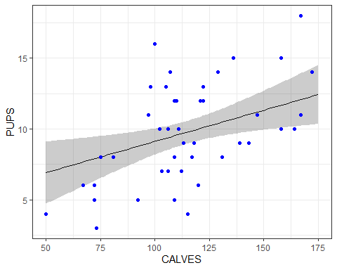 # Interpretation In the fitted model, wolf pup numbers were negatively associated with parasite load and positively associated with moose calf numbers. Each association was estimated while accounting for the other included predictor.Because calf and adult moose numbers were strongly correlated, this analysis provides little basis for separating their associations with pup numbers.

Sample Results text:
The minimal adequate model of wolf recruitment rates showed a significant negative association with parasite load (Slope B = -6.77; Standardized regression coefficient Beta = -1.63; t = -3.68,P= 0.0007; and a positive association with the number of moose calves (B = 0.044, Beta = 1.26; t = 2.83; P = 0.0071; Because moose calf numbers were collinear with adult population size, we cannot distinguish between the effects of adults or calves on wolf recruitment.

