**SIRI USER GUIDE**

**INDEX**

1. **ADMIN LOGIN**

* **ADMIN LOGIN**

1. **User List**

**Link:** [**https://sirinew.kawikatech.com/users**](https://sirinew.kawikatech.com/users)

* Here can create the user login

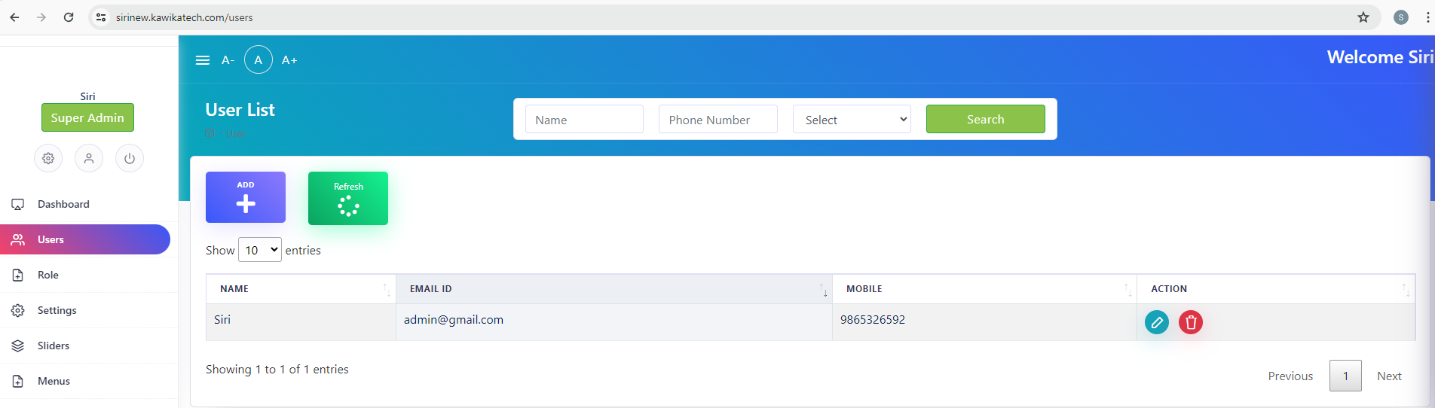

1. **Create User**

**Link:** [**https://sirinew.kawikatech.com/users/create**](https://sirinew.kawikatech.com/users/create)

* Here can create the user login

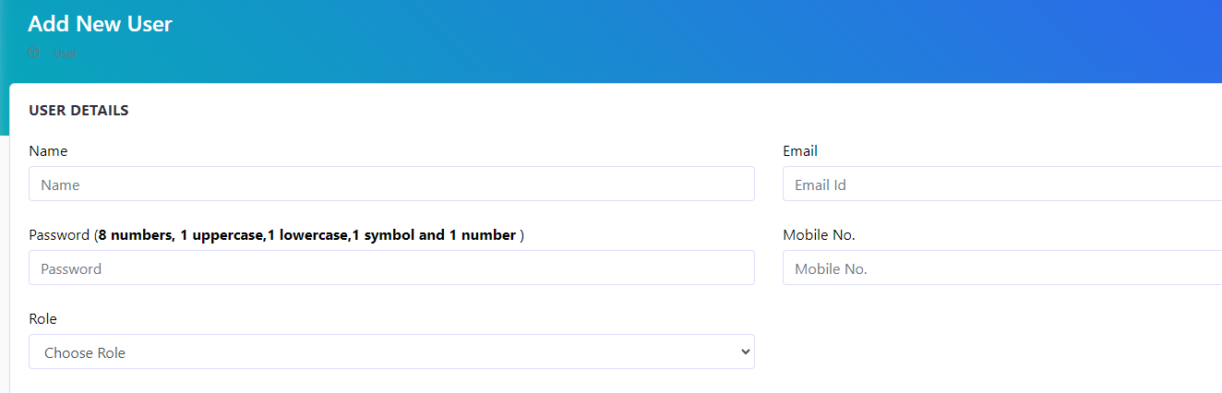

1. **Edit User**

**Link:** [**https://sirinew.kawikatech.com/users/65c9facb8df3551d8408da02/edit**](https://sirinew.kawikatech.com/users/65c9facb8df3551d8408da02/edit)

* Here can edit the user login



1. **Delete User**

**Link:** [**https://sirinew.kawikatech.com/users/65c9facb8df3551d8408da02/edit**](https://sirinew.kawikatech.com/users/65c9facb8df3551d8408da02/edit)

* Here can delete the user login

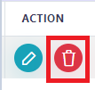

1. **Role Management**

**Link:** [**https://sirinew.kawikatech.com/roles**](https://sirinew.kawikatech.com/roles)

* Here can create the roles

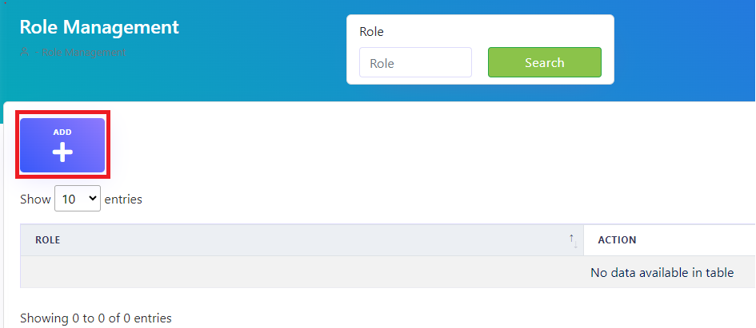

1. **Sliders Category**

**Link:** [**https://sirinew.kawikatech.com/slidercategories/create**](https://sirinew.kawikatech.com/slidercategories/create)

* Here can create the roles

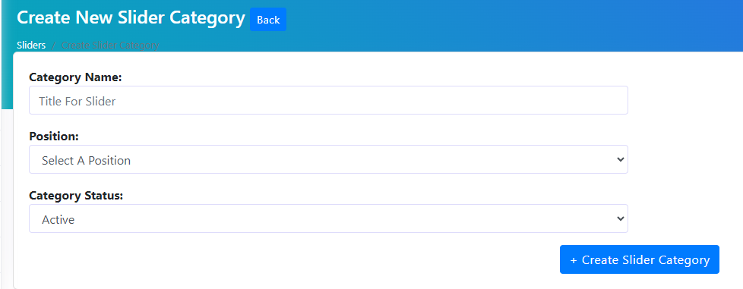

1. **Menus**

**Link:** [**https://sirinew.kawikatech.com/menus**](https://sirinew.kawikatech.com/menus)

* Here can create the menus
* And each menus can create sub menus

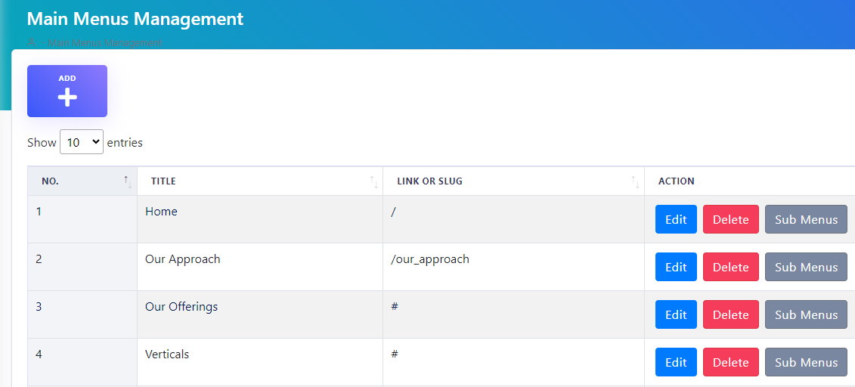

1. **Gallery**

**Link:** [**https://sirinew.kawikatech.com/gallery_category**](https://sirinew.kawikatech.com/gallery_category)

* Here can create the gallery

1. **Our Approach**

**Link:** [**https://sirinew.kawikatech.com/admin-approach**](https://sirinew.kawikatech.com/admin-approach)

* Here can create the our approach

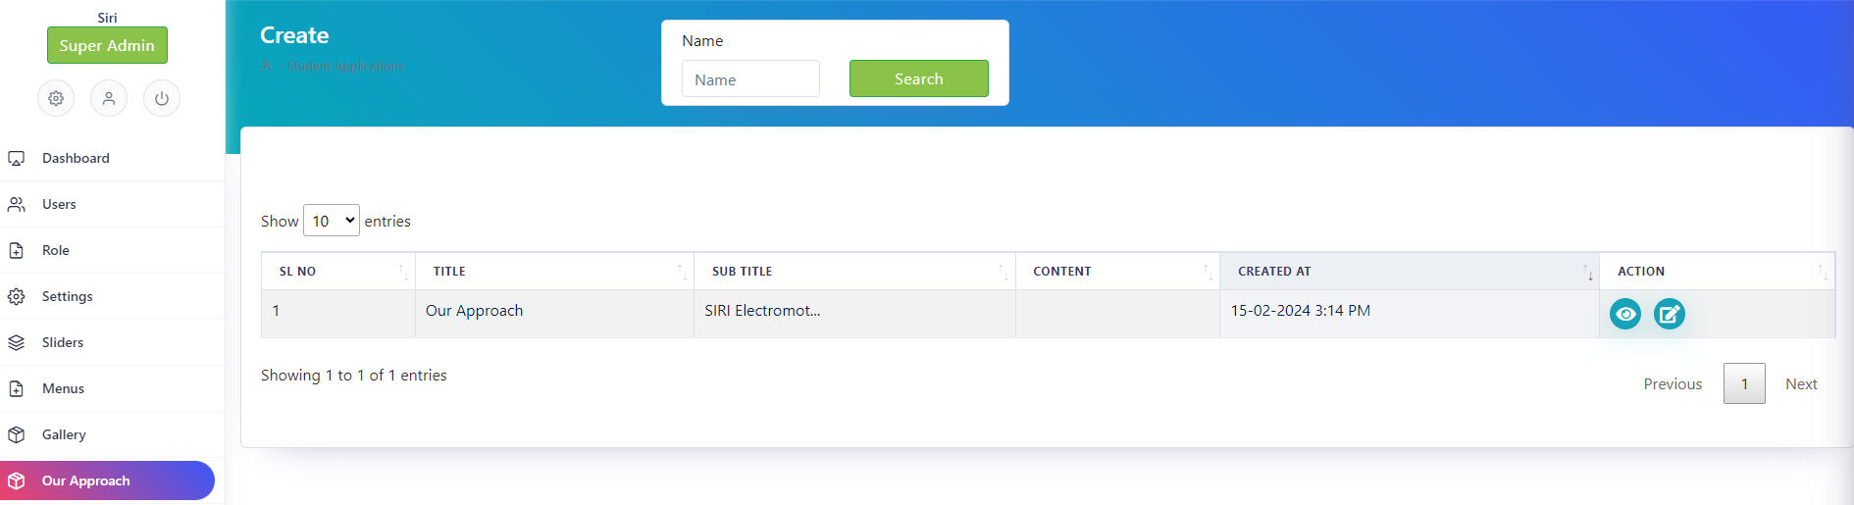

**Verticals -**

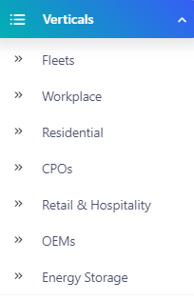

1. **Fleets List**

**Link:** [**https://sirinew.kawikatech.com/admin/verticals/fleets**](https://sirinew.kawikatech.com/admin/verticals/fleets)

* Here we can edit and view the fleets list

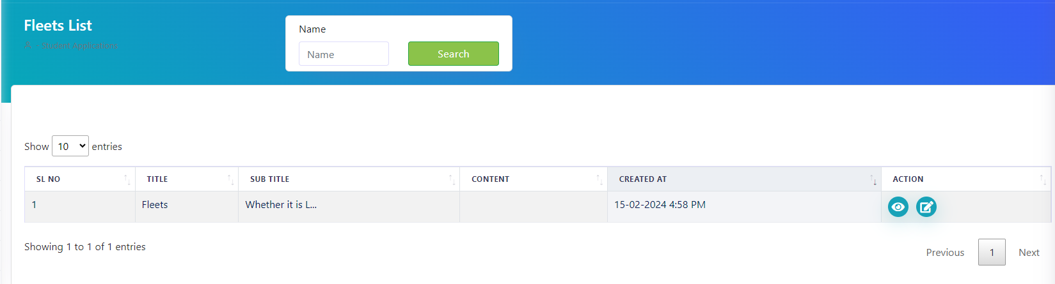

1. **Workplace**

**Link:** [**https://sirinew.kawikatech.com/admin/verticals/workplace**](https://sirinew.kawikatech.com/admin/verticals/workplace)

* Here we can edit and view the Workplace list

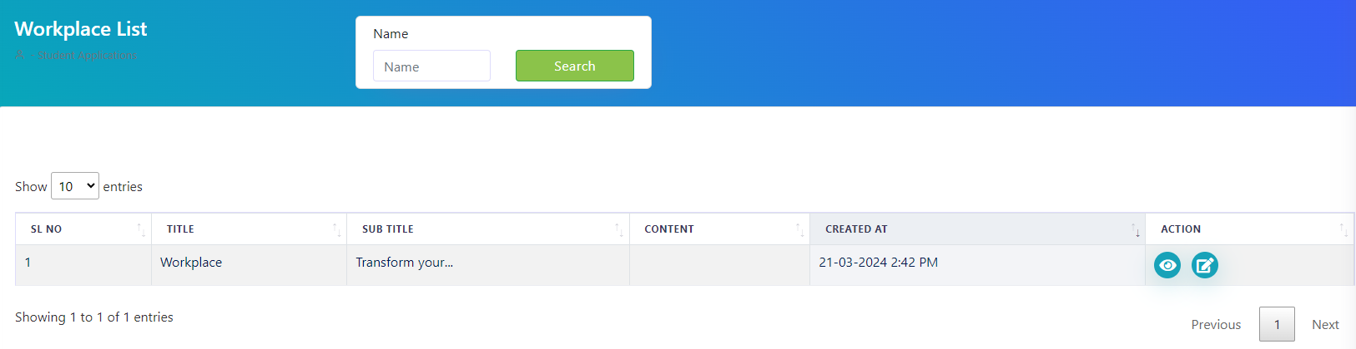

1. **Residential**

**Link:** [**https://sirinew.kawikatech.com/admin/verticals/residential**](https://sirinew.kawikatech.com/admin/verticals/residential)

* Here we can edit and view the Residential list

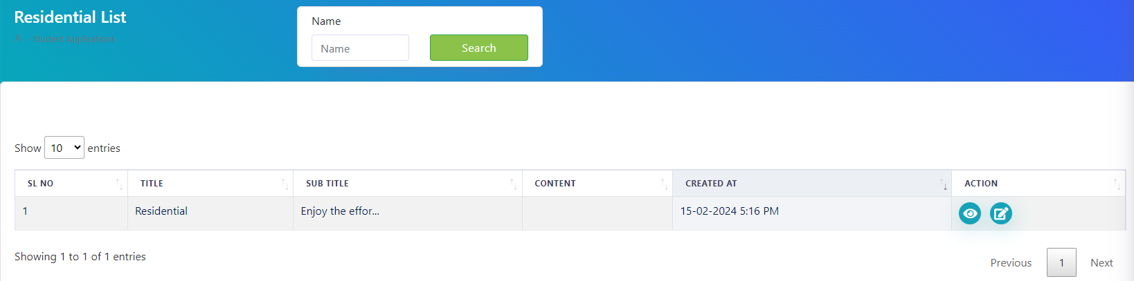

1. **Cops**

**Link:** [**https://sirinew.kawikatech.com/admin/verticals/cpos**](https://sirinew.kawikatech.com/admin/verticals/cpos)

* Here we can edit and view the Cops list

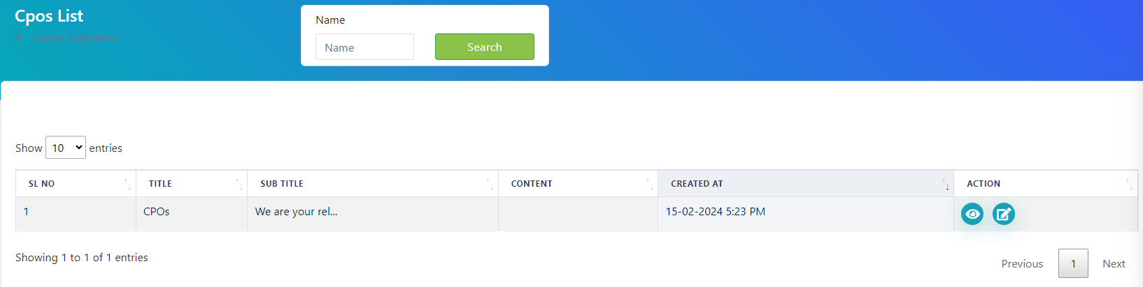

1. **Retails & Hospitality List**

**Link:** [**https://sirinew.kawikatech.com/admin/verticals/retail%20&%20hospitality**](https://sirinew.kawikatech.com/admin/verticals/retail%20&%20hospitality)

* Here we can edit and view the Retails & hospitality list

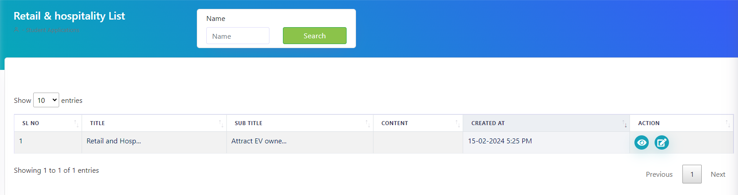

1. **Energy Storage List**

**Link:** [**https://sirinew.kawikatech.com/admin/verticals/energystorage**](https://sirinew.kawikatech.com/admin/verticals/energystorage)

* Here we can edit and view the Retails & hospitality list

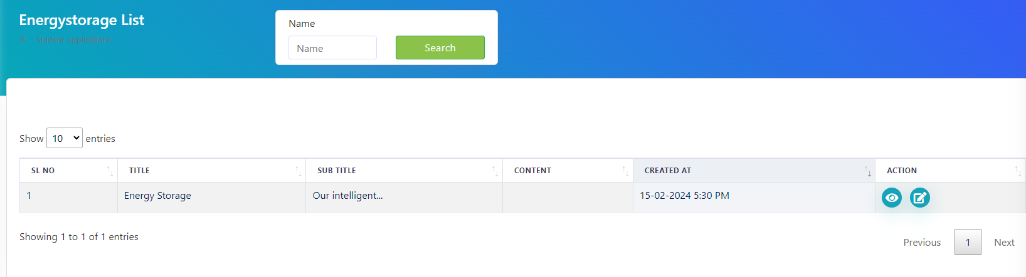

1. **Oems**

**Link:** [**https://sirinew.kawikatech.com/admin/verticals/oems**](https://sirinew.kawikatech.com/admin/verticals/oems)

* Here we can edit and view the Oems list

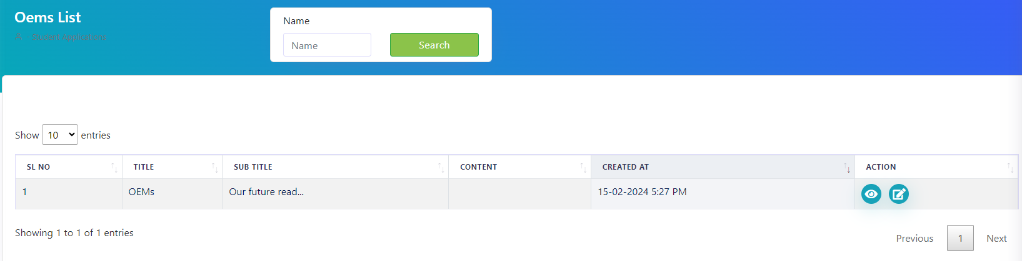

**Innovations -**

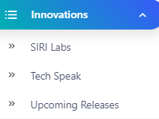

1. **Siri labs**

**Link:** [**https://sirinew.kawikatech.com/admin/innovation/sirilabs**](https://sirinew.kawikatech.com/admin/innovation/sirilabs)

* Here we can edit and view the Oems list