



**Green Oasis**

Organic Smoothie & Juice Bar

greenoasis.com

**BUSINESS PLAN**

Prepared by

«Display_name»

«Address»

«Business_Address_City»

# Introduction

In the heart of the urban landscape, the Green Oasis Organic Smoothie & Juice Bar emerges as a beacon of health, freshness, and revitalization. As the name suggests, we offer an oasis amidst the bustling city life—a place where individuals can find a moment of tranquility while savoring the nourishing benefits of organic produce.

## Mission Statement

Our mission at Green Oasis is not just about serving beverages; it's about serving the community. We are dedicated to offering fresh, organic, and delectably crafted smoothies and juices that not only satiate thirst but also promote a healthier lifestyle. Each sip is a testament to our commitment to quality and the well-being of our patrons.

## Summary of the Business Concept

Nestled in a trendy downtown district, Green Oasis stands out with its chic, eco-friendly design and a tantalizing menu. We specialize in organic smoothies, cold-pressed juices, and light bites, meticulously crafted to cater to the diverse palate of the health-conscious urbanite. Whether it's a detox green smoothie, an energizing berry blend, or a refreshing cold-pressed citrus juice, our offerings are not just beverages—they are experiences.

## Objectives

1. Open our flagship store in the heart of downtown within the next 6 months
2. After Year 1, we aim to become the go-to spot for health enthusiasts in the vicinity.
3. Within five years, we envision Green Oasis flourishing in three prime locations

## Key to Success

The bedrock of our anticipated success lies in three pivotal elements:

Prime Location

Commitment to   
Organic Ingredients

Unparalleled   
Customer Service

# Company Overview

## Legal Structure

Green Oasis operates as a Limited Liability Company (LLC). This structure not only offers protection of personal assets but also provides flexibility in operations and tax benefits, ensuring the sustainable growth of our enterprise.

## History

The genesis of Green Oasis traces back to 2053, a brainchild of Jane and John Smith. Both Jane and John are fervent believers in the power of nutrition to transform lives. With their combined knowledge and passion for nutrition, they envisioned a haven where the community could access fresh, organic, and health-boosting beverages. Thus, Green Oasis was born.

## Current Position and Assets

Having secured a lease in a prime downtown location, Green Oasis is poised to become the city's newest health hotspot. The strategic choice of this location guarantees high visibility and accessibility to our target audience. The founders, Jane and John Smith, have passionately invested an initial sum of $100,000, ensuring that the establishment is equipped with state-of-the-art facilities and high-quality ingredients from day one.

## Team Structure

**Jane Smith**

CEO

**John Smith**

COO

**Emily Jackson**

Marketing Director

# Products & Services

Our offerings are about revitalizing the body and spirit. Every item on our menu is crafted with the utmost care, ensuring a perfect blend of taste and health. Our dedication to quality is apparent in every sip and bite, as we use only certified organic produce. With a dynamic range that caters to diverse preferences and needs, Green Oasis promises an invigorating experience every time.

## Our Offerings

|  |  |  |
| --- | --- | --- |
| Product | Description | Key Highlights |
| Smoothies | A wide variety of blends, from fruity delights to green wonders. | Made with 100% organic fruits, vegetables, and supplements. |
| Cold-pressed Juices | Freshly squeezed juices, offering pure, unadulterated nutrients. | No additives or preservatives. |
| Light Bites | Includes granola bowls, fruit salads, and more, perfect for a wholesome snack. | Freshly prepared daily with organic ingredients. |
| Wellness Shots | Concentrated shots tailored for specific needs like detox, immunity, and energy. | Quick and effective health boosters. |

## Unique Selling Proposition (USP)

At Green Oasis, we believe in transparency and trust. We ensure that every ingredient used is certified organic, promising not just flavor but also unparalleled quality. Our team constantly experiments to bring forth health-boosting recipes tailored for specific needs, whether it's detoxification, an energy spike, or fortifying immunity.

## Lifecycle

At Green Oasis, we understand the allure of variety. This is why our menu isn't static. We introduce seasonal menu rotations, ensuring that our customers get to savor diverse flavors throughout the year. From summer delights to winter warmers, our offerings mirror the beauty of changing seasons.

# Market Analysis

In recent years, the global perspective on wellness and nutrition has undergone a paradigm shift. As people become increasingly conscious about what they consume and its impact on their health, the demand for organic, fresh, and transparent food and beverage options has surged. Green Oasis is poised at this intersection of health-consciousness and premium service, catering to a rapidly growing segment of the market.

## Target Market & Their Needs

|  |  |  |
| --- | --- | --- |
| Demographic | Description | Needs & Preferences |
| Age Group | 20-45 years old | * Products that align with a dynamic lifestyle, offering both taste and health. * Willingness to pay a premium for quality, organic, and transparent products. * A preference for organic, fresh, and health-boosting food and beverage options. * Diverse menu catering to specific dietary requirements and choices. |
| Economic Status | Middle to upper income |
| Lifestyle Preference | Health-conscious individuals |
| Dietary  Choices | Open to vegan, vegetarian, and balanced dietary options |

## Market Trends

The current market landscape is characterized by several favorable trends for businesses like Green Oasis:

* **Organic Consumption:** There has been a noticeable surge in organic food and beverage consumption. Consumers are becoming more educated and wary of synthetic additives, preservatives, and genetically modified organisms (GMOs).
* **Health and Wellness:** The global conversation around health and wellness has expanded beyond mere physical fitness. Nutritional intake, mental well-being, and holistic health have taken center stage.

* **Transparency and Authenticity:** Modern consumers value transparency in sourcing, production, and ingredients, leading to an increasing demand for brands that uphold these principles.

## Market Growth & Industry Analysis

The organic beverage industry is experiencing robust growth, with a 10% annual increase. This growth signifies a burgeoning market with ample opportunities for establishments that prioritize organic and fresh ingredients.

Furthermore, the broader juice and smoothie bar industry, of which we are a part, boasts a market value of $3 billion and continues to grow at an impressive rate of 4% annually. This solidifies the potential and profitability of our venture, given our unique positioning within this industry.

# Competitive Analysis

Every thriving market landscape is accompanied by competition, and the juice and smoothie industry is no exception. For Green Oasis Organic Smoothie & Juice Bar to carve its niche and succeed, it's essential to understand the competitive terrain, assess the major players, and strategize our unique positioning.

## Major Competitors

|  |  |  |
| --- | --- | --- |
| Competitor Name | Key Strengths | Weaknesses |
| Local Juice Bars | Proximity to local clientele | Limited menu and  lack of organic focus |
| Personalized, localized service | Might not have  standardized processes |
| Jamba Juice | Strong brand recognition | Mass production might compromise on ingredient freshness |
| Established supply chain and distribution | Less focus on organic and health-specific offerings |

## Competitive Positioning

Green Oasis differentiates itself from the competition by occupying a premium niche that is intensely focused on organic offerings. While many competitors might provide smoothies and juices, our unwavering commitment to certified organic produce and health-centric recipes places us in a unique category. Coupled with personalized service that ensures each patron feels valued, Green Oasis aims to offer an experience that is both luxurious and nourishing.

|  |  |
| --- | --- |
| Barriers to Entry | Window of Opportunity |
| * Initial investment on premium equipment and organic ingredients can be substantial. * With established franchises and local juice bars, new entrants must work hard to secure their market share and customer loyalty. | * As consumers become increasingly health-conscious, the demand for organic products is on the rise. * The global shift towards holistic wellness presents a ripe opportunity for establishments that prioritize health and well-being. |

# Marketing & Sales Strategy

To resonate with our target audience and establish Green Oasis as a premier brand in the organic beverage industry, a robust and dynamic marketing and sales strategy is imperative. We've designed our approach to foster brand loyalty, maximize outreach, and drive consistent sales.

* **Social Media Campaigns:** Leveraging platforms like Instagram, Facebook, and Twitter, we'll showcase our products, share customer testimonials, and promote health tips. Engaging visuals and interactive content will help in fostering community engagement.
* **Local Partnerships:** Collaborating with local businesses, especially those aligned with health and wellness, will increase our brand visibility. Joint promotions with gyms, yoga studios, or wellness clinics can be particularly beneficial.
* **Sampling Events:** Hosting events where potential customers can sample our offerings will not only introduce our products but also create a memorable brand experience.

## Sales Process

* **In-store Purchases:** A seamless and pleasant in-store experience will be a priority, ensuring quick service without compromising on quality.
* **Online Ordering:** A user-friendly website and mobile app will facilitate easy online ordering, catering to the growing demand for convenience.
* **Loyalty Program:** Rewarding regular customers with points, discounts, or exclusive offers will foster brand loyalty and repeat business.

## Distribution Channels

While our primary sales channel will be in-store purchases, we're exploring partnerships with local gyms and wellness centers. This collaboration can introduce our products to a wider audience and provide convenient access to health-conscious individuals.

# Operations

## Location & Facilities

Our 1,500 sq. ft. store, strategically located in a bustling downtown area, is designed to cater to both quick grab-and-go customers and those wishing to have a relaxed experience. The modern, eco-friendly interior design resonates with our brand ethos and provides a welcoming ambiance.

## Production Process

Every product at Green Oasis is freshly made in-house. We adhere to strict standards to maintain the freshness and nutritional value of our organic ingredients. Regular training ensures that our staff is well-versed in crafting each beverage to perfection.

## Suppliers

Our commitment to organic and fresh produce is uncompromising. We've partnered with local organic farms and distributors, ensuring a consistent supply of the highest quality ingredients. These close ties with suppliers also enable us to stay updated on the latest organic produce trends.

## Management & Personnel

* Store Manager: Oversees the day-to-day operations, inventory management, and staff coordination.
* Assistant Manager: Assists the store manager, especially in customer service and managing peak hours.
* Part-time Employees: Trained in crafting our beverages, ensuring hygiene standards, and providing impeccable customer service.

## Equipment & Technology

* Commercial Juicers and Blenders: High-quality equipment guarantees the perfect texture and taste for each beverage.
* POS System: A modern point-of-sale system ensures smooth billing, inventory tracking, and sales analysis.

# Financial Projections

Financial projections offer a roadmap of expected financial performance, guiding our strategy and decisions. Here, we outline the anticipated financial landscape for the first six months of operation for Green Oasis.

## Start-up Costs

The initial investment of $150,000 encompasses:

* Leasehold improvements: Setting up the store, interior design, signage, etc.
* Equipment: Commercial juicers, blenders, POS system, etc.
* Initial Inventory: Stocking up on organic ingredients, packaging materials, etc.

## 6-Month Financial Projections

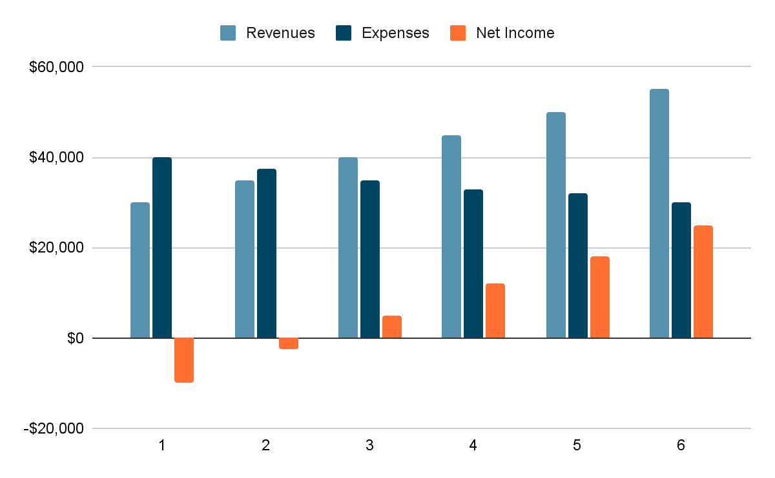

## Profit and Loss Forecast

With a projected $500,000 in sales in the first year and considering the expense trends, we anticipate a net profit margin of 10%, amounting to a net profit of $50,000.

## Cash Flow Forecast

Given our projections, by month 6, we anticipate having a positive cash flow, with cumulative net income reaching $47,500, indicating the business's capability to sustain operations and potentially reinvest.

## Break-even Analysis

Considering our fixed and variable costs, Green Oasis is expected to reach its break-even point by the 4th month. From this point forward, we expect to generate a profit.

## Assumptions

These projections are based on:

* A timely store opening without unforeseen delays.
* A consistent and steady growth in our customer base, aided by our marketing strategies.
* Stable supplier costs and no unexpected macroeconomic downturns.

# Exit Strategy

While our primary focus and vision for Green Oasisrevolve around long-term growth and consistent value delivery to our patrons, it's prudent for any business to consider potential exit strategies. This not only offers clarity to our investors but also provides us with a roadmap for possible future scenarios.

## Selling the Business

One of the most straightforward exit strategies is to sell the business. Given our unique positioning in the market, a larger food or beverage chain might see value in acquiring Green Oasis. Such a sale would offer an opportunity for our brand to potentially expand under the umbrella of a larger entity, while also providing a substantial return on investment for our stakeholders.

## Harvesting

Another option is harvesting, wherein we continue the operation of Green Oasis without any significant reinvestment or expansion. In this scenario, the business runs to generate a stable income for its owners and stakeholders. This approach is often adopted when the market matures, and growth prospects are limited, allowing for consistent revenue extraction without aggressive expansion.

## IPO (Initial Public Offering)

While going public and listing Green Oasis on a stock exchange could be a potential exit strategy for many businesses, it's not a path we're currently considering. An IPO involves a different level of scrutiny, regulatory compliance, and operational transparency. At this juncture, our focus is on organic growth and consolidating our position in the market rather than preparing for a public listing.

**CHOOSE & DOWNLOAD MORE** [**BUSINESS PLAN TEMPLATE**](https://www.template.net/editable/business-plans/word) **©**  [**TEMPLATE.**NET](https://www.template.net/)