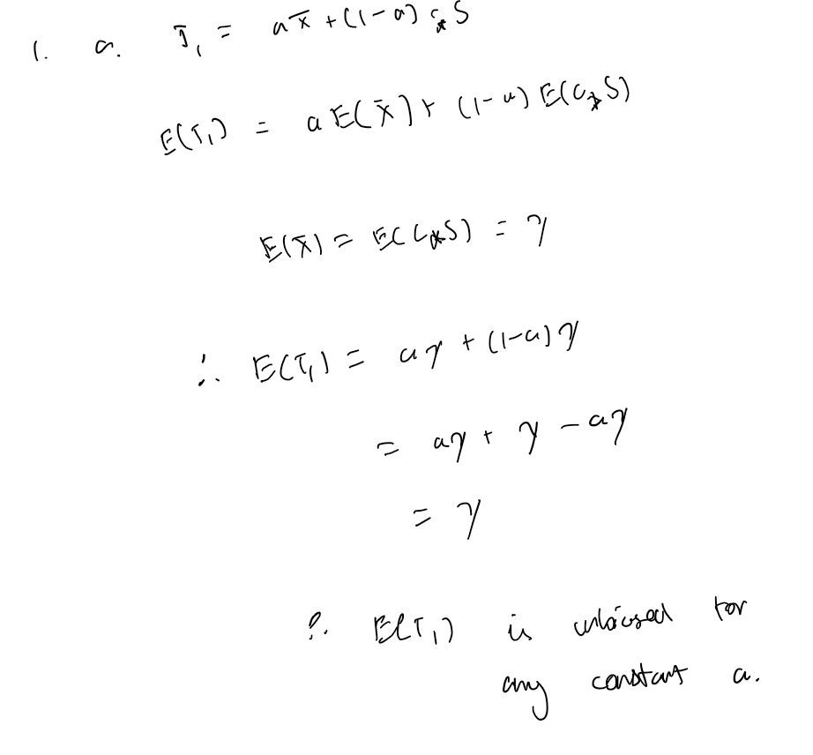c.  
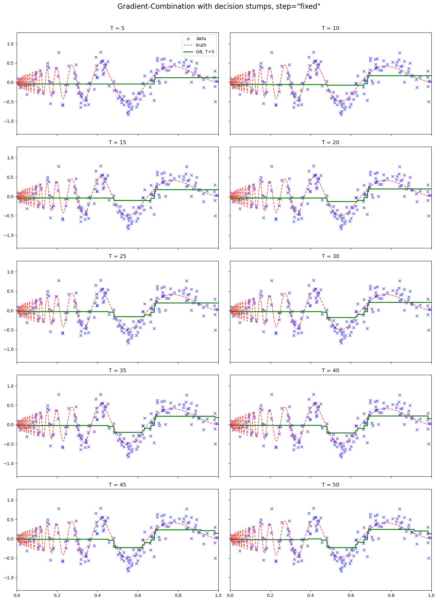

With the fixed step size, it underfits significantly, even at high T. The adaptive step size converges much faster and also fits the data much better.

for a fixed alpha = 0.1, fit is piecewise constant but tracks the curvature well. adaptive alpha: each tree is stronger, so adaptive boosting zooms in on residuals very quickly. therefore, it ends up overfitting the data.

