**ACTIVITY DIAGRAM**

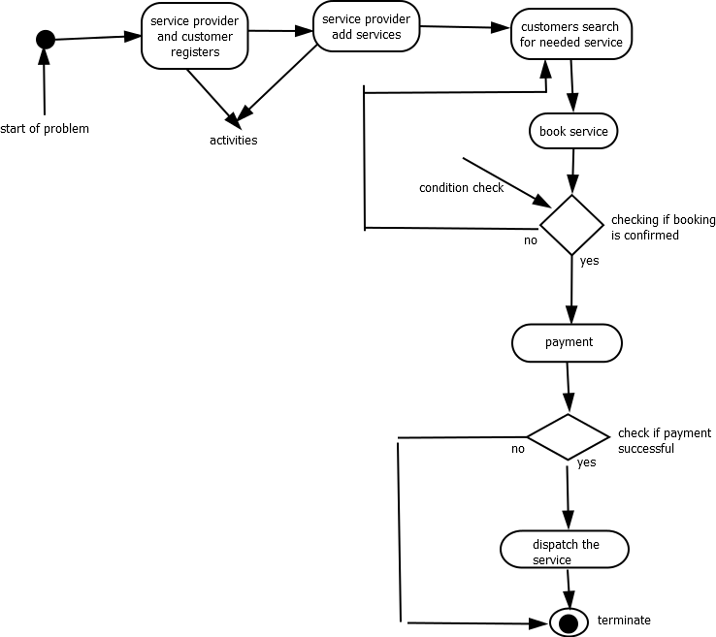

**CLASS DIAGRAM**

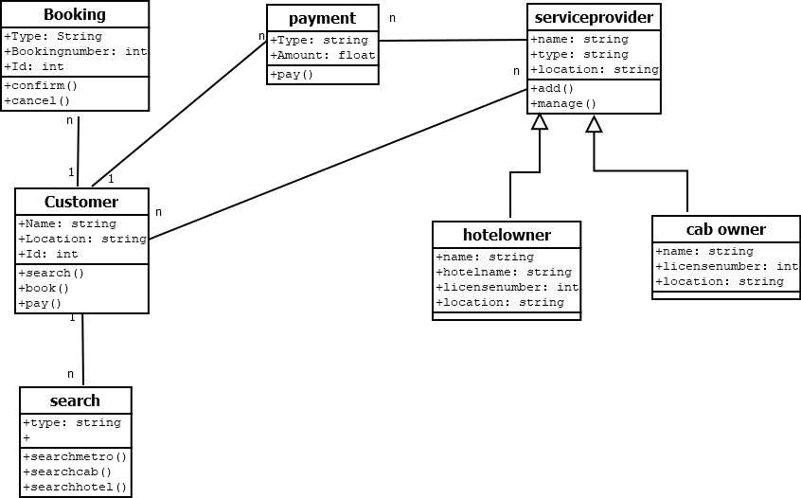

**COLLABORATION DIAGRAM**

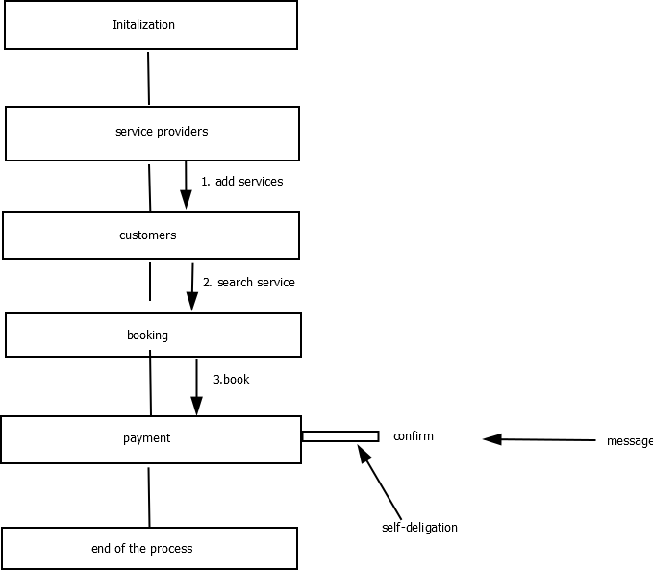

**OBJECT DIAGRAM**

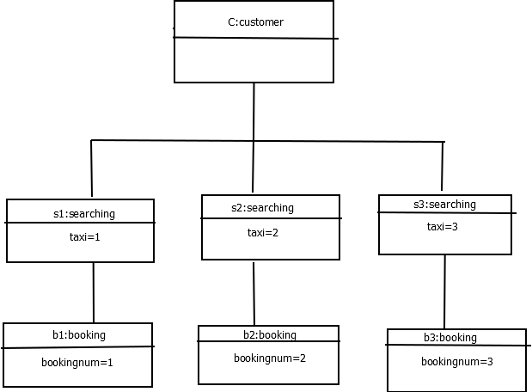

**SEQUENCE DIAGRAM**

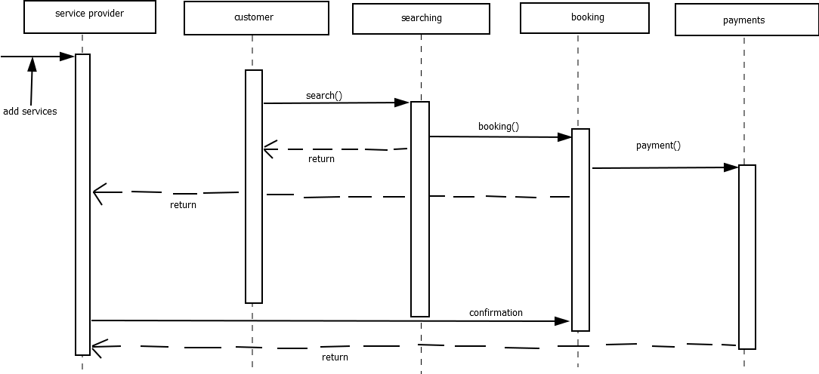

**STATE CHART DIAGRAM**

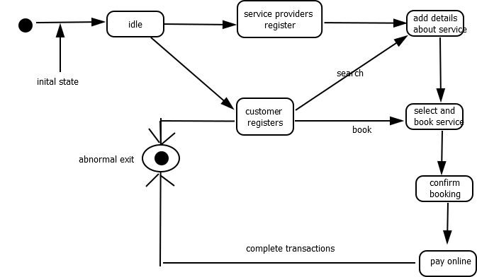

**USECASE DIAGRAM**

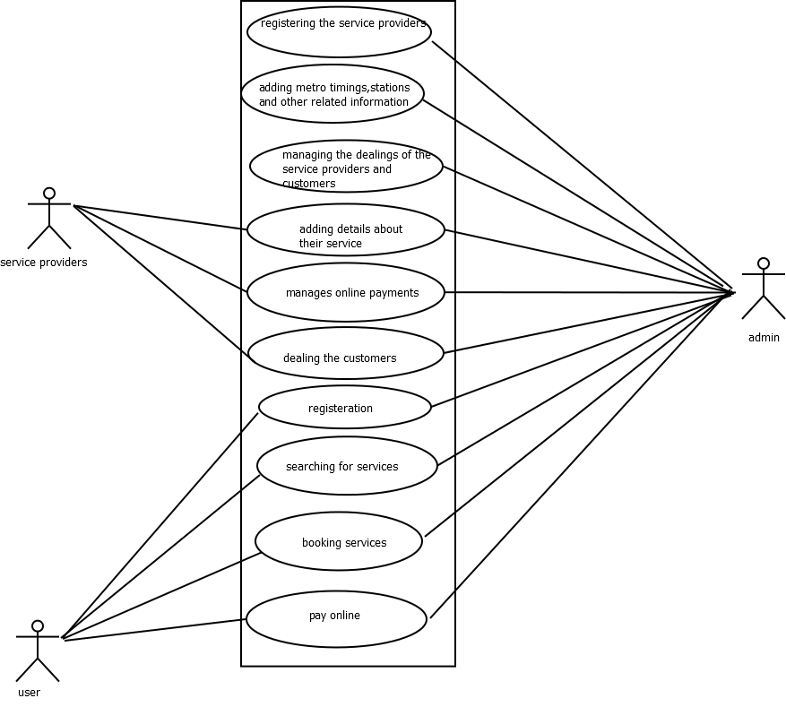

**COLLABORATION DIAGRAM**