

VISVESVARAYA TECHNOLOGICAL UNIVERSITY
Belgavi, Karnataka State, India
A project report on
“PHISHING WEBSITE AND SERVER”
Submitted in partial fulfillment
Master of Computer Applications
Submitted by
Ms. Anjali Myageri
USN: 2BA23MC003
Under the Guidance of
Prof. Karuna.B.K
Dept. of MCA

DEPARTMENT OF MASTER OF COMPUTER APPLICATIONS (MCA)
BASAVESHWAR ENGINEERING COLLEGE, BAGALKOTE.
2024-2025.

Visvesvaraya Technological University
Belgavi, Karnataka State, India.


Department of Master of Computer Applications (MCA)
Basaveshwar Engineering College
Bagalkote – 587 102
CERTIFICATE
This is to certify that Ms. Anjali Myageri, bearing USN 2BA23MC003, has satisfactorily completed the project work entitled ‘PHISHING WEBSITE AND SERVER’ submitted to the Basaveshwar Engineering College, Bagalkote, in partial fulfillment of the requirements for the award of Master of Computer Applications (MCA), during the academic year 2024-2025.
Prof. Guide Name Dr./Mr./Ms. Guide Name
Internal Guide External Guide
Prof. M. H. Shirur Prof. Sudha K. S. Dr. B. R. Hiremath
Project Coordinator Head of the Department Principal

Date of Submission:
Examiners:
DECLARATION
I am, Anjali Myageri,(2BA23MC003), a student of the 4th semester MCA at Basaveshwar Engineering College(Autonomous),Bagalkot,and here by declare that the mini-project entitled “PHISHING WEBSITE AND SERVER” has been carried out independently by me at the Master of Computer Applications Department,Basaveshwar Engineering College (Autonomous), Bagalkot. This mini-project is submitted in partial fulfilment of the requirements for the award of the degree MASTER OF COMPUTER APPLICATIONS by Basaveshwar Engineering College (Autonomous), Bagalkot, during the academic year 2024- 2025.

Yours Sincerely,
Anjali Myageri
USN:2BA23MC003

Acknowledgement
I would like to express my heartfelt gratitude to everyone who supported and guided me throughout the completion of this project, “Phishing Website and Server.”
First and foremost, I wish to express my heartfelt thanks to Principal,Dr.B.R.Hiremath], for providing an excellent academic environment and the necessary facilities to carry out this project work.
I am deeply grateful to our Head of the Department, Prof.Sudha.K.S, for the encouragement, valuable suggestions, and continuous support throughout the duration of this project.
I would also like to express my deep appreciation to my External Guide, Joseph Sakari for sharing their practical knowledge and providing insightful feedback, which helped me understand real-world aspects of phishing detection and cybersecurity
First and foremost, I sincerely thank my project guide, Prof.Karuna.B.K, for their continuous guidance, valuable suggetions, and encouragement, which helped me at every stage of this project.
My sincere thanks go to our Project Coordinator, Prof.M.H.Shirur, for their coordination, motivation, and timely help during the various stages of the project.
Lastly, I would like to thank all the faculty members of the Department of Master of Computer Application, for their continuous academic support and encouragement. I am also grateful to my family and friends for their constant motivation, patience, and moral support, which inspired me to give my best effort. Their encouragement played a vital role in the successful completion of this project.

Abstract
The Phishing Website and Server Project is designed to study and demonstrate how phishing attacks work in a controlled and ethical environment. It allows users to understand how fake websites are created to steal personal data and how such attacks can be detected and prevented. The system includes modules for website simulation, data collection, and secure server management. Administrators can generate phishing templates, monitor user responses, and analyze results using a simple dashboard. All activities are conducted within a protected environment to ensure data privacy and prevent misuse. This project aims to raise awareness about online security and teach users how to identify phishing attempts. It also provides a practical platform for cybersecurity learners and researchers to test defense mechanisms. Overall, the project contributes to building stronger security awareness and reducing the risk.

Table Of Content
Section No. | Title | Page No.
1 | Introduction to the Area | 1
2 | Literature Survey  2.1 Existing System  2.2 Problems in the Existing System  2.3 Available Solution and Their Features  2.4 Proposed Solution(Generic)  2.5 Advantages of Proposed Solution | 2-3  3-4  5  6  6-7
3 | Problem Definition  3.1 Problem Definition  3.2 Proposed Solution(Specific)  3.3 Development Process | 8  9-10  10-11
4 | Software Requirement Specification(SRS)  4.1 Purpose and Scope  4.2 Product Overview  4.3 Functional Requirement  4.4 Performance Requirement  4.5 Exception Handling  4.6 Acceptance Criteria  4.7 Design Hints and Guidelines  4.8 Glossary of Terms  4.9 Technology Requirement | 11-12  12-13  13-14  14-15  15-16  16-17  17  18  19
5 | System Design  5.1Use Case Model OR Architectural Design | 20-23
6 | Detailed Design  6.1 High-Level Design  -ER Model and DFD Diagram  6.2 Low-Level Design  -Relational Model,Flowchart,Pseudo-code | 24-26  27-36
7 | Implementation | 37-38
8 | Testing and Results | 39-44
9 | Conclusion | 45-46
10 | Future Enhancement | 47-48
11 | Reference Book,Sites,and Other Resources | 49
12 | Appendices | 50-53

1.Introduction to the Area
Phishing has evolved into one of the most insidious and prevalent cyber threats in today’sinternet-connected world. Unlike traditional hacking, which typically targets system-level vulnerabilities, phishing targets the human element—the most unpredictable and oftenweakest link in the cybersecurity chain. It exploits user psychology by manipulating trust,urgency, curiosity, or fear to coerce users into performing insecure actions, such as clicking malicious links or entering sensitive information into spoofed websites.
The Phishing Simulation Project is a purpose-built platform that enables ethical demonstration and exploration of these tactics in a safe, controlled setting.
Developed using Python and the Flask web framework, this project simulates real-world phishing scenarios by dynamically cloning target websites, collecting user input, and analyzin behavior via an integrated dashboard. Its use of Selenium ensures even JavaScript-rich websites can be cloned accurately This simulation serves not only as an educational tool but also as a research and testing environment for cyber professionals, researchers, and learners.
With the growing complexity of phishing attacks—ranging from generic emails to highly targeted spear phishing campaigns—awareness, preparedness, and interactive learning are more vital than ever. Through its features, the project makes abstract concepts tangible and fosters critical thinking around trust, identity, and information disclosure online.
Phishing has become one of the most common and dangerous online threats in the modern digital world. Unlike regular hacking, which focuses on breaking into computer systems, phishing targets people instead of machines. Attackers use tricks that play on human emotions such as trust, fear, or curiosity. They try to convince users to click fake links or share personal details like passwords and bank information on websites that look real but are actually fake. In this way, phishing takes advantage of human behavior, which is often the weakest part of cybersecurity.
This simulation acts as both a learning tool and a testing platform for students, researchers, and cybersecurity professionals. As phishing attacks continue to evolve—from simple fake emails to advanced, targeted campaigns—it is becoming increasingly important to build awareness and readiness. complex cybersecurity ideas into easy-to-grasp.

2.Literature Survey
2.1 Existing System:
The Literature Survey section provides an overview of existing systems, research, and methods related to the project topic. It helps in understanding what has already been developed, what problems still exist, and how the proposed project will offer a better or improved solution.In this part, you first describe the existing system, explaining how current tools or methods work and what their limitations are. Then you discuss the problems faced in these existing systems, such as security risks, lack of efficiency, poor user interface, or outdated technology.
Next, you highlight available solutions and summarize their main features, showing what has already been done in this field. After that, you introduce your proposed solution in a general way—explaining how your project will overcome the identified problems and improve performance, security, or usability.
Currently, many organizations rely on:
- Email filters: Attempt to remove phishing-laden messages before they reach inboxes.
- Commercial training: Provides generic modules or online quizzes.
- Manual site checks: Security teams manually clone sites using specialized pentesting
These solutions often lack a user-friendly interface or integrated log
Phishing, as a subset of social engineering, has a rich and concerning history cybersecurity domain. Over the past two decades, its forms and delivery methods have evolved significantly—transitioning from crude mass emails to highly targeted, socially engineered, multi-stage attacks. Despite the increasing sophistication of security tools and awareness campaigns, phishing continues to be 3 one of the most successful initial attack vectors in cyber intrusions.
Recent academic and industry literature sheds light on multiple facets of phishing:
1. Machine-Learning Based Detection Systems
Several studies highlight the promise 5 of machine learning (ML)
attempts through:
- URL classification (e.g., detecting obfuscated links or typosquatting domains),
- Page content analysis (e.g., visual similarity and DOM structure comparison),
- Behavioral tracking (e.g., script execution paths).
2. Effectiveness of User Awareness Programs
According to numerous peer-reviewed papers and whitepapers from organizations like
NIST, ENISA, and SANS Institute, user education remains the strongest line of defense
against phishing.
Key insights from published research:
- Simulated phishing campaigns conducted periodically reduce success rates by up 40–70% over time.
- Feedback mechanisms (e.g., awareness pop-ups after a simulation) are more effective than passive training modules.
Repetition and reinforcement (e.g., monthly simulations) outperform one-time training sessions in long-term memory retention. These findings reinforce the value of simulation tools like the one developed in this project,
2.2 Problems in the Existing system:
- LackofRealExperience:
Most phishing awareness tools only send sample phishing emails. They don’t allow users to explore how a real phishing website looks or behaves, so people don’t gain enough practical understanding.
- Many browser security systems depend on pre-collected lists of phishing sites. Since these lists are not updated instantly, new or short-lived phishing sites often escape detection.
• Test environment not isolated
Problem: Simulations run on networks or servers that are accessible outside the lab, risking accidental exposure.
Fix: Run simulations inside a private network or VMs/containers and block external access.
• Collecting real credentials or PII
Problem: The system sometimes stores actual usernames, passwords, or other personal data without clear consent.
Fix: Avoid collecting real credentials. If needed, get written consent and encrypt or hash sensitive values.
• No encryption for data in transit or at rest
Problem: Data moves or sits unencrypted, making it easy to intercept or steal.
Fix: Use HTTPS/TLS everywhere and encrypt sensitive database fields and backups.
• Weak user permissions
Problem: Testers or low-level users can see admin features or raw captured data.
Fix: Implement role-based access control so each user only sees what they need.
• Unsafe template rendering (XSS risk)
Problem: Admins can save and preview raw HTML/JS templates that could run malicious scripts.
Fix: Sanitize templates, preview them in sandboxed iframes, and restrict executable code.
• Input validation gaps (SQL injection risk)
Problem: Form inputs are not properly validated or parameterized, allowing injection attacks.
Fix: Use prepared statements/ORMs, validate input lengths/types, and test for injections.
• Weak or missing audit logs
Problem: There’s no reliable record of who did what, or logs can be altered.
Fix: Keep append-only audit logs and store critical events in an immutable or restricted location.
• Poor anonymization and privacy controls
Problem: Reports and exports include IPs or identifiers that can identify participants.
Fix: Mask or hash IPs and remove unnecessary identifiers before sharing or exporting reports.
• Confusing or clumsy admin UI
Problem: The dashboard is hard to use, making it difficult to find important metrics.
Fix: Redesign the UI with clear filters, KPIs, and simple export options.
• Limited behavioral analytics
Problem: The platform only stores raw logs and doesn’t measure user behavior (time to submit, focus, clicks).
Fix: Add event tracking (timing, focus events) and dashboard charts to show behaviour patterns.

2.3 Available solution and their features:
- Gophish
Gophish is an open-source framework that emphasizes:
- Email campaign management
- Tracking of email opens, link clicks, and credential submissions
- Real-time dashboards for monitoring campaign effectiveness
- Browser-Based ML Extensions
Browser extensions like Netcraft, Avira Browser Safety, or PhishTank Checker offer real
time phishing detection by:
- Using URL-based heuristics
- Scanning page metadata
- Comparing pages to known phishing signatures
Strengths:
- Simple to install
- Immediate real-time protection
- Integrated with browser interfaces
Limitations:
- Limited to detection, not simulation
- No educational or feedback components
- Easy to bypass
- using obfuscation or domain tricks

2.4 Proposed Solution(Generic):
The proposed system brings together both phishing simulation and phishing detection within a single platform. The main goal of this project is to help users understand how phishing attacks happen and how they can be identified and avoided in real life.
The system includes a simulation feature that can create a safe copy of real websites. This helps demonstrate how attackers make fake web pages that look genuine in order to steal user information. The forms and data entered on these cloned pages are stored securely in a protected database for learning and analysis purposes only.
Another part of the system focuses on detection. It checks different website features like the domain name, structure, and content to identify if a website could be suspicious or fake. This helps users learn what signs to look for when identifying phishing sites.
By combining both these features, the project provides a safe, interactive learning environment. Users can experience how phishing works without any risk and gain a deeper understanding of how to protect themselves from online scams.
Overall, this proposed system aims to increase awareness, improve knowledge, and build confidence in recognizing and preventing phishing attacks effectively.
2.5 Advantages of proposed solution:
1.Combines Learning and Practice: The system allows users to not only learn about phishing but also experience how it actually happens through safe simulations. This hands-on approach helps build stronger awareness.
2. Realistic Phishing Experience: By creating and displaying cloned websites, users can clearly see how phishing pages look and understand how attackers try to trick people.
3. Safe and Controlled Environment: The system is completely secure and designed only for educational and testing purposes. No real data or websites are harmed during simulations.
4. Improved User Awareness: The project helps users recognize phishing attempts by showing real examples and explaining the warning signs of fake websites or emails.
5. Integrated Detection and Simulation: Unlike traditional systems that focus only on detection, this system provides both simulation and analysis in one place.
6. Better Understanding of Human Behavior: The collected data helps analyze how users react to phishing attempts, which can be useful for training and awareness programs.
7. Useful for Students and Professionals: The platform can be used by learners, educators, and cybersecurity researchers to study phishing techniques and prevention methods in detail.
8.Practical Learning Experience:The system allows users to safely experience how phishing attacks work through realistic simulations, helping them understand and identify such threats more effectively.
9.Integrated Simulation and Detection: It combines both phishing simulation and detection features in one platform, making it easier to study, analyze, and prevent phishing activities in a secure environment.

3.Problem Definition
3.1 Problem Definition:
Despite massive investments in cybersecurity tools, many organizations still fall victim to phishing attacks. This paradox reveals a deeper issue—insufficient experiential training and weak user awareness.
Key challenges observed:
1. Credential Theft is Rampant
Attackers replicate login pages of internal portals or cloud services, and users often fail to
notice the difference. The 1 stolen credentials are then used for privilege escalation or
ransomware deployment.
2. Training is Often Ineffective
Many training modules rely on checklists, videos, or outdated email examples. They fail to
recreate the tension and realism of a live phishing event.
3. No Unified Simulation Framework
There’s a lack of open-source tools that combine:
- Dynamic website cloning
- Secure credential logging
- Educational feedback
- Admin oversight
The Phishing Simulation Project seeks to bridge this gap by offering a complete training
ecosystem that simulates phishing while preserving safety and ethics.

3.2 Proposed Solution(Specific):
The proposed system provides a practical and safe way to understand, simulate, and detect phishing attacks. It is designed to help users, students, and researchers study how phishing websites are created, how attackers deceive users, and how such threats can be identified and prevented.

1. Phishing Simulation Module
- This part of the system allows the creation of fake websites that closely resemble real ones.
- It copies the layout, design, and input forms of genuine web pages to show how phishing sites trick users.
- When a user enters any data on the cloned website, the information is safely stored in a protected database.
- The purpose is purely educational — no real data or harm is caused.

2. Server and Database Module
- The server handles all requests between the user and the simulated phishing site.
- It stores the entered details in a secure database, which can later be used for analysis and study.
- This data helps in understanding how users respond to phishing and what patterns attackers might use.

3. Detection Module
- The detection feature helps identify whether a website is legitimate or suspicious.
- It checks website features such as domain names, URLs, links, and content patterns.
- By analyzing these factors, the system helps users recognize common signs of phishing attempts.

4. User Awareness and Training
- The system provides a hands-on experience to users so they can learn how phishing websites operate.
- It helps users identify fake pages, suspicious links, and unsafe website behaviors.
- This improves awareness and builds confidence in handling real-world phishing threats.

5. Security and Privacy
- The entire system operates in a controlled environment, ensuring that no sensitive information is misused.
- All stored data is encrypted and used only for testing, research, and educational purposes.
3.3 Development Process:

1.Requirement Analysis
- In this stage, the main objectives of the project were identified — to simulate phishing attacks safely, collect data for study, and provide a learning environment.
- The hardware, software, and database requirements were defined.
- User needs, such as easy navigation, realistic simulation, and data security, were also considered.

2. System Design
- The design phase involved creating diagrams like flowcharts, DFDs, and system architecture.
- The layout of the phishing simulation website, database structure, and detection module were planned.
- User interfaces were designed to be simple, interactive, and educational.

3. Implementation
- The phishing website was developed using web technologies such as HTML, CSS, JavaScript, and PHP for backend logic.
- A secure database (e.g., MySQL) was created to store simulated credentials and system logs.
- Server-side scripting handled the communication between the website and the database.
- The detection feature was integrated to analyze URLs and webpage elements for phishing patterns.

4. Testing
- The system was tested to ensure that all modules worked correctly and securely.
- Unit testing, integration testing, and user testing were conducted.
- Simulated attacks were performed to confirm that the system accurately detected phishing activities without exposing real data.

5. Evaluation and Improvement
- Feedback was collected from users and evaluators to identify areas for enhancement.
- Improvements were made in interface design, data handling, and report generation.
- Additional security measures were added to ensure that the simulation environment remains safe and controlled.

6. Deployment and Documentation
- After successful testing, the system was deployed for educational and research purposes.
- Complete documentation, including the user manual and system guide, was prepared to help users operate and understand the system easily.

4.Software requirements specification

4.1 Purpose:
The main purpose of this project is to create a safe and controlled environment to study phishing attacks and understand how they operate. The system helps users learn how phishing websites are designed, how they collect sensitive data, and how such attacks can be identified and prevented.
It aims to increase user awareness, improve cybersecurity skills, and support researchers and students in analyzing phishing behavior without any real-world risks.
Scope:
The scope of this project covers the simulation, detection, and analysis of phishing attacks.
It allows users to:
- Create and test fake phishing websites safely.
- Understand the structure and functioning of phishing servers.
- Analyze how users interact with suspicious sites.
- Learn methods to detect and prevent phishing through awareness and training.
This project is designed for educational, research, and training purposes. It does not perform real phishing attacks but simulates them to enhance understanding of cybersecurity practices.
To address the identified problems and fulfill the project’s purpose, the following objectives were set:
- Clone Authentic Websites: Achieve visual and structural fidelity using Selenium, ensuring that cloned pages look and behave like the real ones.
- Seamless Credential Capture: Design back-end routes that receive and log credentials without disrupting the user’s flow,while collecting valuable metadata for analysis.
3. Educate and Alert the Use: Integrate a redirection system that takes the user to an awareness page immediately after form submission, reinforcing learning in the moment.
4. Secure Admin Portal: Protect all logs and controls behind a login system. Include session management, logout
4.2 Product Overview:
This project is an educational and research tool that simulates phishing attacks in a safe, controlled environment. It replicates the way phishing websites look and operate, along with the server-side processes that attackers use. The system is designed for learning, testing detection methods, and understanding how phishing attacks work, without targeting real users or stealing real data.
Purpose
- To help students, cybersecurity professionals, and developers understand how phishing attacks function.
- To provide a safe platform for practicing detection, prevention, and response to phishing attempts.
- To support hands-on exercises in cybersecurity courses, awareness training, and research.
Key Features:
- Simulated phishing pages: Realistic, editable templates of common login pages for educational use.
- Server-side simulation: Handles form submissions, logs activity, and shows how attackers process information.
- Activity tracking: Logs user interactions and provides clear reports for analysis.
- Role-based access: Different views for instructors and learners to control scenarios and track results.
- Safe and isolated: Designed to work in a sandboxed environment to prevent misuse.
- Customizable scenarios: Easy to add new templates or attack simulations for practice.
Componets:
- Front-end pages: Demonstrates how phishing websites appear to users.
- Back-end server: Manages submitted data and records simulated attack events.
- Database/log storage: Stores test data securely for analysis.
- Admin dashboard: Allows instructors to manage simulations and review results.
- Documentation and exercises: Step-by-step guides for safe learning and training.
4.3 Fuctional Requirements :
1. Website Cloning
The system must offer a form-based interface in the admin dashboard where the administrator can enter any target URL. Upon submission, the application should use tools like Selenium or BeautifulSoup to fetch and store the HTML, CSS, and JS of the target page. This enables near-perfect replication of the original site’s interface.
2. Form Re-mapping
After cloning the target website, the system must intelligently analyze the form action and input fields. It should replace the original action URL with a local route (/cloned_login) which is designed to capture user input securely. The form should also maintain the same visual layout to preserve realism.
3. Credential Logging
All submitted data from the cloned site should be collected and stored securely. The data to be logged includes:
- Username/email
- Password
- IP address
- Browser user-agent string
- Date and time of submission
This log should be written to a .json file or an SQLite database, depending on configuration.
4. Admin Access and Authentication
A protected admin portal must be available with secure login. Only authenticated users with valid credentials (stored securely in hashed form) should be allowed to access logs, initiate cloning, or manage simulations. Session-based authentication should be implemented.
4. Admin Access and Authentication
A protected admin portal must be available with secure login. Only authenticated users with valid credentials (stored securely in hashed form) should be allowed to access logs,initiate cloning, or manage simulations. Session-based authentication should be implemented 4 to prevent unauthorized access.
4.4 Performance Requirement:
1.Performance
The system must be optimized to handle multiple concurrent requests, especially during organization-wide simulations. Techniques such as asynchronous processing (e.g., using ThreadPoolExecutor) should be considered to avoid delays during site cloning or log analysis.
2. Security
All logs and sensitive admin routes must be protected via authentication and proper session management.
- Input sanitization and CSRF protection mechanisms should be enforced.
- 11 Sensitive data should never be exposed in URLs or client-side scripts.
- Passwords (admin credentials) must be hashed using secure algorithms (e.g., bcrypt).
3. Usability
The admin interface should be simple, responsive, and self-explanaEven non-technical users (such as HR or training personnel)
- Clone a website
- View logs
- Trigger simulations
- Download reports
4.5 Exception handling
Exception handling in this project is used to manage unexpected errors or issues that may occur while the phishing website or server is running. It helps the system continue working smoothly without crashing or losing important data. When a user enters invalid information or leaves a required field empty, the system displays a clear message to guide them instead of stopping suddenly. If the server becomes unreachable or the database connection fails, the system records the issue in a log file and shows a simple notification like “Server temporarily unavailable. Please try again later.” This approach ensures that users understand what went wrong without facing technical confusion. In addition, all input data is validated to prevent any misuse or unwanted operations during simulations. Overall, exception handling improves the system’s reliability, user experience, and safety by managing problems in a controlled way.
- If a user enters invalid data or leaves a required field blank, the system should show a clear error message instead of failing.
- When the server is down or unreachable, a friendly message should appear, such as “Server temporarily unavailable. Please try again later.”
- If the database connection fails, the system should log the issue and safely stop the affected process.
- All system errors should be recorded in a log file for later review by the administrator.
- Input validation should be applied to prevent misuse or unwanted data submission during simulations.
4.6 Acceptance Criteria
The acceptance criteria define the conditions that must be met for the Phishing Website and Server project to be considered complete and ready for use. The system should successfully simulate phishing pages that allow users to experience how phishing works in a safe environment. The server must correctly record all submitted data and generate accurate logs for instructors to review. The overall performance should be smooth, with no crashes or major delays during operation. The system’s design must also follow ethical and security standards, ensuring that no real or sensitive user data is used. The interface should be simple, clear, and easy to navigate for both students and administrators. Once all these criteria are fulfilled and verified through testing, the project can be accepted as a fully functional and reliable educational tool.
4.7 Design hints and guidelines
The design of the Phishing Website and Server Project should focus on simplicity, security, and usability. The system must be easy to understand for both instructors and students, allowing them to simulate and study phishing behavior safely. The design should look realistic enough to show how phishing websites operate, but it must be clearly used only for educational and research purposes, never for real-world data collection.
The interface should be clean, organized, and user-friendly. Each page should have clear labels, instructions, and input validation to help users avoid mistakes while entering data. Navigation should be simple, with menus and buttons that are easy to identify. The layout must be responsive so that it works smoothly on different devices such as desktops, laptops, and mobile phones. Color choices should be professional and easy on the eyes, avoiding too many bright or confusing designs.
On the technical side, the system should follow a modular design — dividing the project into parts like the user interface, server logic, database, and detection system. This makes the system easier to develop, test, and update. The server must be designed to handle multiple requests efficiently, store data securely, and generate accurate logs for analysis. Proper input validation and error handling should be implemented to prevent crashes or misuse during simulations.
Security should always be a top priority. The project must run in a closed, controlled environment to ensure that no real data or external connections are used. All simulations should use test credentials or dummy information. Ethical rules should be followed strictly so that the system cannot be used for harmful purposes.

4.8 Technology requirements
- Hardware
Processor: Intel i5 or AMD equivalent (Quad-core or higher)
RAM: 8 GB recommended
Storage: ~200 GB for OS, logs, and potential multiple clones
Network: Stable broadband for fetching external site data
- Software
Operating System: Windows 10/11, Ubuntu Linux, or macOS
Python 3.9+
Flask 2.0+
Selenium 4+
ChromeDriver/Firefox Geckodriver (depending on chosen browser)
Additional Python libraries: requests, beautifulsoup4

4.9 Overview of Technologies
1. Python: A high-level language with extensive data processing and web libraries.
2. Flask: A microframework that uses routes for dynamic pages, making it straightforward to create web endpoints.
3. Selenium: Automates browsers and loads JavaScript-laden pages, ensuring clones capture dynamic elements.
4. Requests & BeautifulSoup: Provide easy HTTP requests and HTML parsing, though Selenium typically does both.
5.JSON/SQLite: Simple, lightweight data storage mediums for captured credentials

5.System design
5.1 Use case model
Use Case Model describes how different users interact with the Phishing Website and Server System. It helps to identify the roles of each user, their actions, and how the system responds. This model ensures that the project’s functions are well-understood and organized before implementation.
The Phishing Simulation Project is structured into modules:
1. Clone: Accepts the target URL and uses Selenium (or requests/BeautifulSoup) toretrieve the page source.
2. Rewrite: Adjusts all relative links, ensures the form submission route is replaced with local endpoint.
3. Serve: Saves the cloned HTML in cloned_login.html, referencing local copies of CSS/JS if needed.
4. Capture: A route (/cloned_login) logs the credentials if the user is tricked into submitting them.
5. Admin: Ensures only authorized persons can see or manage logs.
6. Awareness: Optional route to educate users post-submission.
Use Case Model:
- Admin:
The administrator manages the system. Their duties include creating cloned sites for simulation, tracking user activity, and running phishing detection analysis.
- Target User:
The target user (or participant) interacts with the simulated phishing website as part of the awareness or testing process.

Admin Use Cases:
- login
  - The admin logs into the system using valid credentials to access the control panel.
  - Once logged in, they can manage different modules of the system such as website cloning and analytics.
- Create Website Clone
  - The admin selects a legitimate website and initiates a cloning process.
  - The system uses either Selenium (for dynamic content) or BeautifulSoup (for static content) to generate a sanitized copy.
  - The cloned version is used strictly for educational or testing purposes.
- Monitor Activities
  - The admin reviews captured activity data such as user clicks or form submissions from the cloned website.
  - These activities are analyzed to study phishing behaviors or to evaluate the detection algorithm’s performance.
- Run Detection Analysis
  - The admin starts phishing detection algorithms to compare collected data and identify suspicious or risky user actions.
  - Results are shown in the form of charts and summarized analytics.
Target User Use Cases:
- Access Simulated Website
  - The user visits the cloned phishing website created by the admin.
  - The website looks similar to a real one but is hosted safely for testing or educational demonstration.
- Submit Test Credentials
  - The user enters sample data (e.g., username and password) into a form.
  - The system safely records this input for analysis but does not store or misuse any real credentials.
- View Awareness Feedback
  - After submitting information, the user sees a feedback message explaining that it was a phishing simulation.
  - The system provides guidelines to help the user recognize and avoid phishing attempts in the future.
Top of Form
Bottom of Form
Main Use Cases:
- Create Simulation: The admin designs and launches phishing web pages for educational or testing purposes.
- Manage Credentials: The admin creates and stores dummy credentials that users can use safely during testing.
- Monitor Users: The admin tracks user activities during simulations to see how they interact with phishing websites.
- View Logs and Reports: The admin checks all submitted information, reviews detection results, and generates performance reports.
- Ensure Security: The admin makes sure that no real user data is used and that all activities remain within the lab or testing environment.

Architecture Design:

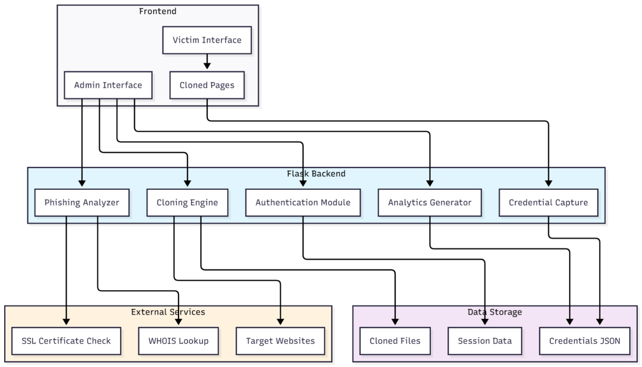

6.Detailed Design
6.1 High-Leve Design
6.1.1 ER Model
SI.NO | Symbol | Meaning
1 |  | Entity
2 |  | Attributes
3 |  | Relationship
4 |  | Weak Entity Relationship
5 |  | Multivalued Attribute
6 |  | Key Attribute
7 |  | Weak Entity
8 |  | Link attributes to entity sets
9 |  | Composite attribute

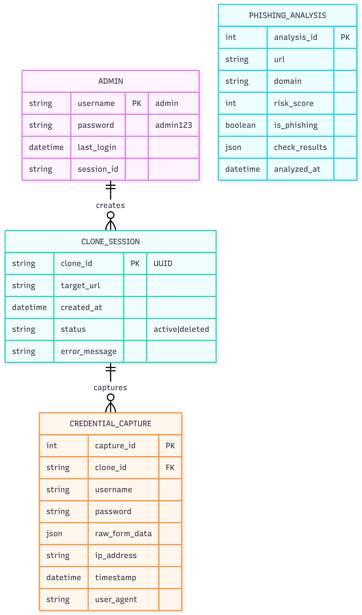
DFD-Diagram:
Level 0 DFD

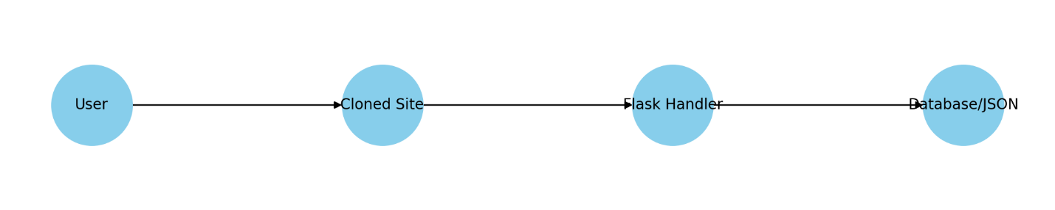
Level 1 DFD
- Admin:
  - Logs in -> [App verifies credentials] -> Gains access to logs -> Sees captured attempts
- Cloning:
  - Admin inputs site URL -> [Selenium fetches HTML] -> [Rewrite links/forms] -> [Saves to cloned_login.html]

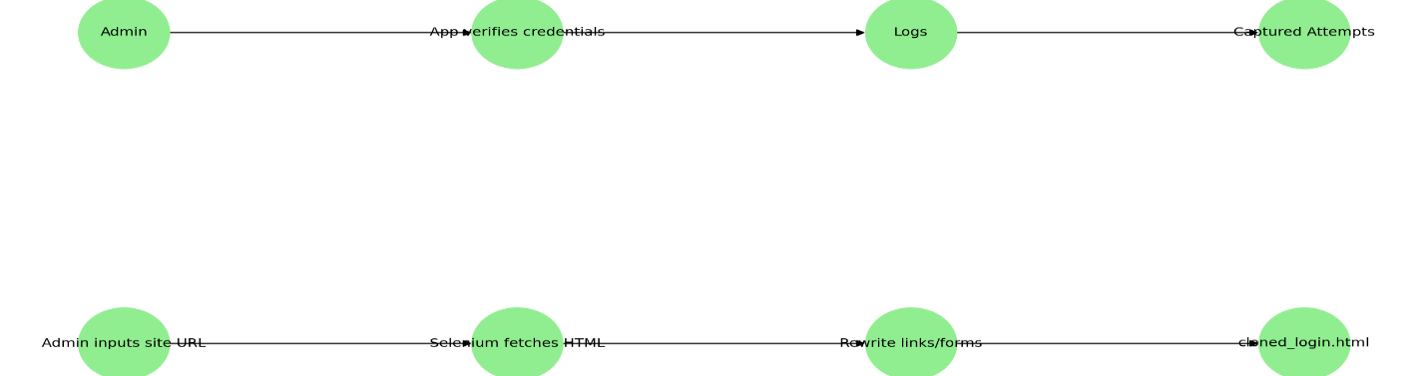

Relational Model:

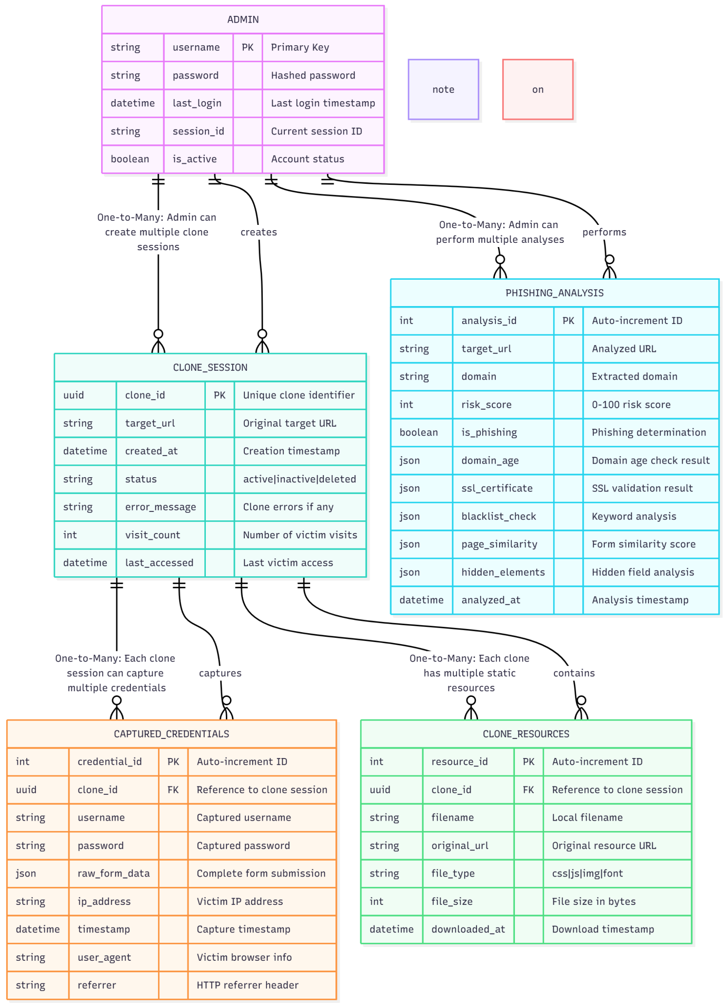
Flow chart:
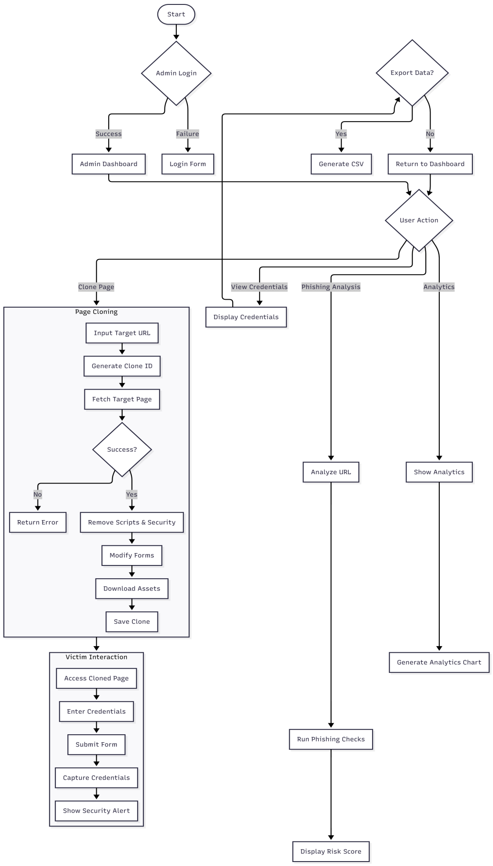
Pseudo code:
CREATE TABLE credentials (
credential_id TEXT PRIMARY KEY DEFAULT (lower(hex(randomblob(16)))),
clone_id TEXT, -- Should be FK
source_url TEXT,
username TEXT,
password TEXT,
raw_data JSON,
ip_address TEXT,
user_agent TEXT,
timestamp TIMESTAMP NOT NULL DEFAULT CURRENT_TIMESTAMP,
);
Proposed Update (Adding FK):
CREATE TABLE credentials (
credential_id TEXT PRIMARY KEY DEFAULT (lower(hex(randomblob(16)))),
clone_id TEXT,
source_url TEXT,
username TEXT,
password TEXT,
raw_data JSON,
ip_address TEXT,
user_agent TEXT,
timestamp TIMESTAMP NOT NULL DEFAULT CURRENT_TIMESTAMP,
FOREIGN KEY (clone_id) REFERENCES clones(clone_id) ON DELETE SET NULL
);
2.ops_log Table
The ops_log table has clone_id, which links it to the clones table.
SQL Original Table:
CREATE TABLE ops_log (
id TEXT PRIMARY KEY,
op_type TEXT,
url TEXT,
clone_id TEXT, -- Should be FK
note TEXT,
created_at TIMESTAMP NOT NULL DEFAULT CURRENT_TIMESTAMP
);
Proposed Update :
CREATE TABLE ops_log (
id TEXT PRIMARY KEY,
op_type TEXT,
url TEXT,
clone_id TEXT,
note TEXT,
created_at TIMESTAMP NOT NULL DEFAULT CURRENT_TIMESTAMP,
FOREIGN KEY (clone_id) REFERENCES clones(clone_id) ON DELETE SET NULL
);
3.resources Table
The resources table already correctly defines the Foreign Key to clones:
SQL
Current Schema (Correctly defines FK):
CREATE TABLE resources (
resource_id TEXT PRIMARY KEY,
clone_id TEXT REFERENCES clones(clone_id) ON DELETE CASCADE,
filename TEXT,
original_url TEXT,
size_bytes INTEGER
); SQL
Users
CREATE TABLE users (
user_id TEXT PRIMARY KEY DEFAULT (lower(hex(randomblob(16)))),
username TEXT NOT NULL UNIQUE,
password_hash TEXT NOT NULL,
created_at TIMESTAMP NOT NULL DEFAULT CURRENT_TIMESTAMP
);
Clones
CREATE TABLE clones (
clone_id TEXT PRIMARY KEY,
target_url TEXT,
preserve_js BOOLEAN DEFAULT 0,
created_at TIMESTAMP NOT NULL DEFAULT CURRENT_TIMESTAMP
);
Credentials
CREATE TABLE credentials (
credential_id TEXT PRIMARY KEY DEFAULT (lower(hex(randomblob(16))))),
clone_id TEXT,
source_url TEXT,
username TEXT,
password TEXT,
raw_data JSON,
ip_address TEXT,
user_agent TEXT,
timestamp TIMESTAMP NOT NULL DEFAULT CURRENT_TIMESTAMP,
-- FK to Clones
FOREIGN KEY (clone_id) REFERENCES clones(clone_id) ON DELETE SET NULL
);
Ops Log
CREATE TABLE ops_log (
id TEXT PRIMARY KEY,
op_type TEXT,
url TEXT,
clone_id TEXT,
note TEXT,
created_at TIMESTAMP NOT NULL DEFAULT CURRENT_TIMESTAMP,
-- FK to Clones FOREIGN KEY (clone_id) REFERENCES clones(clone_id) ON DELETE SET NULL

Coding Details:
Below is a high-level code outline (omitting some advanced error handling for brevity):
- app.py:
  - Imports: Flask, render_template, request, session, redirect, url_for, json, plus Selenium libraries.
  - Routes:
    - /admin/login: Handles admin authentication.
    - /admin: Displays logs, site cloning form.
    - /clone: Processes the cloning of an external site.
    - /cloned_login: The endpoint for submitted credentials from the cloned site.
    - /: Main phishing page, or a default route for another scenario.
  - Data Storage:
    - credentials.json updated with each new submission.
    - admin session key used to track admin login status.

HTML Templates:
  - admin.html: Contains a form for entering the target URL to clone, plus a table showing captured credentials.
  - cloned_login.html: Overwritten each time a new site is cloned, storing the page’s HTML.
  - admin_login.html: Basic form for admin user authentication.
  - awareness.html: Optional page that educates the user on phishing best practices.
- Code Example
- function analyze_phishing(url):
domain_age = check_domain_age(url)
ssl_validity = check_ssl(url)
keyword_score = check_keywords(url)
similarity_score = check_page_structure(url)
hidden_elements = check_hidden_inputs(url)
risk = weighted_sum(domain_age, ssl_validity, keyword_score,
similarity_score, hidden_elements)
if risk > 70:
return "Phishing Suspected"
else:
return "Likely Safe"

Some use case models:

SI.NO | Symbol | Meaning
1. |  | System
2. |  | Use case
3. |  | Actors

7.Implementation
1. Full Dynamic Rendering (Selenium)
- Pros: Captures JavaScript-laden pages, ensures near-perfect clones.
- Cons: Slower, can be CPU-intensive.
2. Static Scraping (Requests + BeautifulSoup)
- Pros: Lightweight, faster.
- Cons: Might miss dynamic or heavily JS-dependent content.
In practice, many sites rely on advanced JavaScript, so Selenium is chosen for
authenticity. The final user can pick which approach best suits their environment.
The implementation phase focuses on converting the planned design of the Phishing Website and Server Project into a fully functional system. It involves developing both the front-end and back-end components, connecting them, and ensuring that the system performs as expected in a safe and controlled environment.
The front-end part of the system includes the phishing web pages that mimic real websites. These pages are created using simple web technologies such as HTML, CSS, and JavaScript. The purpose of these pages is to show how phishing websites appear to users and how easily they can trick someone into sharing personal details. Each page includes form fields where users can enter dummy data for testing purposes only.
The implementation of the project focuses on simulating phishing attacks in a safe environment to study user behavior and train awareness. The system is designed so that no real credentials are collected, and all activities are performed ethically. The implementation covers system architecture, modules, database, backend, frontend, and workflow.

Following are the terms which are used for designing the database of the application
• Database – It is the group of associated data in the form of the tables.
• Tables– Tables which are called as the relations that are used to store the proper data in the forms of rows and the columns.
• Column – Columns are called as data element which are used to identify the field names in the tables.
• Row – This consists of relatable data for the application. The data which is stored in the table is called as tuple. Row is called as a collection of a data which points to different columns of the same table.
• Primary key – The table must consists of only one primary key which is always be unique in the table. Tables which consists of records must be always unique.

8.Testing and Results
1. Unit Testing
- Isolate the cloning script to ensure it handles typical websites effectively.
- Confirm the form rewriting logic properly points to our local /cloned_login route.
2. Integration Testing
- Input a known URL like https://example.com.
- Inspect the resulting cloned_login.html for form correctness.
- Submit dummy credentials to confirm logs appear in credentials.json.
3. System Testing
- Evaluate performance under multiple simultaneous requests.
- Confirm the system remains responsive for both the admin page and the cloned site.
4. User Acceptance Testing
- Let employees or students unknowingly attempt to log in via the cloned page.
- See if the logs are consistent with their input, and observe if the awareness page is
triggered.

Test cases:
Test Case | Description |  | Input |  | Expected Result |  | Status
TC1 | Clone a basic site |  | http://example.com |  | Creates cloned_login.html with example.com’s layout |  | Pass
TC2 | Capture credentials |  | Email: user@domain, Pass: test123 |  | Logs user@domain + IP + user agent in credentials.json |  | Pass
TC3 | Admin Login w/ correct credentials |  | Username: admin, Password: securepass |  | Redirects to /admin dashboard, sets session |  | Pass

Result:
Upon successful deployment:
  - Cloning: The system reliably duplicates a variety of websites, capturing visual design and forms. Some advanced or single-page apps may partially fail if they use complex,repeated asynchronous calls or embedded tokens for session checks.
  - Credential Harvesting: In controlled tests, unsuspecting users generally submit their credentials, especially if the site is well-cloned.
  - Awareness Improvement: Many participants express surprise at how real the cloned site appears, reinforcing the lesson that checking domain names, SSL certificates, and other security cues is critical.

1.Admin Login Page: A screenshot featuring a username/password box titled “Admin Login,” typically displayed in a minimalistic design.
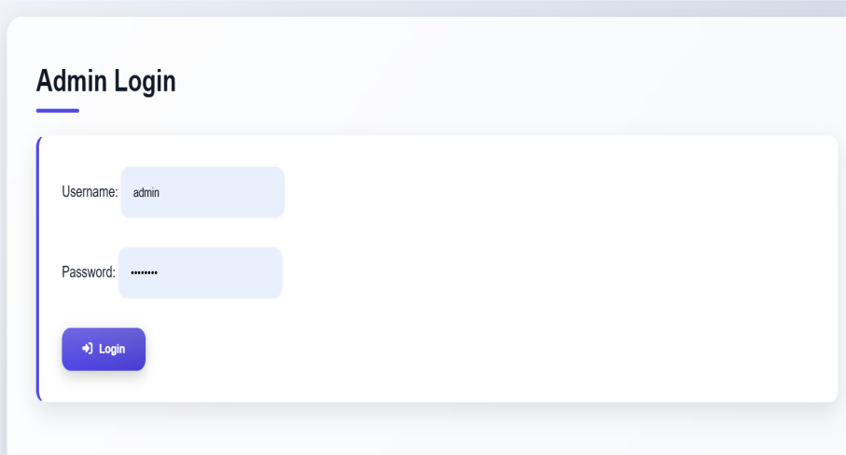

2.Admin Dashboard:
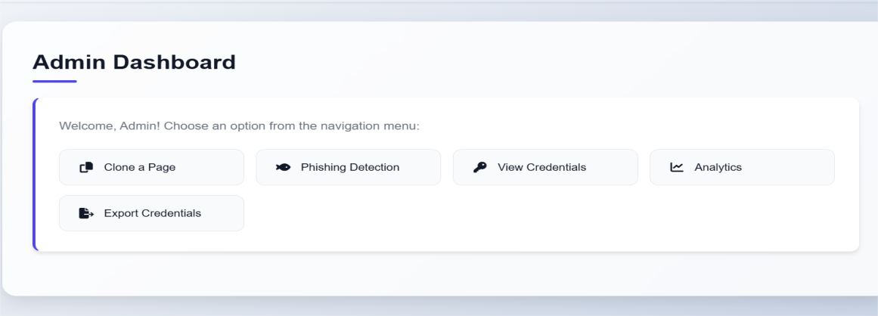

3.Cloned Page: Show how the tool fetches an official brand website’s login form. Observers can see the brand’s logo, color scheme, and legitimate-looking fields.
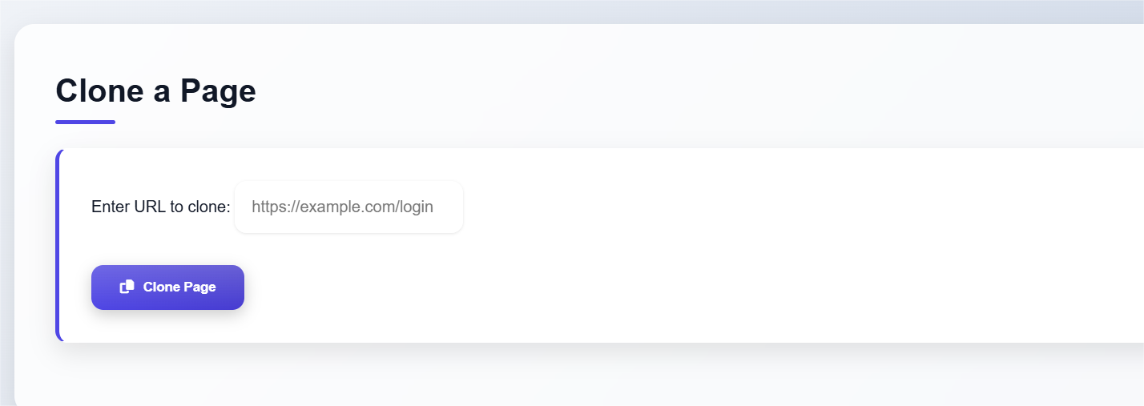

4.Awareness Page: A quick educational page with bullet points on verifying site identity, suspicious link checking, and reminders not to reuse passwords.
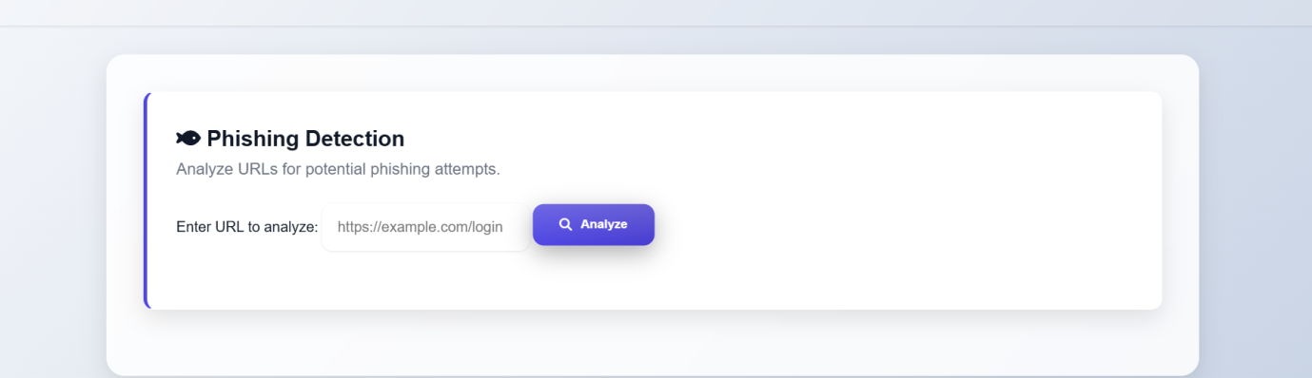

9.Conclusion:
The Phishing Simulation Project effectively bridges a critical gap in the cybersecurity training landscape by offering a real-world simulation environment for phishing attacks.Unlike purely theoretical awareness programs, this project enables users—ranging from students to corporate professionals—to engage with phishing tactics in a hands-on, experiential manner. Through this active engagement, participants not only recognize thedangers of deceptive web content but also internalize lessons in digital vigilance that are often missed in passive learning formats.
The project achieves this through a seamless integration of technologies—Python, Flask,and Selenium—which collectively allow for high-fidelity website cloning, real-time credential capture, and a secure administrative dashboard for analysis. This enables security teams and educators to deploy simulations without needing a deep background in web development or ethical hacking.
Further, the tool can act as a baseline evaluation system for organizations aiming to sess 3 the current state of phishing awareness within their workforce. By logging credential submissions, timestamps, and IP addresses, the system yields actionable insights into employee readiness, behavioral patterns, and potential training gaps. These insights can then inform future cybersecurity strategies, awareness campaigns, and policy frameworks.
In conclusion, the Phishing Simulation Project is more than just a technical implementation—it is a strategic asset for proactive cybersecurity defense. By raisingawareness, providing measurable outcomes, and encouraging ethical practices, it supports the creation of a security-first culture within digital ecosystem

Limitations :
Despite its capabilities, the Phishing Simulation Project is not without its constraints.These limitations, though manageable, must be understood to ensure realistic expectations and appropriate use:
1. Dynamic Website Complexity:
Many modern websites today are built using single-page applications (SPAs) with asynchronous JavaScript loading and token-based session validation. Such features can interfere with the cloning process, 5 making it difficult to replicate the entire behavior and appearance of the original site without manual intervention.
2. Anti-Automation & Bot Detection:
Sites may employ CAPTCHA systems, JavaScript obfuscation, or behavioral tracking mechanisms to detect bots. Selenium, being an automation tool, can be flagged or blocked
during cloning, especially on financial or login-sensitive websites. This introduces variability in results across different targets.
3. Lack of Email Campaign Management:
The current version focuses purely on the site cloning and credential capturing workflow. It does not offer built-in support for generating, managing, or monitoring phishing email
campaigns—key components for conducting full-scale simulations across large user bases.
4. Legal and Ethical Boundaries:
Unauthorized usage of phishing tools is illegal under cybersecurity laws across the world. The tool must only be used in controlled environments, such as training labs or with explicit consent from participants. Failure to comply with ethical standards can result in serious legal repercussions.
5. Absence of 2FA/OTP Handling:
Multi-Factor Authentication (MFA) is a standard in modern web applications. This tool currently does not simulate or handle OTP-based logins, hardware tokens, or biometric authentication. As such, simulations involving these technologies may remain incomplete.
6.User Awareness Dependency:
The effectiveness of the simulation is still dependent on how observant or curious the users are. If users do not attempt logins or explore the site, the simulation yields little data. This makes engagement strategies (e.g., realistic scenario crafting or timing) critical for success.

10.Future Enhancement
To further evolve the tool and meet advanced enterprise requirements, the following
enhancements are proposed:
1. Integrated Email Phishing Campaign Module:
Embedding an email distribution system (like integration with SMTP servers or SendGrid APIs) would enable administrators to generate and dispatch phishing emails with embedded tracking links. This would allow the simulation to assess not just login submission but also click-through rates, email open rates, and response time, enhancing the depth of behavior analysis.
2. Adaptive Cloning Engine:
An intelligent engine capable of handling complex sites using headless browsers and script analysis could improve the fidelity of clones. Integration with DOM mutation observers and honeypot bypass techniques can allow the system to mimic sites more precisely without triggering anti-bot defenses.
3. Visual Reporting and Analytics Dashboard:
Adding interactive charts, timeline graphs, and heatmaps to the admin dashboard would offer an immediate visual overview of attack success rates, peak user activity, and regional/IP trends. This would make the platform ideal for conducting organizational risk assessments or compliance audits.
4. AI and Machine Learning Integration:
Introducing ML models can aid in automatic classification of user behavior—e.g., identifying risky users, simulating A/B phishing tactics, and fine-tuning the effectiveness of cloned interfaces. Moreover, AI can help adapt 13 phishing templates based on user roles or past behavior to increase realism.
5. Cloud-Based Deployment and Multi-Tenant Support:
Migrating the platform to a cloud infrastructure with multi-tenant capabilities would enable training across large organizations, educational institutions, or third-party vendors. With secure user management and access controls, remote simulations could be conducted at scale.
6. Gamified Training Layer:
Adding a gamification element post-simulation—such as scoring users based on their 3 ability to detect phishing cues—could increase engagement and foster a competitive educational culture within organizations.

7. Legal and Consent Framework Module:
Embed a built-in consent capture and disclaimer system within the phishing workflow.
Before users proceed, the system could offer a legal declaration form (configurable by the admin), ensuring ethical compliance in each simulation round.

11.Reference
- Verizon Data Breach Investigations Report (2022).
- APWG (Anti-Phishing Working Group) Global Phishing Survey.
- Flask Documentation: https://flask.palletsprojects.com
- Selenium HQ: https://www.selenium.dev
- Social Engineering Toolkit: https://github.com/trustedsec/social-engineer-toolkit
- Gophish: https://github.com/gophish/gophish

12.Appendix

Purpose:
This project is developed to study phishing behavior and create cybersecurity awareness in a safe, education.
It demonstrates how phishing websites operate, helps analyze user interaction, and supports ethical training in identifying and preventing phishing attacks.

1.user
- Both admins and test users can register to access the system.
- Each user must enter a valid username, password, and email ID during registration.
- After registration, users can log in using their credentials to enter the dashboard.
- Only authorized users can create, launch, or analyze phishing campaigns.
2.Dashboard overview:
- The dashboard is the main control center of the system.
- It displays:
  - List of phishing campaigns created by the admin.
  - Logs of user interactions and submission events.
  - Summary reports with charts and analysis results.
- Admins can also view the system’s overall performance and detection analytics here.

3.Creating phishing Page:
- Go to the Phishing Templates section in the admin dashboard.
- Choose from available templates (like email, social media, or banking logins) or create a new one.
- The system will clone the layout of a legitimate website using Selenium (for dynamic sites) or BeautifulSoup (for static pages).
- The cloned version is sanitized — meaning it removes any real form actions or trackers to make it completely safe.
- Once ready, the admin saves and deploys the page on the local or test server for training use.

4.launching a phishing campaign
- Admins configure the campaign by adding:
  - A name and description.
  - The cloned page to use.
  - The list of test users (dummy or consenting participants).
- The system then sends simulated phishing emails or test links to those users.
- Each email includes a unique tracking token to monitor link clicks and interactions safely.
- The admin can track:
  - How many users opened the link.
  - How many attempted to log in on the fake page (using dummy credentials).

5.Data capture Analysis
- When a test user interacts with the simulated page:
  - The system records non-sensitive data such as the time of interaction and browser type.
  - No real passwords or personal data are stored — only dummy credentials or hashed values for research analysis.
- Admins can view statistics such as:
  - Click Rate: Number of users who clicked the fake link.
  - Submission Rate: Number of users who entered data on the simulated page.
  - Overall Awareness Score: Indicates how well users recognized the phishing attempt.
- These analytics help measure awareness and training effectiveness.

- The system’s primary goal is to educate users about phishing attacks.
- It can be used to:
  - Simulate real-world phishing techniques in a safe environment.
  - Demonstrate how users can detect fake pages and emails.
  - Generate awareness reports that highlight risky behaviors.
- After simulations, users can receive feedback and tips to strengthen their online security awareness.
7.Admin Features:
Admins have full control over the system and can:
- Manage Templates: Create, edit, or delete phishing templates.
- Monitor Logs: View all captured events from the campaigns.
- Manage Users: Add or remove test users, reset passwords, or adjust permissions.
- Run Analysis: Generate graphical reports using Matplotlib to visualize user performance.
- System Configuration: Adjust settings like email setup, data retention period, and security options.
8.Data privacy and ethical use
- The system is built strictly for educational and research purposes.
- It must not be used to deceive or harm any real users.
- Data collected during testing:
  - Must not include real credentials.
  - Should be stored securely (e.g., in hashed form).
  - Should be deleted after the training session is complete.
- All participants must give informed consent before being part of any phishing simulation.
9.Common issues and solutions
Issue | Possible Cause | Solution
Emails not sending | SMTP not configured properly | Check server email settings
Cloned page not displaying correctly | Missing JavaScript or image assets | Use Selenium rendering or re-import page
Events not recording | Event API not reachable | Check backend endpoint /api/event and database connection
Admin login error | Invalid credentials or session expired | Reset password or re-login
Charts not showing | Matplotlib not installed or missing data | Reinstall library and verify logs
10.Example workflow:
- Admin logs into the system.
- Creates a new phishing campaign.
- Clones a sample website template.
- Sends test phishing
Top of Form

Bottom of Form

