CottonQTLome
User guide
A step-by-step tour of the database: how to search it, browse and export its tables, use its genome maps, hotspots and linkage maps, and read its statistics. Each screenshot is numbered; the list under it explains every numbered item.
This guide is also available on the site under About → Tutorial.
At the time this guide was generated the database held 51,048 linkage QTL, 24,115 GWAS loci (137,949 associations), 4,372 computed meta-QTL, 855 epistatic QTL pairs and 52 hotspot regions, from 397 studies; 1,434 papers are indexed.
Contents
1. Overview (home page)
2. Overview: traits, findings and the genome-wide view
3. Advanced search
4. All data tables
5. Working with a table
6. Meta-QTL
7. Genome map: ideogram view
8. Genome map: Circos view
9. Hotspots
10. Hotspots: chromosome profile and table
11. Linkage maps
12. Linkage maps: one group and the map list
13. Markers and primers
14. Statistics
15. Insights
16. Literature index

1. Overview (home page)
The overview page is the starting point: search everything at once, see how much the database holds, and jump to any part of it.
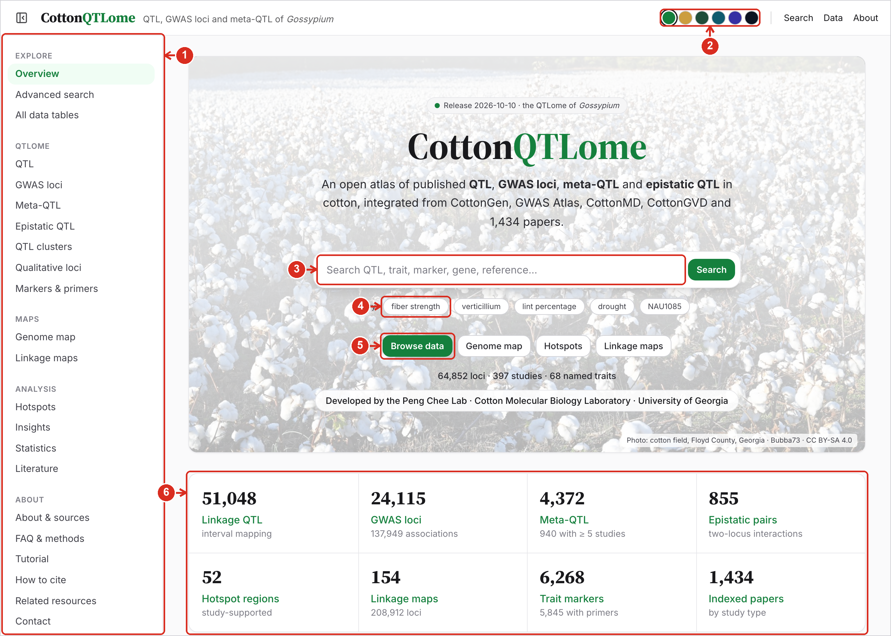
1 | Side menu. Every page, grouped as Explore, QTLome (the data tables), Maps, Analysis and About. The button at the top left hides or shows it.
2 | Colour theme. Changes the colours of the site; the choice is remembered in your browser.
3 | Search box. Type a QTL name, trait, marker, gene or author and press Search; the Advanced search page opens with the results.
4 | Example searches. Run a ready-made search in one click.
5 | Quick links. Open the data tables, the Genome map, the Hotspots or the Linkage maps.
6 | Live counts. Linkage QTL, GWAS loci, meta-QTL, epistatic pairs, hotspots, linkage maps, trait markers and papers, read from the current data. Click one to open that table.

2. Overview: traits, findings and the genome-wide view
Further down the overview page are the trait categories, the main findings and a genome-wide plot of where the loci are.
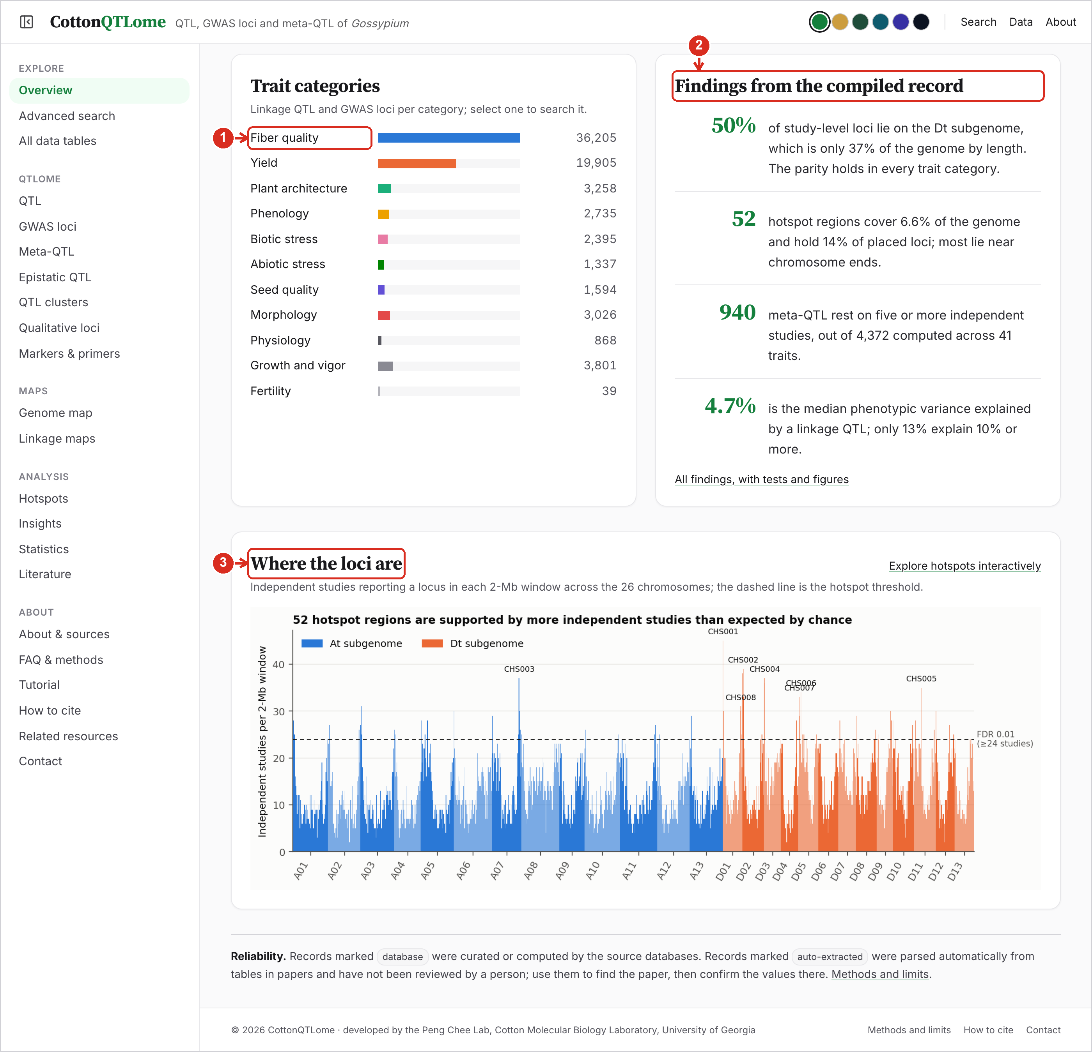
1 | Trait categories. Records per trait category. Click a category to search all of its loci.
2 | Findings. The headline results of the analysis. “All findings, with tests and figures” opens the Insights page.
3 | Where the loci are. Independent studies per 2-Mb window along all 26 chromosomes. Peaks above the dashed line are hotspots; “Explore hotspots interactively” opens the Hotspots page.

3. Advanced search
Advanced search filters linkage QTL and GWAS loci together. Filters apply as you set them, and the table below updates at once.
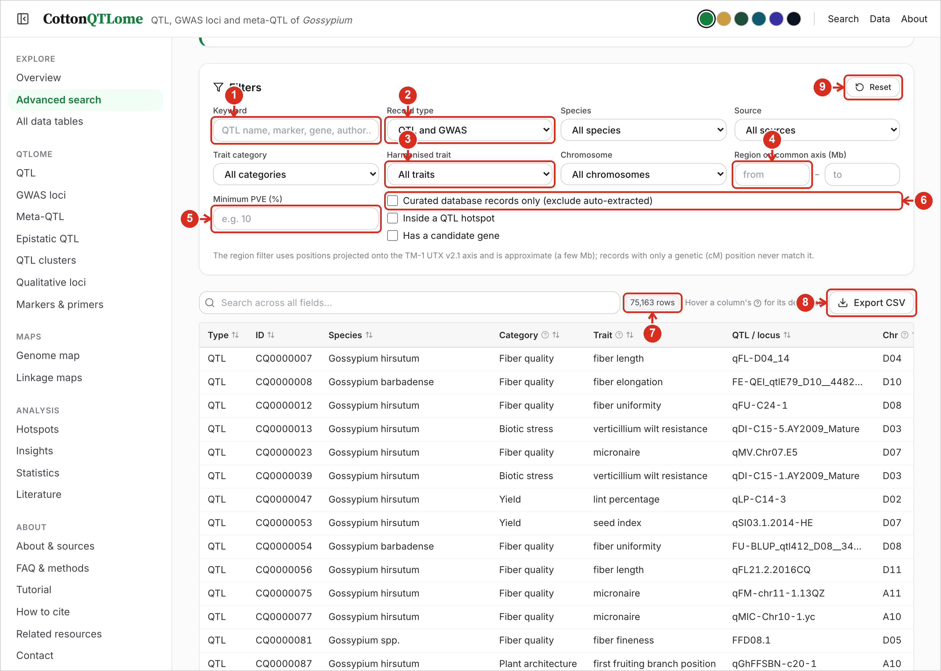
1 | Keyword. Matches QTL name, marker, candidate gene, author and the other text fields.
2 | Record type, species and source. Linkage QTL, GWAS loci or both; one species; one source database (CottonGen, CottonGVD, CottonMD, GWAS Atlas) or the literature.
3 | Trait category and trait. A category such as Fiber quality, then a harmonised trait such as fiber strength. Trait names from different studies are merged into one harmonised name.
4 | Chromosome and region. Pick a chromosome and give a start and end in Mb to list the loci in that window. Positions are projected onto TM-1 UTX v2.1, so the window is approximate; loci with only a cM position are never matched.
5 | Minimum PVE. Keep only loci that explain at least this percentage of phenotypic variance.
6 | Evidence filters. Keep only records from curated databases, only loci inside a hotspot, or only loci with a candidate gene.
7 | Result count. The number of matching rows.
8 | Export CSV. Downloads exactly the matching rows, with every column.
9 | Reset. Clears every filter.

4. All data tables
The data page lists every table with its size. Each opens as a sortable, searchable table that can be exported.
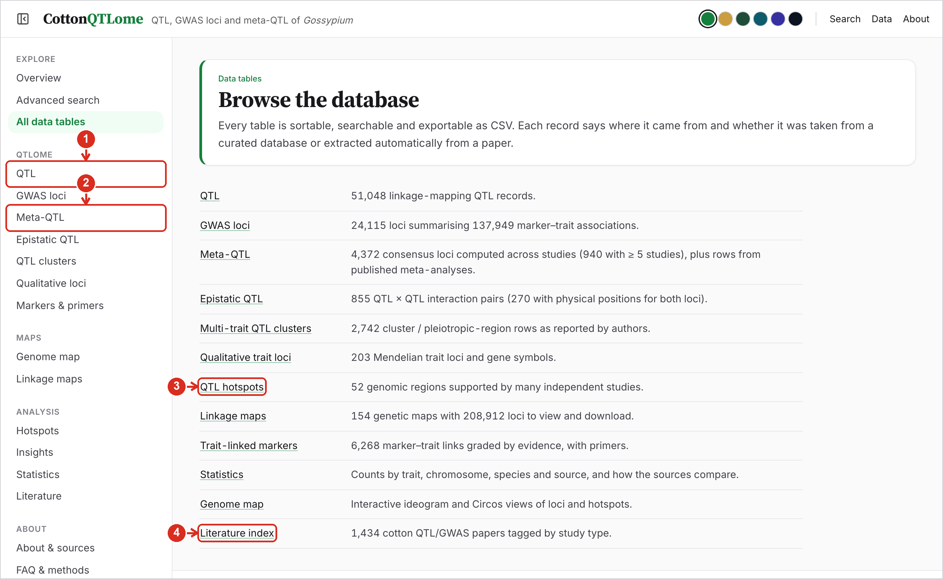
1 | QTL and GWAS loci. Linkage-mapping QTL, and GWAS loci (each locus summarises the associations reported at one position).
2 | Meta-QTL, epistatic QTL, clusters, qualitative loci. Consensus loci computed across studies, QTL × QTL interactions, multi-trait clusters reported by authors, and Mendelian trait loci.
3 | Hotspots, linkage maps and markers. Study-supported hotspot regions, genetic maps with their markers, and trait-linked markers with primers.
4 | Literature index. Every indexed cotton QTL and GWAS paper, tagged by study type.

5. Working with a table
Every table works the same way, whether it is QTL, GWAS loci, meta-QTL, markers or the literature.
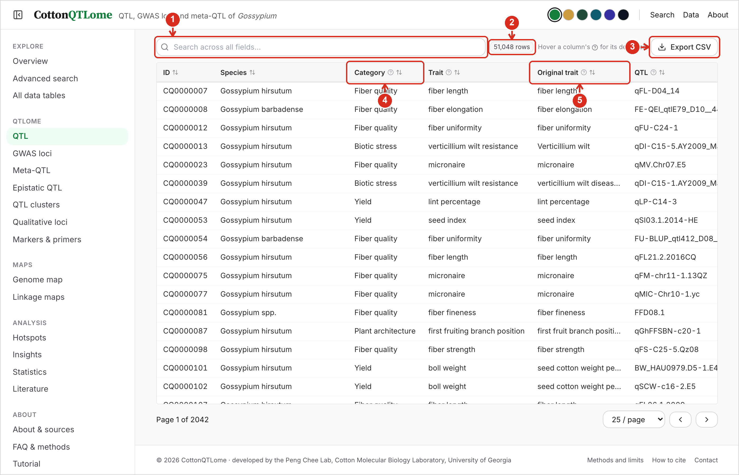
1 | Search the table. Filters the rows as you type, across all columns.
2 | Row count. The number of rows currently shown.
3 | Export CSV. Downloads the rows currently shown.
4 | Sort and definitions. Click a column heading to sort by it; click again to reverse. Hover the small “?” for the definition of the column.
5 | Harmonised and original trait. Trait is the harmonised name used for searching; Original trait is the name the study used. Scroll the table sideways for position, LOD, PVE, markers, source, evidence and the reference.

6. Meta-QTL
Meta-QTL are consensus loci computed from all placed QTL and GWAS loci of a trait, each supported by at least two independent studies.
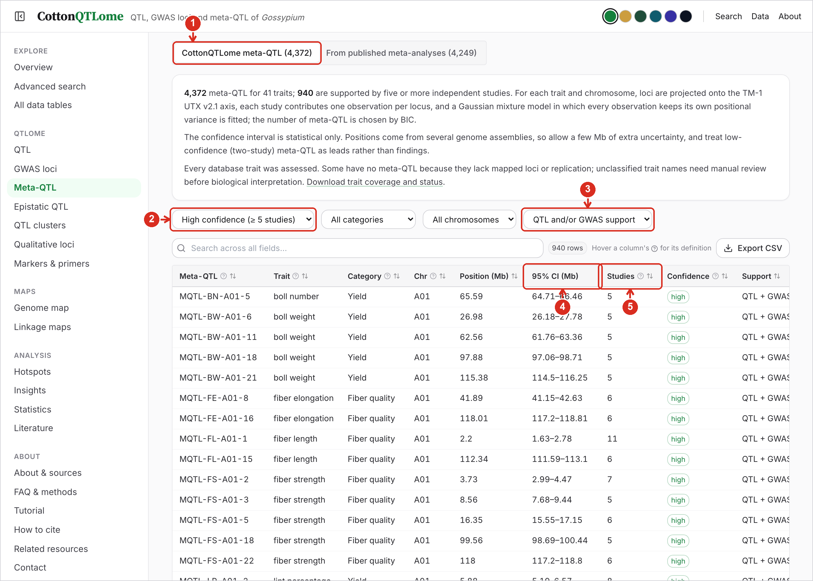
1 | Two tables. Meta-QTL computed by this project, or the rows from published meta-analyses.
2 | Confidence. High (five or more studies), moderate (three or more) or all (two or more).
3 | Category, chromosome and support. Limit by trait category or chromosome, or to meta-QTL supported by linkage QTL, GWAS or both.
4 | Position and interval. Consensus position and its 95% confidence interval in Mb on TM-1 UTX v2.1.
5 | Studies and confidence. How many independent studies support the meta-QTL, and the confidence level that follows from it.

7. Genome map: ideogram view
The Genome map draws loci, meta-QTL and hotspots on the 26 chromosomes of allotetraploid cotton, coloured by trait category.
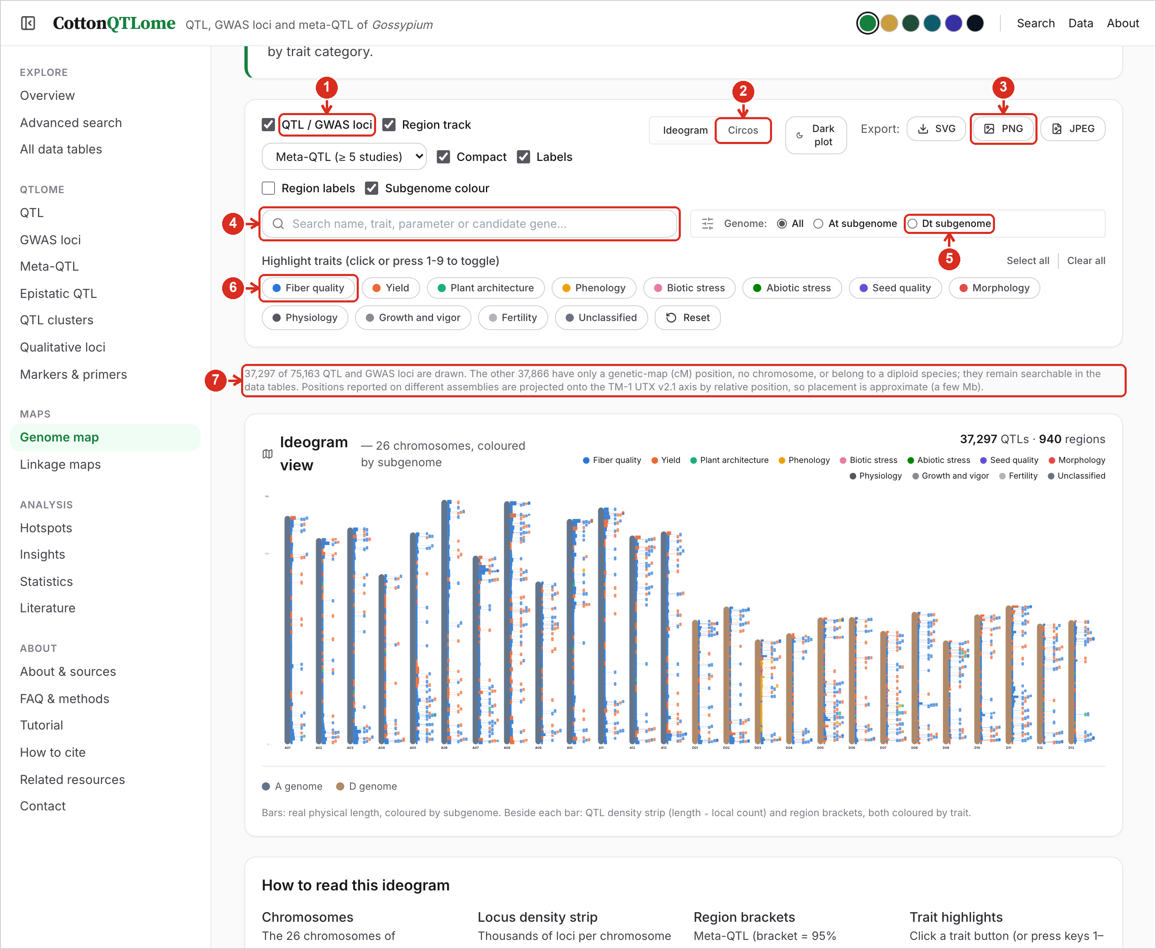
1 | Layers. Switch the loci and the region track on or off. The list chooses what the region track shows: high-confidence meta-QTL, all meta-QTL or hotspots.
2 | Choose the view. Ideogram (chromosomes side by side) or Circos (all chromosomes in a circle). “Dark plot” draws the figure on a dark background.
3 | Export. Save the current figure as SVG, PNG or JPEG.
4 | Search the map. Shows only the loci whose name, trait or candidate gene matches.
5 | Subgenome. Show all chromosomes, or only the At (A01–A13) or Dt (D01–D13) subgenome.
6 | Highlight traits. Click one or several categories (or press 1–9) to show only those; “Reset” shows all again. The colours are those of the plot.
7 | What is drawn. How many loci have a physical position and are drawn. The others (cM position only, or a diploid species) stay searchable in the tables.

8. Genome map: Circos view
The Circos view puts all 26 chromosomes in one circle, with rings for locus density, regions and loci of each trait category.
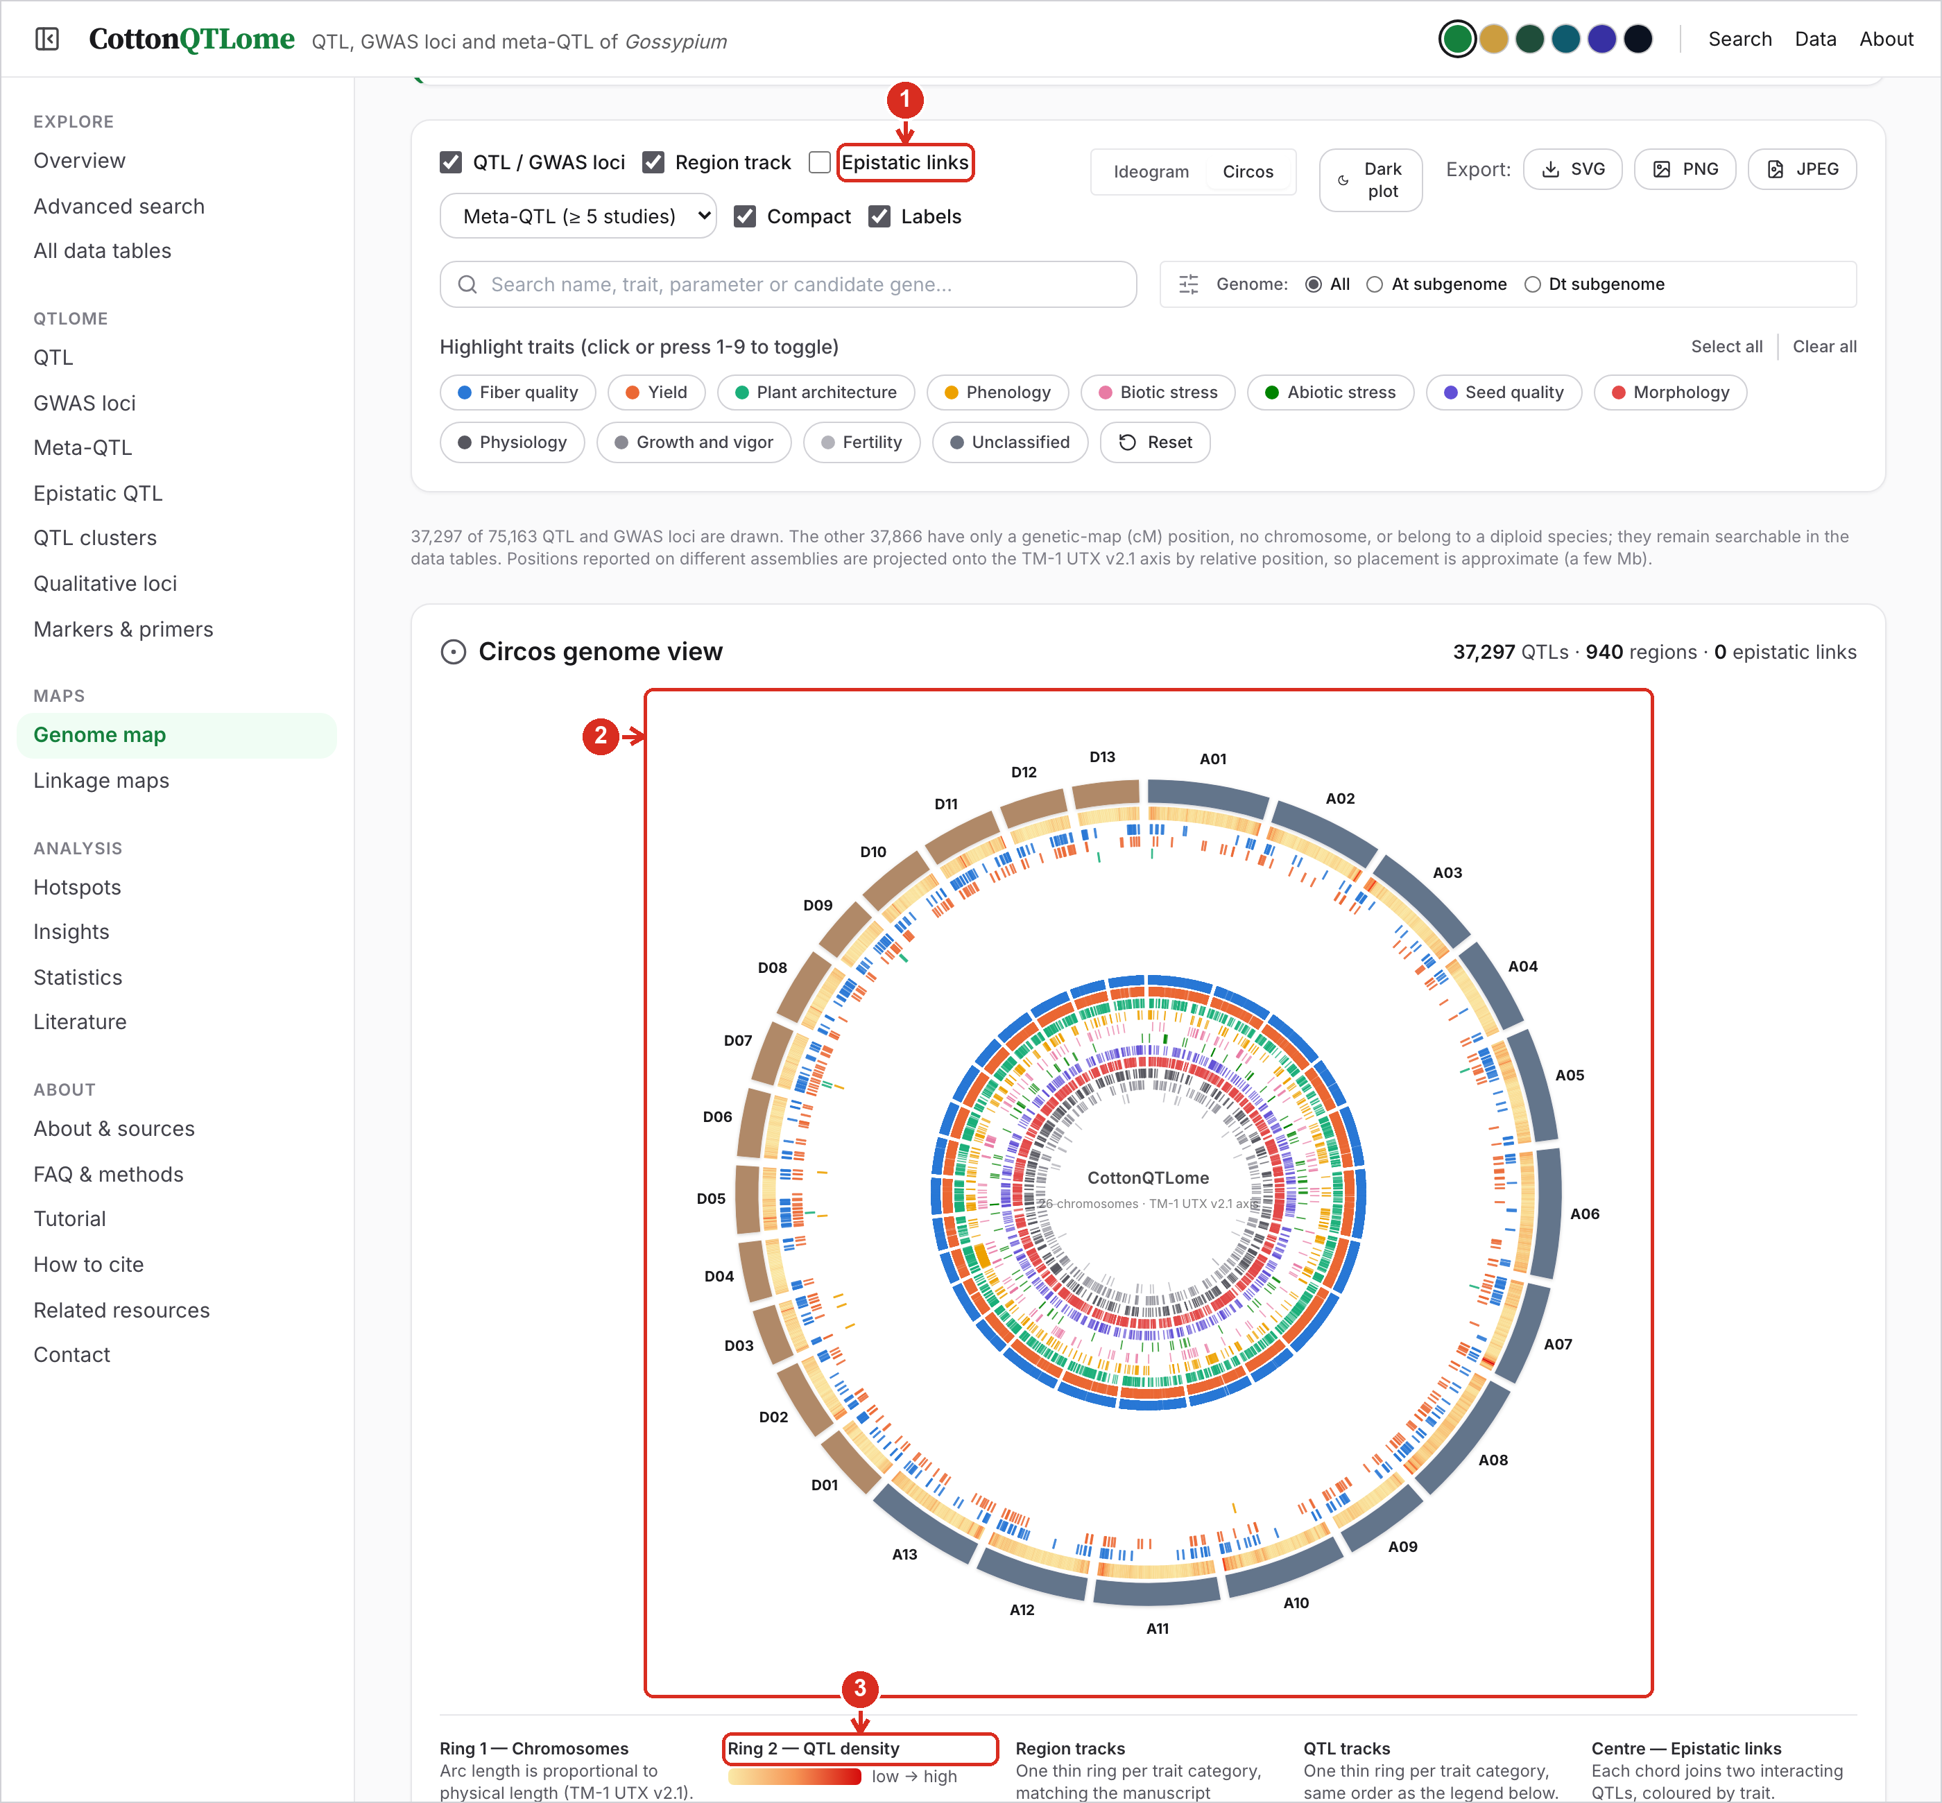
1 | Epistatic links. Tick to draw chords joining the two loci of each epistatic pair.
2 | The plot. Outer ring: chromosomes, by subgenome. Next: locus density. Then one thin ring per trait category for regions and for loci. Hover any mark for its details.
3 | Key. What each ring shows, with the colour scale for density.

9. Hotspots
Hotspots are regions where loci from many independent studies fall together, more than expected by chance.
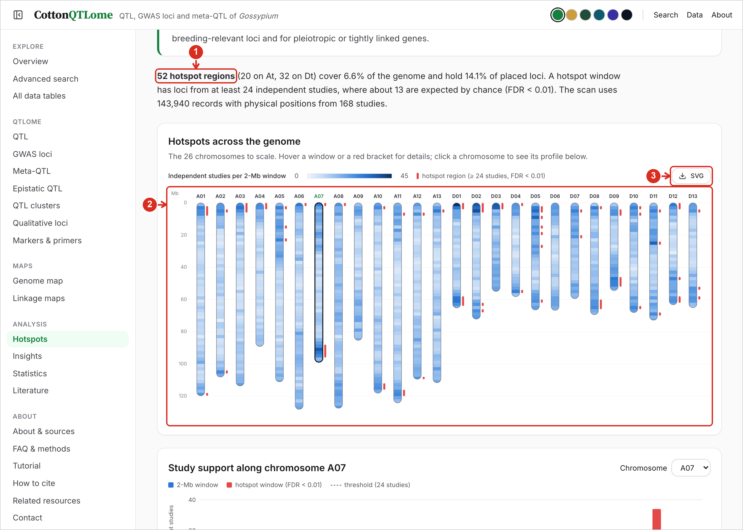
1 | Summary. How many hotspots there are, how much of the genome they cover, and the study threshold used to call them.
2 | Karyotype. All 26 chromosomes to scale. Shading shows independent studies per 2-Mb window; red brackets are hotspots. Hover for details; click a chromosome to see its profile below.
3 | Save the figure. Downloads the karyotype as SVG.

10. Hotspots: chromosome profile and table
Below the karyotype, one chromosome is shown in detail, followed by the table of all hotspot regions.
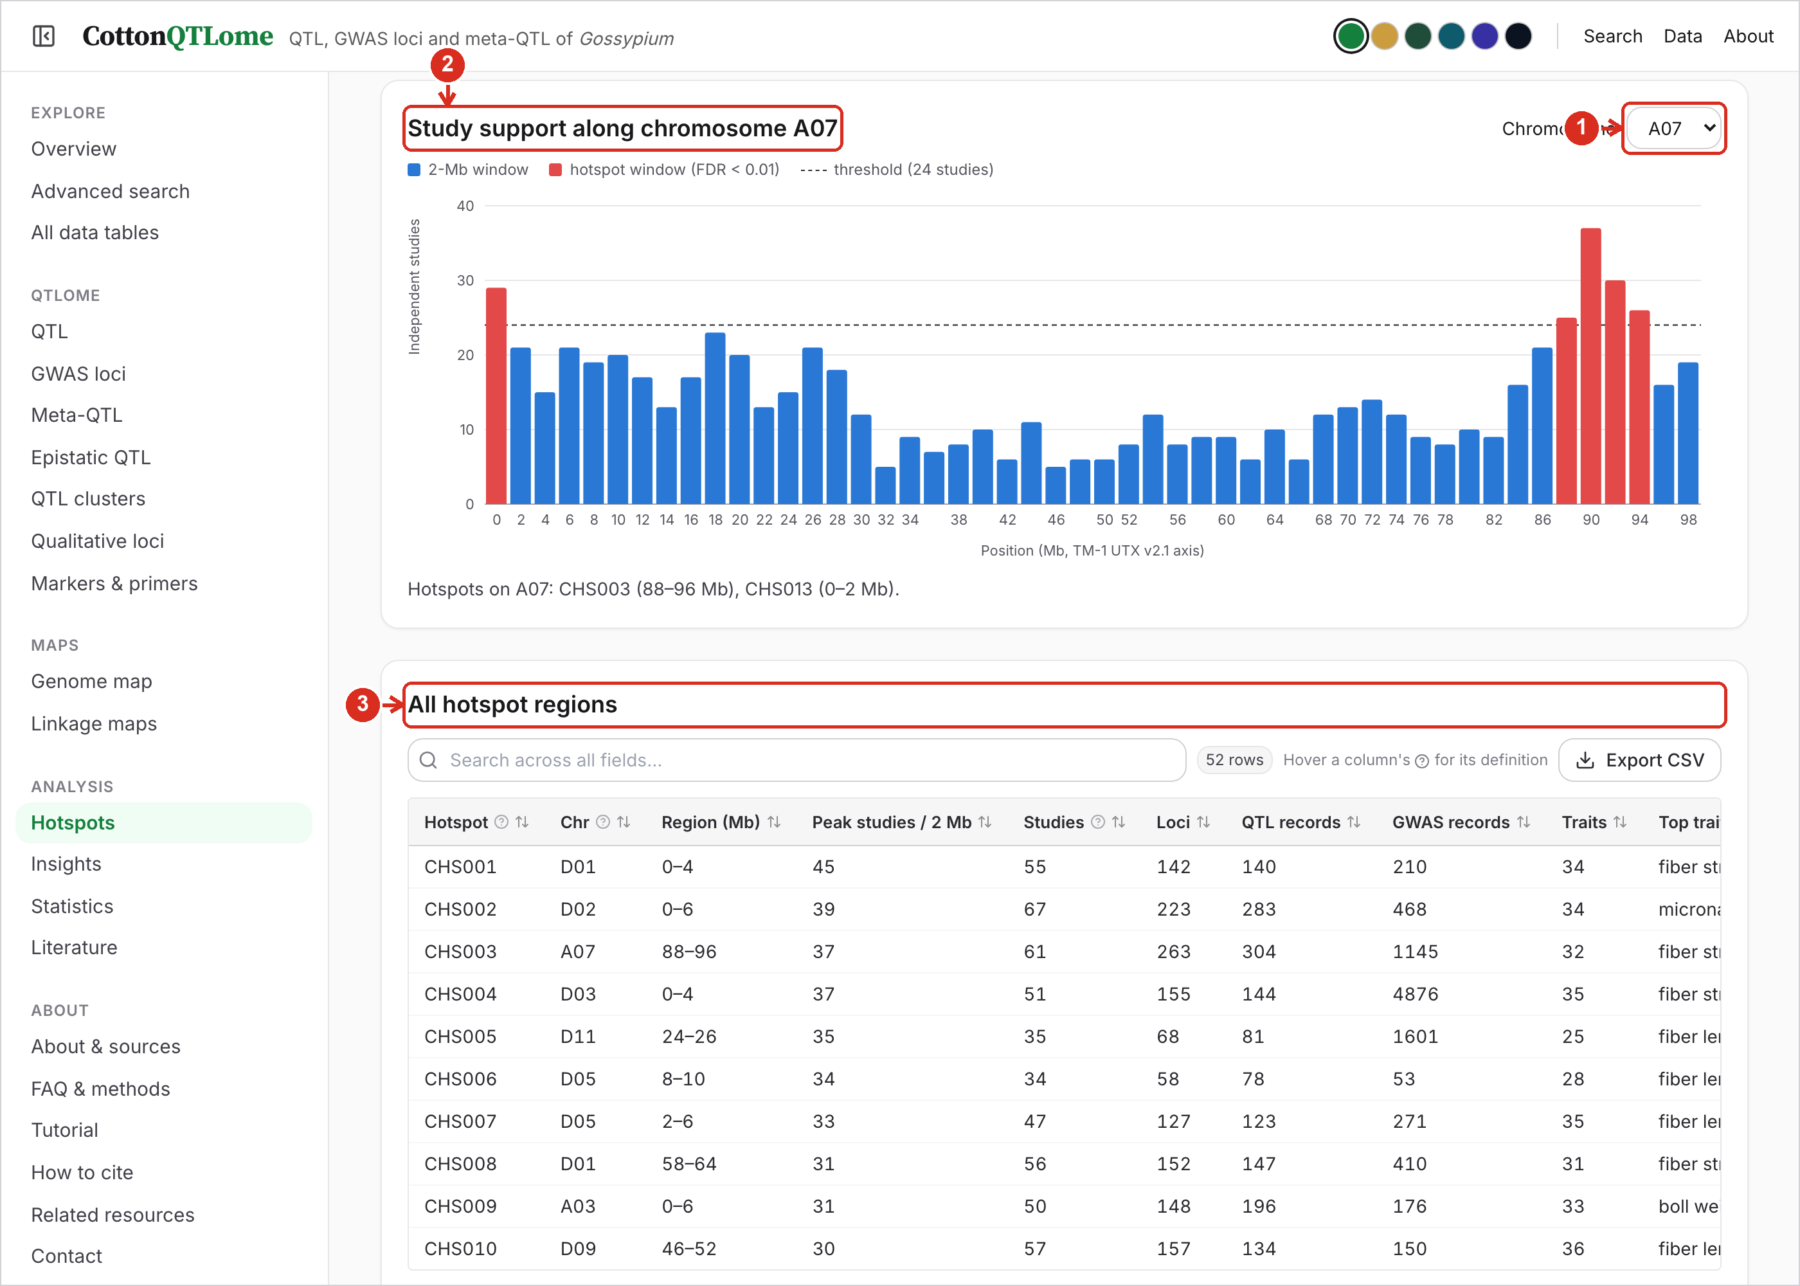
1 | Chromosome. Choose the chromosome whose study-support profile is drawn.
2 | Profile. Independent studies per window along the chromosome; windows above the threshold form hotspots.
3 | Hotspot table. Each hotspot with its region, number of studies and loci, top traits, example QTL and recurrent candidate genes.

11. Linkage maps
Marker orders and cM positions of cotton genetic maps, from CottonGen and from supplementary files of mapping papers.
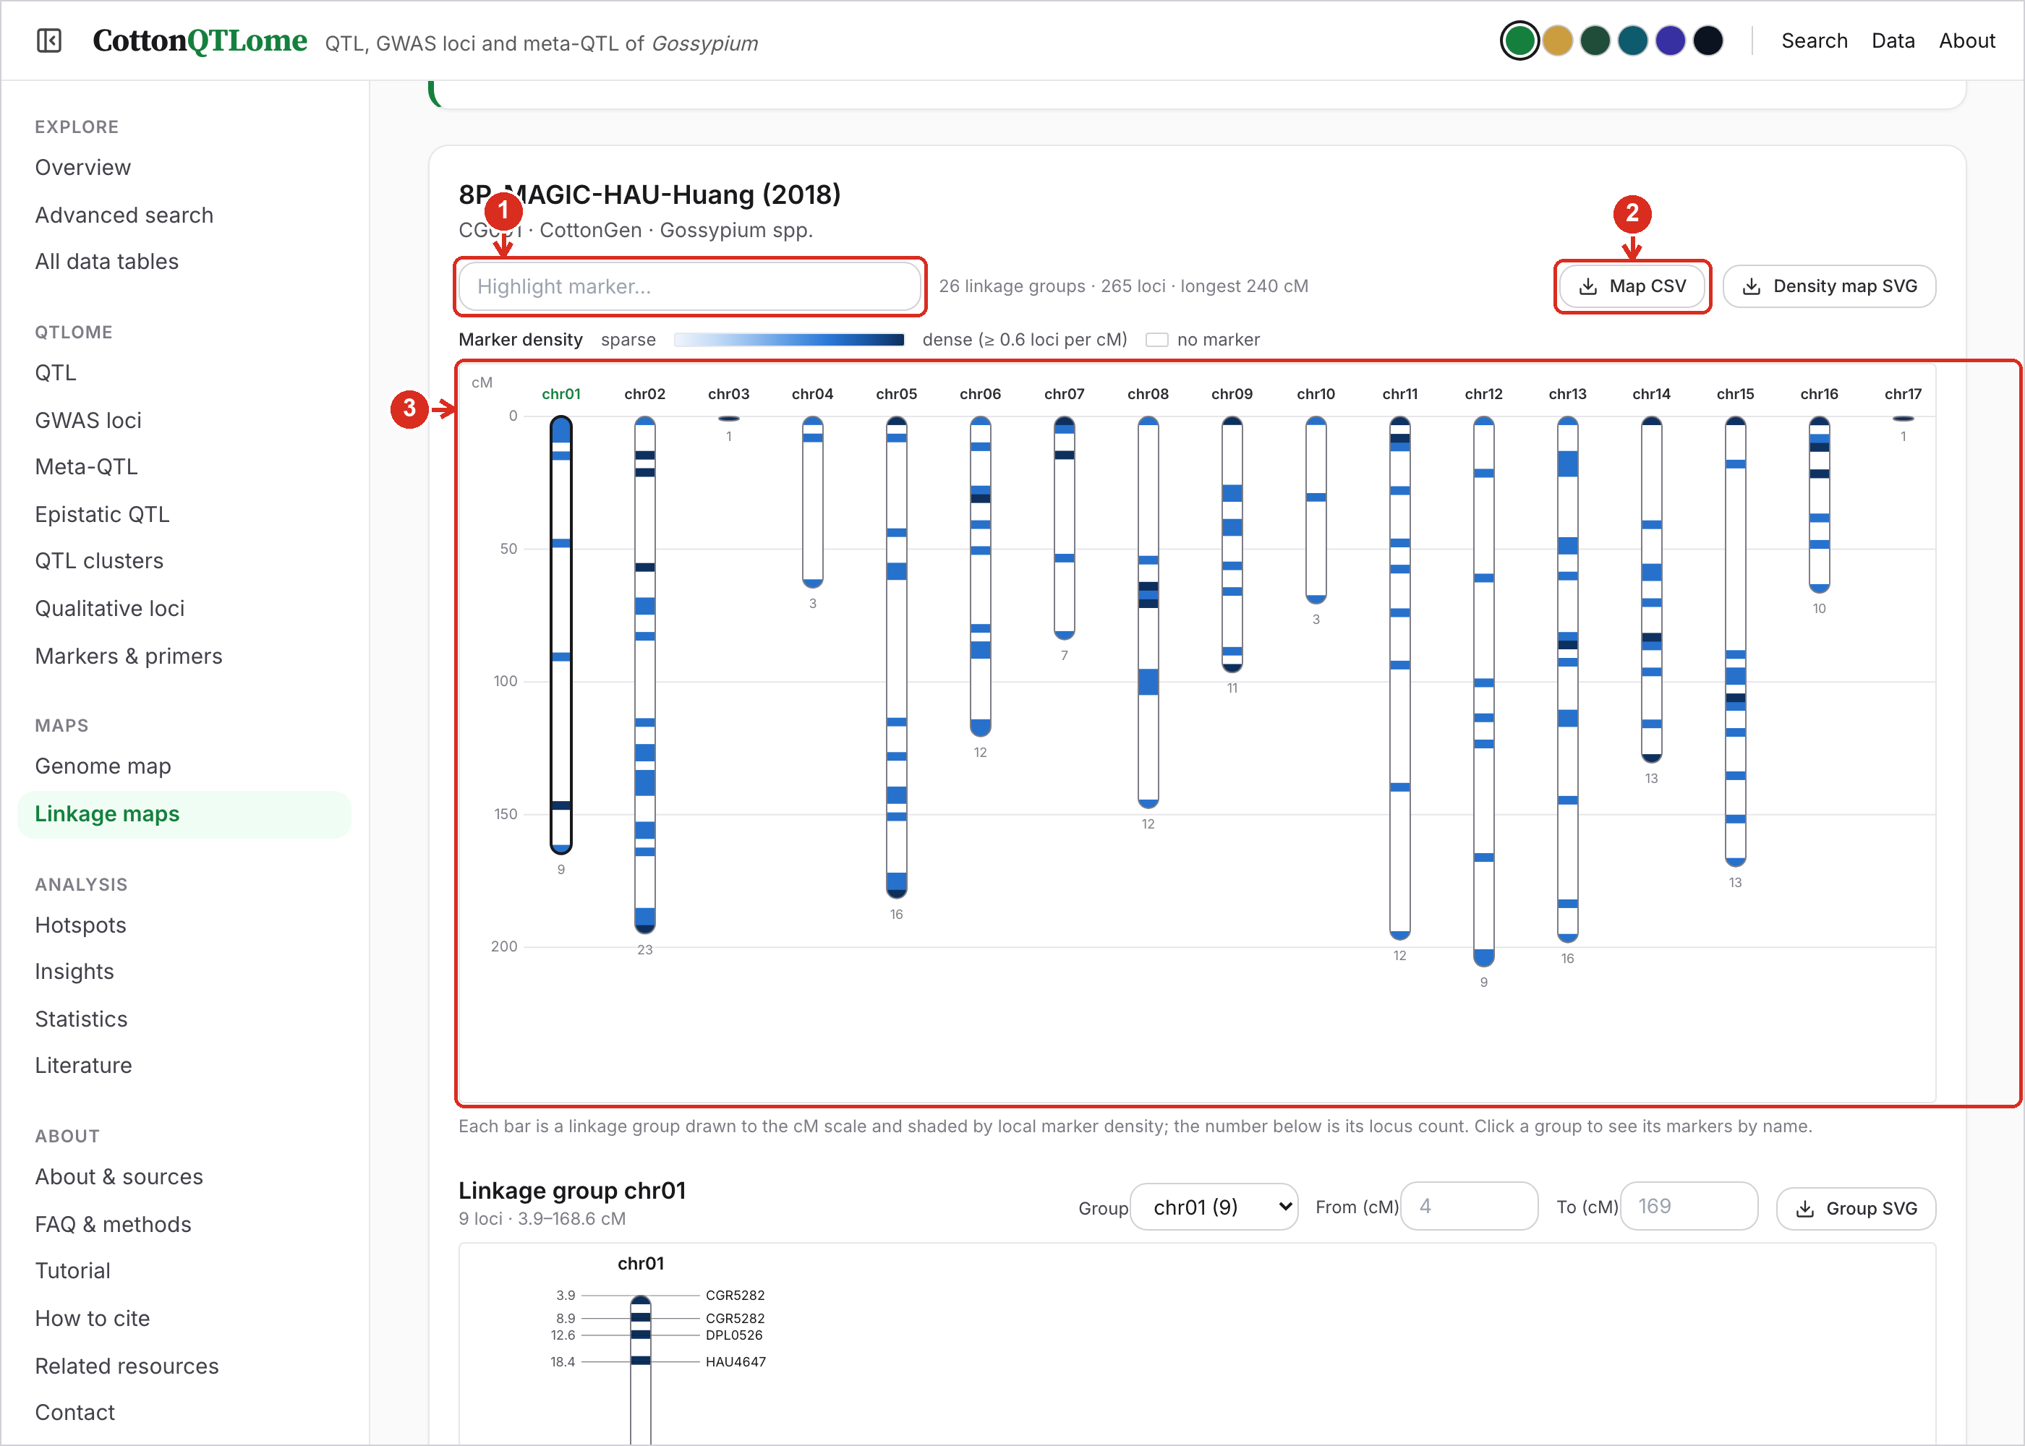
1 | Highlight a marker. Type a marker name to mark it on the map.
2 | Download. Download the whole map as CSV, or the density figure as SVG.
3 | Density map. One bar per linkage group, drawn to the cM scale and shaded by marker density; the number below is its locus count. Click a group to list its markers.

12. Linkage maps: one group and the map list
The selected linkage group is drawn with its marker names; below it every available map is listed.
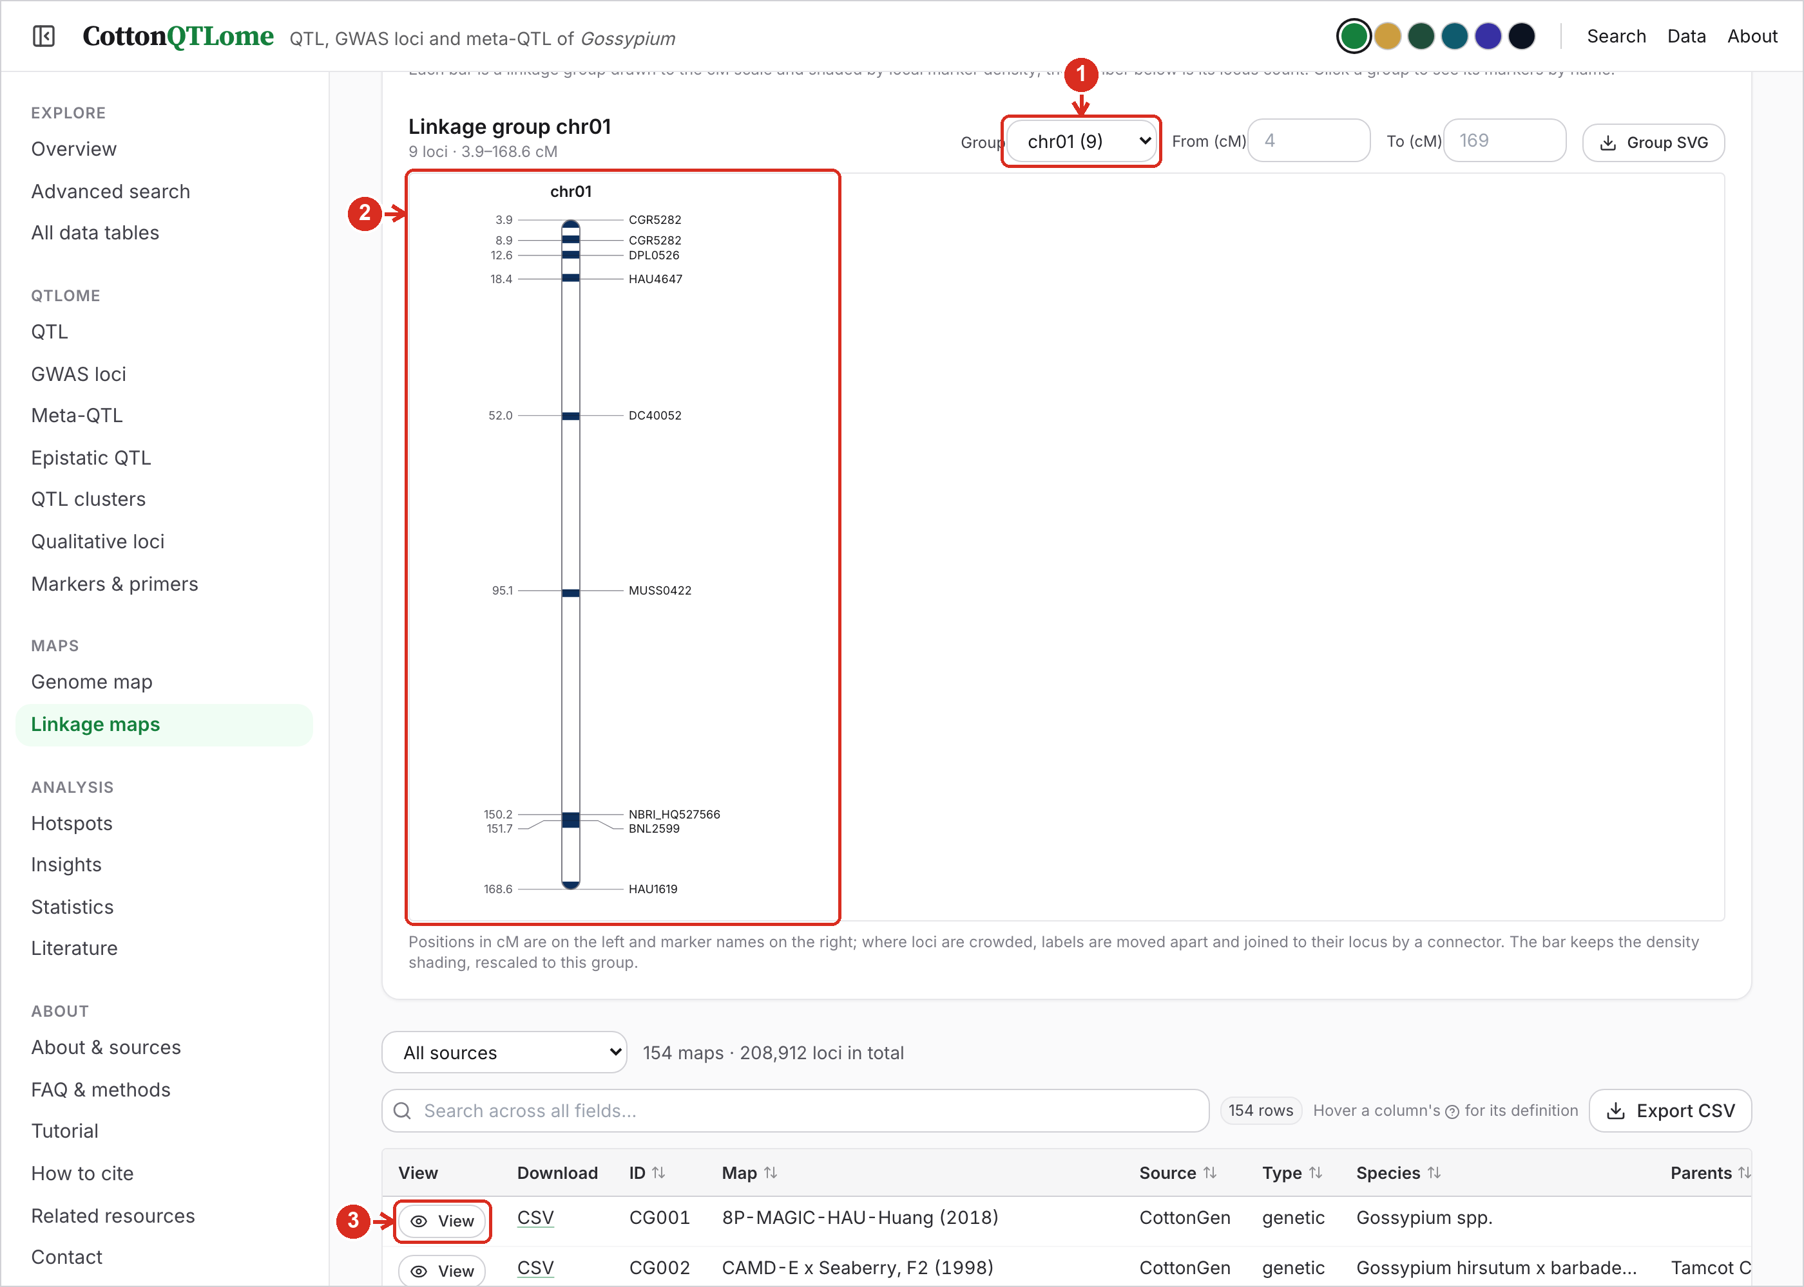
1 | Group and cM window. Choose a linkage group and the cM range to draw.
2 | Group view. Markers in map order at their cM positions.
3 | Choose a map. Click View on any map in the list to draw it above.

13. Markers and primers
Markers linked to traits, graded by the evidence behind the link, with primer sequences where a source gives them.
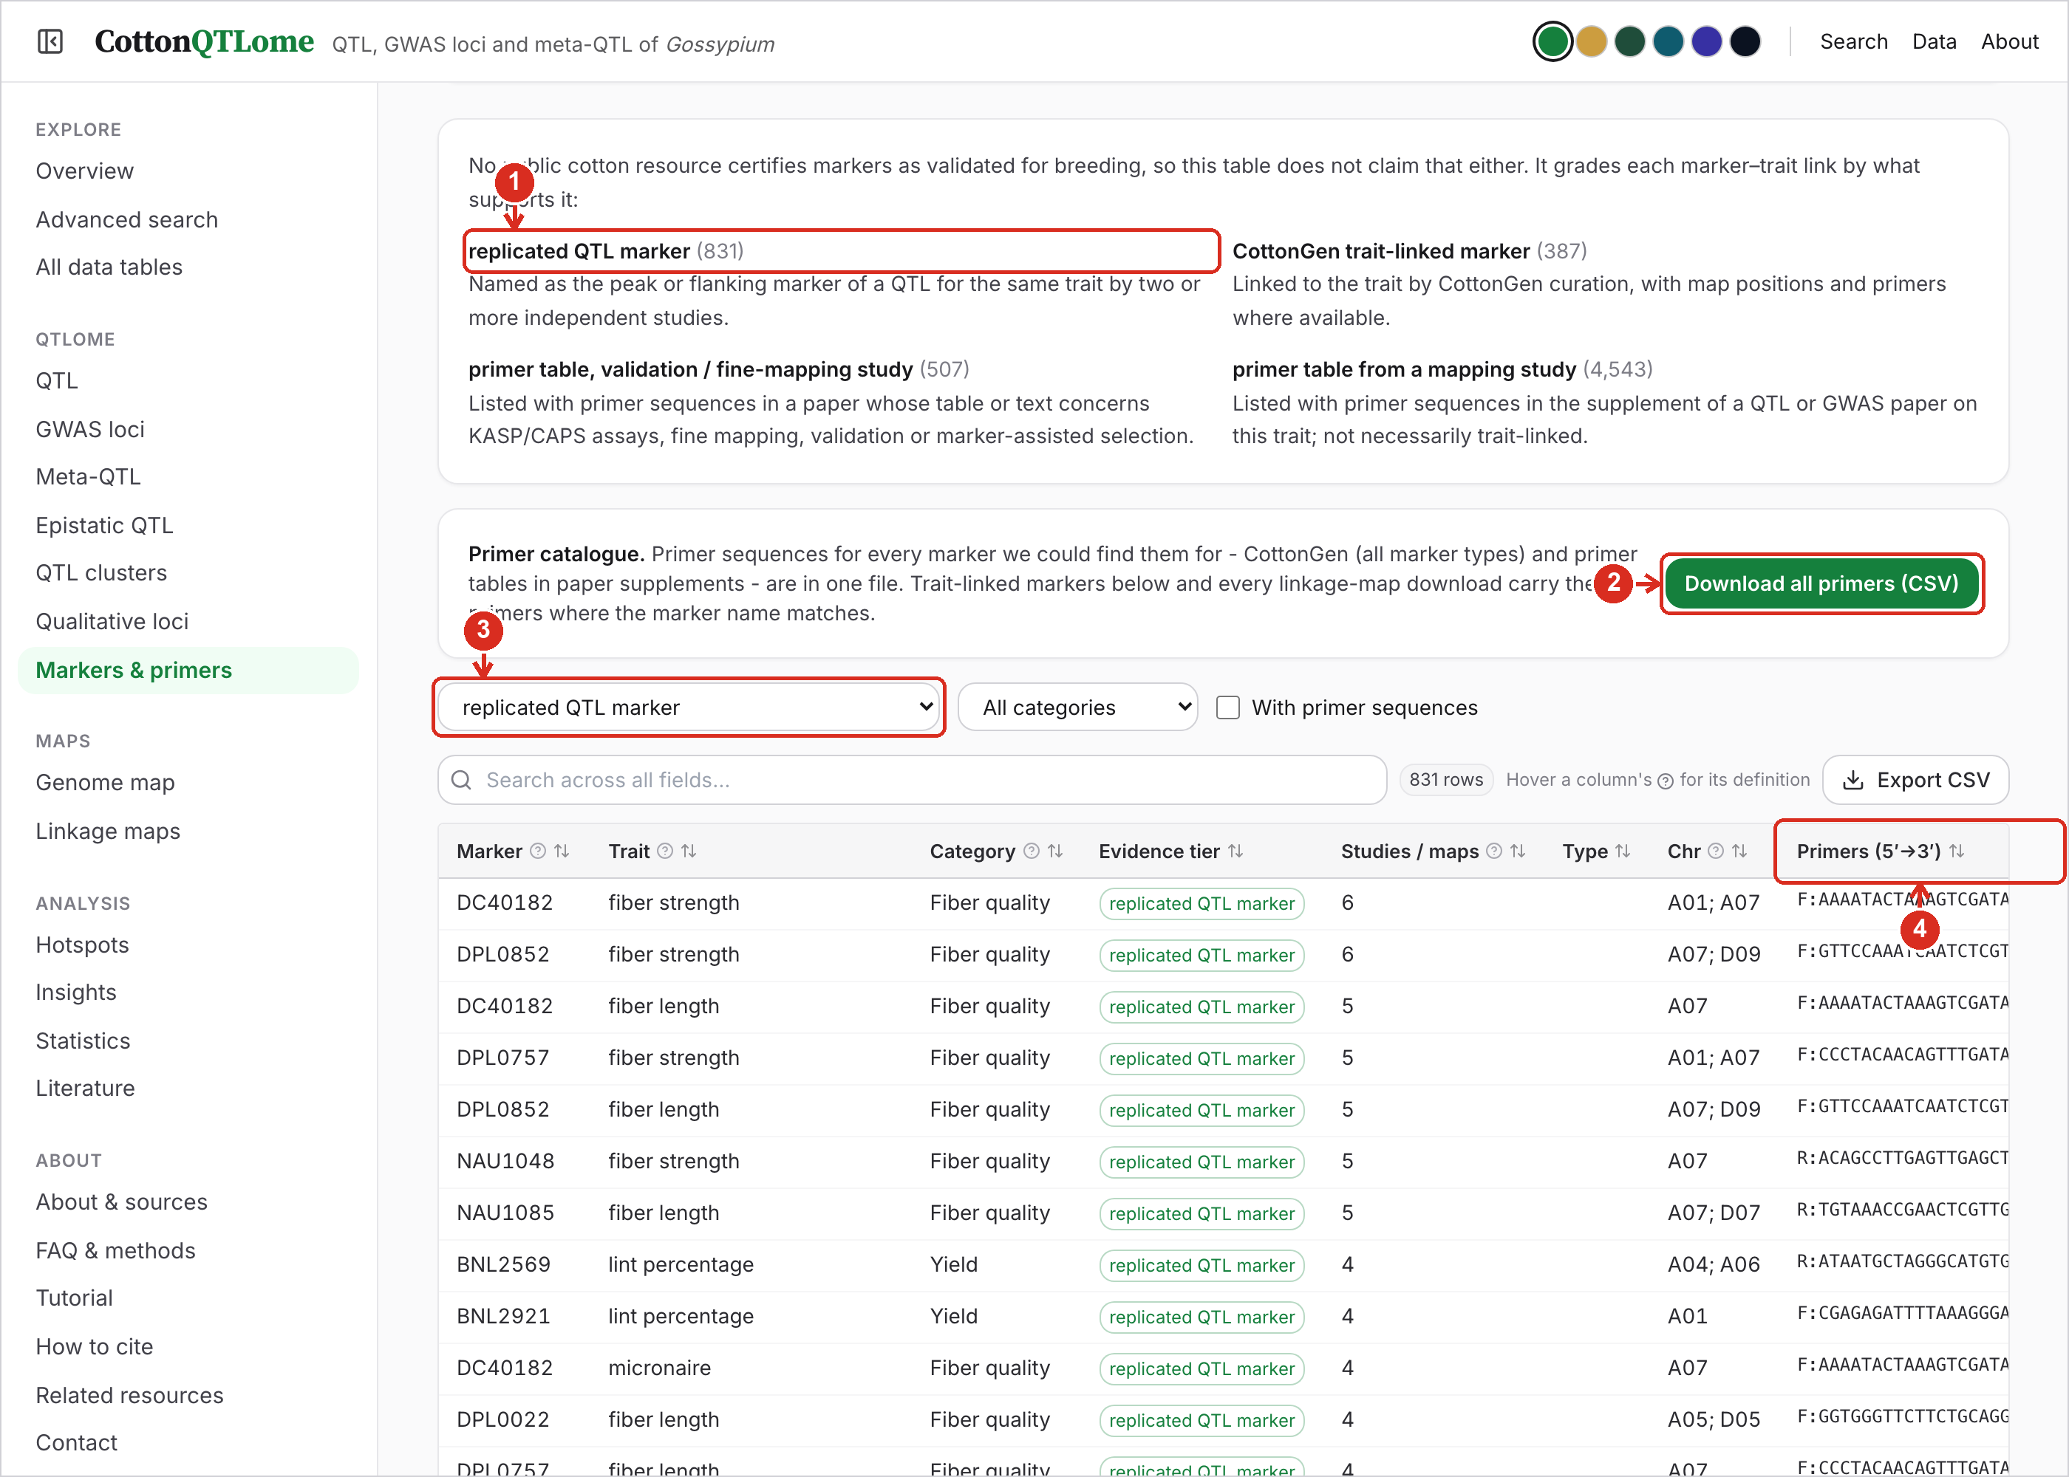
1 | Evidence tiers. What each grade means. No public resource certifies cotton markers as validated for breeding, so the grade says what supports the link.
2 | Primer catalogue. One CSV with primers for every marker found in CottonGen and in paper supplements.
3 | Filters. Limit by evidence tier or trait category, or to markers with primer sequences.
4 | Primers. Forward (F) and reverse (R) primer, 5′→3′.

14. Statistics
Counts by record type, trait, chromosome, species and source. All numbers refer to de-duplicated records.
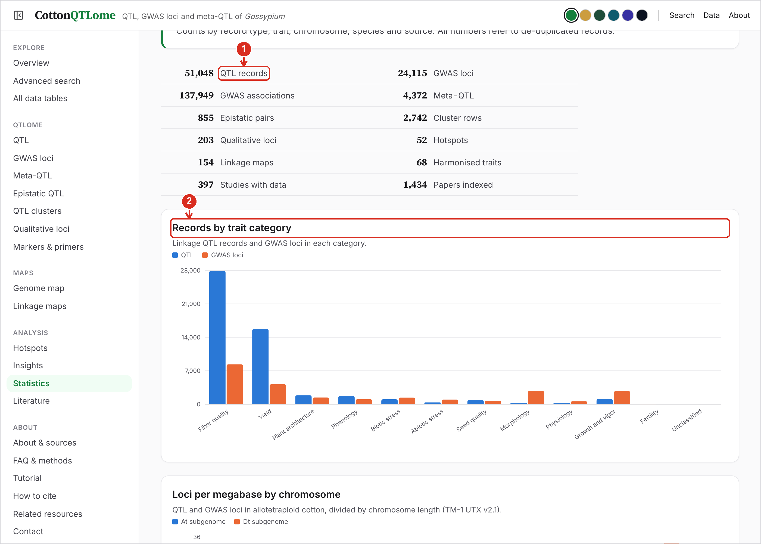
1 | Totals. Records of every type, harmonised traits, studies with data and papers indexed.
2 | Charts. Records by trait category, loci per Mb by chromosome, most studied traits, species, source, papers per year and the share of major-effect QTL. Hover a bar for its value.

15. Insights
What the combined record says about where trait loci sit in the cotton genome, with the statistical test behind each statement.
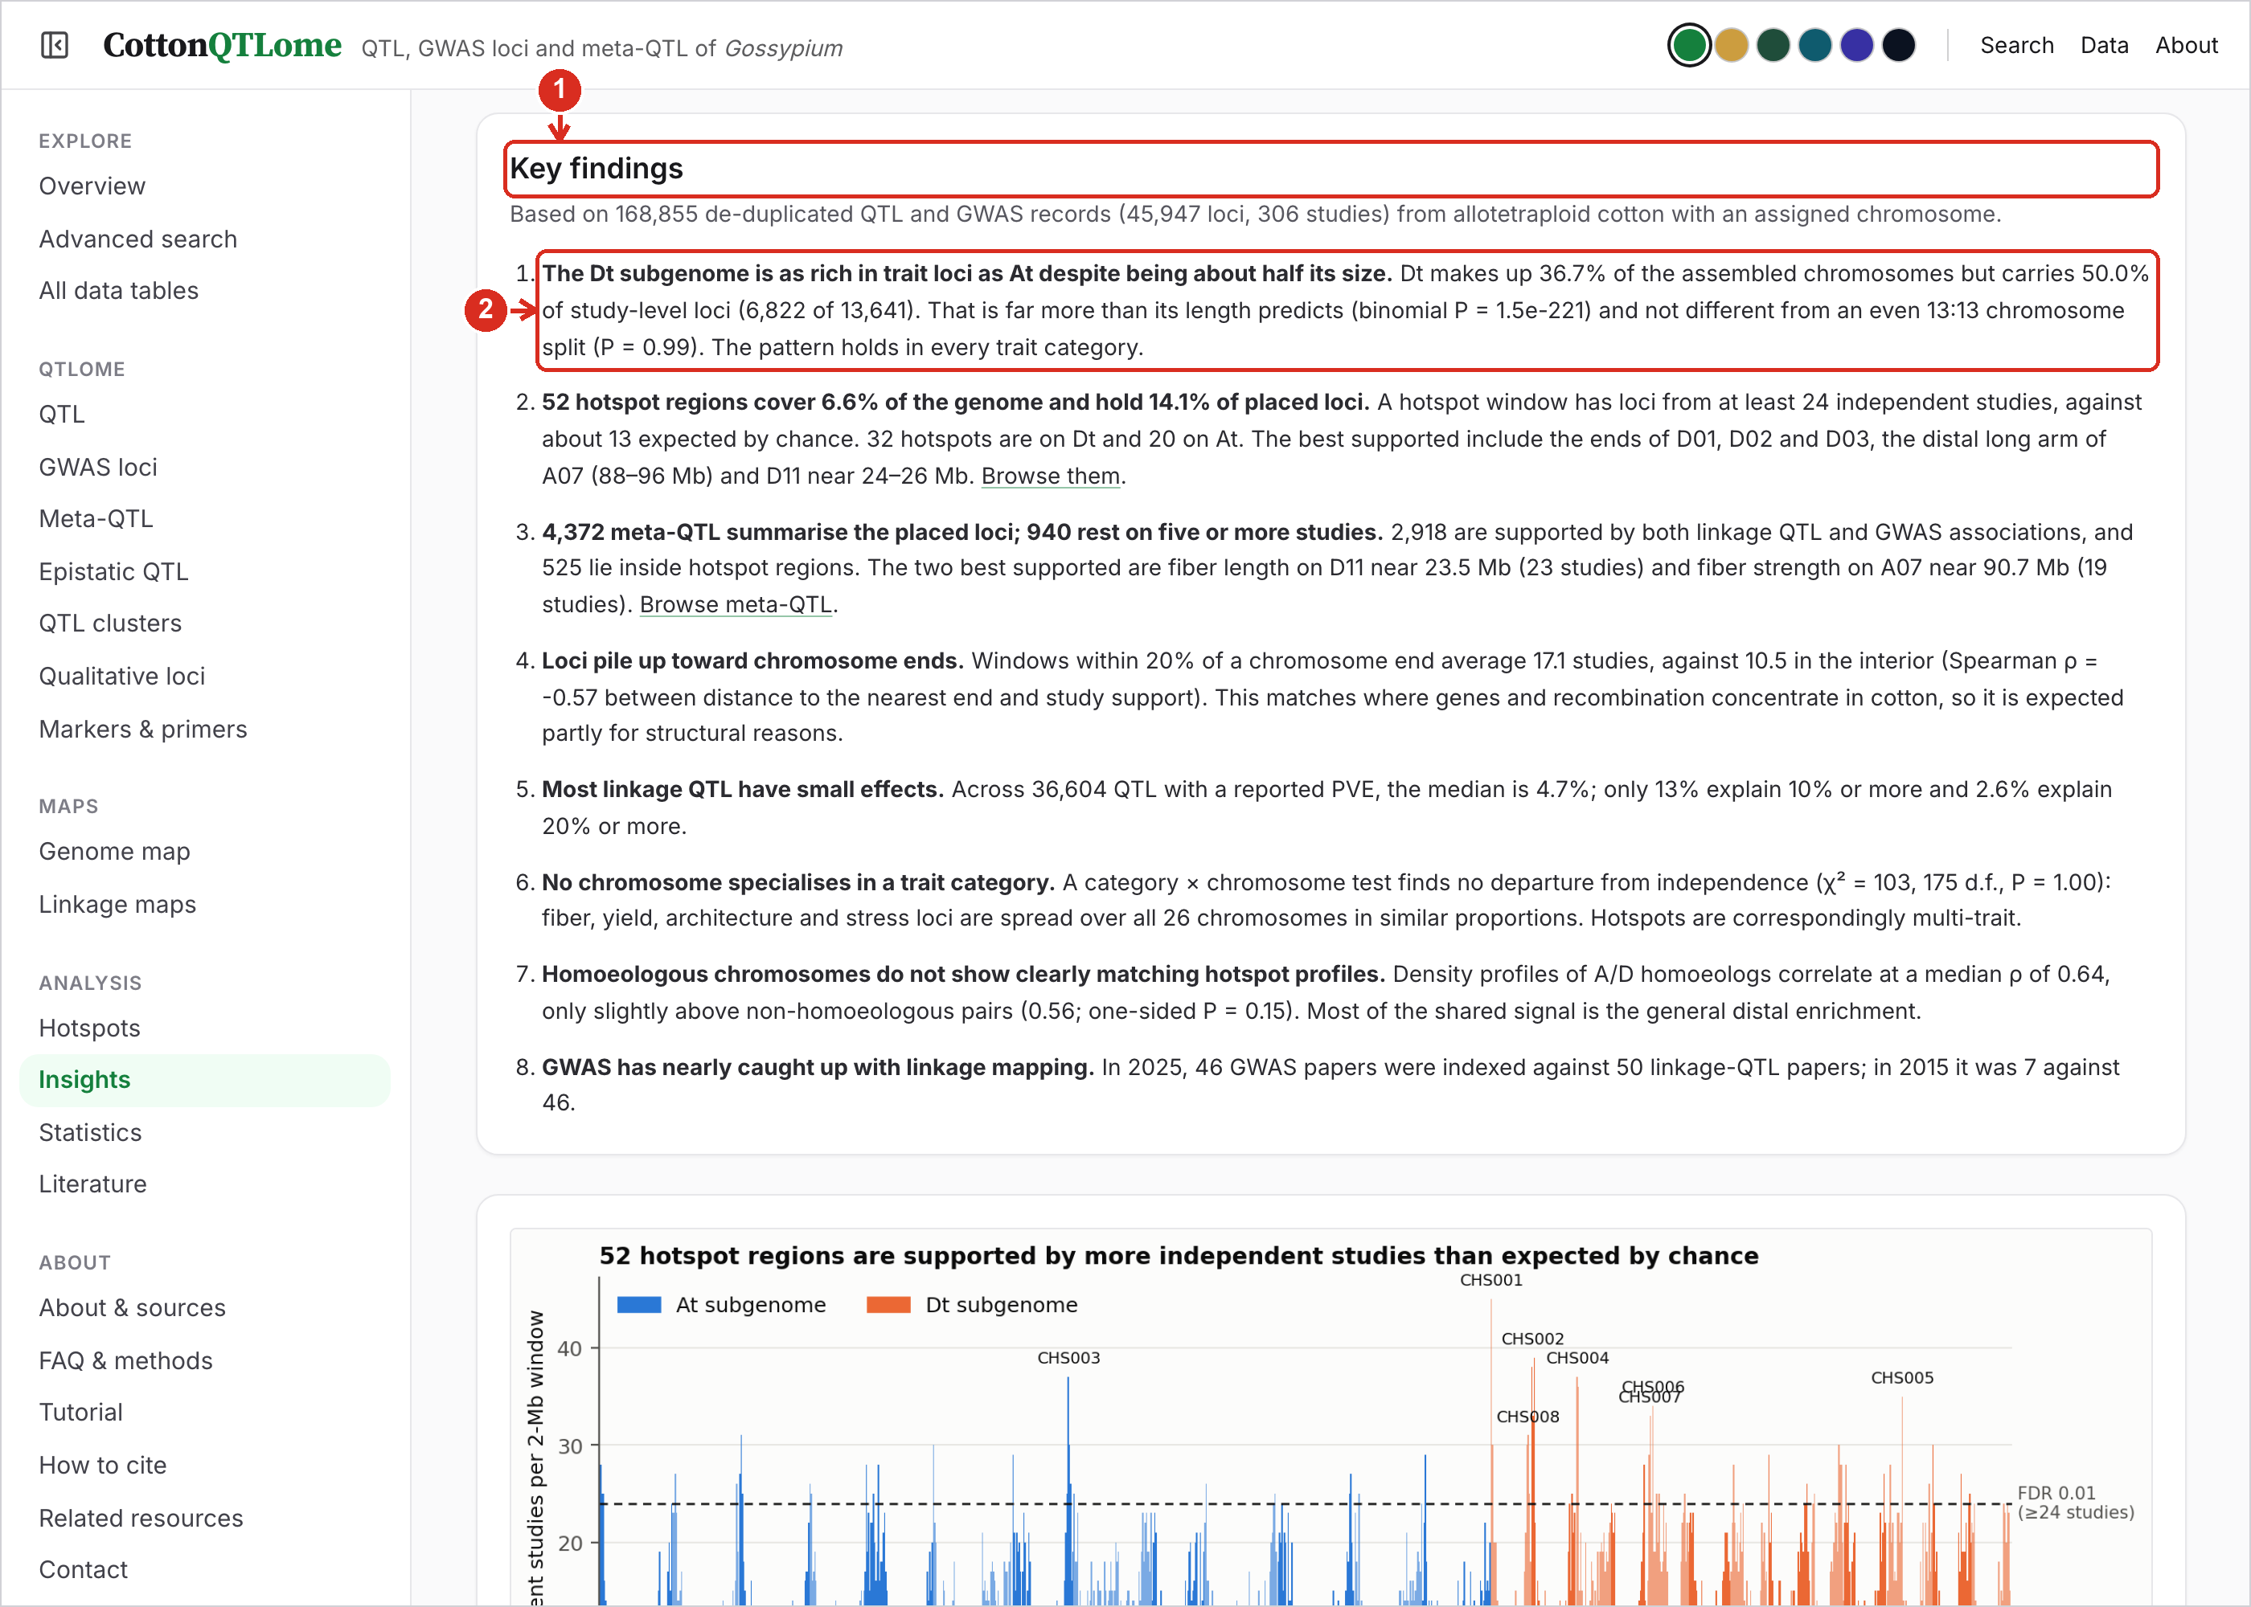
1 | Key findings. Each finding in one sentence, then the numbers and the test. Links open the data behind it.
2 | A finding. The figures further down the page illustrate each finding; “Read these with care” at the end lists the limits of the data.

16. Literature index
Cotton QTL, GWAS, meta-QTL and epistasis papers indexed from Europe PMC and tagged by study type.
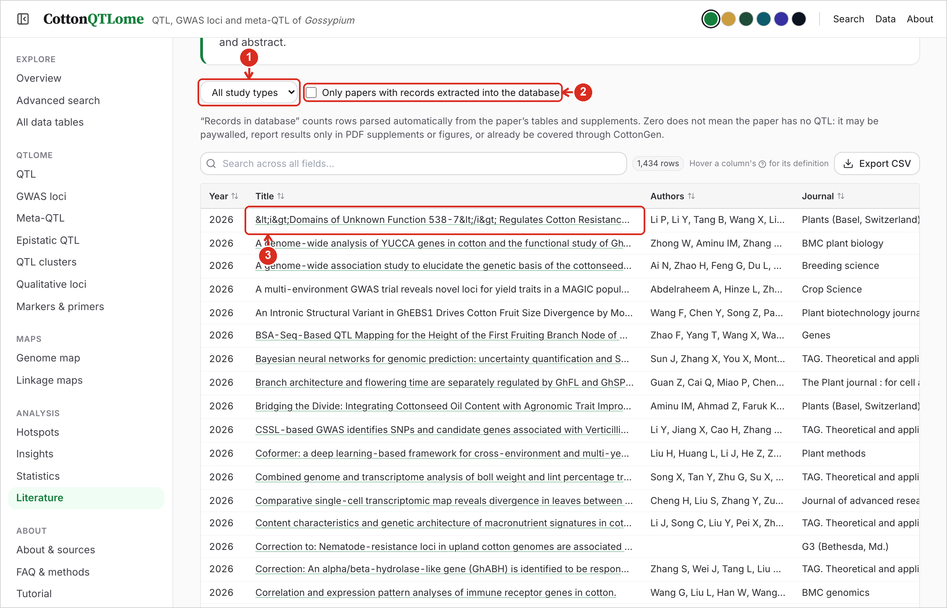
1 | Study type. Show only linkage QTL, GWAS, meta-QTL, epistasis or other study types.
2 | Papers with records. Tick to show only papers whose results are in the data tables.
3 | Title. Opens the paper. Scroll sideways for the study type and the number of records taken from it.

