WheatQTLdb V3.0
User guide
A step-by-step tour of the database: how to search it, browse and export its tables, read its statistics and use its genome maps. Each screenshot is numbered; the list under it explains every numbered item.
The database is at https://wheatqtldbv3.org. This guide is also available on the site under Tutorial.
At the time this guide was generated the database held 80,640 QTL / MTA records, 3,058 MetaQTLs and 1,226 epistatic QTL pairs from 1,383 publications.
Contents
1. Home page
2. Home page: browse by chromosome and news
3. Search
4. Data tables
5. Working with a table
6. Statistics
7. Statistics: charts
8. Genome map: Circos view
9. Genome map: Ideogram view
10. Genome map: Linkage (cM) view
11. Linkage maps
12. Publications
13. Candidate genes
14. Studies awaiting curation and News

1. Home page
The home page is the starting point: search the whole database, see how much it holds, and jump straight to a trait.
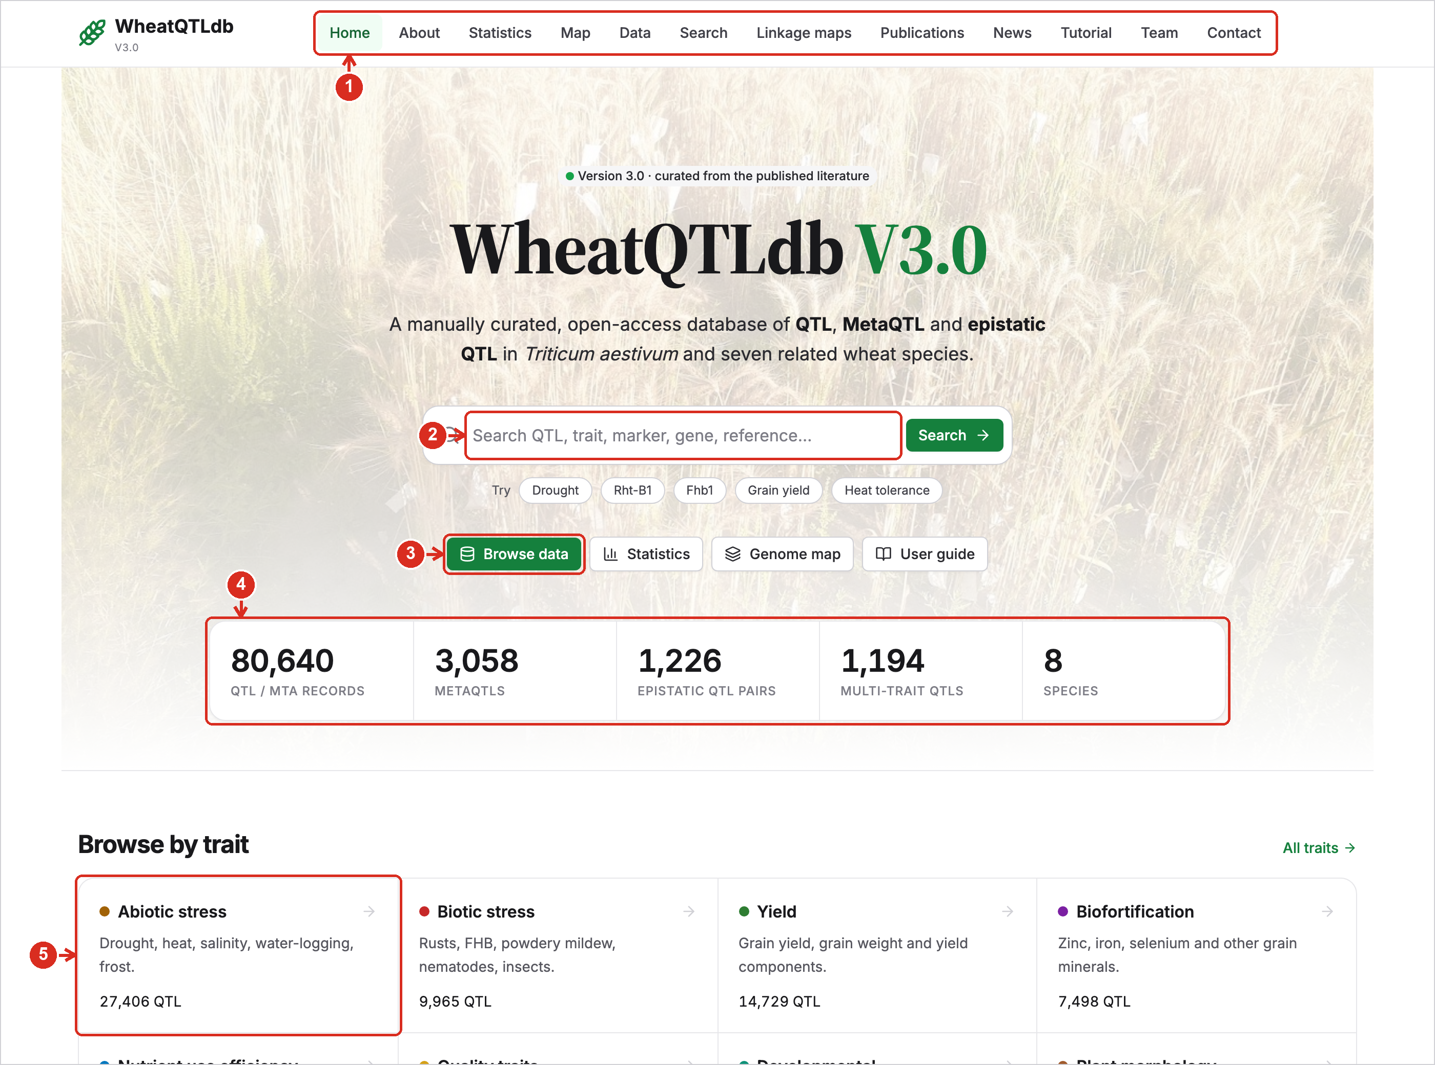
1 | Menu. Every part of the database is one click away: Statistics, Map, Data, Search, Linkage maps, Publications, News and this Tutorial.
2 | Search box. Type a QTL name, trait, marker, gene or author and press Search. The examples below it (Drought, Rht-B1, Fhb1 …) run a search in one click.
3 | Quick links. Open the data tables, the Statistics page or the Genome map.
4 | Live counts. The number of QTL, MetaQTL, epistatic QTL pairs, multi-trait QTL and species, read from the current data. Click a number to open that table.
5 | Browse by trait. Each tile shows how many QTL the trait has and opens the Search page with that trait already selected.

2. Home page: browse by chromosome and news
Further down the home page you can pick a chromosome, read what has changed recently and copy the citation.
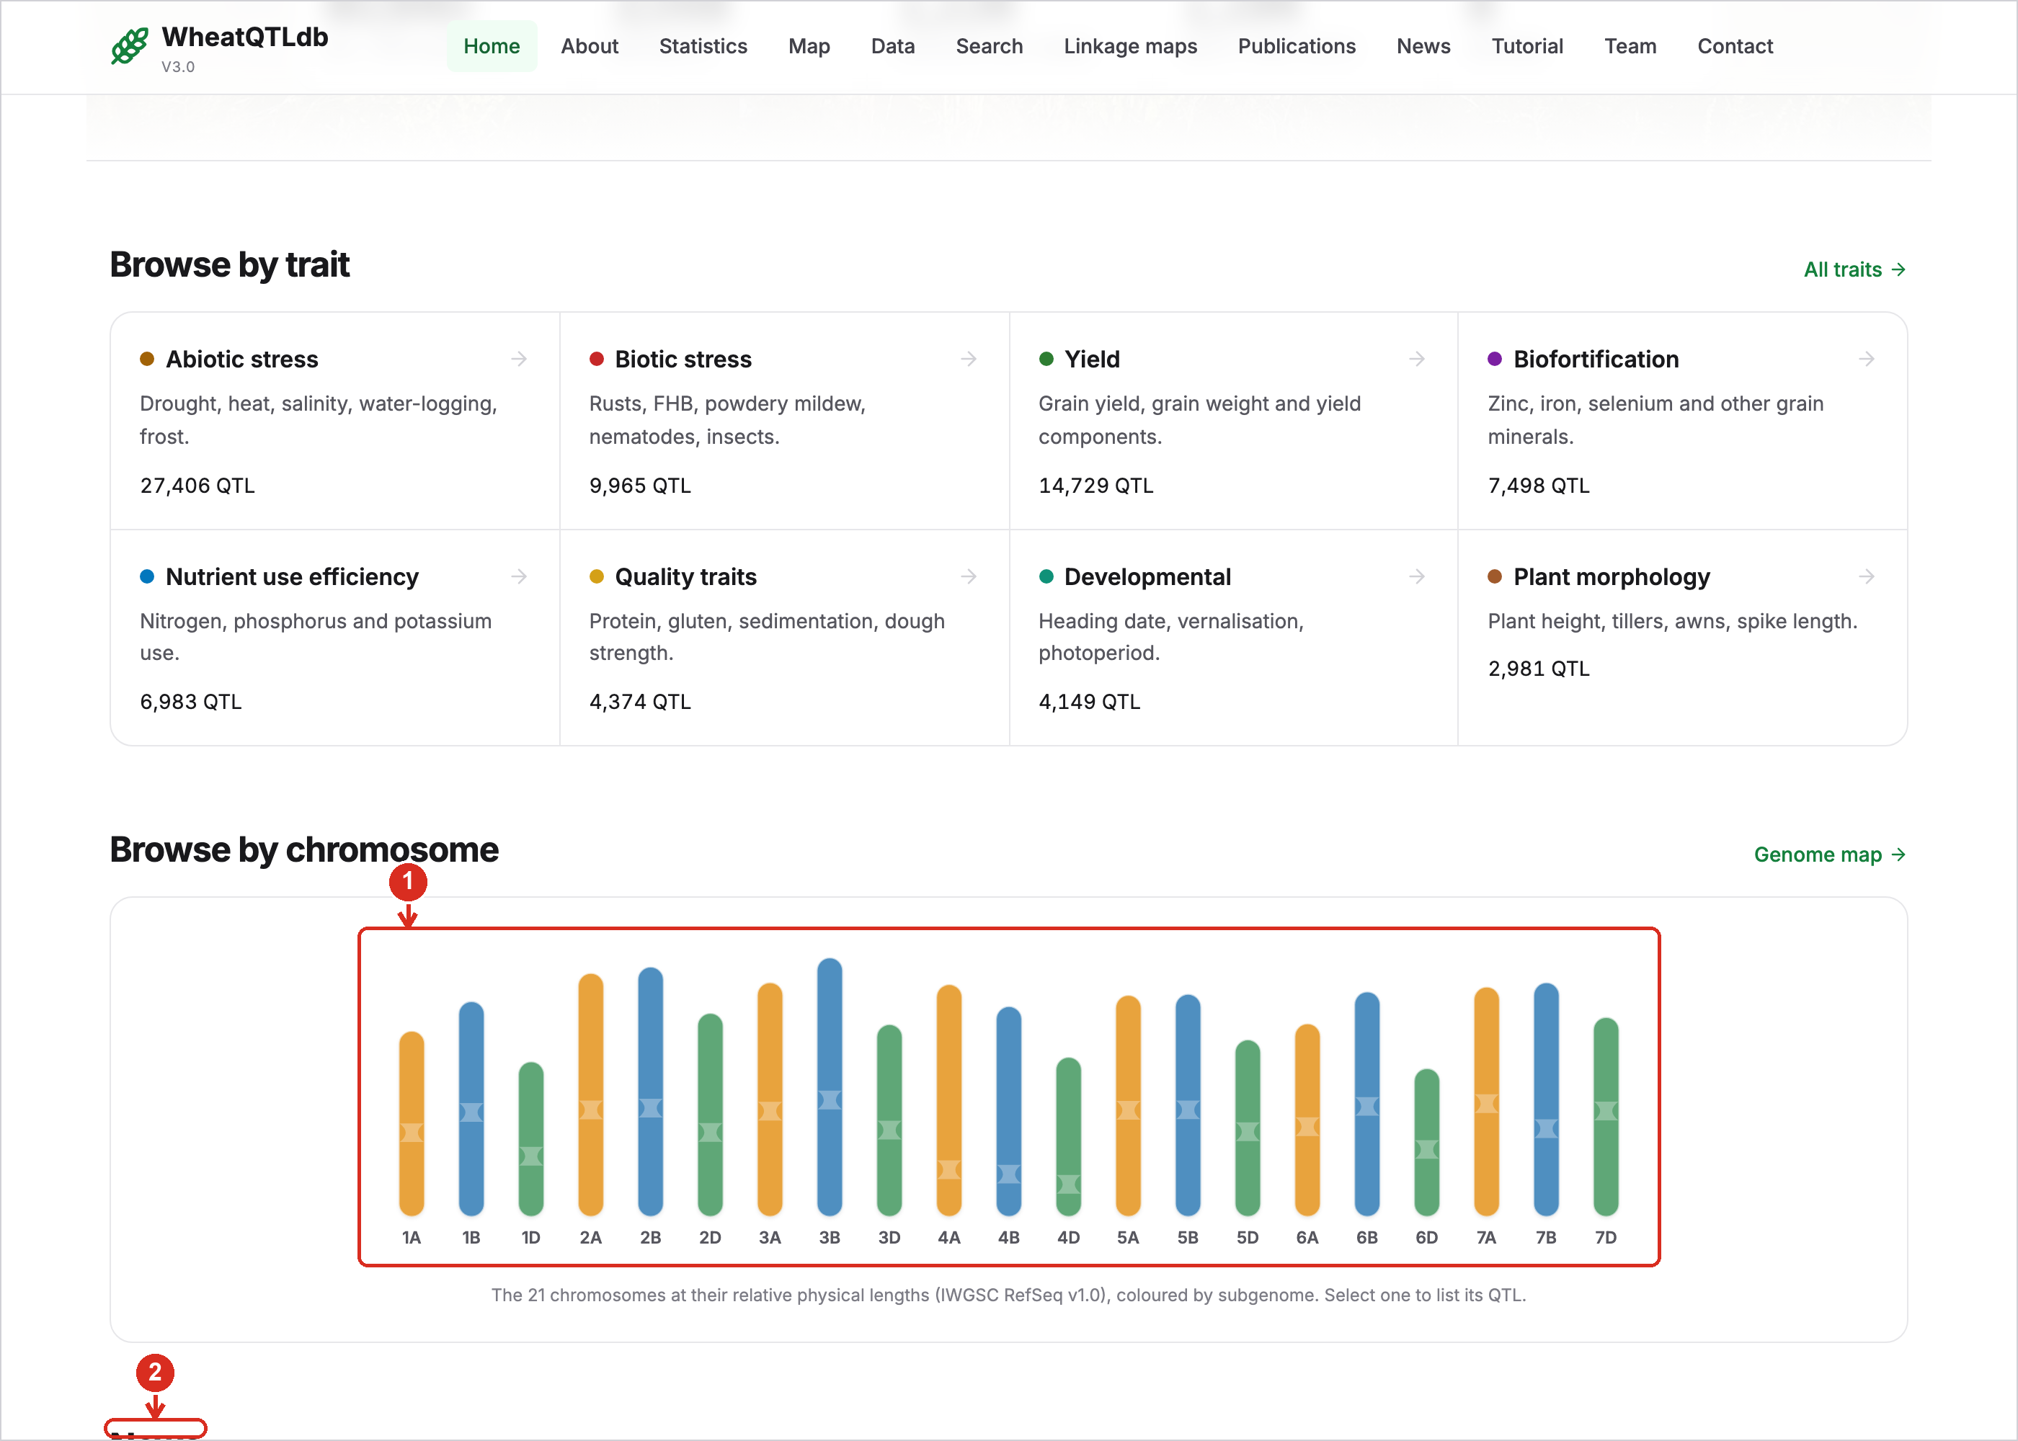
1 | Chromosome picker. The 21 chromosomes drawn at their relative lengths and coloured by subgenome. Click one to list all of its QTL.
2 | News. Data releases and new features, most recent first. “All news” opens the full list.

3. Search
Search combines free text with filters. Filters narrow the table as you set them, and the web address changes with them, so a search can be bookmarked or shared.
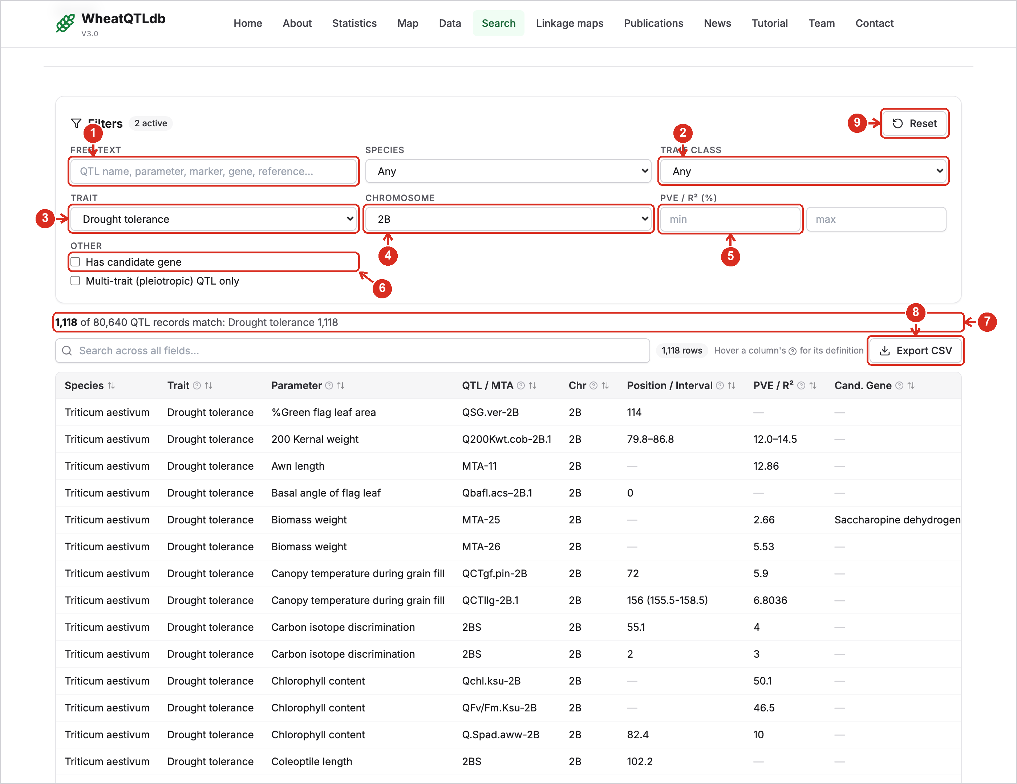
1 | Free text. Matches QTL name, trait, parameter, marker, candidate gene, reference, cross and population.
2 | Trait class. One of the five main traits. Choosing one limits the Trait list to its sub-categories.
3 | Trait. A single trait, such as Drought tolerance or Fungal resistance. Biofortification and Nutrient use efficiency offer a further Sub-trait list.
4 | Chromosome and species. Limit the results to one chromosome or one species.
5 | PVE range. Keep only QTL whose phenotypic variance explained falls between a minimum and a maximum (in %).
6 | Other filters. Show only QTL with a candidate gene, or only multi-trait (pleiotropic) QTL.
7 | Result count. How many records match, out of the whole database, and which traits they belong to.
8 | Export CSV. Downloads exactly the rows that match, with every column, for use in R, Python or Excel.
9 | Reset. Clears every filter.

4. Data tables
The Data page lists every table in the database. Each opens as a sortable, searchable table that can be exported.
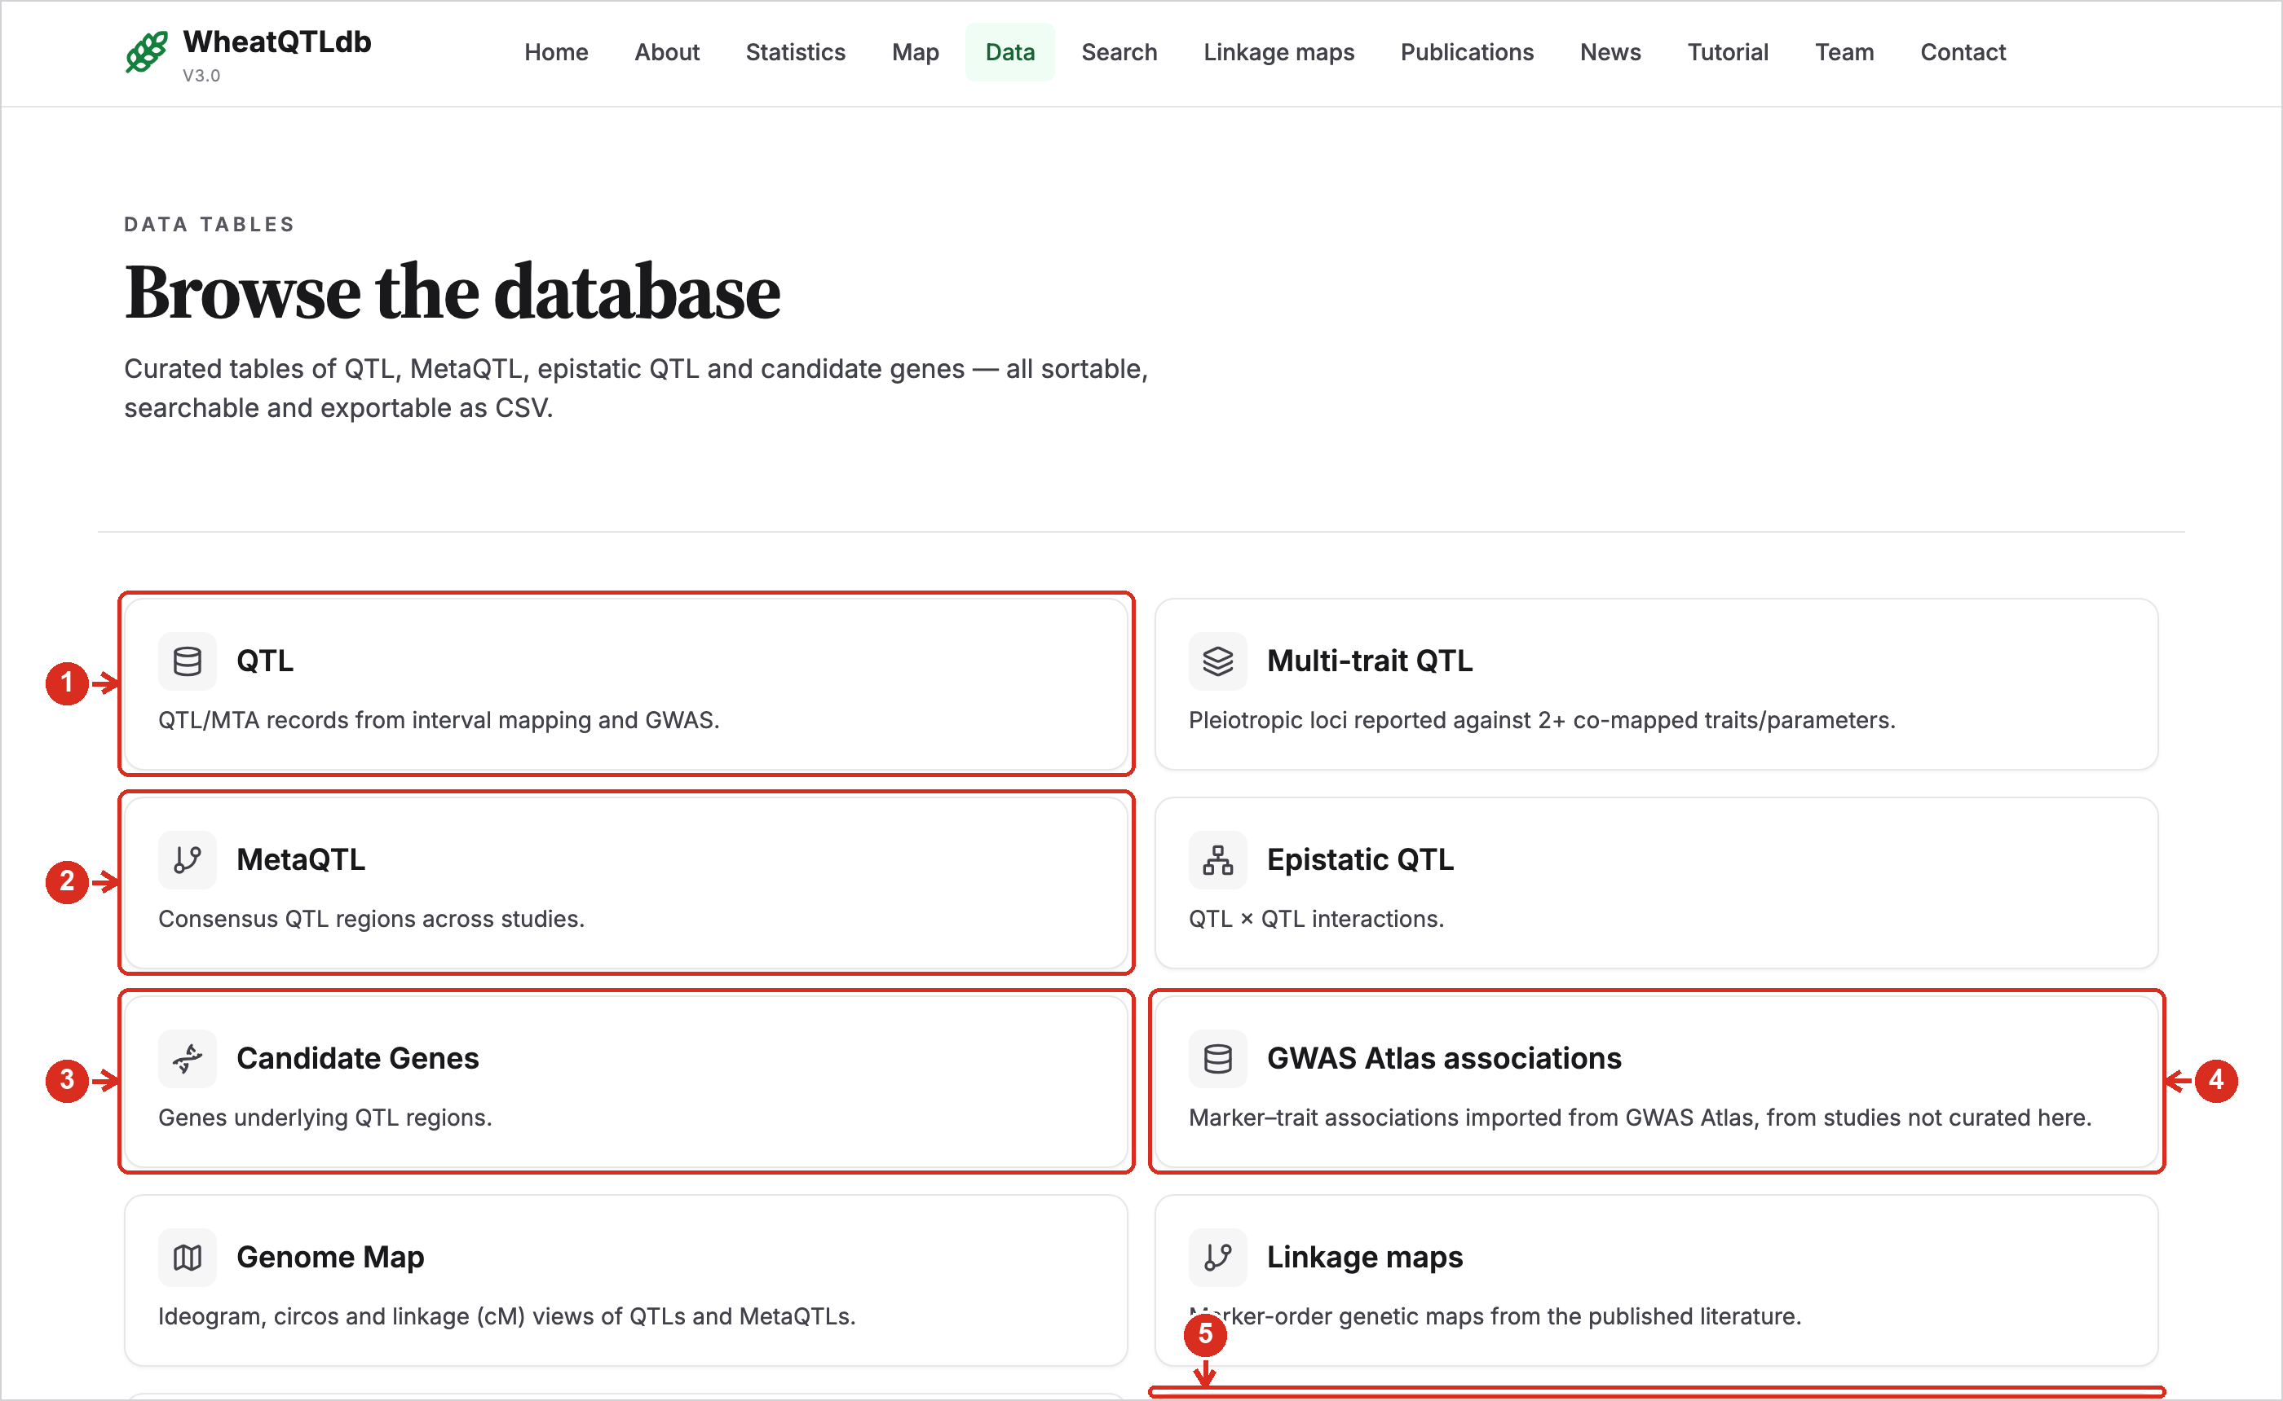
1 | QTL. All main effect QTL and marker–trait associations.
2 | MetaQTL and epistatic QTL. Consensus QTL regions across studies, and QTL × QTL interactions.
3 | Candidate genes. Every gene named as a candidate, linked to GrainGenes or Ensembl Plants.
4 | GWAS Atlas associations. Marker–trait associations imported from GWAS Atlas. They are a separate table and are not part of the QTL counts.
5 | Studies awaiting curation. Papers found in the literature that are not yet in the database.

5. Working with a table
Every table works the same way, whether it is QTL, MetaQTL, candidate genes or publications.
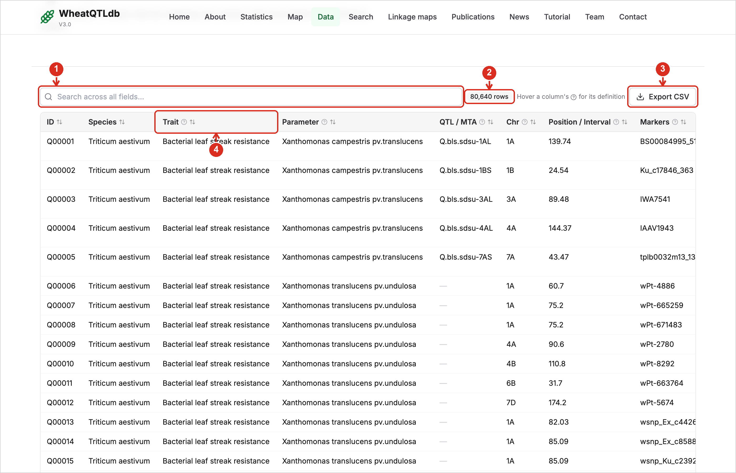
1 | Search the table. Filters the rows as you type, across all columns.
2 | Row count. The number of rows currently shown.
3 | Export CSV. Downloads the rows currently shown.
4 | Sort and definitions. Click a column heading to sort by it; click again to reverse. Hover the small “?” for the definition of the column.
5 | Reference. Opens the source publication. A dash means the source did not report that value.

6. Statistics
The Statistics page summarises what the database holds. All numbers are computed from the current data when the page opens.
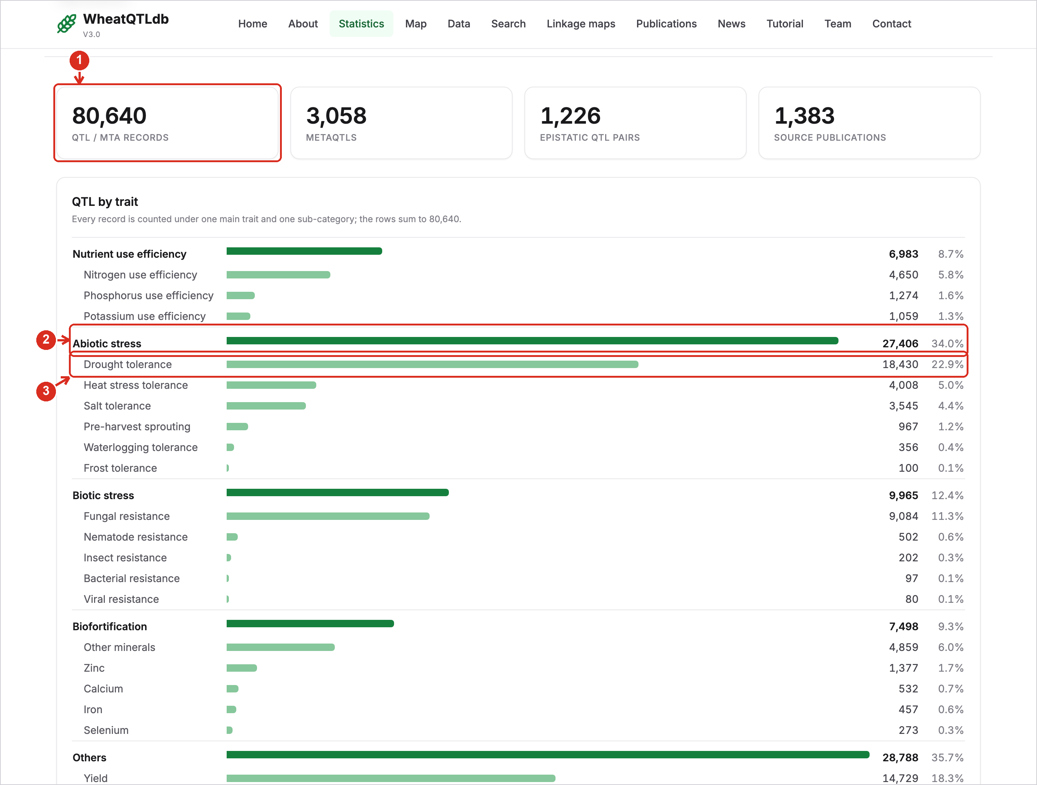
1 | Totals. QTL, MetaQTL, epistatic QTL pairs and source publications.
2 | Main traits. The five main traits with their totals. The bar length is proportional to the number of QTL.
3 | Sub-categories. Each sub-category with its count and its share of all records. The rows add up to the total.

7. Statistics: charts
Below the trait table are charts by chromosome and publication year, and summaries of position type, species and literature coverage.
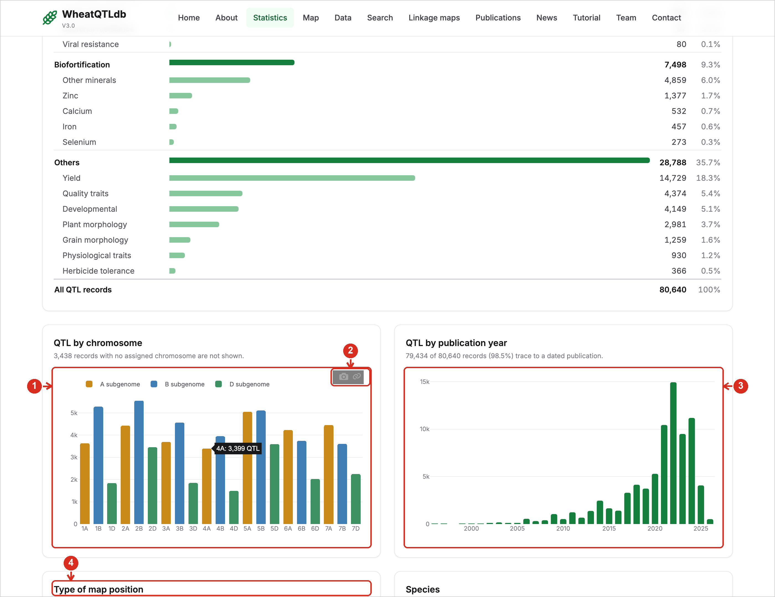
1 | QTL by chromosome. Bars are coloured by subgenome (A, B, D). Hover a bar to read its exact value.
2 | Save a chart. Hover a chart and click the camera icon to save it as a high-resolution PNG.
3 | QTL by publication year. The year of the study each QTL came from.
4 | Type of map position. How many QTL have a physical position, a genetic position only, or none.

8. Genome map: Circos view
The Map page draws QTL and MetaQTL on the wheat genome. The Circos view shows all 21 chromosomes in a circle.
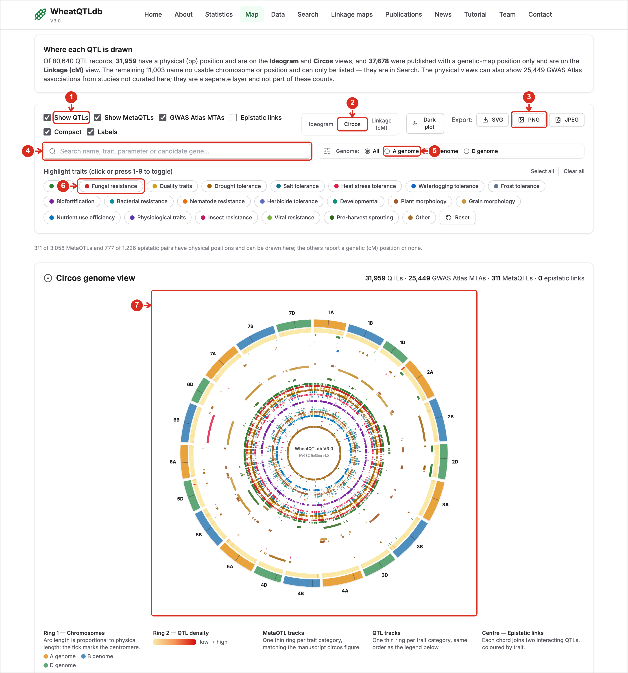
1 | Layers. Switch QTL, MetaQTL, GWAS Atlas associations and epistatic links on or off.
2 | Choose the view. Ideogram and Circos show QTL with a physical position; Linkage (cM) shows QTL mapped only on a genetic map.
3 | Export. Save the current view as SVG, PNG or JPEG. PNG and JPEG are saved at print resolution.
4 | Search the map. Shows only the QTL whose name, trait, parameter or candidate gene matches.
5 | Subgenome. Limit the view to the A, B or D subgenome.
6 | Highlight traits. Click one or several traits to show only those. The colours here are the colours used in the plot.
7 | The plot. Outer ring: chromosomes. Next ring: QTL density. Inner rings: one ring per trait for MetaQTL and for QTL. Hover any mark for its details.

9. Genome map: Ideogram view
The Ideogram view lays the chromosomes side by side, each at its true physical length.
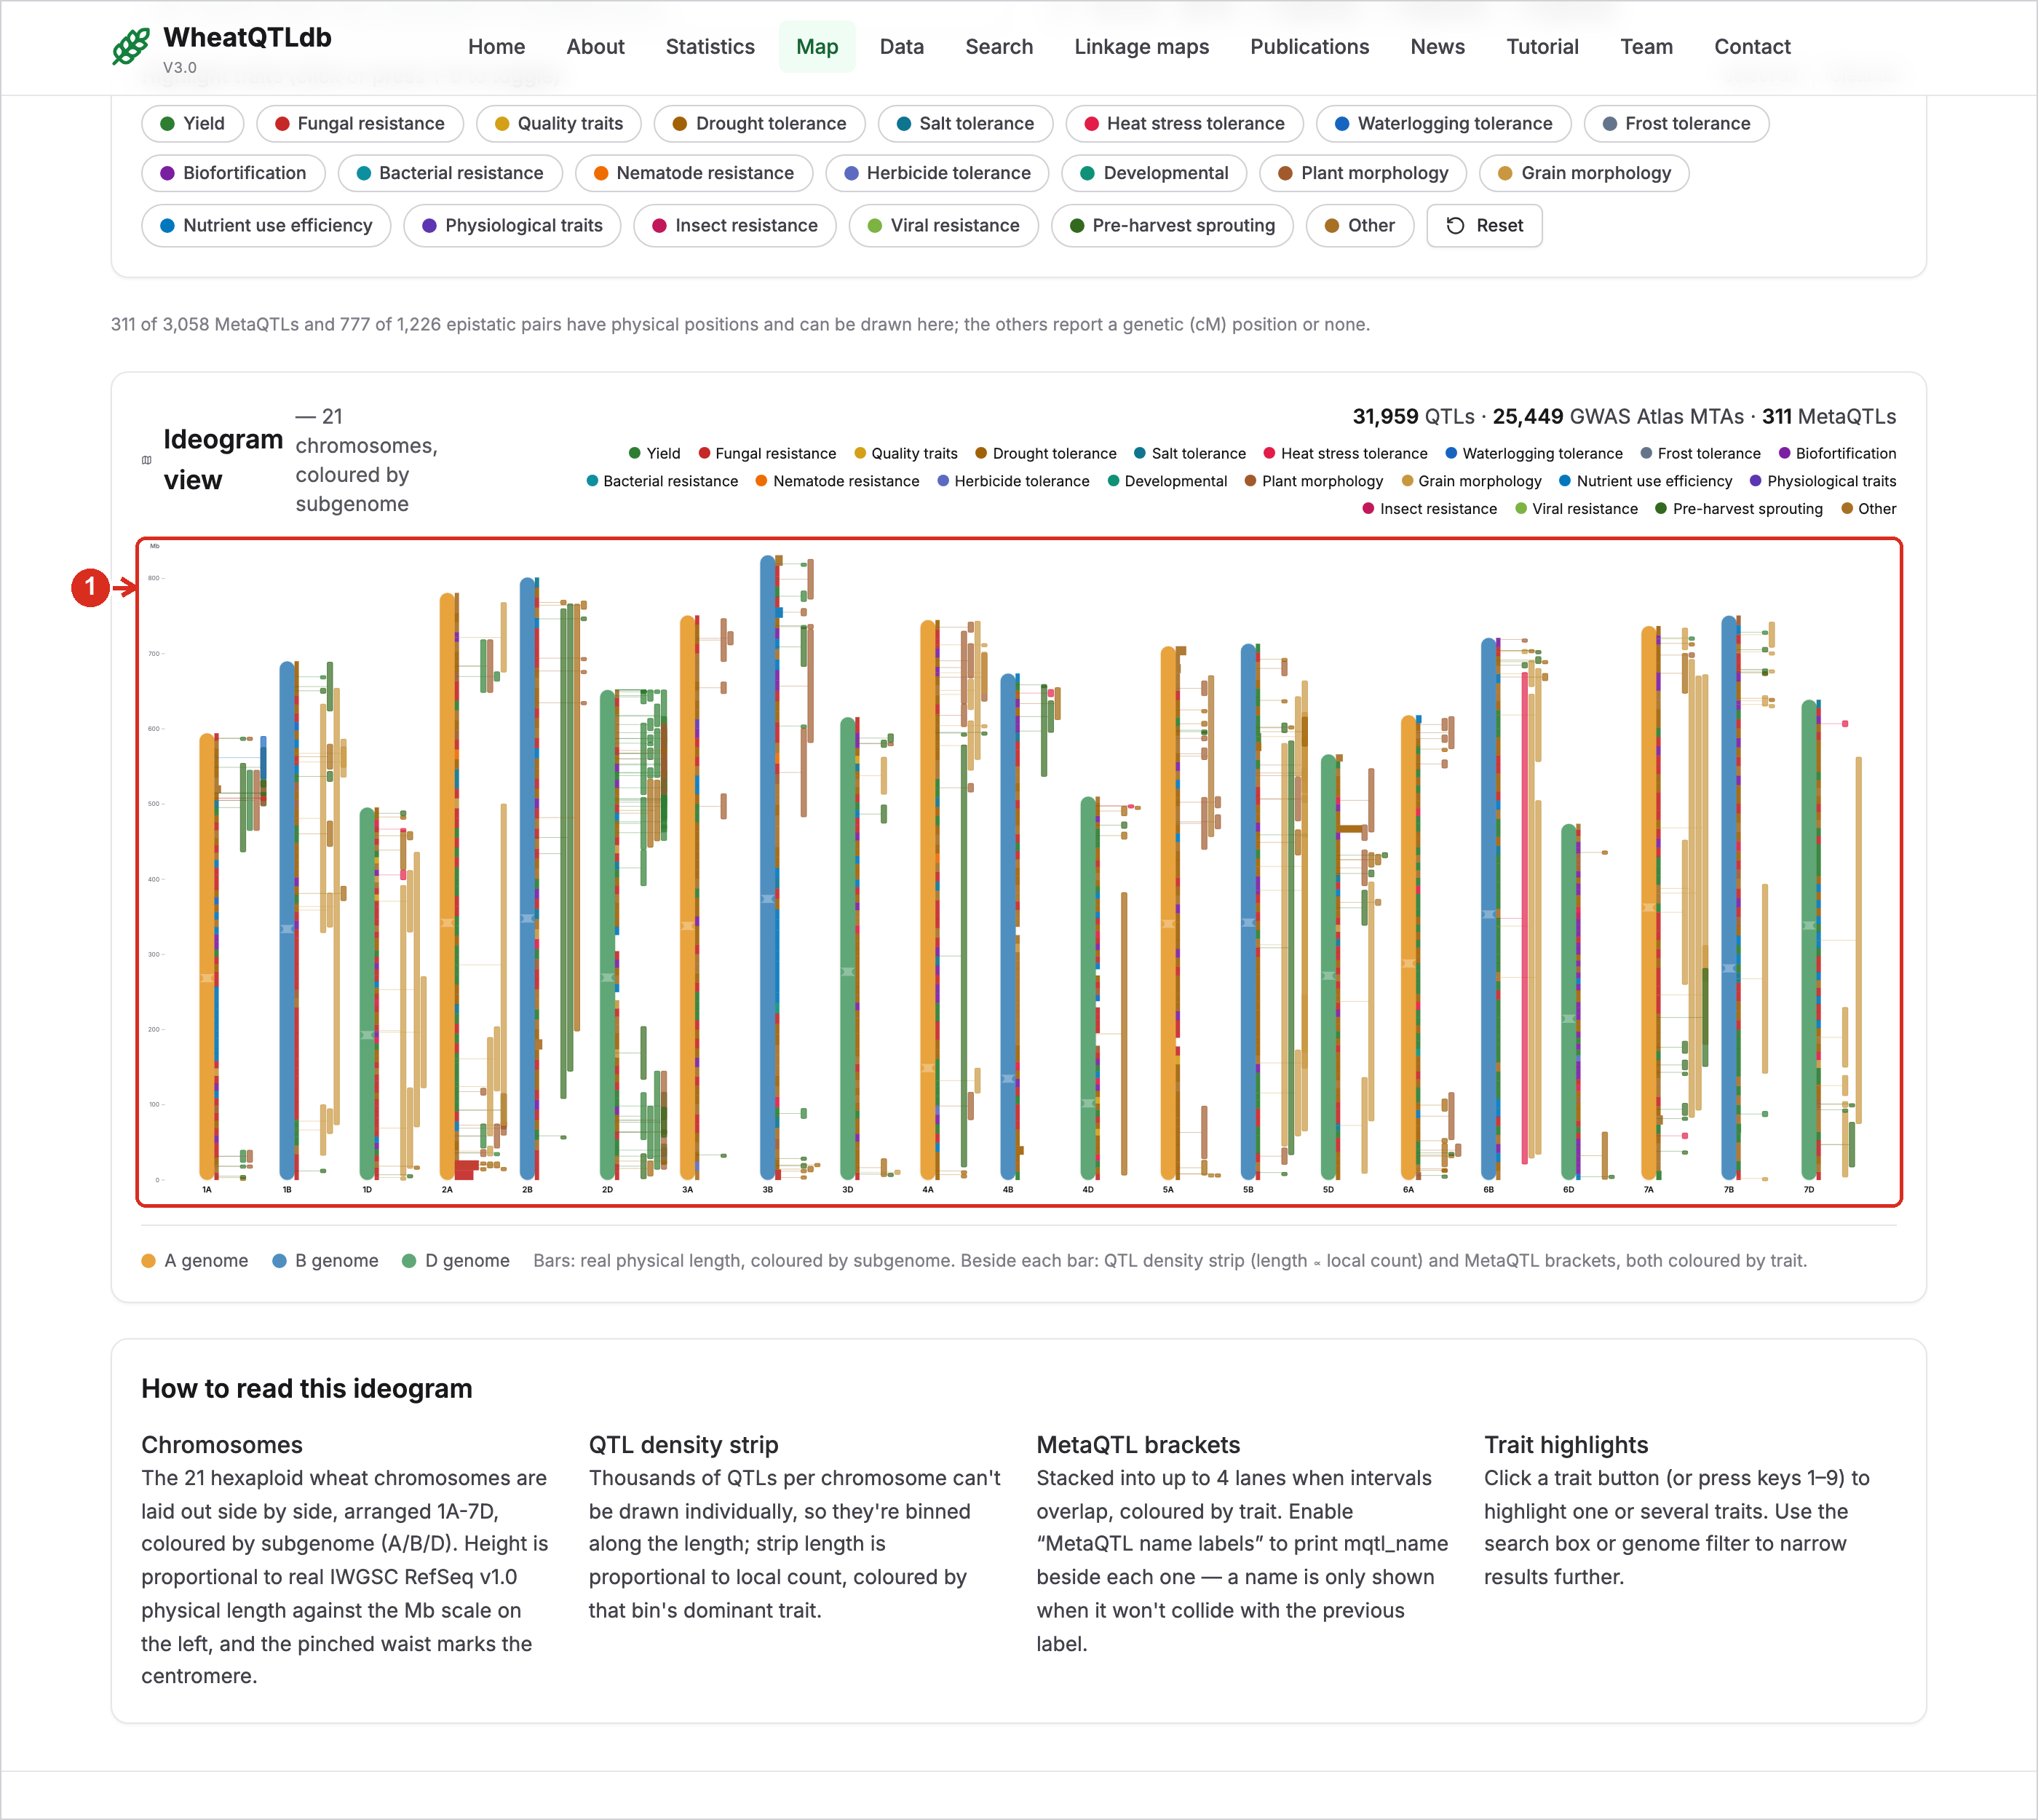
1 | Chromosomes. Height is proportional to physical length; the pinch marks the centromere. The strip beside each chromosome shows QTL density, coloured by the most frequent trait, and the brackets are MetaQTL intervals.

10. Genome map: Linkage (cM) view
Many QTL were published with a genetic-map position only. They cannot be placed on the physical views, so they are drawn here on a centimorgan scale.
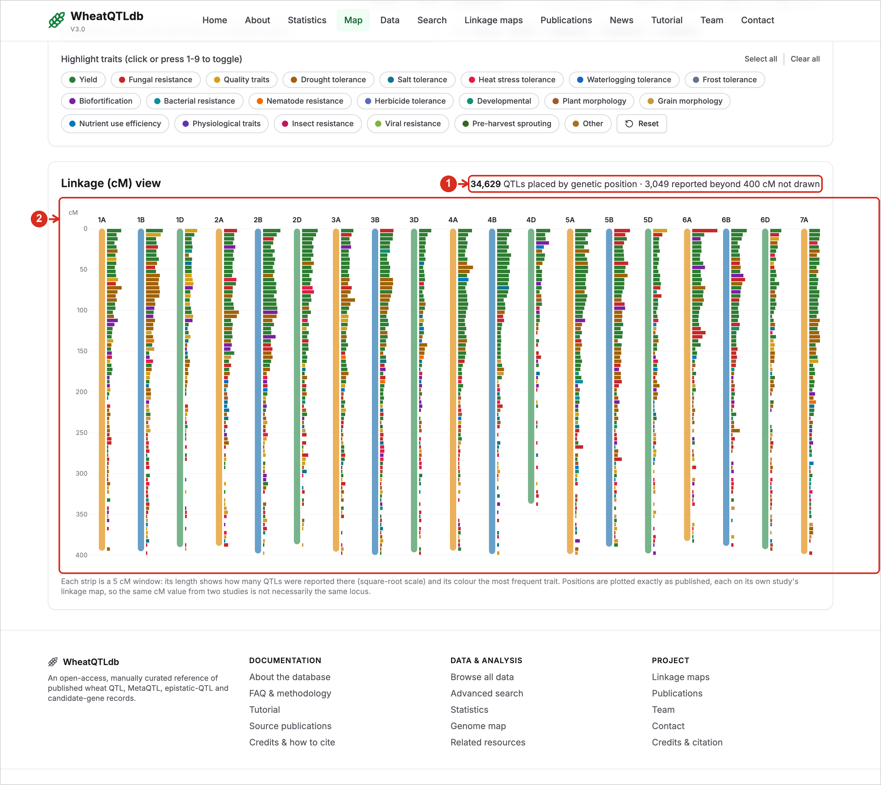
1 | How many are shown. The number of QTL drawn by their genetic position.
2 | cM scale. Each strip is a 5 cM window: its length shows how many QTL were reported there and its colour the most frequent trait. Positions are as published, each on its own study’s map.

11. Linkage maps
Genetic maps behind the mapped QTL: the GrainGenes catalogue plus maps whose marker positions can be viewed here.
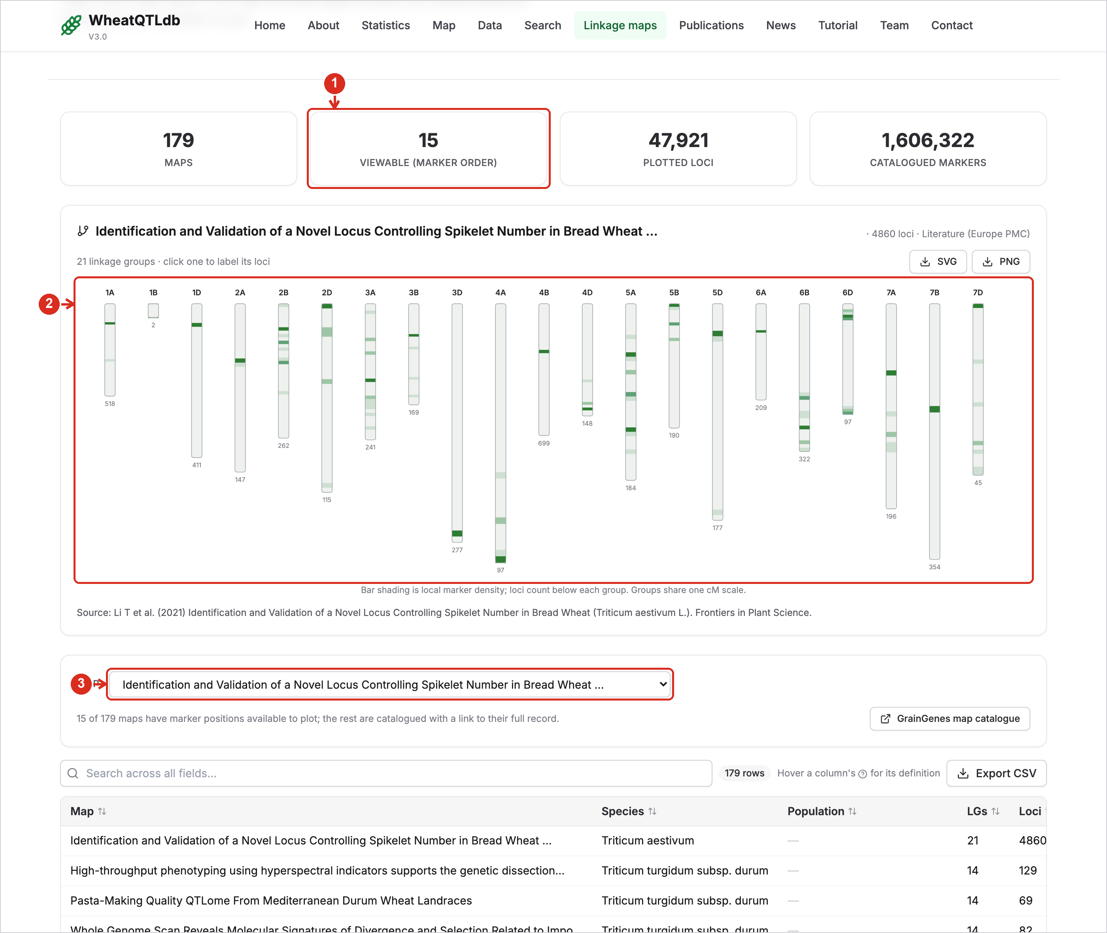
1 | Viewable maps. How many of the catalogued maps can be drawn with their marker positions.
2 | Map viewer. One bar per linkage group; shading shows marker density. Click a group to list its markers.
3 | Choose a map. Maps with marker positions are listed first; the others are catalogue records with a link to GrainGenes.

12. Publications
Every study behind a record, with its title, authors, journal, year and the number of records it contributed.
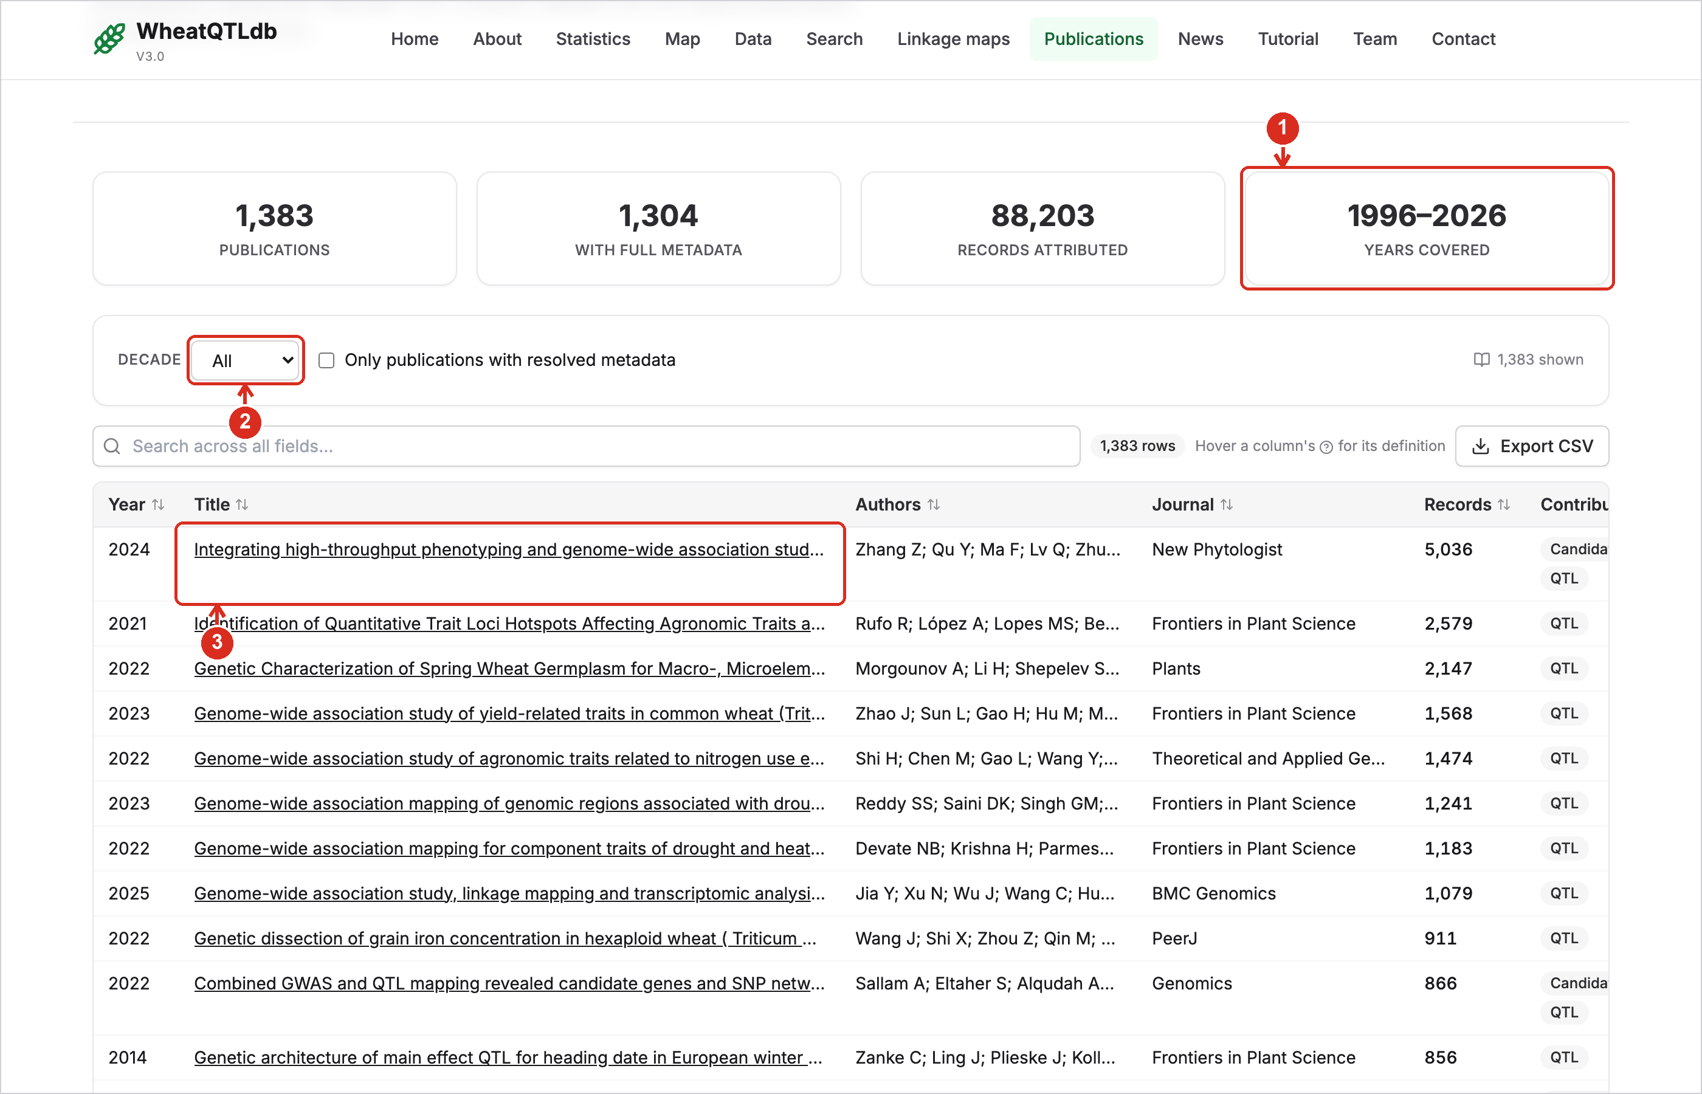
1 | Summary. The number of publications and the years they span.
2 | Decade. Show only the publications of one decade.
3 | Title. Opens the publication. The Records column shows how many records came from it.

13. Candidate genes
Genes proposed as underlying a QTL, each with the link that suits its identifier.
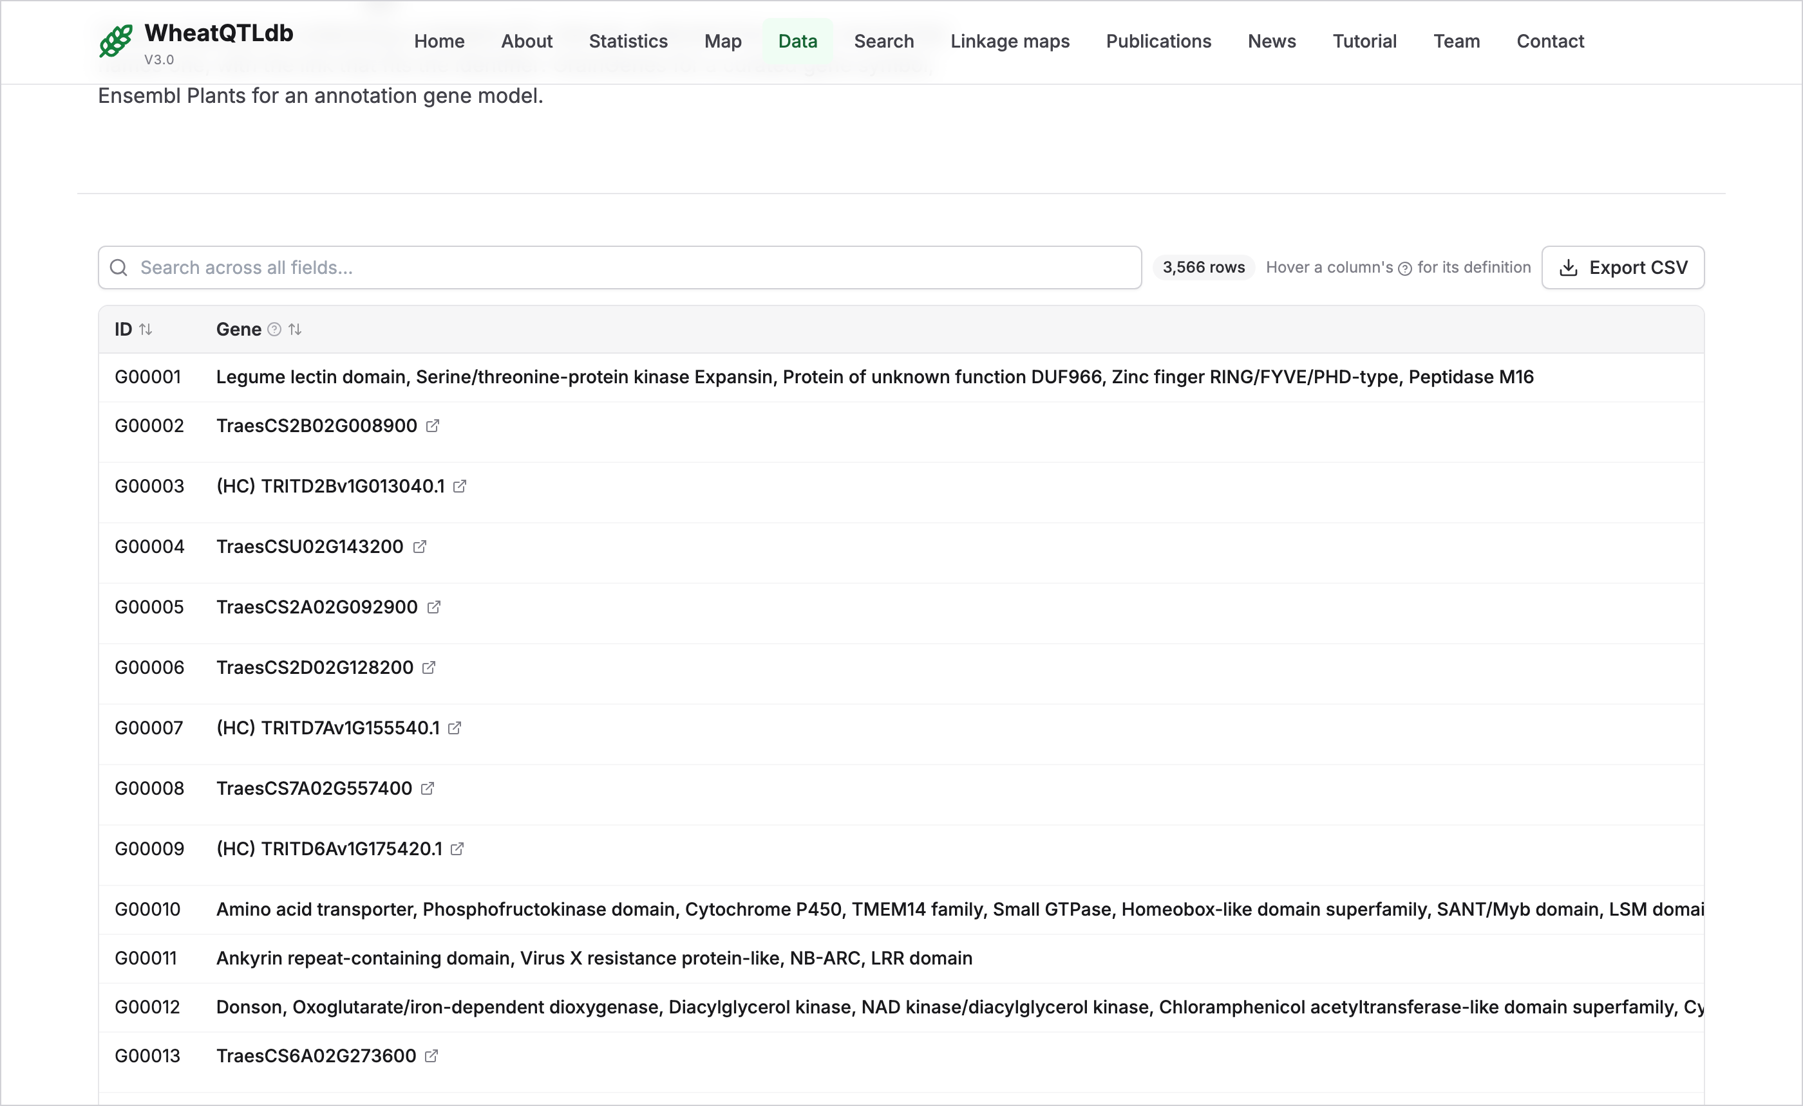
1 | Kind of identifier. Says whether the entry is a gene symbol, an annotation gene model or a functional description.
2 | Resources. Gene symbols open in GrainGenes; gene models open in Ensembl Plants; a position opens the genome browser at that location.

14. Studies awaiting curation and News
Papers found by a literature search that are not yet in the database. They are listed so that curators, and users, can see what is still to come; no QTL has been taken from them. New data and features are announced on the News page.
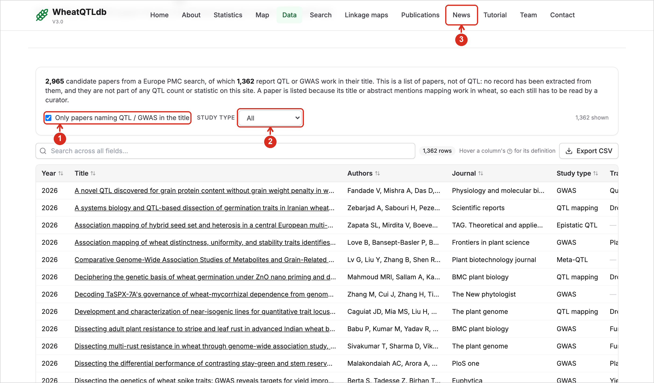
1 | Strongest candidates. Tick to show only papers whose title reports QTL or GWAS work.
2 | Study type. QTL mapping, GWAS, meta-QTL or epistatic QTL.
3 | News. Opens the list of data releases and new features.

