1. Create one vpc in N.virginia region.

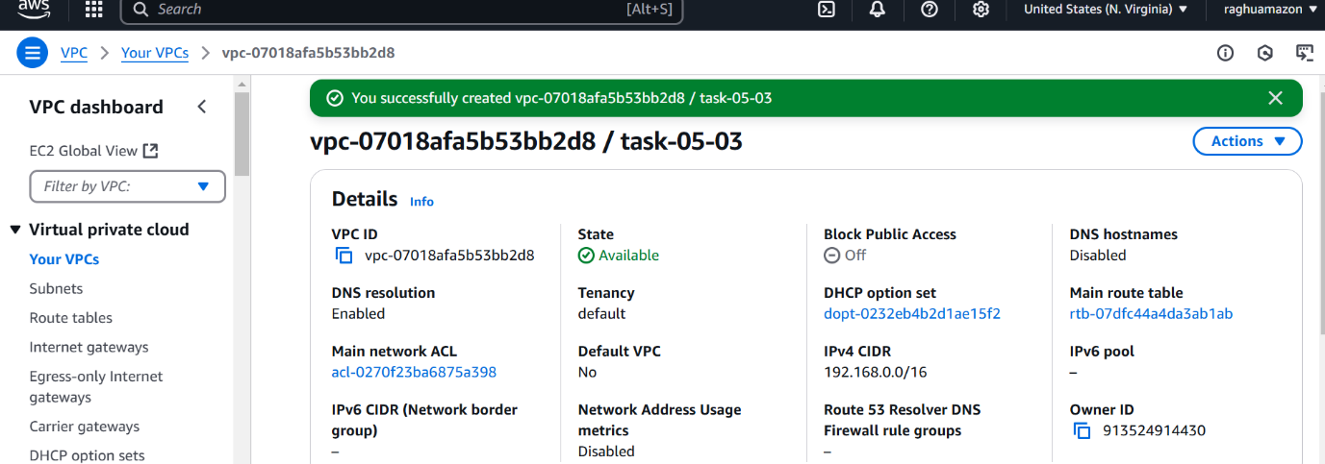

1. Create two subnets. One Public subnet and one private subnet.

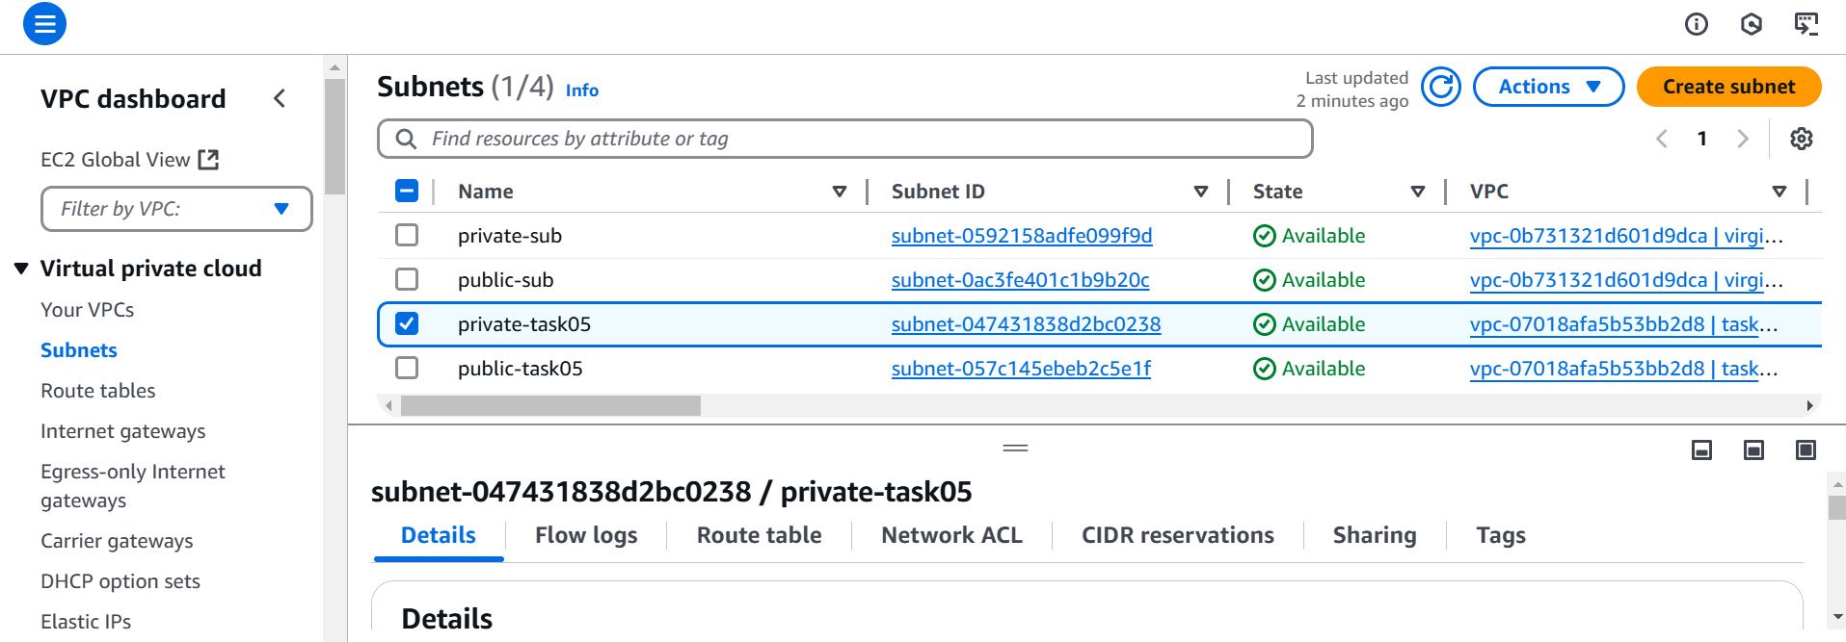

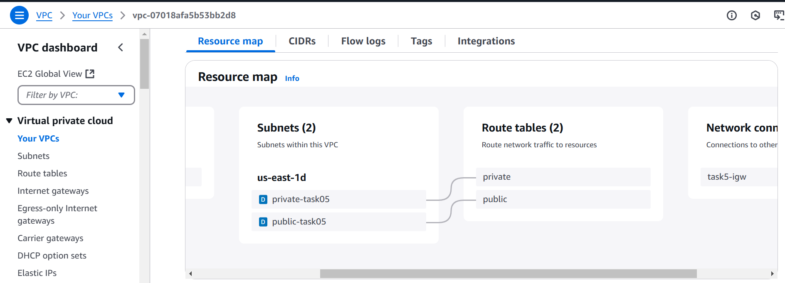

1. Provide the IGW to the vpc.

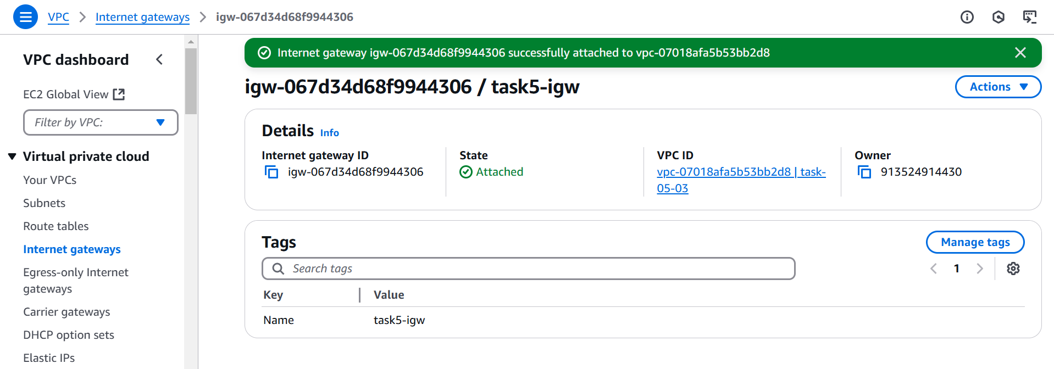

1. Create One public RT and one private RT.

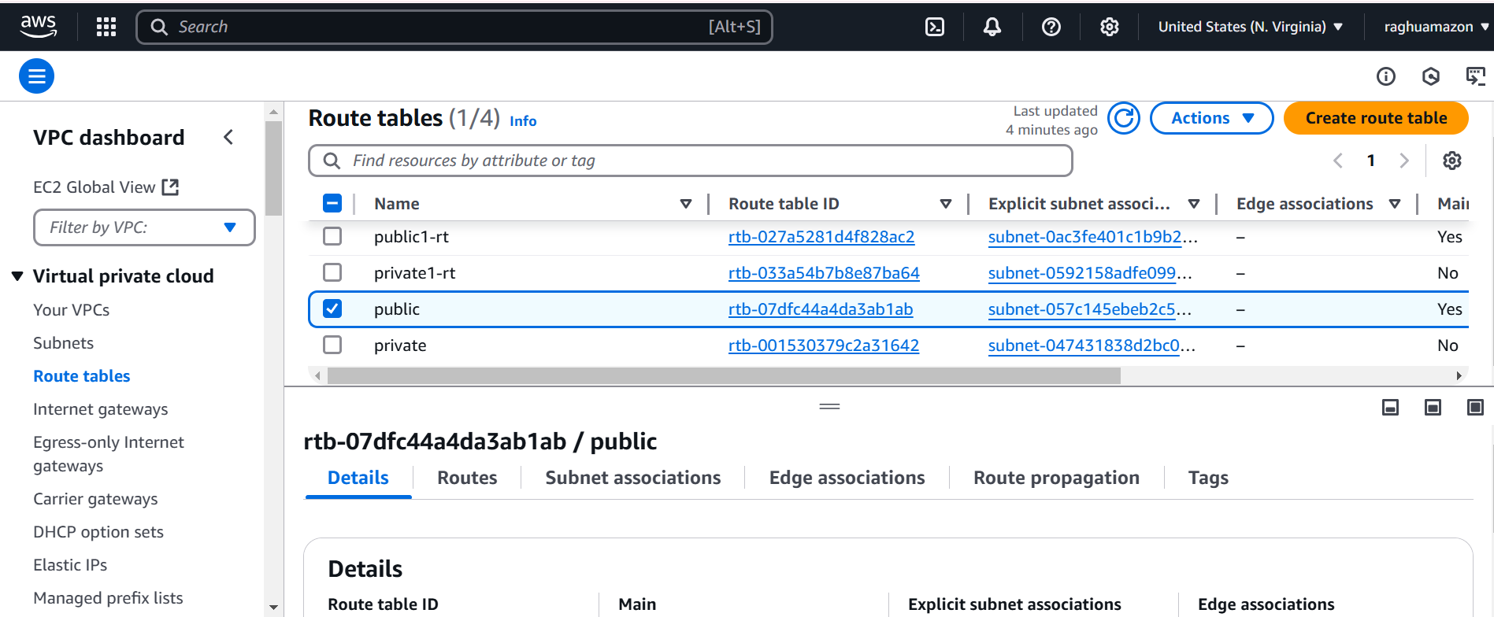

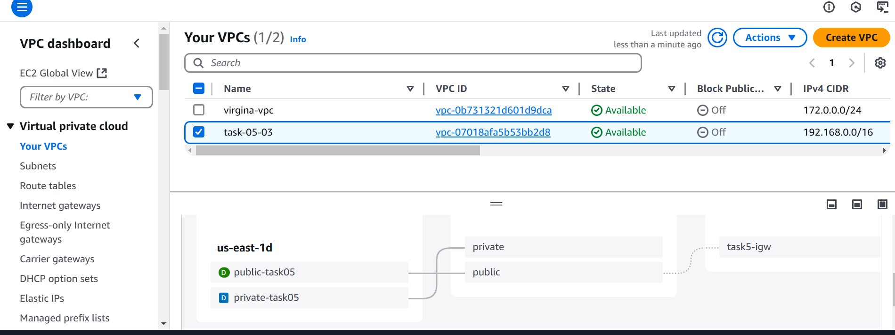

1. Deploy NAT gateway on public subnet and attach the NAT gatewat to private subnet.

Create 1 NAT gate way in public subnet

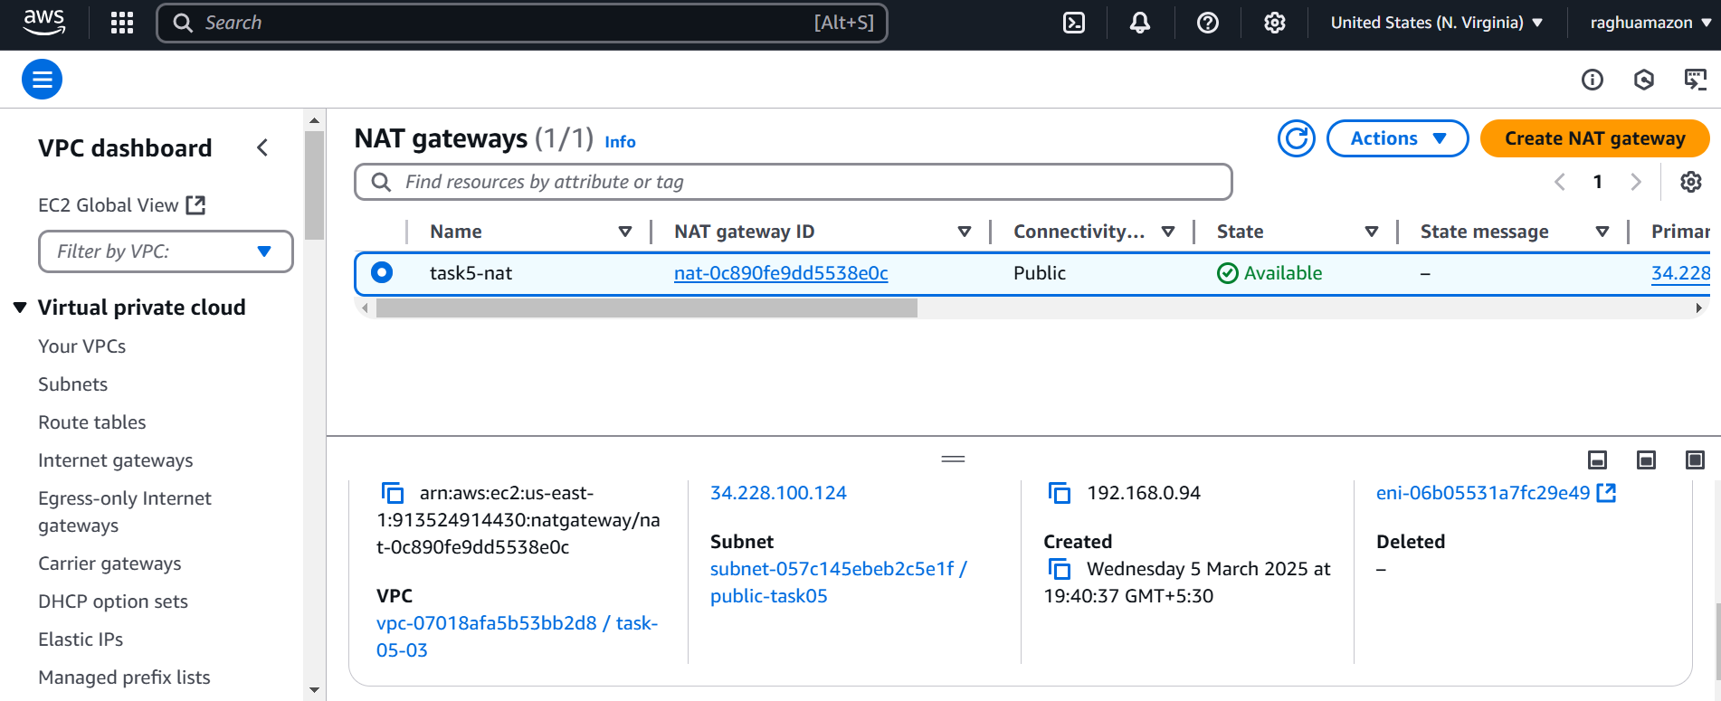

Go to private subnet and attached to NAT gateway

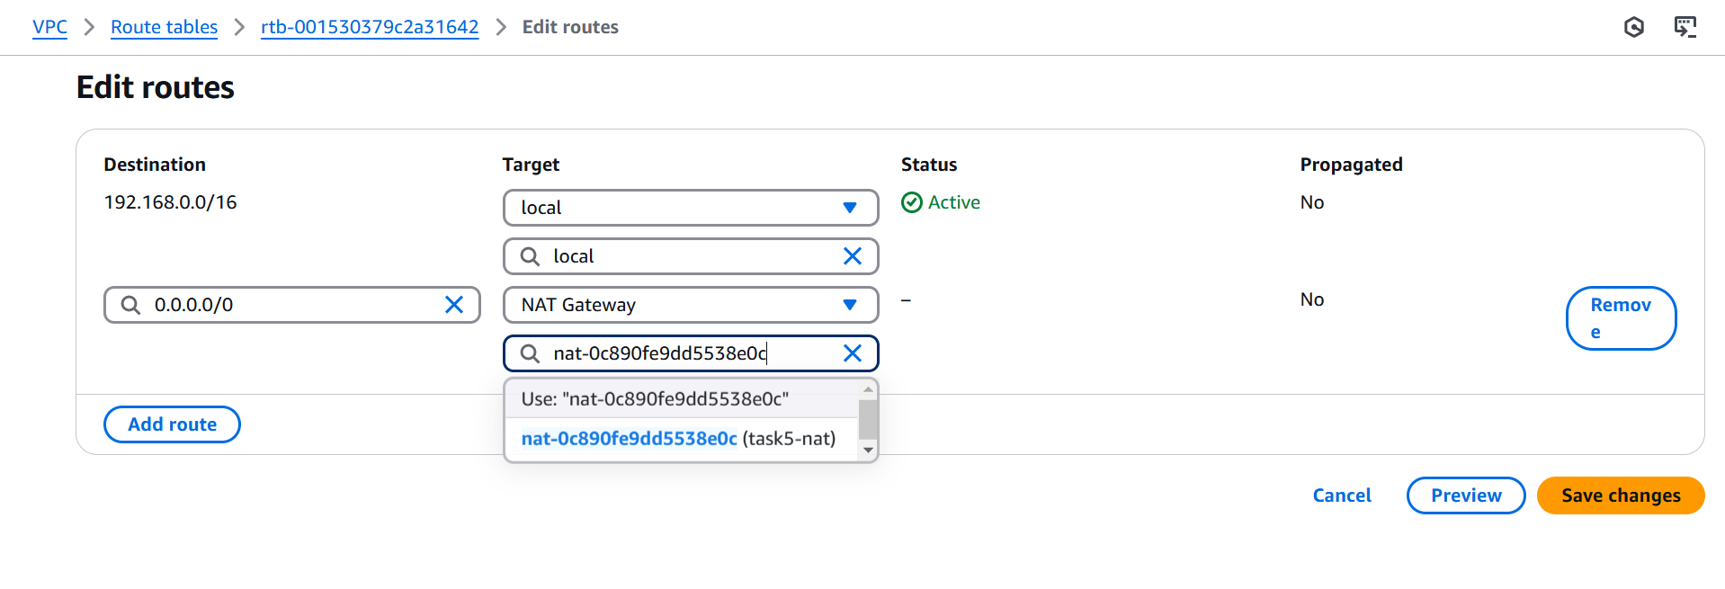

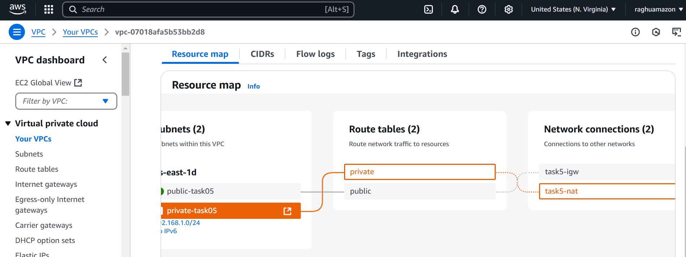

1. Create Two instances,one in public subnet and one in private subnet.

Create instances in public subnet

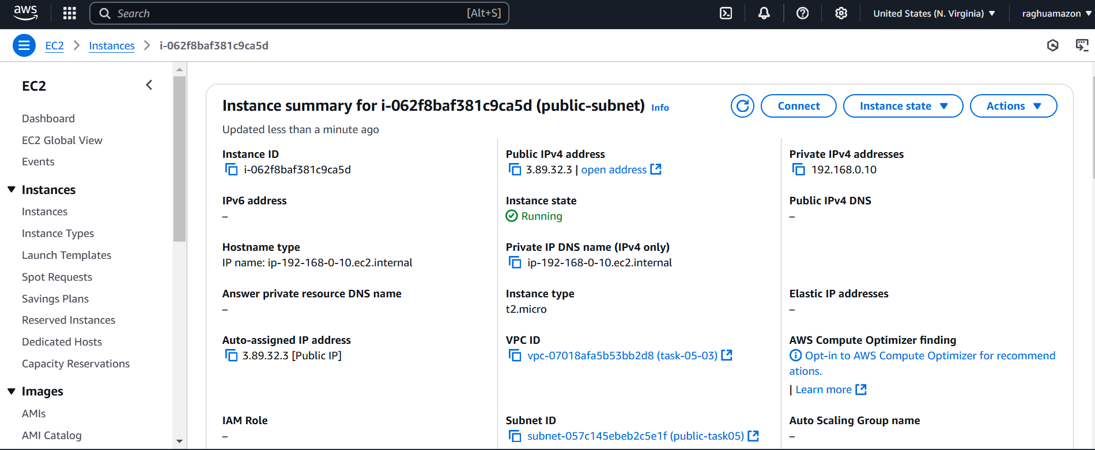

Create instances in public subnet

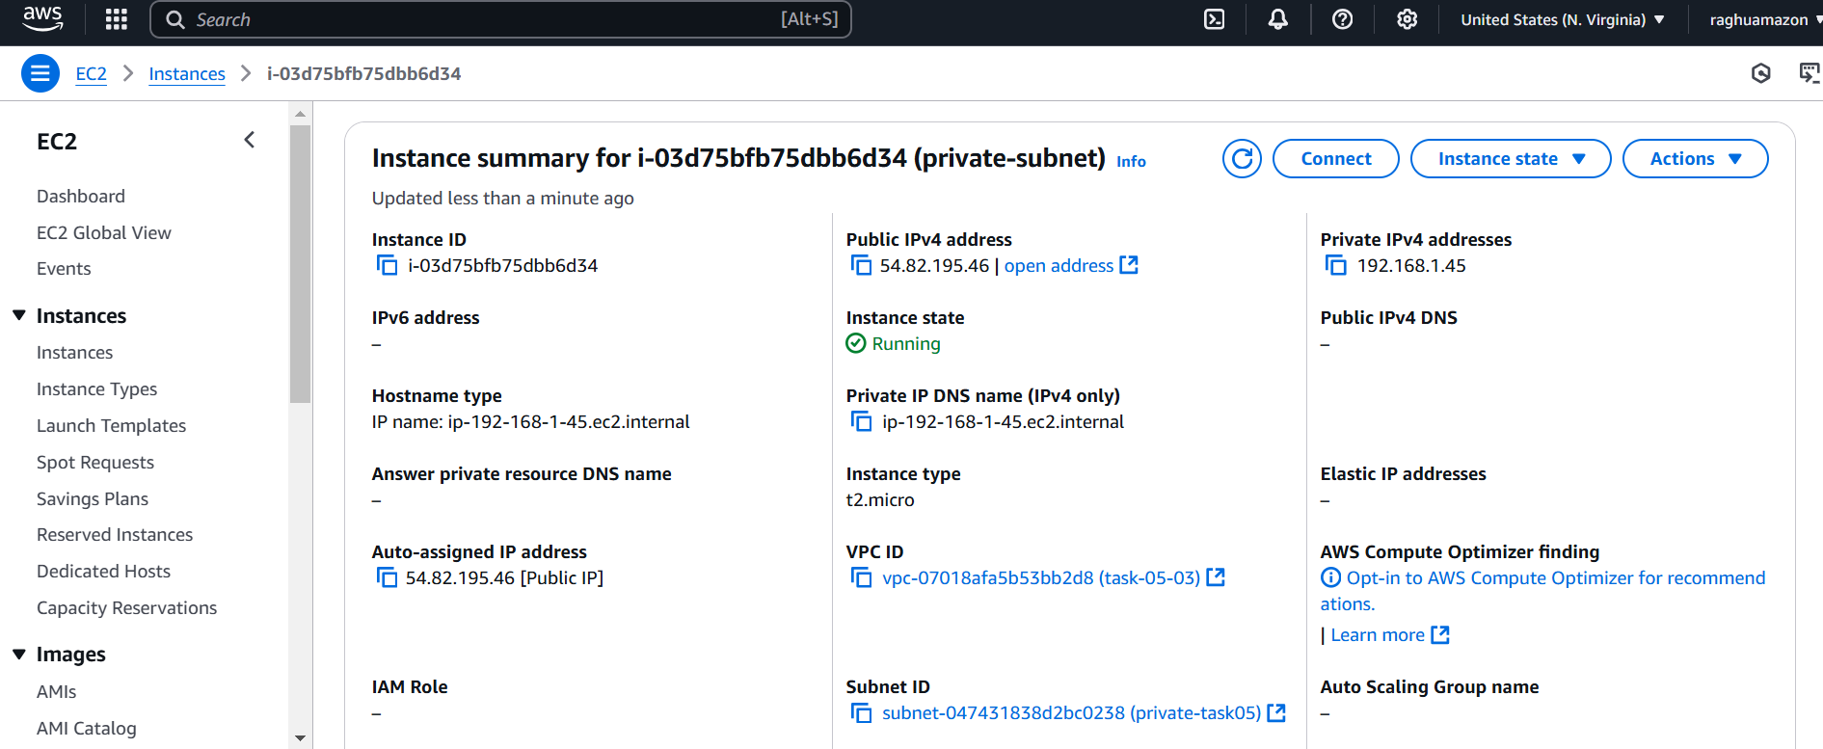

1. Deploy Apache server on both the ec2 instances with sample index.html file.

Deploy Apache server on public ec2 instances





Deploy Apache server on private ec2 instances

First vi key

Chmod 400 key

ssh -i mykey.pem 192.168.1.45(private ip of private instance instance)

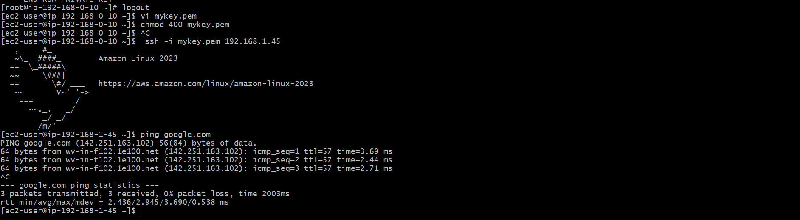

Install and start httpd on private instance

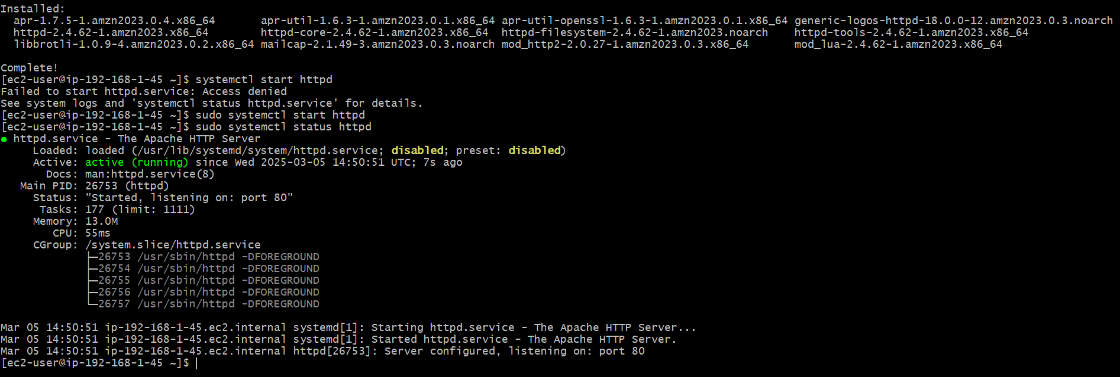

Output of private instance

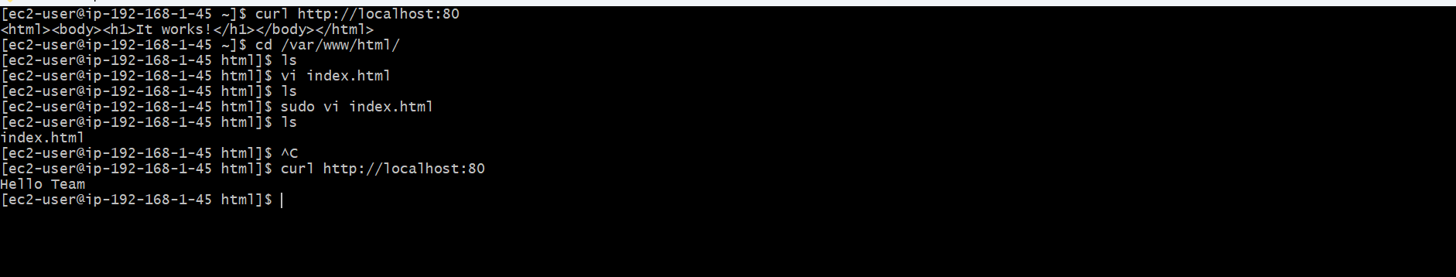

1. Create one application load balancer and attach the load balancer to both the ec2 instances.

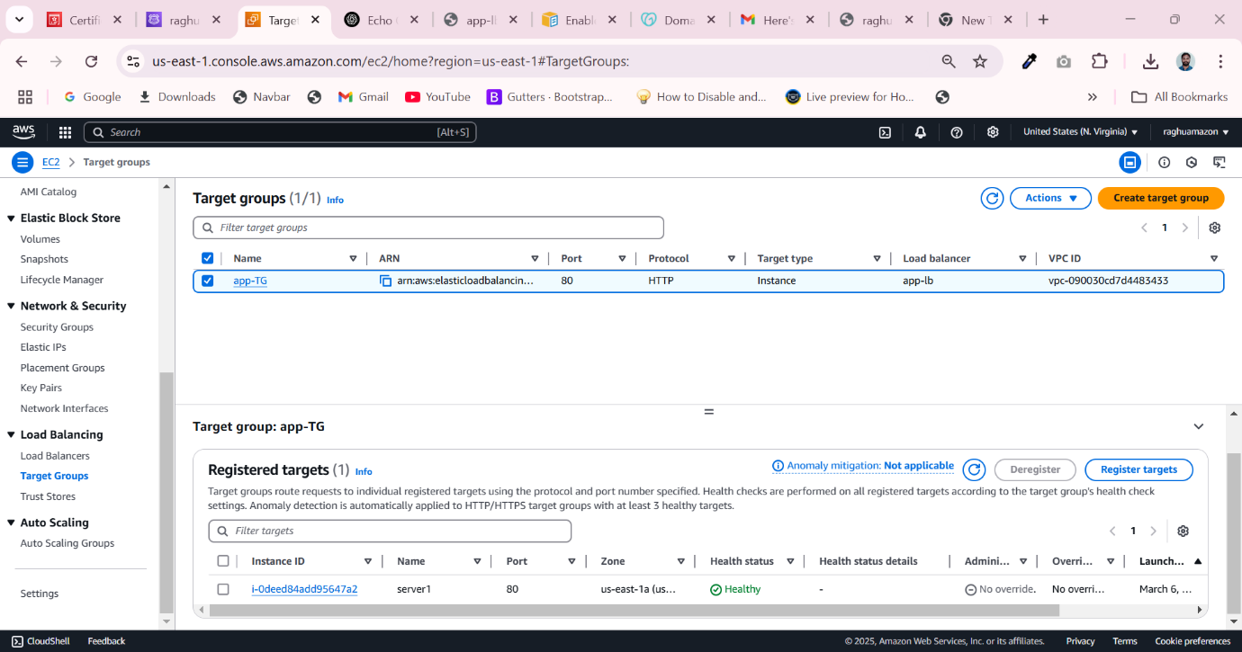

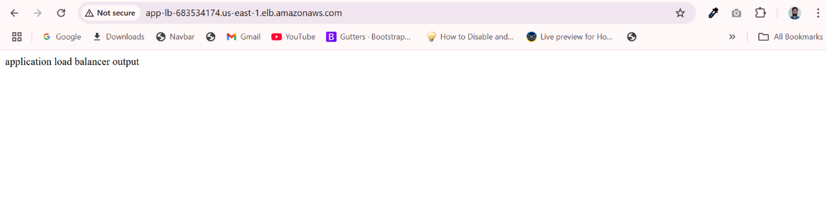

1. Store Application load balancer logs to s3.

I create bucket in S3

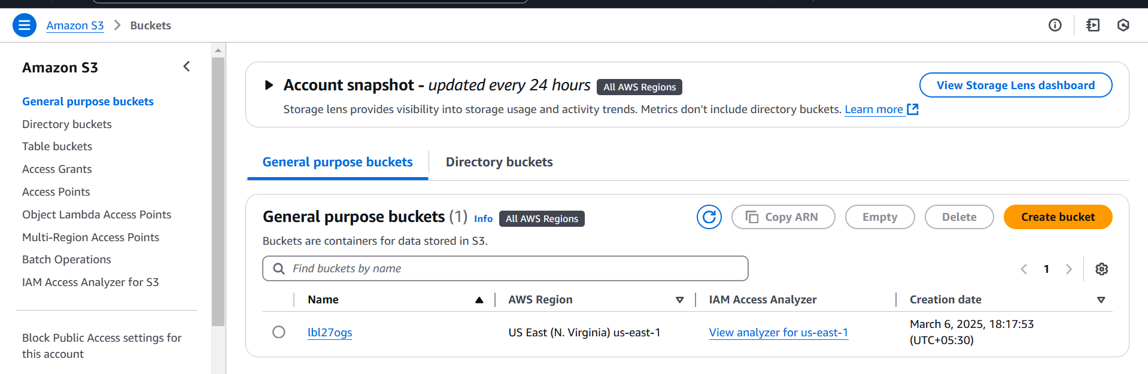

Attach bucket policy to bucket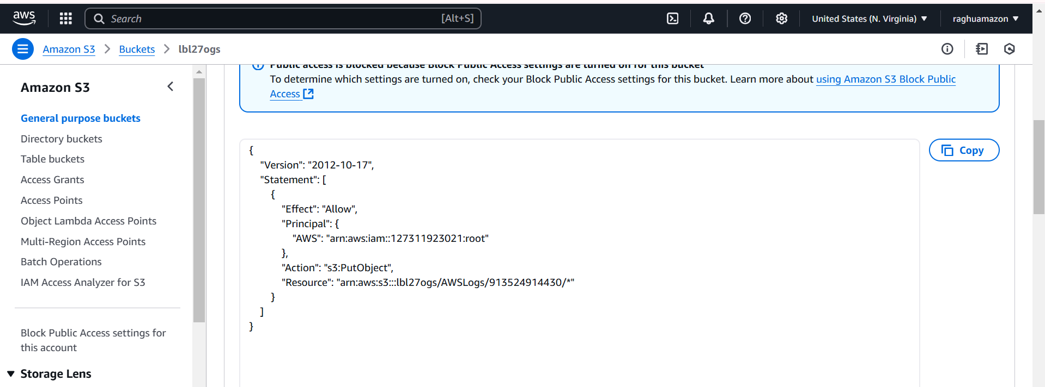

S3 bucket logs

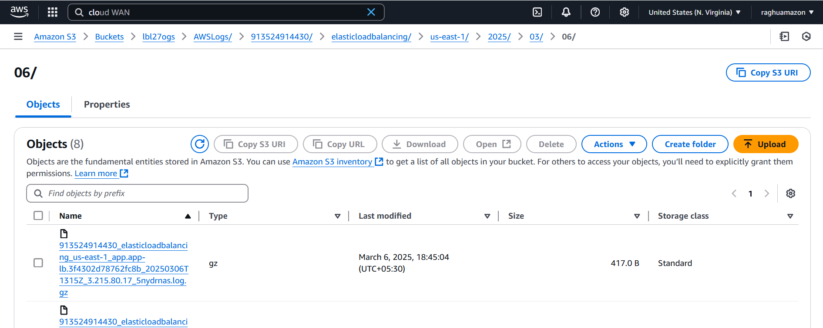

1. Store the vpc flow logs to cloudwtach group.

I am Role for vpc flow logs

{

"Version": "2012-10-17",

"Statement": [

{

"Effect": "Allow",

"Action": [

"logs:CreateLogGroup",

"logs:CreateLogStream",

"logs:PutLogEvents",

"logs:DescribeLogGroups",

"logs:DescribeLogStreams"

],

"Resource": "\*"

}

]

}

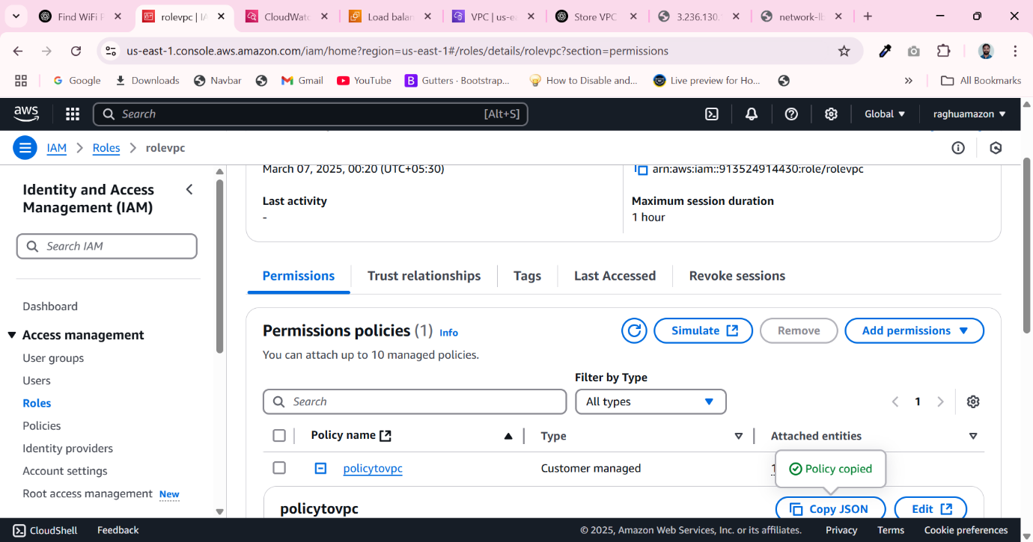

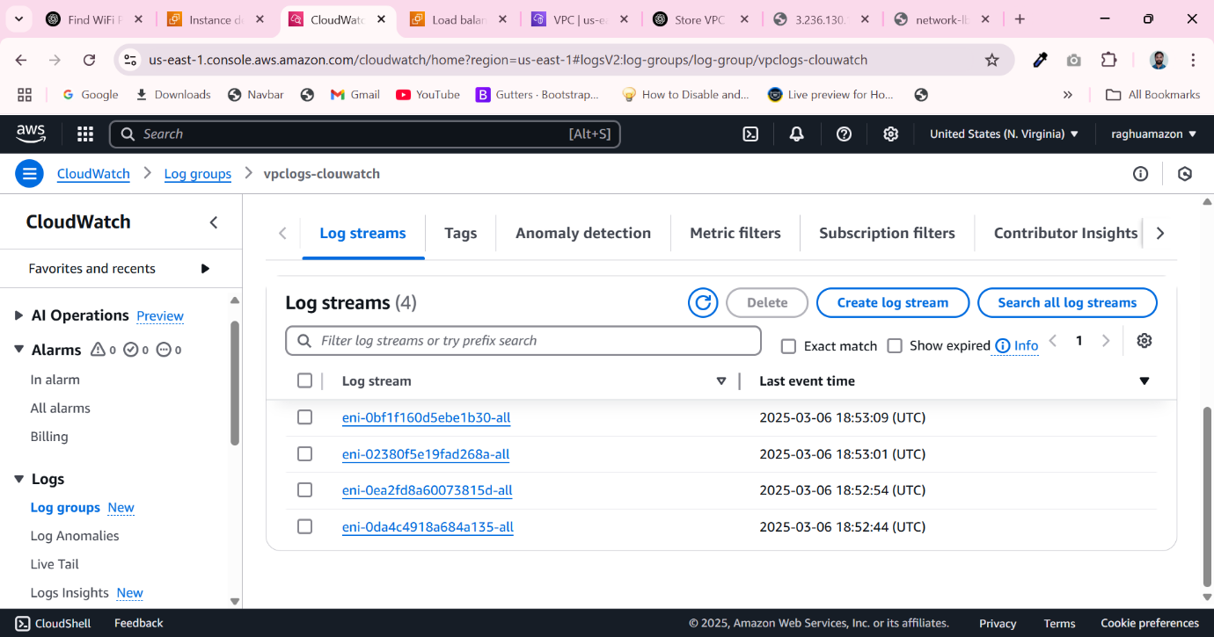

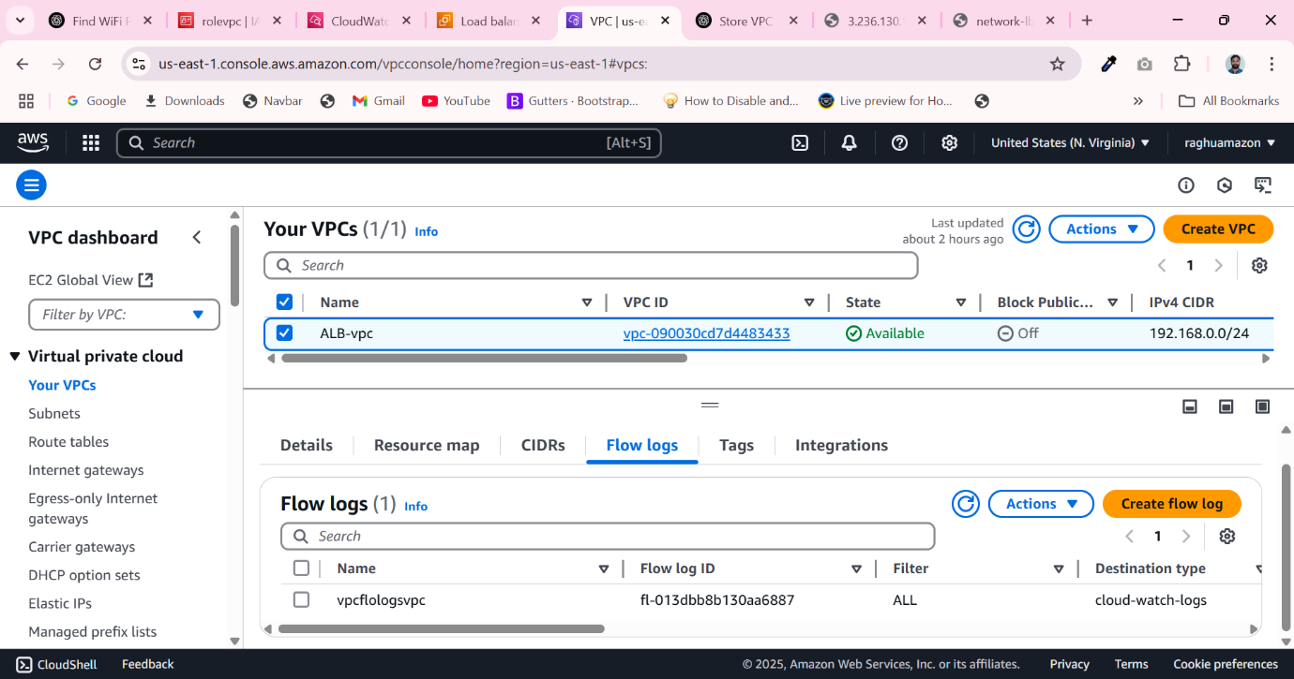

1. Create Monitoring Dashboards to monitor cpu utilization and to monitor apache service.

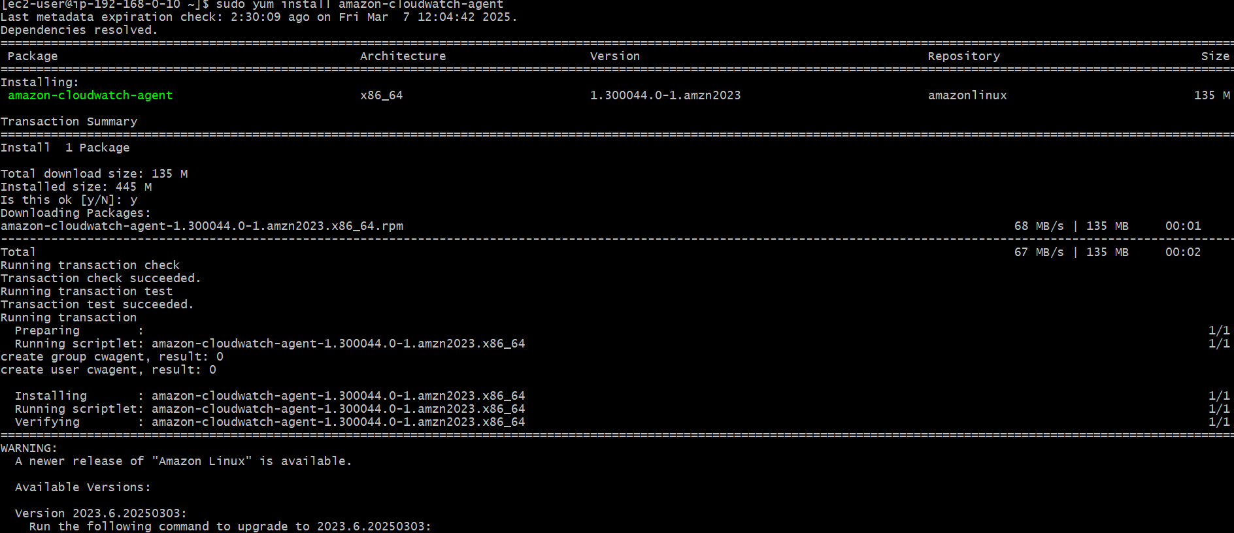

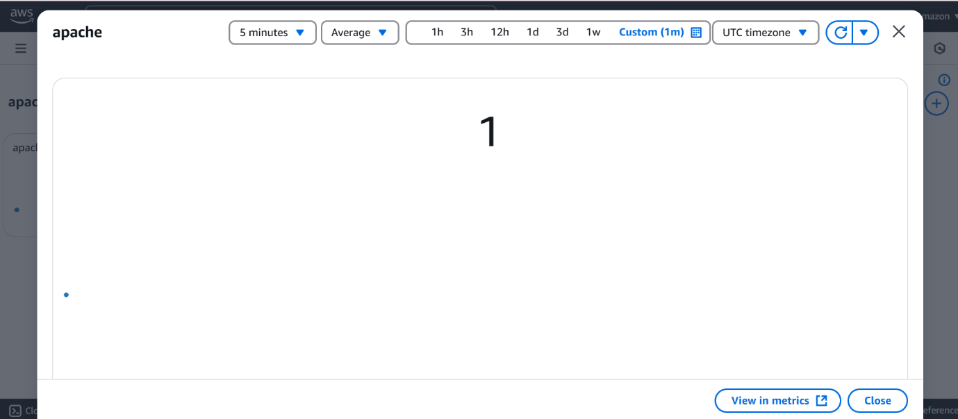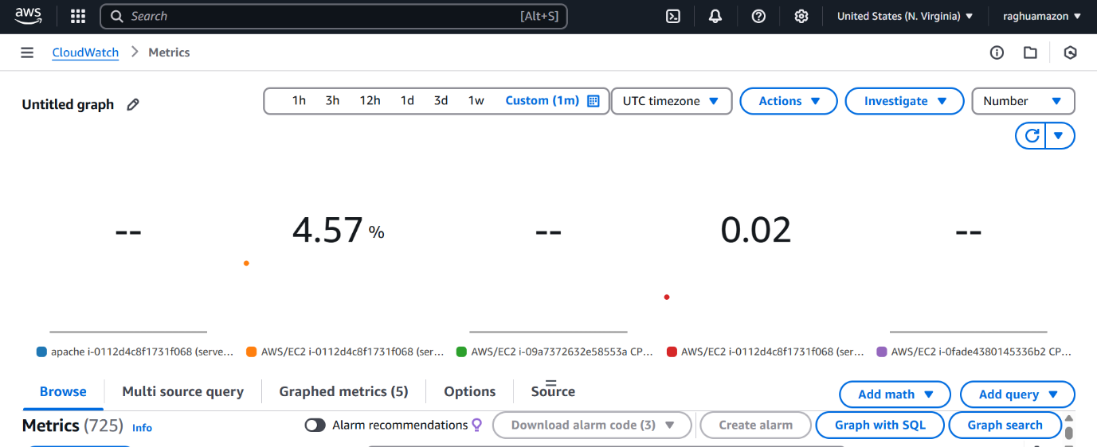

1. CPU utilizationis more than 70% then it should triggere Autoscaling and launch new instance.

