1.Write a bash script to find the latency from the sample nginx log file.

Bash script should only only print the latency.

Send the log_test.csv file from windows to linux

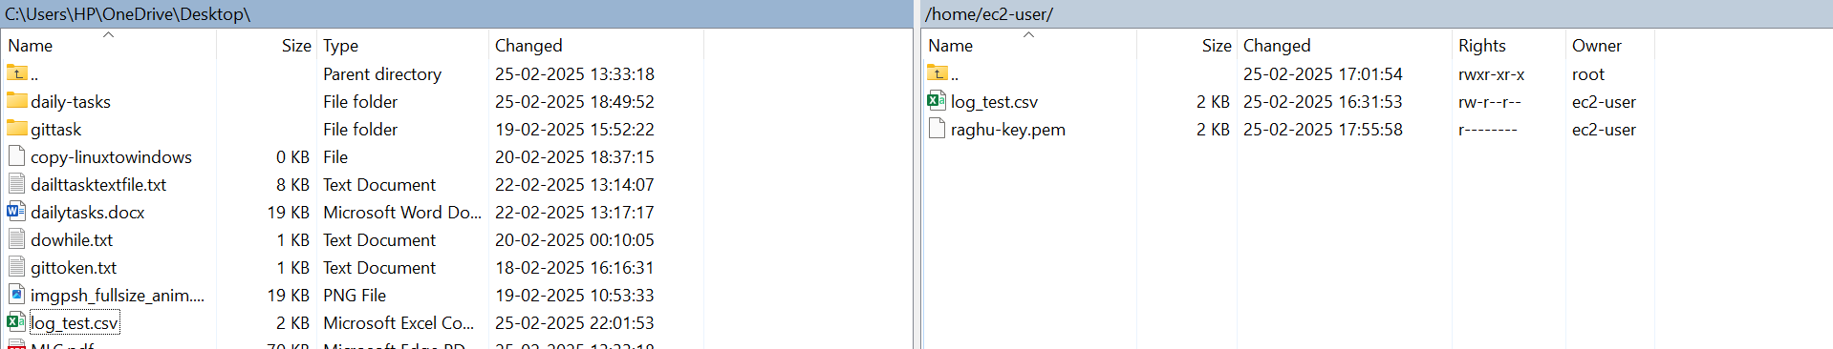

Script

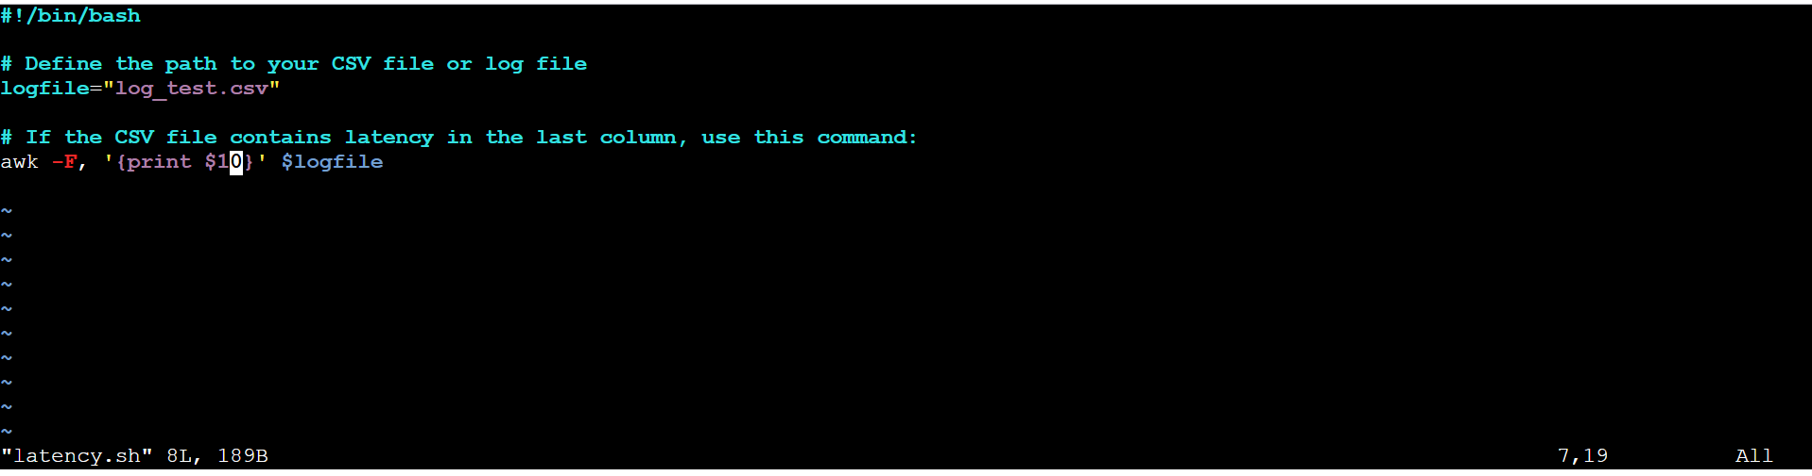

Output: print the value of the **10th field** in each line of the file.

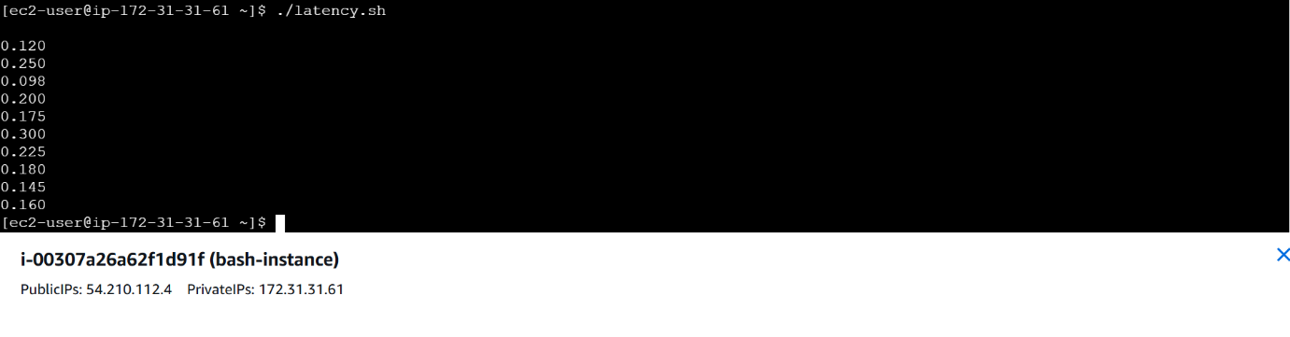

2.Bash Script to create repo in github.

New repo created name of Raghu-bash

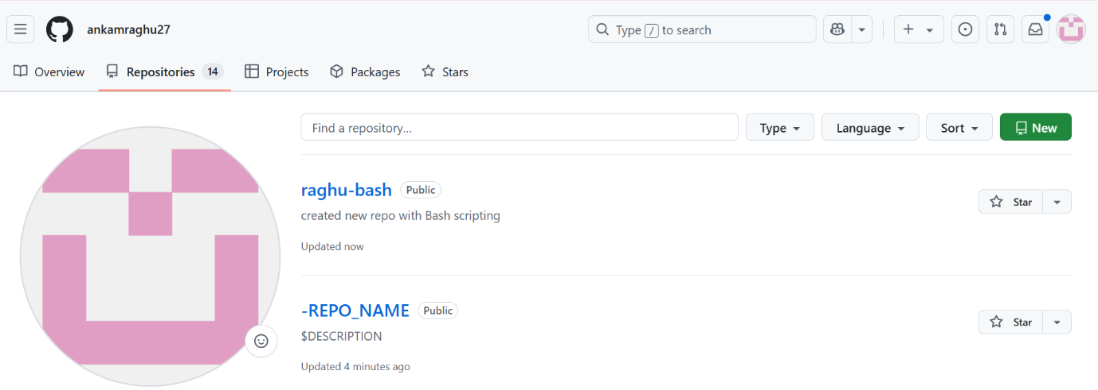

Cat script.sh

