1. Enable cloudtrail monitoring and store the events in s3 and cloudwatch log events.

store the events in s3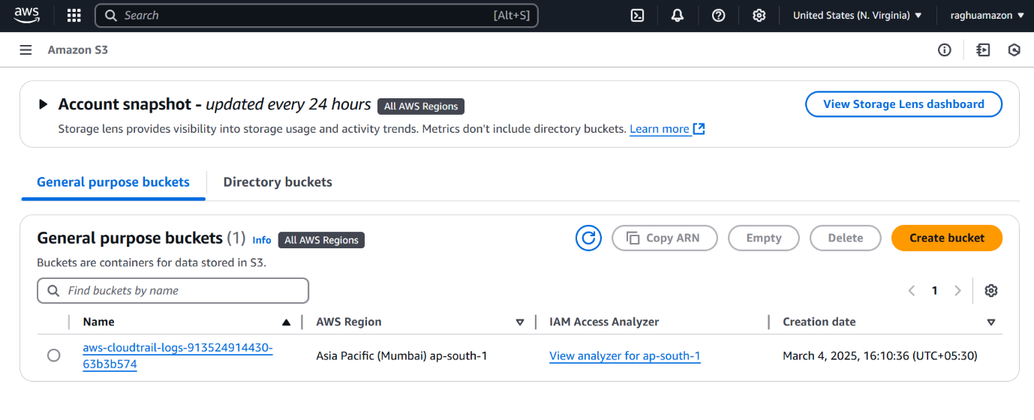

store the events in cloud watch

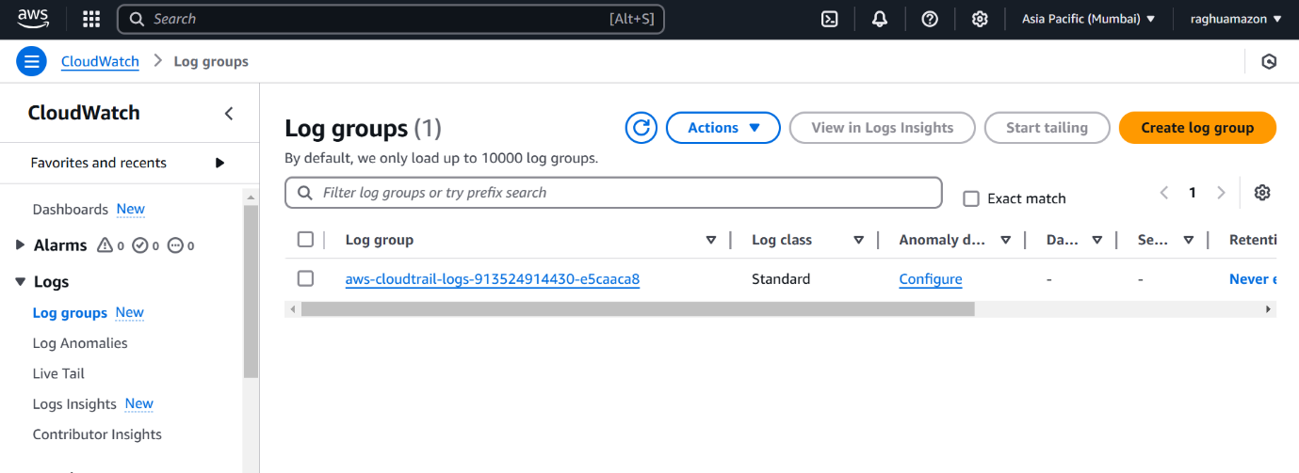

1. Enable SNS for cloudtrial to send alert on email.

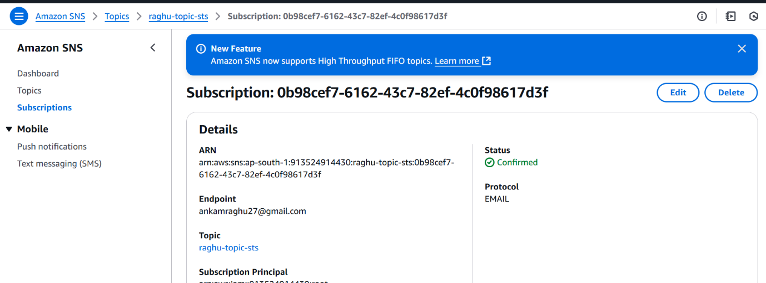

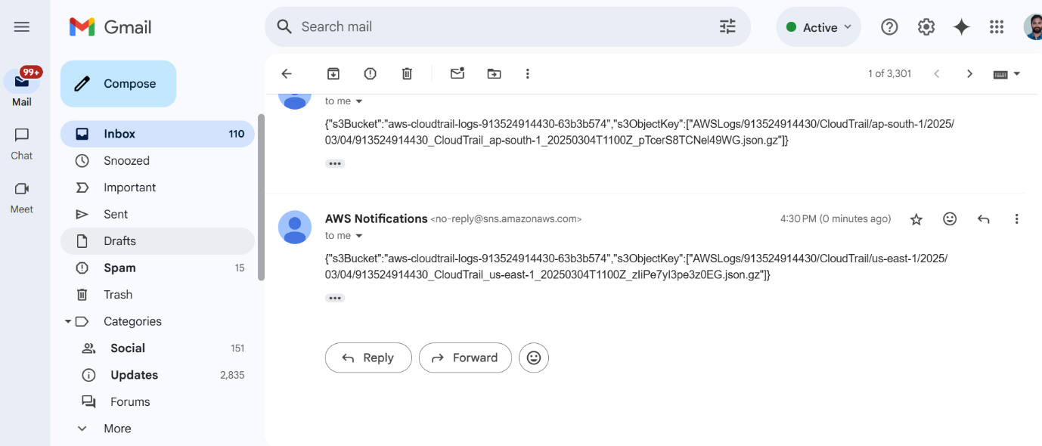

1. Configure cloud watch monitoring and record the cpu utilization and other metrics of ec2.

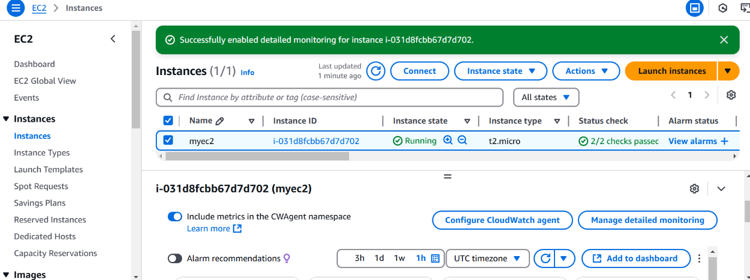

Ec2 -> go to detailed monitoring and enable monitoring

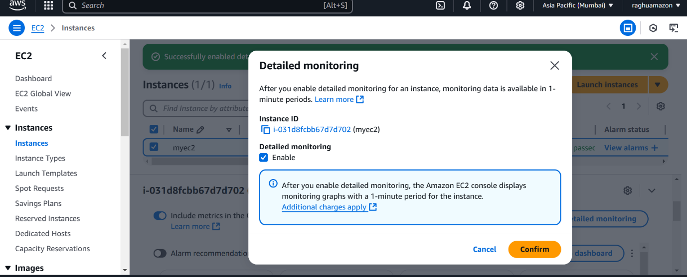

Create dashboard in cloud watch and add cpu metrics

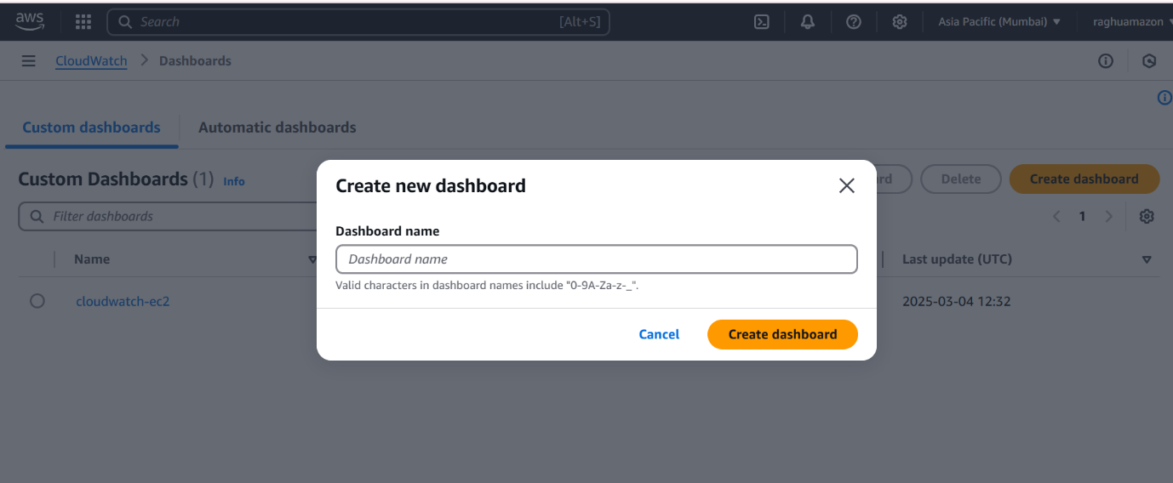

4) Create one alarm to send alert to email if the cpu utilization is more than 70 percent.

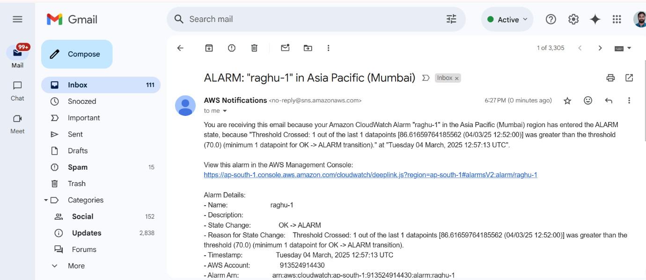

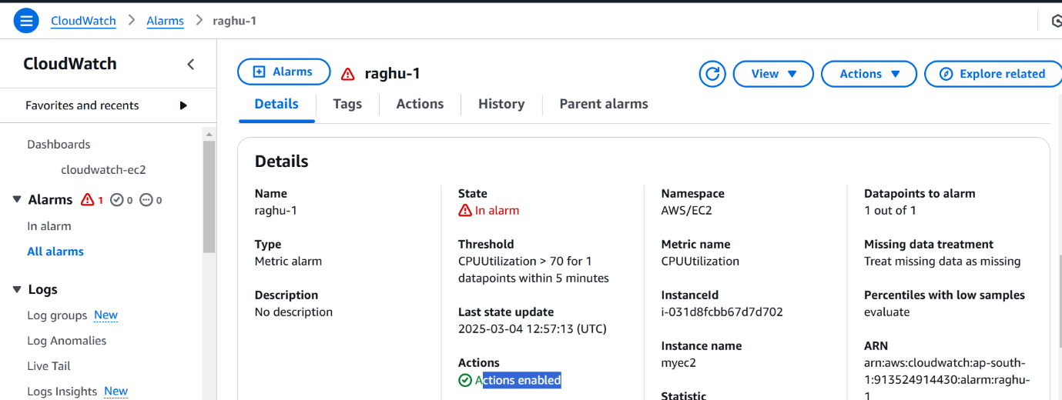

1. Create Dashboard and monitor tomcat service wether it is running or not and send the alert.

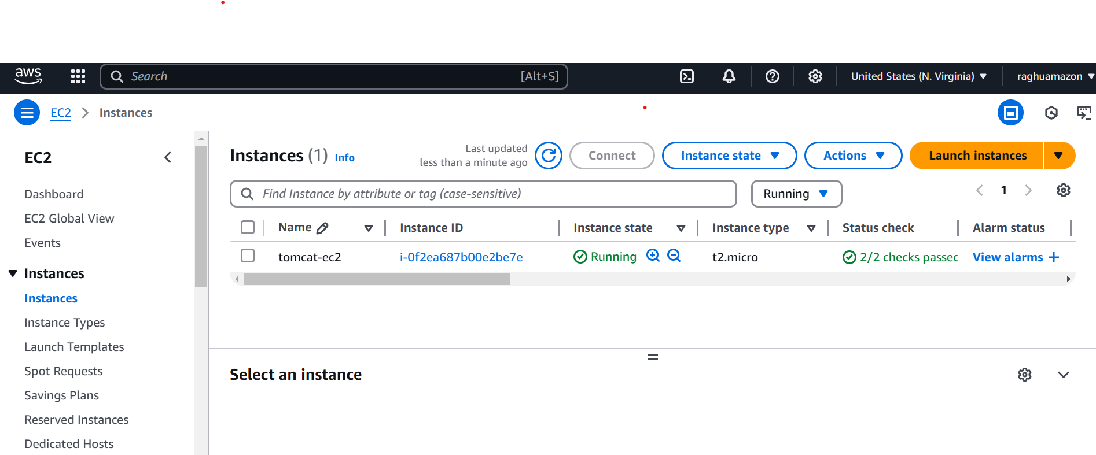

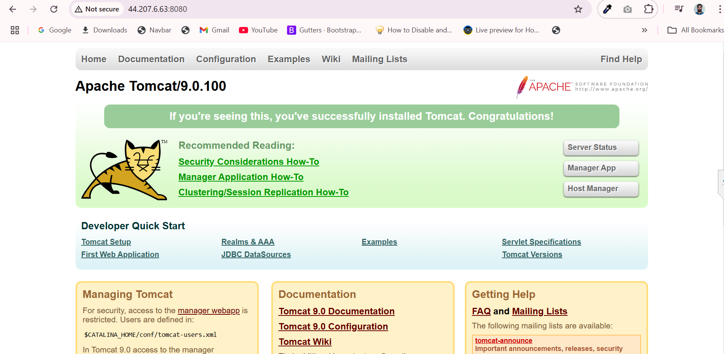

Role is created for cloudwatch and sns to attach Ec2

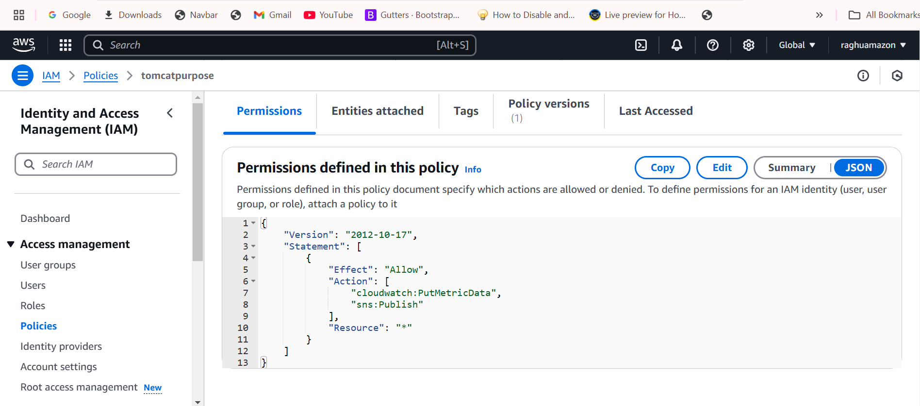

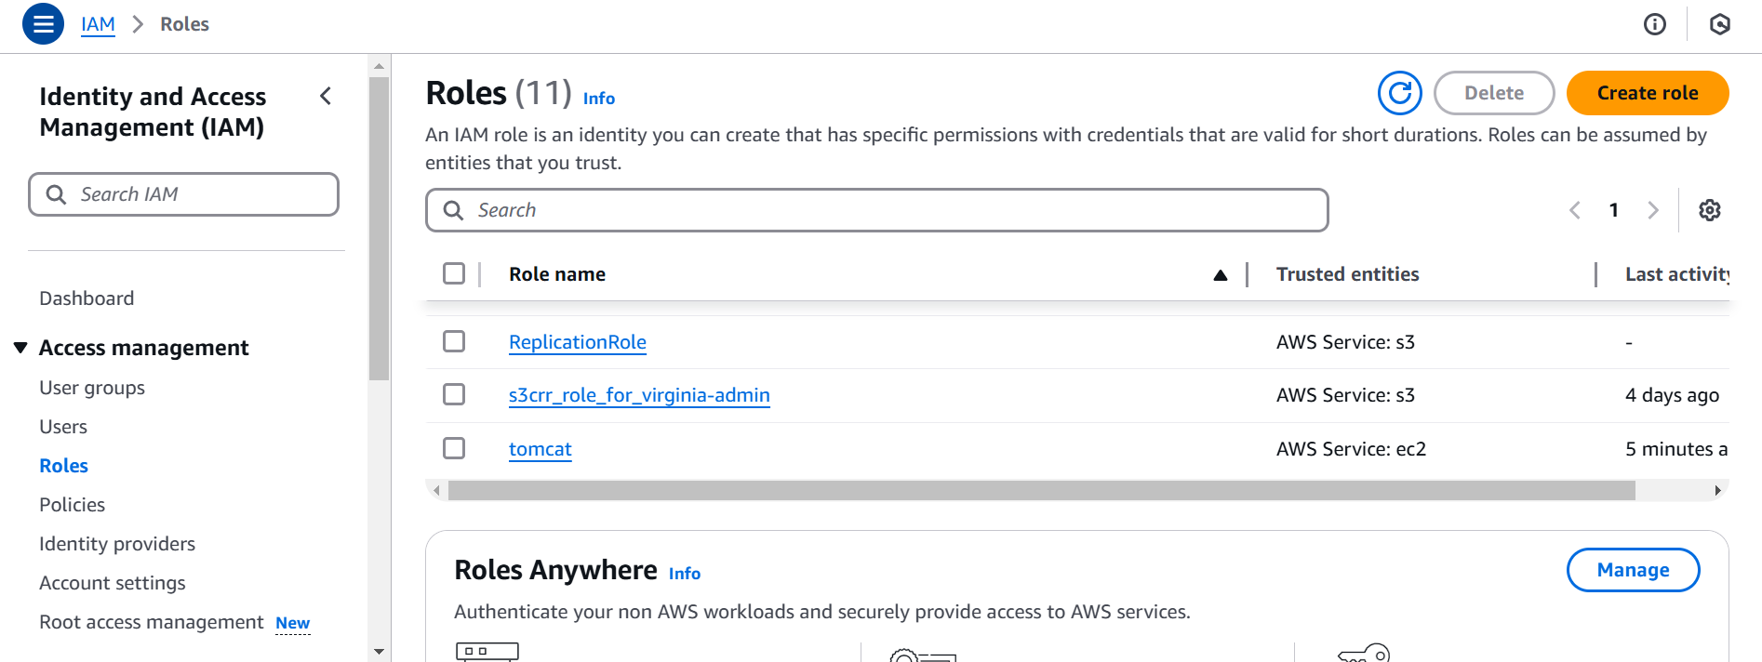

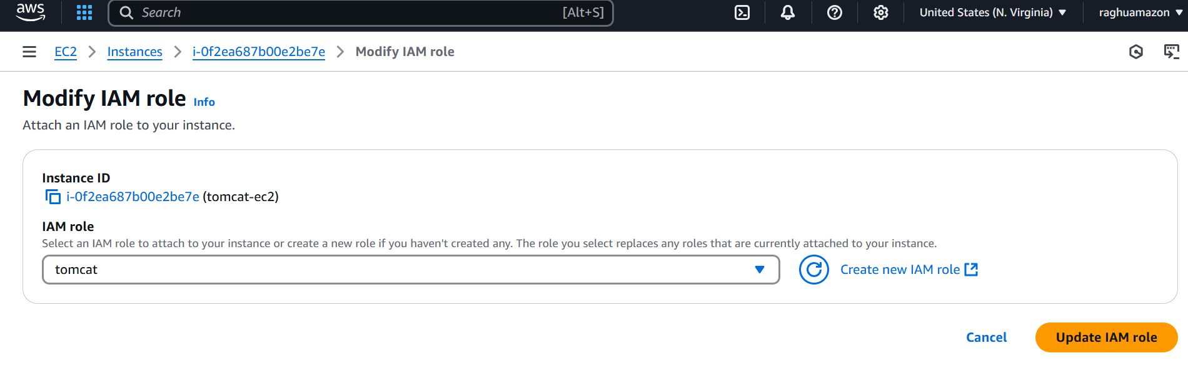

SNS created

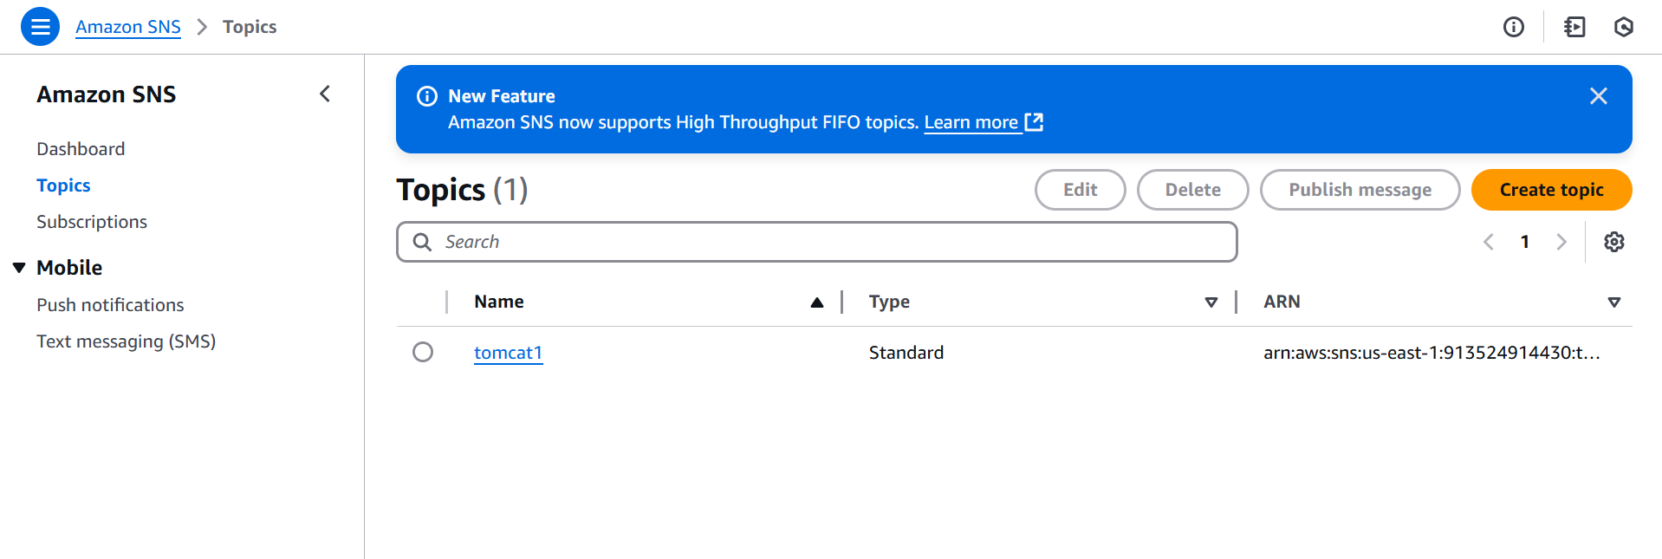

Create subscription

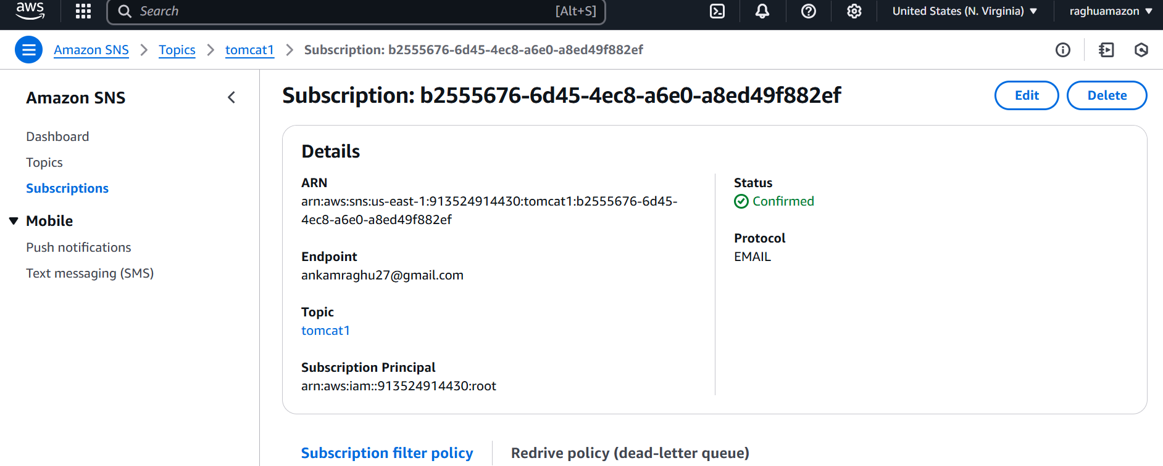

Create one script for tomcat running or not

Running state is 1

Stop stage is zero 0

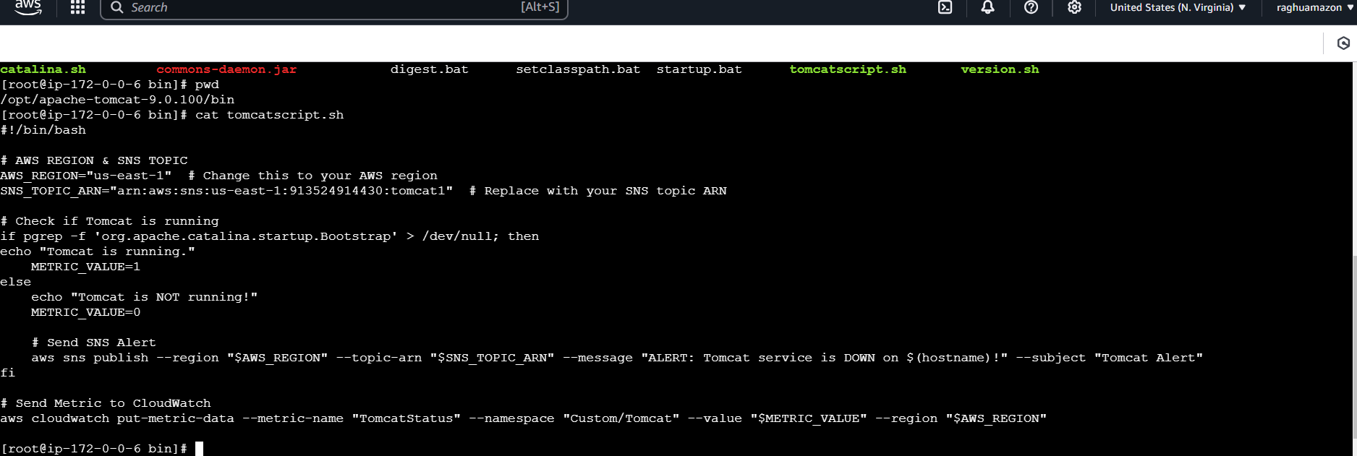

Tomcat start alarm with email

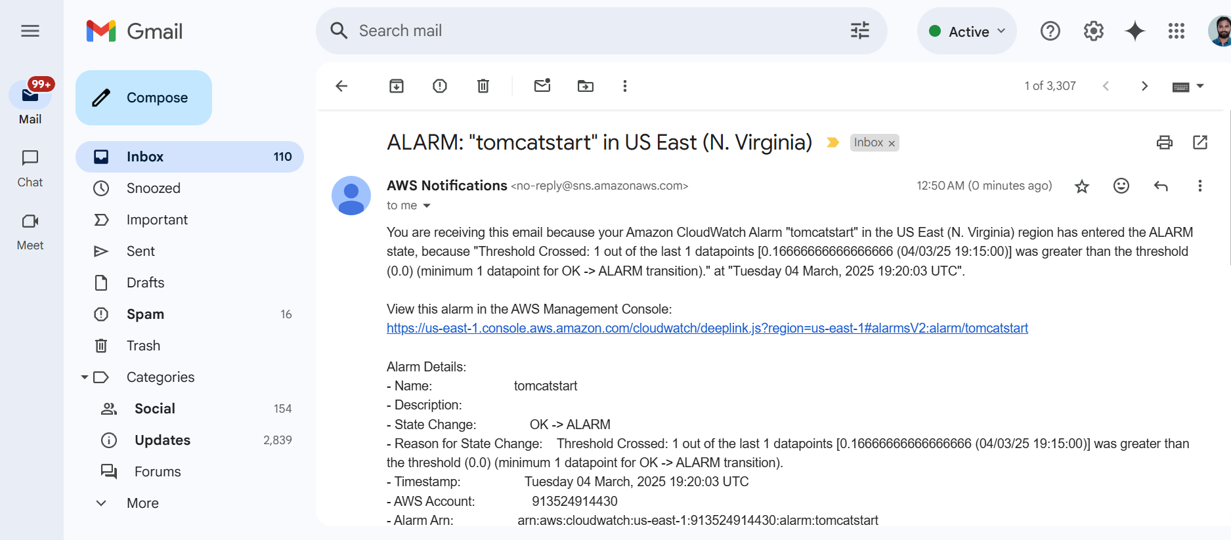

Tomacat stop

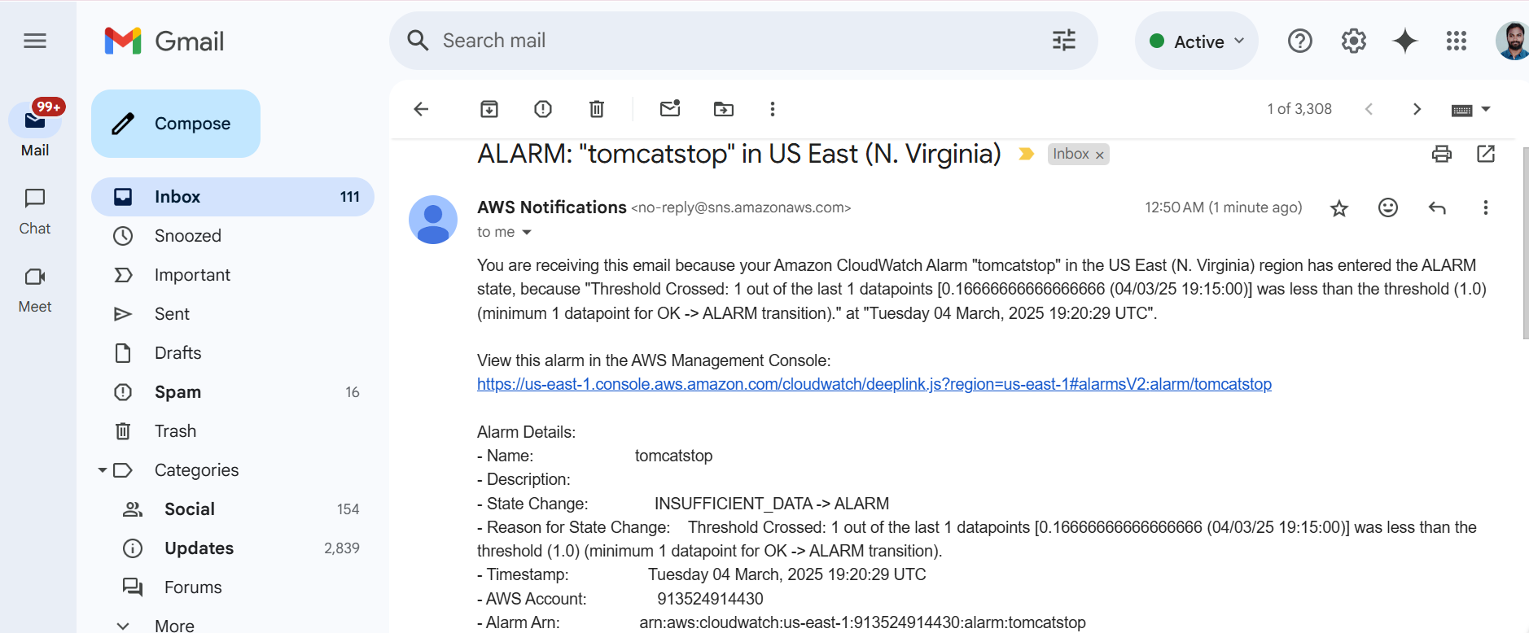

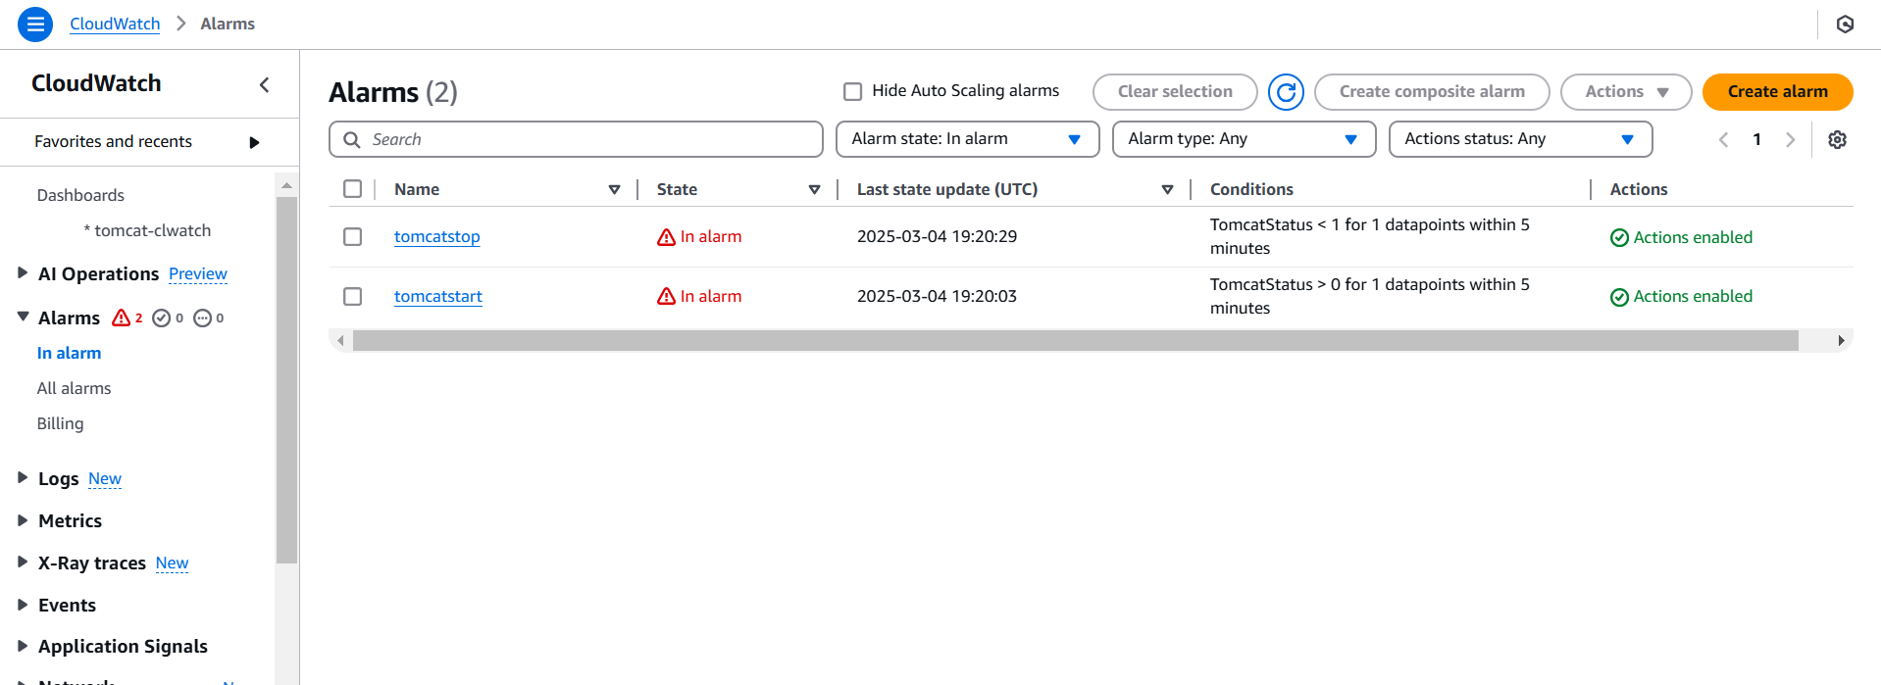

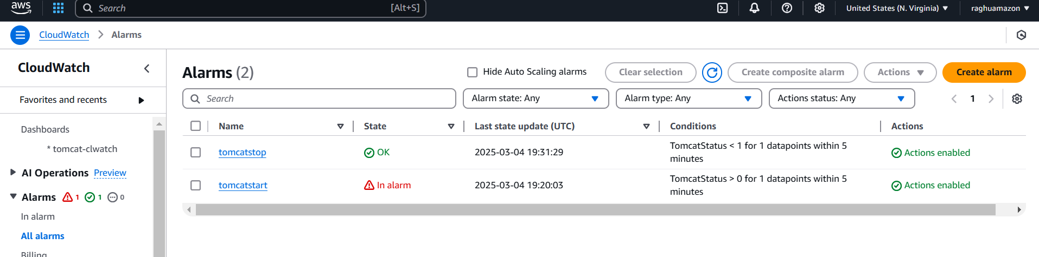

1. Create Dashboard and monitor nginx service to send the alert if nginx is not running.

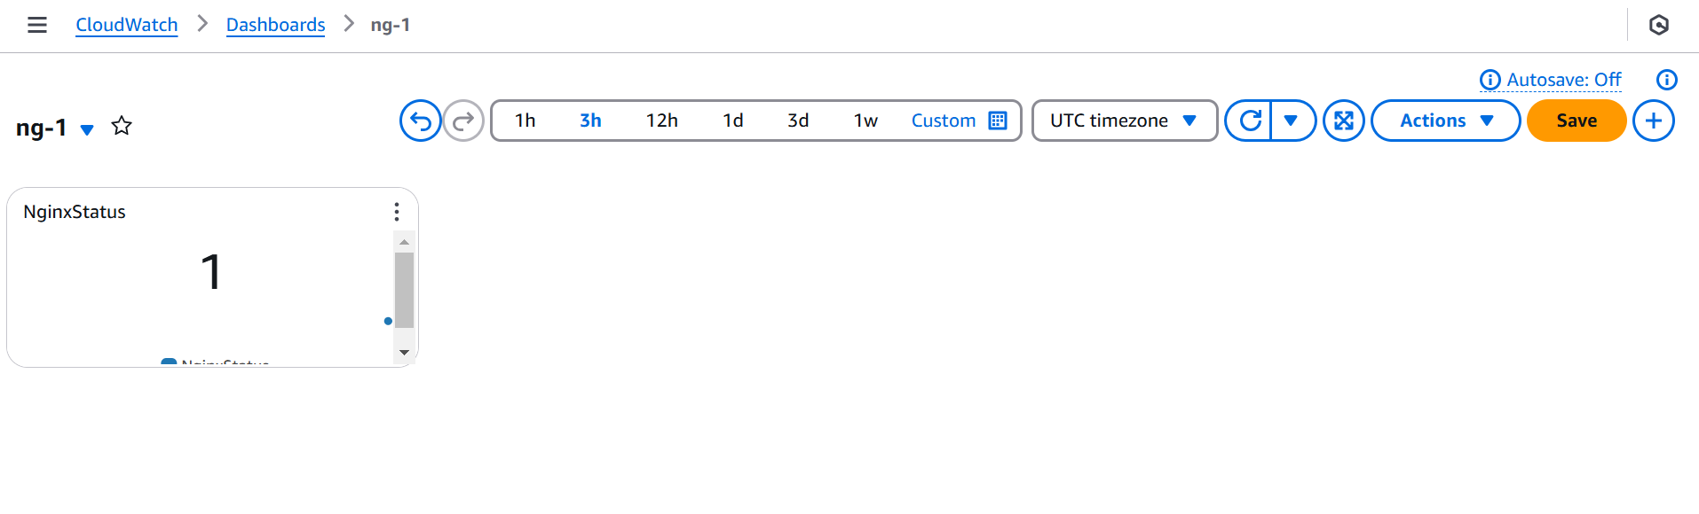

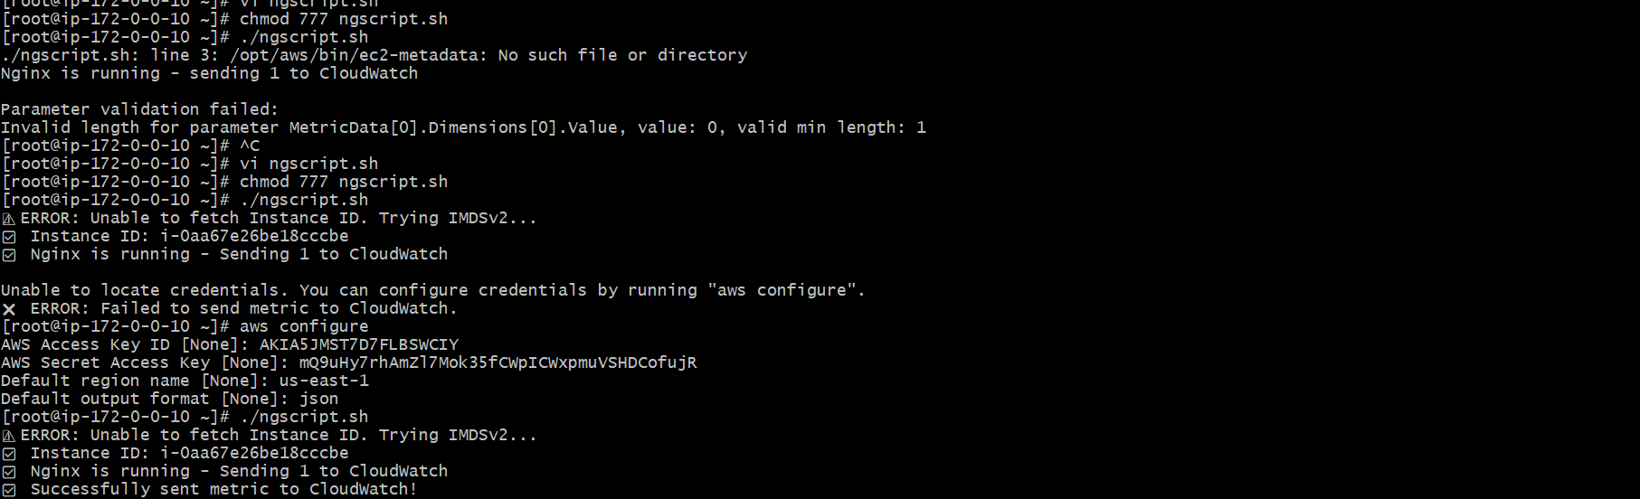

I am not getting my instance so I am using this script

