we create a policy to grant access to the API Gateway to Lamda

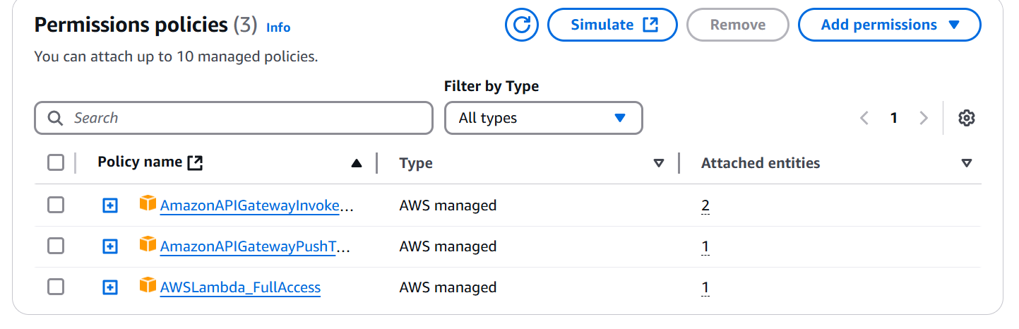

Create a function in lambda

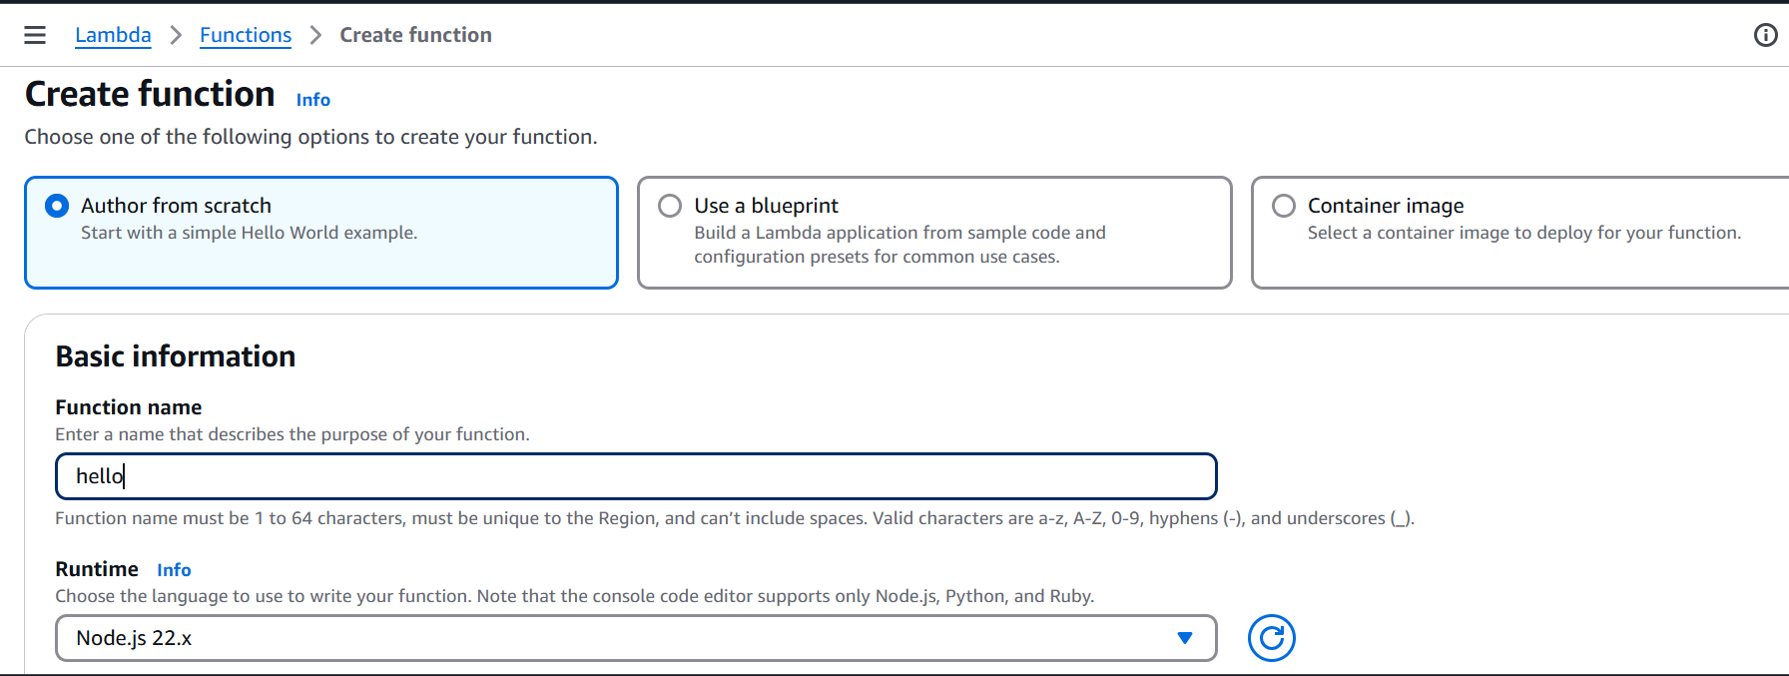

Use an existing role

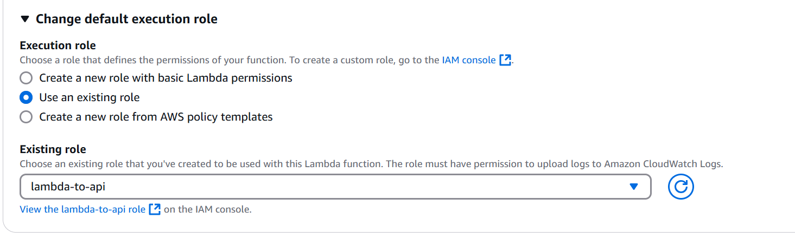

Successdully created function hello.

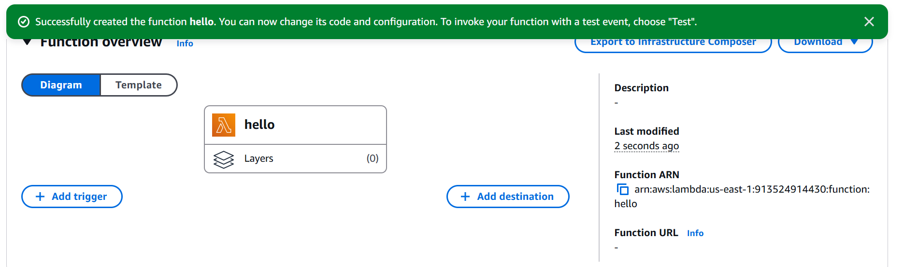

Goto Api gateway service and start creating an API

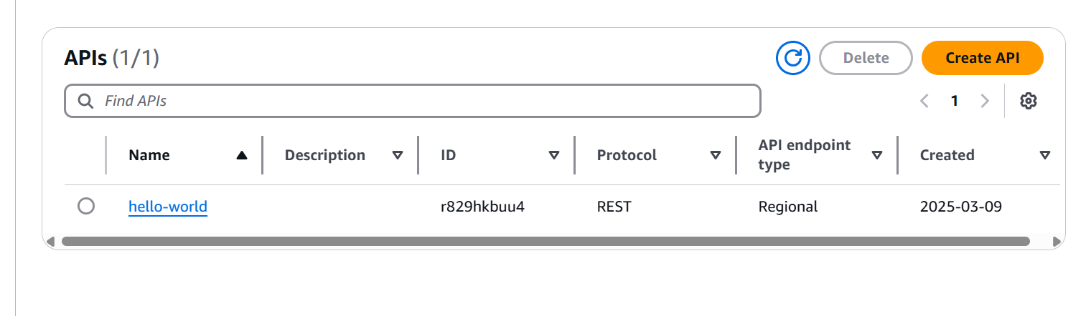

We have multiple option in api gateway

But I select Rest API it allows lambda , http, aws services

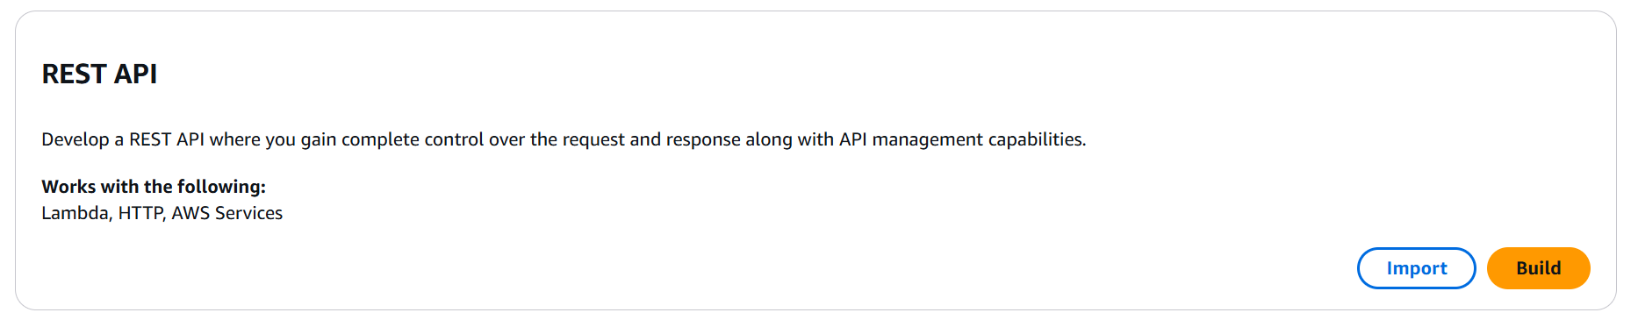

Create API

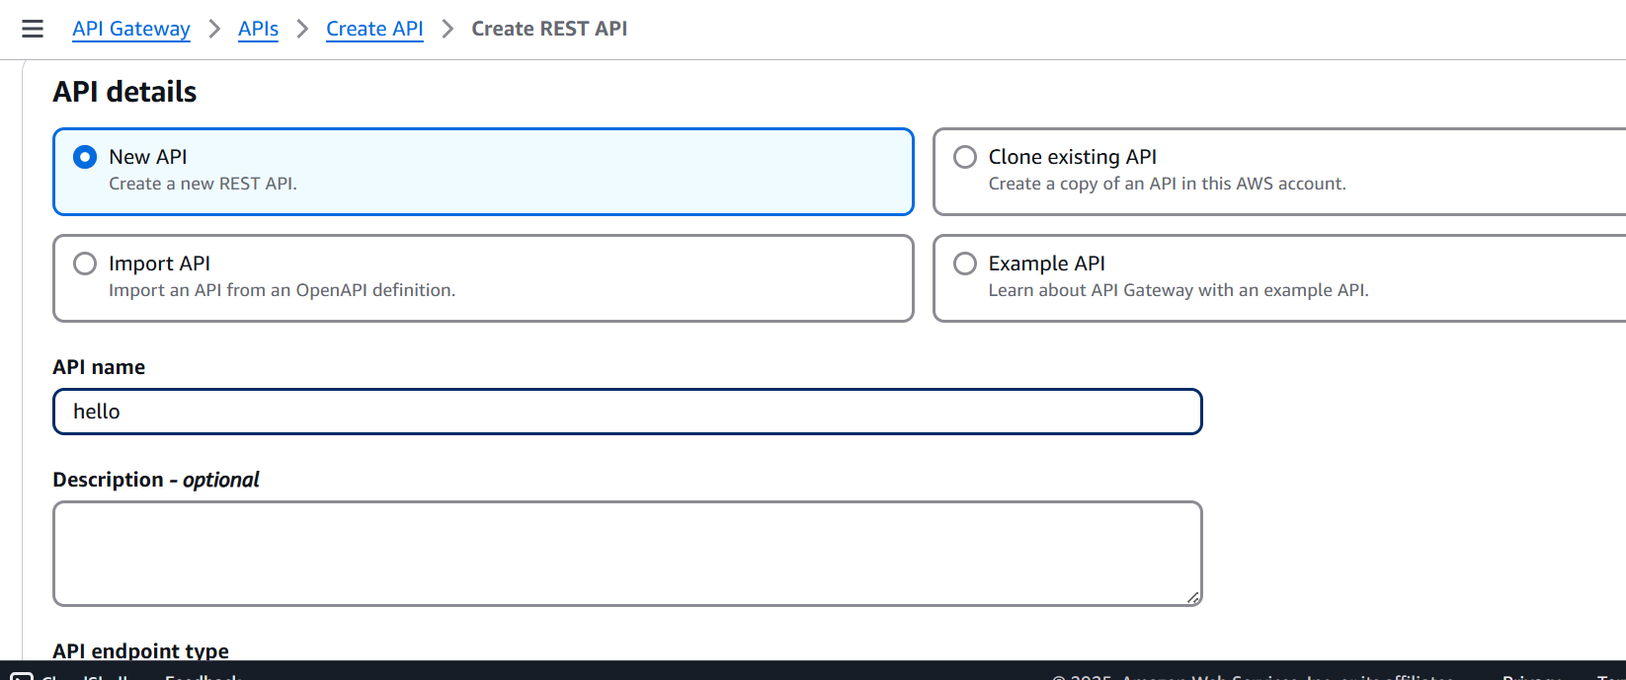

Successfully created rest api

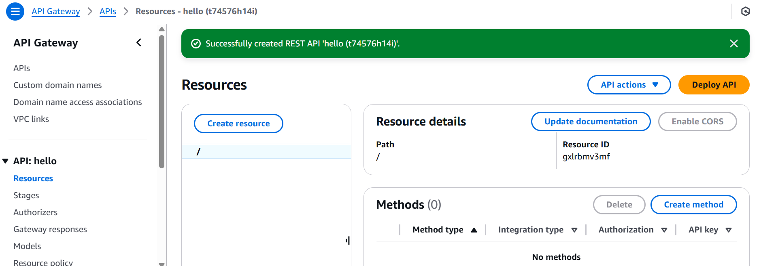

After that we create resource

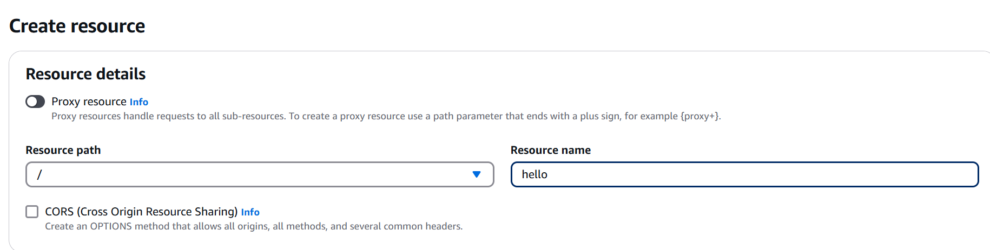

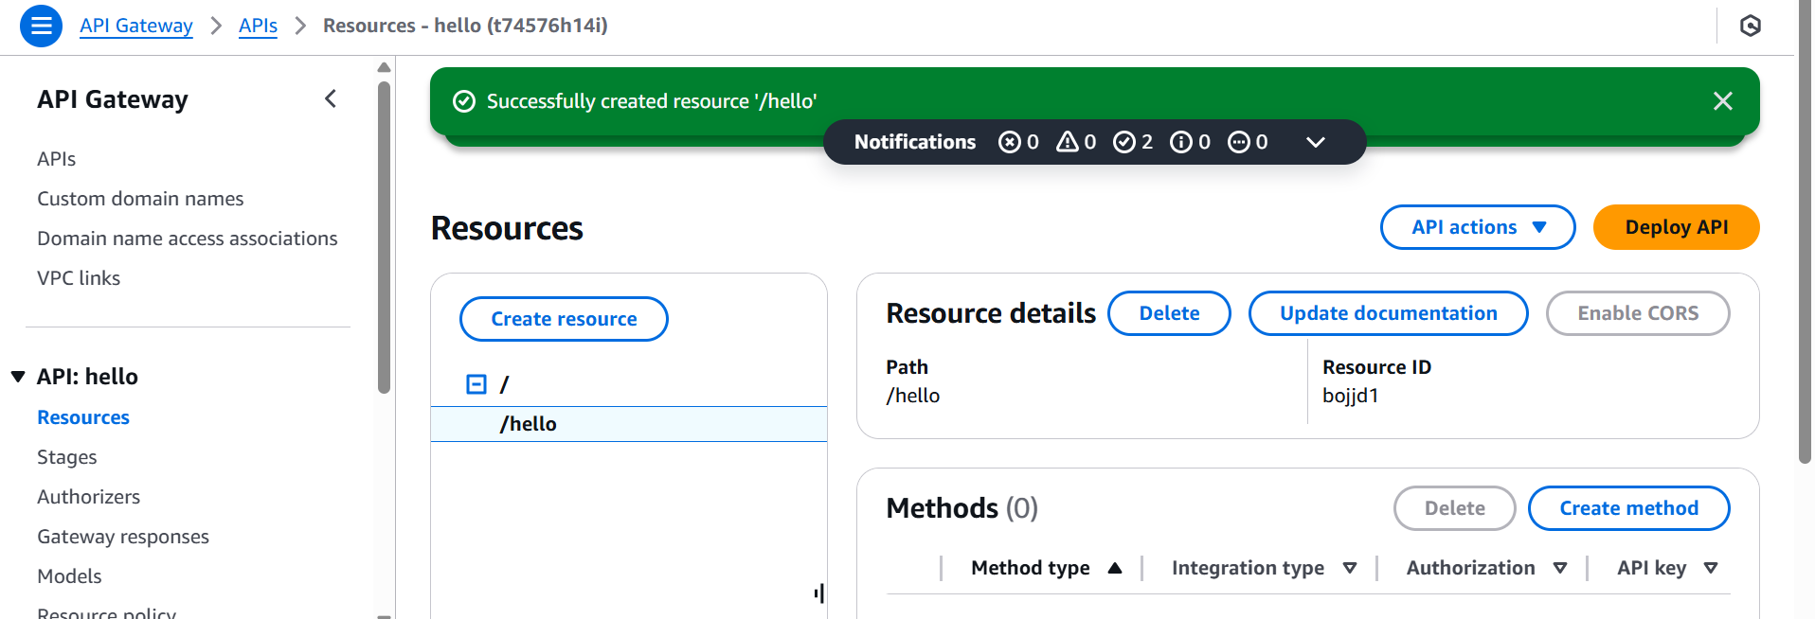

Create a method GET

And enable lambda proxy integration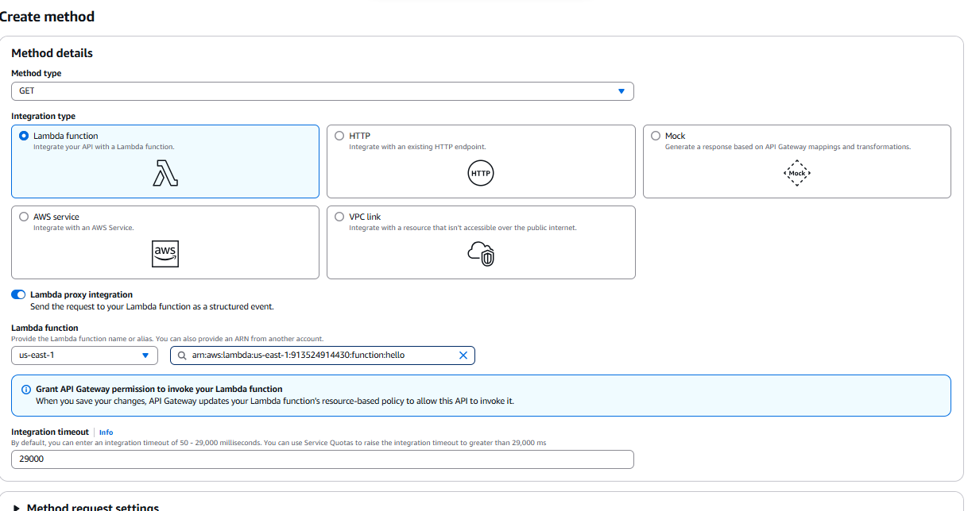

Deploy the api:

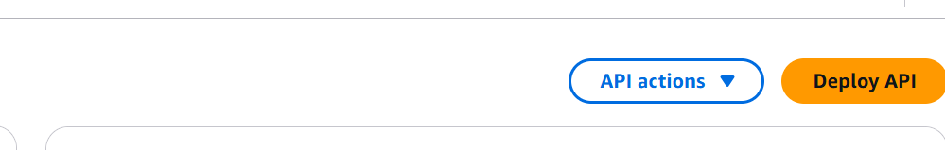

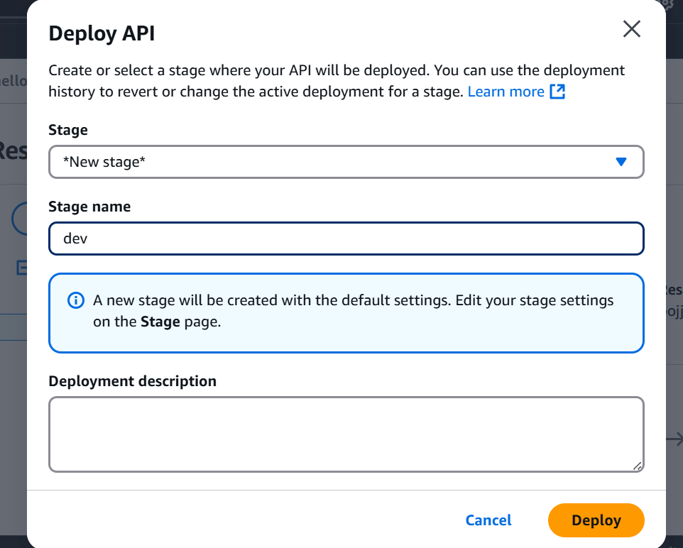

Invoke(call) the api url we get the response from api as follows:

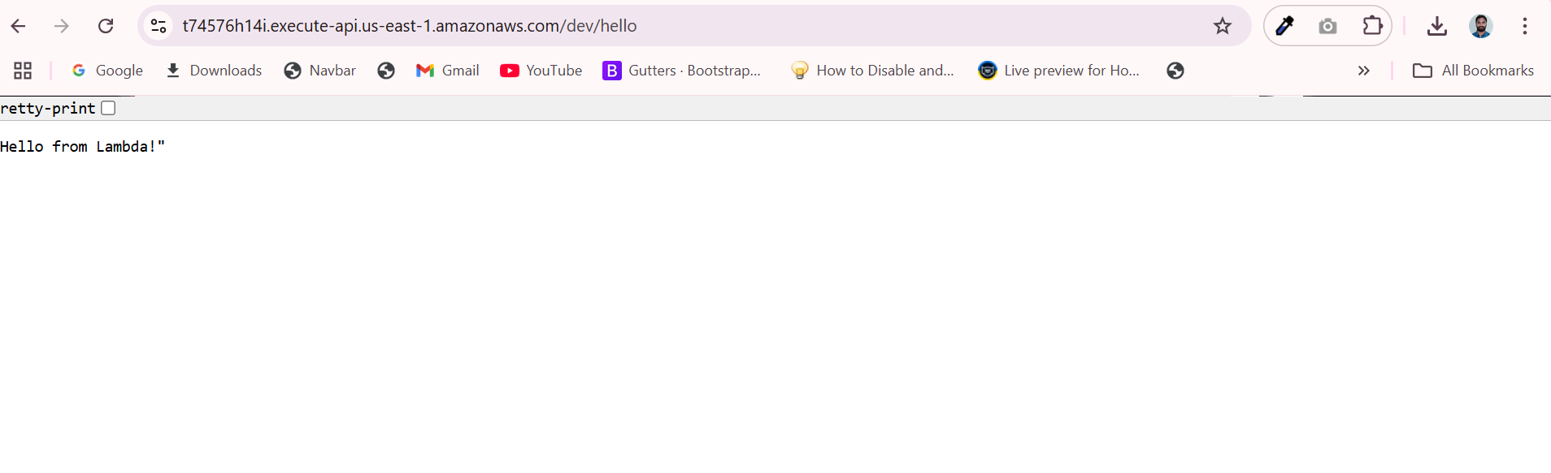

Goto lambda service:

