1. Configure VPC peering in cross regions.

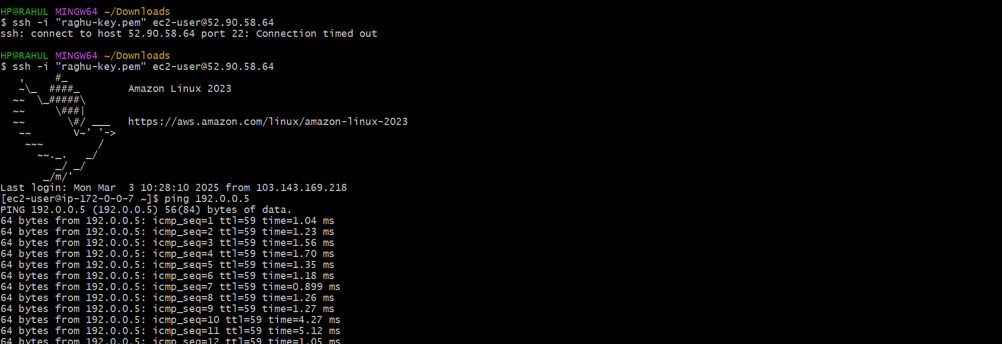

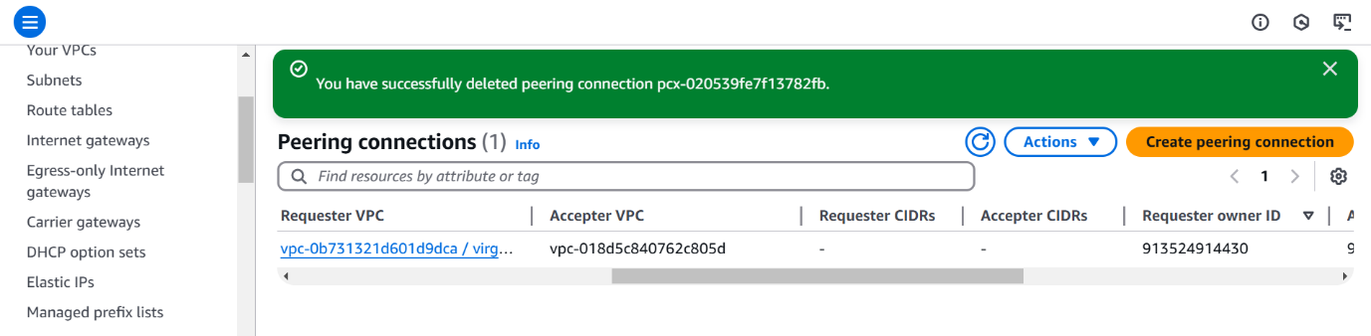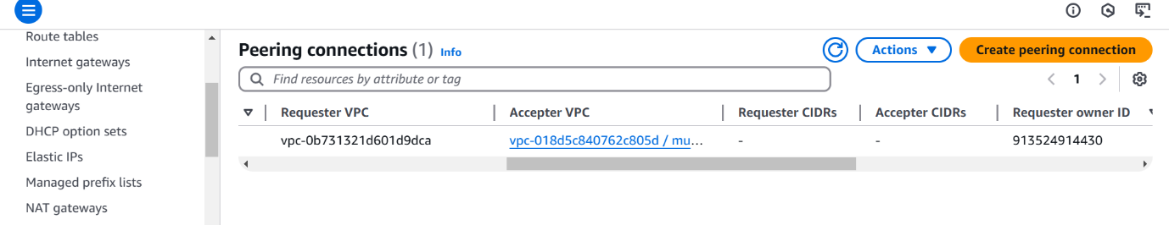

1. Purchase one domain from GoDaddy.

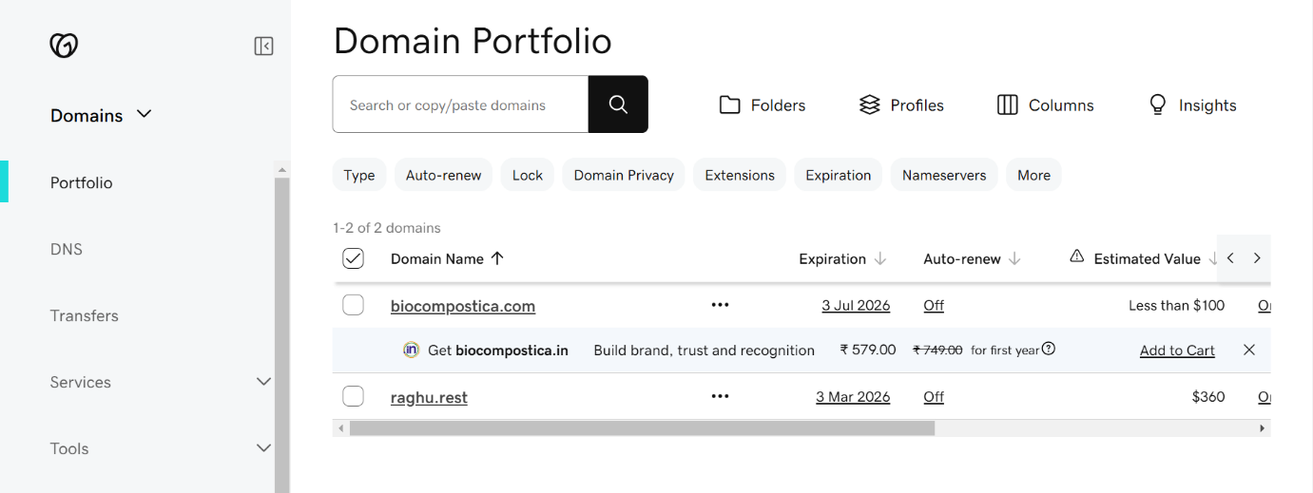

1. Deploy static website in s3.

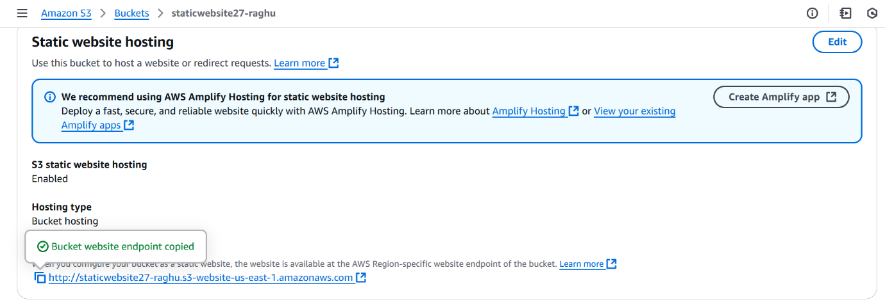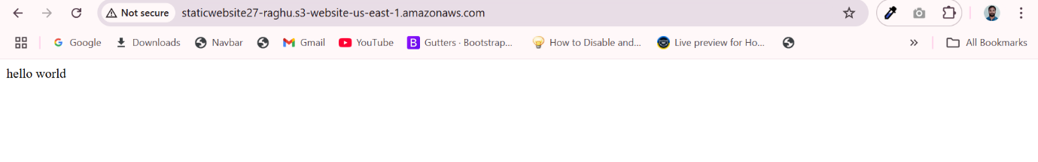

1. Create CDN and attach one SSL certificate.

Create cloud font distribution

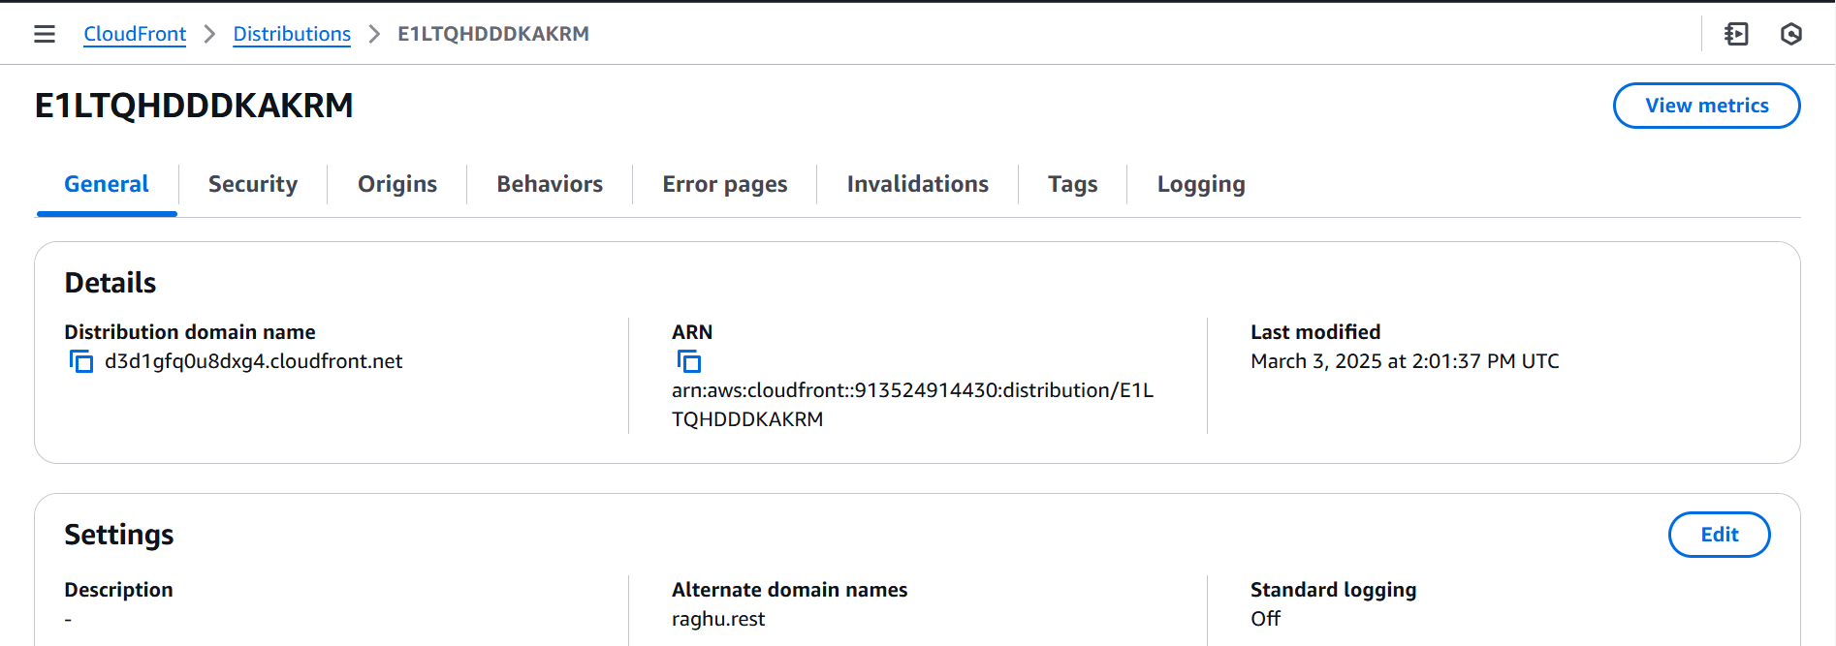

attach one SSL certificate.

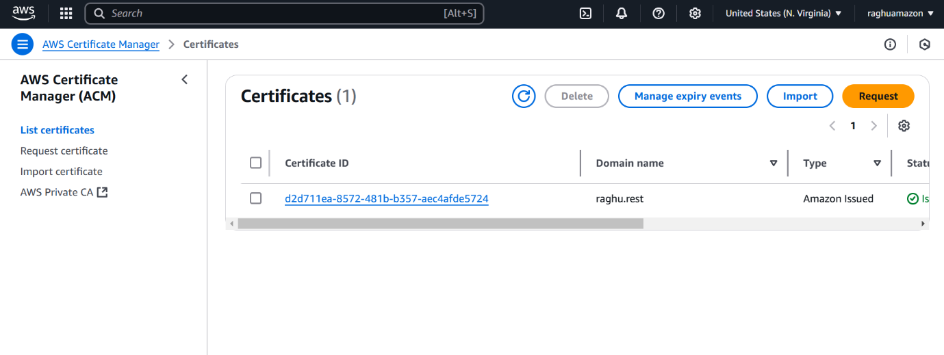

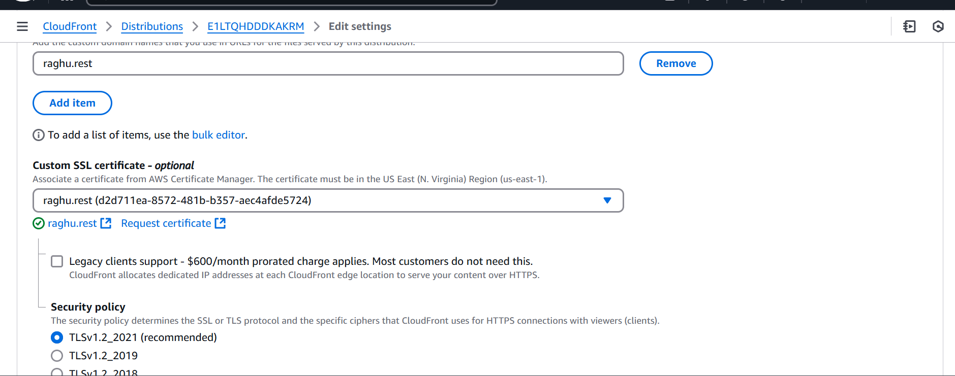

1. Create Route53 hosted zone and MAP the domain with CDN.

Route53 hosted zone

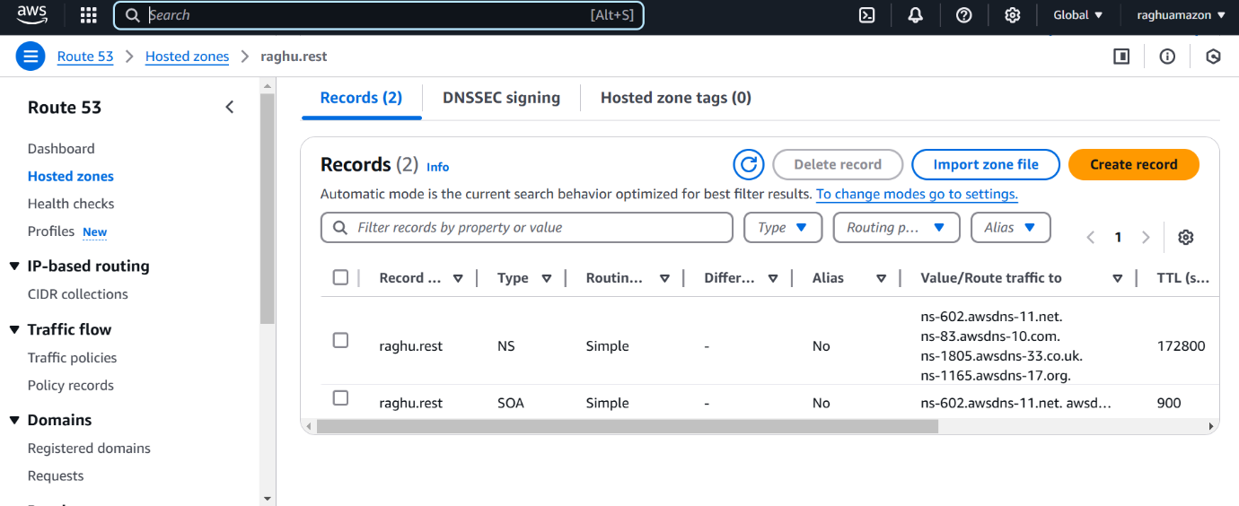

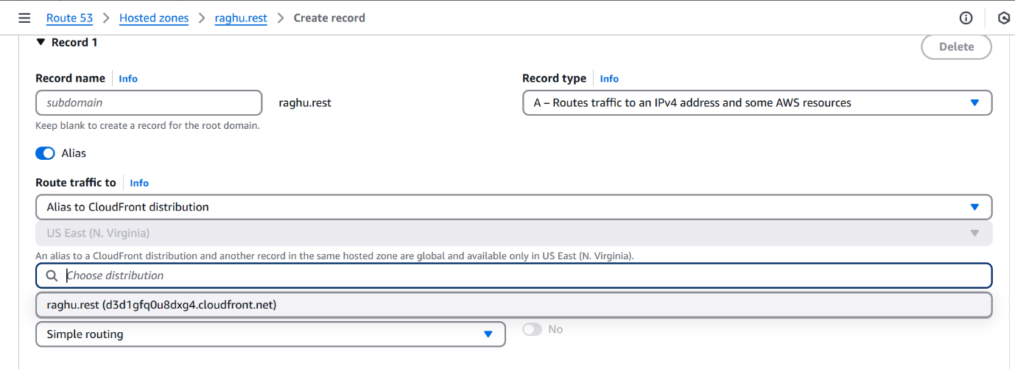

1. Update the index.html in s3 bucket and the updated file should be accessible by using domain name.

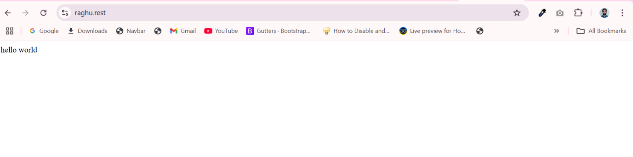

Click on Invalidations → Create Invalidation in CloudFront distribution

After refresh the page you get below output

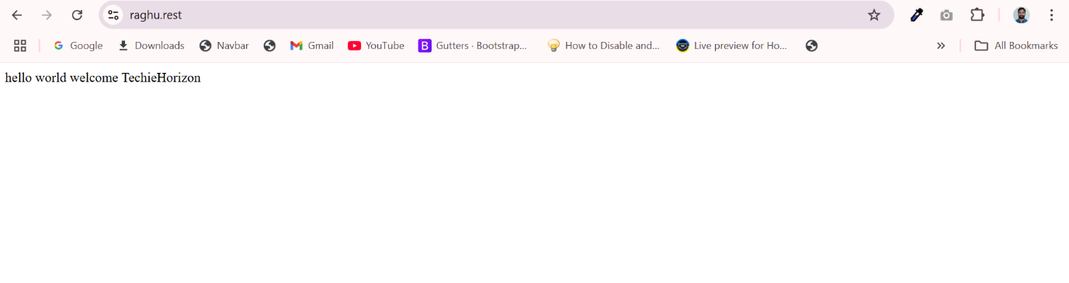

1. Share the Domain name in slack to test the connectivity.

**Raghu.rest**