1. Launch on amazon ec2 linux sever

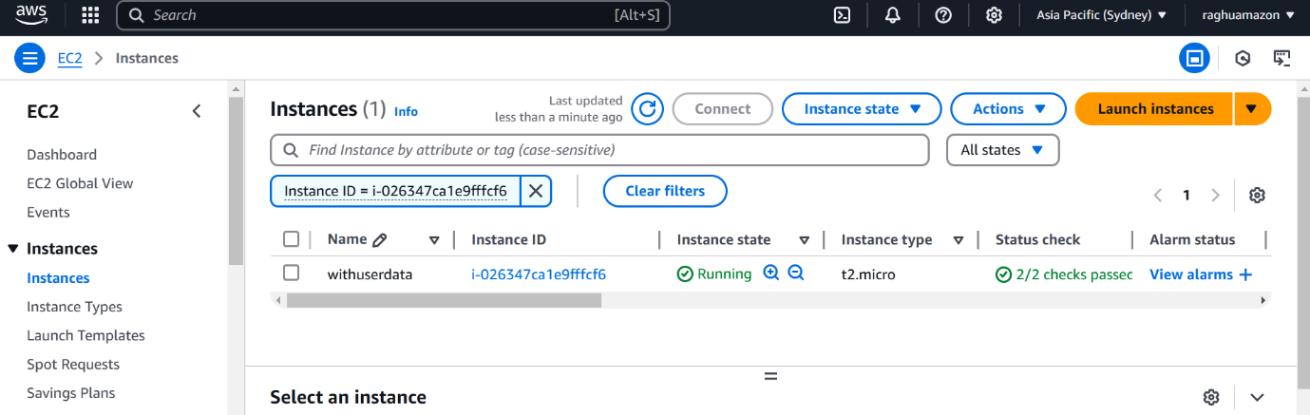

1. Create one file with below format. (<your_name>_<Date>)

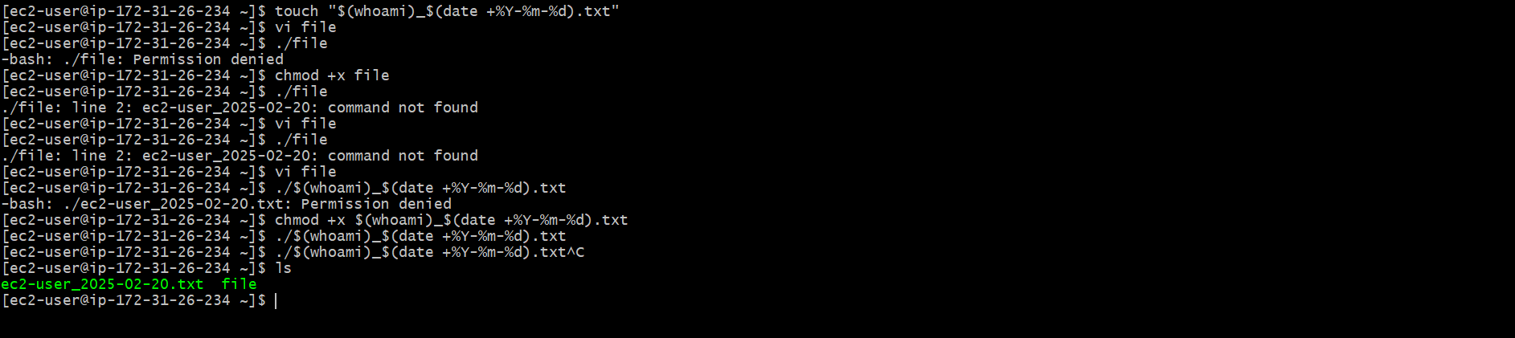

1. Copy the file from amazon linux to your local windows machine.

