1.Create one VPC,with 1 one public subnet and 1 private subnet.

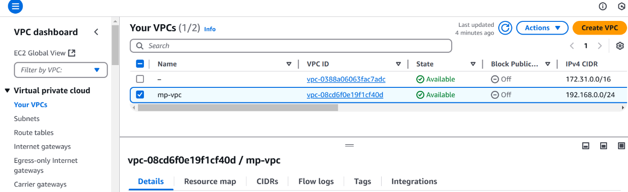

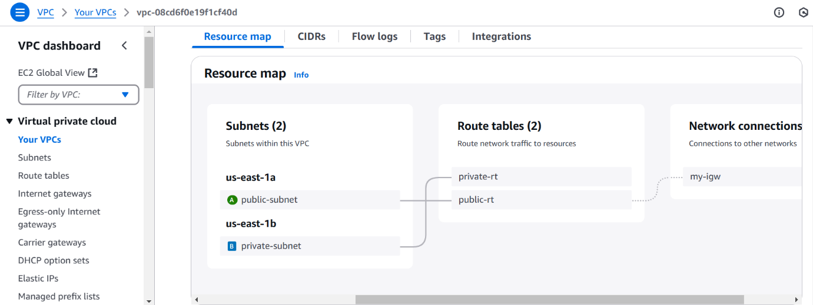

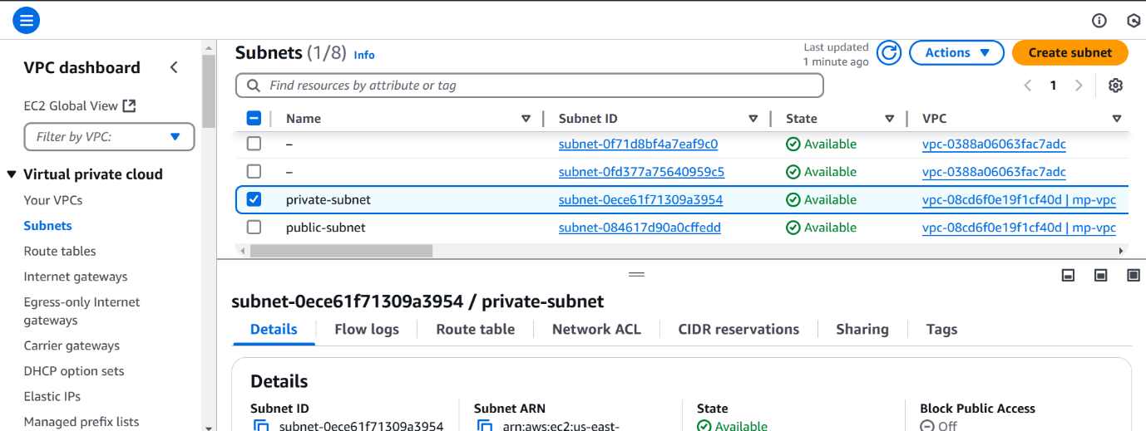

2.Enable VPC peering for cross region.

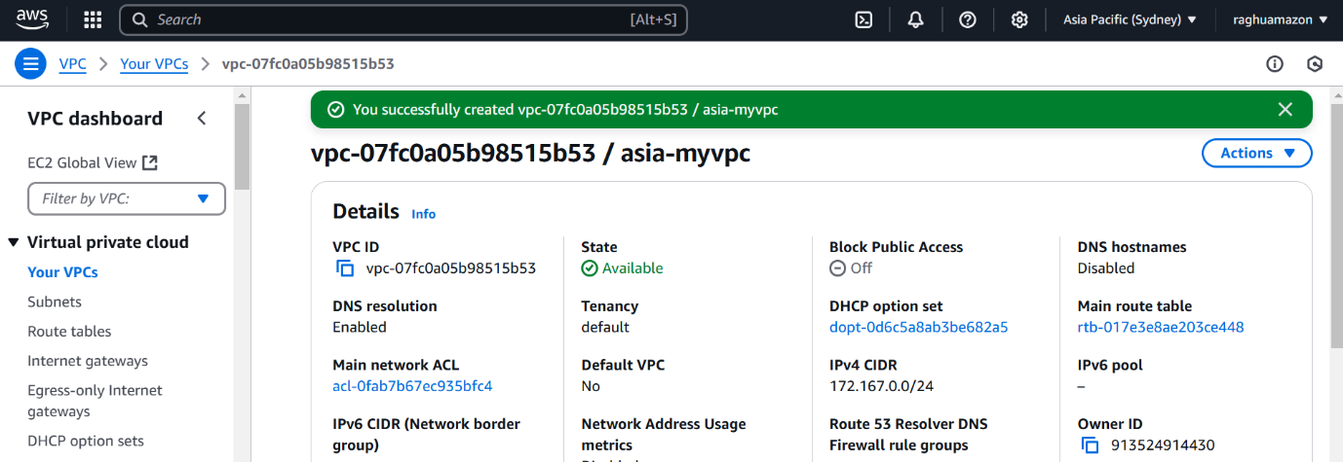

3. Enable VPC peering for cross account. (You can collaborate with your friend and do this task).



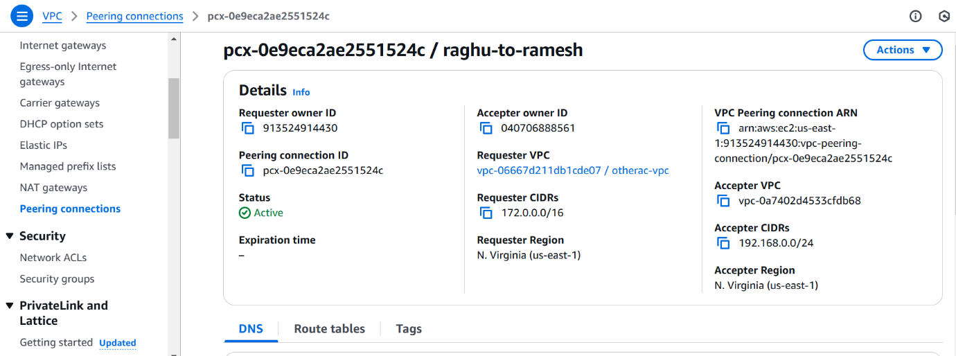

3. Setup VPC Transist gateway.

Server 1 to server2

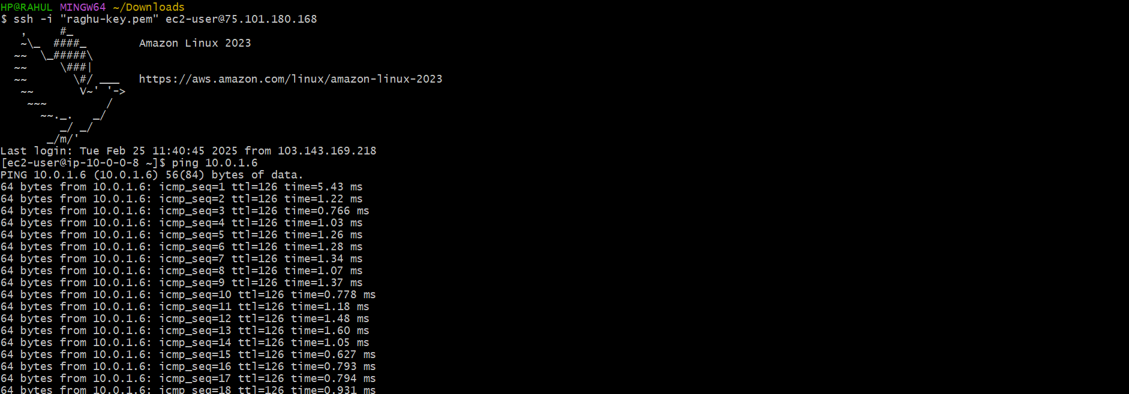

Server 2 to server1



Server4 to server1

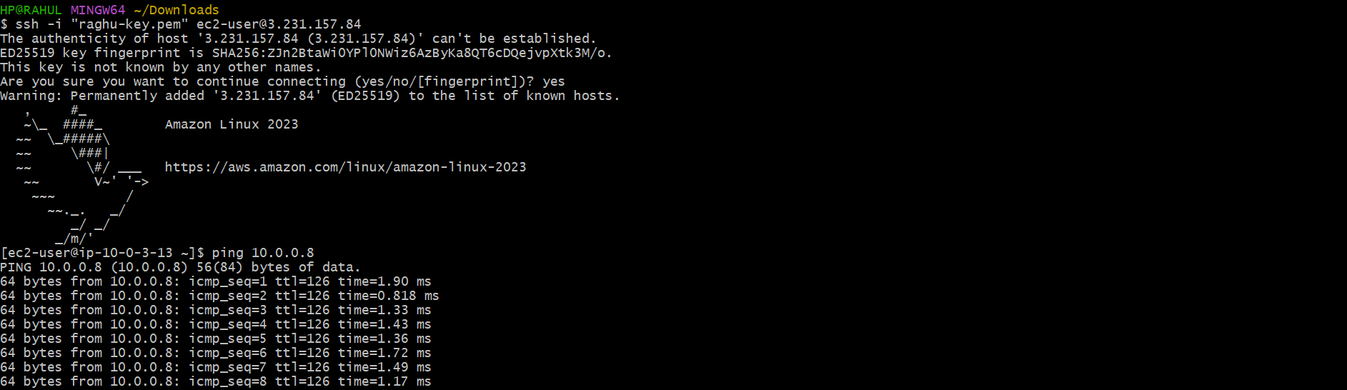

Server 4 to server 3



5. Setup VPC End Point.

