1) Install nginx and run nginx on port number 81.



2) Deploy a sample index.html file on nginx.



3) Install Apache and run Apache on port number 82



4) Deploy a sample index.html file on Apache.



5) Install Apache tomcat on port number 8082

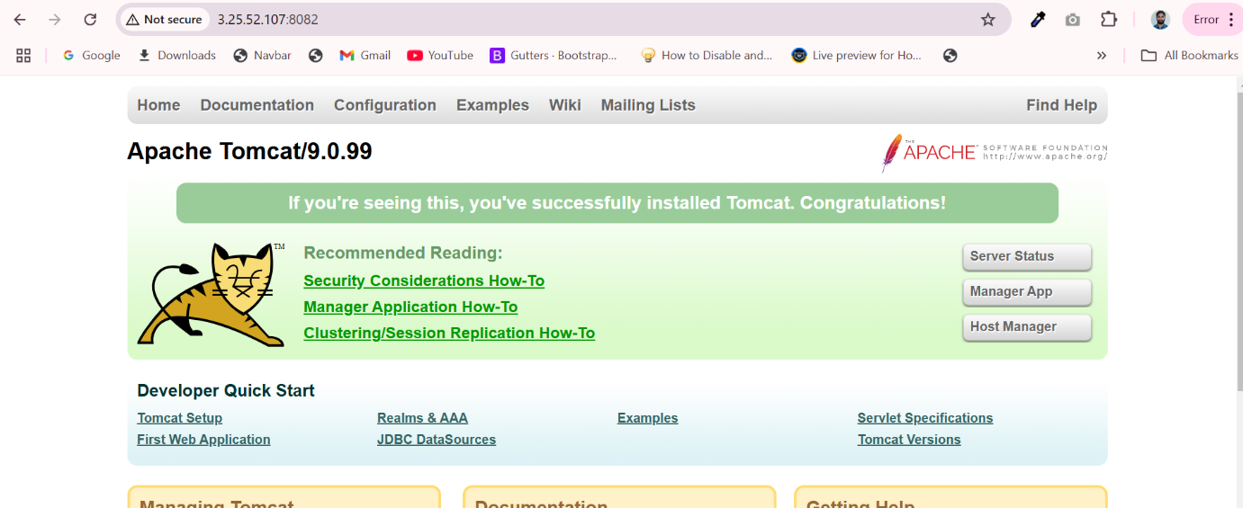

6) Deploy a sample app on webapps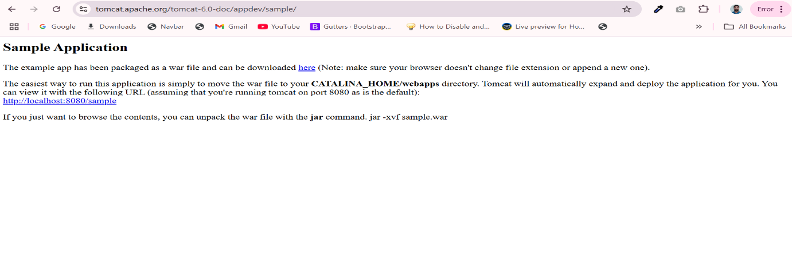

7) Create a tomcat.service file for tomcat.

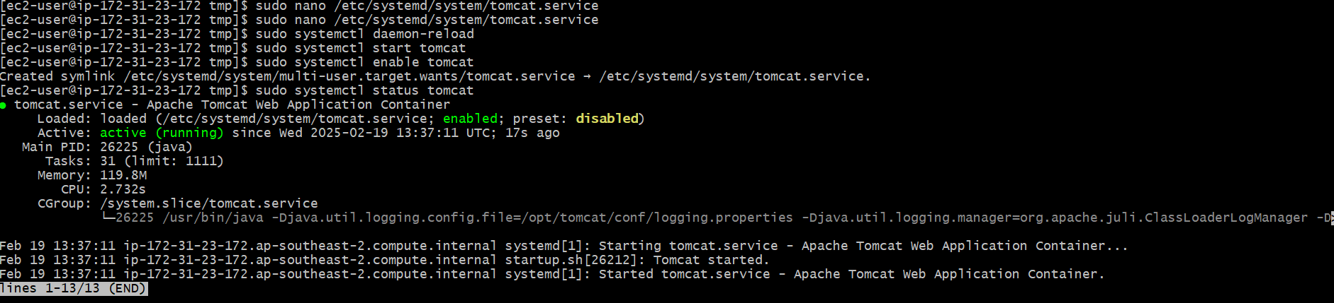

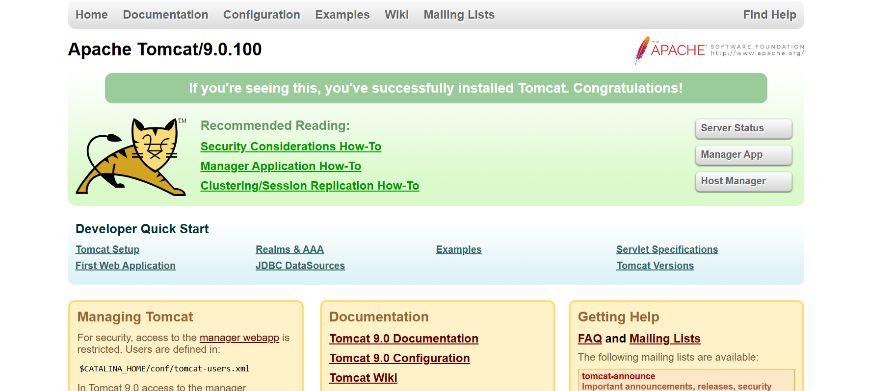

8) Configure HA Proxy server

# **Configure HA Proxy Server:**

**Launch 3 ec2 instances Server1, Server2, HA-Proxy-Server.**

**Server-1 Steps:**

**ssh -i "raghu-key.pem"** [**ec2-user@3.231.159.119**](mailto:ec2-user@3.231.159.119)

**go to root using with sudo -i**

To update system packages **yum update -y**

Install Apache in server1 **yum install httpd -y**

Now we need to add HA-Proxy-Server Public IP address to our Server1 EC2 instance so go to:

**vi /etc/hosts**

Public IP of HA-Proxy-Server and paste



ping load_balancer -c 4



systemctl start httpd

systemctl status httpd

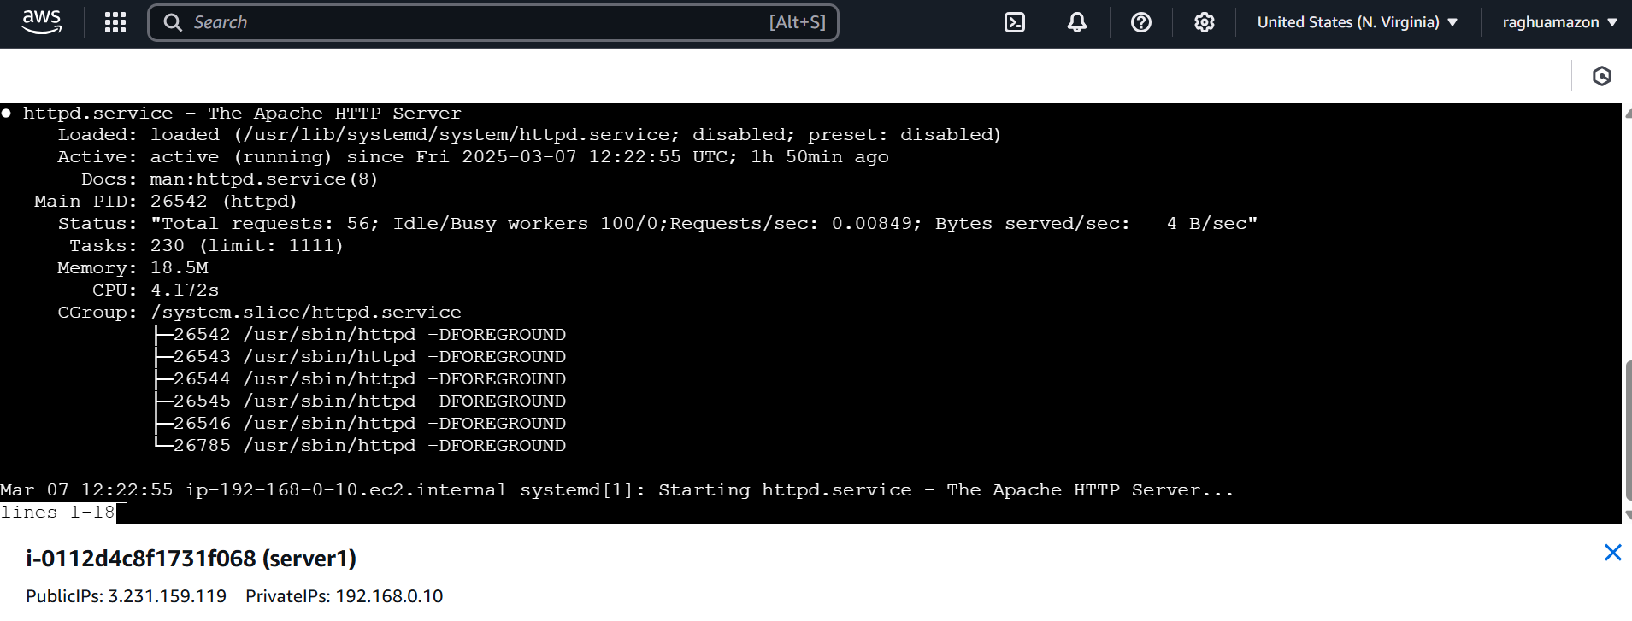

**Server2 Steps:**

**$ ssh -i "raghu-key.pem" ec2-user@34.231.169.211**

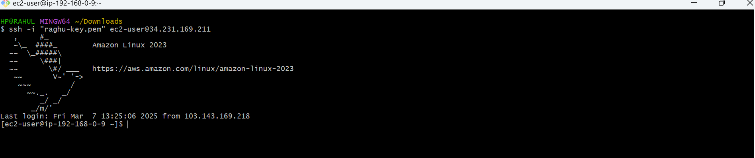

**go to root using with sudo -i**

To update system packages **yum update -y**

Install Apache in server1 **yum install nginx -y**

Now we need to add HA-Proxy-Server Public IP address to our Server2 EC2 instance so go to:

**vi /etc/hosts**

Public IP of HA-Proxy-Server and paste



ping load_balancer -c 4



systemctl start nginx

systemctl status nginx



Browse with Server2 Public IP address:80 it will work

HA-Proxy-Server Steps:

Run following command to Access HA-Proy-Server

ssh -i "raghu-key.pem" ec2-user@3.239.218.160



sudo -i

yum update -y

yum install haproxy -y

vi /etc/hosts

Add Server-1, Server-2 Public IP’s



vi /etc/haproxy/haproxy.cfg

Add Server-1, Server-2 public IP’s



systemctl enable haproxy

systemctl start haproxy

systemctl status haproxy

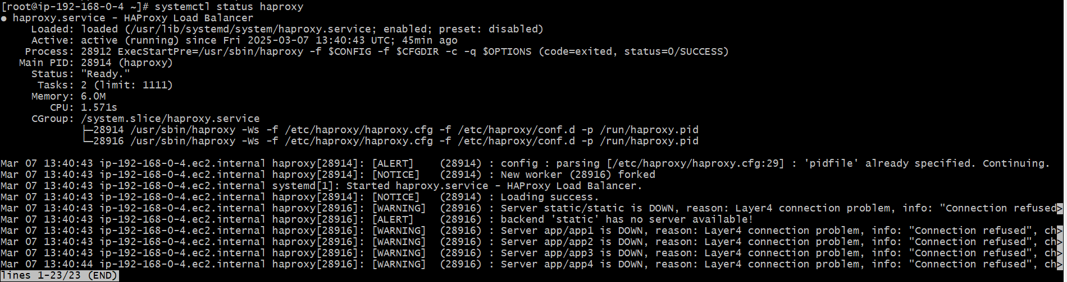

now browse with HA-Proxy-Server PublicIP:80 it will distribute load to Server-1, Server-2



