**ANKAN MUKHERJEE , ROLL - 1828049 , SECTION - CSSE-1**

**ASSIGNMENT-1**

**Q1.**

**Program to find the GCD of n numbers.**

**Input: n=6**

**5 10 25 45 95 65**

**Output: 5**

#include <stdio.h>

#include <stdlib.h>

int* sort(int a[],int n){

for (int i = 0; i < n; ++i)

{

for (int j = i+1; j <n ; ++j)

{

if (a[i] >= a[j])

{

int t = a[i];

a[i] = a[j];

a[j] = t;

}

}

}

return a;

}

int gcd(int a[], int n){

int c=2,c1=0,b=1;

int *d = (int*)malloc(n*sizeof(int));

d= sort(a,n);

do{

for (int i = 0; i < n; ++i)

{

if (*(d+i)%c == 0)

{

c1++;

}

}

if (c1 == n){

b=c;c++;c1=0;

}else{

c++;c1=0;

}

}while(c<=*(d+0));

return b;

}

int main(){

int n;

printf("Enter no of items\n");

scanf("%d",&n);

int a[n];

printf("Enter the no\n");

for (int i = 0; i < n; ++i)

{

scanf("%d",&a[i]);

}

int ans = gcd(a,n);

printf("GCD = %d\n",ans );

}

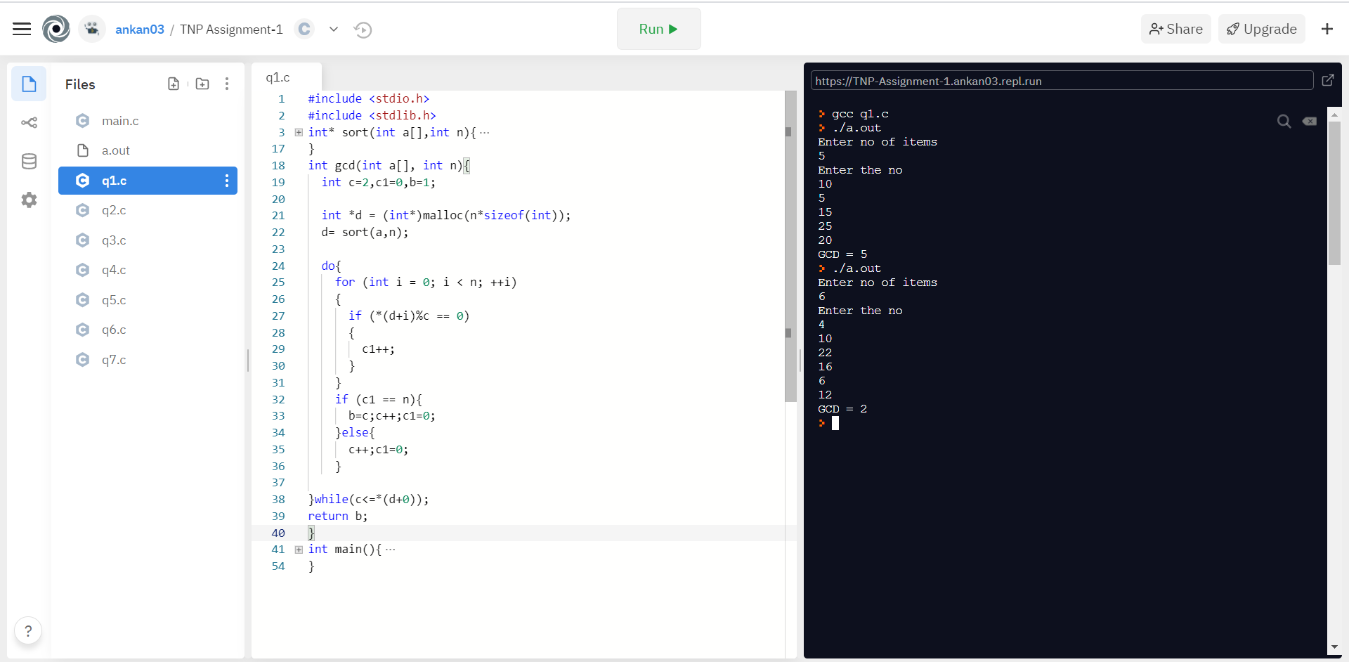

**Q2.**

**Program to print nth Fibonacci number. 0 1 1 2 3 5 8 13 21…….**

**Input: n=7**

**Output: 8**

#include <stdio.h>

#include <stdlib.h>

int fib(int n){

int x=0,y=1,z=x+y;

int a[n];

a[0]=0;a[1]=1;

int n1=2;

while(n1<=n){

z=x+y;

x=y;

y=z;

a[n1]=z;

n1++;

}

return a[n-1];

}

void main(){

int n;

printf("Enter value of n\n");

scanf("%d",&n);

int ans = fib(n);

printf("%d th Fibonacci number is = %d\n",n,ans);

}

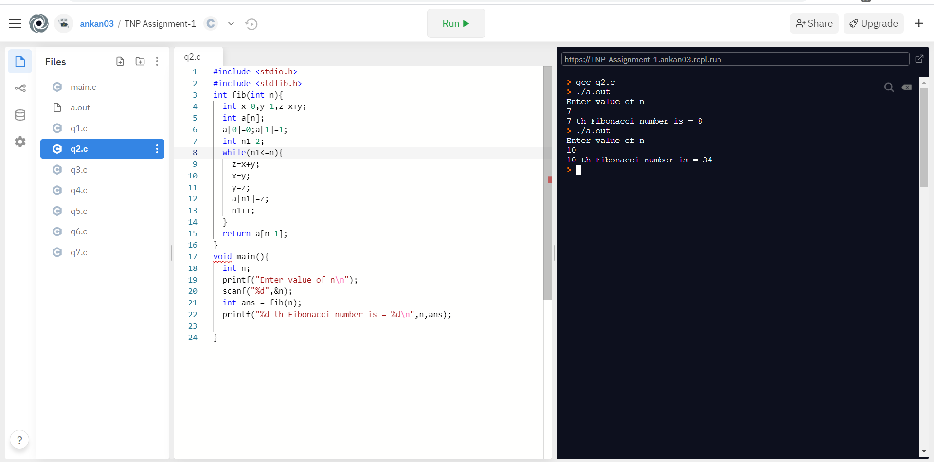

**Q3.**

**Program to print nth prime number.**

**Input: n=5**

**Output: 11**

#include <stdio.h>

#include <stdlib.h>

int prime(int n){

int a[n];

int n1=0,j=1,k=0;

while(n1<=n){

int c=0;

for (int i = 2; i <j ; ++i)

{

if (j%i == 0)

{

c++;

}

}

if (c==0)

{

a[k]=j;

k++;

n1++;

}

j++;

}

return a[n1-1];

}

void main(){

int n;

printf("Enter value of n\n");

scanf("%d",&n);

int ans = prime(n);

printf("%d th prime number is = %d\n",n,ans);

}

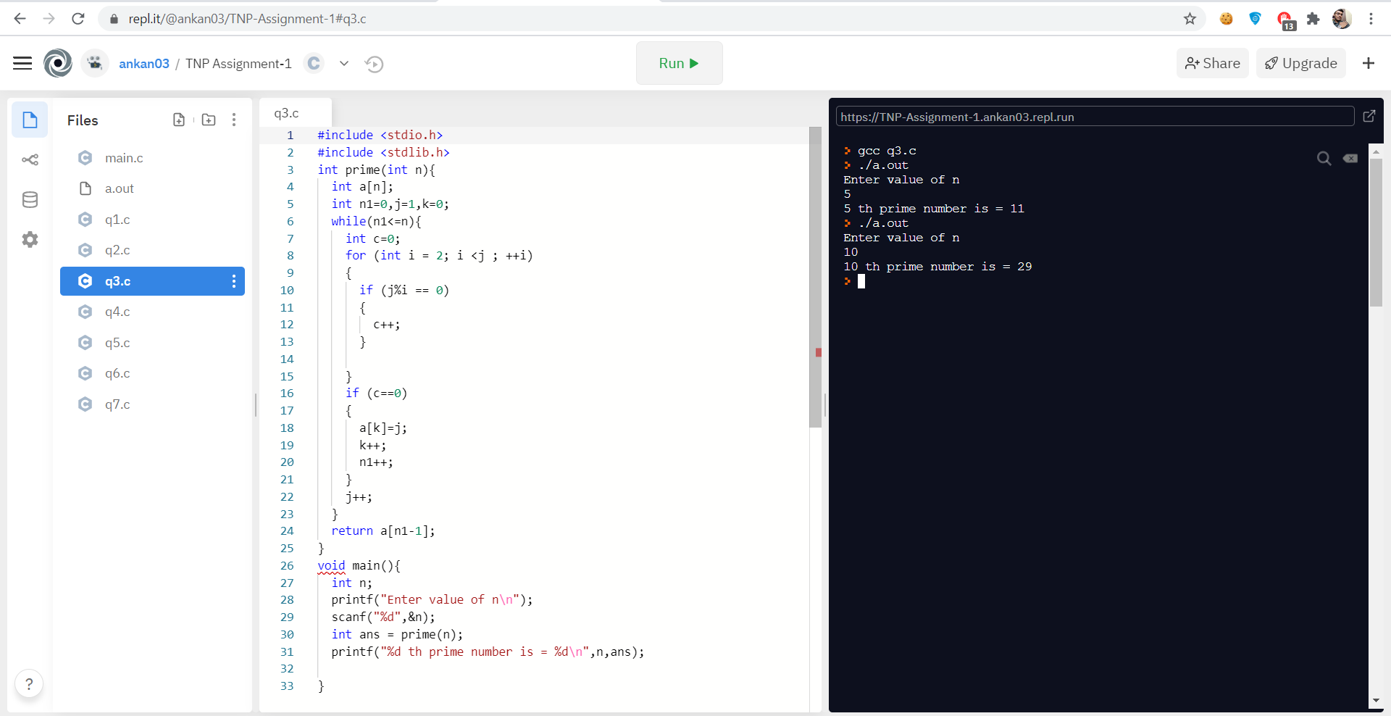

**Q4.**

**Program to find sum of the prime factors of a number.**

**Input: n=100**

**Output: 2+5=7**

#include <stdio.h>

#include <stdlib.h>

int isPrime(int n){

int c=0;

for (int i = 2; i <= n/2; ++i)

{

if (n%i==0)

{

c++;

}

}

if (c==0)

{

// printf("n = %d, returned 1\n",n );

return 1;

}else{

// printf("n = %d, returned 0\n",n );

return 0;

}

}

int SumPrimeFactor(int n){

int a[n];

int c=0,s=0;

for (int i = 2; i <= n/2; ++i)

{

if (n%i == 0)

{

if (isPrime(i))

{

a[c]=i;

c++;

}

}

}

for (int i = 0; i < c; ++i)

{

s += a[i];

}

return s;

}

void main(){

int n;

printf("Enter value of n\n");

scanf("%d",&n);

int ans = SumPrimeFactor(n);

printf("Sum of Prime Factor of %d is = %d\n",n,ans);

}

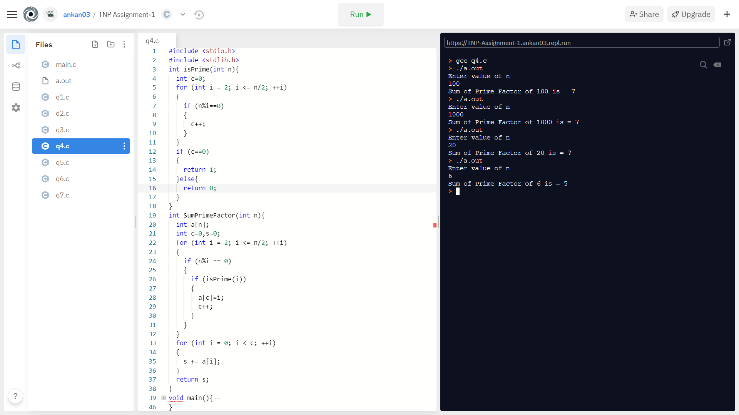

**Q5.**

**Program to print first n non-fobo numbers. First n numbers not in Fibonacci series. 0 1 1 2 3 5 8 13……**

**Input: n=5**

**Output: 4 6 7 9 10**

#include <stdio.h>

#include <stdlib.h>

void fib(int n){

int x=0,y=1,z=x+y,k=0;

int a[n+5],b[n];

a[0]=0;a[1]=1;

int n1=2;

while(k<=n){

z=x+y;

x=y;

y=z;

a[n1]=z;

if (a[n1]-a[n1-1]>1)

{

// printf("a[n1] = %d , a[n1-1] = %d\n",a[n1],a[n1-1]);

int p = a[n1-1]+1;

while(p < a[n1]){

b[k]=p;

k++;p++;

}

}

n1++;

}

for (int i = 0; i < n; ++i)

{

printf("%d\t",b[i] );

}

// return b[n-1];

}

void main(){

int n;

printf("Enter value of n\n");

scanf("%d",&n);

fib(n);

// printf("%d th Non-Fibonacci number is = %d\n",n,ans);

}

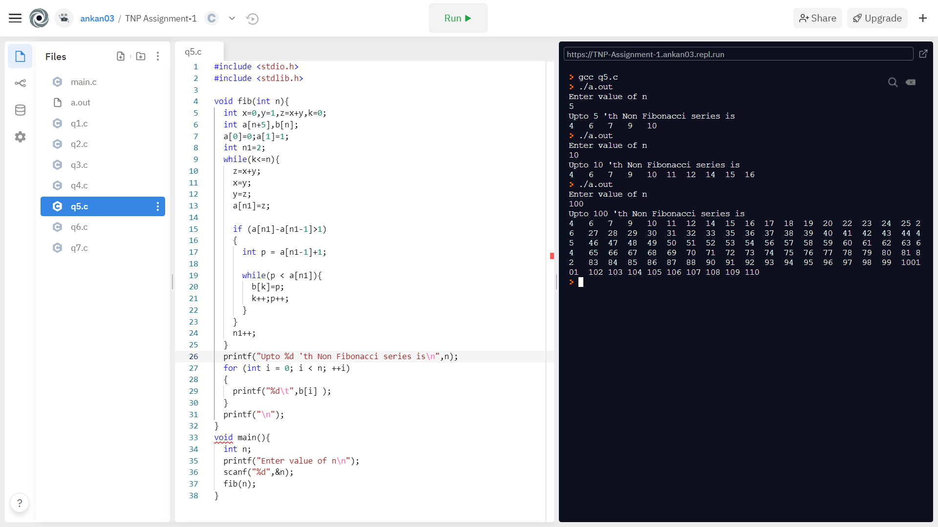

**Q6.**

**Program to convert a number from decimal to binary**

**Input: 5**

**Output: 0101**

#include <stdio.h>

#include <math.h>

int main(){

int n,j=0;

printf("Enter no\n");

scanf("%d",&n);

printf("Binary value of %d = ",n );

int a[(int)log2(n) +1];

while(n>0){

a[j] = n % 2;

j++;

n /= 2;

}

for (int i = j-1; i >=0; i--)

{

printf("%d", a[i]);

}

}

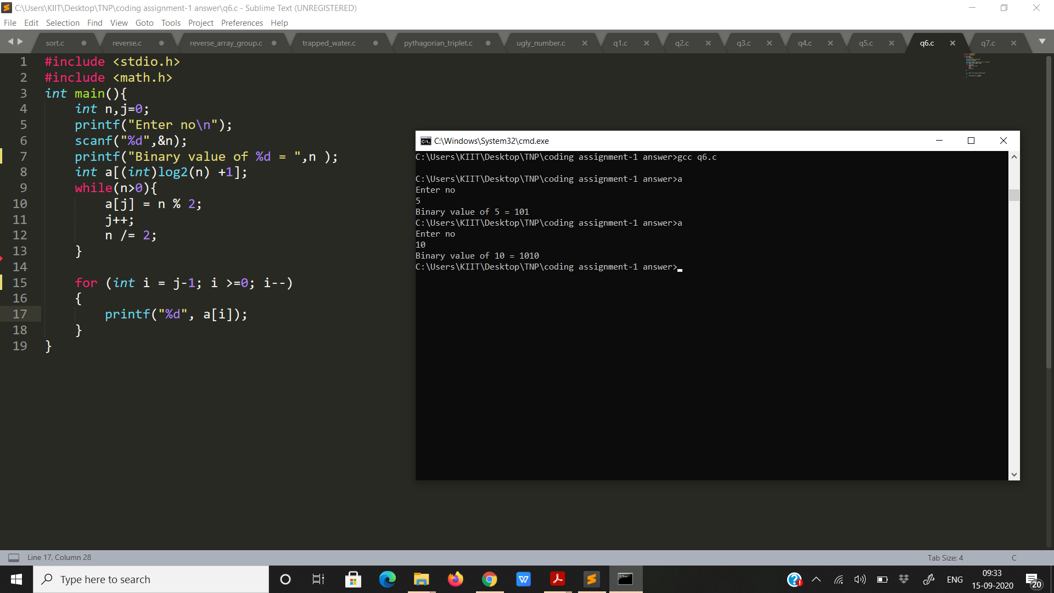

**Q7.**

**Program to check whether a number is a Harshad number or not. Harshad Number is an integer that is divisible by the sum of its digits.**

**Input: 1729**

**Output: Harshad Number**

#include <stdio.h>

void harshadNumber(int n){

int n1=n,s=0;

while(n1>=1){

s = s + n1%10;

n1 /= 10;

}

if (n%s == 0)

printf("Harshad number\n");

else

printf("Not a Harshad number\n");

}

int main(){

int n;

printf("Enter no\n");

scanf("%d",&n);

harshadNumber(n);

return 0;

}

