PIZZA SALES SQL QUERIES
KPI:1-5
1.Total Revenue: The sum of the total price of all pizza orders.
select sum(total_price) as Total_revenue from pizza_sales;
output:
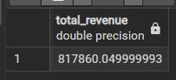

2.Average Order Value: The avg amount spent per order, calculated by dividing the total revenue by the total number of orders.
select sum(total_price)/count(distinct order_id) as avg_odr_value from pizza_sales;
output:


3.Total Pizzas Sold: The sum of the quantities of all pizzas sold.
select sum(quantity) as total_pizza_sold from pizza_sales;
output:
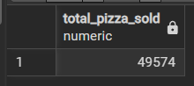

4.Total Orders: The total number of orders placed.
select count(order_id) as total_orders from pizza_sales;
output:


5.Average Pizzas Per Order: The average number of pizzas sold per order, calculated by dividing the total number of pizzas sold by the total number of orders.
select sum(quantity)/(select count(distinct order_id)from pizza_sales)
as avg_pizza_per_odr from pizza_sales;
output:


6. Monthly Trend for Orders
select to_char(order_date, 'Mon') as month, count(distinct order_id) as total_orders from pizza_sales group by 1;
output:
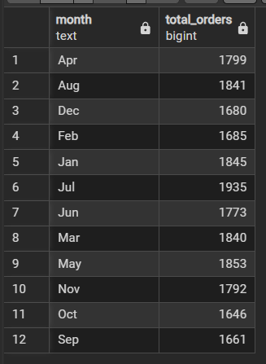

7. Daily Trend for Total Orders
select to_char(order_date,'Day') as day,
count(distinct order_id) as total_orders from pizza_sales group by 1;
output:
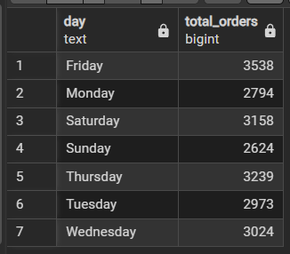

8. % of Sales by Pizza Category
select pizza_category, sum(total_price) revenue,(sum(total_price)*100/ (select sum(total_price) from pizza_sales))as pct from pizza_sales group by 1;
output:
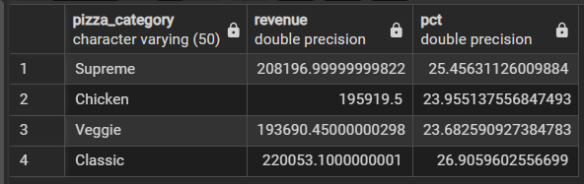

9. % of sales by pizza size
select pizza_size, sum(total_price) revenue,(sum(total_price)*100/
(select sum(total_price) from pizza_sales)) as pct from pizza_sales group by 1;
Output:
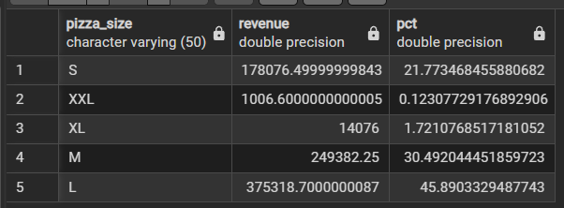

10. Total Pizzas Sold by Pizza Category
select pizza_category, sum(quantity) as qnt_sold from pizza_sales group by 1;
output:
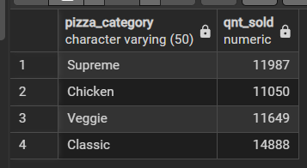

11. Top 5 Pizzas by Revenue
select pizza_name, sum(total_price) total_revenue from pizza_sales
group by 1 order by 2 desc limit 5;
output:
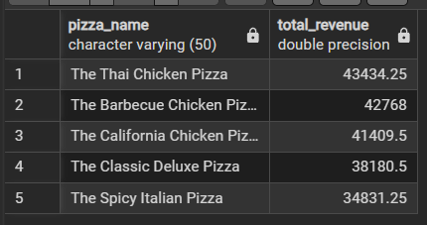
12.Bottom 5 Pizzas by Revenue
select pizza_name, sum(total_price) total_revenue from pizza_sales
group by 1 order by 2 asc limit 5;
output:
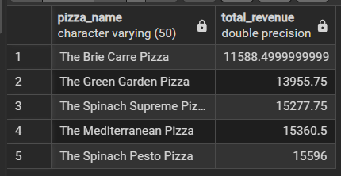

13. Top 5 Pizzas by Quantity.
select pizza_name, sum(quantity) total_revenue from pizza_sales
group by 1 order by 2 desc limit 5;
output:
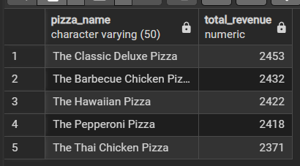

14.Bottom 5 Pizzas by Quantity.
select pizza_name, sum(quantity) total_revenue from pizza_sales
group by 1 order by 2 asc limit 5;
output:
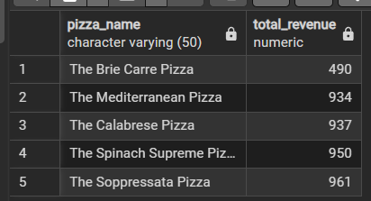

-----END----

