HEALTHCARE ANALYTICS FOR DOCTOR VISITS
DIY Project Report
Student Name: Ankana Paul
Student ID: STU674aa6f6f33431732945654
Date: 07 October 2026

1. Problem Statement
Healthcare data contains information about people, their health conditions, healthcare support, and doctor visits. The problem addressed in this project is to identify useful patterns associated with the number of doctor visits and understand how health, illness, activity reduction, income, age, chronic conditions, gender, and healthcare support relate to visit frequency.

2. Project Objective
The objective is to perform an educational healthcare analytics study using the supplied doctor-visit dataset. The analysis focuses on data quality, descriptive statistics, group comparisons, numerical relationships, visualizations, and an exploratory machine-learning baseline.

3. Dataset Overview
According to the supplied Student Dataset Guide, the dataset contains 5,190 records and 13 columns. The guide identifies doctor visits as the main outcome and groups the remaining fields into personal, financial, health, healthcare-support, and record-identification information.
Column | Meaning | Category
visits | Number of doctor visits during the covered period | Doctor visit
gender | Gender such as male/female | Personal
age | Age stored in numerical/decimal form | Personal
income | Income level / financial background | Financial
illness | Number of illnesses or health problems | Health
reduced | Days normal activities were reduced due to health problems | Health impact
health | Numerical indicator of general health condition | Health
private | Private healthcare/insurance coverage indicator | Healthcare support
freepoor | Free healthcare support based on financial need | Healthcare support
freerepat | Special repatriation-related healthcare support indicator | Healthcare support
nchronic | Chronic health condition indicator | Chronic condition
lchronic | Long-term chronic health condition indicator | Chronic condition
Unnamed: 0 | Record identifier; not a healthcare measurement | Identification

4. Tools and Technologies
Python 3, Jupyter Notebook, pandas, NumPy, Matplotlib, scikit-learn, python-docx, and python-pptx.

5. Methodology
- Loaded the supplied CSV dataset into pandas.
- Checked data types, missing values, duplicate rows, and descriptive statistics.
- Excluded the record identifier `Unnamed: 0` from analytical relationships.
- Analyzed the distribution of doctor visits.
- Compared average visits across gender, healthcare-support indicators, and chronic-condition indicators.
- Calculated Pearson correlations between visits and the main numerical variables.
- Built an exploratory Random Forest regression baseline using one-hot encoding for categorical variables.
- Evaluated the baseline with Mean Absolute Error (MAE) and R² and inspected feature importance.

6. Results and Findings
The dataset has 5,190 records after retaining the supplied analytical columns. The mean number of visits is 0.302, while the median is 0.
79.8% of records have zero recorded doctor visits, meaning the outcome is strongly concentrated at zero.
The strongest positive Pearson correlation among the main numerical health variables is `reduced` (0.419). `illness` (0.224) and `health` (0.193) also show positive associations.
Average visits are 0.362 for females and 0.236 for males in this dataset.
For long-term chronic condition, the average is 0.603 for `yes` versus 0.262 for `no`.
The exploratory Random Forest baseline achieved MAE = 0.438 and R² = 0.122 on a held-out 20% test set. This modest R² indicates that the model should be treated as an educational baseline rather than a reliable clinical prediction tool.

Doctor Visit Distribution
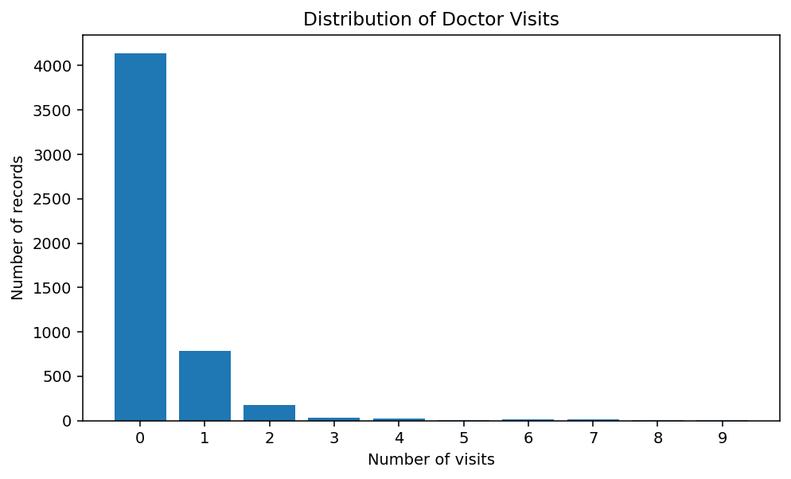

Average Visits by Gender
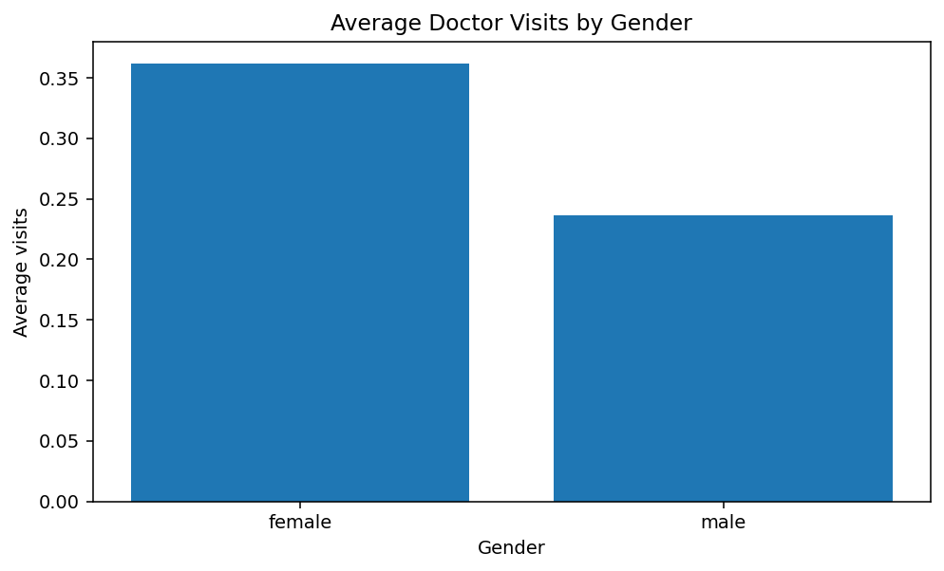

Correlation with Doctor Visits
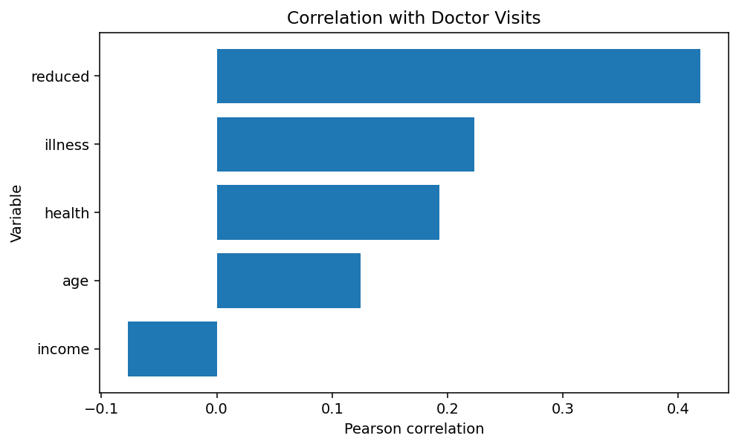

Average Visits by Long-Term Chronic Condition
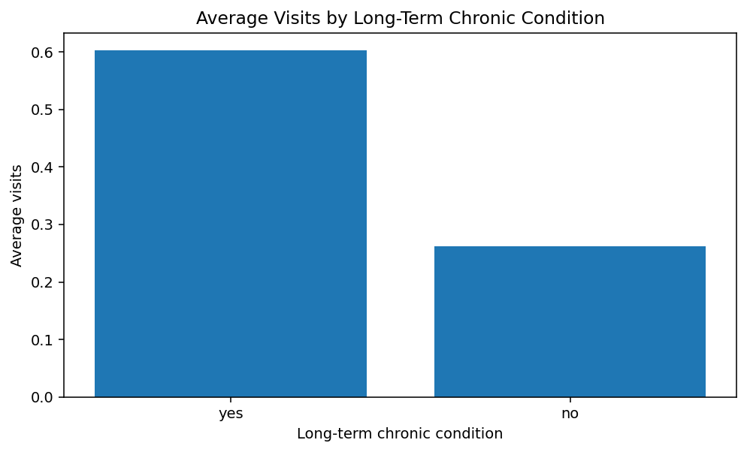

Exploratory Model Feature Importance
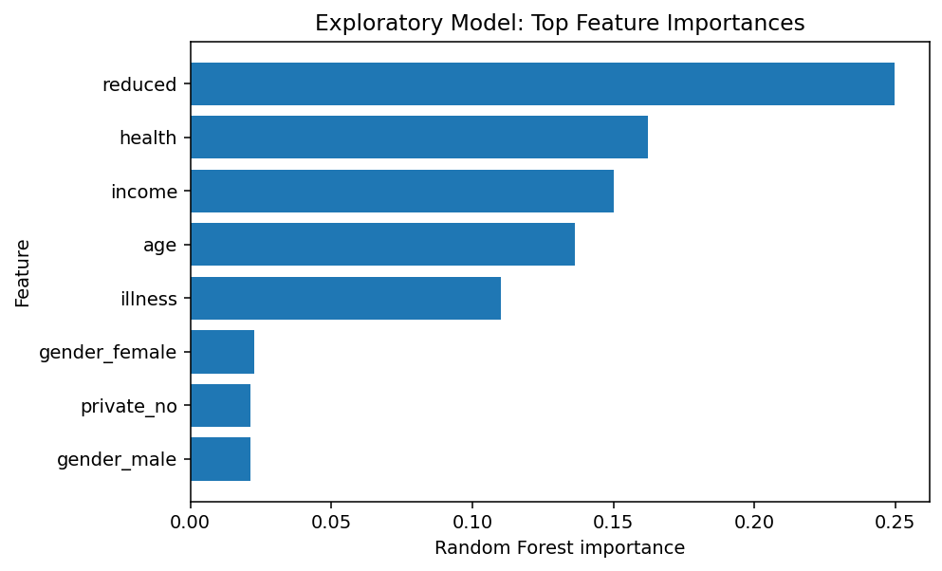

7. Limitations
- The supplied guide does not define a clinical conversion or interpretation for every numerical scale.
- Correlation and group differences describe association and do not prove causation.
- The visits outcome is heavily zero-inflated.
- The dataset is educational and should not be used for diagnosis or clinical decision-making.
- The age variable remains in its supplied decimal format because the guide does not specify a conversion formula.
- The analysis cannot establish why a person receives particular healthcare support or why visits occur.

8. Conclusion
The analysis demonstrates how healthcare analytics can be used to identify patterns in doctor visits. Activity reduction, illness, health status, and chronic-condition indicators show meaningful relationships with visit frequency in this dataset. The project provides a reproducible notebook, visual outputs, documentation, and presentation for educational submission.

9. Project Files
- Healthcare_Analytics_Doctor_Visits.ipynb – executed analysis notebook.
- requirements.txt – Python dependencies.
- README.md – GitHub setup and usage instructions.
- Healthcare_Analytics_ProjectReport.docx – this report.
- Healthcare_Analytics_Doctor_Visits_Presentation.pptx – completed PPT based on the supplied template.
- data/healthcare_doctor_visits.csv – project dataset copy.
- outputs/ – generated charts used in the report and presentation.

