# **Preparing montage files**

In our lab, we use two types of electrode montages: CAC and CMA. For our recording, we generally use 64 electrodes. To simplify understanding, we refer to the CAC-type actiCAP64 electrodes as ‘**actiCAP64’** and the CMA-type actiCAP64 electrodes as ‘**actiCAP64_UOL**’. ‘actiCAP64’ is also called uniform optimized layout.

We outline the steps below for preparing the relevant montage files to work with the EEGLab and Fieldtrip for each cap type.

# **Please note that while executing any functions or scripts for setting up Montage locations, ensure that your present working directory (PWD) is set to 'ProgramsMAP'.**

**Scripts used to Prepare Montage files:**

We use the following code flow (as shown in the diagram below) to generate the required montage formats for our electrodes in EEGLAB and field trips. A detailed description of each function is available in the .m file.

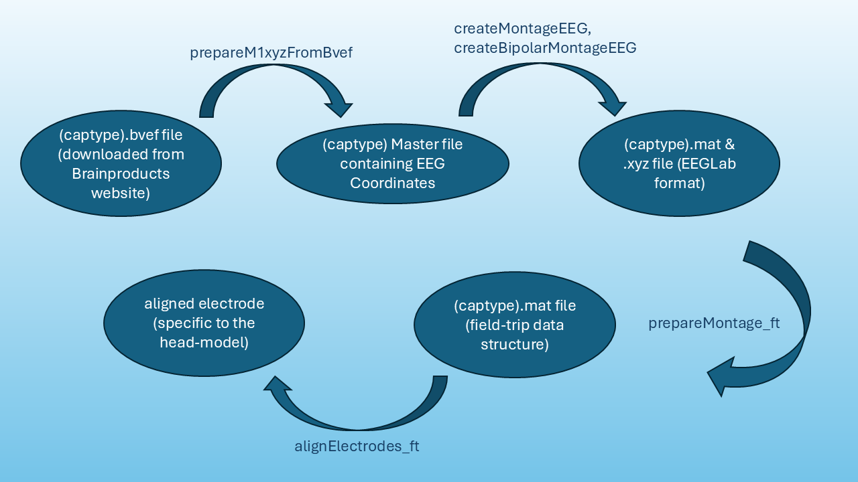

# **acticap64 Layout (CAC)**

Murthy used the following procedure to generate the required montage files for the acticap64 Layout. Do report any bugs/suggestions to MD at [murtydinavahi@gmail.com](mailto:murtydinavahi@gmail.com).

**Source of the M1_XYZ file**

M1_XYZ.mat file has been taken from Easycap's website and converted to a .mat file in MATLAB. I guess chanloc positions are already transposed to suit EEGLAB's coordinates, hence no further transposition required. (unlike that used for createBipolarMontageEEG.m).

Step 1:

Make sure M1_XYZ.mat file is in pwd/Montages. Currently, this file supports only 64-channel settings.

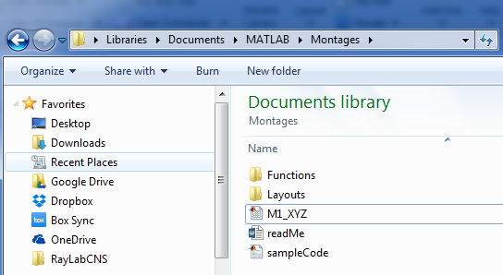

Step 2:

Add a .mat file in the format [*capName* ‘Labels.mat’] in the folder pwd/Montages/Layouts/*capName* folder.

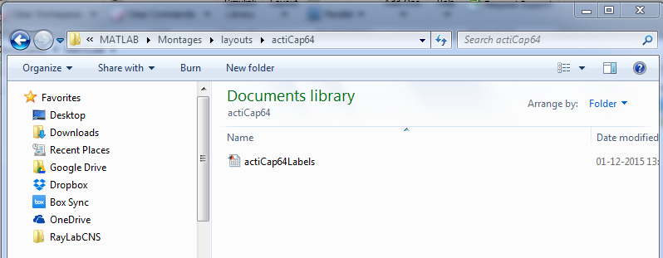

This is an nX2 cell with the variable name *montageLabels*, where n represents the no. of electrodes, 1st column is the physical number of the electrode, and 2nd column is the standard label of the electrode. The label should be in the international system and be present in M1_XYZ.mat file.

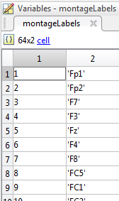

Step 3:

Run the sample code for unipolar reference to generate *capName*.mat and *capName*.xyz in the cap’s directory.

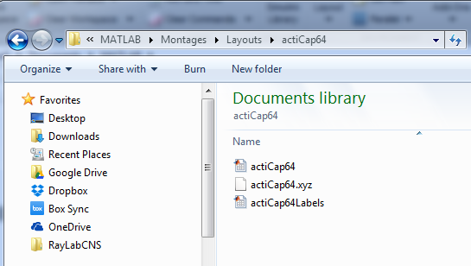

Step 4:

Add a file [‘bipChInfo’ upper(*capName*(1)) capName(2:end) ‘.mat’] in the cap’s folder.

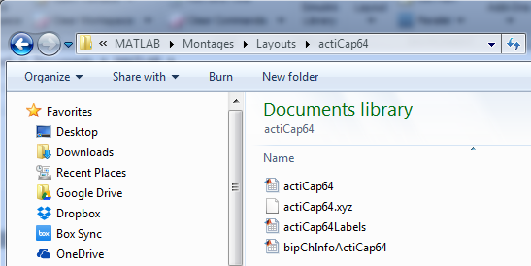

This is an nX2 matrix. Each row represents the physical number of the new bipolar electrode, with physical numbers of the two participating unipolar electrodes specified in column 1 and column 2. This matrix has a variable name *bipolarLocs*.

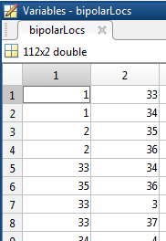

Step 5:

Run the sample code for bipolar channels. This generates [‘bipolarChanlocs’ upper(*capName*(1)) capName(2:end) ‘.mat’] and [‘bipolarChanlocs’ upper(*capName*(1)) capName(2:end) ‘.xyz’] in the cap’s folder.

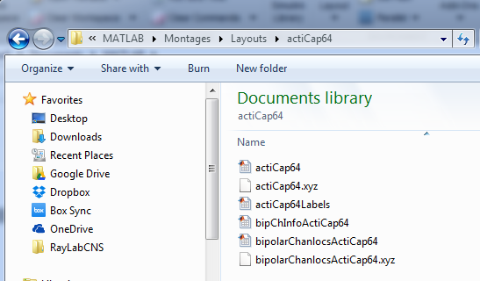

So, bingo... It is ready… .xyz format could be used in EEGLAB. .mat format could be passed as the *chanlocs* argument for topoplot.m function.

**Observations:**

I (Ankan) have observed that **M1_XYZ** contains electrode locations in the X, Y, and Z columns. However, the **actiCap64.mat** file within the montage folder contains chanlocs, which labels the electrode locations with the first column as Y, the second as X, and the third as Z. Despite this, the order is correct again when generating the .xyz file because we are using **M1_XYZ** directly. Therefore, when we read the locations using topoplots, the visualization is accurate.

This issue might occur because readlocs flips the X locations while reading the .xyz file.

# **acticap64_UOL Layout (CMA)**

The actiCAP64_UOL layout was created using electrode locations, read from the .bvev file provided with the BrainProducts cap. The steps for setting up this layout are detailed below:

**a. Download the Layout for Your Cap Type**

You can download the relevant files for your cap type from the BrainProducts website without the need for an account from <https://www.brainproducts.com/downloads/cap-montages/>

Extract the files once they have been downloaded. There are layouts for different kinds of caps in the extracted files. The necessary files for our use are found in the actiCAP UOL 64 Channel folder. The following files are available in the BrainAmp subdirectory and are unique to this type of cap:

* CMA-64.pdf: Contains the layout diagram.
* CMA-64_REF.bvef: The file used to access electrode locations.

We have kept the. bvef and layout files in the ‘BrainAmp’ folder under the actiCAP_UOL cap type.

**b. Reading the .bvef File**

To load the .bvef file, the **bva-io** EEGLAB plugin is required. Follow these instructions:

1. Verify if the bva-io plugin is installed in your EEGLAB directory. If it is not, download it from the [bva-io GitHub repository](https://github.com/sccn/bva-io) (<https://github.com/sccn/bva-io>).
2. Place the plugin in the eeglab\plugin directory.
3. Add the plugin path to MATLAB using the addpath function.

Then, use the ‘prepareM1XYZfromBvef.m’ function to convert the master location file for acticap64_UOL. Once you have the master file, you can follow similar steps as ‘acticap64’ to generate location files for EEGlab and FieldTrip as outlined above.

.