SEC-EDGAR Financial RAG & Evaluation Engine
Architecture & Engineering Report
Retrieval-augmented question answering over Nasdaq-100 SEC 10-K / 10-Q filings, built and measured phase by phase on a 4 GB-VRAM laptop with free models only.

Generated 2026-09-29 from the repository state at commit 655fdca
Repository: D:\SEC EDGAR RAG
Every number in this report is computed from files in the repository by docs/tools/report_data.py; each table names its source file.

Contents
Right-click and choose Update Field (or press F9) to build the table of contents.

1. Executive summary
This project builds a question-answering system over U.S. SEC filings: it retrieves the exact table rows and passages that answer a financial question and generates a cited answer whose numbers are verified against those sources. It was built in explicit phases, and every component was kept only if it improved a measured baseline.
The corpus is 726 filings (181 annual 10-Ks and 545 quarterly 10-Qs, filed 2024-09-30 to 2026-09-24) from 93 Nasdaq-100 companies, parsed into 240,832 retrieval chunks and 103,145 context sections. The final pipeline splits multi-part questions into single lookups, retrieves each with BM25, re-scores candidates with a BGE cross-encoder that reads tables as sentences, expands to the parent section, and answers with a local Qwen3-4B model that delegates all arithmetic to Python.
Headline results (eval set v1: 236 questions with deterministic answer keys, 3 companies; details in Section 6):
- Retrieval MRR@10: dense 0.132 → BM25 0.428 → + reranker 0.614 → + decomposition 0.725.
- Multi-fact questions: every required fact in the top 10 (all-hit@10) went from 0.000 to 0.917 for cross-quarter and 0.000 to 1.000 for cross-company comparisons once questions were decomposed.
- Table linearization: showing the reranker table rows as sentences lifted MRR@10 by +0.323 (95% CI [+0.258, +0.389], significant) on eval v0.
- Answer accuracy: 52.5% → 87.5% correct on the same 40 questions with decomposition (15 fixed, 1 broken, McNemar p = 0.0005).
- Numerical safety: 0% of answers contained a number that no source supports (all generation runs G1-G6).
- Scale: at 726 filings (240,832 chunks) V5 MRR@10 changed by -0.010 (95% CI [-0.031, +0.009], not significant) relative to 24 filings; retrieval p50 493 ms.
- What the number check cannot see: planted invented numbers were flagged 97.5% of the time, planted wrong-cell numbers 0.0%. In the <calc> runs (G5, G6, G7) none of the 19 wrong answers was flagged: they quote real figures from another period, filing, row or column, or miss a fact retrieval did not find (Section 5.16).
- <calc> ablation: without <calc> (G8) 87.5% of answers were correct vs 82.5% with it (G7; McNemar p = 0.50, not significant), and neither run made an arithmetic error. <calc> stays because it keeps the number check meaningful: without it 60% of correct answers were flagged, vs 3% with it.
- Negative results, kept on record: dense retrieval and hybrid fusion did not help on this workload, HyDE gave no measurable gain, and a local 8B model was not a reliable faithfulness judge.
Constraints that shaped everything: an NVIDIA RTX 3050 Laptop GPU with 4 GB VRAM, 16 GB RAM, Windows 11, all data on the D: drive, and free models only (local open-weight models; hosted judges only on free tiers). The pipeline is served by a FastAPI service with a chat UI, traced in Arize Phoenix and packaged with Docker (Section 5.17). Open items: Ragas scoring is paused at 32 answers because of free-tier limits, and vector quantization (Phase 18) has not been run.

1a. Naming key: short forms used throughout
Experiments are labelled with short IDs. Each is defined below from the notes and options recorded in data/eval/results/experiments.csv, the result file names, the generation evaluation code and the commit messages. Every later chapter spells an ID out on first use.
Table 1. Run identifiers and version labels
ID | Stands for | Exact configuration | Eval set | Phase | Results
V1 | Dense retrieval | bge-small-en-v1.5 embedding search over child chunks, no filters | v0, v1 | 7 | experiments.csv; */V1_dense_*
V1h | Dense retrieval with HyDE | V1 but the query vector = mean(hypothetical-passage embedding, question embedding) | v1 | 15 | retrieval_v1/V1h_hyde_dense_*
V2 | BM25 | Qdrant sparse vectors (fastembed Qdrant/bm25, IDF modifier, avg_len 113.5) | v0, v1 | 8 | */V2_bm25_*
V3 | Hybrid | dense top-30 + BM25 top-30, relative-score fusion, alpha 0.3 (chosen on dev split) | v0, v1 | 9 | */V3_hybrid_*
V4 | Reranked BM25 | BM25 top-60 → bge-reranker-base (fp16, raw logits) reading linearized tables | v0, v1 | 10 | */V4_rerank_*
V4-md | V4 ablation | same as V4 but the reranker reads markdown tables | v0 | 10 | V4-md_rerank_*
V4h | V4, hybrid pool | pool = BM25-45 + dense-15, then the V4 reranker | v0 | 10 | V4h_rerank_*
V5 | V4 + decomposition | regex router → Qwen3-4B JSON sub-questions → V4 per sub-question → round-robin interleave | v1 | 14 | retrieval_v1/V5_decomposed_*
V5h | HyDE control | V5 with pool BM25-45 + plain dense-15 | v1 | 15 | retrieval_v1/V5h_decomposed_*
V6 | V5 + HyDE | V5 with pool BM25-45 + HyDE-dense-15 | v1 | 15 | retrieval_v1/V6_decomposed_*
Vn@Sx | Scaled run | retrieval version n measured with the index at scaling stage x (e.g. V5@Sall) | v1 | 16 | retrieval_v1/V*@S*_*
G1 | Generation run 1 | 30 numeric questions (eval v0), V4 retrieval, prompt v1 | v0 | 11 | G1_generation.csv
G2 | Generation run 2 | 40 questions stratified over 5 answerable types (eval v1), V4, prompt v1 | v1 | 12 | G2_generation.csv
G3 | Generation run 3 | same 40 questions, prompt v2 (calc for every change, comparisons state the difference, no appended refusal) | v1 | 12 | G3_generation.csv
G4 | Generation run 4 | same 40 questions, prompt v2 + decomposition (V5 retrieval) | v1 | 14 | G4_generation.csv
G5 | Generation run 5 | G3 setup on 64 questions (40 + 24 narrative); answers and exact contexts saved for Ragas | v1 | 13 | G5_generation.csv, G5_ragas_input.jsonl
G6 | Generation run 6 | G4 setup on the same 64 questions; contexts saved for Ragas | v1 | 13 | G6_generation.csv, G6_ragas_input.jsonl
G7 | Generation run 7 | G4 setup re-run on the full 726-filing index (the <calc> control for G8) | v1 | 17 | G7_generation.csv, G7_ragas_input.jsonl
G8 | Generation run 8 | G7 with the no-<calc> prompt: the model does its own arithmetic (ablation) | v1 | 17 | G8_generation.csv, G8_ragas_input.jsonl
phase17_* | Phase 17 outputs | per-question audit, per-number origins, planted-error stress test, arithmetic status | v1 | 17 | phase17_audit/numbers/stress/arithmetic.csv
S24 ... Sall | Scaling stages | index containing 24, 56, 104, 254 and 726 filings (3, 7, 13, 32, 93 companies) | v1 | 16 | scaling_stages.json, scaling.csv
v0 / v1 | Evaluation sets | v0: 164 questions (numeric + narrative); v1: 236 questions (6 types, multi-fact gold groups) | - | 7, 12 | data/eval/retrieval_v*.jsonl
prompt v1 / v2 | Generation prompts | v2 added rules 4-6: calc for every change incl. rounding, state differences, refusal only if no figure | - | 11, 12 | src/generation/generator.py (git history)
parser v1-v4 | Parser output versions | v2 section fallbacks; v3 font-size headings + section_mode; v4 header-row detection (year rows, period labels, unit captions) | - | 3, 10 | src/parsing/parser.py PARSER_VERSION
chunker v1-v3 | Chunker output versions | v2 split oversized footnotes; v3 re-chunk after the header-row fix | - | 4, 10 | src/chunking/hierarchical.py CHUNKER_VERSION
judges | Ragas judges | groq-gpt-oss-120b (Groq free plan); local-llama3.1-8b (Ollama, schema-constrained) | - | 13 | configs/evaluation.yaml
Question types (eval v1): numeric (one statement row), yoy (current vs prior-year value in one row), pct_change (percentage change between two periods), cross_quarter (same metric in two quarterly filings), cross_company (same concept for two companies), narrative (hand-written, rule-based relevance). Metric short forms are defined in Section 8 and Appendix C. Result files are named <ID>_<retriever>_per_query.csv and <ID>_<retriever>_traces.jsonl (for example V4_rerank_per_query.csv, V5@Sall_decomposed_traces.jsonl): eval v0 files sit in data/eval/results/, eval v1 files in data/eval/results/retrieval_v1/. Ranges such as V1-V3 mean 'V1, V2 and V3'.
Source: data/eval/results/experiments.csv (version, retriever, dataset, notes); src/evaluation/generation.py; git log

2. Constraints and principles
- Hardware: RTX 3050 Laptop GPU with 4 GB VRAM, 16 GB RAM, Windows 11. The LLM feasibility benchmark found that Windows reserves about 0.8 GB of the GPU and llama.cpp keeps about 1 GB free, so a local LLM gets roughly 2.25 GB of VRAM and spills the remaining layers to the CPU (Section 5.6).
- Storage: all data, models, pip caches and Docker's disk image live on D:; model caches that default to C: (Hugging Face, LlamaIndex, fastembed) are redirected in src/config.py.
- Measure every component: each addition is compared against the previous version on a fixed evaluation set with paired significance tests, and settings are chosen on a dev split and reported on a test split.
- Free models only: local open-weight models (bge-small, bge-reranker-base, Qwen3-4B, Llama 3.1 8B) and hosted judges only on free plans with call caps and clean stops on quota limits.
- Scale gradually: 24 filings end-to-end first, then 56, 104, 254 and 726 filings (Section 5.15).

3. System architecture

3.1 Offline ingestion and indexing
The offline pipeline turns public SEC filings into two stores: a Qdrant collection of small, searchable child chunks (dense vector + BM25 sparse vector + payload), and a SQLite store of the larger parent sections the LLM reads. Every stage is resumable through JSON checkpoints and idempotent (deterministic IDs; a filing's points are deleted by accession number before re-upsert).
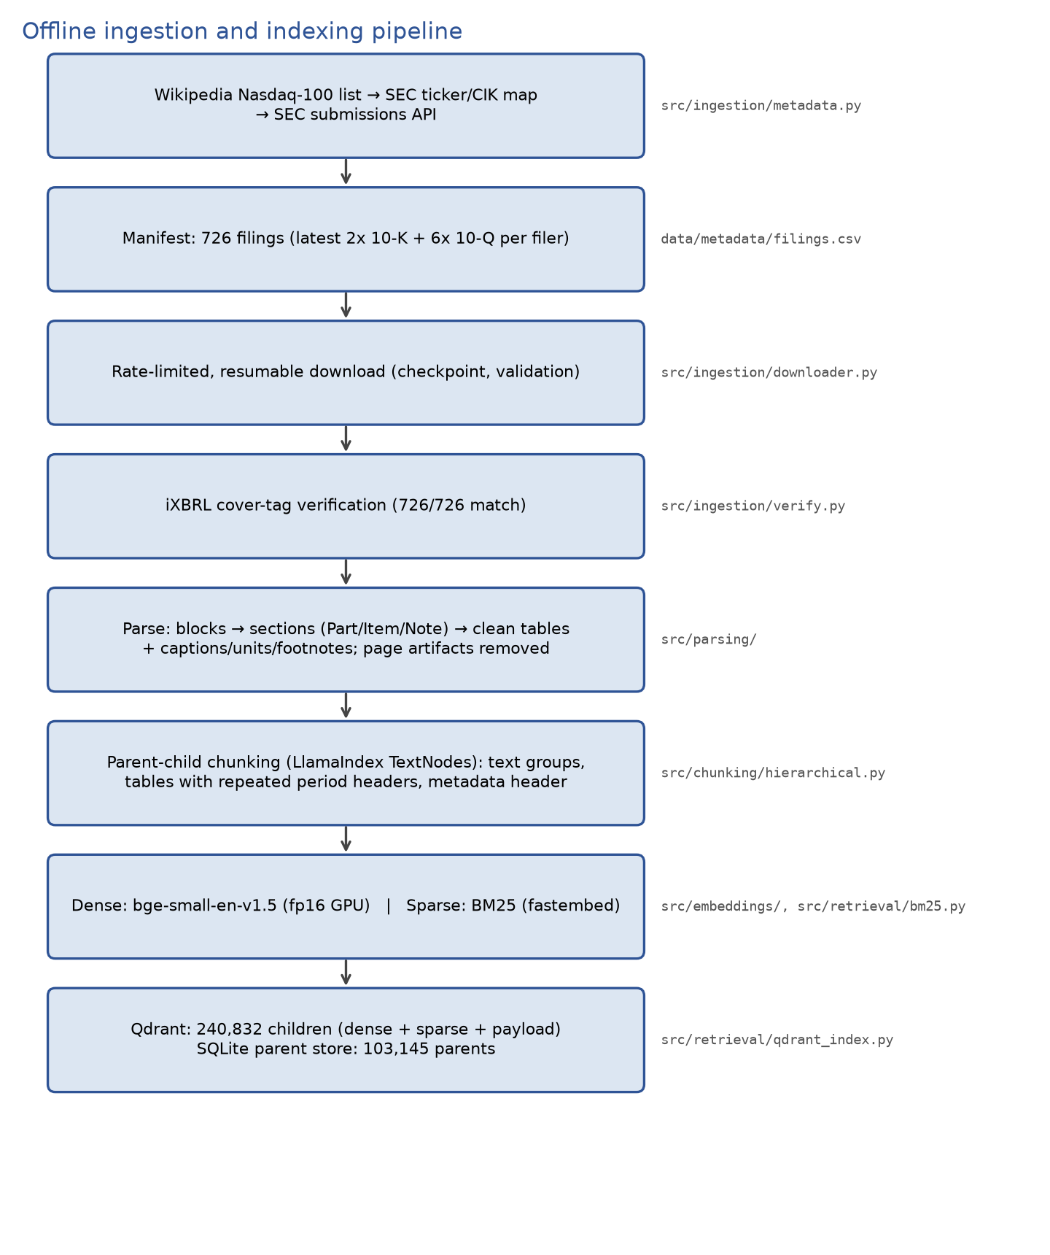
Figure 1. Offline pipeline. Source: src/ingestion, src/parsing, src/chunking, src/embeddings, src/retrieval.

3.2 Online query pipeline
At query time a regex router sends only comparison or multi-period questions to the decomposer; each sub-question is retrieved with BM25 and re-scored by the cross-encoder, and the rankings are interleaved so every fact is represented near the top. Retrieved children are replaced by their parent sections within a token budget, formatted as numbered sources and passed with the original question to the local LLM, whose arithmetic and numbers are checked in Python.
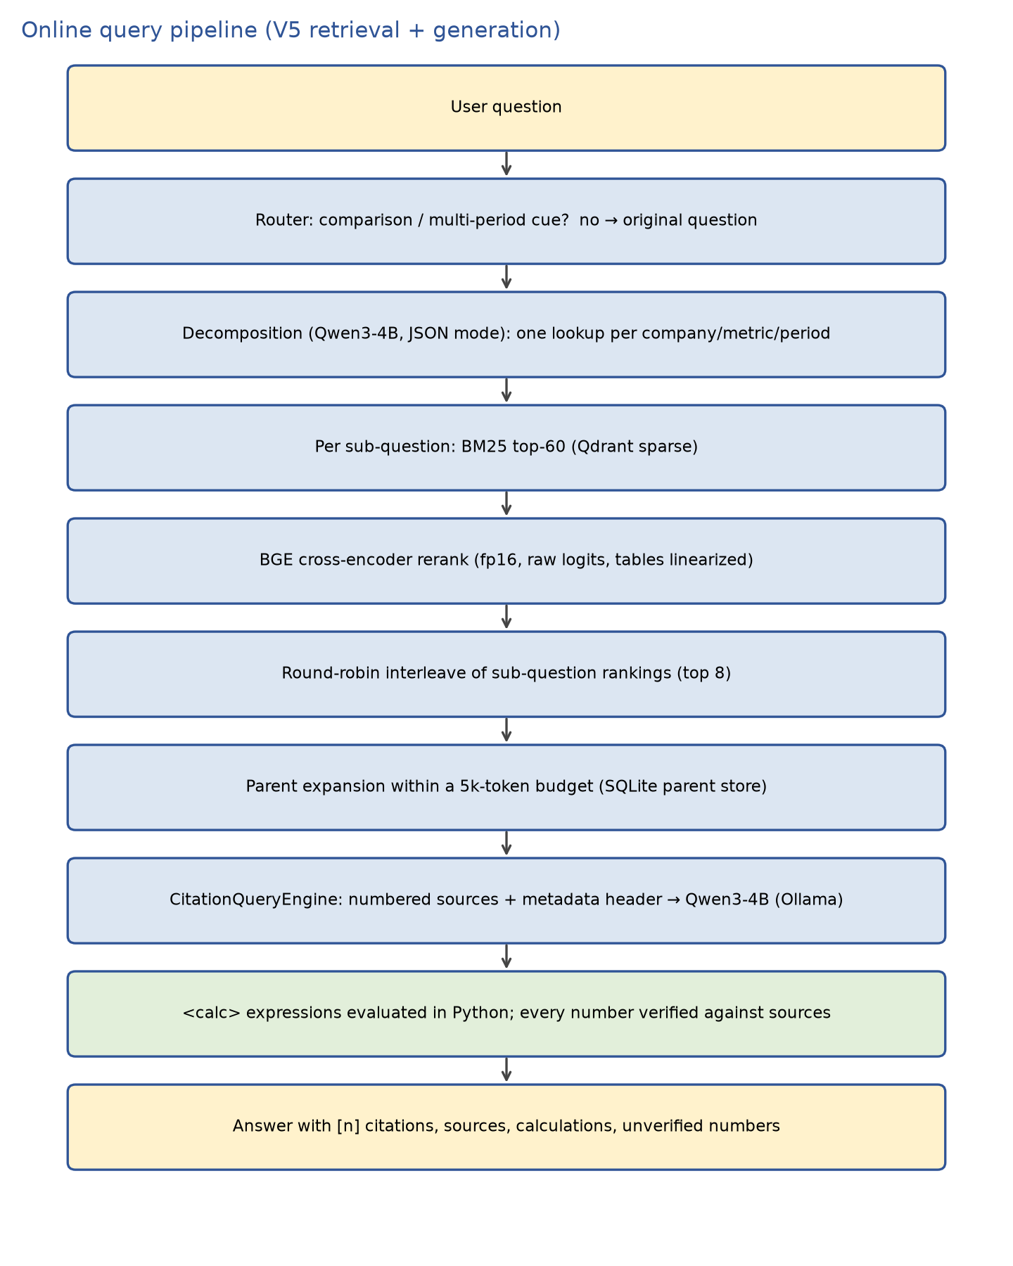
Figure 2. Online query pipeline. Source: src/query, src/retrieval, src/generation.

3.3 Data model
- Elements (parser output): heading, paragraph, table (markdown grid + caption + units + footnote links), footnote; each labelled with part, item, section, note and subsection.
- Parents: heading-delimited text groups (<= 1024 tokens) and whole tables with caption, units and footnotes (<= 2048 tokens; larger tables split with repeated headers).
- Children: ~256-token sentence-split text, or table row groups that repeat the period header rows.
- Metadata header: company, ticker, form, fiscal period (e.g. 'fiscal 2025 Q3 (quarter ended June 28, 2025)'), heading path, table caption and units are prepended to the text the embedder, BM25 and reranker see; IDs and URLs are excluded.
- IDs: uuid5(accession/p{i}/c{j}): re-running never duplicates vectors.
- Qdrant collection: named dense vector text-dense (384-d cosine) and sparse vector text-sparse-new (IDF modifier), on-disk payload, keyword and datetime payload indexes.

3.4 Repository map
Table 2. Repository layout
Path | Responsibility
src/ingestion/ | manifest, rate-limited SEC client, resumable downloader, checkpoints, iXBRL verification
src/parsing/ | HTML → elements; sections; table reconstruction; page-artifact removal
src/chunking/hierarchical.py | parent/child TextNodes, metadata header, deterministic IDs
src/embeddings/embedder.py | bge-small embeddings (fp16), per-filing vector cache, token checks
src/retrieval/ | Qdrant index, BM25, hybrid fusion, dense/HyDE, linearization, reranker, decomposed retriever, parent store
src/query/ | decomposition + router, HyDE
src/generation/ | Ollama server control, parent expansion, CitationQueryEngine generator, <calc> + number verification, LLM benchmark
src/evaluation/ | eval-set builder, retrieval metrics, sweeps, bootstrap comparison, generation accuracy, Ragas, numerical-hallucination audit and stress test
src/pipeline/scale.py | staged scaling with footprint capture and re-evaluation
src/observability/ | OpenTelemetry setup for Arize Phoenix, custom spans, latency report
src/api/ | FastAPI service (POST /query, GET /health, GET /metrics) and the chat UI at GET /
docker/, docker-compose.yml | API image; Qdrant, Phoenix, Ollama and API services
configs/*.yaml | every tunable with its rationale
tests/ | 67 unit tests pinning parser, chunker, retrieval metrics, number safeguards, judge guards, API, tracing and the Phase 17 locators

4. Models and components: what, why and how they work

4.1 bge-small-en-v1.5 (dense embeddings)
Role: bi-encoder for dense retrieval; 384-d vectors, fp16 on GPU, batch 64.
Mechanism: query and passage are encoded independently; the CLS representation is L2-normalised so cosine similarity is a dot product. BGE v1.5 is asymmetric: queries get the instruction prefix 'Represent this sentence for searching relevant passages:' and passages do not. That asymmetry mattered for HyDE, where the hypothetical passage is embedded as a passage.
Why: small enough to co-reside with the reranker and the LLM on 4 GB (298 MiB peak during embedding; commit 7fbd8b0), 512-token limit comfortably above the 490-token largest child. Weakness measured here: a single vector for a 15-row table dilutes the one row a numeric question asks about (V1 numeric P@3 was 0.024 on eval v0).

4.2 BM25 as Qdrant sparse vectors
Role: lexical retrieval; fastembed Qdrant/bm25 with k = 1.2, b = 0.75, avg_len = 113.5 (measured mean of stemmed, stopword-free chunk length; fastembed's default is 256).
Mechanism: each document stores term-frequency weights with saturation (k) and length normalisation (b); the query sends each unique stemmed token with weight 1; Qdrant's IDF modifier multiplies by collection-wide IDF at query time, so IDF stays correct as filings are added.
Why: financial questions name exact line items ('operating income', 'accounts payable'); BM25 lifted numeric P@3 on eval v0 from 0.024 to 0.264.

4.3 bge-reranker-base (cross-encoder)
Role: re-scores the ~60 candidates; fp16, batch 16.
Mechanism: query and candidate are concatenated and read jointly with full attention (XLM-RoBERTa, 12 layers), so the model can check that this row is the asked line item for the asked period, which a bi-encoder cannot.
Engineering: ranks on raw logits (the default sigmoid saturates near 0.999 and turns the top of the list into ties); tables are linearized ('Operating income: Three Months Ended June 28, 2025 = 28,202; ...') because a prose-trained cross-encoder preferred MD&A text about a metric over the markdown row containing it.

4.4 Qdrant and the parent store
Qdrant v1.19.1 in Docker with a named volume (Windows bind mounts are discouraged by Qdrant); dense vectors use HNSW, sparse vectors an inverted index; payload indexes on ticker, form, fiscal year/period, content type, item, filing and dates. Accessed at 127.0.0.1: on Windows 'localhost' tried IPv6 first and stalled every request by about 2 s.
Parents (only fetched by id, never searched) live in SQLite (WAL), which keeps Qdrant's memory for searchable children.

4.5 LlamaIndex components
Used: TextNode relationships (PARENT/CHILD/PREVIOUS/NEXT/SOURCE), SentenceSplitter, HuggingFaceEmbedding, QdrantVectorStore (hybrid mode with custom sparse functions and fusion), SentenceTransformerRerank (subclassed), CitationQueryEngine, HyDEQueryTransform and the Ollama LLM.
Deliberately bypassed: default HTML readers (tables would lose structure), HierarchicalNodeParser (not structure-aware), the reranker's sigmoid output and markdown input, the embedding of HyDE passages with the query instruction, and SubQuestionQueryEngine (4-5 LLM calls per question instead of 2).

4.6 Qwen3-4B-Instruct-2507 via Ollama (generator)
Q4_K_M quantization, q8_0 KV cache, flash attention, 8k context, temperature 0, one parallel slot. Only ~2.25 GB of the model fits on the GPU; the rest runs on the CPU.
Why: in the feasibility benchmark it was the only candidate that quoted both correct values in all six configurations with no unsupported numbers (Section 5.6). Arithmetic is delegated to Python through <calc> tags because every observed error in the benchmark was a subtraction or a misread value. Phase 17 later found no arithmetic errors without <calc> on the evaluation set; it is kept because it makes every calculation auditable and the number check usable (Section 5.16).

4.7 Judges for Ragas
groq-gpt-oss-120b: open-weight 120B model on Groq's free plan (no billing), reasoning effort low; not the Qwen family, so the generator does not grade itself. Limits observed on this plan: 8,000 tokens/minute (logs/ragas_full.log) and ~200K tokens/day (README).
local-llama3.1-8b: Ollama, schema-constrained decoding (free JSON mode made it echo the schema). Validated against the 120B judge before use (Section 5.13).

4.8 Ragas 0.4 metrics
Faithfulness: the judge extracts the answer's claims and checks each against the retrieved contexts; score = supported / total. A refusal has no claims and would score 0, so refusals are excluded from judging.
Answer relevancy: the judge generates a question from the answer and its embedding similarity to the real question is the score (local bge-small). Terse answers such as '$12,016 million [1].' score low even when correct, so the metric is used to compare setups, not as an absolute quality score.
Source: configs/*.yaml; src/retrieval/reranker.py; src/generation/generator.py; README.md

5. Chronological account of the phases
The project followed a frozen plan with checkpoints (data, retrieval, reranking, generation, production). Three deviations are recorded: a local-LLM feasibility benchmark was inserted before generation, sub-question decomposition (Phase 14) was done before Ragas (Phase 13) because multi-fact questions were the largest measured gap, and the serving phases (19-21) were built before the numerical-hallucination evaluation (Phase 17); vector quantization (Phase 18) is still open.
Table 3. Commit history (chronology)
Commit | Date | Subject
d735f87 | 2026-09-26 11:53 | Phase 0-2: project setup and SEC corpus acquisition
552c51f | 2026-09-26 12:33 | Phase 3: structure-preserving SEC filing parser
fa09f62 | 2026-09-26 13:01 | Phase 4: structure-aware parent-child chunking with LlamaIndex
967a086 | 2026-09-26 14:12 | Phase 5: dense embeddings baseline (bge-small-en-v1.5 on GPU)
03d38ff | 2026-09-26 14:30 | Phase 6: Qdrant index with LlamaIndex QdrantVectorStore
47fdd66 | 2026-09-26 15:14 | Local LLM feasibility benchmark on 4 GB VRAM (Ollama, 3 candidates)
a64c0ec | 2026-09-26 15:29 | Phase 7: retrieval eval set v0 and dense baseline (V1 checkpoint)
8a2f840 | 2026-09-26 15:45 | Phases 8-9: BM25 sparse vectors and hybrid retrieval (V2, V3)
d169c14 | 2026-09-26 16:29 | Phase 10: BGE cross-encoder reranking (V4 checkpoint)
1dbe206 | 2026-09-26 16:30 | README: experiments table generated from experiments.csv (fix hand-copied V1-V3 values)
8e586df | 2026-09-26 17:11 | Phase 11: grounded generation with local Qwen3-4B (G1)
68b99d3 | 2026-09-26 17:48 | Phase 12: evaluation set v1 (multi-fact questions) and re-measured V1-V4, G2-G3
9f250f3 | 2026-09-26 18:31 | Phase 14: sub-question decomposition (V5 retrieval, G4 generation)
e92c26e | 2026-09-26 18:58 | Ragas scorer with a free-tier judge (Groq gpt-oss-120b) and call guards
6d48d7c | 2026-09-26 20:21 | Phase 15: HyDE evaluated with controls -- no measurable gain, off by default
71b502d | 2026-09-26 20:21 | Stop tracking the binary Ragas response cache
bfce71c | 2026-09-26 21:29 | Ragas: multi-judge scorer, local judge validation, paused mid-run
8747af0 | 2026-09-26 22:42 | Phase 16: scale to all 726 filings (S24 → Sall) with quality tracking
d16c7c4 | 2026-09-26 23:01 | Architecture & engineering report (docx) generated from repo evidence
0e1766b | 2026-09-26 23:01 | Track the report builder (anchor the tools/ ignore rule to the repo root)
81f460f | 2026-09-26 23:11 | Phase 19: tracing with Arize Phoenix (local, open source)
0ec6817 | 2026-09-26 23:17 | Phase 20: FastAPI service (query, health, metrics)
c2bbbd5 | 2026-09-26 23:56 | Phase 21: Docker (full stack with GPU API and Ollama)
ea3edf0 | 2026-09-27 00:20 | Chat UI served by the API at GET /
3b00db1 | 2026-09-27 00:48 | Disable llama-server's RAM prompt cache (runner was OOM-killed)
41ea185 | 2026-09-27 05:45 | Pre-publish cleanup: portable setup path, ignore Office lock files, report TOC
e23f57e | 2026-09-27 05:54 | Add MIT license
f68e12b | 2026-09-28 14:40 | Architecture overview diagram generated from report data
c7d9cee | 2026-09-29 17:16 | README: Mermaid system architecture and retrieval-evolution diagrams
791c596 | 2026-09-29 18:12 | Phase 17: numerical-hallucination evaluation
13f42a4 | 2026-09-29 18:12 | Chat UI: highlight the source cell behind every number
7070de1 | 2026-09-29 18:12 | Refresh the report, README and diagram through Phase 21
5265a5d | 2026-09-29 19:36 | Highlight cited numbers in the original SEC filing
655fdca | 2026-09-29 20:26 | README: 63 tested example questions for the chat UI
Source: git log --reverse

5.1 Phases 0-2: setup and corpus acquisition (86d486a)
Goal: a reproducible, verified corpus of 10-K/10-Q primary documents on D:.
Built: src/ingestion/{metadata,sec_client,downloader,checkpoint,verify}.py; data/metadata/*.csv
Checkpoint verdict: passed - every downloaded file matches its manifest entry on form type, period end and CIK.

Goal: a reliable, verifiable corpus. The manifest is built from the Wikipedia Nasdaq-100 list mapped to SEC CIKs (100 filers after merging share classes such as GOOG/GOOGL) and the SEC submissions API, keeping the latest 2 10-Ks and 6 10-Qs per filer: 726 filings. 7 foreign private issuers (ARM, ASML, CCEP, FER, NBIS, PDD, TRI) file 20-F/40-F and are excluded by design. Downloads are rate-limited (5 req/s, under the SEC's 10), validated, written atomically with metadata sidecars and checkpointed: 1.73 GB of primary documents.
Verification reads each document's own iXBRL cover tags (dei:DocumentType, DocumentPeriodEndDate, EntityCentralIndexKey) and compares them with the manifest: 726/726 match. It also records the fiscal year and period, which later drive period labels (NVIDIA's quarter ending July 2026 is fiscal 2027 Q2).
Problems fixed: nested ix:nonNumeric tags (a DocumentPeriodEndDate wrapping a CurrentFiscalYearEndDate) produced false mismatches until extraction became nesting-aware; the checkpoint's atomic rename was refused by transient Windows file locks, fixed with short retries.
Source: data/metadata/*.csv; src/ingestion/verify.py; src/ingestion/checkpoint.py

5.2 Phase 3: structure-preserving parser (2cd034a)
Goal: turn typeset HTML into ordered, labelled elements without breaking tables.
Built: src/parsing/{parser,structure,tables,cleaners}.py; tests/test_parsing.py
Checkpoint verdict: passed with a documented limitation - standard Item structure for the large majority of filings, title fallback flagged for the rest.

SEC HTML is typeset, not structured. The parser walks the DOM into text blocks, tables and page breaks; removes running headers/footers and page numbers near page breaks; tracks Part/Item/Note headings with ordering guards; and rebuilds tables (colspan expansion, '$' and ')' cells merged into values, compatible-column merging, header detection, continuation tables inheriting headers, captions, units and footnotes). Across the corpus: 44,870 tables and 10,725 linked footnotes; 716 filings use standard Item headings and 10 (Intel, Honeywell 10-Ks) needed a title-based fallback, flagged as lower confidence.
Problems fixed: <br> and block boundaries concatenated words ('June 28,2025'); spanned period headers were merged into the label column (Microsoft balance sheet); split tables lost their period headers; 10-Q Item 1 headings were often missing; Intel marks headings with font size rather than bold. Later (Phase 10) the header detector was extended to year rows, period labels in the label column and unit captions (parser v4).
Source: data/checkpoints/parse_state.json; src/parsing/*.py; tests/test_parsing.py

5.3 Phase 4: parent-child chunking (839bb3c)
Goal: small precise retrieval units that still carry their table headers, period and section.
Built: src/chunking/hierarchical.py; configs/chunking.yaml; tests/test_chunking.py
Checkpoint verdict: passed - every child within the embedder's 512-token limit; every table child repeats its period header.

LlamaIndex TextNodes with parent/child relationships: 240,832 children (median embedding text 278 tokens, largest 490) and 58,250 text + 44,895 table parents. Table children are row groups that repeat the period header, so '| Operating income | 28,202 | 25,352 |' always arrives with 'Three Months Ended June 28, 2025 / June 29, 2024'.
Problems fixed: children inside merged parents carried the first subheading instead of their own (fixed by labelling each child at its midpoint); some footnote blocks exceeded the 512-token embedder limit (split at sentence boundaries).
Source: data/checkpoints/chunk_state.json; src/chunking/hierarchical.py; tests/test_chunking.py

5.4 Phase 5: dense embeddings (7fbd8b0)
Goal: dense vectors on a 4 GB GPU, cached for reuse.
Built: src/embeddings/embedder.py; configs/embedding.yaml
Checkpoint verdict: passed as infrastructure; dense retrieval itself became the weak baseline (V1).

bge-small-en-v1.5 in fp16 on the GPU with per-filing vector caching, so indexing and model experiments never recompute. The dense baseline exposed the central weakness: for numeric questions the top-3 results were always the right company, but only 6% of those chunks contained the asked line item, because one vector per table chunk dilutes a single row (README, V1 finding).
Problem fixed: LlamaIndex's HuggingFaceEmbedding ignored HF_HOME and cached the model on C:; LLAMA_INDEX_CACHE_DIR now points to D:.

5.5 Phase 6: Qdrant index (ef8ebde)
Goal: a persistent vector store ready for hybrid search, plus a parent store.
Built: docker-compose.yml; src/retrieval/{qdrant_index,parent_store}.py; configs/qdrant.yaml
Checkpoint verdict: passed - Qdrant results match brute force; re-indexing is idempotent.

A single collection with named dense and (reserved) sparse vectors in LlamaIndex's naming, so hybrid search later needed no migration; payload indexes for filters; SQLite parent store. Qdrant's top-10 matched brute-force search (same sets; only score ties swapped).
Bottleneck: requests to 'localhost' took about 2 s each on Windows (IPv6 tried first, port bound to IPv4); switching to 127.0.0.1 cut per-request latency to about 8 ms and indexing the 24 test filings from 3 min 46 s to about 21 s (README).

5.6 Local-LLM feasibility on 4 GB VRAM (903d9f9)
Goal: choose a generator that fits 4 GB VRAM next to the embedder and reranker.
Built: src/generation/{ollama_server,llm_feasibility}.py; configs/llm.yaml
Checkpoint verdict: Qwen3-4B selected on correctness; speed and context length are the binding constraints.

Three 4-bit (Q4_K_M) candidates were run on a real RAG prompt (Apple FY2025 Q3 parents) at 4k/8k/16k context with f16 and q8_0 KV caches, recording VRAM, CPU spill, speed and whether the answer quoted the correct figures.
Table 4. LLM feasibility (q8_0 KV cache for speed; correctness over all 6 runs per model)
Model | gen tok/s 4k | 8k | 16k | both values correct | runs with unsupported numbers
llama3.2-3b | 61.0 | 31.4 | 8.6 | 5/6 | 2/6
phi4-mini | 25.7 | 13.1 | 5.0 | 4/6 | 4/6
qwen3-4b | 17.0 | 7.3 | 2.9 | 6/6 | 0/6
Source: data/benchmarks/llm_feasibility.csv
Qwen3-4B was chosen: slower than Llama-3.2-3B but the only model with every run correct and no unsupported numbers. With the embedder and reranker resident (927 MiB), all three still fit (3.3 of 4.0 GB used; README co-residency table).

5.7 Phase 7: evaluation set v0 and the dense baseline (c918f46)
Goal: a deterministic, auditable evaluation set and a measured baseline.
Built: src/evaluation/{dataset,retrieval}.py; configs/eval_narrative.yaml; src/retrieval/dense.py
Checkpoint verdict: baseline established (checkpoint 1) - and shown to be weak on table rows.

Eval set v0: 164 questions (140 numeric generated from primary-statement rows with the period text validated against the filing's period end; 24 hand-written narrative questions with auditable relevance rules). Dense retrieval (V1) found the right company but rarely the asked row.

5.8 Phases 8-9: BM25 and hybrid retrieval (1124f0b)
Goal: add lexical matching and test whether fusing it with dense search helps.
Built: src/retrieval/{bm25,hybrid}.py; src/evaluation/fusion_sweep.py; configs/retrieval.yaml
Checkpoint verdict: BM25 adopted; hybrid fusion not adopted for ranking (no gain), kept only as a candidate-pool option.

BM25 (V2) moved MRR@10 on v0 by +0.375 (95% CI [+0.301, +0.449], significant) over dense. Hybrid fusion was tuned on the dev split: relative-score fusion with alpha 0.3 (dev MRR 0.508) beat alpha 0.5, 0.7 and RRF (dev MRR 0.292). Even so, hybrid V3 did not beat BM25: V2 → V3 MRR -0.027 (95% CI [-0.054, -0.000], significant), numeric -0.041 (95% CI [-0.068, -0.013], significant).
Its value was as a candidate pool: BM25 top-60 contained a relevant chunk for 97.0% of questions and dense top-60 for 57.3%; only the union reached 100.0% on narrative questions.
Source: data/eval/results/fusion_sweep.csv, candidate_pools.csv (both measured before the parser v4 header fix)

5.9 Phase 10: cross-encoder reranking (8932d01)
Goal: precision on top of a high-recall pool using a cross-encoder.
Built: src/retrieval/{reranker,linearize}.py; src/evaluation/compare.py
Checkpoint verdict: passed (checkpoint 3) - significant gain over BM25 once tables are linearized.

Out of the box the reranker made numeric retrieval worse: it preferred MD&A prose about a metric to the markdown row containing it (for 22 of 40 inspected numeric questions the top-1 result was such a text chunk; README). Two fixes: rank on raw logits, and linearize tables into sentences. On the test split, BM25-60 + reranker went from MRR 0.399 (markdown) to 0.750 (linearized). Final V4 vs V2 on v0: +0.239 (95% CI [+0.174, +0.303], significant); linearization alone (V4-md → V4): +0.323 (95% CI [+0.258, +0.389], significant), numeric +0.379 (95% CI [+0.306, +0.452], significant); adding dense candidates (V4 → V4h): -0.003 (95% CI [-0.019, +0.014], not significant).
A second finding came from diagnosing the reranker: Microsoft tables stored their year row ('2025 | 2024') and period label ('Year Ended June 30,') in forms the header detector missed, so later row-group chunks did not repeat their periods. The fix (parser v4, chunker v3) improved BM25 on its own (V2 v0 MRR moved to its current value in experiments.csv).
Source: data/eval/results/rerank_sweep.csv; experiments.csv (v0); per-query files in data/eval/results/

5.10 Phase 11: grounded generation (a5dfc76)
Goal: grounded, cited answers whose numbers can be trusted.
Built: src/generation/{generator,context,numbers}.py; src/evaluation/generation.py; configs/generation.yaml
Checkpoint verdict: passed (checkpoint 4) - no unsupported numbers; remaining errors traced to question generation.

CitationQueryEngine over V4 retrieval with parent expansion, the local Qwen3-4B and a grounding prompt. G1 (30 numeric questions): 80.0% correct, gold in context 96.7%, 0% answers with unverified numbers, p50 12.3 s. Most misses traced to badly generated questions (fixed in Phase 12).
Bottlenecks: prompt processing collapsed to about 70 tokens/s because orphaned llama-server.exe runners from earlier runs held VRAM and pushed the GPU into shared-memory spill; stop() now kills them, the reranker warms up before the LLM loads, and the reranker batch is 16 (439 ms / 906 MiB for 60 pairs vs 939 ms / 1218 MiB at 32; configs/retrieval.yaml).

5.11 Phase 12: evaluation set v1 (cc315ae)
Goal: an evaluation set that covers every question type in the plan, including multi-fact questions.
Built: src/evaluation/dataset.py (v1); data/eval/retrieval_v1.jsonl
Checkpoint verdict: exposed the largest remaining gap: multi-fact retrieval at 0.000 all-hit@10.

Eval set v1: 236 questions - 140 numeric, 24 yoy, 15 pct_change, 24 cross_quarter, 9 cross_company, 24 narrative - with one gold group per required fact and new metrics all-hit@k and fact_recall@10. Generator fixes: cash-flow working-capital rows are phrased as 'change in ...', groups end at their total or 'Net cash' row, current balance-sheet items are marked '(current)', % change only for positive levels.
Every retriever scored 0.000 all-hit@10 on cross-quarter and cross-company questions: the compound question pulled MD&A comparison text instead of the statement rows. Prompt v2 then fixed generation behaviours (G2 → G3): correct 40.0% → 52.5%, correct given facts in context 56.5% → 78.3%, wrong refusals 3 → 0.

5.12 Phase 14: sub-question decomposition (fb67546)
Goal: answer comparisons by retrieving each fact separately.
Built: src/query/decomposition.py; src/retrieval/decomposed.py
Checkpoint verdict: adopted - the largest single improvement in the project.

One Qwen call in JSON mode splits comparisons into single lookups (few-shot examples use companies not in the eval set); a single returned sub-question falls back to the original wording; a regex router agreed with the LLM's own split decisions on all eval questions and removed the LLM call from single-fact questions (median retrieval latency 2.3 s → 0.5 s). V4 → V5 all-hit@10: +0.140 (95% CI [+0.097, +0.186], significant); MRR +0.112 (95% CI [+0.073, +0.153], significant). Generation G3 → G4: 52.5% → 87.5% (15 fixed, 1 broken, McNemar p = 0.0005).
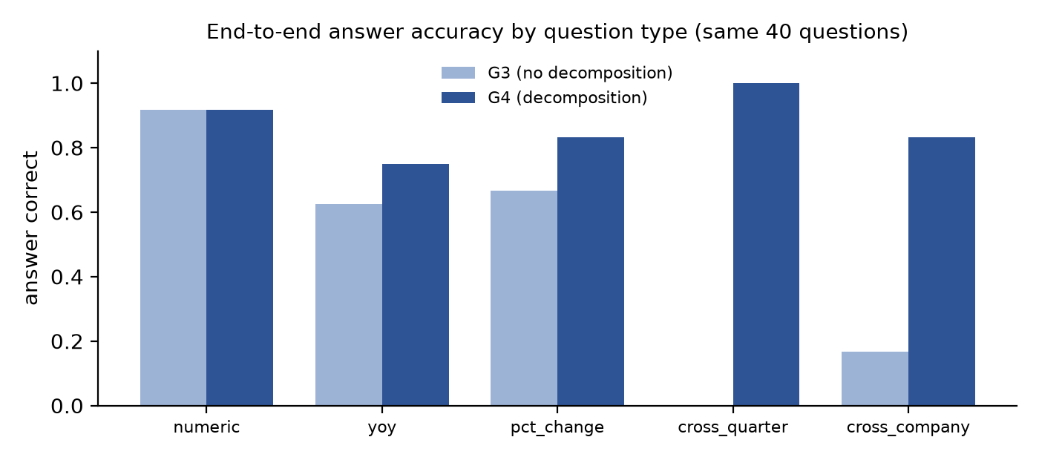
Figure 3. Answer accuracy by type, G3 vs G4. Source: data/eval/results/G3_generation.csv, G4_generation.csv.

5.13 Phase 13: Ragas with free judges (a9c8ed8, ef28e23) - paused
Goal: LLM-judged faithfulness and relevancy with free judges only.
Built: src/evaluation/ragas_eval.py; configs/evaluation.yaml; tests/test_ragas_guard.py
Checkpoint verdict: paused by decision - infrastructure complete; 32 G5 answers judged; local judge valid for relevancy only.

G5 and G6 re-generated the 40 questions plus 24 narrative ones and saved the exact contexts; they reproduce G3 and G4 exactly (52.5% and 87.5%), confirming determinism. The 120B judge scored 32 G5 answers (5 refusals excluded) before Groq's free daily token limit stopped the run cleanly.
Table 5. Judge agreement on the same 27 G5 answers
Metric | 120B judge | 8B judge | mean |diff| | Pearson | Spearman | same side of 0.5
faithfulness | 0.890 | 0.725 | 0.206 | 0.44 | 0.34 | 85%
answer_relevancy | 0.722 | 0.714 | 0.021 | 0.98 | 0.95 | 100%
Source: data/eval/results/G5_ragas_groq-gpt-oss-120b.csv, G5_ragas_local-llama3.1-8b.csv
The local 8B judge agrees on relevancy but not faithfulness; in the disagreements (q0131, q0114, q0168, q0165) the deterministic answer key shows the answers were correct, so it is used for relevancy only. Engineering issues solved on the way: ragas 0.4.3 needed langchain-community 0.4.1, instructor >= 1.9 and openai < 3; the async client had to live in a single event loop; free-tier per-minute limits are waited out while daily limits stop the run; each judge has its own cache.

5.14 Phase 15: HyDE, evaluated with controls (4f27d78)
Goal: test whether HyDE improves retrieval, isolated from the effect of adding dense candidates.
Built: src/query/hyde.py; src/retrieval/dense.py (retrieve_hyde); pool union_45_hyde15
Checkpoint verdict: not adopted - no significant gain, about 3 s extra latency.

A <= 80-word filing-style passage is generated by HyDEQueryTransform (local Qwen), embedded as a passage and averaged with the query embedding. V1 → V1h: +0.011 (95% CI [-0.011, +0.033], not significant). V5h → V6 (same pool, plain vs HyDE dense): -0.000 (95% CI [-0.006, +0.004], not significant). V5 → V6: -0.005 (95% CI [-0.017, +0.008], not significant); numeric -0.009 (95% CI [-0.020, -0.001], significant). HyDE costs about 3 s per query and is off by default.

5.15 Phase 16: scaling to all filings (aa554e4)
Goal: confirm quality, latency and footprint hold on the full corpus.
Built: src/pipeline/scale.py; data/eval/scaling_stages.json
Checkpoint verdict: passed - V5 quality change not significant at 30x the corpus; latency flat.

Stages add companies with the eval companies first and re-run V2, V4 and V5 on the unchanged eval set. V5 from S24 to Sall: MRR -0.010 (95% CI [-0.031, +0.009], not significant), all-hit@10 -0.025 (95% CI [-0.055, +0.004], not significant). V4 (no decomposition): MRR -0.022 (95% CI [-0.042, -0.003], significant), all-hit@10 -0.034 (95% CI [-0.064, -0.004], significant).
Table 6. Scaling stages
Stage | Filings | Cos. | Chunks | V2 MRR | V4 MRR | V5 MRR | V5 all-hit | V5 p50 ms | Qdrant RAM | Qdrant disk | Parents MB
S24 | 24 | 3 | 5,810 | 0.428 | 0.614 | 0.725 | 0.932 | 538 | 308.6MiB | 88M | 13
S50 | 56 | 7 | 13,950 | 0.424 | 0.608 | 0.722 | 0.932 | 524 | 381.9MiB | 104M | 31
S100 | 104 | 13 | 36,207 | 0.406 | 0.605 | 0.722 | 0.924 | 520 | 451.6MiB | 227M | 76
S250 | 254 | 32 | 85,890 | 0.403 | 0.602 | 0.721 | 0.924 | 509 | 486.3MiB | 564M | 182
Sall | 726 | 93 | 240,832 | 0.406 | 0.592 | 0.715 | 0.907 | 493 | 898MiB | 1.2G | 508
Source: data/eval/results/scaling.csv; data/eval/scaling_stages.json
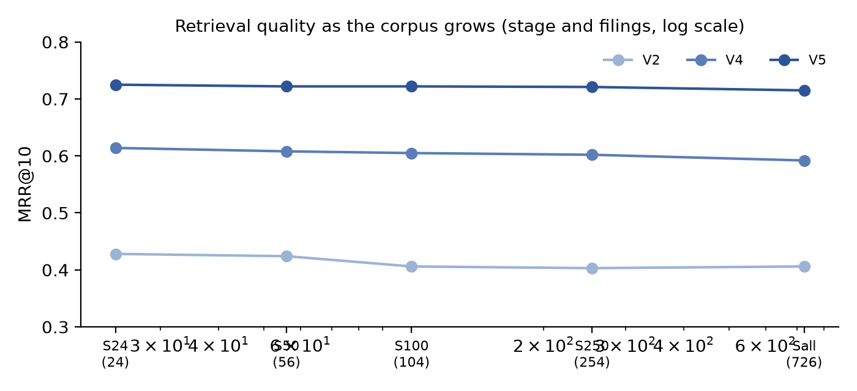
Figure 4. MRR@10 across scaling stages. Source: data/eval/results/scaling.csv.

5.16 Phase 17: numerical-hallucination evaluation
Goal: measure the numerical errors the number check misses, and whether <calc> earns its place.
Built: src/evaluation/numeric_hallucination.py; --no-calc in src/evaluation/generation.py (G8); tests/test_numeric_hallucination.py
Checkpoint verdict: <calc> kept for auditability, not accuracy (no measurable difference); the number check is an invented-number detector - wrong-cell and wrong-period figures pass it, so the remaining numerical risk is choosing the right cell, not inventing one.

verify_numbers() accepts a number when it appears anywhere in the sources. Phase 17 measures what that misses, on generation runs whose exact LLM contexts were saved (G5, G6 and two new runs on the full 726-filing index: G7, the G4 setup with <calc>, and G8, the same run with a prompt that asks the model to do its own arithmetic). The parser's markdown tables in each context are read back into cells (source, table, row, column, row label, value) plus the company and period of the source, so every number in an answer can be traced to the cell it came from.
Table 7. Outcome of every answer-keyed question (flagged = verify_numbers() reported an unsupported number)
Run | questions | correct | refused | wrong, flagged | wrong, not flagged
G5 | 40 | 21 | 11 | 0 | 8
G6 | 40 | 35 | 0 | 0 | 5
G7 | 40 | 33 | 1 | 0 | 6
G8 | 40 | 35 | 1 | 4 | 0
Across G5, G6, G7, G8 there are 23 wrong answers; the number check flagged 4 of them, all in G8, and there only because the model's own subtraction is a number the sources don't contain - the wrong values themselves are real figures and pass. Causes: same line item, other filing or period 7; same line item, other table 4; facts not in context 3; values right, change missing or wrong 3; same column, other row 2; same row, other column 2; text 1; value missing from answer 1. 'Same line item, other filing or period' is the right metric from a table of another quarter or filing (for example a Q2 10-Q figure for a fiscal-year question); 'same column, other row' is another line item of the right period; 'text' is a rounded figure quoted from MD&A prose.
Source: data/eval/results/phase17_audit.csv, phase17_numbers.csv
Stress test: in every correct answer, each exactly quoted answer-key value was replaced by a planted error, and verify_numbers() was run again on the same sources. Invented numbers are the last digit +1, +/-10% and two transposed digits; wrong-cell numbers are real values from the same sources (another column of the same row, the same column of another row, the same line item in another table).
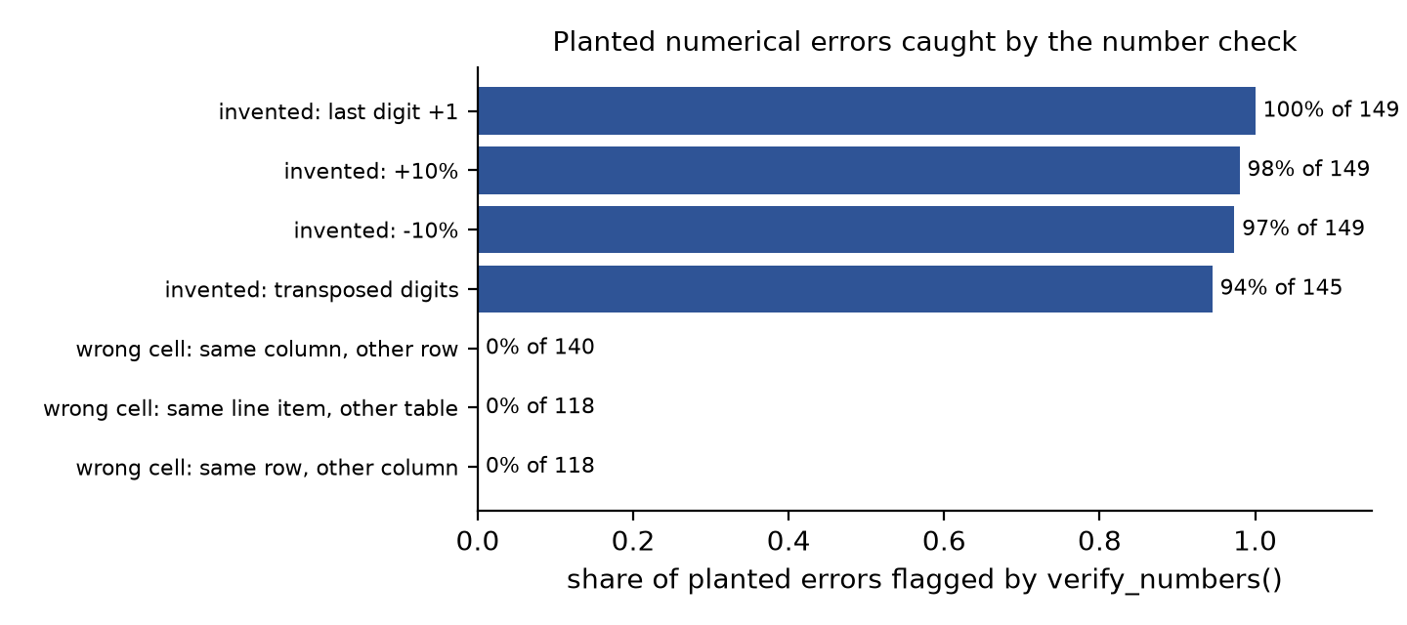
Figure 5. Planted errors flagged by the number check. Source: data/eval/results/phase17_stress.csv.
The check flagged 97.5% of 592 invented numbers and 0.0% of 376 wrong-cell numbers. The 15 invented numbers it missed happen to match another number in the sources or its rounding (for example $979, $44, $4), so they are indistinguishable from a wrong-cell read. A second gap: whole percentages up to 31% are skipped by the day-of-month rule, so they are never checked; 7 such percentages appear in 5 answers. A third gap was found later, while testing example questions, and has been fixed: amounts between 1,900 and 2,100 ('$2,002 million') were skipped as years. A $ sign or thousands comma now always marks an amount, and the figures above are from after the fix, which caught six more planted numbers.
Table 8. Questions that ask for a change or % change: how the stated change relates to the answer key
Run | right | rounded or approximate | arithmetic right, values wrong | sign lost | no change stated | refused
G5 | 9 | 1 | 4 | 0 | 1 | 7
G6 | 19 | 1 | 2 | 0 | 0 | 0
G7 | 17 | 0 | 3 | 1 | 0 | 1
G8 | 18 | 0 | 2 | 1 | 0 | 1
Source: data/eval/results/phase17_arithmetic.csv
G7 repeats G4 on the full 726-filing index instead of the 24-filing one: 87.5% → 82.5% correct (2 fixed, 4 broken, McNemar p = 0.688; facts in context 95.0% → 85.0%). The difference comes from retrieval - more filings, more distractors - not from generation; on the full 236-question set the retrieval change at scale was small and not significant (Section 5.15).
<calc> ablation, same 40 questions and index: correct 82.5% (G7, <calc>) vs 87.5% (G8, own arithmetic); 2 answers fixed and 0 broken without <calc>, McNemar p = 0.500, so no measurable accuracy difference. No stated change was an arithmetic error in any run, with <calc> (G5, G6, G7) or without it (G8): Qwen3-4B subtracted and computed percentages correctly on its own. One question lost a sign in G7 and G8: a negative value in parentheses was quoted without its sign and then subtracted correctly - a quoting error that <calc> cannot prevent. What changes is the number check: correct answers flagged 3% with <calc> vs 60% without, because every self-computed difference is a number the sources don't contain. Without <calc> the flag stops separating right answers from wrong ones, so <calc> stays: it is what makes the arithmetic auditable (each calculation is logged with its expression) and the number check usable.
Consequence: the '0% unverified numbers' result means no answer contained an invented number; it does not mean every number is the right one. The next safeguard is period-aware: compare the period and filing of the quoted cell with the period the question asks for, which is the same period-resolution problem seen live in Phase 20.

5.17 Phases 19-21: tracing, API service and Docker
Goal: run the pipeline as an observable, containerised service on the same 4 GB laptop.
Built: src/observability/; src/api/ (FastAPI + chat UI); docker/Dockerfile; docker-compose.yml
Checkpoint verdict: done - every request is traced per stage; the full stack runs in Docker with the GPU.

Tracing (Phase 19): the OpenTelemetry SDK exports to a local Arize Phoenix over OTLP/HTTP, with OpenInference's LlamaIndex instrumentation plus custom spans for decomposition, the candidate pool, reranking and the <calc>/number check. A warm single-fact query took 18.7 s, of which 17.7 s was the LLM; a two-part comparison took 26.0 s (25.0 s LLM): generation is about 95% of end-to-end latency, retrieval and reranking under a second (README).
API (Phase 20): POST /query returns the answer, sub-questions, cited SEC filings with links, <calc> results, unverified numbers, latency and the Phoenix trace id; GET /health returns 503 until Qdrant, Ollama and the models are ready; GET /metrics reports request counts, p50/p95 and refusal and unverified-number rates. One GPU means one pipeline run at a time (asyncio lock) with at most 4 requests queued, then 503. A chat UI is served at GET /: every number in an answer is traced to the table cell or sentence it was quoted from (the Phase 17 parser), and clicking it opens the source passage with that cell highlighted, with a link to the same spot in the original filing. A number that the filing's iXBRL tags as one business segment's figure, while the filing also reports a different company total, is flagged with the segment name and the total (e.g. Microsoft's Productivity and Business Processes operating income quoted as 'operating income').
Docker (Phase 21): four services bound to 127.0.0.1 - Qdrant, Phoenix, Ollama and the API, with Ollama and the API on the GPU. Models, the parent store and the decomposition cache are bind-mounted from D: and the container runs offline. Warm, the containerised stack answered the single-fact question in 3.9 s and the comparison in 11.8 s; a cold start takes 192 s until /health returns 200 (README; not a controlled speed comparison with the native run).
Source: README.md (Phases 19-21); src/api/main.py; docker-compose.yml

6. Experiment ledger

6.1 Retrieval on eval v0 (164 questions)
Table 9. Retrieval, eval v0
Run | P@3 | R@5 | MRR@10 | Hit@10 | numeric P@3 | narrative P@3 | p50 ms
V1 | 0.089 | 0.106 | 0.153 | 0.244 | 0.024 | 0.472 | 30
V2 | 0.285 | 0.512 | 0.528 | 0.817 | 0.264 | 0.403 | 13
V3 | 0.270 | 0.493 | 0.502 | 0.811 | 0.243 | 0.431 | 34
V4-md | 0.238 | 0.485 | 0.444 | 0.805 | 0.190 | 0.514 | 479
V4 | 0.441 | 0.797 | 0.767 | 0.970 | 0.429 | 0.514 | 529
V4h | 0.441 | 0.786 | 0.764 | 0.957 | 0.426 | 0.528 | 490
Source: data/eval/results/experiments.csv (dataset = retrieval_v0.jsonl)
The P@3 ceiling on v0 is 0.632 because most questions have only one or two relevant chunks (README); V4 reaches about 70% of it.

6.2 Retrieval on eval v1 (236 questions)
Table 10. Retrieval, eval v1
Run | P@3 | R@5 | MRR@10 | Hit@10 | all-hit@10 | p50 ms
V1 | 0.071 | 0.104 | 0.132 | 0.233 | 0.225 | 28
V1h | 0.073 | 0.100 | 0.142 | 0.250 | 0.237 | 3622
V2 | 0.223 | 0.466 | 0.428 | 0.661 | 0.661 | 14
V3 | 0.218 | 0.457 | 0.427 | 0.653 | 0.653 | 34
V4 | 0.321 | 0.611 | 0.614 | 0.805 | 0.792 | 483
V5 | 0.422 | 0.711 | 0.725 | 0.941 | 0.932 | 507
V5h | 0.415 | 0.708 | 0.720 | 0.936 | 0.928 | 577
V6 | 0.421 | 0.710 | 0.720 | 0.936 | 0.928 | 600
Source: data/eval/results/experiments.csv (dataset = retrieval_v1.jsonl)
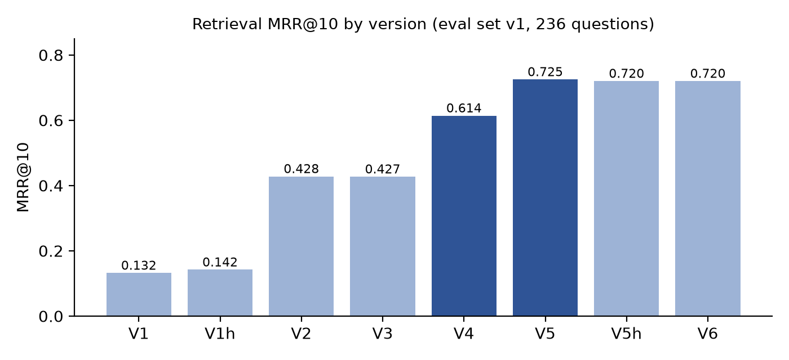
Figure 6. MRR@10 by version on eval v1. Source: data/eval/results/experiments.csv.
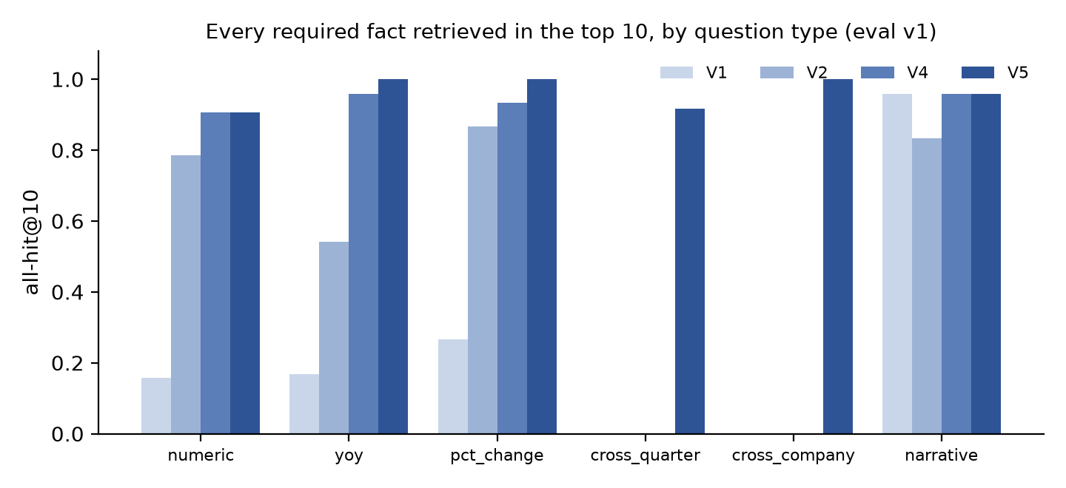
Figure 7. all-hit@10 by question type. Source: data/eval/results/experiments.csv.

6.3 Significance of key comparisons (paired bootstrap, 10,000 resamples)
Table 11. Paired bootstrap over questions (recomputed from per-query files)
Comparison | A | B | diff | 95% CI | significant
V1 → V2 (v0, MRR) | 0.153 | 0.528 | +0.375 | [+0.301, +0.449] | yes
V2 → V3 (v0, MRR) | 0.528 | 0.502 | -0.027 | [-0.054, -0.000] | yes
V2 → V4 (v0, MRR) | 0.528 | 0.767 | +0.239 | [+0.174, +0.303] | yes
V4-md → V4 (v0, MRR) | 0.444 | 0.767 | +0.323 | [+0.258, +0.389] | yes
V4 → V4h (v0, MRR) | 0.767 | 0.764 | -0.003 | [-0.019, +0.014] | no
V4 → V5 (v1, all-hit@10) | 0.792 | 0.932 | +0.140 | [+0.097, +0.186] | yes
V4 → V5 (v1, MRR) | 0.614 | 0.725 | +0.112 | [+0.073, +0.153] | yes
V1 → V1h (v1, MRR) | 0.132 | 0.142 | +0.011 | [-0.011, +0.033] | no
V5h → V6 (v1, MRR) | 0.720 | 0.720 | -0.000 | [-0.006, +0.004] | no
V5 → V6 (v1, MRR) | 0.725 | 0.720 | -0.005 | [-0.017, +0.008] | no
V5@S24 → V5@Sall (MRR) | 0.725 | 0.715 | -0.010 | [-0.031, +0.009] | no
V4@S24 → V4@Sall (MRR) | 0.614 | 0.592 | -0.022 | [-0.042, -0.003] | yes
Source: per-query files in data/eval/results/ and data/eval/results/retrieval_v1/; method of src/evaluation/compare.py
Inconsistencies noted between sources
README experiment values for V1-V3 were first hand-copied and partly wrong; commit de5be8a regenerated the table from experiments.csv, which this report uses.
fusion_sweep.csv and candidate_pools.csv were measured before the parser v4 / chunker v3 header fix; experiments.csv v0 rows (V1-V3 re-run) and rerank_sweep.csv were measured after it, so sweep numbers are not directly comparable with Table 7.
experiments.csv rows from before eval set v1 had no dataset value; they were tagged retrieval_v0.jsonl when v1 was introduced.
data/eval/cache/decompositions.jsonl contains a cached decomposition of the internal string 'warm-up query'; it is never part of an evaluation.

6.4 Generation
Table 12. Generation runs (answer-keyed questions only)
Run | n | correct | facts in context | correct | context | refused | wrong refusals | unverified numbers | cited | p50 s
G1 | 30 | 80.0% | 96.7% | 82.8% | 3.3% | 0 | 0% | 96.7% | 12.3
G2 | 40 | 40.0% | 57.5% | 56.5% | 40.0% | 3 | 0% | 57.5% | 10.8
G3 | 40 | 52.5% | 57.5% | 78.3% | 27.5% | 0 | 0% | 67.5% | 12.4
G4 | 40 | 87.5% | 95.0% | 86.8% | 0.0% | 0 | 0% | 85.0% | 15.7
G5 | 40 | 52.5% | 57.5% | 78.3% | 27.5% | 0 | 0% | 67.5% | 8.4
G6 | 40 | 87.5% | 95.0% | 86.8% | 0.0% | 0 | 0% | 85.0% | 23.2
G7 | 40 | 82.5% | 85.0% | 82.4% | 2.5% | 0 | 2% | 90.0% | 20.6
G8 | 40 | 87.5% | 85.0% | 88.2% | 2.5% | 0 | 62% | 92.5% | 22.4
Source: data/eval/results/G1..G8_generation.csv; McNemar G3 -> G4 and G7 -> G8 computed from the per-question files. G1-G6 were generated on the 24-filing index, G7-G8 on the full 726-filing index.

7. Bottlenecks, bugs and fixes
Table 13. Bottlenecks and fixes (chronological)
Problem | How it showed up | Root cause | Fix | Where
Checkpoint rename refused (Windows file locks) | download crashed mid-run | antivirus/editor locks the target briefly | retry os.replace | src/ingestion/checkpoint.py
Nested iXBRL tags | false period mismatches in verification | regex stopped at inner closing tag | nesting-aware extraction | src/ingestion/verify.py
Words glued ('June 28,2025') | table inspection | <br>/block boundaries dropped by text_content | insert spaces at block tails | src/parsing/parser.py
Period header in label column | MSFT balance sheet misaligned | column merge treated spanned headers as compatible | header rows never merge into label column | src/parsing/tables.py
Split tables lost headers | Apple % table without periods | continuation tables typeset separately | inherit caption/units/header rows | src/parsing/parser.py
Missing / non-standard section headings | corpus-wide section stats | 10-Q Item 1 omitted; Intel/HON layouts | Part I default, title fallback, font-size headings | src/parsing/structure.py
Children with wrong subheading | Gross Margin text labelled otherwise | merged parents kept first heading | label child at its midpoint | src/chunking/hierarchical.py
Oversized footnote chunks | children over the 512-token embedder limit | all footnotes in one child | sentence-split footnotes | src/chunking/hierarchical.py
Model caches on C: | downloads landed in user profile | HF / LlamaIndex / fastembed defaults | cache env vars point to D: | src/config.py
localhost ~2 s per request | indexing 3m46s for 24 filings | Windows tries IPv6 first | use 127.0.0.1 (~8 ms) | configs/qdrant.yaml
Reranker ties at 0.999 | saturated scores | sigmoid on strong matches | rank on raw logits | src/retrieval/reranker.py
Reranker preferred prose | correct row rarely first | prose-trained cross-encoder vs markdown | linearize tables for the reranker | src/retrieval/linearize.py
Year rows not headers (MSFT) | row groups without periods | header detector too strict | year rows/period labels/unit captions are headers | src/parsing/tables.py
Prompt processing ~70 tok/s | generation eval far slower than expected | orphaned llama-server.exe holding VRAM | kill runners; warm-up order; batch 16 | src/generation/ollama_server.py
Compound questions break BM25 | cross-type all-hit@10 = 0.000 | comparison wording matches MD&A text | sub-question decomposition + router | src/query/decomposition.py
Flawed generated questions | G1 misses | cash-flow change rows, group labels | 'change in ...', groups end at totals | src/evaluation/dataset.py
Rewording lost intent | 'What drove X' → 'What was X' | LLM rewrote single lookups | keep original if one sub-question | src/query/decomposition.py
Dependency conflicts | ragas import errors | ragas 0.4.3 vs langchain/instructor/openai | pin langchain-community 0.4.1, instructor, openai<3 | requirements.txt
Async connection errors | judge calls failing | new event loop per metric | one event loop per run | src/evaluation/ragas_eval.py
Free-tier limits | per-minute and daily 429s | Groq free plan quotas | wait on per-minute, stop on daily, cache | src/evaluation/ragas_eval.py
Small judge echoed schema | local 8B output invalid | free JSON mode on long prompts | schema-constrained decoding | configs/evaluation.yaml
phoenix.otel.register() failed | no traces | reads an attribute removed in opentelemetry-exporter 1.45 | configure the OTel SDK directly | src/observability/tracing.py
Retrieved documents missing in traces | empty retriever spans | OTel's default 128-attribute cap | span limit 2048, 4,000-char values | src/observability/tracing.py
SQLite locking errors in Docker | parent store failed in the container | WAL locking on a Windows bind mount | open read-only + immutable; checkpoint WAL after indexing | src/retrieval/parent_store.py
BM25 model not found offline | API container failed to start | fastembed metadata written with backslash paths | load the cached snapshot directly | src/retrieval/bm25.py
Ollama runner OOM-killed | generation fell to 0.16 tok/s, then crash | llama-server's 8 GiB host-RAM prompt cache | LLAMA_ARG_CACHE_RAM=0 | docker-compose.yml
63 s answer after idle | first question after a pause | Ollama unloaded the idle model | keep_alive 24h in the stack | docker-compose.yml
Wrong-cell numbers pass verification | Phase 17 stress test: 0% flagged | check is 'anywhere in the sources' | measured; period-aware check proposed | src/evaluation/numeric_hallucination.py
Source: commit messages; code comments at the listed paths; README.md

8. Evaluation methodology
- Deterministic gold: numeric questions come from primary-statement rows; a chunk is relevant if it contains that row with that value (the same figure reappears as the comparative column of the next year's filing) or a text chunk states the value with the line item. Narrative relevance uses explicit rules in configs/eval_narrative.yaml.
- Periods: the period text of the value column is validated against the filing's period end before a question is emitted.
- Metrics: P@3; R@5 capped at min(|gold|, 5); Hit@k; MRR@10; nDCG@10; for multi-fact questions all-hit@k (every fact found) and fact_recall@10.
- Selection vs reporting: a deterministic 50/50 dev/test split by question id; fusion and pool settings were chosen on dev.
- Significance: paired bootstrap over questions (10,000 resamples, 95% CI); McNemar for paired correctness.
- Why not an LLM judge for retrieval: deterministic gold is reproducible, free and stricter than a judge.
- Limitations: 3 companies, 85% numeric in v0; narrative sets are small (24); relevancy scores penalise terse answers.

9. Results in perspective
Why dense retrieval and HyDE did not help: questions name exact line items and periods, which BM25 matches directly, while a single vector per table chunk averages over many rows. Once a cross-encoder reads each candidate jointly with the question, extra dense candidates rarely change the final ranking (V4 vs V4h, V5h vs V6 are ties). Why decomposition helped so much: a comparison question is two lookups whose vocabulary ('compare', 'higher', 'by how much') matches MD&A comparison prose; each single lookup matches the statement row. Remaining failure modes after G4: wrong-column reads with the right table in context, 'fiscal 2025' answered from a 10-Q's year-to-date column, and occasional self-rounding instead of <calc>. Phase 17 puts a number on this: the wrong answers that remain are real figures from the wrong cell, period or filing, which a presence-in-sources check cannot see, while invented numbers are almost always caught.

10. Open items and next steps
- Ragas (paused): relevancy for all 128 answers with the validated local judge; 120B faithfulness mainly on narrative answers, resuming from cache as free quota allows.
- Phase 18: vector quantization experiment (index size, RAM, latency, recall).
- Period-aware number check: compare the period and filing of each quoted cell with the period the question asks for (the gap Phase 17 measured), and check whole percentages up to 31% instead of skipping them.
- Known issues: period ambiguity ('fiscal 2025' without a quarter, 'latest' filing, calendar vs fiscal year); BM25 on 'revenue' can fill the context with unearned-revenue notes; lower-confidence sections for Intel and Honeywell 10-Ks.

Appendix A. Reproduction commands
.venv\Scripts\python -m src.ingestion.metadata # manifest (network: SEC)
.venv\Scripts\python -m src.ingestion.downloader # download (network: SEC)
.venv\Scripts\python -m src.ingestion.verify
.venv\Scripts\python -m src.parsing.parser
.venv\Scripts\python -m src.chunking.hierarchical
.venv\Scripts\python -m src.embeddings.embedder # GPU
docker compose up -d # Qdrant
.venv\Scripts\python -m src.retrieval.qdrant_index
.venv\Scripts\python -m src.evaluation.dataset --tickers AAPL MSFT NVDA
.venv\Scripts\python -m src.evaluation.retrieval --retriever decomposed --version V5 # GPU + LLM (cached)
.venv\Scripts\python -m src.evaluation.compare V4_rerank V5_decomposed --metric all_hit@10
.venv\Scripts\python -m src.evaluation.generation --version G4 --decompose # GPU + LLM
.venv\Scripts\python -m src.pipeline.scale # GPU
.venv\Scripts\python -m src.evaluation.ragas_eval --input G5 G6 --judge groq-gpt-oss-120b # network, free tier
.venv\Scripts\python -m src.evaluation.generation --version G7 --decompose # GPU + LLM, full index
.venv\Scripts\python -m src.evaluation.generation --version G8 --decompose --no-calc # <calc> ablation
.venv\Scripts\python -m src.evaluation.numeric_hallucination --runs G5 G6 G7 G8 # Phase 17 (offline)
docker compose --profile app up -d --build # full stack; UI at :8000
.venv\Scripts\python docs\tools\build_report.py # this report

Appendix B. Configuration reference
Table 14. Selected configuration values
Key | Value
chunking.text.child_tokens | 256
chunking.text.parent_max_tokens | 1024
chunking.tables.parent_max_tokens | 2048
embedding.model_name | BAAI/bge-small-en-v1.5
retrieval.bm25.avg_len | 113.5
retrieval.hybrid.alpha | 0.3
retrieval.rerank.model | BAAI/bge-reranker-base
retrieval.rerank.default_pool | bm25_60
retrieval.rerank.batch_size | 16
generation.llm.model | qwen3:4b-instruct-2507-q4_K_M
generation.llm.context_window | 8192
generation.context.budget_tokens | 5000
qdrant.url | http://127.0.0.1:6333
qdrant.collection | sec_filings_bge_small
evaluation.ragas.default_judge | groq-gpt-oss-120b
Source: configs/*.yaml

Appendix C. Glossary
Table 15. Glossary
Term | Meaning
P@3 | share of the top 3 results that are relevant
R@5 (capped) | relevant in top 5 / min(relevant, 5)
Hit@k | at least one relevant result in the top k
MRR@10 | mean of 1 / rank of the first relevant result (0 if none in top 10)
all-hit@k | every required fact has a relevant result in the top k
fact_recall@10 | share of required facts found in the top 10
BM25 | lexical ranking with term-frequency saturation, length normalisation and IDF
Bi-encoder | encodes query and passage separately into vectors
Cross-encoder | reads query and passage together and outputs a relevance score
RRF | reciprocal rank fusion: sum of 1/(k + rank) across lists
Relative-score fusion | min-max-normalised scores mixed by alpha
HyDE | hypothetical document embeddings: search with an LLM-written answer passage
Q4_K_M | 4-bit k-quant weight quantization used by llama.cpp/Ollama
KV cache q8_0 | 8-bit key/value cache for attention
iXBRL | inline XBRL: machine-readable tags embedded in the filing HTML
McNemar | paired test on which items flipped between two runs

Appendix D. Run-ID quick reference
Table 16. Run IDs (alphabetical)
ID | Meaning
chunker v1-v3 | Chunker output versions: v2 split oversized footnotes; v3 re-chunk after the header-row fix
G1 | Generation run 1: 30 numeric questions (eval v0), V4 retrieval, prompt v1
G2 | Generation run 2: 40 questions stratified over 5 answerable types (eval v1), V4, prompt v1
G3 | Generation run 3: same 40 questions, prompt v2 (calc for every change, comparisons state the difference, no appended refusal)
G4 | Generation run 4: same 40 questions, prompt v2 + decomposition (V5 retrieval)
G5 | Generation run 5: G3 setup on 64 questions (40 + 24 narrative); answers and exact contexts saved for Ragas
G6 | Generation run 6: G4 setup on the same 64 questions; contexts saved for Ragas
G7 | Generation run 7: G4 setup re-run on the full 726-filing index (the <calc> control for G8)
G8 | Generation run 8: G7 with the no-<calc> prompt: the model does its own arithmetic (ablation)
judges | Ragas judges: groq-gpt-oss-120b (Groq free plan); local-llama3.1-8b (Ollama, schema-constrained)
parser v1-v4 | Parser output versions: v2 section fallbacks; v3 font-size headings + section_mode; v4 header-row detection (year rows, period labels, unit captions)
phase17_* | Phase 17 outputs: per-question audit, per-number origins, planted-error stress test, arithmetic status
prompt v1 / v2 | Generation prompts: v2 added rules 4-6: calc for every change incl. rounding, state differences, refusal only if no figure
S24 ... Sall | Scaling stages: index containing 24, 56, 104, 254 and 726 filings (3, 7, 13, 32, 93 companies)
v0 / v1 | Evaluation sets: v0: 164 questions (numeric + narrative); v1: 236 questions (6 types, multi-fact gold groups)
V1 | Dense retrieval: bge-small-en-v1.5 embedding search over child chunks, no filters
V1h | Dense retrieval with HyDE: V1 but the query vector = mean(hypothetical-passage embedding, question embedding)
V2 | BM25: Qdrant sparse vectors (fastembed Qdrant/bm25, IDF modifier, avg_len 113.5)
V3 | Hybrid: dense top-30 + BM25 top-30, relative-score fusion, alpha 0.3 (chosen on dev split)
V4 | Reranked BM25: BM25 top-60 → bge-reranker-base (fp16, raw logits) reading linearized tables
V4-md | V4 ablation: same as V4 but the reranker reads markdown tables
V4h | V4, hybrid pool: pool = BM25-45 + dense-15, then the V4 reranker
V5 | V4 + decomposition: regex router → Qwen3-4B JSON sub-questions → V4 per sub-question → round-robin interleave
V5h | HyDE control: V5 with pool BM25-45 + plain dense-15
V6 | V5 + HyDE: V5 with pool BM25-45 + HyDE-dense-15
Vn@Sx | Scaled run: retrieval version n measured with the index at scaling stage x (e.g. V5@Sall)

