BOARDEX

MVP UI Design Review
  - Premium product enhancement report grounded in the existing walkthrough and current interaction flow
Executive conclusion
Boardex already has the correct product structure: task delegation, explicit safety gates, live execution, physical evidence, and honest reporting. The premium gap is primarily visual hierarchy, scale, component consistency, and motion discipline. Keep the flow. Refine the surface.

Reviewed sources
- boardex-walkthrough.mp4 · 1920×1080 · 7:09 · light theme
- SHOTLIST.md · segments, review questions, color rules, and known-issue exclusions
- Review emphasis begins at 1:16; the first minute was also assessed as the product’s guided demo experience.
Design target
A calm, exact desktop instrument with the confidence and finish of Cursor or Devin, while preserving Boardex’s hardware-first identity and current MVP flow.

REVIEW MAP

Contents and decision frame
01 | Executive assessment and scorecard
02 | Direct answers to the four review questions
03 | Global premium design direction
04 | Segment-by-segment walkthrough review
05 | Component and interaction specifications
06 | Real-hardware failure and trust presentation
07 | Prioritized implementation backlog
08 | Acceptance checklist for the polish release

Non-negotiable constraints preserved
- Light theme remains the sole MVP theme. No gradients, glassmorphism, or decorative color.
- Green means pass or found; red means fail; amber means approval or warning; purple remains the action/focus accent.
- The existing task → plan → approval → run → evidence → report flow remains the ground truth.
- The report checkmark fallback issue is excluded from this review, as requested.
- The design review favors refinement over feature expansion.

01 · EXECUTIVE ASSESSMENT

One serious refinement pass away from premium
Boardex already reads as a real product rather than a concept. The autonomous run timeline, approval gates, evidence drawer, source citations, and honest failed-run handling create a strong trust model. Those are the difficult product decisions, and they are already present.
The current visual layer still carries the character of a polished internal engineering dashboard. At 1920×1080, typography is often one size too small, several states sit inside oversized white canvases, and the component hierarchy relies heavily on thin borders and repeated status text. The result feels precise, yet underweighted.
Final design decision
Preserve the current information architecture. Introduce a stronger canvas/surface hierarchy, a split badge system, deliberate right-rail composition, larger critical typography, and more disciplined technical density. This will move the product from “clean dashboard” to “premium lab instrument” without changing the user flow.

Dimension | Score | Current reading | Premium target
Product clarity | 8.5/10 | The workflow is understandable and sequential. | Maintain clarity while increasing visual authority.
Trust and evidence | 9.0/10 | Approvals, citations, raw artifacts, and honest failure are excellent. | Make evidence states easier to scan and compare.
Information architecture | 8.0/10 | Three-zone run workspace and evidence drawer are structurally sound. | Stabilize panel sizing and remove sparse states.
Visual hierarchy | 6.5/10 | Critical text and badges are often too small; large white fields weaken focus. | Clear scale ladder and stronger surface separation.
Premium finish | 6.2/10 | Consistent, but still resembles a clean web dashboard. | Desktop-grade panel rhythm, motion, and technical typography.
Instrument identity | 7.2/10 | Behavior is instrument-like; visual language remains generic in places. | Use precise numeric typography, stable status rails, and evidence-led detail.
Overall current state: approximately 7.2/10. A focused P0 polish pass can realistically move the product into the 8.5–9.0 range without expanding scope.

02 · REVIEW QUESTIONS

Direct decisions on the four requested areas

1. Badge treatment
Decision: keep the instrument character, split the badge system.
The uppercase 11px treatment works for global machine states such as RUNNING, COMPLETED, FAILED, PLAN READY, and AWAITING APPROVAL. It is too small and too faint when used for repeated measurement verdicts and risk labels.

- Global run-state badge: 11px uppercase, 600 weight, 0.05em tracking, 20–22px height, 8–10px horizontal padding.
- Measurement verdict: 12px minimum, icon-led, “Pass / Fail / Not recorded” or stronger uppercase with the same 12px minimum. Avoid text-only color.
- Risk badge: 10.5–11px uppercase, neutral fill for LOW and amber fill/border for MEDIUM. LOW must remain visibly active rather than looking disabled.
- Use badges for categorical state. Use plain status text for repeated timeline outcomes to reduce visual noise.

2. Right rail composition
Decision: the status-only rail currently reads sparse.
The rail becomes intentional once an approval card appears. During autonomous execution, the single Status card floats inside a tall white column and feels unfinished. Preserve the rail, but give it a defined surface and a compact “Current activity / No action required” state.

- Use a subtle rail canvas (#F7F7F8) separated by a 1px divider, with white cards inside.
- Keep Status as the sticky rail header. Below it, show the active step summary while Boardex is running autonomously.
- When no gate is active, use a quiet state such as “Boardex is running · no approval required.” This confirms that the empty area is deliberate.
- When a gate activates, replace that quiet state with the Approval card in the same reserved slot. Avoid vertical layout jumps.

3. Empty states
Decision: the zero-run Home is too underweighted at 1920px.
The minimal direction is correct. The hero’s scale and vertical position make it look stranded. Increase the hero’s authority rather than filling the page with dashboard content.

- Move the hero upward by roughly 60–80px and target 38–42% of viewport height.
- Increase the title to approximately 22–24px and body copy to 14px/21px, with a 440–480px text width.
- Keep the two-action structure. Add a play icon to “Watch a demo run” and increase both buttons to 38–40px height.
- Add one compact process line beneath the actions: Plan → Flash → Measure → Verify. This gives the whitespace a product-specific purpose.
- The collapsed 56px sidebar works, but every icon needs a tooltip; the isolated green runner dot also needs a hover label.

4. Precise lab instrument or generic dashboard?
Decision: the product behavior reads as a lab instrument; the visual skin still reads as a generic SaaS dashboard.
The timeline, logs, approvals, protocol decode, citations, and evidence-linked report are highly specific. The generic impression comes from the pure-white canvas, small type, uniform thin borders, repeated green status words, and sparse side regions.

The upgrade path is visual, not conceptual: introduce off-white application canvas, crisp white work surfaces, stronger technical typography, measured panel density, and calmer semantic color. Boardex can achieve an unmistakable instrument identity while keeping the current flow intact.

03 · GLOBAL DESIGN DIRECTION

Calm precision: the visual system Boardex should adopt
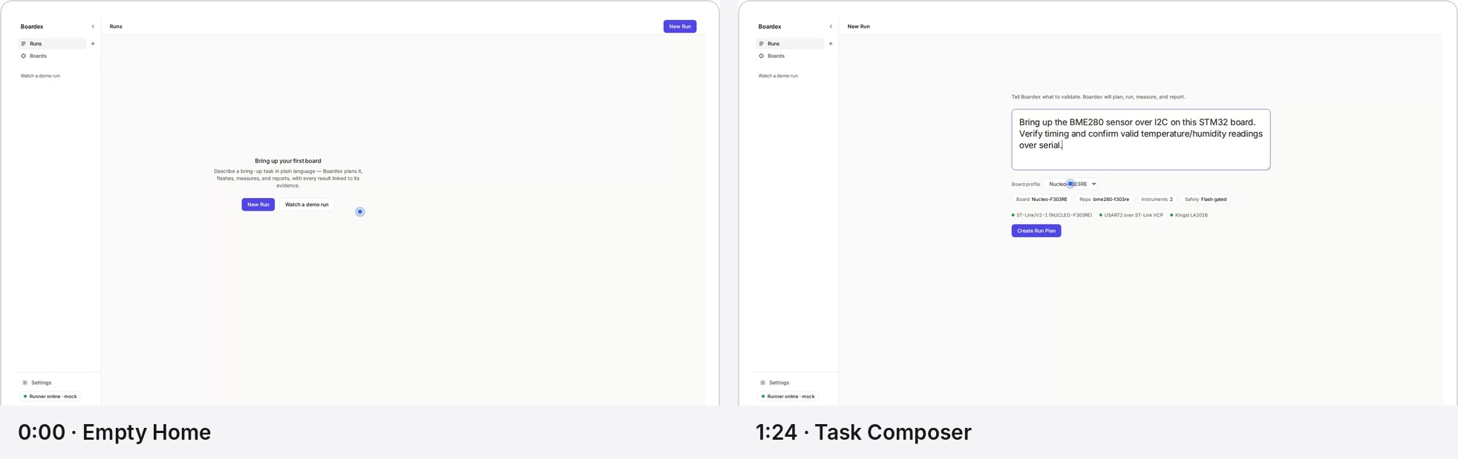
Figure 1. The entry flow is clear; the empty hero needs more authority while the composer already has the correct task-first emphasis.
Keep  - Task-first composition and natural-language prompt.  - Light theme and restrained purple accent.  - Visible board, repository, instruments, and safety context.  - Consistent left navigation and global New Run action. | Refine  - Create a visible canvas/surface hierarchy instead of white-on-white.  - Increase title, critical label, and status scale.  - Use a more deliberate 8px spacing grid.  - Reduce duplicated and low-value visual elements.

Recommended core visual tokens
Token | Value | Use
Application canvas | #F7F7F8 | Separates the desktop shell from work surfaces.
Navigation surface | #FBFBFC | Quiet, persistent orientation layer.
Primary surface | #FFFFFF | Cards, run workspace, report, evidence drawer.
Default border | #E2E3E7 | Visible without becoming card-heavy.
Strong border | #D2D4DA | Focused cards, tables, approvals.
Text | #17171A | Primary engineering information.
Secondary text | #5C6068 | Descriptions and metadata.
Accent | #5B4CF0 | Actions, focus, selected tabs, cited-source rail.
Pass | #168A4A | Pass/found only.
Fail | #C73535 | Unresolved failure only.
Approval | #A86D00 | Approval/warning only.
03 · TYPOGRAPHY AND GEOMETRY

Increase authority without increasing visual noise
Typography scale  - Primary page title: 22–24px / 28–30px.  - Top-bar title: 15–16px / 20px.  - Card title and step title: 14px / 20px, semibold.  - Body: 13.5–14px / 20px.  - Secondary text: 12.5–13px / 18px.  - Metadata: 12px / 16px.  - Critical badges: 11–12px / 14px.  - Logs/code: 12.5px / 19px monospace. | Geometry and density  - 8px base spacing grid: 4, 8, 12, 16, 24, 32.  - Card radius: 8px. Control radius: 6px. Badges may remain pill-shaped.  - Button height: 36px standard, 40px primary gate action.  - Expanded sidebar: 208px. Collapsed: 56px.  - Top bar: 48–52px.  - Right rail: 308–324px.  - Evidence drawer: 840px or 46–48vw at 1920px.  - Minimum interactive target: 32px; 36–40px for critical controls.

Color discipline
The current semantic rule is correct. The refinement is to reduce the total amount of semantic color. Repeated “Succeeded” words in the timeline can become neutral text paired with a green check icon. This keeps green strictly meaningful while reducing the “all-green dashboard” effect.

Surface hierarchy
- Use an off-white application canvas for the shell.
- Place the run workspace, rail cards, report, modals, and drawers on white surfaces.
- Use borders for structure and very subtle shadows only for floating layers such as callouts, command palette, and drawers.
- Keep the instrument feeling crisp: minimal rounding, no glow, no decorative gradients.

Desktop motion language
- Hover/focus: 100–140ms.
- Badge and state transition: 160–200ms.
- Drawer/modal: 200–240ms ease-out.
- FAIL → PASS: 240–300ms icon morph/crossfade with one restrained background pulse. No bounce or celebration.
- Approval state: preserve layout; update card content in place.
- Logs: auto-scroll only while the user remains at the bottom; show “Resume live” when they inspect earlier lines.

04 · WALKTHROUGH REVIEW

Segment 1 — Empty Home and navigation

What works
- The two-action model is immediately understandable.
- The headline communicates a concrete hardware outcome.
- The top-right New Run action preserves a familiar desktop pattern.
- The 56px collapsed sidebar preserves usable space and the core icons remain recognizable.

What limits the premium impression
- The hero title and copy are small relative to the 1920×1080 canvas.
- The hero sits in a very large undifferentiated white field, producing a “stranded” feeling.
- The demo affordance appears both in the hero and the sidebar, weakening intentionality.
- The collapsed runner indicator becomes a lone green dot with no persistent meaning.

Enhancement specification
- Scale and move the hero as specified in the direct decision section.
- Keep the global New Run button; treat the hero button as the dominant first-run path.
- Use a single prominent demo affordance on the empty state; retain the sidebar link only after runs exist or label it with a play icon.
- Add hover tooltips to collapsed navigation and runner status.
- Use a subtle active rail or 2px accent indicator in collapsed navigation; the icon background alone is too quiet.
Priority
P0 for hero scale and sidebar tooltips. P1 for process-line enrichment and demo-affordance cleanup.

04 · WALKTHROUGH REVIEW

Segment 2 — Guided demo

Current reading
The demo explains the product successfully, and the walkthrough copy correctly emphasizes safety, evidence, and iteration. The callout card itself is clean. The target relationship is visually weak: the card labels a zone but does not clearly attach to the relevant UI region.

Enhancement specification
- Keep the top demo bar, but give it a slightly tinted neutral/purple background so “recorded run” remains explicit throughout playback.
- Anchor each callout to its target with a short connector line or subtle spotlight. Dim the rest of the workspace by approximately 8–12%, not enough to obscure the product.
- Use adaptive placement so the callout never covers the evidence band or primary approval controls.
- Reduce paragraph copy by roughly 15% and increase the callout title to 15–16px.
- Replace the plain 3/6 counter with six small progress ticks plus the numeric counter. Keep the counter readable for accessibility.
- When paused on an approval gate, visually freeze the active target with a 2px accent outline; this reinforces the product’s safety model.
Design verdict
The guided demo belongs in the product. Its content is strong. The final polish should make the target relationship unmistakable and the overlay feel native rather than layered on top.

04 · WALKTHROUGH REVIEW

Segment 3 — Composer and plan gate
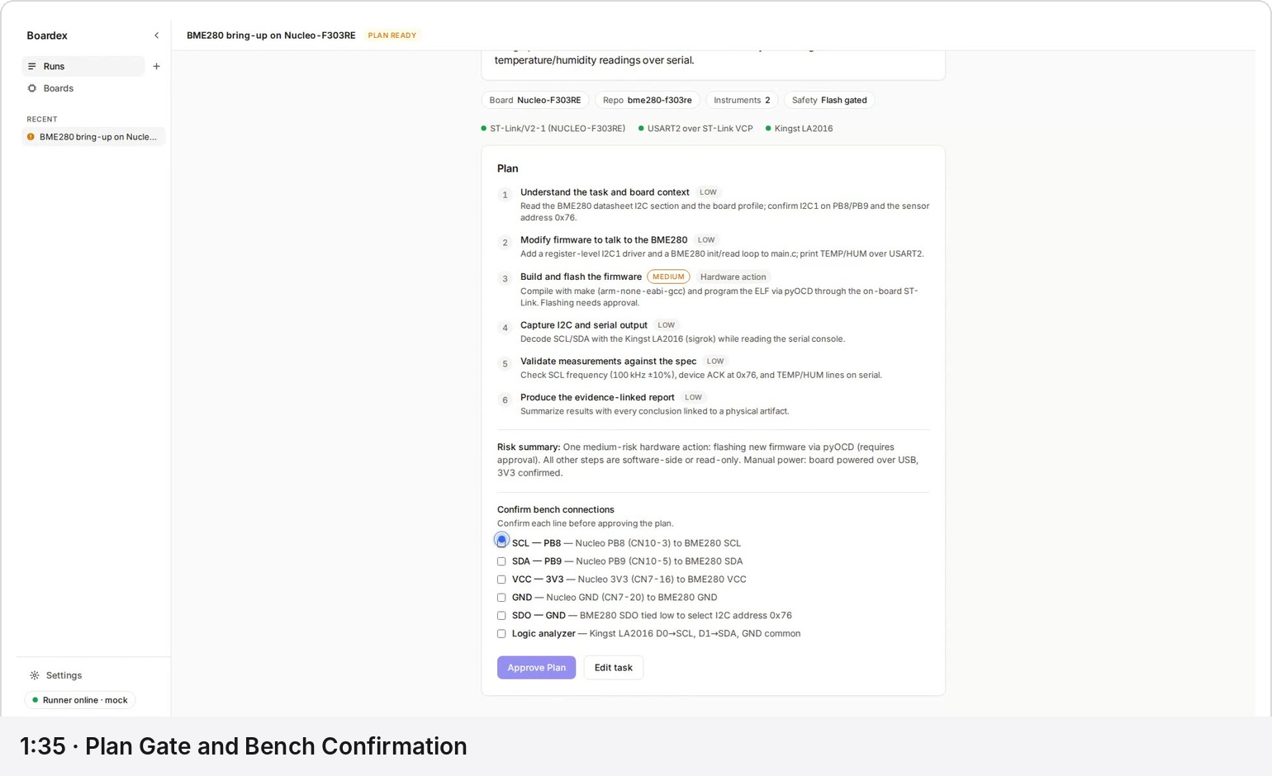
Figure 2. The plan gate carries the right information. The main improvements are badge contrast, checklist hit targets, and explicit gate progress.

Composer
- The task-first center composition is correct and should remain.
- The large text area gives the agent interaction appropriate importance.
- The board/repo/instrument/safety chips create confidence before execution.
- Increase the helper line and context-label scale by 1px; they currently recede too far.
- Align the primary button to the composer’s right edge or keep it left-aligned consistently across all task forms. Current placement is acceptable, but the product should choose one form-action alignment rule.

Plan gate
- LOW badges currently approach disabled contrast. Give them a neutral filled capsule and darker text.
- The MEDIUM badge reads correctly as approval/warning and should remain amber.
- Increase checkbox visual size to 16–18px and row hit targets to at least 32px.
- Add explicit progress above the checklist: “0 of 6 bench connections confirmed.” Update it as checks are completed.
- Change the disabled action copy dynamically: “Approve plan · 0/6 confirmed.” When complete, switch to “Approve plan” with a check icon.
- Keep the risk summary. Use a quiet neutral surface with a narrow amber rail only when a medium-risk action exists.
- Keep “Edit task” secondary and move it away from the primary action by 8–12px.
Critical UX point
The physical connection checklist is one of Boardex’s strongest trust surfaces. It should feel like an intentional safety gate, not a form that happens to disable a button.

04 · WALKTHROUGH REVIEW

Segment 4 — Live run, approvals, failure, and iteration
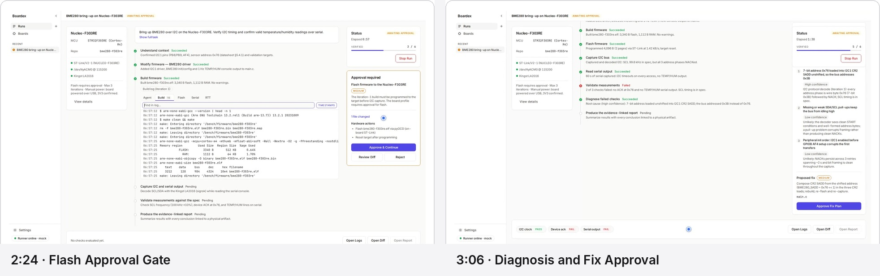
Figure 3. The live workspace has the correct three-zone structure. Approval hierarchy is strong; the right rail and repeated status treatment need refinement.

Run workspace
- Preserve the three zones: board context, execution timeline, status/approval rail.
- Introduce a light application canvas and white surfaces so the zones read as one desktop workspace rather than three isolated cards.
- Keep the center timeline dominant. Increase step titles and active-step content by approximately 1px.
- Use green primarily on check icons. Set repeated “Succeeded” labels in neutral text; reserve green text for summary and final verdicts.
- Give the active step a subtle tinted surface and 2px accent rail. Auto-expansion is correct and should remain.

Logs
- Keep the monospace stream and timestamp option. The density feels appropriate for an engineering product.
- Use a fixed-width 76–84px timestamp column and 12.5px/19px monospace type.
- Make the find bar and timestamp toggle a coherent toolbar rather than two input-like controls.
- Add a “Resume live” affordance if the user scrolls away from the bottom during streaming.
- Use a slightly stronger selected-tab treatment; the current underline is easy to miss inside the open step.

Approval card
- “Approve & Continue” is unmistakably primary and should remain full width.
- Keep Review Diff as a bordered secondary action.
- Treat Reject as tertiary/destructive text with red hover/focus rather than giving it equal boxed weight to Review Diff.
- Increase the file-change link and hardware-action text to 12.5–13px.
- Keep the amber border/risk badge; avoid amber on any surrounding non-warning element.

Diagnosis and iteration
- Ranked hypotheses are valuable but visually dense. Increase spacing between hypotheses and place the confidence label directly below each title.
- Give the highest-confidence hypothesis a subtle neutral surface; retain low-confidence items as plain rows.
- Keep the iteration divider. Increase its label weight and ensure the timeline line visually restarts after the divider.
- For FAIL → PASS, animate the icon and verdict in place with a brief highlight. The current flip can be missed during the run.

04 · WALKTHROUGH REVIEW

Status rail and evidence band
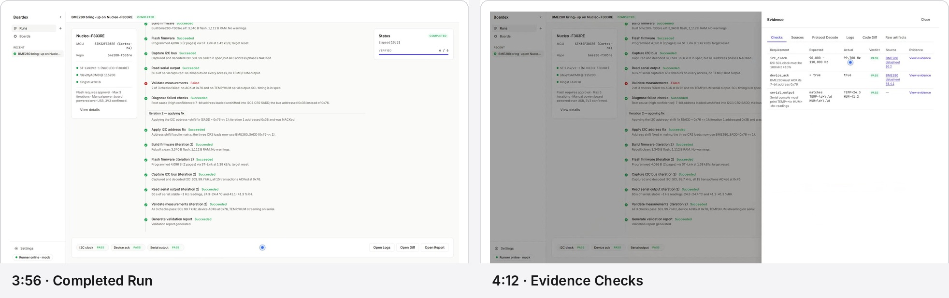
Figure 4. Completion is clear and the evidence band is a strong navigation surface. The status-only rail needs a deliberate autonomous state.

Right rail target composition
- Sticky Status card: run state, elapsed time, coverage, progress bar, and stop action while running.
- Reserved action slot: “No approval required · Boardex is executing [active step]” when autonomous.
- Approval card replaces the autonomous-state module when a gate is active.
- Completion module replaces the action slot with the Open Validation Report action.

Evidence band
- Keep the bottom evidence band fixed. It is a distinctive and useful product element.
- Increase chip height to 28–30px and verdict text to 12px.
- Add an icon before Pass/Fail so color is never the only signal.
- Maintain stable chip widths when states change, preventing movement during FAIL → PASS.
- Use “Not recorded” as a neutral gray state with a hollow-circle or dash icon.
- The band’s right-side Open Logs / Open Diff / Open Report actions should use one shared secondary-button style.

Completion
- COMPLETED and VERIFIED 6/6 communicate success well.
- Keep elapsed time frozen.
- When complete, make the status card more compact and elevate the report action without increasing purple usage elsewhere.
- Consider changing “VERIFIED” to “Checks verified” in the detail line while retaining the compact machine-state badge.

04 · WALKTHROUGH REVIEW

Segment 5 — Evidence drawer
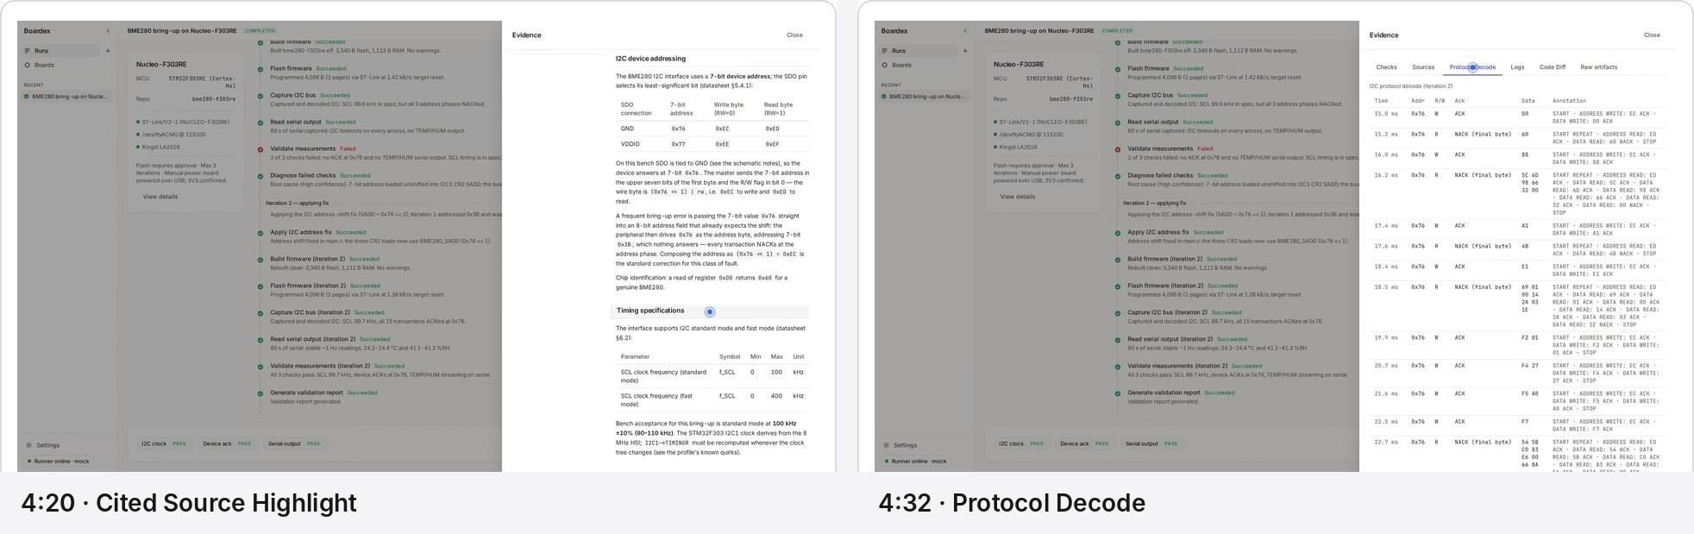
Figure 5. Source traceability is a major differentiator. The source highlight should be stronger; the protocol table needs more deliberate technical density.

Drawer shell
- Increase the default width from 760px to approximately 840px at 1920px, capped at 46–48vw.
- Keep the dimmed run visible. Use a slightly lighter scrim so the relationship to the run remains legible.
- Make the drawer header and tab bar sticky.
- Use a close icon plus “Esc” hint; retain accessible text in the tooltip.
- Increase tab labels to 13–14px and use a 2px accent indicator.

Checks table
- Keep the six-column evidence model. It tells the full story.
- Use 12.5–13px body type, 12px monospace for expected/actual, and a sticky header.
- Change verdict cells to icon-led Pass/Fail labels at 12px minimum.
- Align numeric values and use tabular figures.
- Make the full row clickable while retaining explicit Source and View evidence links.

Cited source highlight
- Current tint is too quiet. Use a 3px purple left rail, a light purple background, and a small “Cited source” label above the heading.
- Apply a 600–800ms highlight on arrival, then settle into the persistent rail/tint state.
- Scroll with 20–24px top offset so the heading does not touch the sticky header.

Protocol decode
- Use a compact 32–36px row height with tabular monospace values.
- Freeze Time, Addr, R/W, and ACK columns; allow Annotation to use remaining width.
- Clamp annotations to two lines with row expansion on click.
- A protocol-level final-byte NACK should remain neutral unless the validation rule marks it as a failure.
- Offer a subtle transaction-group separator for write/read pairs rather than zebra striping.

04 · WALKTHROUGH REVIEW

Evidence tools — logs, code diff, and artifacts
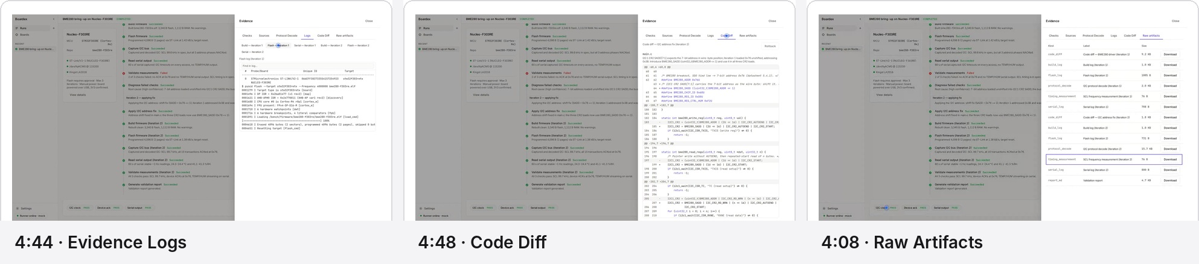
Figure 6. All required evidence surfaces exist. The largest visible prototype artifact is the wrapped log sub-tab system.

Logs
P0 issue
The iteration/log-type tabs wrap onto two lines inside the drawer. This immediately lowers the premium impression and makes scanning harder.

- Replace the six flat sub-tabs with two compact selectors: Iteration [1 | 2] and Type [Build | Flash | Serial].
- Keep the find field directly above the log output.
- Use consistent log padding and the same monospace specification as the live run.
- Preserve the log output exactly; only the navigation around it changes.

Code diff
- Use a sticky filename/iteration header and keep the unified diff format.
- Add subtle red/green backgrounds to changed lines; current syntax coloring alone is understated.
- Disable line wrapping and expose horizontal scroll. Long register expressions should never clip silently.
- Keep Rollback in the header as a secondary/destructive action with confirmation.
- Use 12–12.5px monospace with 18–19px line height.

Raw artifacts
- Add “Download all” in the section header.
- Replace repeated full-width Download buttons with a compact download icon/action at row end.
- Group or sort by iteration, then artifact type.
- Right-align sizes using tabular figures.
- Keep the current labels; they are clear and specific.

04 · WALKTHROUGH REVIEW

Segments 6–7 — Report, board profiles, and settings
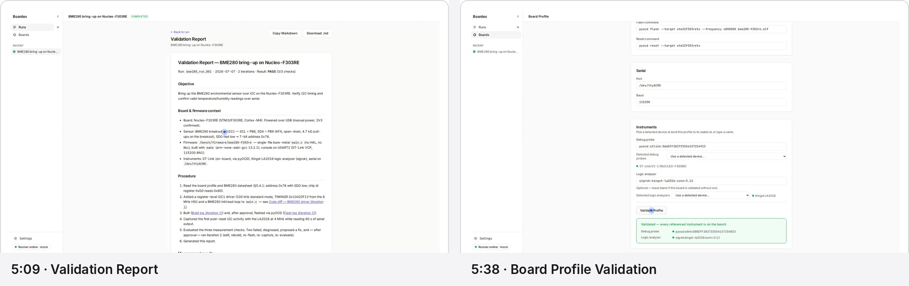
Figure 7. The report is useful and credible. Long-form typography and form-page composition need stronger scale and surface hierarchy.

Validation report
- Use an off-white page canvas with a white report surface; the current white-on-white treatment weakens the document boundary.
- Increase report max width to approximately 820–860px.
- Report title: 22–24px. Section headings: 15–16px. Body: 13.5–14px/21px.
- Convert the metadata line into a compact summary row: Run ID, date, iterations, result, checks.
- Keep underlined evidence links. Their restraint is appropriate.
- Keep Copy Markdown and Download .md. The “Copied ✓” in-button state is clear and should remain for 1.5–2 seconds.
- Use a sticky or persistent Back to run action at the page header.

Board profile list and editor
- Constrain list-page content to roughly 960px and increase the profile card’s internal hierarchy.
- Within the existing card, add visible metadata already available in the system: validated state, instrument count, and last updated. This is presentation of current context, not a new workflow.
- In the editor, use stronger section separation and 16–24px rhythm between groups.
- Keep the green validation panel; it uses green correctly. Reduce its height and align per-instrument findings into a compact list.
- Use a sticky Save / Validate Profile footer for long forms so the action remains available after scrolling.

Settings
- Increase the content column to 680–760px. The current page feels too small inside the desktop canvas.
- Group Runner connection, Model, and Appearance & behavior into defined sections with 24–32px spacing.
- Increase Test connection and Save controls to standard 36px height.
- Keep “Online · mock” as a compact status line with a semantic green dot and neutral text.
- Keep Replay onboarding as a quiet secondary action.

04 · WALKTHROUGH REVIEW

Segment 8 — Command palette and keyboard
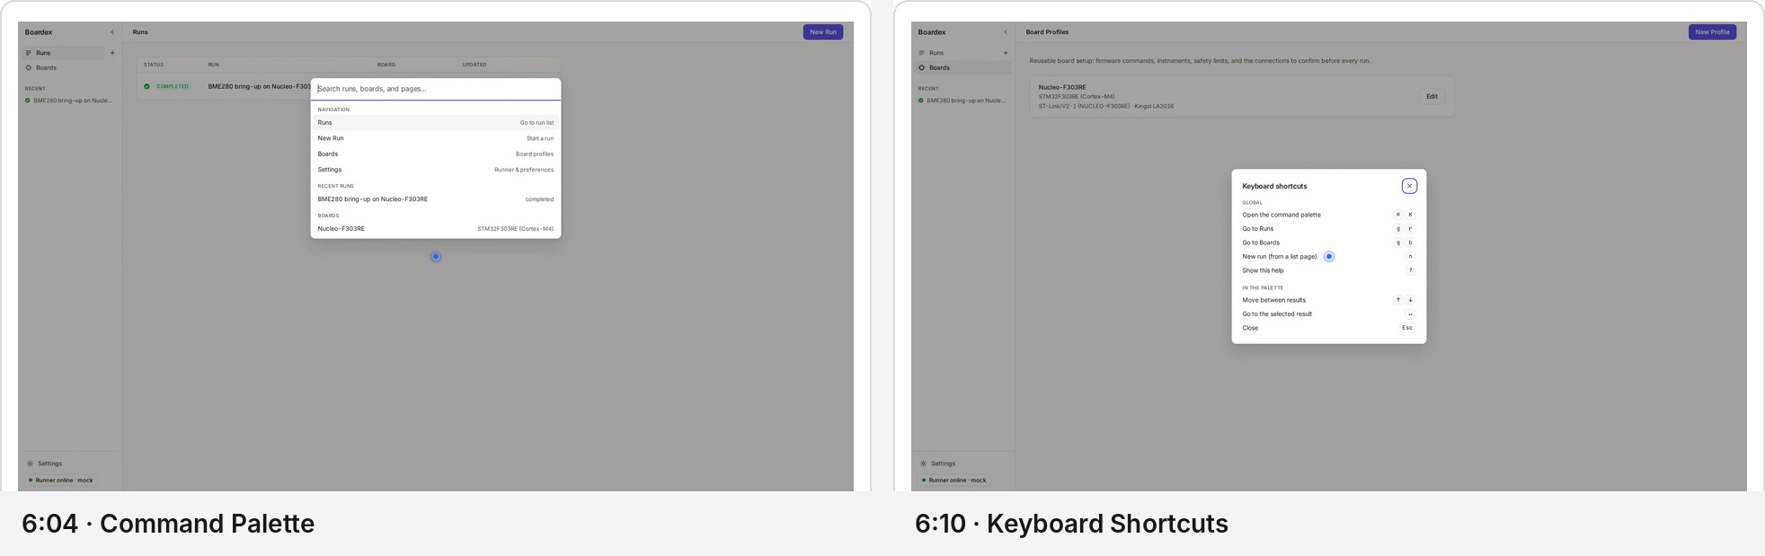
Figure 8. The keyboard surfaces are already close to the target quality and require only small consistency refinements.

Command palette
- The 580–620px centered modal, grouped results, and right-aligned descriptions are appropriate.
- Use accent color plus semibold weight for fuzzy-matched characters. Avoid underlining matched substrings.
- Keep selected-row background neutral; the purple focus line on the search field is sufficient.
- Use 36–40px result rows and 12–13px section labels.
- Add a subtle footer with ↑↓ navigate · Enter open · Esc close if space allows.

Shortcut overlay
- The Global / In the palette grouping is clear.
- Keep the compact modal size; it should feel like a reference sheet rather than a page.
- Standardize keycaps to a minimum 24px height and use tabular alignment for multi-key sequences.
- Use the same close control and modal shadow as the command palette.
Verdict
These surfaces already feel desktop-native. Their main role in the polish pass is to establish the shared modal, focus, and keyboard-control system used across the rest of Boardex.

05 · TRUST STORY

Segment 9 — Real hardware run and honest failure
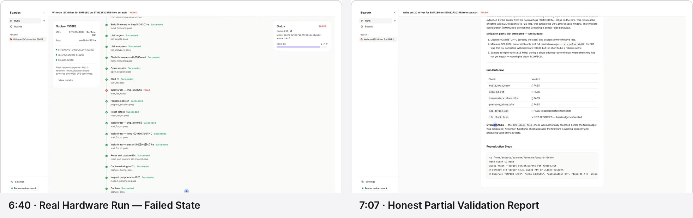
Figure 9. The UI reports a real failure calmly and truthfully. The next refinement is to distinguish run execution from validation coverage.

What is already strong
- The FAILED badge is legible and restrained; it communicates seriousness without alarm.
- The trail preserves real agent behavior rather than presenting a sanitized success story.
- The report explains that functional checks passed while one check was not formally recorded.
- NOT RECORDED is conceptually distinct from FAIL and should remain so.

Critical clarity enhancement
Separate two outcomes
Present “Run execution” and “Validation coverage” as separate summary dimensions. The current overall FAILED label is truthful, but it can be misread as hardware/firmware failure even when the functional checks passed.

- Status card: Run execution — Failed. Reason — turn budget exhausted.
- Status card: Validation coverage — 6 of 7 checks recorded.
- Report summary: Functional result — Passed. Evidence completeness — Incomplete. Run terminal state — Failed.
- Keep the top-level FAILED badge because it reflects the run state. Place the validation summary directly below it.
- Use neutral gray for NOT RECORDED, including a dash or hollow-circle icon. Reserve red for failed checks and the run terminal state.

Timeline density
- Group repeated tool retries such as multiple Read memory failures into a single expandable row: “Read memory · 3 failed attempts · recovered / unresolved.”
- Distinguish recovered tool errors from unresolved failures. Use red for unresolved; use amber or neutral “Recovered” for errors that the agent overcame.
- Keep the complete raw trail accessible in the expanded step or logs, preserving honesty without overwhelming the primary timeline.
- Place the model name and turn budget under a compact “Run details” section so the status card remains readable.

06 · COMPONENT SPECIFICATION

Premium component rules for the existing UI

Badge system
Class | Type | Height | Typography | Use
Run state | Capsule | 20–22px | 11px / 600 / uppercase | RUNNING, COMPLETED, FAILED, PLAN READY, AWAITING APPROVAL
Risk | Capsule | 20px | 10.5–11px / 600 / uppercase | LOW neutral; MEDIUM amber
Verdict | Icon + label | 24–28px | 12px / 600 | Pass, Fail, Not recorded
Inline step status | Icon + text | Auto | 12.5–13px / 500 | Succeeded, Active, Pending, Recovered

Buttons
- One primary action per approval or plan gate.
- Primary: filled purple, 40px height in gates, 36px elsewhere.
- Secondary: white surface, strong neutral border, dark text.
- Tertiary: text button; destructive actions gain red only on hover/focus or when confirmation is required.
- Disabled buttons must remain clearly disabled while retaining readable labels.
- Loading state should replace label with a specific verb: Approving…, Flashing…, Validating….

Cards and rails
- Use 8px radius and 1px default border.
- Approval cards may use an amber 1px border plus a 3px top/left accent rail.
- Status cards remain compact and sticky.
- Use shadows only for floating layers: demo callout, command palette, modal, and evidence drawer.
- Never use color as decorative card fill.

Tables
- Sticky header for evidence, protocol decode, and artifact tables.
- Critical values use tabular figures and monospace where appropriate.
- No dense zebra striping; use 1px row rules and hover tint.
- Rows 44–48px for evidence tables; 32–36px compact mode for protocol decode.
- Long cells clamp and expand rather than forcing the full table to become tall.

06 · INTERACTION SPECIFICATION

Behavior that makes the product feel expensive

Stable geometry
- The center timeline, board context, and right rail should keep their widths throughout a run.
- Approval cards occupy a reserved rail slot, preventing the page from reflowing when a gate appears.
- Evidence chips keep fixed widths as verdicts change.
- Active-step expansion should push content predictably and preserve the user’s scroll position.
- Drawers and modals should restore focus to the invoking control when closed.

Focus and keyboard
- 2px purple focus ring with 2px offset on all interactive controls.
- Visible focus inside tables, tab bars, and log controls.
- Esc closes the topmost overlay; Enter activates the primary action only when safe.
- Approval and power/hardware actions require explicit focus and activation; no accidental keyboard submission.

Readability and accessibility
- Minimum 4.5:1 contrast for normal text and status labels.
- Critical state text at 12px minimum; 11px reserved for secondary machine labels.
- Every Pass/Fail/Approval state includes text and icon, never color alone.
- Checkbox rows and compact controls provide at least a 32px pointer target.
- Use aria-live for run-state changes and approvals without announcing every streamed log line.
- Honor reduced-motion preference by removing pulses and using immediate state swaps.

Responsive desktop widths
- 1920px: full three-zone layout with 840px evidence drawer.
- 1440px: compact left context and 300px rail; center remains dominant.
- Below approximately 1280px: left context becomes a collapsible panel; rail remains visible for approvals.
- Tables preserve columns through horizontal scrolling rather than compressing values below legibility.

07 · IMPLEMENTATION BACKLOG

Prioritized polish plan
Pri. | Enhancement | Reason | Effort | Acceptance signal
P0 | Global typography and contrast pass | Critical labels and body copy are undersized at 1920px. | M | Readable hierarchy at 1440 and 1920.
P0 | Canvas and surface hierarchy | White-on-white weakens desktop structure. | S | Shell, work surfaces, and overlays separate clearly.
P0 | Split badge system | 11px uppercase is overused for verdicts. | S | Run states remain compact; verdicts become icon-led and legible.
P0 | Intentional right rail | Status-only state looks sparse. | M | Autonomous and approval states occupy the same reserved slot.
P0 | Plan checklist progress | The safety gate relies on a disabled button to explain completion. | S | Visible 0/6 progress and larger hit targets.
P0 | Approval action hierarchy | Reject currently competes visually with Review Diff. | S | One unmistakable primary, one secondary, one tertiary destructive.
P0 | Evidence log navigation | Sub-tabs wrap and feel prototype-like. | M | Iteration and log type selectors never wrap.
P0 | Real-run dual outcome summary | FAILED can be read as hardware failure. | M | Run state and validation coverage are independently clear.
P0 | Status color-noise reduction | Repeated green words dilute semantic impact. | S | Green icons carry repeated success; summary text remains calm.
P1 | Empty-state scale and process line | Hero is stranded at 1920px. | S | Hero reads immediately and retains minimal character.
P1 | Cited-source highlight | Current source arrival is too quiet. | S | Cited heading is unmistakable without shouting.
P1 | Protocol decode density | Annotation wrapping makes scanning slow. | M | Fixed technical columns and expandable annotations.
P1 | Code-diff treatment | Long lines and changes lack strong scan cues. | M | Changed lines are clear; horizontal scroll is explicit.
P1 | Report typography and metadata | Report feels like Markdown inside a generic card. | S | Readable long-form surface with compact run summary.
P1 | Board/settings page rhythm | Long pages feel sparse and actions can leave view. | M | Consistent width, section rhythm, sticky form actions.
P1 | Motion and state choreography | Some state changes are easy to miss. | M | Stable 160–300ms transitions with reduced-motion support.
P2 | Demo target spotlight | Callouts describe zones more than point to them. | M | Each callout visibly anchors to its target.
P2 | Retry grouping in real runs | Repeated recoverable tool errors dominate the trail. | M | Condensed primary trail with full raw expansion.
P2 | Connection-diagram entry point | Checklist can later link to physical setup diagram. | L | Added without changing the existing approval flow.
Recommended sequencing
Complete P0 as one integrated visual-system pass. Implementing isolated items one by one will preserve inconsistencies. Follow with P1 evidence/report polish, then P2 onboarding and trail-density improvements.

08 · ACCEPTANCE CRITERIA

Definition of done for the premium polish release

App shell and hierarchy
☐ At 1920×1080, the empty Home and Settings pages feel intentionally composed rather than stranded.
☐ The application canvas, primary surfaces, and floating layers are visually distinct.
☐ Top bar, sidebar, and page gutters follow one spacing system.
☐ Collapsed navigation provides tooltips and a clear active state.

Run workspace
☐ Timeline remains the dominant surface at 1440 and 1920 widths.
☐ Right rail always communicates whether action is required.
☐ One primary action is obvious at every gate.
☐ Active step, logs, and timeline do not shift unexpectedly.
☐ FAIL → PASS updates are noticeable without celebratory motion.

Status and semantics
☐ Run-state, risk, verdict, and inline-status components use separate specifications.
☐ No critical status relies on color alone.
☐ Green, red, amber, and purple are used only according to Boardex’s semantic rules.
☐ NOT RECORDED is visually neutral and distinct from FAIL.

Evidence and report
☐ Evidence drawer tabs and log selectors never wrap.
☐ Checks, protocol decode, logs, code diff, and artifacts remain readable at default drawer width.
☐ Cited-source navigation clearly identifies the target heading.
☐ Report body is comfortable to read for a full scroll.
☐ Real-run reporting distinguishes terminal run status from functional validation coverage.

Keyboard and accessibility
☐ Every control has visible keyboard focus.
☐ Modal and drawer focus returns correctly on close.
☐ Critical labels meet minimum size and contrast targets.
☐ Reduced-motion mode removes pulses and nonessential transitions.
Final verdict
Keep the product flow exactly where it is. Boardex’s differentiated value is already visible in the run timeline, safety gates, evidence chain, and honest reporting. The next release should focus on visual authority, intentional composition, and component discipline. That is the shortest route to a premium product.

Boardex closes the loop: plan, flash, measure, diagnose, verify.
The interface should feel equally exact.

