Interblock Streaming FIFO with Backpressure Hardware Specification
Hardware Microarchitecture Specification & SystemC TLM AT Performance Modeling Guide • Rev 2.0
HARDWARE SPEC NOTE: This specification details a streaming FIFO interconnect with valid/ready backpressure flow control and provides SystemC TLM 2.0 2-Phase AT performance modeling instructions.

1. Executive Summary & Hardware Microarchitecture
This document specifies a streaming data interconnect featuring flow control backpressure: Producer Core -> 4-Entry Streaming FIFO Interconnect -> Consumer Core.
The FIFO interconnect buffers bursty stream traffic. When the FIFO queue depth reaches 4 (full), the FIFO deasserts p2f_ready, backpressuring the Producer. When the Consumer is busy processing, it deasserts f2c_ready, stalling the FIFO.
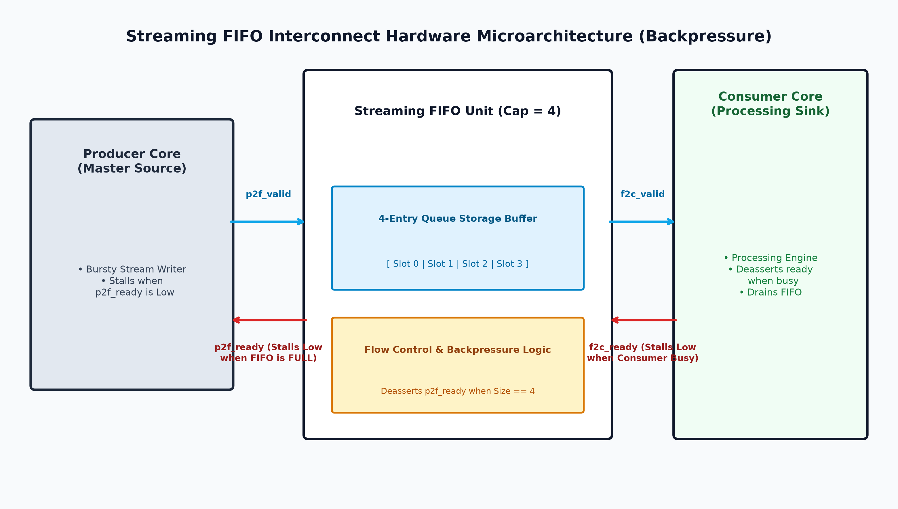
Figure 1: Streaming FIFO Interconnect Hardware Microarchitecture Diagram

2. Hardware Interface Signal Specifications
Signal Name | Direction | Width | Description
clk | Input | 1 bit | Master clock (100 MHz, 10 ns period)
rst_n | Input | 1 bit | Active-low system reset
p2f_valid | Input | 1 bit | Producer asserts high when driving stream data
p2f_ready | Output | 1 bit | FIFO asserts high when buffer space is available; deasserts Low on FULL
f2c_valid | Output | 1 bit | FIFO asserts high when popped data is forwarded to Consumer
f2c_ready | Input | 1 bit | Consumer asserts high when ready; deasserts Low when BUSY
stream_data | Input/Output | 32 bits | 32-bit streaming data packet payload

2.2 Performance Tracing Register Map
Signal Name | Type | Range | Description
fifo_size | Output | 0 to 4 items | Current count of data packets buffered in FIFO storage queue
producer_stalled | Output | 1 bit (Bool) | Active High when Producer is backpressured by full FIFO
consumer_stalled | Output | 1 bit (Bool) | Active High when FIFO is stalled by busy Consumer

3. Timing & Control State Specifications
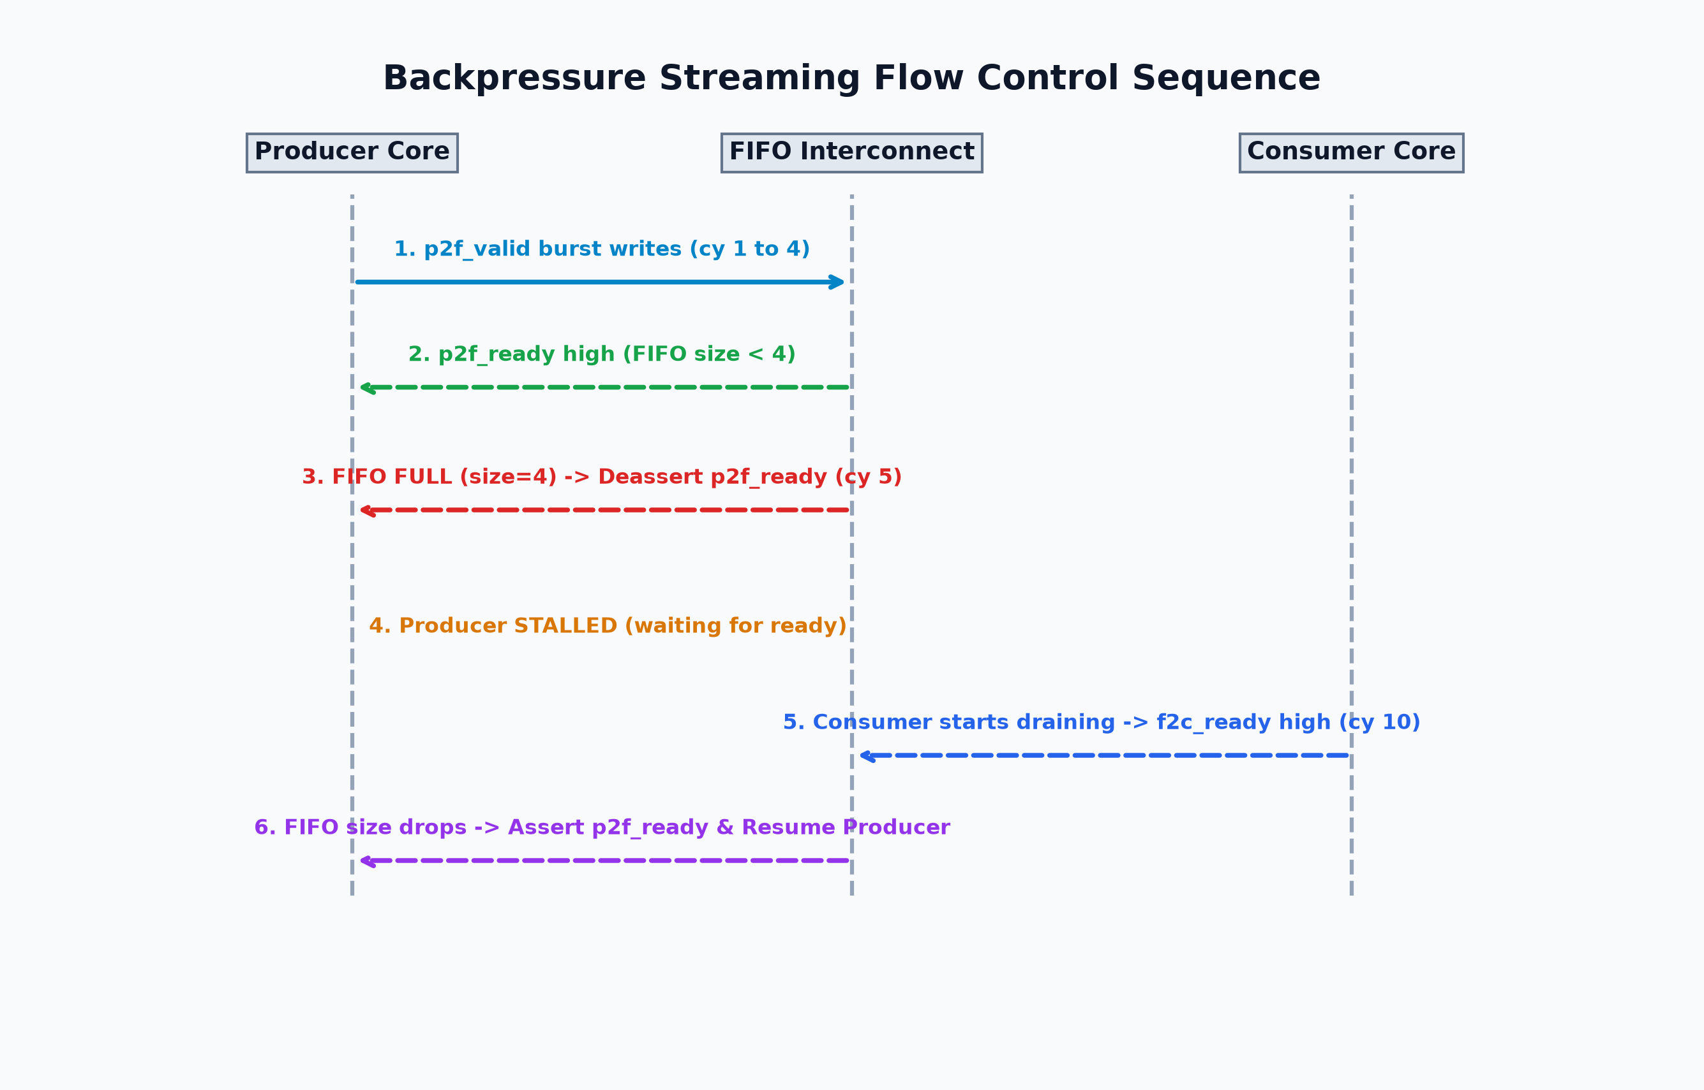
Figure 2: Backpressure Streaming Flow Control Sequence
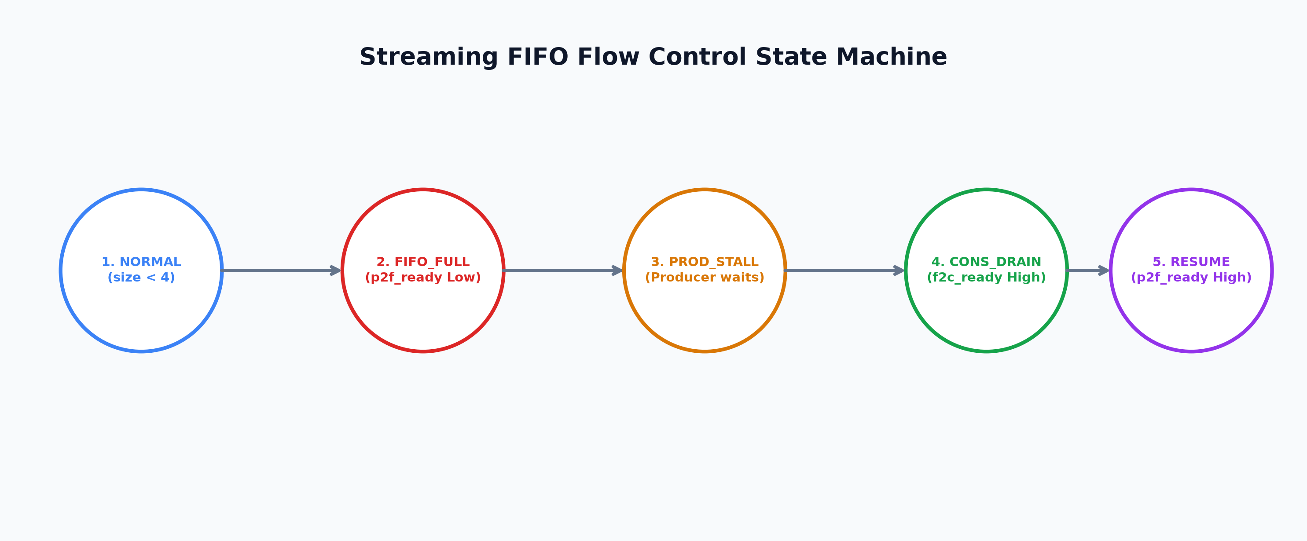
Figure 3: Streaming FIFO Flow Control State Machine
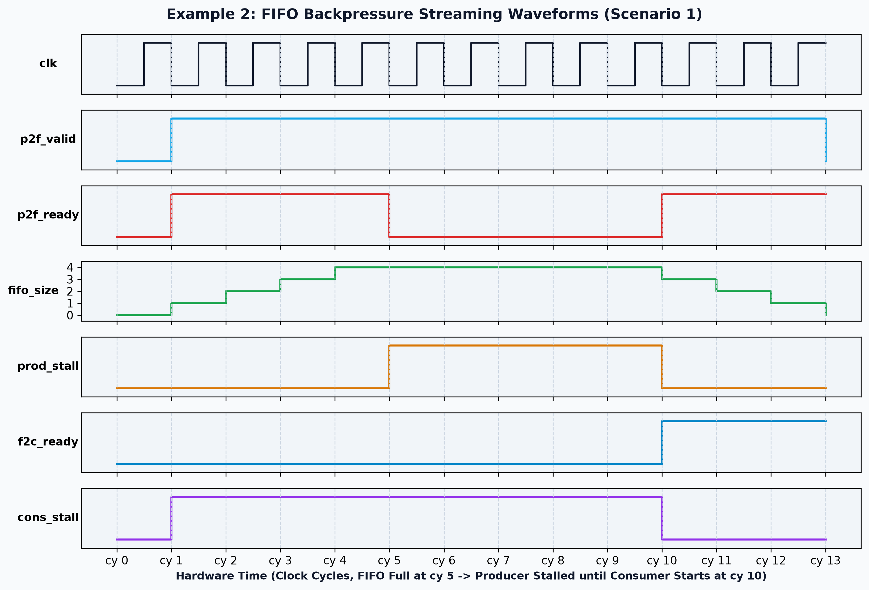
Figure 4: Cycle-Accurate Backpressure Streaming Waveforms (Scenario 1)

4. SystemC TLM 2.0 Performance Model Implementation Guide
Hardware Spec Feature | SystemC TLM 2.0 AT Implementation Pattern
Producer Stall on FIFO Full (p2f_ready Low) | In nb_transport_fw_write: If fifo_size == 4, return TLM_ACCEPTED without END_REQ phase. Stash trans in m_pending_writes. Producer thread blocks on wait(m_end_req_event).
FIFO Stall Release Backward | When Consumer drains a packet, pop pending write from m_pending_writes and call socket->nb_transport_bw(*trans, phase=END_REQ, delay=10ns) backward.
Consumer Busy Stall (f2c_ready Low) | In Consumer nb_transport_fw: If busy, return TLM_ACCEPTED without END_REQ. FIFO push_to_consumer_thread blocks on wait(m_consumer_released_event).
FIFO Write Buffer Execution Delay (2 cy) | Register accepted write with PEQ: m_peq.notify(trans, delay + 20ns). Push to m_fifo_data queue on expiration.

NOTE: A SystemC performance modeling engineer reading Section 4 will build an Approximately-Timed streaming model identical to example2_backpressure in this repository!

5. Verification Scenarios
Scenario | Traffic Pattern | Observed Behavior | Expected Verification Results
Scenario 1 | Fast Producer (1 cy), Slow Consumer (starts cy 10) | FIFO fills to capacity=4 at cy 5. Producer stalls cy 5-10. Drains when Consumer starts. | Producer stalls on write 5. Releases at cy 10 as Consumer processes.
Scenario 2 | Slow Producer (6 cy), Fast Consumer | FIFO stays mostly empty. No backpressure stalls. | Smooth continuous streaming without producer stalls.
Scenario 3 | Bursty Producer & Bursty Consumer | Transient queue buildup with temporary stalls | FIFO absorbs burst, temporary backpressure pulse released as consumer drains.

