Pipelined ALU Hardware Architecture Specification
Hardware Microarchitecture Specification & SystemC TLM AT Performance Modeling Guide • Rev 2.0
HARDWARE SPEC NOTE: This document provides the formal hardware microarchitecture specification for a Pipelined Arithmetic Logic Unit (ALU) and provides SystemC TLM 2.0 2-Phase AT performance modeling instructions.

1. Executive Summary & Hardware Microarchitecture
The Pipelined ALU is a high-performance 32-bit arithmetic compute block designed for integration into superscalar processor cores. The core supports parallel execution of 32-bit Addition (3 clock cycles execution latency) and 32-bit Multiplication (4 clock cycles execution latency).
The input interface uses a decoupled Valid/Ready handshake protocol with a 1-cycle input register setup delay. Output results are committed in strict program issue order via an internal Reorder Buffer (ROB).
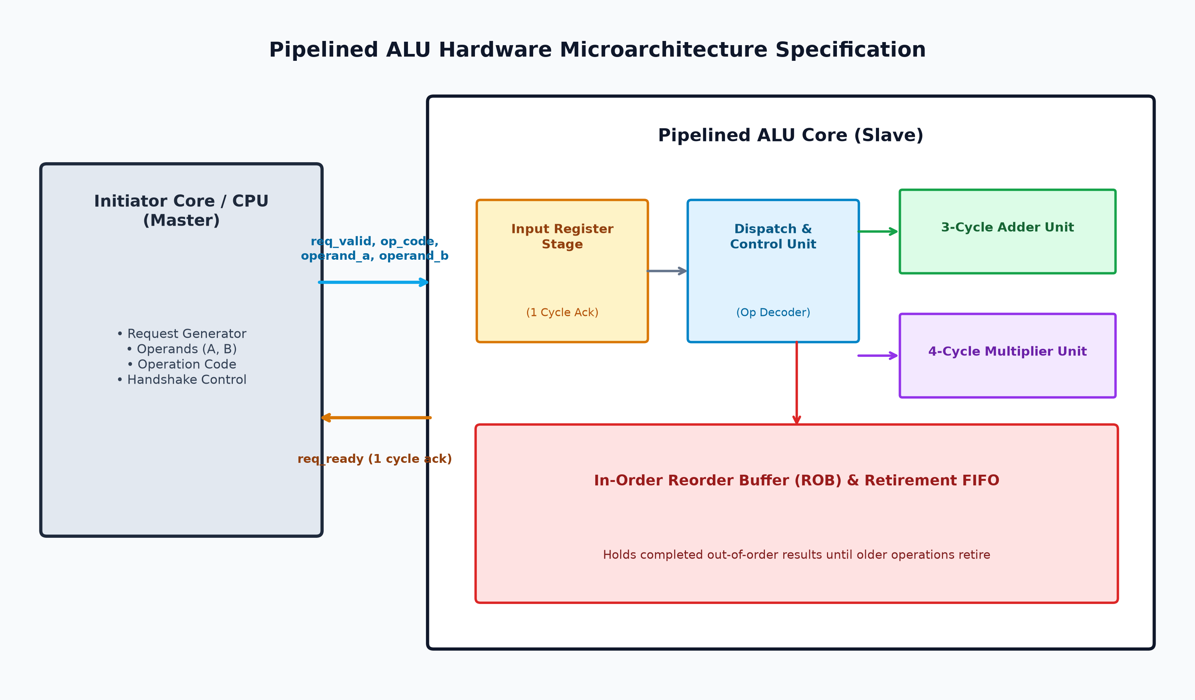
Figure 1: Pipelined ALU Microarchitectural Block Diagram

1.1 Sub-Block Microarchitecture
1. Initiator Core (Master): Generates instruction requests, driving valid signals, operation codes (0 = ADD, 1 = MUL), and 32-bit operands (A, B).
2. Input Register Stage: Samples incoming requests when req_valid is high. Asserts req_ready 1 clock cycle later to acknowledge request receipt, freeing the initiator interface.
3. Execution Pipelines: Parallel processing pipelines: 3-cycle pipelined Adder Unit and 4-cycle pipelined Multiplier Unit.
4. Reorder Buffer (ROB) & Retirement Queue: A multi-entry FIFO buffer that tracks issue order. Out-of-order completed results are held in ROB slots until all preceding in-flight operations have retired.

2. Hardware Interface Signal Specifications

2.1 Primary Input/Output Signals
Signal Name | Direction | Width | Description
clk | Input | 1 bit | System master clock (100 MHz, 10 ns period)
rst_n | Input | 1 bit | Asynchronous active-low system reset
req_valid | Input | 1 bit | Initiator asserts high when driving valid command and operands
req_ready | Output | 1 bit | ALU asserts high for 1 cycle when input stage accepts request
op_code | Input | 1 bit | 0 = 32-bit Addition (ADD), 1 = 32-bit Multiplication (MUL)
operand_a | Input | 32 bits | First 32-bit input operand
operand_b | Input | 32 bits | Second 32-bit input operand
out_valid | Output | 1 bit | ALU asserts high when retired result is valid
result_data | Output | 32 bits | 32-bit computation result output

2.2 Performance Monitor & Tracing Register Map
Signal Name | Type | Range | Description
input_stage_occupied | Output | 0 (Idle), 1 (Occupied) | Active high during 1-cycle input register setup
pipeline_depth | Output | 0 to 8 operations | Current count of active in-flight operations
active_op | Output | 00:IDLE, 01:ADD, 10:MUL, 11:MIXED | Current execution pipeline activity state
retired_tx_id | Output | 0 (None), 1-255 (Tx ID) | ID of transaction retired in current clock cycle

3. Timing & Control State Specifications
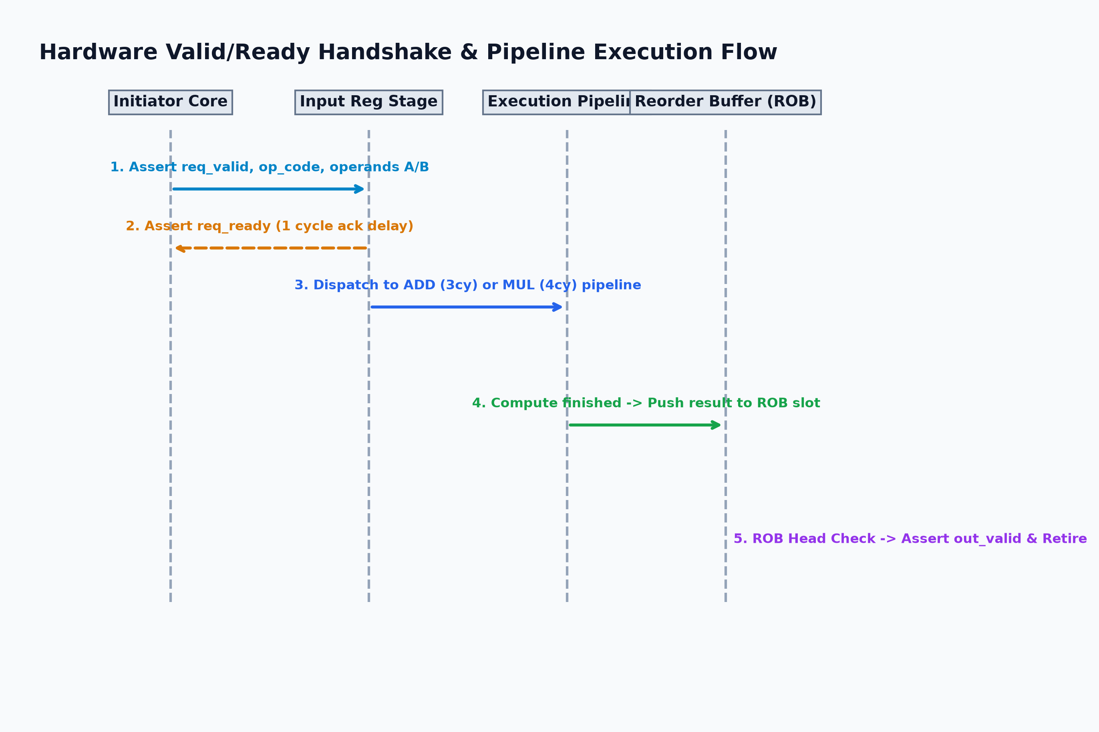
Figure 2: Hardware Valid/Ready Handshake & Pipeline Execution Flow
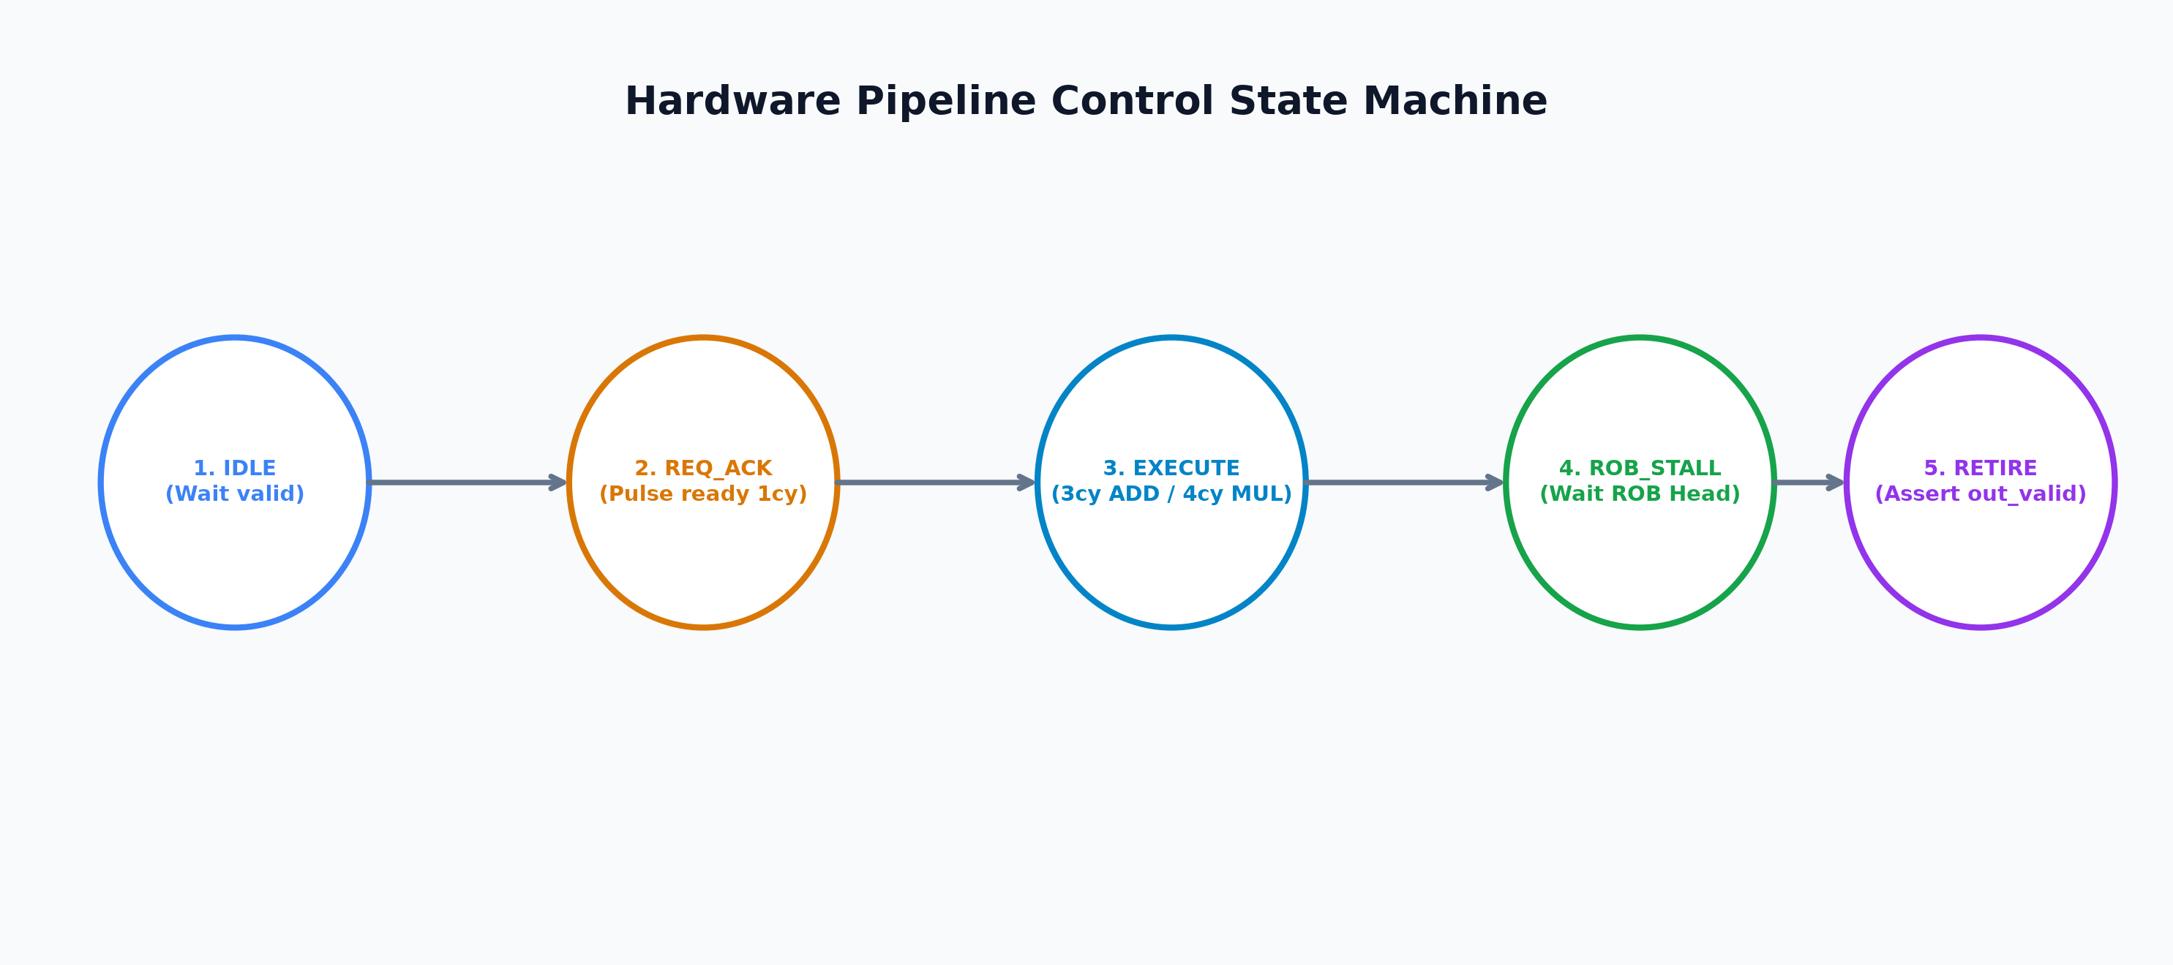
Figure 3: Hardware Pipeline Control State Machine
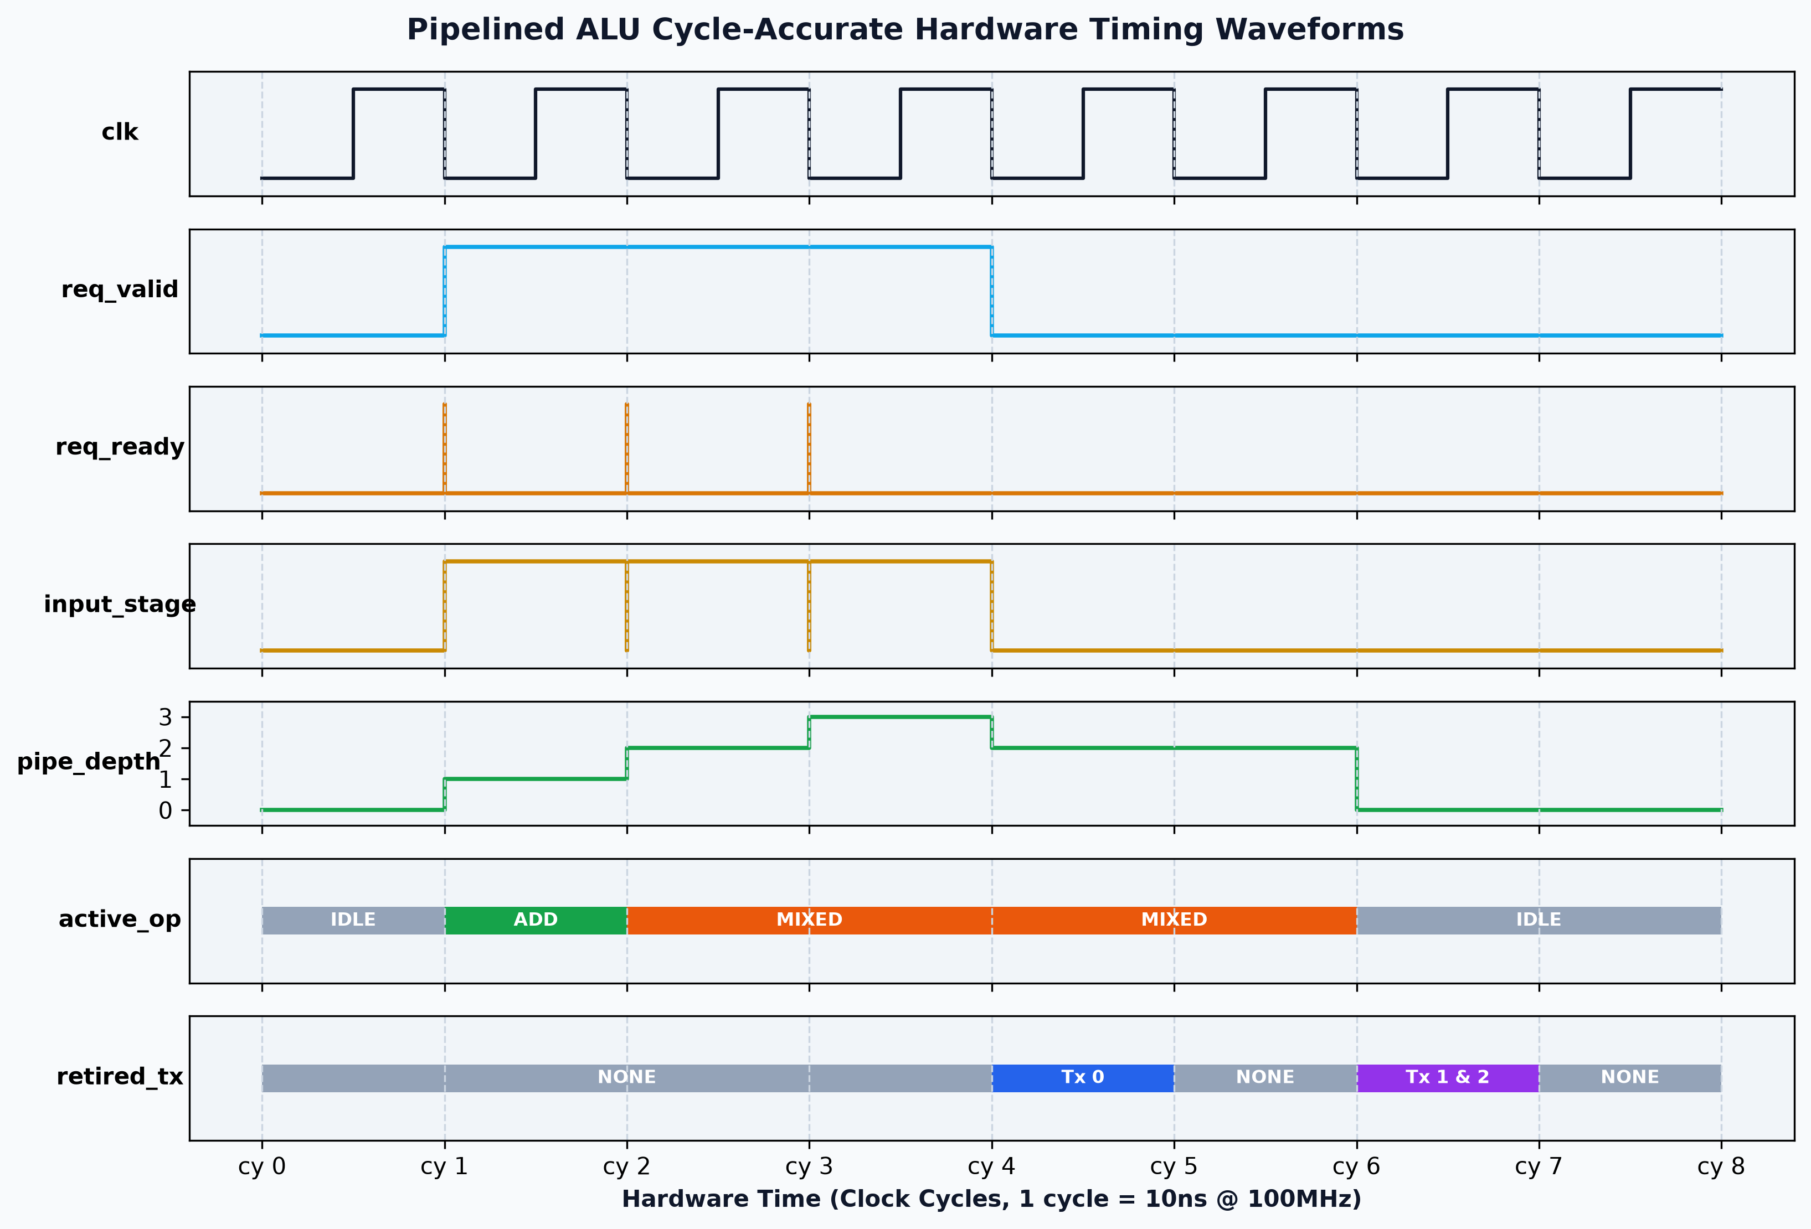
Figure 4: Cycle-Accurate Digital Waveforms (Scenario 1)

4. SystemC TLM 2.0 Performance Model Implementation Guide
Hardware Spec Feature | SystemC TLM 2.0 AT Implementation Pattern
Valid/Ready Handshake (req_valid / req_ready) | Use 2-Phase protocol: Initiator sends nb_transport_fw(BEGIN_REQ). Target responds after 1 cycle with TLM_UPDATED(END_REQ, delay=10ns).
Execution Pipeline Delays (3cy ADD, 4cy MUL) | Use Payload Event Queue (tlm_utils::peq_with_get). Target notifies PEQ: m_peq.notify(trans, delay + 30ns or 40ns).
Out-of-Order Execution vs In-Order Retire | PEQ worker thread retrieves finished payloads out-of-order, setting completed=true. Main pipeline_thread monitors head of m_pipeline_queue to retire in-order.

NOTE: A SystemC performance modeling engineer reading Section 4 will build a 2-Phase Approximately-Timed model that behaves identically to example1_pipeline in this repository!

5. Verification Scenarios
Scenario | Traffic Pattern | Observed Behavior | Expected Retirement Cycles
Scenario 1 | Mixed (ADD, MUL, ADD) | Continuous execution with out-of-order completion | Tx 0 (ADD) retires at cy 4; Tx 1 (MUL) & Tx 2 (ADD) retire at cy 6
Scenario 2 | Slow MUL followed by Fast ADDs | In-order retirement stall in ROB | Fast ADDs complete at cy 4 but stall in ROB until cy 6 to retire behind MUL
Scenario 3 | Continuous Back-to-Back ADDs | 100% compute pipeline saturation | Pipeline depth stays at 3 in-flight items; 1 operation retires every cycle

