Simple 3-Stage Pipeline Hardware Specification
Hardware Microarchitecture Specification & SystemC TLM AT Performance Modeling Guide • Rev 2.0
HARDWARE SPEC NOTE: This specification details a 3-stage hardware compute pipeline (Component A -> Stage B -> Endpoint C) and provides SystemC TLM 2.0 2-Phase AT performance modeling instructions.

1. Executive Summary & Hardware Microarchitecture
This document describes a 3-stage hardware compute pipeline consisting of three connected functional blocks: Component A (Initiator Core), Component B (3-Cycle Pipelined Compute Stage), and Component C (1-Cycle Endpoint Compute Unit).
The pipeline decouples input handshaking from compute latency using 1-cycle register setup delays, allowing continuous throughput across all three stages.
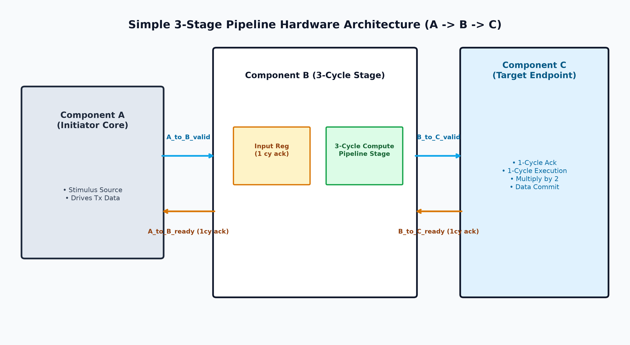
Figure 1: 3-Stage Pipeline Hardware Microarchitecture Block Diagram

1.1 Sub-Block Specifications
1. Component A (Initiator): Master core generating instruction transactions and driving output data payload.
2. Component B (Pipelined Stage): Accepts requests with a 1-cycle A_to_B_ready acknowledgment, processes transactions through a 3-cycle internal compute pipeline, and forwards completed payloads to Component C.
3. Component C (Target Endpoint): Accepts requests with a 1-cycle B_to_C_ready acknowledgment, executes a 1-cycle doubling calculation, and commits final data.

2. Hardware Interface Signal Specifications

2.1 Primary Input/Output Signals
Signal Name | Direction | Width | Description
clk | Input | 1 bit | Master clock (100 MHz, 10 ns period)
rst_n | Input | 1 bit | Active-low system reset
A_to_B_valid | Internal | 1 bit | High when Component A drives valid data to B
A_to_B_ready | Internal | 1 bit | High for 1 cycle when B accepts A's request
B_to_C_valid | Internal | 1 bit | High when B forwards completed data to C
B_to_C_ready | Internal | 1 bit | High for 1 cycle when C accepts B's request
tx_data | Internal | 32 bits | 32-bit transaction payload data

2.2 Performance Tracing Register Map
Signal Name | Type | Range | Description
pipeline_depth | Output | 0 to 3 items | Count of active transactions inside B's pipeline
A_B_req_tx | Output | 0 to 255 ID | Transaction ID currently active on A-B interface
B_C_req_tx | Output | 0 to 255 ID | Transaction ID currently active on B-C interface

3. Timing & Control State Specifications
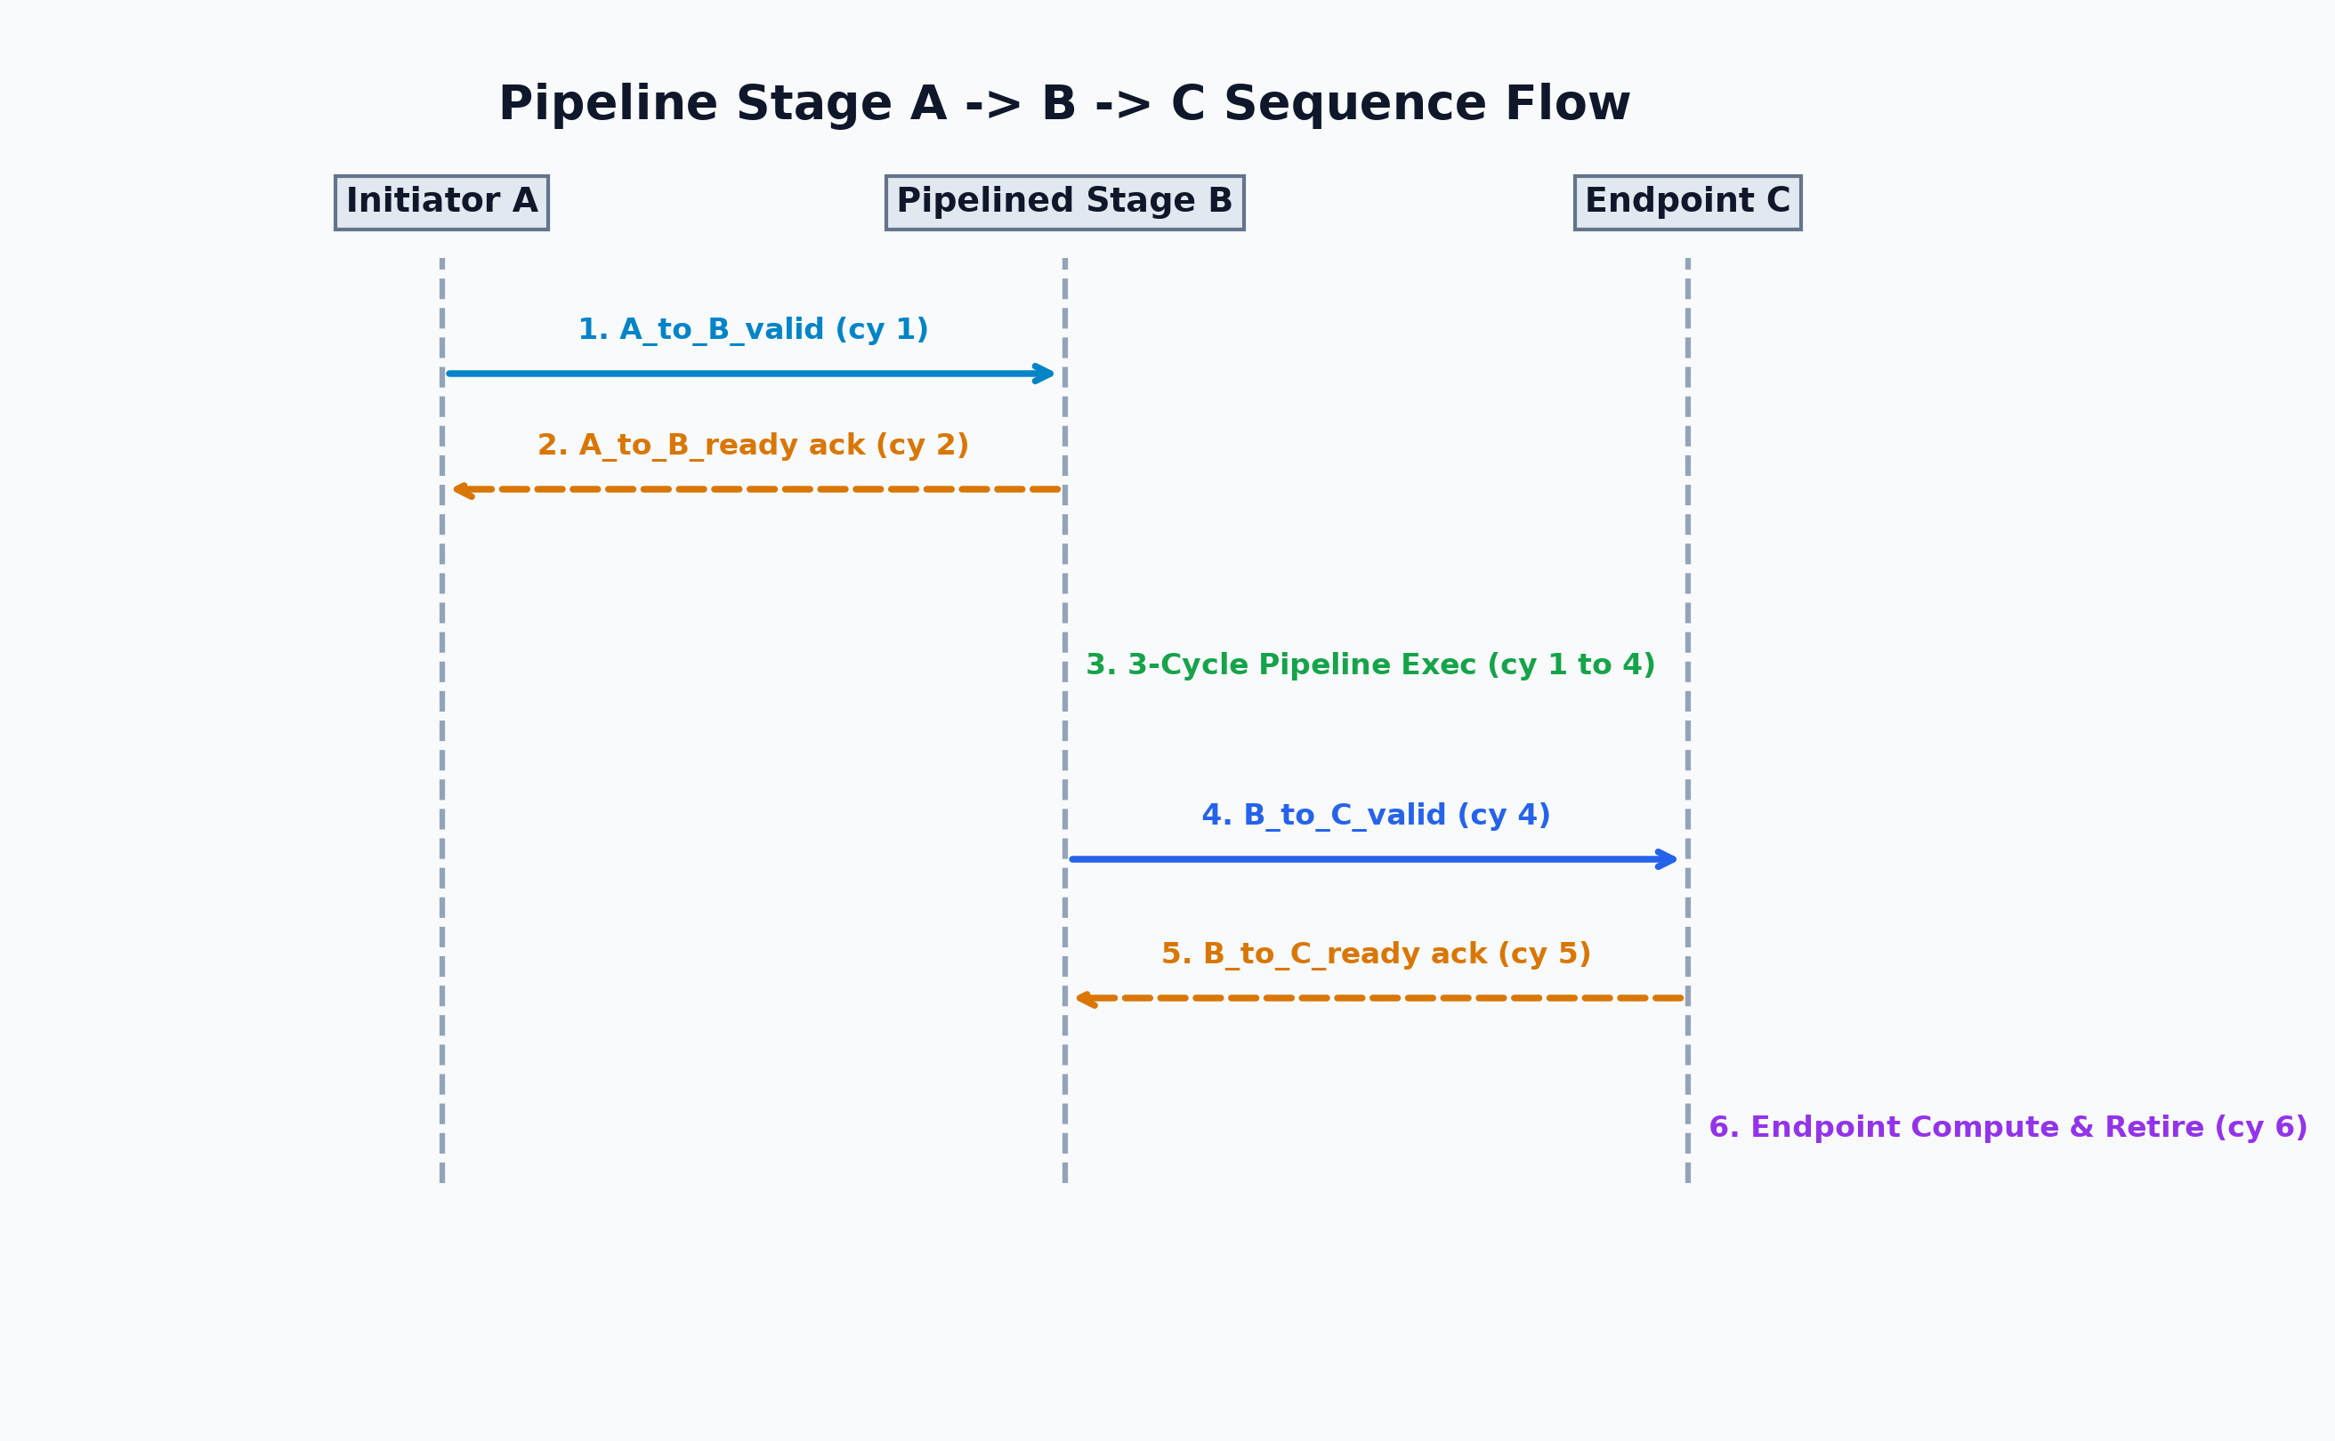
Figure 2: Pipeline Stage A -> B -> C Sequence Flow
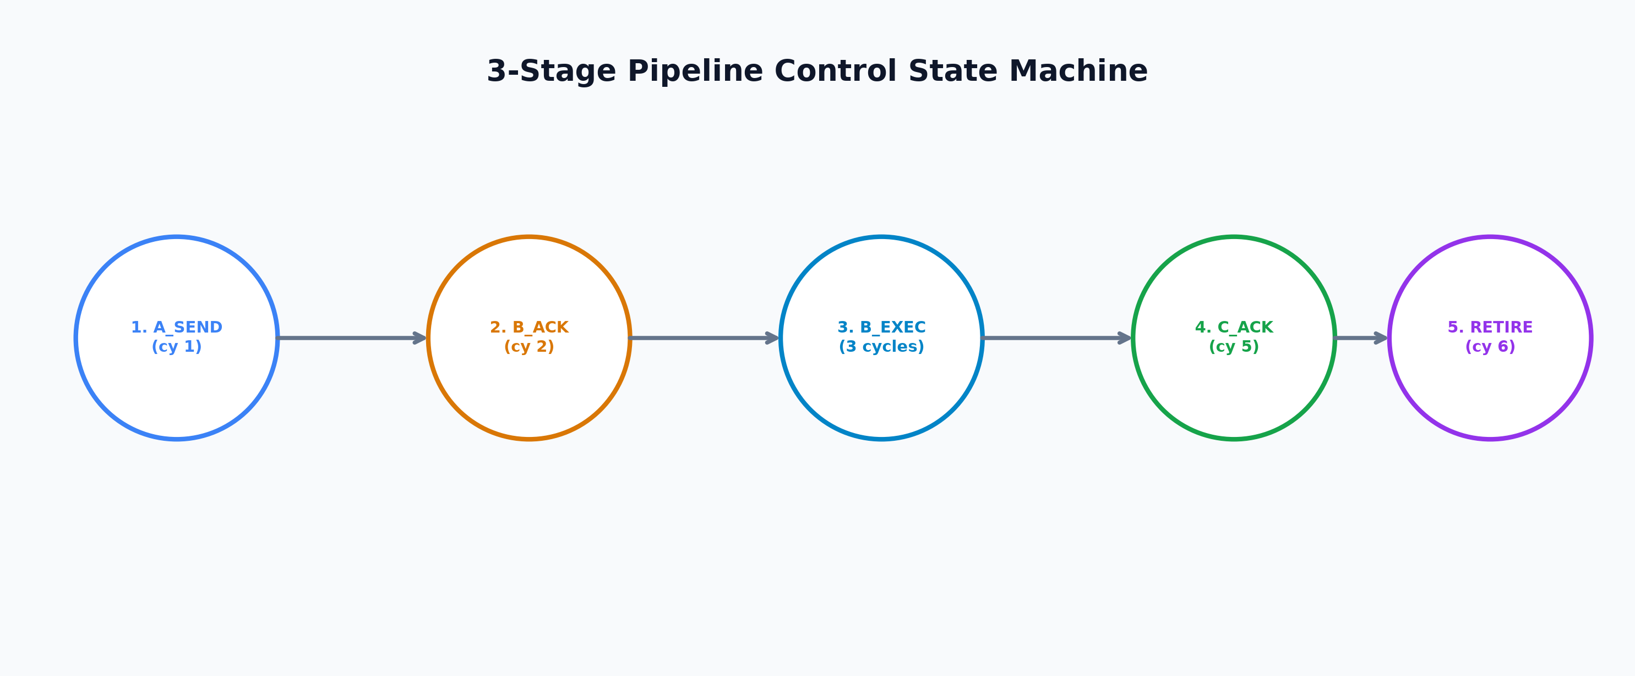
Figure 3: 3-Stage Pipeline Control State Machine
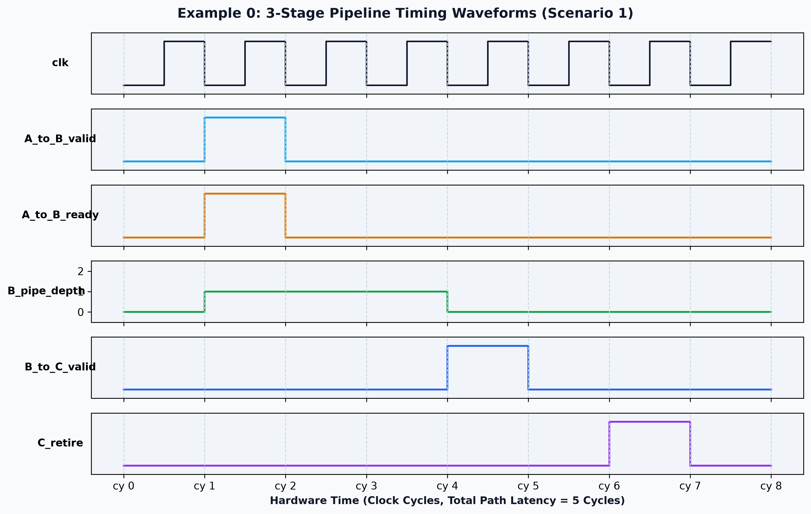
Figure 4: Cycle-Accurate Pipeline Timing Waveforms (Scenario 1)

4. SystemC TLM 2.0 Performance Model Implementation Guide
Hardware Spec Feature | SystemC TLM 2.0 AT Implementation Pattern
A-B & B-C Valid/Ready Handshakes | Use 2-Phase protocol: nb_transport_fw(BEGIN_REQ) returning TLM_UPDATED(END_REQ, delay=10ns).
Component B Execution (3 cy) | Register payload with PEQ: m_peq.notify(trans, delay + 30ns). Pop payload on expiration and forward to C.
Component C Endpoint Execution (1 cy) | Register payload with PEQ: m_peq.notify(trans, delay + 10ns). Double data value on expiration.
Tracing Signals | Instantiate sc_signal<int> sig_pipeline_depth, sig_A_B_req_tx, sig_B_C_req_tx and update on event triggers.

NOTE: A SystemC performance modeling engineer reading Section 4 will build an Approximately-Timed model identical to example0_simple in this repository!

5. Verification Scenarios
Scenario | Traffic Pattern | Observed Behavior | Expected Retirement Cycles
Scenario 1 | Single Request at cy 1 | Single transaction propagates through B and C | A sends cy 1, B accepts cy 2, B forwards cy 4, C retires cy 6
Scenario 2 | 5 Back-to-Back Requests | Pipeline holds multiple items in flight | Transactions retire consecutively at cy 6, 7, 8, 9, 10
Scenario 3 | Alternate Cycle Requests | Dynamic pipeline filling and draining | Transactions retire at cy 6, 8, 10

