Shared Switch Crossbar Interconnect Hardware Specification
Hardware Microarchitecture Specification & SystemC TLM AT Performance Modeling Guide • Rev 2.0
HARDWARE SPEC NOTE: This specification details a 4-by-4 shared crossbar switch interconnect with Round-Robin arbitration and provides SystemC TLM 2.0 2-Phase AT performance modeling instructions.

1. Executive Summary & Hardware Microarchitecture
This document specifies a Shared Crossbar Switch interconnect connecting 4 Initiator Cores (Core 0..3) to 4 Target Memory Nodes (Node 0..3).
When multiple cores issue simultaneous write requests, a Round-Robin arbiter selects a winning core, grants access, and locks the switch for 3 clock cycles (30 ns transmission duration). Other contending cores are held in a pending request queue and granted sequentially every 3 cycles.
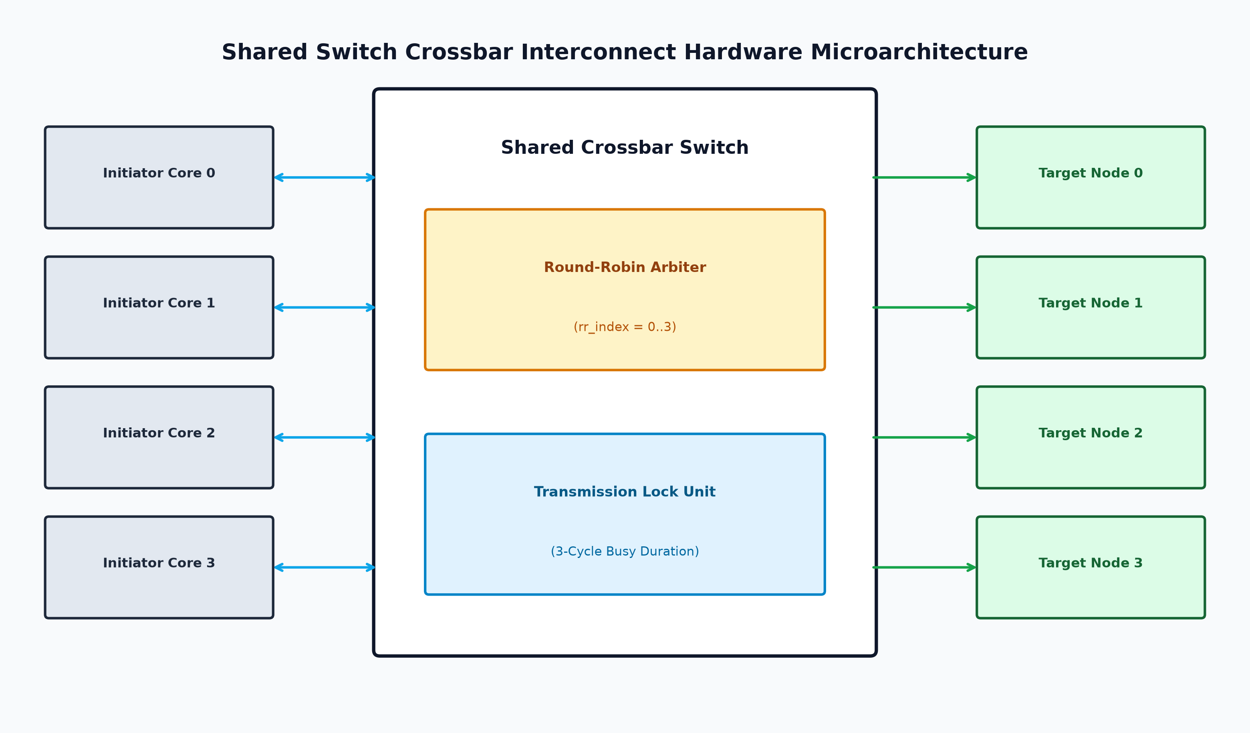
Figure 1: Shared Switch Crossbar Interconnect Microarchitecture Diagram

2. Hardware Interface Signal Specifications
Signal Name | Direction | Width | Description
clk | Input | 1 bit | Master clock (100 MHz, 10 ns period)
rst_n | Input | 1 bit | Active-low system reset
req_valid[3:0] | Input Vector | 4 bits | 1 valid request bit per Initiator Core (0 to 3)
req_grant[3:0] | Output Vector | 4 bits | 1-cycle grant pulse returned to winning Core
dest_addr | Input Bus | 4 bits | Destination Target Node index (0 to 3)
write_data | Input Bus | 32 bits | 32-bit transaction payload data

2.2 Performance Tracing Register Map
Signal Name | Type | Range | Description
switch_busy | Output | 1 bit (Bool) | Active High while switch is locked transmitting (3 cycles)
switch_rr_index | Output | 0 to 3 ID | Current Round-Robin arbiter pointer index
active_initiator_id | Output | 0 (None), 1-4 (Core ID) | ID of currently granted initiator core
pending_req_count | Output | 0 to 4 cores | Number of contending cores currently queued and stalled

3. Timing & Control State Specifications
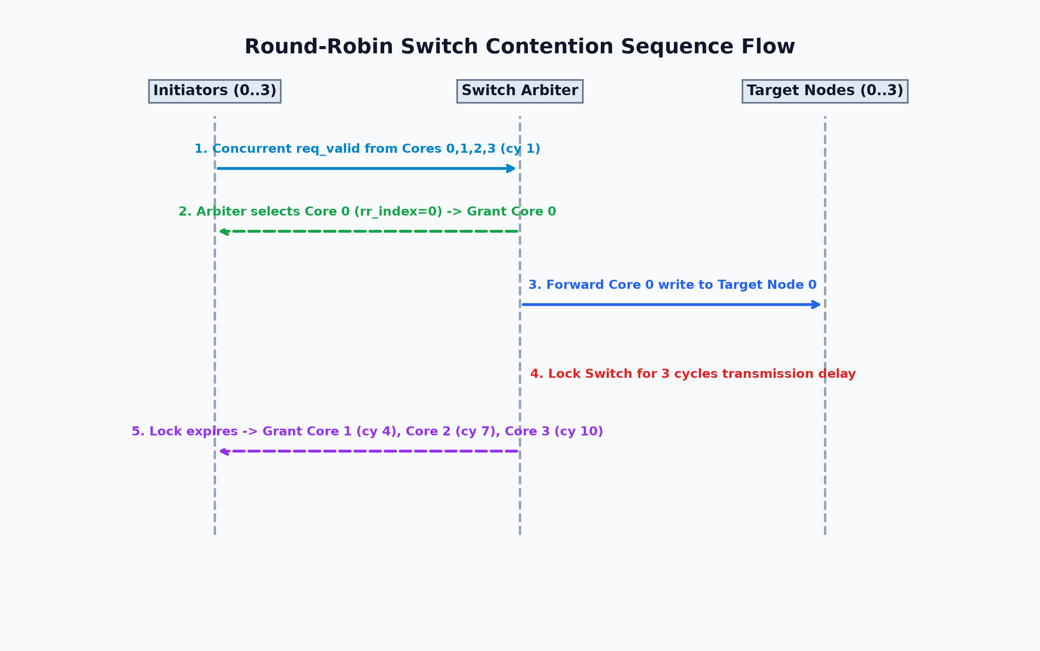
Figure 2: Round-Robin Switch Contention Sequence Flow
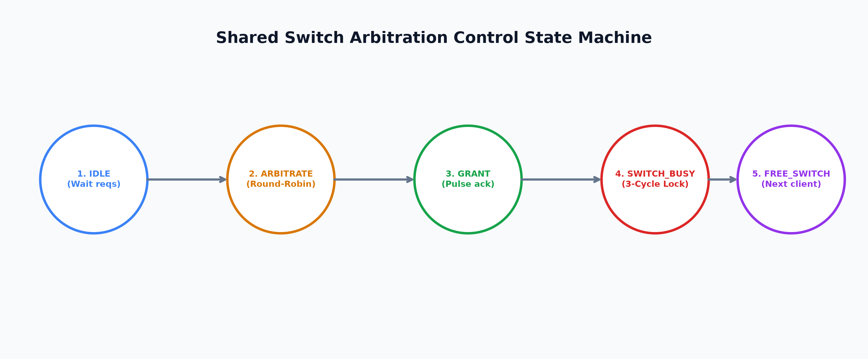
Figure 3: Shared Switch Arbitration Control State Machine
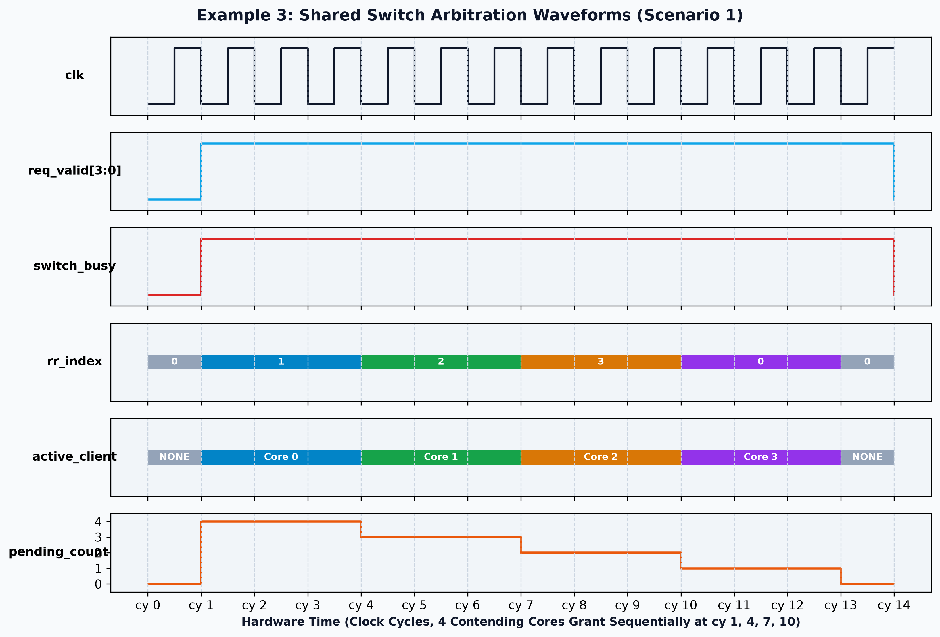
Figure 4: Cycle-Accurate Switch Arbitration Waveforms (Scenario 1)

4. SystemC TLM 2.0 Performance Model Implementation Guide
Hardware Spec Feature | SystemC TLM 2.0 AT Implementation Pattern
Multi-Core Socket Binding | Use tlm_utils::multi_passthrough_target_socket<SwitchTarget> for inputs and multi_passthrough_initiator_socket for outputs.
Contention Stalling | In nb_transport_fw(id, trans, phase, delay): Push request to m_pending_requests and return TLM_ACCEPTED without END_REQ. Initiator thread stalls on wait(m_end_req_event).
Round-Robin Arbiter Thread | arbiter_thread loops on m_pending_requests. Selects winner using m_rr_index pointer, sends backward nb_transport_bw(END_REQ, delay=10ns) grant pulse to winner.
Switch Transmission Lock (3 cy) | Register busy transmission with PEQ: m_peq.notify(trans, 30ns). busy_release_thread unlocks switch when PEQ expires, triggering arbiter for remaining queued cores.

NOTE: A SystemC performance modeling engineer reading Section 4 will build an Approximately-Timed arbitration model identical to example3_arbitration in this repository!

5. Verification Scenarios
Scenario | Traffic Pattern | Observed Behavior | Expected Grant Cycles
Scenario 1 | Coordinated Contention (Cores 0,1,2,3 request at cy 1) | All 4 cores contend simultaneously. Round-Robin arbiter serializes grants. | Core 0 granted cy 1; Core 1 granted cy 4; Core 2 granted cy 7; Core 3 granted cy 10.
Scenario 2 | Staggered Requests (requests spaced 4 cycles apart) | No contention. Switch is free for every incoming request. | Every core receives immediate grant at its request cycle without arbitration delay.
Scenario 3 | Unbalanced Traffic (Core 0 floods, others sparse) | Core 0 requests repeatedly; arbiter fairly yields to sparse requests from Cores 1,2,3. | Fair Round-Robin bandwidth distribution prevents starvation.

