WPS AI Studio

System Design

STATUS  Draft |  | OWNER  To assign |  | LAST UPDATED  October 7 2026

Authors | Not specified
Reviewers | Not assigned
Related docs | PLATFORM.md and requirements-runtime.txt
Scope | A Linux chat builder and a saved Windows data analysis application

1. Abstract
Build reusable data analysis applications through chat on Linux. Save the accepted cleanup, analysis code, controls, and dashboard as one versioned project. Export that project with a prebuilt Windows runtime so it can run on replacement CSV files without an LLM or internet access.
Version 1 serves one local author and one Windows workstation. Each project accepts one CSV up to 100 MB. It supports descriptive analysis, statistical calculations, forecasts, and what-if controls. Multi-file joins, scheduled refresh, shared hosting, and offline pipeline editing are deferred.

2. Goals and Non-Goals
Goals | Non-goals
Run accepted logic on replacement CSVs without an LLM | Chat or structural pipeline editing offline
Save cleanup, analysis, dashboard, controls, and provenance | Multi-file joins or append history
Support statistics, forecasts, and what-if calculations | General machine-learning training or arbitrary React apps
Retain accepted work through failed changes and refreshes | Shared hosting, multiple tenants, or scheduled refresh

3. Background and Problem Statement
The original prototype stored questions, generated snippets, and individual charts. Every new question required a model. Its distribution still required Python on the target. This design adds a durable application contract, repeatable execution, cleanup review, complete dashboard composition, and a model-free deployment package.
The builder generates and validates project revisions. The shared engine executes their named Python functions. The dashboard binds reusable components to computed outputs. The exported Windows application contains the accepted revision and the same engine. The accepted project is authoritative; chat records how it was developed.

4. Proposed Architecture

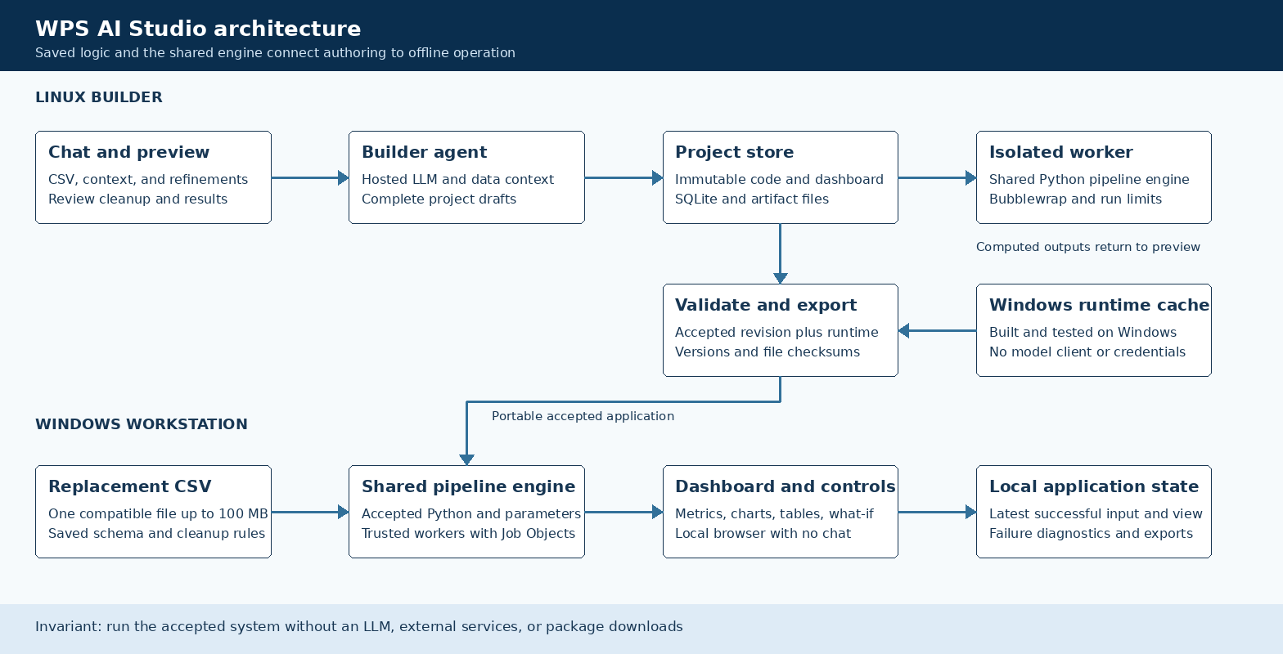
Figure 1. Builder and offline application boundaries.

Core components

Component | Responsibility | Primary storage | Failure behavior
Project store | Persist immutable revisions, inputs, messages, and run records | SQLite and artifact files | Keep accepted and display pointers unchanged on failure
Builder agent | Generate drafts from chat and current project state | Configured hosted model | Bounded repair; report terminal failure
Pipeline engine | Execute named functions in dependency order | Worker checkpoints and full outputs | Deadline, cancellation, and explicit errors
Dashboard renderer | Render metrics, charts, tables, filters, and forms | Saved specification and computed outputs | Retain and identify the last successful view
Export service | Attach a compatible verified Windows runtime | Runtime cache and immutable package | Reject missing runtime, version drift, or failed validation

5. Request Lifecycle
- Create a project, upload a CSV, and describe its columns, units, and business meaning. Profiling identifies parsing issues, missing values, duplicates, and bounded samples.
- Validate upload size, schema, and parameter types. Block cross-site browser access to the local API. The intended deployment is a local workstation, with no shared-user authentication in version 1.
- Load the current draft, input profile, recent chat, saved source, and runtime contract. Send this bounded context to the configured model; preserve the complete CSV locally.
- Generate a complete draft with separate cleanup and analysis steps. Run it on a copy of its input. Show the dashboard and before-and-after cleanup counts before the user accepts substantive changes.
- Write the immutable revision and running record before execution. A successful run updates the display pointer; it does not automatically change the accepted revision.
- Stream progress and allow bounded model repairs during authoring. Workers have a 120-second deadline and 4 GiB memory limit. Cancellation terminates the worker. Infrastructure failures stop repair attempts.
- Record final status, input fingerprint, parameters, duration, and outputs. Accept only a validated current revision at default parameters, with cleanup confirmation where required. Export only accepted revisions.

6. API and Data Contracts

Primary data contract

Field | Type | Required | Description
revision_id | String | Yes | Immutable project revision identity and parent link
input_contract | Object | Yes | Required columns, types, null policy, encoding, and delimiter
steps | Array | Yes | Python source, function name, inputs, outputs, stage, and rationale
parameters | Array | No | Typed controls with defaults, limits, and filter bindings
dashboard | Object | Yes | Component layout and named output bindings
dependencies | Array | Yes | Supported libraries from the fixed runtime release
run_record | Object | Per run | Input hash, revision, parameters, status, errors, and results

Contract guarantees

- Validate source, input schema, step order, controls, and bindings before execution.
- Identify revisions and runs uniquely. Persist immutable source and transactional project pointers.
- Capture input hashes, revision, parameters, seed, runtime versions, and output checksums for replay.
- ProjectRevision defines saved logic. RunRecord describes an execution. Chat is development history.
Builder APIs use /api/projects; offline APIs use /api/runtime. Version 1 contracts are defined at
pipeline_core/models.py. Update its schema and runtime ABI together when compatibility changes.

7. Consistency, Idempotency, and Replay

One pipeline operation runs at a time. Repeated execution can reuse checkpoints when source, input hashes, parameters, seed, and runtime versions match. Presentation changes reuse calculations. Code changes invalidate affected outputs. A failed draft or refresh retains the accepted revision and last successful dashboard.
Scenario | Expected behavior | Reasoning
Repeated input or presentation change | Reuse matching checkpoints and preserve source data | Content hashes and runtime identity control reuse
Missing runtime or storage failure | Reject export or execution; retain prior accepted work | A package must contain all required files and a successful validation
Invalid CSV, cancellation, or timeout | Report the failure and retain the last successful dashboard | A failed refresh cannot promote partial output
Configuration or source changes | Use an immutable revision and a new run record | Each result remains tied to its exact saved inputs and logic

8. Security and Privacy Considerations

- Serve on localhost. Isolate generated code on Linux. Run accepted Windows exports as trusted application code.
- Send bounded samples, profiles, business descriptions, and validation feedback during authoring. Do not automatically transmit the complete CSV. Keep runtime requests local and reject external chart assets and hyperlinks.
- Load model credentials only in the builder. Strip inherited credentials from worker environments. The exported runtime imports no model client or builder configuration and contains no model key.
- Linux uses Bubblewrap with separate namespaces, restricted mounts, no network, and no capabilities. Fail closed when isolation is unavailable. Windows uses Job Objects for limits and termination; these are not a full security sandbox.
- Retain source CSVs, revisions, and run records locally. Store runtime state outside the immutable package. Hashes detect file changes but do not prove authorship. Automatic retention and deletion policies are deferred.

9. Operational Readiness
Signal | SLO or alert | Owner | Launch gate
Calculation correctness | Known-result and independent reference cases pass | To assign | Required
Worker limits | Deadline and cancellation terminate execution | To assign | Required
Model repair failures | Surface bounded retries and terminal errors | To assign | Required
Package drift | All files and dependency versions verify | To assign | Required
Offline recovery | Failed refresh retains the prior dataset and view | To assign | Required
Rollout constraint: verify the real Windows package on a clean machine with external network access blocked. No Windows release is claimed from Linux-only tests.

10. Alternatives Considered

Alternative | Why it was considered | Why it was not selected
Question answering only | Reuses the original chat prototype | Does not save a complete reusable application
Typed operations only | Simplifies validation and deterministic code generation | User selected generated Python for analytical flexibility
Generated React screens | Allows custom interface behaviour | Reusable components reduce build complexity and improve offline portability
Container deployment | Provides a consistent runtime image | Target is a Windows workstation without containers

11. Open Questions
- Release gate: run the frozen launcher, replacement upload, controls, cancellation, and exports on a clean Windows 11 x64 VM with external network access blocked.
- Operational decision: assign a release owner, retention policy, and code-signing policy before distributing production packages.
- Capacity gate: benchmark representative 100 MB CSVs and forecasts on target hardware. No production latency SLO is claimed from small fixtures.
- Model-quality gate: evaluate full project generation and refinement on representative datasets. Mocked orchestration checks cannot establish real-model quality.

12. Decision and Next Steps
Use the shared engine and immutable project contracts as the version 1 foundation. Ship only after the Windows build and clean-machine checks pass. The Linux implementation and automated checks cover the builder, renderer, persistence, recovery, and export gates. Windows release verification remains a required milestone.
Milestone | Deliverable | Exit criteria
M1 | Shared contracts, runner, and Windows runtime proof | Known results match on Linux and a clean Windows machine
M2 | Chat building, cleanup review, and dashboard preview | Create and validate a complete saved project from a CSV
M3 | Refinement, rollback, controls, statistics, and forecasts | Preserve accepted work and pass independent numerical checks
M4 | Verified export and offline application release | Run uploads, controls, recovery, and exports with external network blocked

Source CSVs are preserved. Draft cleanup runs on a copy; accepted rules run again on replacement inputs.

