# COL783 Assignment 1 Report

Manu Mitraan *2015CS10236*

Ankesh Gupta *2015CS10435*

# Case : 1 Face image

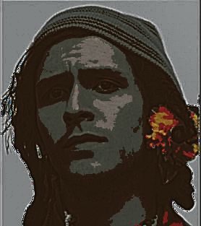

sigma = 1  
k = 1.6  
tau = 0.998  
eps = 0.35  
phi = 10  
  
dither = False  
color_levels = 256  
color_palette = 200

# Case : 2 Butterfly image

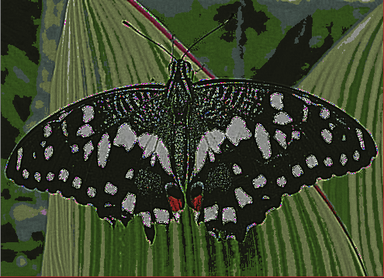

sigma = 1  
k = 1.6  
tau = 0.998  
eps = 0.35  
phi = 10  
  
dither = False  
color_levels = 256  
color_palette = 100

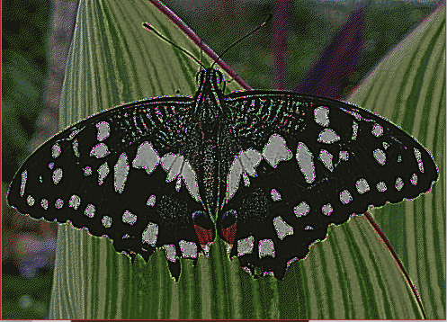

sigma = 1  
k = 1.6  
tau = 0.998  
eps = 0.35  
phi = 10  
  
dither = True  
color_levels = 256  
color_palette = 100

# Case : 3 Building image

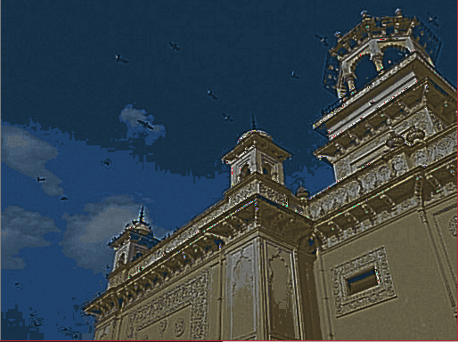

sigma = 1  
k = 1.6  
tau = 0.998  
eps = 0.35  
phi = 10  
  
dither = False  
color_levels = 256  
color_palette = 200

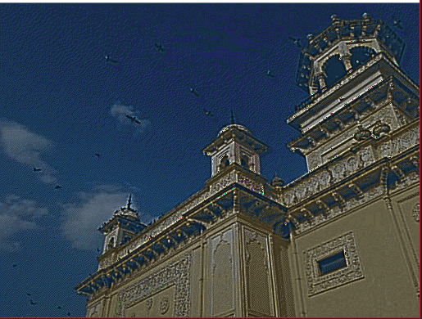

sigma = 1  
k = 1.6  
tau = 0.998  
eps = 0.33  
phi = 10  
  
dither = True  
color_levels = 256  
color_palette = 200

General Notes:

1. On increasing epsilon parameter, image tend to get darker as the threshold of xDoG increases
2. Increasing phi makes the difference between edges and non-edges noticeable.