# COL783 Assignment 3 Report

Manu Mitraan *2015CS10236*

Ankesh Gupta *2015CS10435*

# Part : 2 Image inpainting

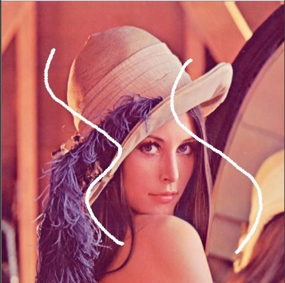 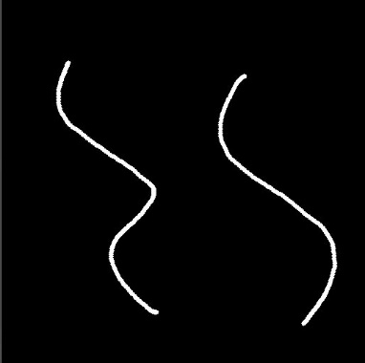 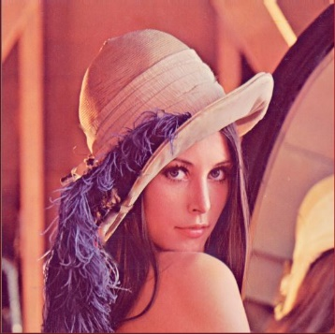

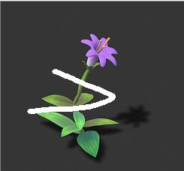 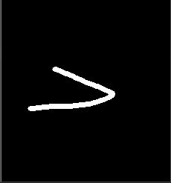 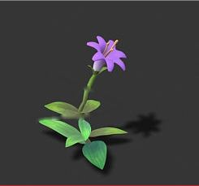

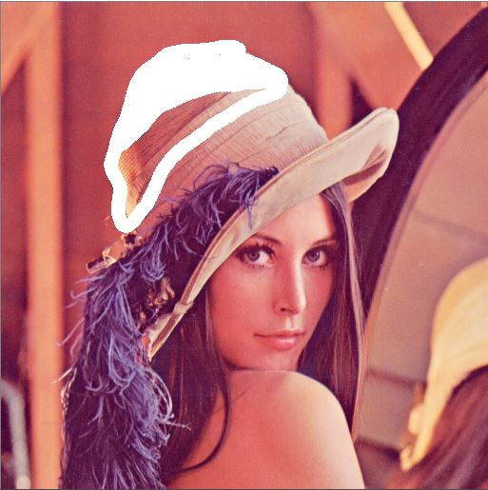  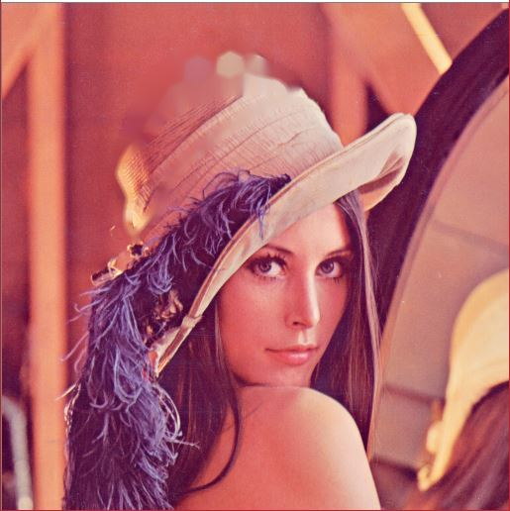

# Points

1. If the thickness of area to be inpainted is huge then it takes a lot of time to complete and image looks a bit blurred in that area
2. When sharp isophotes intersect the region’s boundary almost tangentially, the image is not able to reconstruct those areas well