**Part 1 Analysis**

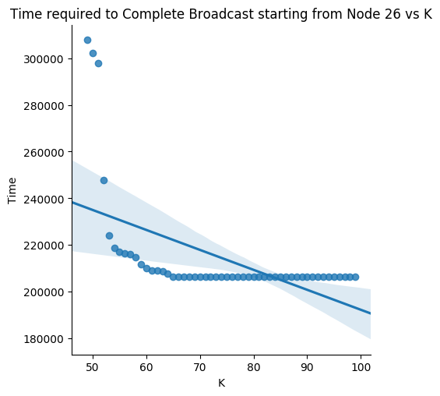

Yes, for **node 26, from K=67**, there was no improvement of increasing K on broadcast time. The broadcast time remained constant and broadcast completed successfully on each occasion. There can be *possible explanations* for the same.

1. The broadcast might be **getting completed** before the 67th transfer is made by any node to its neighbour, so any increase in K henceforth would be futile.

2. Devices benefitting from broadcast would have **later received** the message from some other node, thereby adding no improvements to overall network. Similarly, devices coming in range because of increased K might have already received data from some other node in the ad-hoc network.

3. The **degree cap** for the node, that is, unique neighbours a device see is less than 67, for all node in the network. Although this explanation does not fit our trace (max degree>66), but in general setting this might be an explanation for saturation of broadcast time.

Fitting **linear regression** clearly shows the decreasing trend in the graph.

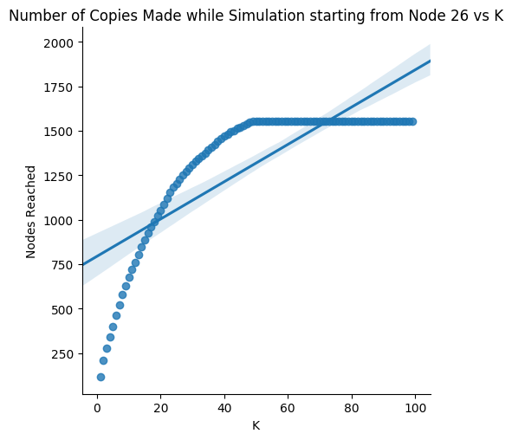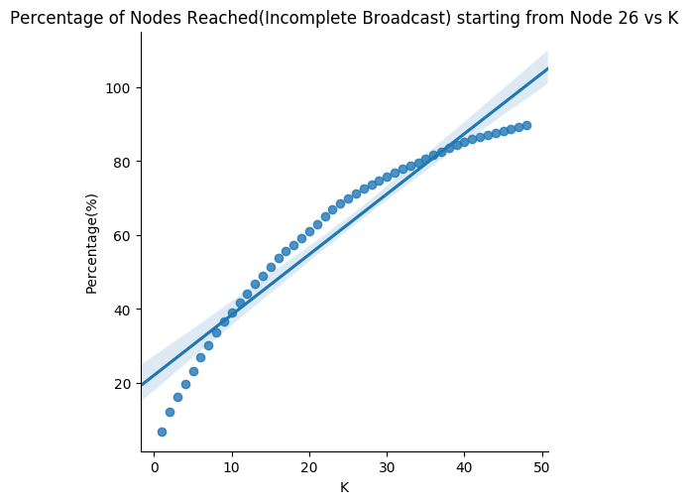

**K=49** is the threshold when broadcast starts getting **completed**. Also, for incomplete broadcast, percent of nodes reached is plotted which clearly shows an increasing trend with K.

This is intuitive as increasing K increases the **networks potential to share** and ability of the message to get broadcasted to many other nodes.

**Linear regression** fits also matches with the explanation mentioned.

Number of copies made follows the **exact pattern** as the percentage graph for values of K causing incomplete broadcast, and thereafter, peaking to fixed value for other K's with value=90% of total nodes(1723).

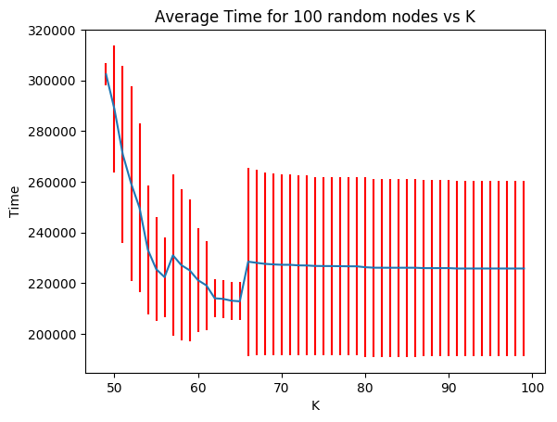

The graph of mean time for different values of K for 100 random nodes appears interesting. The graph begins from K~50, thereby indicating that for values < 50, **broadcast fails** to complete for any node **in general** across the network.

In general, we expect general broadcast time to **go down** on increasing K. Some discontinuous rise are clear in the graph.

This can be explained as phenomenon, that some nodes which were initially unable to complete broadcast has now the **potential** to complete broadcast. But, their **broadcast time may be higher** thereby pushing the overall average higher.

***Note:*** for calculating time, only those node time are considered who were able to complete broadcast. Shall we always consider all the time, graphs may show a different trend.

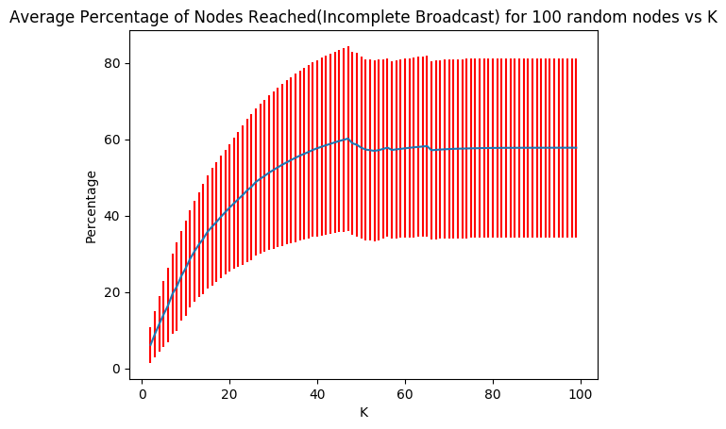

Similar patterns were observed for average percentage graph for **cases of incomplete broadcast**. Slight falls in percentage can be explained because certain nodes with **high percentage** may just **cross threshold** to other side, thereby decreasing their contributions.

Also, the curve flattens, thereby showing that changing K does not make any **effect on some nodes** and explanations are similar with ones mentioned above.

Studying trends for node 26 vs 100 random nodes, we observe that node 26 shows **similar trends** as the average, for both ranges of K, that is, when it completes/ not complete the broadcast.

**Standard deviations** remained quite high for all the readings.