**Part 3 Analysis**

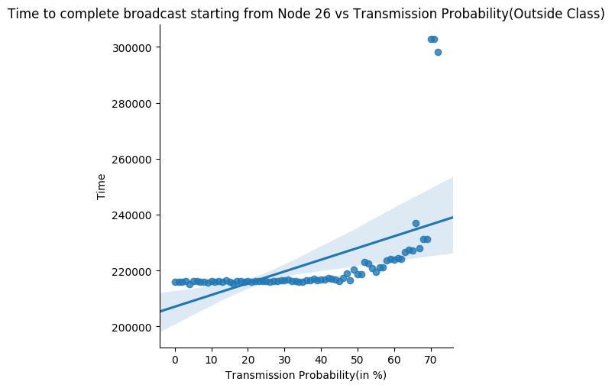Modularity measures how well a **network decomposes** into modular **communities/subnetworks**. Classes represent **tightly knit communities** which have a lot more **interconnections** between their nodes than with nodes in other communities.

Starting broadcast from **node 26**, we observe that time for broadcast completion remains **nearly constant till X=40%**, and thereby starts rising, so much so that broadcast **fails to complete** for transmission probability **above ~70%**.

**Insights-** To understand this effect we analyse what a community class is. As mentioned, it represents nodes **tightly knitted**, hence a node has **many of its neighbour** in this class. As X increases, transmission probability inside the class starts to fall. As such, **expected transmissions** inside a community class experiences a **plummet**.

One may argue that the class might see an **increased inter-class communication**, but modularity classes are such designed that **intra-class communications** are much larger, and decreasing intra-class transmission rate is decreasing in an **expected sense**, the **potential** of the network to transmit. **Average number of transmissions** go down and graph reflects it.

A **linear regression** fit shows similar trend.

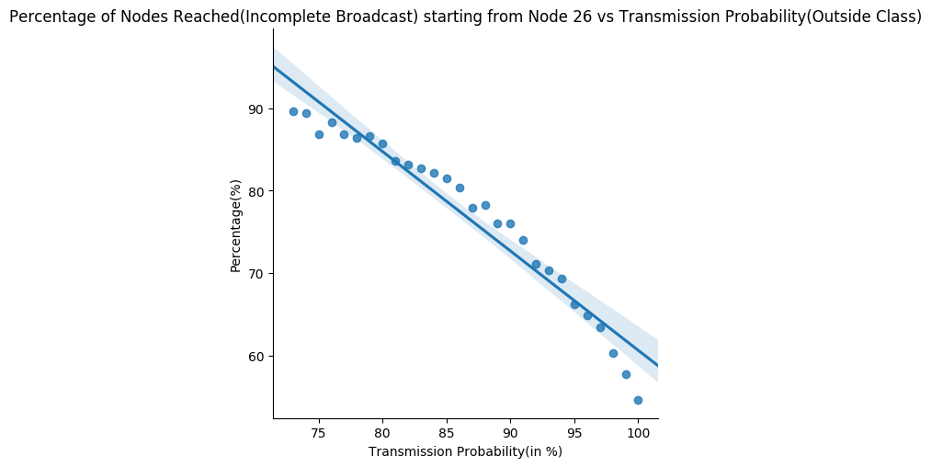

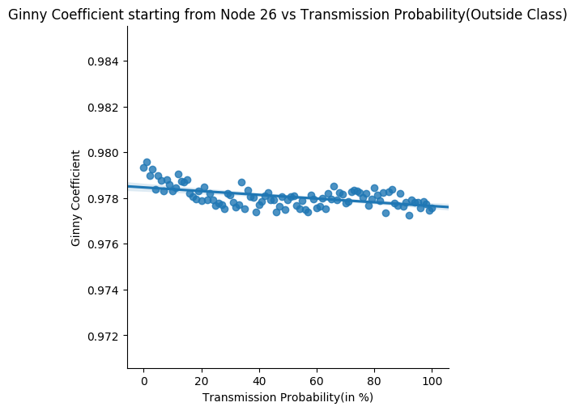

Former claims are **reinforced** when we analyse the graph of percent of nodes reached in case of **incomplete broadcast**. Increasing inter-class communication probability here too, **decreases network potential** to communicate and transfer data. The fall can be quite fairly modelled by a **linear fit as apparent**.

Coming to **gini co-efficient**, we realize that though its value has a very low standard deviation, it has a **slight decreasing trend**. This falls in line because increasing X is taking away networks potential to transmit, so in a way, it’s actually **decreasing the stress** as stress is only generated if we work!

So, as X is increased, the intense intra-class communication **starts easing** and **loose** inter class communication become prominent. The **perpetual high** gini coefficient value is because some nodes having **large network coverage** (strong/super) as compared to most with **only 1 neighbour**.

**Average Graphs for 100 Random Nodes**

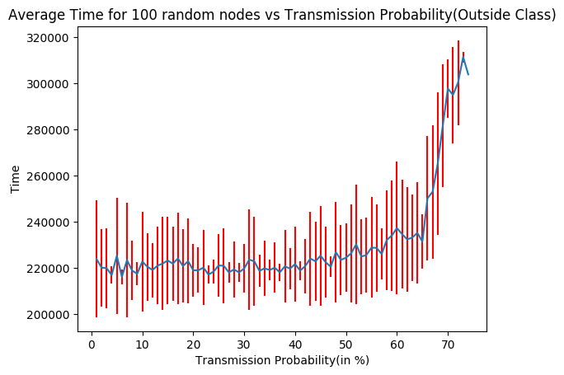

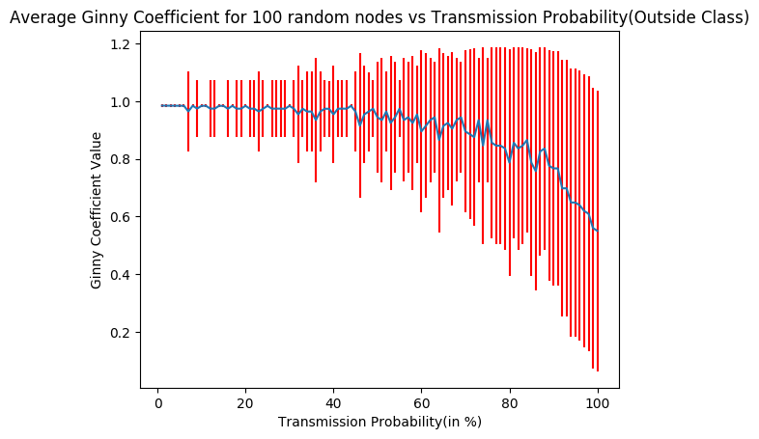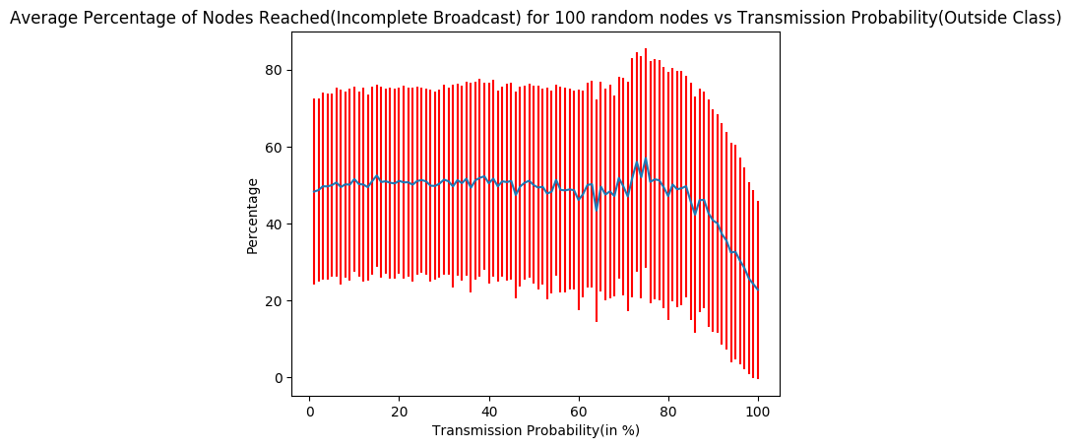

For finding the ideal combinations, different graphs were analysed.

The ideal combination appears when X is in **range - (25, 33) %**. Around this value of X, node 26 sees a **global minima** in broadcast time and Gini coefficient is **low** around the range. Also, when experimented with 100 different nodes, average broadcast time graph showed a **global minima** in similar range of its **weakly parabolic** nature. Average percentage of nodes reached in cases of incomplete broadcasted showed **better numbers** in this range. Average Gini for 100 nodes also displays a **fall** in this range.

The average graphs for 100 different nodes test were **in tandem** with observations for node 26. Ginny was a **slight offset**, when in average sense, it **falls sharply** for larger X values, showing how important is **intra class transmissions** in such a **disjoint-union class network**.

*Insights behind the combination obtained-* Although experimental, we can provide some **intuition** for the ideal combination obtained. Clearly we realised how important is intra-class communication for a network. This is also apparent when X is very low, where the network is still potentially able to complete broadcast. But, that does not give best performance as a community might receive a **message too late**, causing delayed transmissions, and at times, **broadcast failure** as well. As such, the ideal comes around a range, where although intra-class transfers are given **high priority**, inter-class transmissions are not **completely neglected**, and hence the best performance.