WEEK 2 TASK REPORT
Advanced Data Visualization and Storytelling with Python
Domain: COVID-19 trends in India — a visual storytelling case study

Submitted by | Ankesh Diwakar
Programme / Institute | Integrated MCA • IIPS, DAVV
Internship task | Week 2 — Advanced Data Visualization
Tools | Python, pandas, Matplotlib, python-docx

Important data note: The charts in this draft use a curated illustrative monthly index to demonstrate the analysis workflow and storytelling structure. They are NOT official case counts and must not be cited as measured epidemiological results. Replace the illustrative series with verified data from the linked public sources before treating the findings as factual.

1. Executive Summary
This report demonstrates how a sequence of visualizations can turn a complex public-health dataset into a story that a non-technical audience can follow. The narrative moves from timing (when waves occurred), to concentration (which years carried the largest indexed burden), to association (how cases and deaths moved together), and finally to context (vaccination rollout and month-by-month patterns).
The illustrative series is intentionally designed to show two prominent rises followed by a lower level. These are teaching patterns, not a substitute for an official data extract. The main practical lesson is to combine clear chart selection with honest labels, explicit caveats, and a decision-oriented conclusion.

2. Introduction and Questions
Public-health data can contain many dates, indicators, and reporting differences. A spreadsheet alone makes it difficult to notice timing, peaks, and relationships. Visual storytelling reduces this complexity by answering a small set of connected questions.
- How did the monthly case indicator change over time, and where were the major peaks?
- How was the indexed burden distributed across years?
- Did months with higher case values also show higher death values?
- How did the vaccination timeline overlap with the later part of the series?
- Which calendar months appear as high-activity periods in the illustrative heatmap?

3. Data and Methodology

3.1 Data source and limitations
For a production-quality submission, use a downloaded, dated extract from Our World in Data’s COVID-19 dataset or the WHO COVID-19 dashboard/data portal. Keep the source URL, download date, country filter, and variable definitions in the final report. Public reporting may change over time because of revisions, backfills, and differences in national reporting.
Suggested public sources:
- • Our World in Data — COVID-19 data: https://github.com/owid/covid-19-data/tree/master/public/data
- • WHO COVID-19 dashboard: https://data.who.int/dashboards/covid19
This generated draft uses 22 monthly rows with illustrative case-index, death-index, and vaccination-coverage values. The word “index” is used deliberately: the values are not represented as official raw counts. The figures should be replaced with real monthly aggregates before final submission if the internship evaluator expects empirical findings.

3.2 Workflow
- Define the audience and the questions before choosing chart types.
- Create a tidy monthly table with one row per month and consistent column names.
- Check missing values, duplicate dates, units, and whether values are counts, rates, percentages, or indices.
- Aggregate daily records to monthly totals or averages only when the measure supports that operation.
- Build charts with descriptive titles, readable axes, legends, annotations, and source notes.
- Compare charts as a sequence so each figure adds a new piece of the story.

3.3 Libraries
pandas is used for tabular transformation and aggregation. Matplotlib is used to create reproducible figures with annotations and readable labels. Seaborn or Plotly could be added for statistical styling or interactive exploration, but static charts are appropriate for a Word report that must remain readable when printed.

4. Visual Analysis and Storytelling

Figure 1 — The epidemic moved in distinct waves
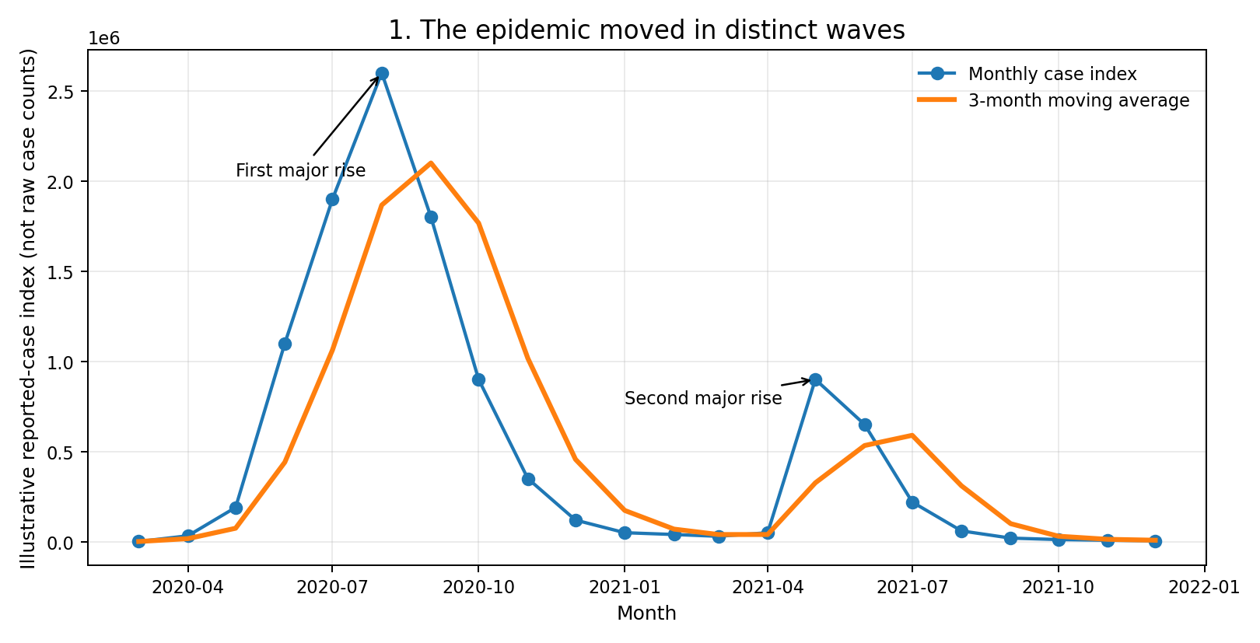
What it shows: The line chart shows the monthly case index, with a three-month moving average to reduce short-term noise.
Why this chart: A line chart is best for ordered time data because direction, turning points, and peaks are immediately visible. The moving average adds context without hiding the original monthly values.
Story point: The illustrative series contains two strong rises. This motivates planning around changing demand rather than assuming risk stays constant.
Interpretation caution: A moving average smooths variation and can delay visible turning points. The plotted values are illustrative indices, not official case counts.

Figure 2 — Annual totals show concentration
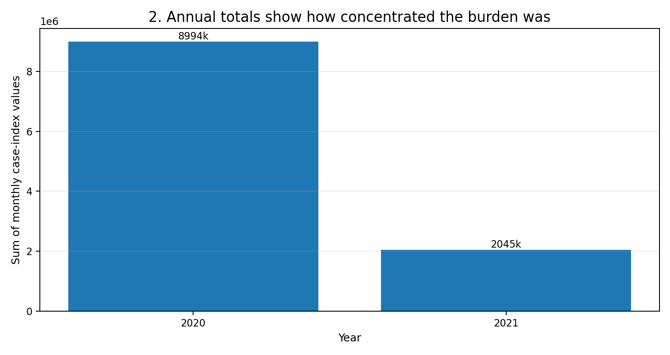
What it shows: The bar chart sums the monthly case-index values within each year.
Why this chart: Bars make category comparisons easier than comparing many separate monthly values. A common zero baseline helps the audience judge differences.
Story point: In this illustrative series, the years containing the major waves account for most of the indexed burden. Annual summaries are useful for high-level resource planning.
Interpretation caution: The partial first and last years do not cover complete calendar years. A real analysis should clearly identify incomplete years and use consistent date coverage.

Figure 3 — Cases and deaths moved together in high-activity months
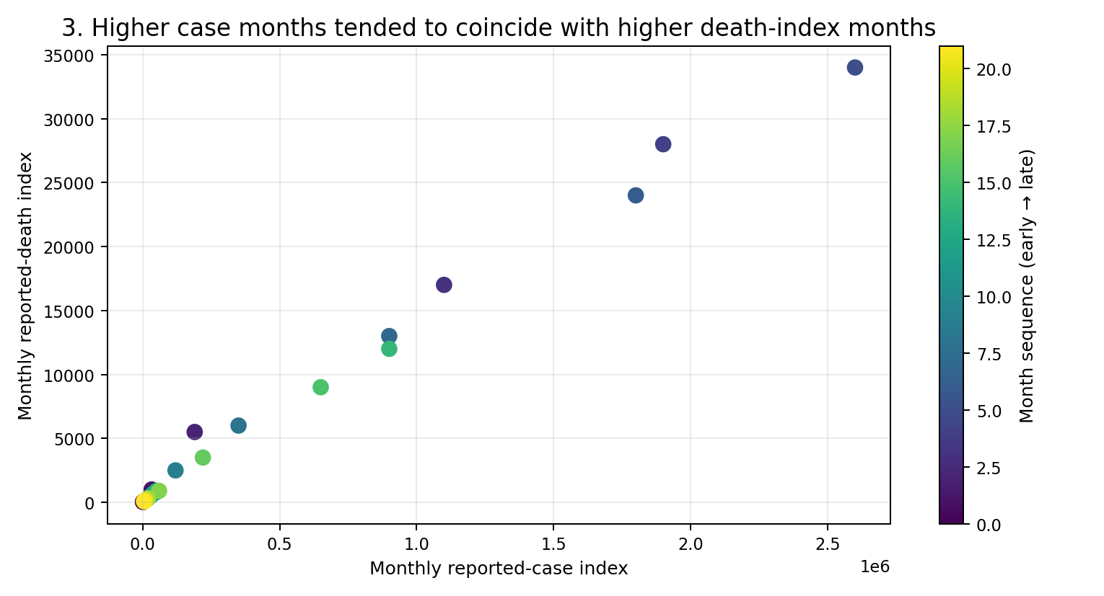
What it shows: Each dot represents one month, with case index on the horizontal axis and death index on the vertical axis. Colour indicates the sequence from earlier to later months.
Why this chart: A scatter plot is useful for examining whether two numeric measures tend to rise together and for spotting unusual months.
Story point: The illustrative points suggest a positive association: months with higher case values generally also have higher death values. This supports monitoring multiple indicators together.
Interpretation caution: Association does not prove causation. Reporting delays, age distribution, testing, treatment, and changing definitions can affect the relationship.

Figure 4 — Vaccination rollout and the later epidemic period
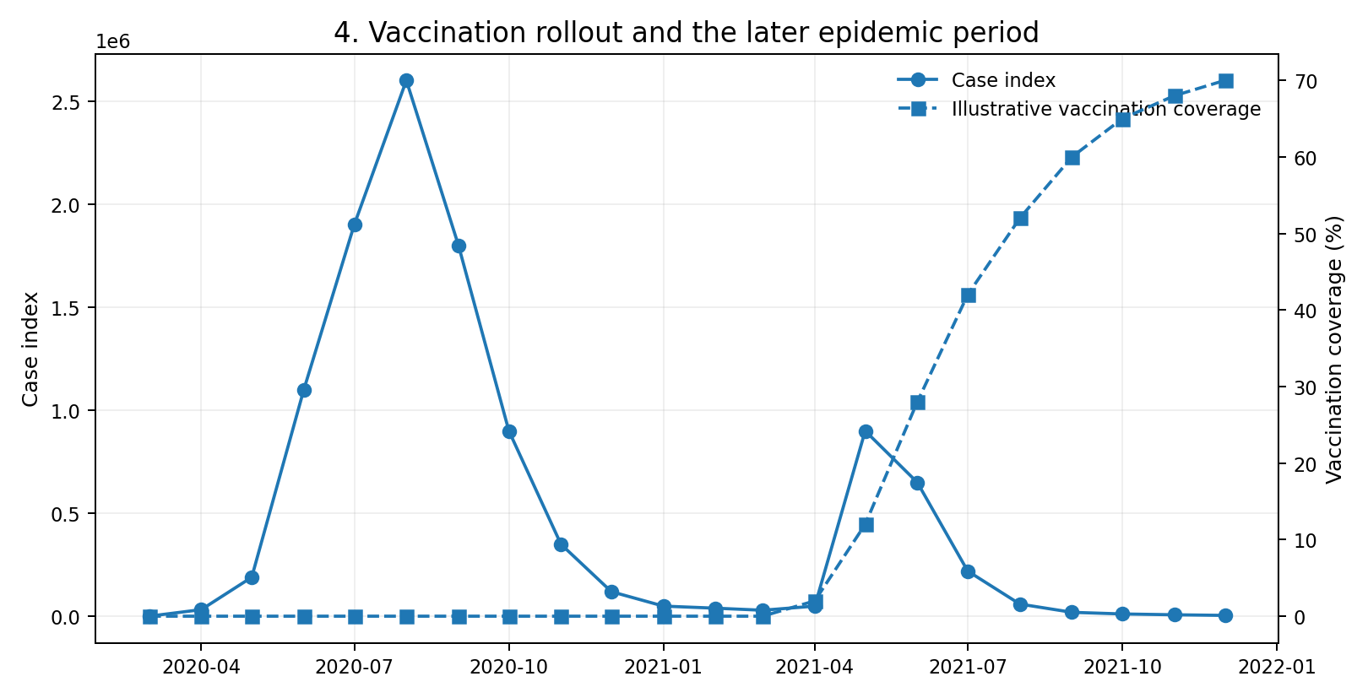
What it shows: Two timelines are shown together: the case index and an illustrative vaccination-coverage percentage.
Why this chart: A dual-axis chart can help compare timing when variables have different units, but it must use clearly labelled axes and should be interpreted carefully.
Story point: The chart prompts a useful question: how did the epidemic pattern change as vaccination coverage increased? That question should be tested using verified data and additional context.
Interpretation caution: The vaccination values are illustrative and this chart cannot establish vaccine effectiveness. A causal analysis would require validated data and control for confounding factors.

Figure 5 — Calendar heatmap highlights timing
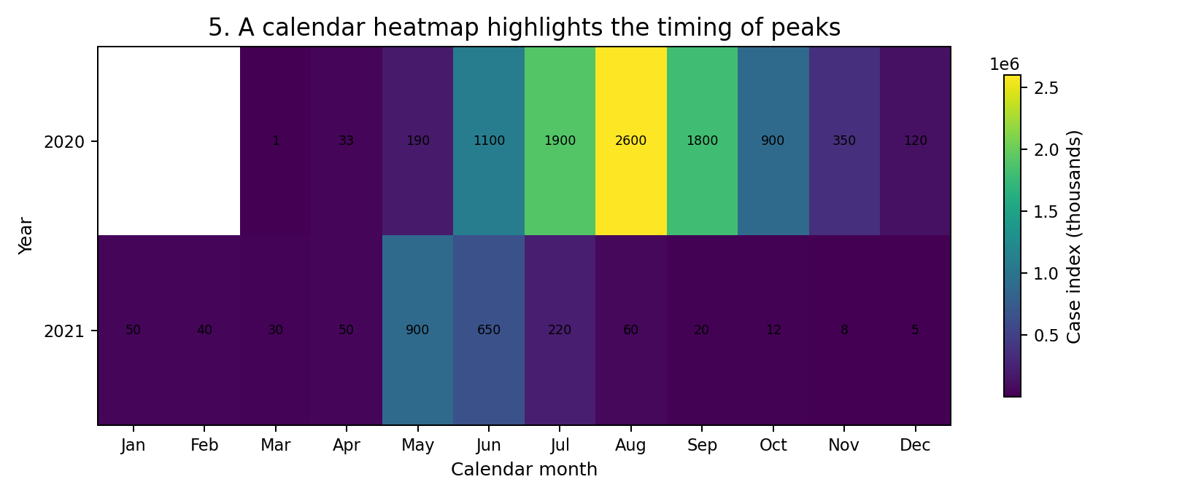
What it shows: The heatmap places years in rows and calendar months in columns, using shading to reveal periods with higher index values.
Why this chart: Heatmaps are compact and make repeated seasonal timing or unusually intense periods easy to spot across multiple years.
Story point: The visual suggests that activity is unevenly distributed across the calendar. This makes the heatmap a useful starting point for further investigation of timing and operational readiness.
Interpretation caution: The sample spans incomplete years and is illustrative. Do not claim seasonality without enough years of consistent, real observations.

Figure 6 — The deaths-to-cases index varies over time
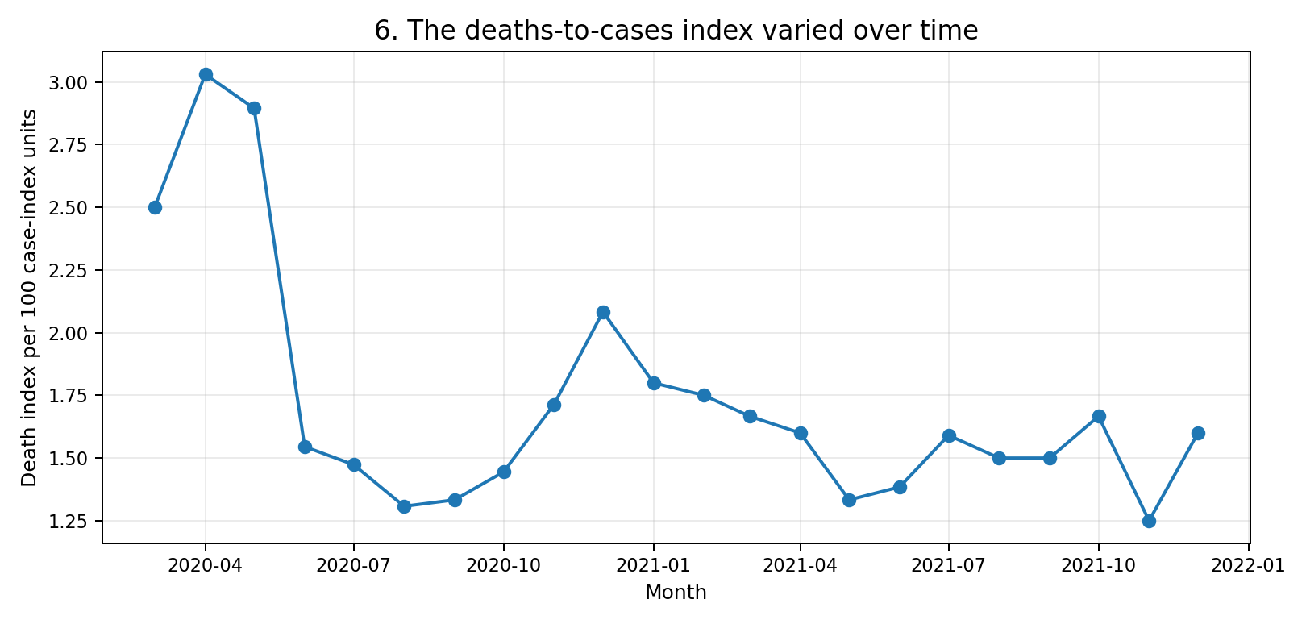
What it shows: The line chart divides the death index by the case index and expresses the result per 100 case-index units.
Why this chart: A normalized ratio can reveal changes that are less visible in raw totals. It gives the audience another perspective on how indicators relate over time.
Story point: The changing ratio shows why totals alone are not enough; the relationship between indicators can vary from month to month.
Interpretation caution: This is not a clinical case-fatality rate. Because the inputs are illustrative indices and same-month counts can be affected by reporting lags, the ratio is only a demonstration.

5. Integrated Narrative
Taken together, the figures tell a coherent sequence. First, the time series identifies when activity rises and falls. Second, annual aggregation shows how the burden is concentrated across periods. Third, the scatter plot checks whether two related indicators move together. Fourth, the vaccination timeline introduces an important public-health context, while explicitly avoiding a causal claim. Fifth, the heatmap reveals calendar timing, and the final ratio chart demonstrates why normalized measures can add information beyond totals.
The narrative is designed for a non-technical audience: each chart answers one question, titles state the main message, axes state units, and caveats distinguish observed patterns from causal explanations. In a final empirical report, replace every illustrative value and rewrite the insights based on the actual downloaded data.

6. Business and Scientific Implications
Public-health planning: Reliable peak detection can help hospitals, laboratories, and local agencies plan staffing, beds, supplies, and public communication ahead of periods of increased demand.
Early-warning dashboards: A combination of time trends, moving averages, and multiple indicators can help analysts flag changing conditions sooner than a single total can.
Communication and trust: Simple charts with clear units and visible caveats reduce the chance that a non-technical audience will confuse a trend with proof of cause.
Scientific follow-up: A verified dataset could support more rigorous work on lagged relationships, regional differences, age-adjusted outcomes, and the association between vaccination and severe outcomes.
Data governance: Maintaining source links, extraction dates, data dictionaries, and reproducible code helps teams audit results when public datasets are revised.

7. Quality Checks and Reproducibility
- Confirm the source, date range, geography, and units for every column.
- Check duplicate dates, missing values, negative values, and unexpected jumps.
- Distinguish daily new cases from cumulative totals; never sum cumulative totals as if they were daily counts.
- Use consistent scales and label any secondary axis clearly.
- Include captions and caveats directly below each chart.
- Save the cleaned dataset and Python script alongside the report or link them in the project repository.
- Re-run the analysis after replacing the illustrative table with verified data and update all narrative statements.

8. Conclusion
Advanced visualization is not simply about producing attractive charts. It is about selecting a visual form that fits the question, explaining what the audience should notice, and being transparent about uncertainty. The six figures in this report demonstrate complementary approaches: time-series lines, annual bars, a scatter plot, a dual-axis timeline, a heatmap, and a normalized ratio trend. Used with verified public data, this sequence can support clearer public-health communication and better-informed planning.

9. References
Our World in Data. COVID-19 dataset repository. https://github.com/owid/covid-19-data/tree/master/public/data
World Health Organization. WHO COVID-19 dashboard. https://data.who.int/dashboards/covid19
Matplotlib documentation. https://matplotlib.org/stable/
pandas documentation. https://pandas.pydata.org/docs/
Python documentation. https://docs.python.org/3/

Appendix A — Suggested final submission checklist
☐ Replace the illustrative index with verified data downloaded from a public source.
☐ Record download date, country filter, and variable definitions.
☐ Regenerate all figures and rewrite insights so they match the verified results.
☐ Add the GitHub repository URL if the code and dataset are uploaded.
☐ Proofread the DOCX and confirm all charts remain readable after export/printing.

