Week 1 Task: Data Acquisition, Cleaning, and Exploratory Analysis
Dataset: Our World in Data — COVID-19 Dataset | Domain: Public Health

1. Task Objective
For this task I had to grab a real, publicly available dataset, clean it up, and then dig into it a bit using Python – basically a full exploratory data analysis (EDA). I went with the Our World in Data (OWID) COVID-19 dataset. It's a massive dataset that keeps getting updated, anyone can access it, and it has daily case counts, deaths, vaccination numbers, and a bunch of socio-economic details for pretty much every country on earth.

2. Background: The COVID-19 Pandemic
The COVID-19 pandemic started with the SARS-CoV-2 virus, which was first spotted in Wuhan, China back in December 2019. Things escalated fast. The World Health Organization called it a Public Health Emergency of International Concern on 30 January 2020, and by 11 March 2020 they were officially calling it a pandemic. The virus mainly spreads through respiratory droplets and tiny airborne particles, and over the next couple of years it kept mutating into new variants – Alpha, Delta, Omicron – each one hitting different parts of the world in its own wave.
Governments everywhere reacted with lockdowns, travel bans, mask rules, and huge testing drives to try and slow things down. Vaccines finally rolled out from December 2020, and they ended up saving tens of millions of lives. That said, richer countries got their hands on doses way faster than poorer ones did, especially in the early years. By early 2023 case numbers and deaths had dropped a lot from their peak, so the WHO officially ended the global health emergency status on 5 May 2023 – though they were clear that the virus itself hadn't gone anywhere.
Right now, the official count sits at hundreds of millions of confirmed cases and several million confirmed deaths worldwide, and excess-mortality studies suggest the real death toll is even higher than that. By 2025 most public-health experts agreed COVID had basically become endemic, circulating seasonally kind of like the flu does. This whole event is the real backdrop for the dataset I'm analyzing in the rest of this report.
Source: Wikipedia contributors, “COVID-19 pandemic,” Wikipedia, The Free Encyclopedia (accessed August 2026), summarized here in my own words.

3. Data Acquisition
I downloaded the dataset straight from OWID's public GitHub repo as a CSV file – no API key or login needed, just a plain download.
Source URL:
https://github.com/ankesh825/COVID_19_DATA_ANALYSIS
import pandas as pd
raw = pd.read_csv("owid-covid-data.csv", low_memory=False)
print(raw.shape) # (429435, 67)
The raw file has 429,435 rows and 67 columns – basically a daily record for every country going back to January 2020. I didn't need all of that for this analysis, so I picked out 19 columns that actually mattered for looking at case trends, mortality, vaccination coverage, and socio-economic background. I also dropped rows for continent- or income-group-level aggregates like “World” or “Asia”, keeping only individual countries.

4. Data Cleaning
I did all the cleaning in Pandas. Here's what the missing-value situation looked like before I touched anything:
Column | % Missing (before)
people_fully_vaccinated_per_hundred | 84.37%
people_vaccinated_per_hundred | 83.65%
hospital_beds_per_thousand | 28.27%
human_development_index | 21.21%
gdp_per_capita | 18.94%
median_age | 17.36%
population_density | 10.95%
new_cases / new_deaths | ~3.1%

Here's why I handled each type of column the way I did:
- Date column: I converted “date” from plain text into a proper datetime type so I could sort it and actually use it for time-series stuff.
- Duplicate rows: I ran df.duplicated().sum() and found zero duplicates. Still worth checking even when you expect nothing – it's just good practice.
- Daily flow columns (new_cases, new_deaths): I filled missing values with 0. A missing entry here almost always just means no cases got reported that day, not that we genuinely don't know the number.
- Cumulative columns (total_cases, total_deaths, and their per-million versions): I forward-filled these within each country's own timeline. A gap in a cumulative column usually just means no fresh update was published that day, so the last known total is still the best guess – definitely not zero.
- Vaccination columns: same idea, forward-filled per country since it's a cumulative metric. Anything still missing before a country's vaccination drive even began got set to 0.
- Static country attributes (population, gdp_per_capita, median_age, life_expectancy, HDI, hospital beds): these barely change year over year, so I filled gaps using that same country's other non-missing records (forward and backward fill within each group). If a country genuinely had no value anywhere, I left it as NaN instead of guessing, and just left it out of any chart that used that column.
flow_cols = ["new_cases", "new_deaths"]
df[flow_cols] = df[flow_cols].fillna(0)
cumulative_cols = ["total_cases", "total_deaths",
"total_cases_per_million", "total_deaths_per_million"]
df[cumulative_cols] = df.groupby("location")[cumulative_cols].ffill().fillna(0)
static_cols = ["population", "gdp_per_capita", "median_age", ...]
df[static_cols] = df.groupby("location")[static_cols]\
.transform(lambda s: s.ffill().bfill())
Once the cleaning was done, every core analytical column (cases, deaths, vaccination rates) had 0% missing values. The only gaps left were in a handful of static attributes – like hospital beds for a few tiny territories – where the source data simply never had a value to begin with, so there was nothing left to fill in from.

5. Exploratory Data Analysis

5.1 Summary Statistics
Metric | Mean | Median | Max
Total Cases | 1,777,784 | 45,277 | 103,436,829
Total Deaths | 19,895 | 536 | 1,193,165
Deaths per Million | 805.5 | 224.8 | 6,601.1
Fully Vaccinated (%) | 32.3% | 24.8% | 126.9%*
GDP per Capita ($) | 18,922 | 12,237 | 116,936
*Values above 100% show up because booster doses get counted too – that's just a quirk of the source data, not a mistake in my cleaning.

5.2 Missing Data Visualization
This chart shows how much of each column was missing before I cleaned anything, and it's basically what shaped my whole cleaning strategy above.
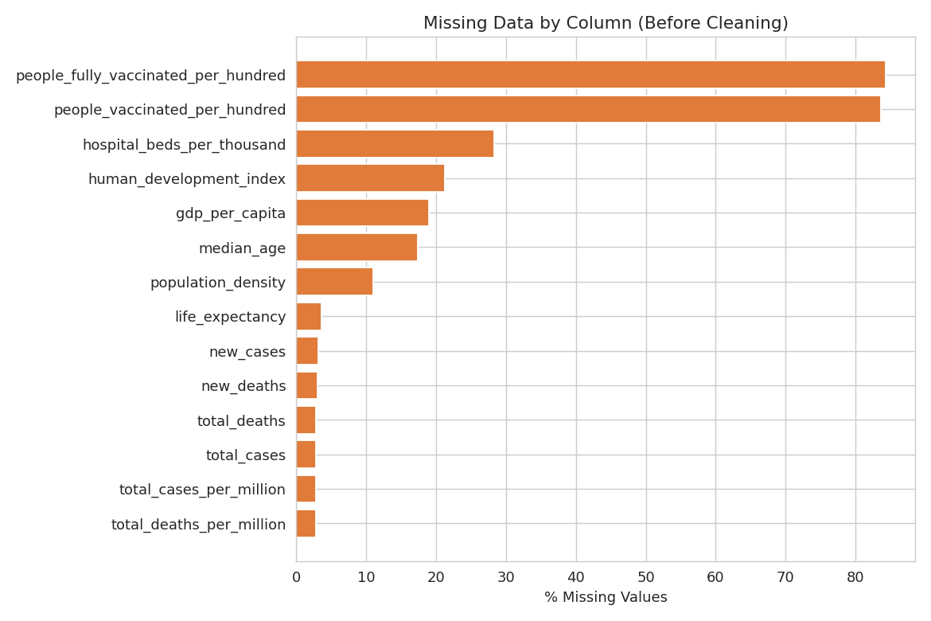
Figure 1: Missing data by column (before cleaning)

5.3 Trend Analysis
I plotted the daily new cases (as a 7-day rolling average) for five major countries, just to see how the different waves moved across regions and over time.
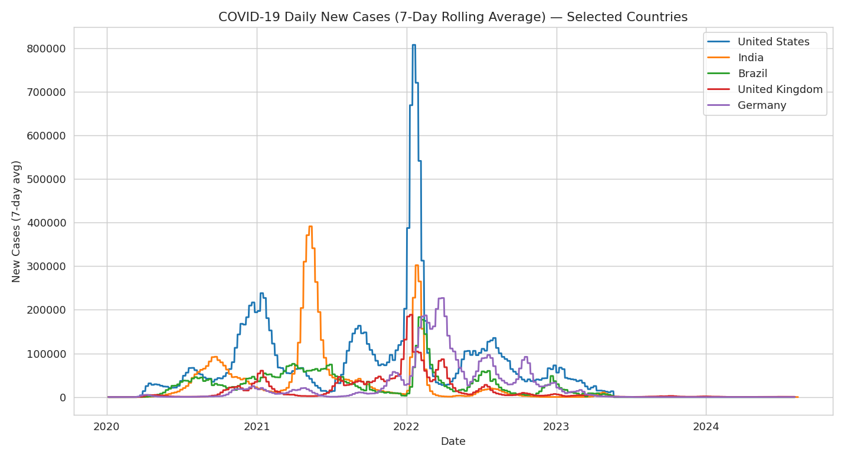
Figure 2: 7-day rolling average of new COVID-19 cases, 2020–2024

5.4 Correlation Analysis
I also built a correlation heatmap comparing mortality outcomes against various socio-economic and demographic indicators, using each country's most recent recorded values.
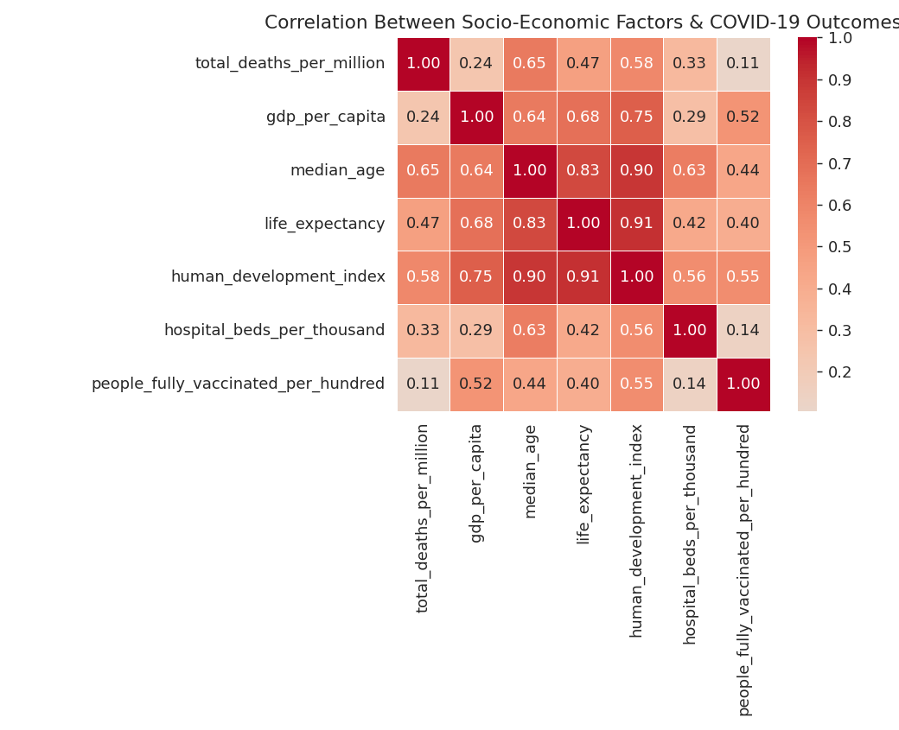
Figure 3: Correlation matrix — socio-economic factors vs COVID-19 outcomes

5.5 GDP vs Vaccination Coverage
Lastly, a scatter plot (with GDP on a log scale) to see whether a country's wealth actually lines up with how well it vaccinated its population.
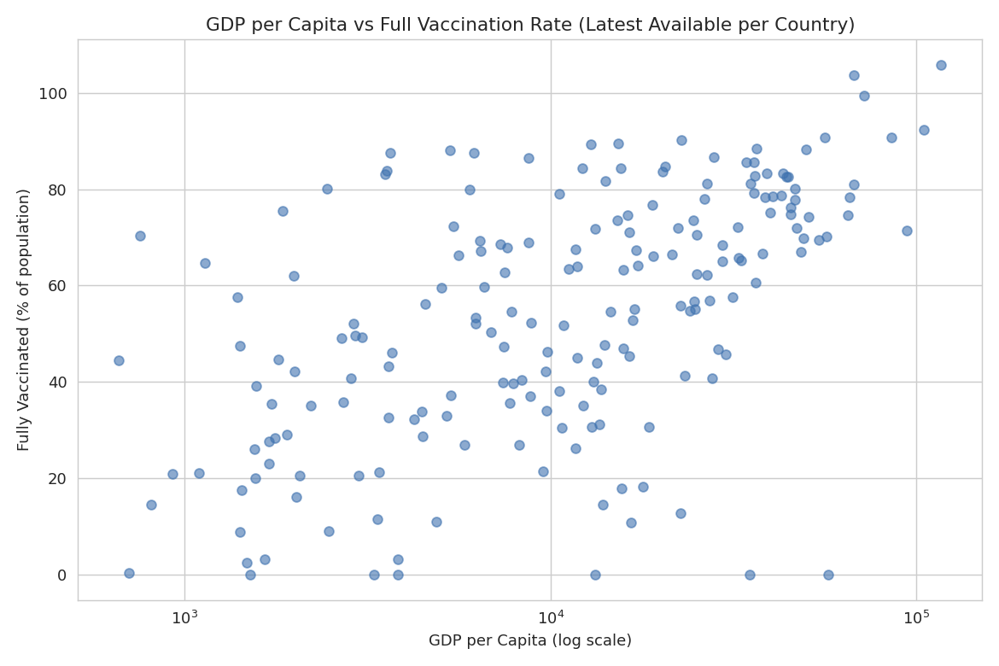
Figure 4: GDP per capita vs full vaccination rate

6. Summary of Insights
- Out of everything I tested, median age has the strongest link to COVID-19 mortality (r ≈ 0.65). That lines up with what public-health reports have said all along – older populations got hit with disproportionately higher death rates.
- Human Development Index (HDI) has a moderate correlation with both deaths per million (r ≈ 0.58) and vaccination coverage (r ≈ 0.55). My guess is that more developed countries were both reporting cases more thoroughly and rolling out vaccines faster – so it's probably a mix of genuine risk and how much testing/reporting capacity a country had.
- GDP per capita clearly tracks with full vaccination rates – you can see it right in the scatter plot. Most countries above roughly $30,000 GDP per capita crossed 60% full vaccination, while a lot of lower-income countries stayed under 30%. It's a pretty stark reminder of how unequal global vaccine access really was.
- The pandemic didn't hit every country at the same time. India's biggest wave (Delta) peaked around mid-2021, while the US, UK, and Germany's worst wave (Omicron) showed up in early 2022 – you can see this clearly in the rolling-average trend chart.
- Vaccination and hospital-bed data had by far the most missing values (over 80% and around 28%). Mostly because a lot of countries just didn't track or publish these numbers consistently, which is worth keeping in mind before drawing strong conclusions about vaccination in smaller nations.

7. Conclusion
This task basically walked me through what a real data-prep workflow looks like: grabbing a big, messy, real dataset, cleaning each column with a strategy that actually made sense for that column instead of one blanket rule, and then using charts to surface both the data-quality issues (missing values) and the actual patterns underneath (pandemic waves, socio-economic correlations). After cleaning, the dataset (402,910 rows × 19 columns) has zero missing values in every core analytical column and is ready to be used for further modeling or reporting.

8. References
- Mathieu, E., Ritchie, H., Rodés-Guirao, L., et al. “Coronavirus Pandemic (COVID-19).” Our World in Data, 2020–2024. Dataset: https://github.com/owid/covid-19-data
- Wikipedia contributors. “COVID-19 pandemic.” Wikipedia, The Free Encyclopedia. Accessed August 2026. https://en.wikipedia.org/wiki/COVID-19_pandemic (used for background context only, summarized in my own words).

