Pic1: V1 of the rolling deployment

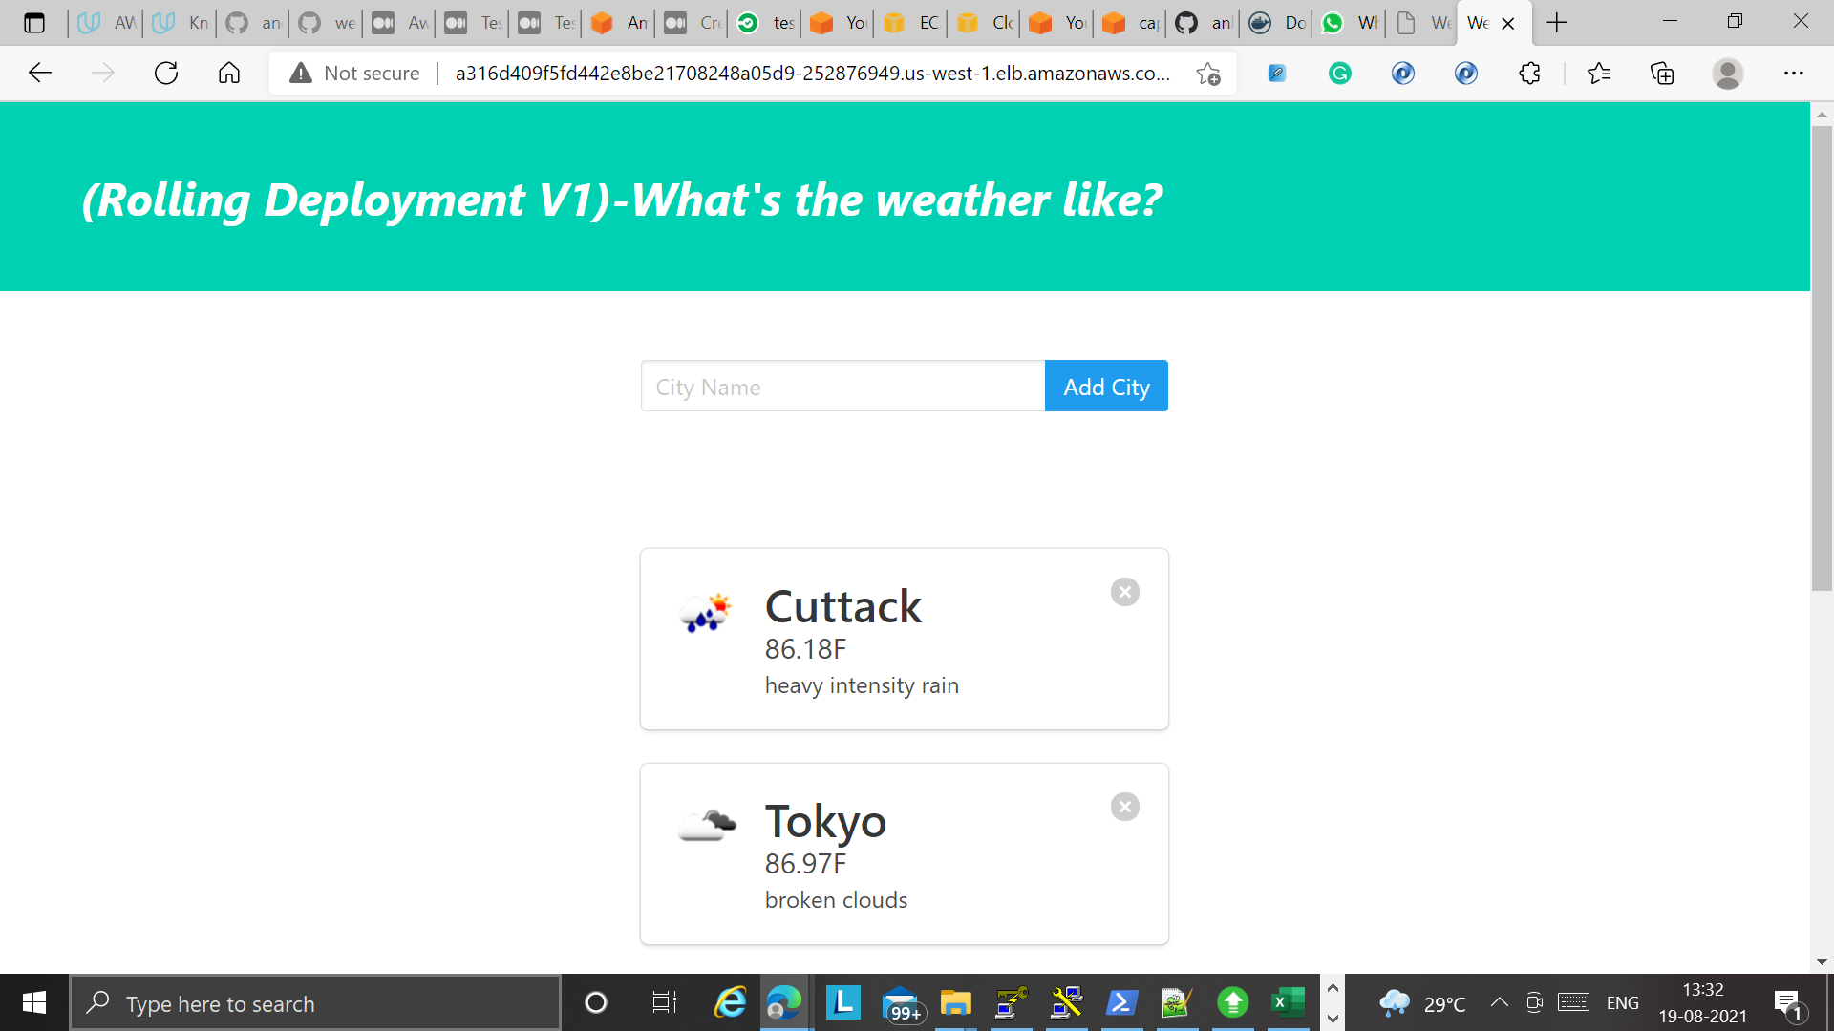

V2 after rolling update:

Pic2: Lint failure

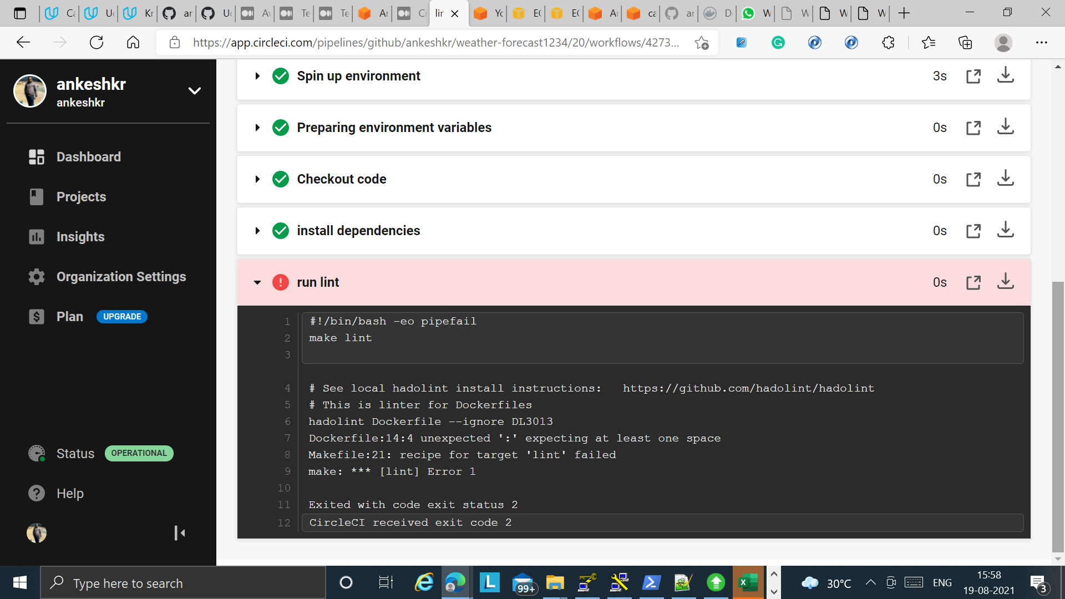

Pic3: Lint Success

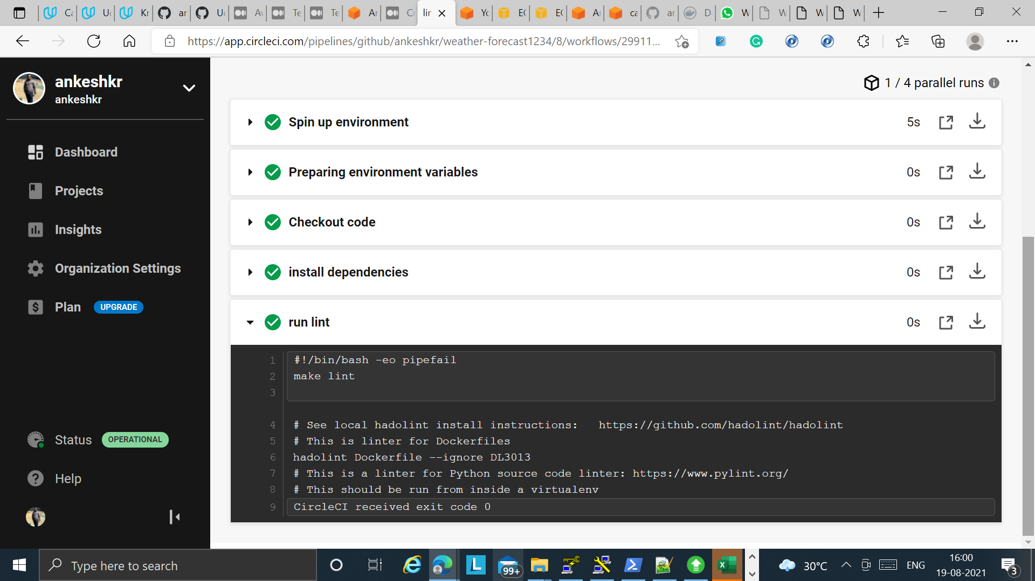

Pic4: Successful Deployment

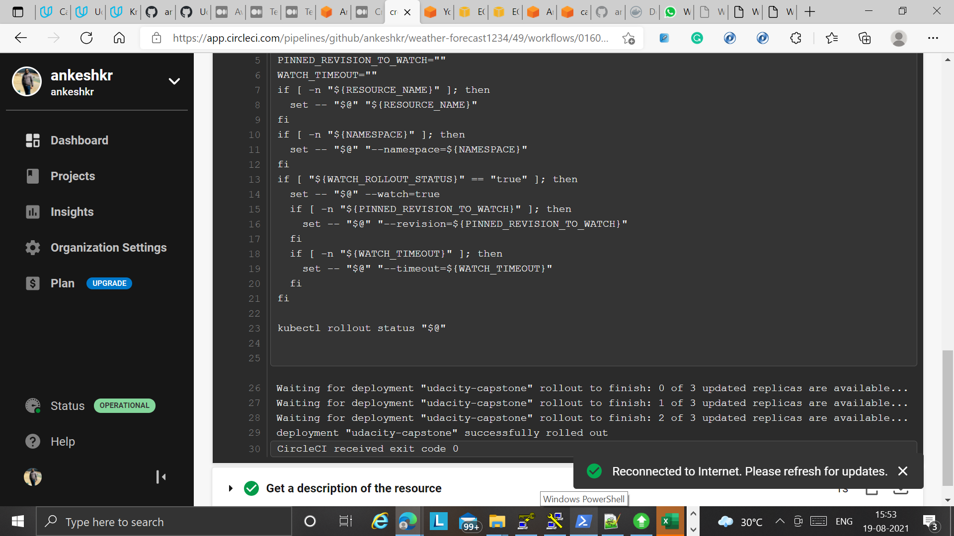

Pic5: EKS Cluster created

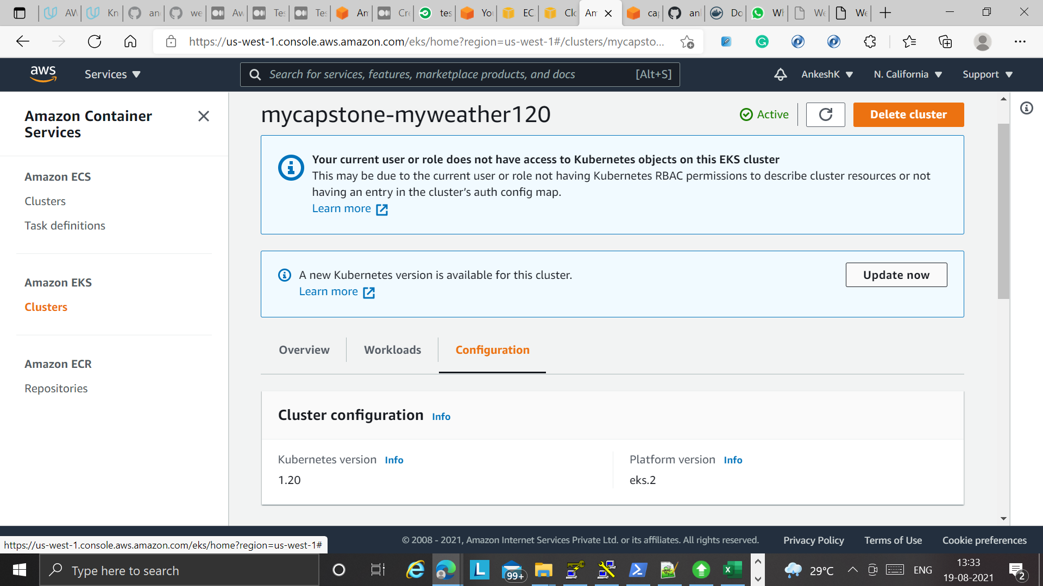

Pic 6: Rolling update, image update and deployment successful

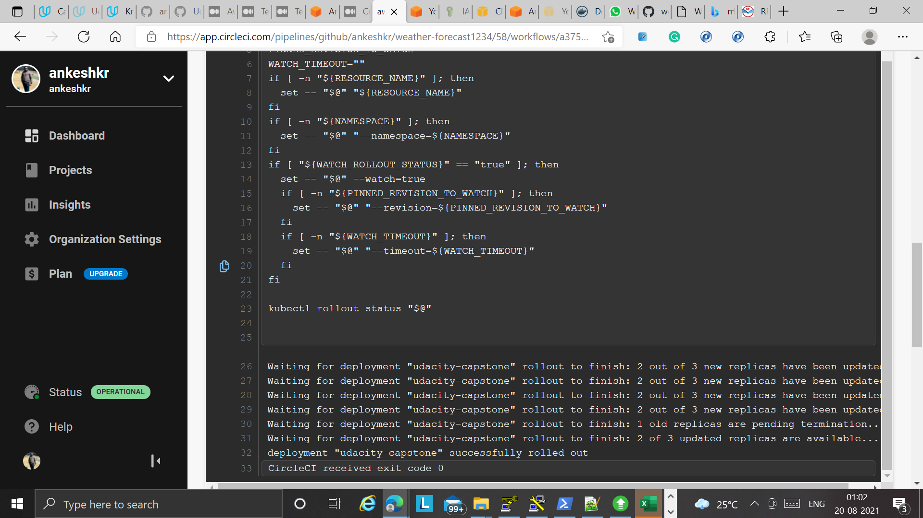

Pic 7: Rolling deployment

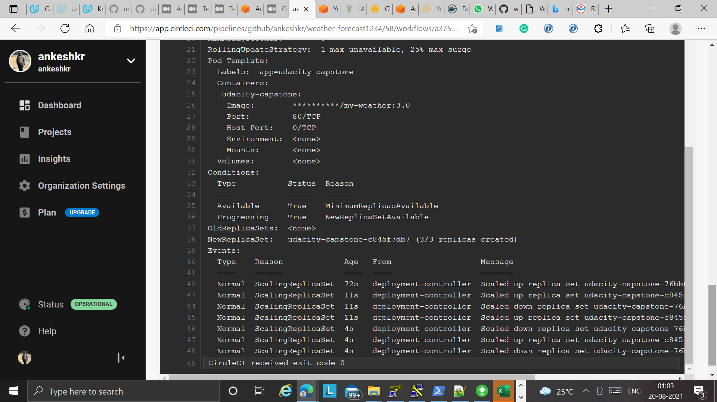

Pic 8: Cluster creation

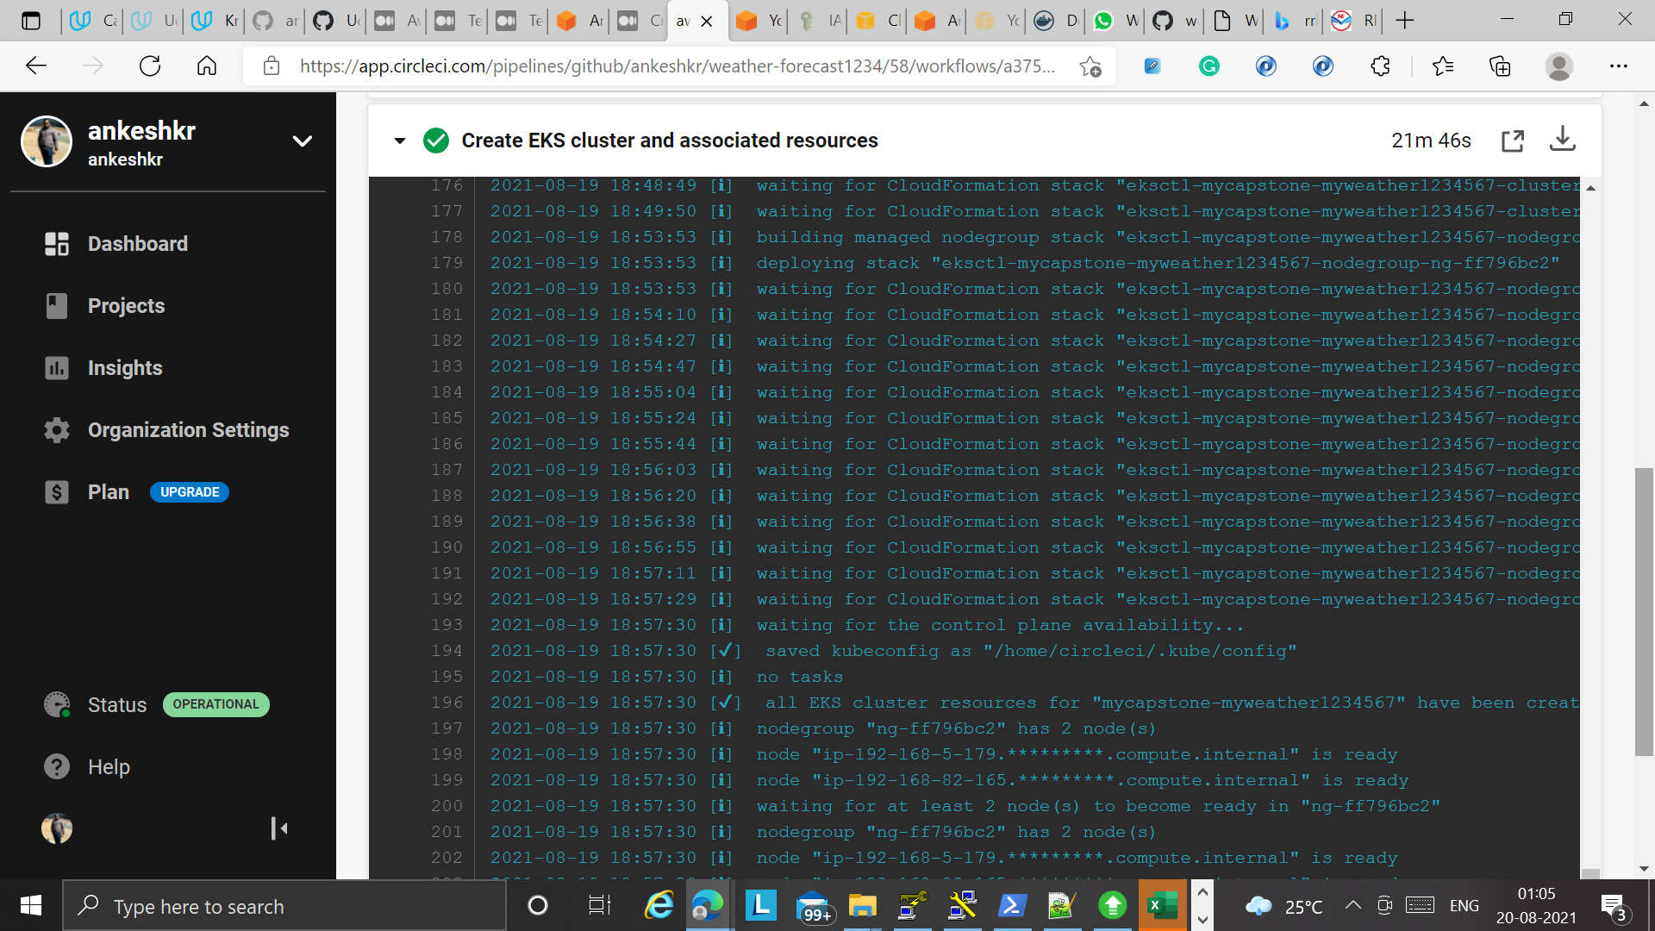

Pic9 : Docker image configuration

