HARCOURT BUTLER TECHNICAL UNIVERSITY



A

Project Report

On

HOTEL AUTOMATION SYSTEM For The Course – Software Engineering SUBMITTED BY

Ankesh Kumar (180108006)

Ankesh Ojha (180108007)

Ashutosh Bhalothia (180108008)

GUIDED BY

Mr. Indresh Kumar Gupta (CSE Dept.)

1

INTRODUCTION

Project title “Hotel Automation” (a project for keeping customers record and calculate customer bill slip and managers salary)

The name of project is “Hotel Automation”. The objective of the project is to computerize the system of the hotel. “Hotel Automation “is the project not only keeps the record of various people like customers, manager etc. but as well as it reduce the extensive paper work in the present system. It wills maker the system more versatile and user friendly. It also calculates the proper billing slip of high level and middle level customers. This project is based on description about the structure of HOTEL

AUTOMATION SYSTEM. The project contains:

➢Keeping the records of all persons like

customers, managers etc.

➢Updating the check status as per the need of the customer.

➢Maintaining and updating room status.

➢Maintains proper list of all persons.

➢Generating the pending bill.

2

OBJECTIVES

During the past several decades personnel function has been transformed from a relatively obscure record keeping staff to central and top level management function. There are many factors that have influenced this transformation like technological advances, professionalism, and general recognition of human beings as most important resources.

➢ A computer based management system is designed to handle all the primary information required to calculate monthly statements. Separate database is maintained to handle all the details required for the correct statement calculation and generation.

➢ This project intends to introduce more user friendliness in the various activities such as record updating, maintenance, and searching.

➢The searching of record has been made quite simple as all the details of the customer can be obtained by simply keying in the identification of that customer.

➢ Similarly, record maintenance and updating can also be accomplished by using the identification of

3

the customer with all the details being

automatically generated.

➢The entire information has maintained in the database or Files and whoever wants to retrieve can’t retrieve, only authorization user can retrieve the necessary information which can be easily be accessible from the file.

The main objective of the entire activity is to automate the process of day to day activities of Hotel like:

• Room activities,

• Admission of a New Customer,

• Assign a room according to customer’s demand, • Checkout of a computer and releasing the room • Finally compute the bill etc.

• Maintaining employee records.

• Calculating the pending amount of each customer. • Data regarding various department.

4

ADVANTAGES-

**Performance:** During past several decades, the records are supposed to be manually handled for all activities. The manual handling of the record is time consuming and highly prone to error.

To improve the performance of the Hotel Automation System, the computerized system is to be undertaken. This project is fully computerized and user friendly even that any of the members can see the report and status of the company.

**Efficiency:** The basic need of this system is efficiency. The system should be efficient so that whenever a new user submits his/her details the database is updated automatically. This record will be useful for other users instantly.

**Control:** The complete control of the project is under the hands of authorized person who has the password to access this project and illegal access is not supposed to deal with. All the control is under the administrator and the other members have the rights to just see the records not to change any transaction or entry.

**Security:** Security is the main criteria for the proposed system. Since illegal access may corrupt the database. So security has to be given in this project.

5

PRODUCT FEATURES-

“Hotel Automation System” has been designed to computerize the following functions that are performed by the system:

➢Room Detail Functions

➢Opening a New Room

➢Adding New Employee

➢Adding and Updating Rooms

➢Maintaining records of all employees

➢Maintaining records of all drivers along with their current location

➢Various departments and their allocated budgets ➢Modification to room assigned

➢Check-in and check-out Detail Functions ➢Admission of New customer

➢Check-out of customer

➢Room assigning related to customer’s need. ➢Statement of Customer Details

➢Check-in customer

➢Check-out customer

➢Room Details

6

**ER DIAGRAM-**

7

**CONTEXT DIAGRAM (DFD LEVEL 0)-**

8

**DFD LEVEL-1 DIAGRAM-**

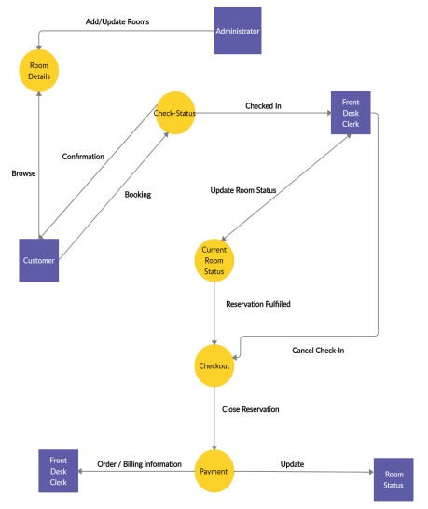9

**DFD LEVEL-2 DIAGRAM-**

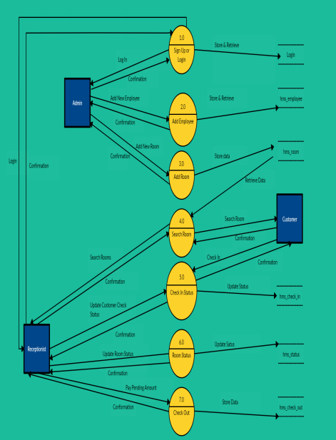10

**SNAPSHOTS OF PROJECT-**

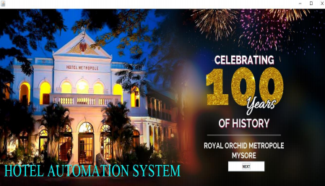 Welcome Page

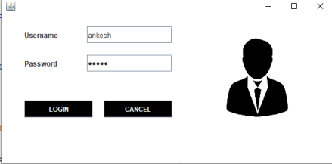 Login Page

11

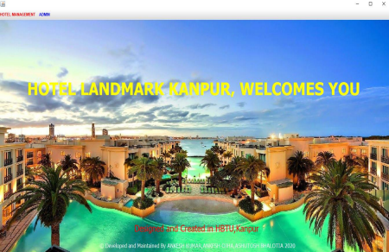 Main Dashboard

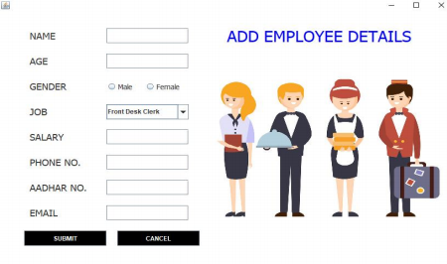Add Employee Details

12

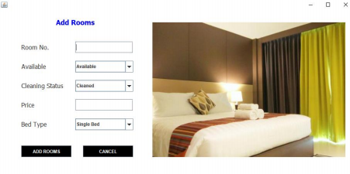Add Room Details

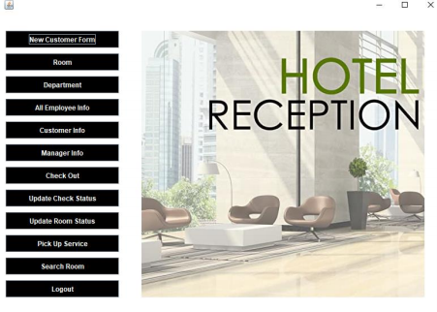Reception Desk Page

13

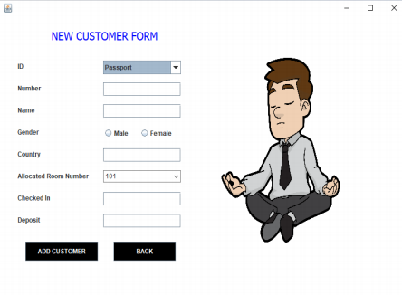New Customer Form

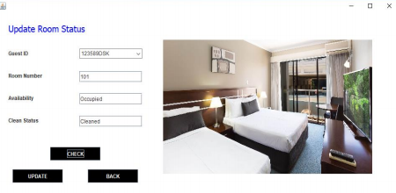Update Room Details

14

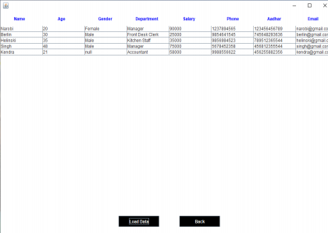All Employee Details

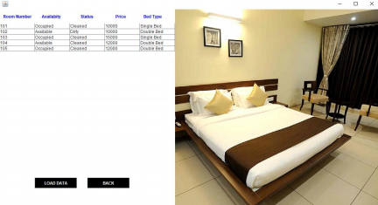All Room Details

15

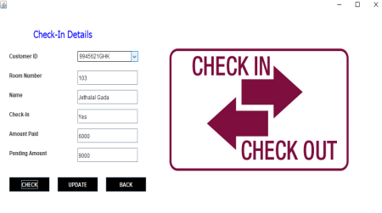Update Check Status

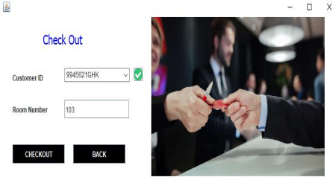Check Out Page

16

SOFTWARE REQUIREMENTS

This application is develop using NetBeans IDE that uses JDK8.0, JRE for the coding and MySQL 8.0 for the database.

NETBEANS IDE 8.1-

• NetBeans IDE runs on the Java SE Development Kit (JDK) which consists of the Java Runtime

Environment and developer tools for compiling, debugging, and running applications written in the Java language.

• The tested JDK for this release is JDK 8u60 for Windows, Linux, and OS X. The 8.1 version of the IDE cannot be installed or run using JDK 6.0.

MySQL8.0

MySQL is free and open-source software under the terms of the GNU General Public License, and is also available under a variety of proprietary licenses.

17

TECHNICAL REQUIREMENTS

|  |  |
| --- | --- |
| **LANGUAGE**  **USED** | Java |
| **DATABASE** | Managed by MySQL 8.0 |
| **INTERFACE** | Graphical User Interface |
| **IDE** | NetBeans 8.2 |

18

SCOPE OF FUTURE APPLICATION

This project can be used in the hotel after adding some more useful modules in the project for which hotel are providing services.

Utmost care and back-up procedures must be established to ensure 100% successful implementation of the computerized hotel system. In case of system failure, the organization should be in a position to process the transaction with another organization or if the worst comes to the worst, it should be in a position to complete it manually.

SCOPE OF IMPROVEMENT

Now a day’s hotel are providing many other facilities, this project can also be improved with the improvement in the Hotels.

Utmost care and back-up procedures must be established to ensure 100% successful implementation of the computerized banking system. In case of system failure, the organization should be in a position to process the transaction with another organization or if the worst comes to the worst, it should be in a position to complete it manually.

19

CONCLUSION

This project is designed to meet the requirements of Hotel Automation System. It has been developed in Core Java and MySQL keeping in mind the specifications of the system.

For designing the system, we have used simple data flow diagrams.

Overall, the project teaches us the essential skills like:

▪ Using system analysis and design techniques like data flow diagram in designing the system.

▪ Creation of various framework using Java Swing.

▪ Understanding the database handling and query processing.

20