**Assignment No: 1**

**# Code for iterative method#**

import java.util.Scanner;

public class iterativeFibonacciSeries {

    public static void printFibonacci(int length) {

        int first = 0;

        int second = 1;

        System.out.print(first + " " + second + " ");

        length -= 2;

        while (length > 0) {

            int next = first + second

            System.out.print(next + " ");

            int temp = second;

            second = next;

            first = temp;

            length -= 1;

        }

    }

    public static void main(String[] args) {

        Scanner scanner = new Scanner(System.in);

        System.out.print("Enter the length of the Fibonacci series: ");

        int length = scanner.nextInt();

        scanner.close();

        System.out.println("Fibonacci Series - ");

        printFibonacci(length);

    }

}

**Output:**

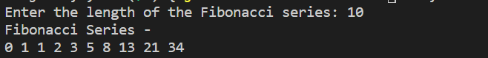

**#Code for Recurrsive method#**

import java.util.Scanner;

public class recurrsiveFibonacci {

    public static void printFibonacci(int first, int second, int length) {

        if (length == 0) {

            return;

        }

        System.out.print(first + second + " ");

        printFibonacci(second, first + second, length - 1);

    }

    public static void main(String[] args) {

        Scanner scanner = new Scanner(System.in);

        System.out.println("Fibonacci Series - ");

        System.out.print("Enter the length of the series: ");

        int length = scanner.nextInt();

        if (length >= 2) {

            System.out.print("0 1 ");

            printFibonacci(0, 1, length - 2);

        } else if (length == 1) {

            System.out.print("0 ");

        }

        scanner.close();

    }

}

**Output:**

