Q1. Write a Python function `is_prime(n)` to check if a number is prime. Use an AI
coding tool to generate and justify a set of test cases before implementation. Pass all
generated test cases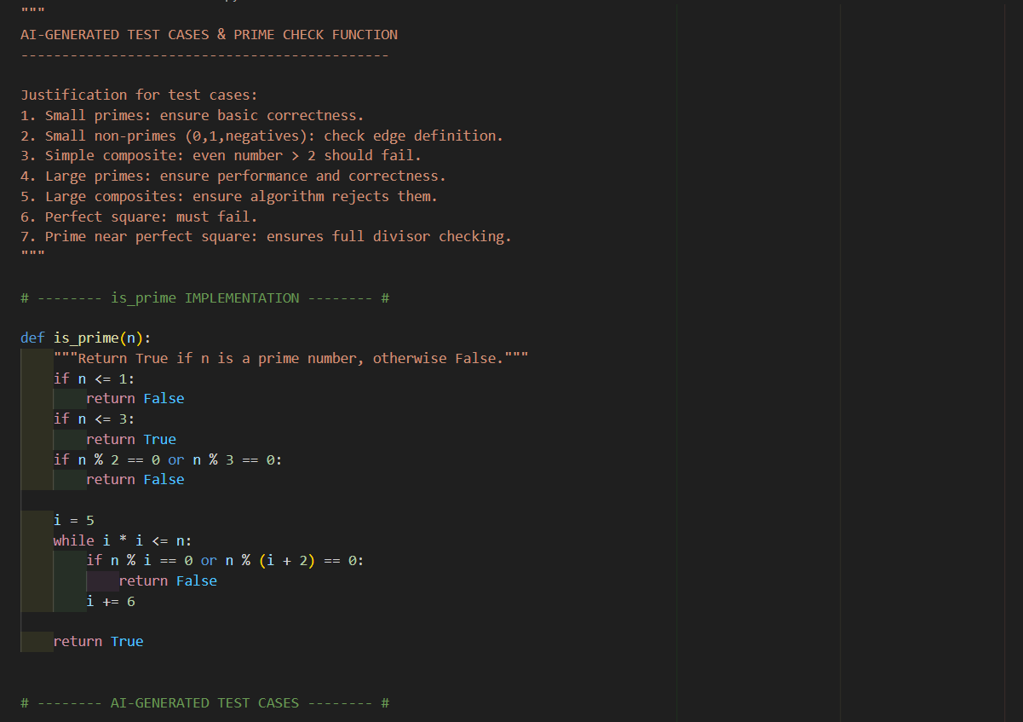

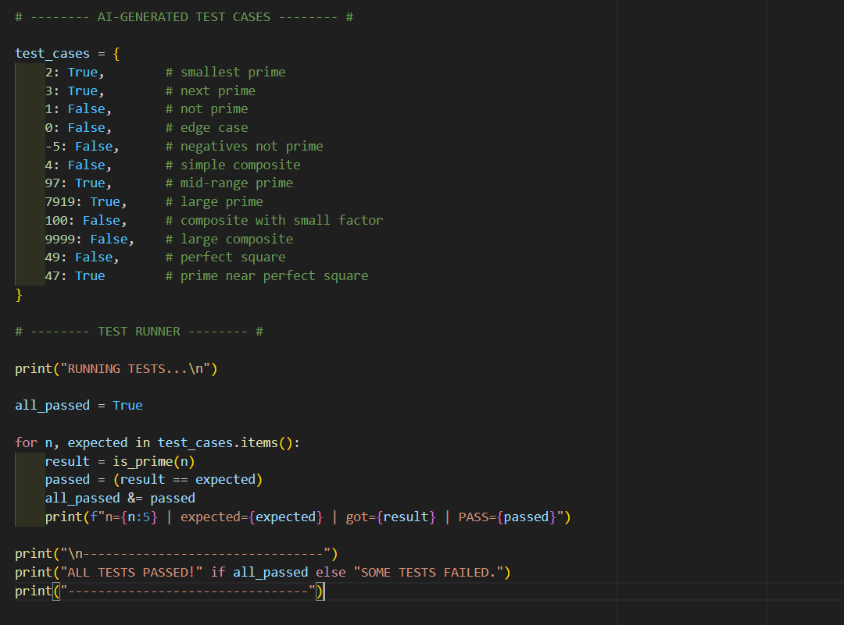

PRACTICAL OUTPUT:-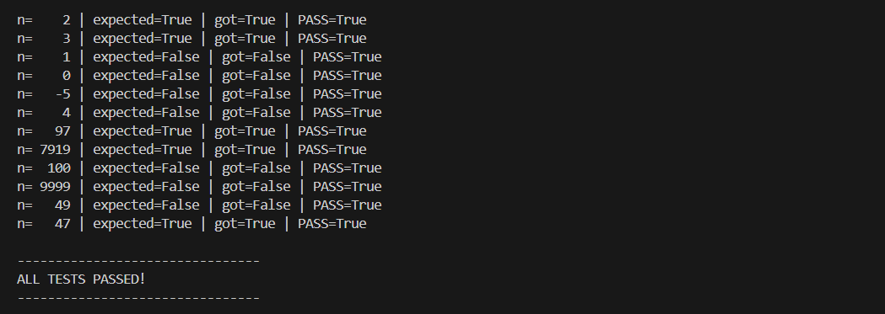

Q2 .Develop a Python class `Rectangle` with methods for area and perimeter. Use an AI assistant for auto-generating docstrings and inline comments. Compare them with your manual documentation.
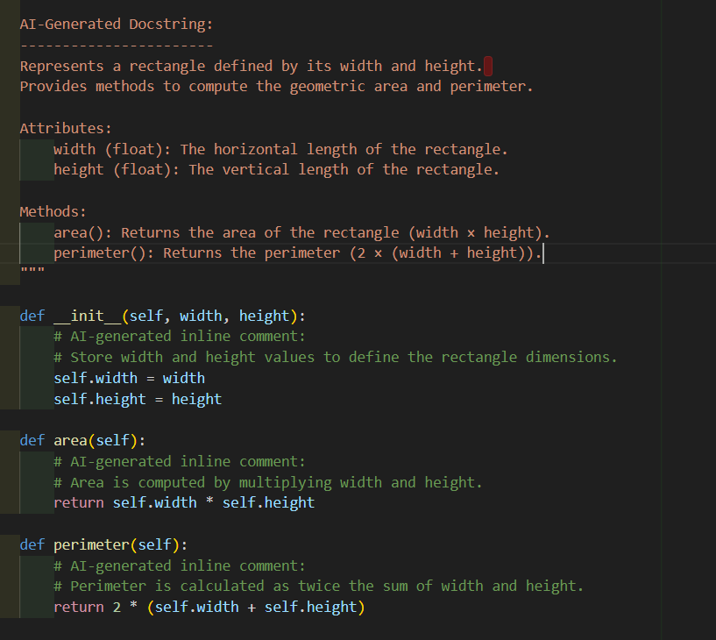
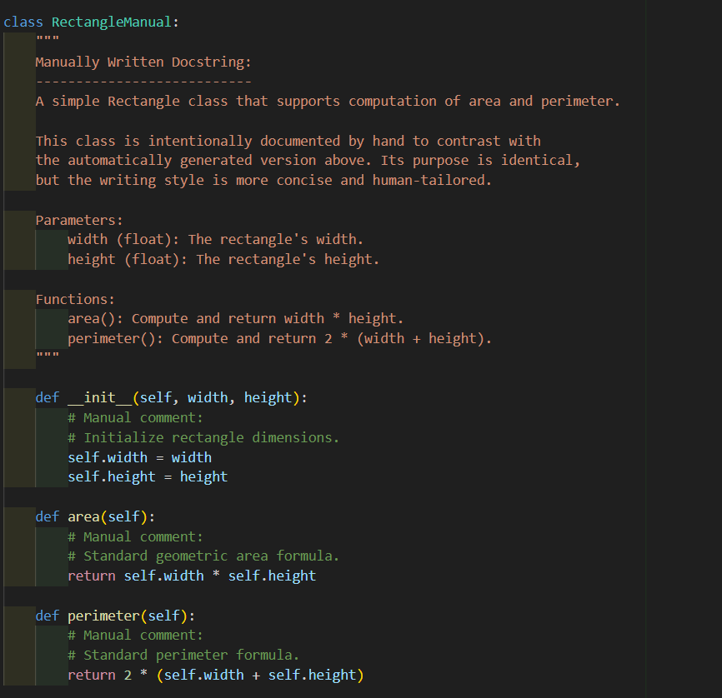
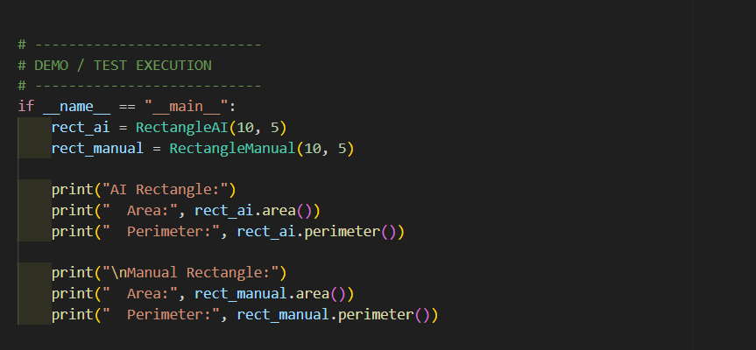

PRACTICAL OUTPUT: -
