-- create table

CREATE EXTERNAL TABLE Employees(

Job_Titles STRING,

Department STRING,

Full_or_Part_Time STRING,

Salary_or_Hourly STRING,

Typical_Hours INT ,

Annual_Salary DOUBLE,

Hourly_Rate FLOAT

)

ROW FORMAT DELIMITED FIELDS TERMINATED BY ','

LINES TERMINATED BY '\n'

LOCATION '/user/cloudera/input/'

tblproperties("skip.header.line.count"="1");

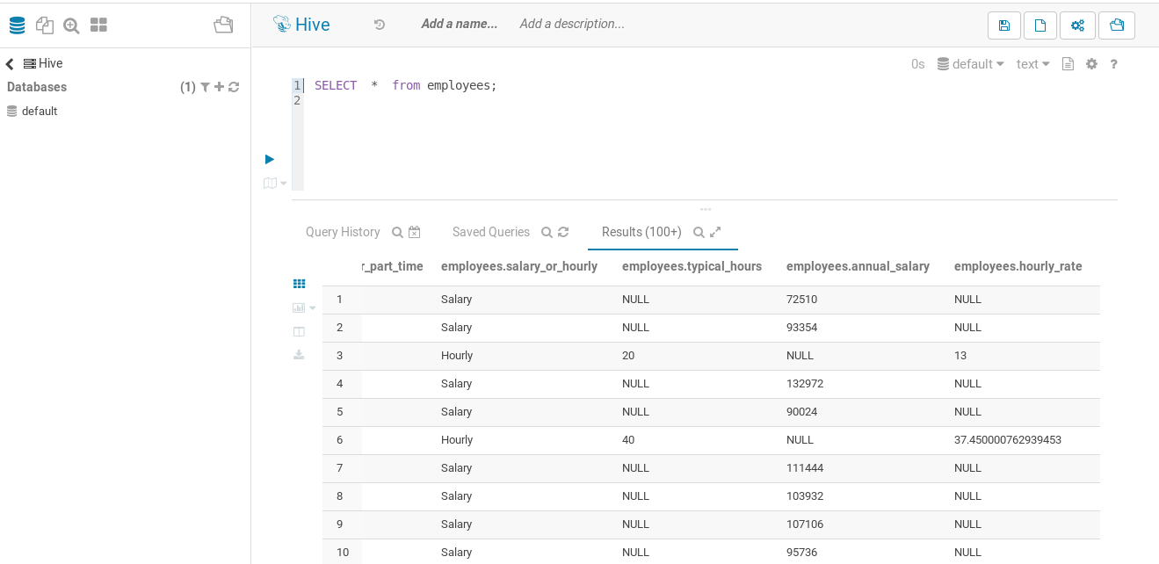

-- Queries

1.

select avg(Annual_Salary)

from employees

where Job_Titles like ‘%Police officier%’ and Salary_or_Hourly = ‘Salary’

2.

select Full_or_Part_Time , count(Full_or_Part_Time)

from employees

group by Full_or_Part_Time

3.

select Department , min(Annual_Salary), avg(Annual_Salary), max(Annual_Salary)

from employees

where Salary_or_Hourly = ‘Salary’

group by Department