**LAB7**

-- Sqoop

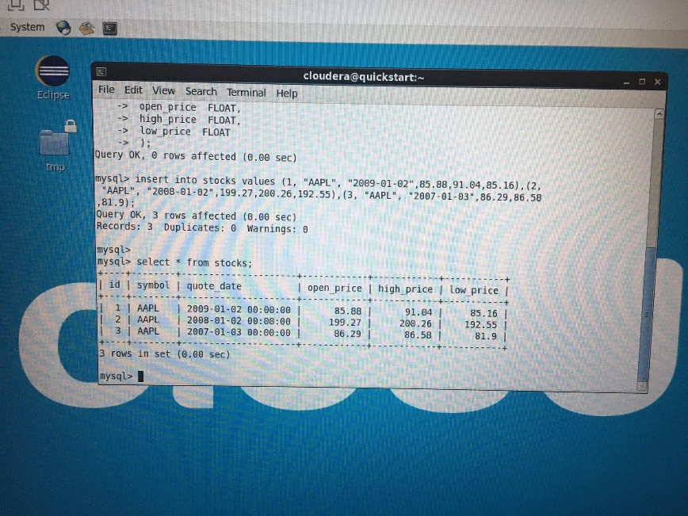

sqoop import --connect jdbc:mysql://localhost/cs523 --username root -password cloudera --table stocks --columns "id,symbol,open_price" --target-dir=/user/cloudera/sqoopOutputStocks -m 1 --fields-terminated-by '\t'

**-- Flume**

mkdir /tmp/input

mkdir /tmp/spooldir/

mkdir /tmp/spooldir/finished/

mkdir /tmp/error

flume-ng agent --conf /home/cloudera/cs523/flume/conf --conf-file /home/cloudera/cs523/flume/conf/myFlumeConf.conf --name a1 -Dflume.root.logger=INFO,console

-- in conf file:

