## horizontal line

INF240: Project Documentation

(ABCDEFG Resale store)

Ankhbayar Enkhlkhagva INF240A Website Development

ID: 100132497 Fall 2019

Mail address: ANE171@aubg.edu Instructor: Metodi Traykov

I. Ankhbayar Enkhlkhagva, hereby declare that submitted project is all my own work. I did not copy the material from someone else; did not use any web design software; and no one, but me developed the website. I also declare that I have successfully completed the assignment.

# 

# Abstract

This website is a sample website for a resale store.

It consists of 5 separate pages and one CSS file:

1. Homepage
2. Hats
3. Accessories
4. Sweatshirt
5. Contact

Used application:

1. Notepad++ (XHTML, CSS, JavaScript)

# Design and Layout

This website is mainly Black & White colored, in order to keep it simple and appealing. Every page has 2 column layout (Navigation bar on the left side and Contents on the right side) which makes it unique (compared to most of the websites)

# Homepage (index.html)

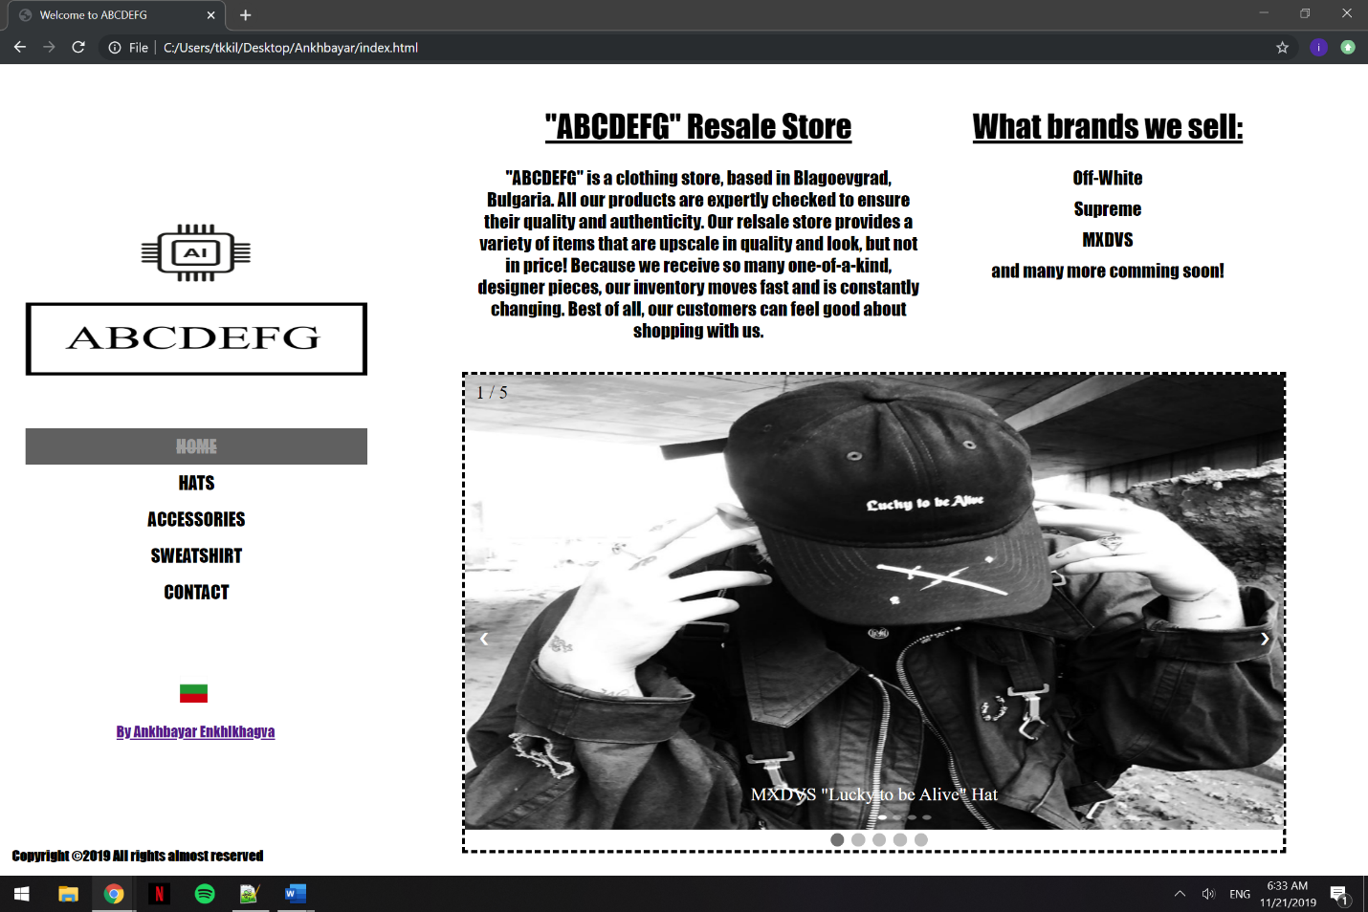Homepage has a logo followed by the navigation bar placed left side of the page. I used fixed positioning method on my navigation bar, so it won’t move when user scroll the page down. If the user clicks on a Bulgarian flag down the bar, it will open a google map showing our location. If the user clicks on my name, it will open my Instagram page. Right hand side of the homepage has a general information about the resale store “ABCDEFG”, and the brands we sell. I also separated them in two blocks with different class ID, to make 2 column view. Below the information section, there is an image slideshow with 5 images. The number of the image is shown in the top left corner, the description and the dots (represents the position of current slide) is shown in the bottom. I used JavaScript to make this interactive slideshow, which contains PlusSlides(), CurrentSlide() and ShowSlides() functions. Plays mp3 music automatically.

Homepage ss

# Hats/Accessories/Sweatshirt (hats.html/access.html/sweat.html)

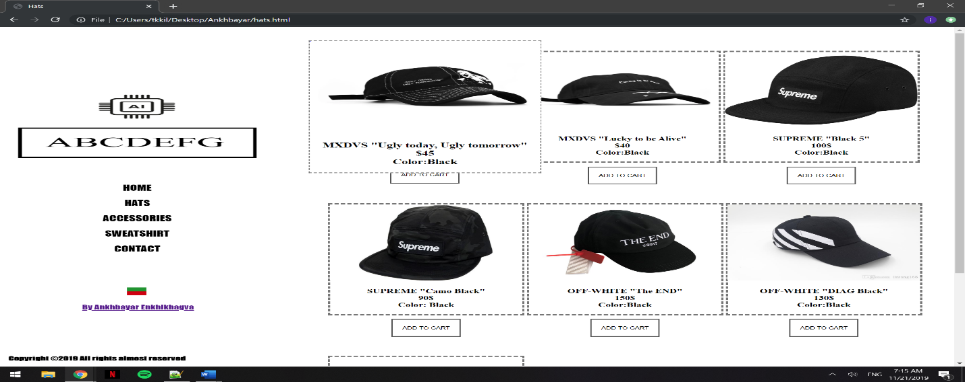These pages have same layout and functionalities. On the right side of the page, the products are shown in a table-like structure. Each product has its own table cell which contains its picture and brief information. When user brings the mouse cursor on the item, it zooms the cell and a bigger image and a description about the product appears. This result was achieved using transform and transition properties of CSS. Also, I added a button (with hover effect and shadow) for every product, which opens a dialog box shown below. I used CSS to set the position, background opacity, close button (with hover effect) for the dialog box. To make them in action, I used JavaScipt, containing 7 variables and functions for each product, to link them with one dialog box. Also, it contains a set of lines which closes the dialog box if user clicks anywhere outside the dialog box.

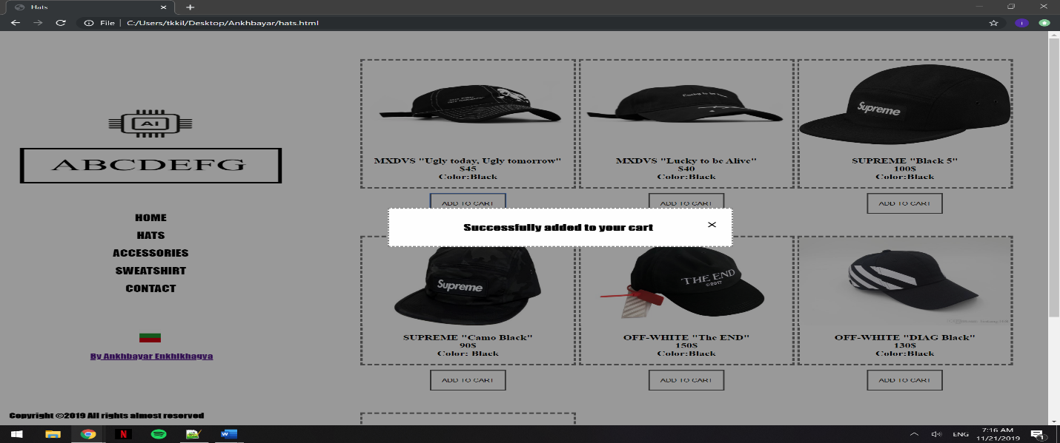Zoom when hover

Dialog Box

# Contact Us (contact.html)

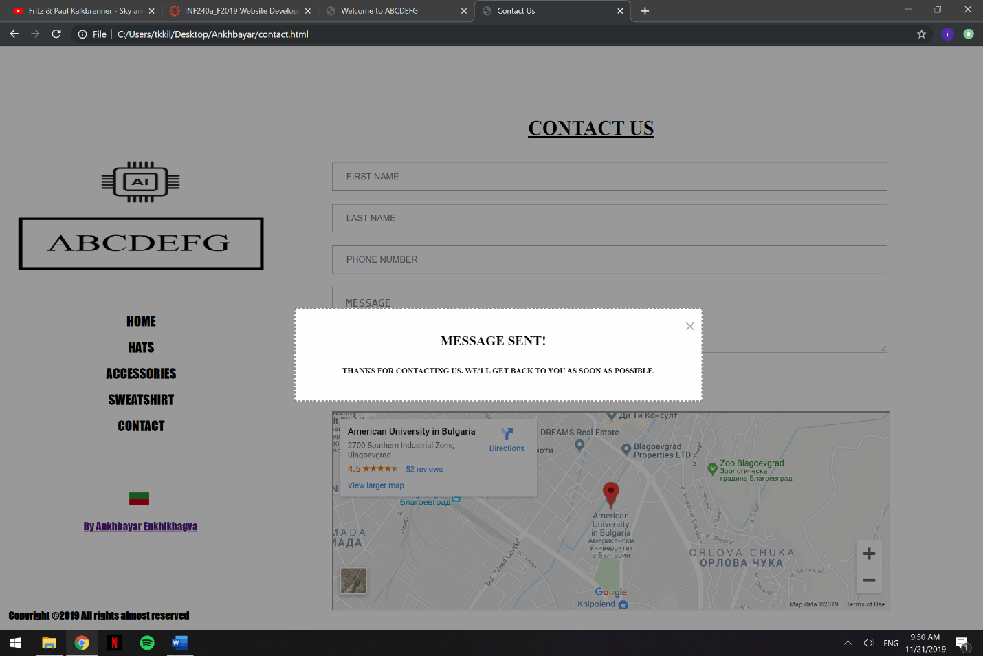Contact Us page contains a map showing the location of the store. I used Google maps HTML link and iframe tag. Figure 7 is a screenshot of the page. There is a form with inputs that the user can send feedback or order products. If a user clicks on the send button, it will show a dialog box (same technique as products) and automatically redirects you to your email application.

Contact Us

# External CSS document (style.css)

style.css contains lines of CSS file, that I used throughout the webpage, which made it easier to modify the design of the website, when it’s needed.

# Screenshots of the W3C XHTML Validator output

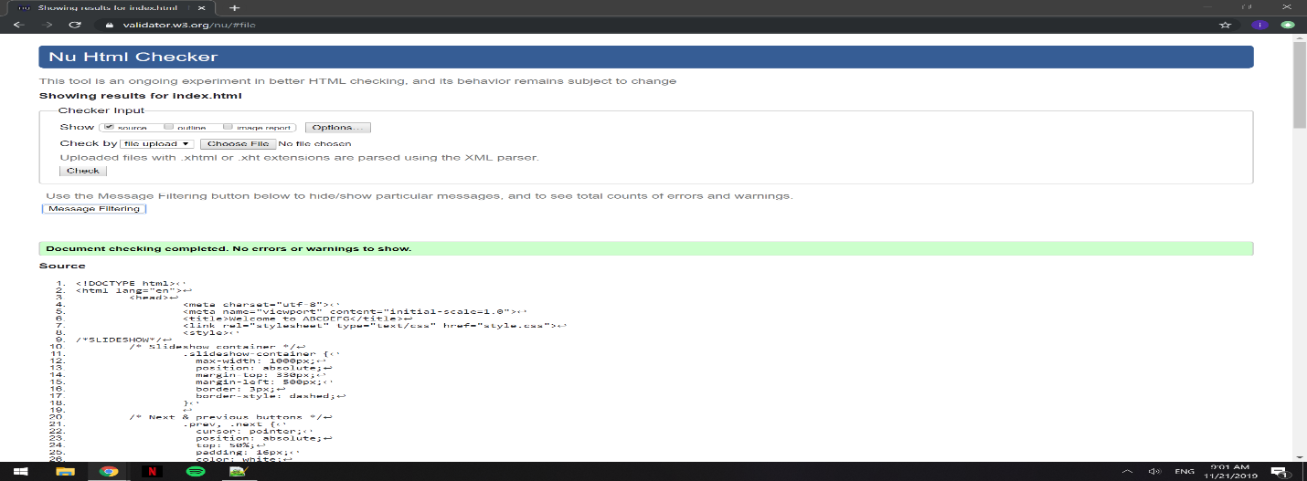index.html

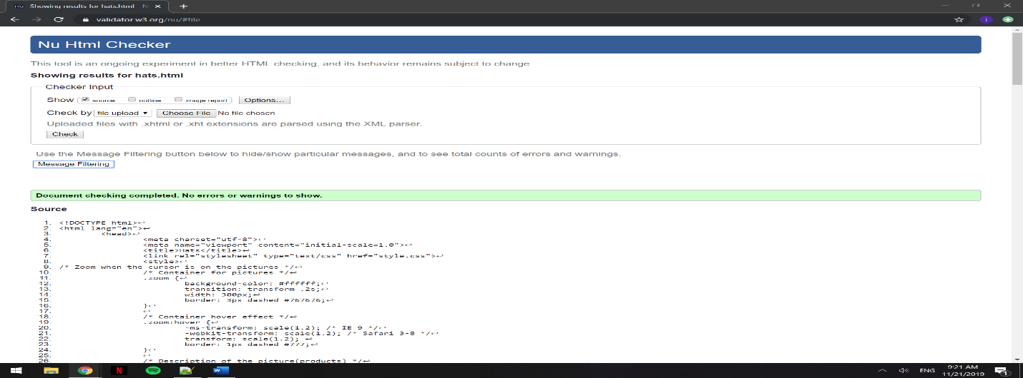hats.html

access.html

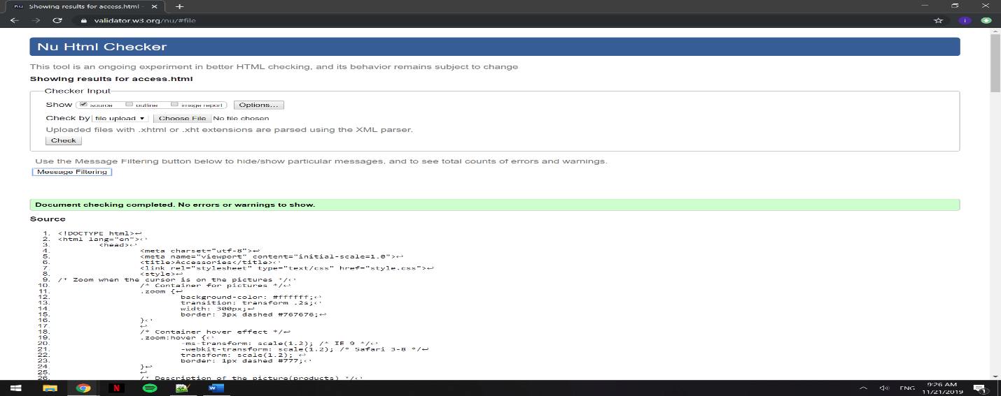

Sweat.html

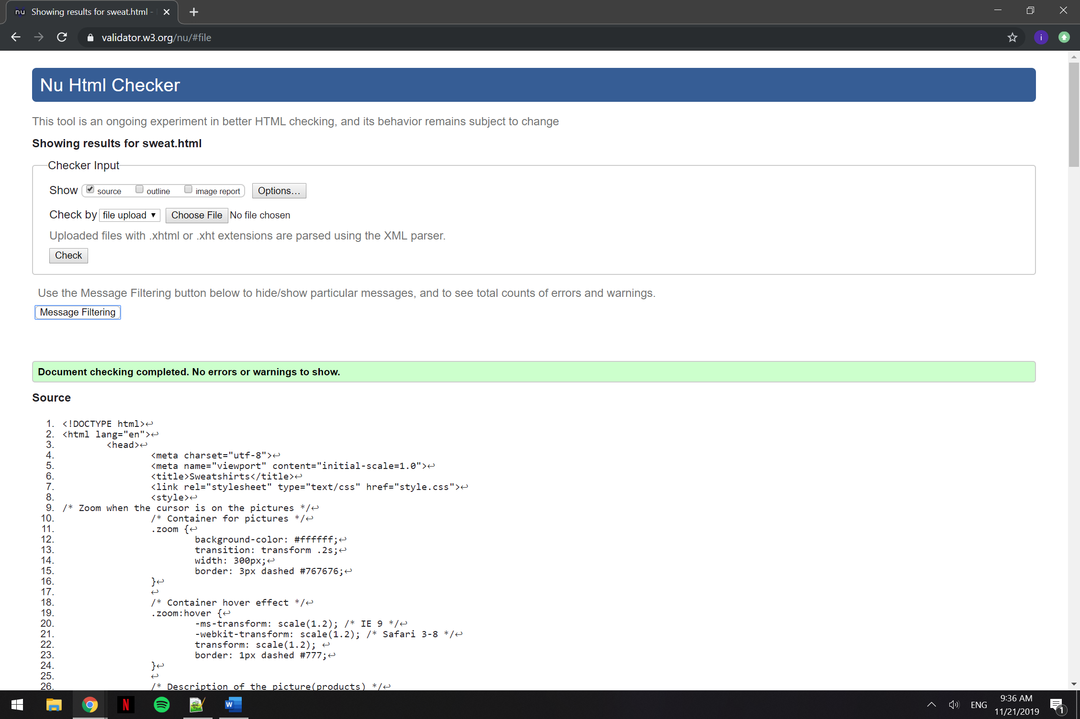

Contact.html 