IGN offers two types of image services (WMS): a raster WMS service and another vector WMS service. Each delivers geolocated images according to the syntax of the WMS 1.3.0 protocol. Those delivered by the first are calculated from the image data of the IGN; those issued by the second come from the vector databases of the IGN.

The following tables contain the list of resources served by each of these services: name of the resource presented during the contract and technical name corresponding to use according to the context of use (GIS or Web use).

Detailed documentation: <https://geoservices.ign.fr/documentation/donnees-ressources-wms-geoportail.html>

Resources available as WMS (Raster) accessible through : <http://wxs.ign.fr/KEY/geoportail/r/wms>

A subset of WMS services:

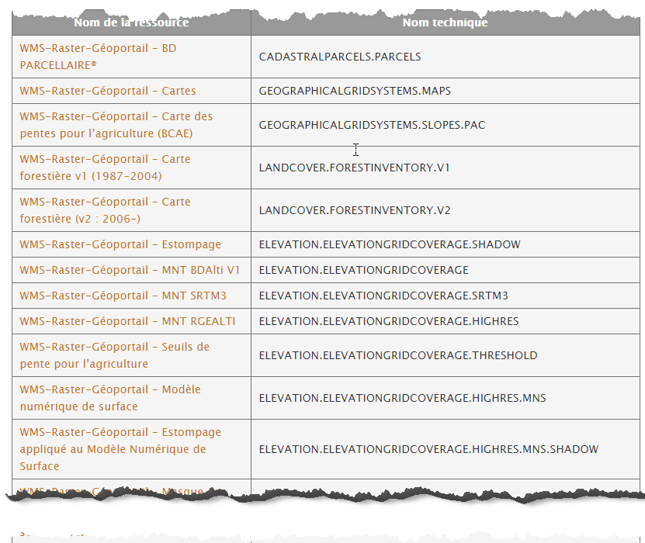

Resources available as WMS (Vector) accessible through : <http://wxs.ign.fr/KEY/geoportail/v/wms>

A subset of WMS services :

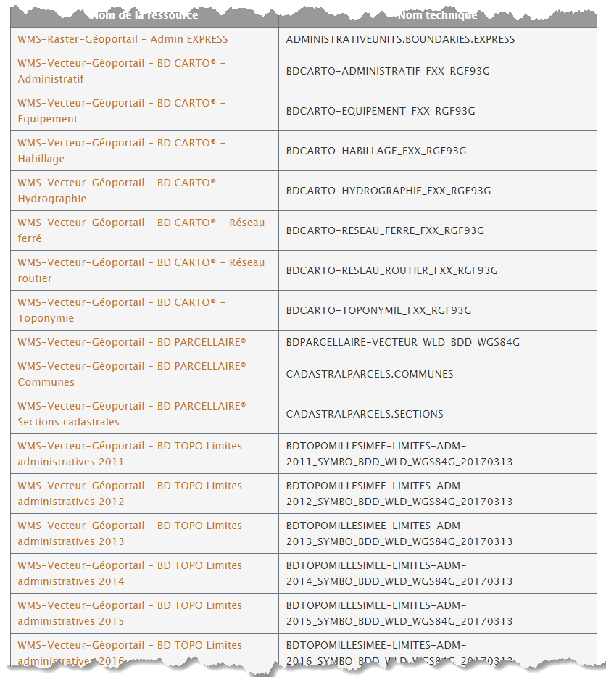

Possible queries :

Geoportal WMS servers respond to the following three types of WMS requests:

* **GetCapabilities:** Returns the service parameters and the layers (a WMS layer is a resource) that are available with the information to set the following queries;
* **GetMap:** returns an image of the map;
* **GetFeatureInfo:**Returns information about the objects used to generate the map (optional).The GetFeatureInfo feature is not supported by all resources. This is indicated layer-by-layer in the response document to the GetCapabilities query.

Available settings :

The parameters that can be used depend on the submitted query (GetCapabilities, GetMap, GetFeatureInfo). They may be common or specific, mandatory or optional. The main parameters used are the following (non-exhaustive list):

*Common parameters*

* SERVICE: the type of service (here "WMS")
* VERSION: the version of the service used (1.1.1, 1.3 ...)
* REQUEST: the request to the server (GetCapabilities, GetMap or GetFeatureInfo)
* NB: the Geoportal WMS services support versions 1.1.1 and 1.3.0 of the WMS protocol.

GetMap specific settings

FORMAT: the output format - type-mime - of the image file ("image / png", "image / jpg", ...);

LAYERS: the resource (s) to use to calculate the image. It is the technical name of the resource that is used;

STYLES: the rendering style of the layers;

WIDTH: width of the final image in pixels;

HEIGHT: height of the final image in pixels;

In WMS 1.0 WMS 1.1 and WMS 1.2, the parameter SRS (Spatial Reference System) and in WMS 1.3 the parameter is renamed CRS. This parameter indicates the coordinate system used;

BBOX (Bounding Box): the geographic footprint of the data to be rendered in the image.

DPI: expected image density in "dot per inch" or "pixel per inch" (default: 90.7 DPI).

GetFeatureInfo specific parameters

A GetFeatureInfo request contains parameters for creating an image and adds the following parameters indicating a point in the image and the format to use to return the response.

I: abscissa of a point in the image in pixels

J: ordinate of a point in the image in pixels

QUERY_LAYERS: The resource (s) whose information you want to retrieve. It is the technical name of the resource that is used;

INFO_FORMAT: the output format - type-mime - of the GetFeatureInfo request (ex: text / plain, text / html, ....)

Formats :

JPEG / PNG / TIFF / GeoTIFF

For WMS (Vector), those formats can be available:  GIF / SVG / KML

Max Size of Image can be 2048 * 2048 (WIDTH / HEIGHT)

Projection:

WMS Services can be served in several coordinate system. The info is stored in the response of the GetCapabilities request.

Eg: <https://wxs.ign.fr/pratique/geoportail/r/wms?SERVICE=WMS&REQUEST=GetCapabilities>