IGN offers two services of tiled images (WMTS) : one serving tiled images in World Projection Web Mercator, the other in legal projection Lambert 93 on Metropolitan France.

The following tables contain the list of resources served by each of these services: name of the resource presented during the contract and technical name corresponding to use according to the context of use (GIS or Web use).

Detailed documentation : <https://geoservices.ign.fr/documentation/donnees-ressources-wmts.html>

Resources available as WMTS in Web Mercator are accessible through : <http://wxs.ign.fr/KEY/geoportail/wmts>

A subset of WMTS services :

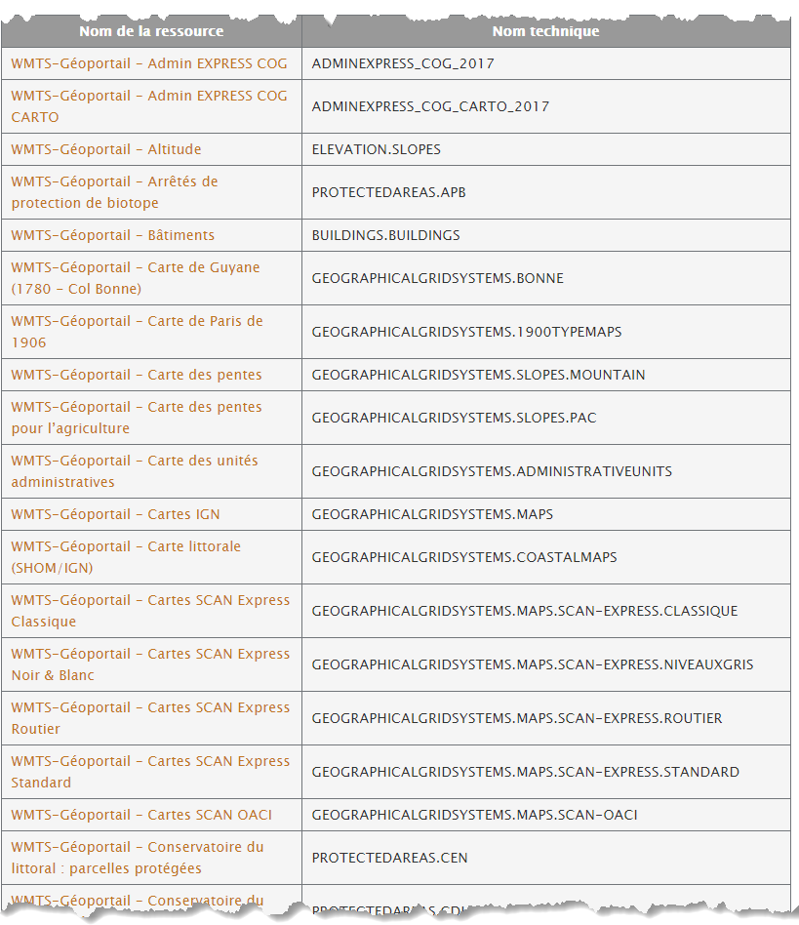

Resources available as WMTS in Lambert 93 are accessible through :

<https://wxs.ign.fr/KEY/geoportail/wmts>

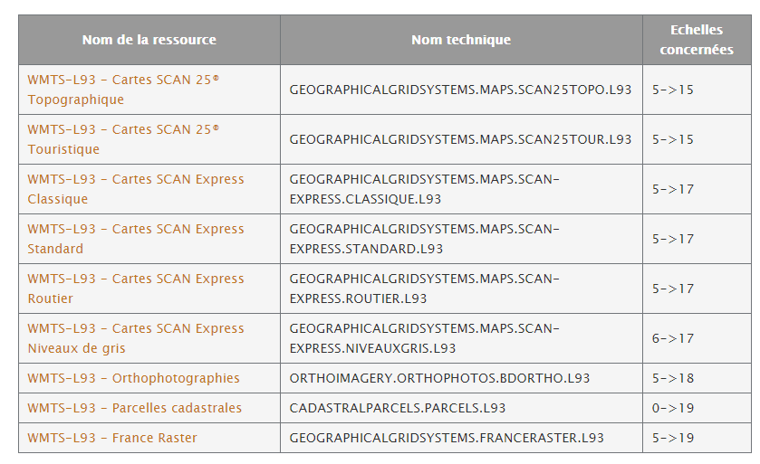

Resources available as WMTS in Lambert 93 are accessible through :

<http://wxs.ign.fr/CLEF/geoportail/wmts>

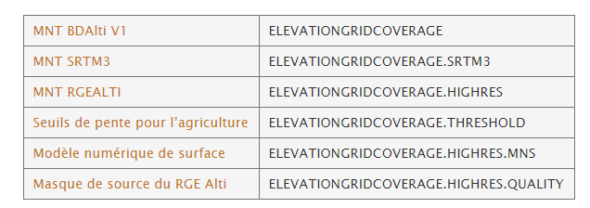

Possible queries :

Geoportal WMS servers respond to the following three types of WMS requests:

* **GetCapabilities:** Returns the service parameters and the layers (a WMS layer is a resource) that are available with the information to set the following queries;
* **GetMap:** returns an image of the map;
* **GetFeatureInfo:**Returns information about the objects used to generate the map (optional).The GetFeatureInfo feature is not supported by all resources. This is indicated layer-by-layer in the response document to the GetCapabilities query.

Available settings

The parameters that can be used depend on the submitted query (GetCapabilities, GetTile, GetFeatureInfo). They may be common or specific, mandatory or optional. The main parameters used are the following (non-exhaustive list):

Common parameters

* SERVICE: the type of service (here: "WMTS")
* VERSION: the version of the service used (1.0.0)
* REQUEST: the request to the server (GetCapabilities, GetTile, or GetFeatureInfo)

GetTile specific parameters

* LAYER: the requested layer (JPG or PNG)
* TILEMATRIXSET: The name of the image pyramid
* TILEMATRIX: The name of the matrix that contains the tile
* TILEROW: The line number of the top left corner of the tile
* TILECOL: The column number of the upper left corner of the tile
* FORMAT: the output format of the image file
* STYLE: the name of a rendering style of the layer to apply

GetFeatureInfo specific parameters

A GetFeatureInfo request contains the parameters of a GetTile request to obtain an image and adds the following parameters indicating a point in the image and the format to use to return the response.

 INFOFORMAT: the format - type-mime - of the answer to the request: (ex: text / html)

I: abcisse of a point in the image in pixels

J: a point in the image in pixels

Formats :

PNG or Jpeg are both available

Size of tiles : 256 * 256. Coordinate of origin for each level of zoom are (0,0) of the used projection.

Level of Zoom : 21 Level

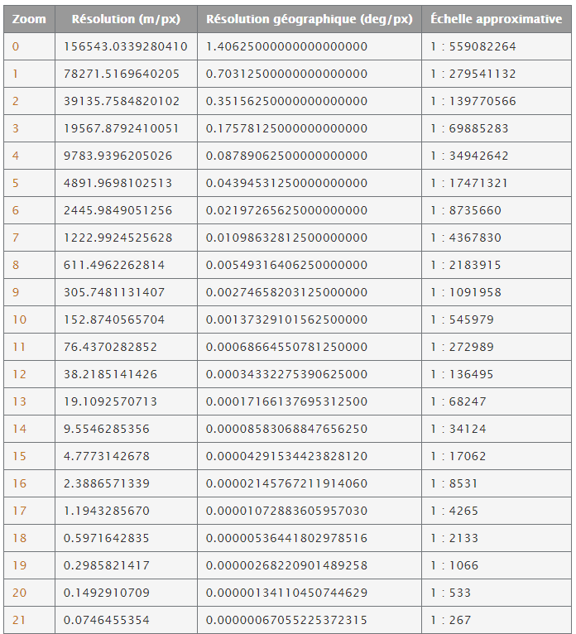 *Web Mecator :*

*Lambert 93  (EPSG : 2154)*

