1.Write a program to demonstrate various process related concept

#include <stdio.h>
#include<unistd.h>
#include<stdlib.h>
#include<sys/types.h>
#include<sys/wait.h>

int main()
{
int pid=fork();
if(pid==0)
{
printf("child=>PPID%d PID %d\n",getppid(),getpid());
exit(EXIT_SUCCESS);
}
else if(pid>0)
{
printf("parent=>PID %d\n",getpid());
printf("waiting for child process\n");
wait(NULL);
printf("child proces finished");
}
else{
printf("unable to create child process");
}
return EXIT_SUCCESS;
}

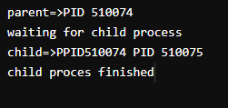

2.

